# Improving Consistency of Internet Access in Asia Pacific College: Bandwidth Optimization and User Policy

Project Documentation Submitted

To the Faculty of School of

Computing and Information Technologies

Of

Asia Pacific College

In Partial Fulfillment of the Requirements for the subject

Applied Projects 2 or Software Development

By

Paulo Capuz

Genesis Diocampo

Jesus Brugada

Jefferson Gonzales

Table of Contents

Improving Consistency of Internet Access in APC: Bandwidth Optimization and User Policy 1

Abstract 3

List of Figures, List of Tables, List of Notations 4

I. Introduction 9

1.1 Background of the Problem 9

1.2 Statement of the Problem 9

1.3 Objectives 9

General Objectives 9

Specific Objectives 10

1.4 Significance 10

II. Scope and Limitations 10

III. Related Literature 10

Bandwidth Management and Quality of Service 10

A Control Approach to Bandwidth Management in Networked Control Systems 11

Bandwidth management in universities in Zimbabwe: Towards a responsible user base through effective policy implementation 11

IV. Theoretical Background 11

Fault Tolerance 11

Scalability 12

Quality of service (QoS) 12

Network Security 12

V. Proposed Solution to the Problem 12

Virtual Local Area Network (VLAN) 12

Bandwidth throttling 12

Web Filtering based on User Policy 12

VI. Results and Discussion, includes theoretical proof, verification, or evidence 13

VII. Conclusions and Recommendations 13

VIII. Appendices 14

# Abstract

This research aims to improve internet connection in Asia Pacific College. The researchers gathered information from school personnel regarding the current network structure, current user policies and a review of what is currently happening in the APC network and the problems arising from the current situation. The researchers sought possible solutions by consulting networking experts to determine what could be done best and the results show that these values the use of VLANs (Virtual Local Area Network), bandwidth management software, web cache, web filtering based on the user policy. The paper recommends utilizing a bandwidth manager software/firewall, and a better implementation of the current user policy.

# List of Figures, List of Tables, List of Notations

**Activity Diagram**

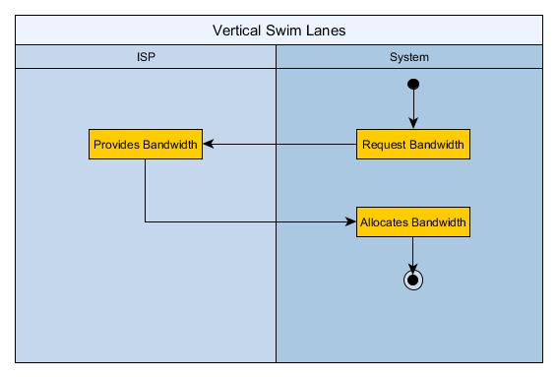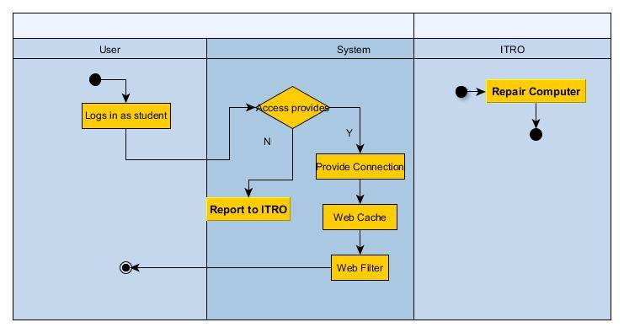

**Use-case Diagram**

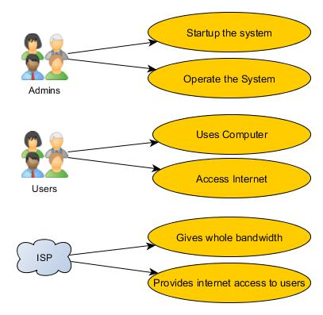

**Class Diagram**

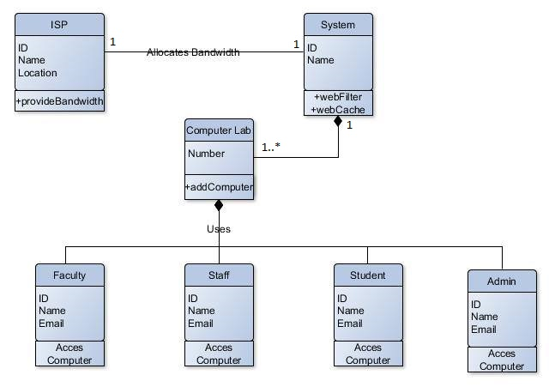

**Communication Diagram**

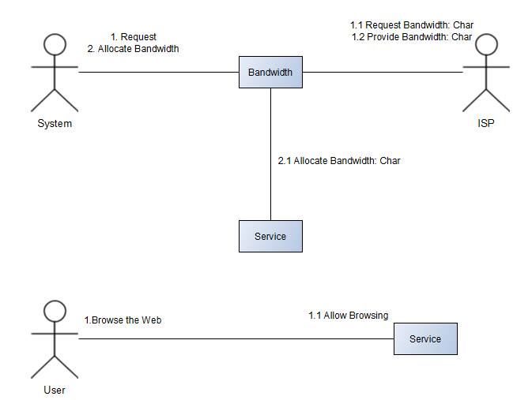

**Object Diagram**

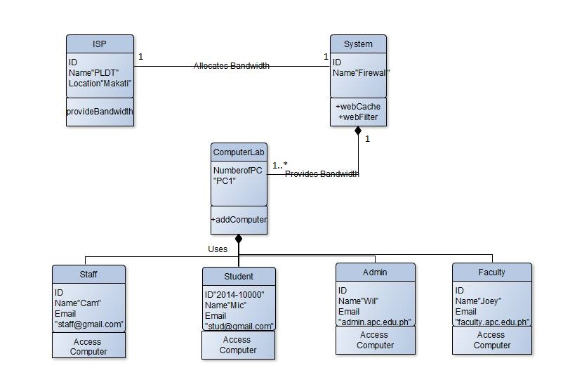

**Sequence Diagram**

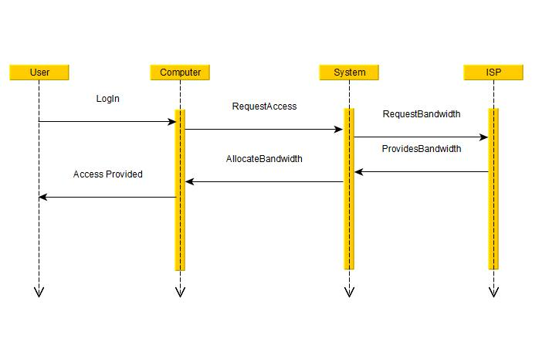

**Sequence Diagram**

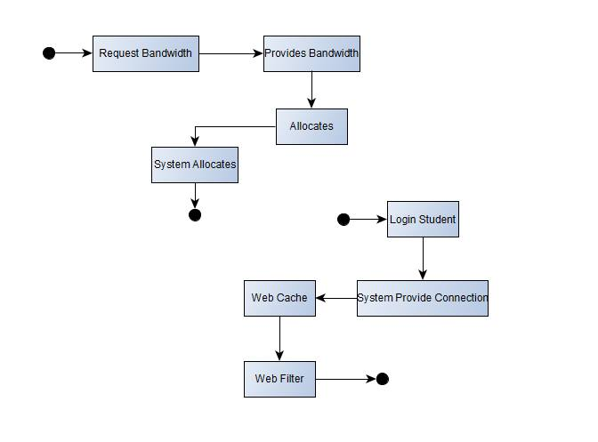

**Timing Diagram**

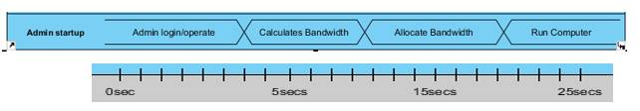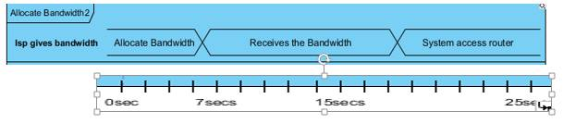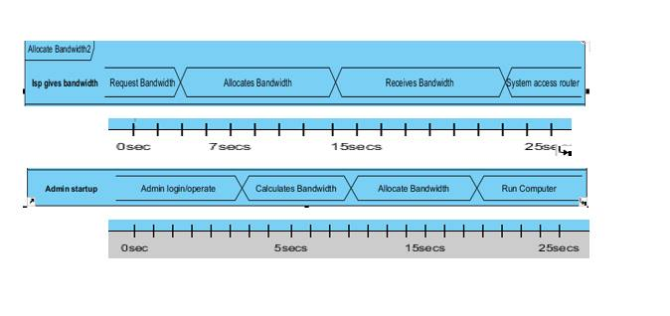

# Introduction

## Background of the Problem

* + 1. The researchers’ problem concerns the slow internet connection speed in APC. Most students would say that the internet connection speed is so poor that it sometimes affects their classes. The researchers claim this is caused by a poor bandwidth management, a lacking network design and policies not implemented properly.
    2. For Bandwidth Management, the researchers tested speed of different computer from a different LAB, the team tested one computer in room 304 between the time of 7:30AM – 9:30AM with a speed of 42kb/s, another computer in room 502 at 9:30AM – 11:30AM has 58kb/s, one computer in room 314 at 1:30PM – 3:30 PM has 39kb/s, this proves that there is no bandwidth management in the network of APC.
    3. Next would be the poor or ineffective design for broadcast domain. For example, if one computer searches one site like google.com, it will send a broadcast and the switch will forward it to every port and all the switches will get a copy of the broadcast packet that reduces the available bandwidth of network links for normal traffic because the broadcast traffic is forwarded to all the ports in a switch. Lastly, policies are not implemented properly.

## Statement of the Problem

* + 1. How can the internet connection in APC be improved in terms of connection consistency?

## Objectives

### **General Objective**

### To improve APC’s internet connection consistency.

### **Specific Objectives**

### To improve quality of service by implementing bandwidth management.

* To improve the connection by implementing VLAN.
* To enforce user policy through web filtering.

## Significance

It is well known that throughout the whole APC building, the internet connection speed in the computer laboratories is limited. It does not load the webpages required for the classes and it sometimes prevents classes from taking online quizzes. This can be problematic to both students and professors. This project’s significance is that the output will benefit the students and professors who will be using computer laboratories in Asia Pacific College.

# Scope and Limitations

The researcher’s project seeks to improve the service of internet connection here in APC. The target will be one computer laboratory for testing but the result itself is not limited to one laboratory but applicable to all laboratories. With APC’s total of 60mb/s bandwidth, the team will be targeting only computers wired to the main network, and owned by APC. The operational hours will be from 7:30 AM – 9:30 PM. This will all be done first in a simulation.

# Related Literature

# Bandwidth Management and Quality of Service

The internet is growing rapidly as a tool of information medium. As the demand continue to increase, it is obvious that internet traffic increases with it. The internet is now filled with different types of users with different types of needs; casual users who are likely going to pay for less bandwidth to be able to access the web and their email, and the users who are willing to pay for higher bandwidth to be able to use multi-media applications and other software that require high consumption of bandwidth.

(<http://citeseerx.ist.psu.edu/viewdoc/download?doi=10.1.1.63.4586&rep=rep1&type=pdf> )

# A Control Approach to Bandwidth Management in Networked Control Systems

TCP cannot determine an error loss event in terms of network highly on wired networks so the TCP Westwood congestion control algorithm is proposed. It is a fuzzy controller that can enhance wired networks that have high error rate. Note that this is already a proposed project. The proposed TCP Fuzzy is tested on OMNET++ IDE based on the reference below and they confirm that the fuzzy controller gives better performance than the standard TCP in wired networks when error rate increase.

(<http://citeseerx.ist.psu.edu/viewdoc/download?doi=10.1.1.684.2516&rep=rep1&type=pdf> )

# Bandwidth management in universities in Zimbabwe: Towards a responsible user base through effective policy implementation

According to this study "The authors recommend that using Quality of Service (QoS) and Bandwidth management will enable network administrators to control network traffic flow so that appropriate users and applications get priority during the allocation of network resources." It means that they want to address a software that can control the bandwidth of their network by not extending the bandwidth that their ISP gives also known as the bandwidth management tool. They also want to monitor the network traffic so they can now manage or control the bandwidth.

(<http://files.eric.ed.gov/fulltext/EJ1084130.pdf> )

# Theoretical Background

### **Fault Tolerance**

This is the ability of a system to respond gracefully to an unexpected hardware or software failure. There are many levels of fault tolerance, the lowest being the ability to continue operation in the event of a power failure.

### **Scalability**

Scalability is a characteristic of a system, model or function that describes its capability to cope and perform under an increased or expanding workload. A system that scales well will be able to maintain or even increase its level of performance or efficiency when tested by larger operational demands.

### **Quality of service (QoS)**

the overall performance of a telephony or computer network, particularly the performance seen by the users of the network. To quantitatively measure quality of service, several related aspects of the network service are often considered, such as error rates, bit rate, throughput, transmission delay, availability, jitter, etc.

### **Network Security**

This refers to all activities designed or performed to protect the network from various threats. Having network security will protect the usability, reliability, integrity and safety of the network and data.

# Proposed Solution to the Problem

#### With the information gathered from different IT professors and school personnel, we have proposed the following solutions:

### **Virtual Local Area Network (VLAN)**

The team has gathered details about the broadcast domain of APC as explained in the background of the problem. The current broadcast domain layout will let a computer send a broadcast and the switch will forward it to all the ports causing bandwidth traffic.

### **Bandwidth throttling**

To provide quality of service (QoS) in the network to assure computer network connections equal bandwidth resulting to stable download and upload speed among computer units.

### **Web Filtering based on User Policy**

Based on the related literature, user access policy is also related to bandwidth consumption. Thus, unnecessary web activities still affect bandwidth traffic. The proposed user access policy will still be based on the APC student handbook.

**Port Network Access Control (PNAC)**

A concept like VLAN, but focuses on implementing access via ports, not user-made local area networks. The team will set up a firewall on the simulation as a representation of pfSense on the project. In the pfSense, lists of websites being permitted or denied of access will be deployed per ports.

# Results and Discussion, includes theoretical proof, verification, or evidence

From the suggestions of the team’s adviser and consultant, the project scope will be met through a simulation of our proposed network topology. It was done to cut time scope of the project, as it is time-consuming to set-up everything.

And so, the researchers have tested the different solutions stated above, starting from creating a topology of the three rooms for comparison: the room 502, open laboratory and faculty room. In each room, a VLAN and DHCP servers was set up. Yet, it had been proven, from the simulation and consultations from the ITRO that setting up VLANs will not be helpful in solving the problem.

In the simulation, the project team made, it had been proven that the proposed model is scalable. Whether a room has thirty computer units or just five, the bandwidth will adjust because the implementation of the rules was done through router ports, which can handle a lot of hosts.

With the addition of a firewall into the topology, the network model, if put into implementation, will be secured and of adequate quality, because it is made to serve the sole purpose of providing internet consistency.

Fault tolerance can still be achieved by providing a redundant switch on the main network for the core switch to have a backup in case of system failure, though it can only be done by experts which the team is not.

# Conclusions and Recommendations

Provided with the paper, the team had made a network topology simulation through Packet Tracer. Included in the packet tracer is the simulated implementation of the pfSense (Firewall) and the access rules to ensure consistency of network traffic as hypothesized by the team in the research paper.

Eventually, the team was torn into choosing which method will be used into providing user policies in the simulation – the VLAN or the PNAC. Both proposed solutions were not demonstrated in the Packet Tracer because of its software limitations. Despite this, the team still believe that VLAN is a must because it will not allow transmission between virtual networks (if configured that way) even though it is inside the same physical network, and doing that will ensure that the user gets what it deserves.

PNAC, on the other hand, will also be helpful in the project. PNAC provides certain access limitations which the port-MAC address access. If this will be put into action, students (and other users alike) cannot use the LAN ports on their personal devices, thus providing local security by preventing user bypass.

In case all of the recommended solutions is deemed ineffective, the last resort would be upgrading the internet service provided that APC has financial capability to do that.

According to our studies, consultations and simulations, replacing VLANs with PNAC will do the job. Instead of setting up multiple VLANs (which is effective but expensive as you need to have Layer 3 switches), PNAC enables ITRO to just set up a Firewall or pfSense to mandate all LANs inside the school. As of this time, ITRO have implemented the VLAN network design, and it is not serving the purpose.

The team still recommends applying web filter in the pfSense as promised in the objective on the project.

# Appendices

Paulo Miguel Capuz

403 Fennel Bldg Acacia Estates Taguig City

**CELL** (0906) 526-7604 • **E-MAIL** pscapuz@student.apc.edu.ph



PROFILE Computer Science undergraduate with strong communication skills. Experienced in leadership through positions in various organizations in college.



EDUCATION **Bachelor of Science Computer Science**

**Major in Systems Software**

Asia Pacific College

2014-present

Concordia College

2010-2014



ACTIVITIES **Director for Logistics**

Junior Philippine Computer Society - Asia Pacific College (2015-present)

**Assistant Director for Logistics**

Junior Philippine Computer Society - Asia Pacific College (2014-2015)



EVENTS ORGANIZED

**Battle of the Bands 2013-2014 Concordia College**

403 Fennel Bldg Acacia Estates Taguig City • 1234 • **CELL** (0906) 526-7604 • **E-MAIL** pscapuz@student.apc.edu.ph

Jesus Brugada Jr.

Brgy. 5 Torres Bugallion, Caloocan City

**CELL** (0999) 849-0325 • **E-MAIL** jpbrugada@student.apc.edu.ph



PROFILE Computer Science major in Systems Software undergraduate with leadership skills acquired in handling student organization. An active participant in computer science-related activities.



EDUCATION **Bachelor of Science Computer Science**

**Major in Systems Software**

Asia Pacific College

2014-present

San Pablo City National High School

2011-2014

San Pablo City Science High School

2010-2011

San Pablo Central School

2007-2010

Francisco Benitez Elementary School III

2004-2007



ACTIVITIES **Member**

Junior Philippine Computer Society-Asia Pacific College (2016-2017)

**Octo-finalist (Adjudicator)**

España Intervarsity, University of Sto. Tomas(2015-2016)

**Senior Member**

APC Speaks-Asia Pacific College (2016-2017)

**Third Best Debate Team**

Kapihan Debate Tournament, University of the Philippines-Diliman(2015-2016)

**Debater**

Manila Intervarsity, University of the Philippines-Manila(2015-present)

**Top 2 Best Debater**

APC Varsity Debate Tournament, Asia Pacific College (2014-2015)



Brgy. 5 Torres Bugallion, Caloocan City **CELL** (0999) 849-0325 • **E-MAIL** jpbrugada@student.apc.edu.ph

Genesis Diocampo

MRB BLDG 2 314 Taguig City

**CELL** (0915) 731-2125 • **E-mail sxhixox@gmail.com**



PROFILE Computer Science specialization in Systems Software undergraduate with strong interpersonal skills with an ability to grasp new things quickly. Organized events in different organizations of the school.



EDUCATION **Bachelor of Science Computer Science**

**Major in Systems Software**

Asia Pacific College

2014-present

MCA Montessori School

2010-2014

Dominican College of Tarlac

2004-2010



ACTIVITIES **Member**

Junior Philippine Computer Society-Asia Pacific College (2014-present)



MRB BLDG 2 314 Taguig City

**CELL** (0915) 731-2125 • **E-mail sxhixox@gmail.com**

Jefferson Gonzales

P27-12 8 7th Street Villamor Air Base Pasay City•

**CELL** (0926) 559-6915 • **E-MAIL** jbgonzales2@student.apc.edu.ph



PROFILE Computer Science specialization in Systems Software undergraduate with strong interpersonal skills with an ability to grasp new things quickly. Organized events in different organizations of the school.



EDUCATION **Bachelor of Science Computer Science**

**Major in Systems Software**

Asia Pacific College

2014-present

Pasay City South High School

2010-2014

Villamor Air Base Elementary School

2004-2010



ACTIVITIES **Logistics Head Officer**

APC Cipher-Asia Pacific College (2016-2017)

**Member**

Junior Philippine Computer Society-Asia Pacific College (2014-present)

**Assistant Committee**

Math Society – Asia Pacific College



P27-12 8 7th Street Villamor Air Base Pasay City•

**CELL** (0926) 559-6915 • **E-MAIL** jbgonzales2@student.apc.edu.ph