Curriculum Vitae of Aaron Andrei D. Ambas
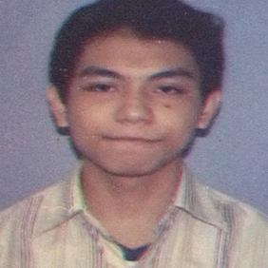 | Aaron Andrei D. Ambas  Sales Manager  House A. 1584 Camino Dela Fe Extension Guadalupe Nuevo  Makati City  Tel: +63212882501  Email: adambas@student.apc.edu.ph

PROFILE

See section on personal profiles

RELEVANT SKILLS
Java Programmer
Information Security Concepts

EDUCATION

Elementary Saint Paul College of Makati - Makati, NCR 2004-2010

High School Saint Paul College of Makati - Makati, NCR 2010-2014

College Asia Pacific College - Makati, NCR Undergraduate

OTHER SKILLS

- E-Sports
- Music

REFERENCES

Justin David Pineda Professor of Asia Pacific College
Roselle Wednesday Gardon Professor of Asia Pacific College
Manuel Calimlim Professor of Asia Pacific College

