# SYSTEM DIAGRAMS

**CONTEXT LEVEL DIAGRAM**

(PDECS)

Diagram 0

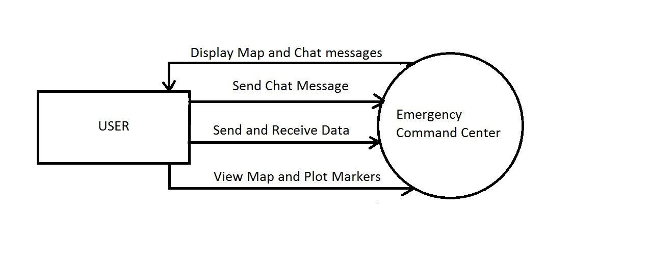

This diagram shows how the intended users, the Disaster Recovery/Relief teams interact with the Communication System (PDECS) created by the project team.

**DATA FLOW DIAGRAM**

(PDECS)

Diagram 1

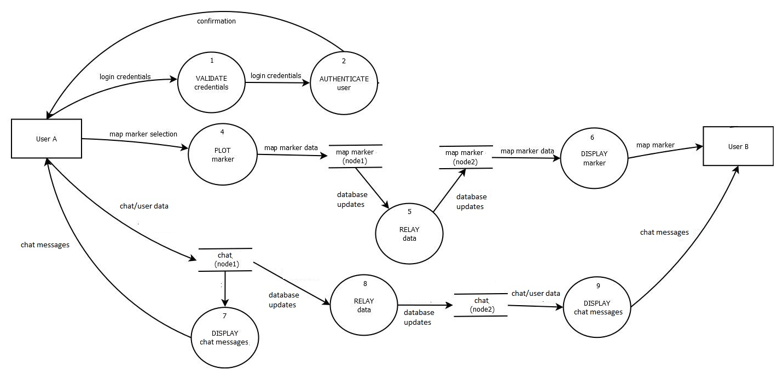

The users of the system can easily log-in using a name of their choice and use the system.

They can send and receive chat messages using the chat module. The messages they send are sent to the database

well as viewing the offline maps pre-downloaded onto the mesh network. The users will also be able to send map marker data by plotting markers using the touch screen on their smartphones. The markers they plot will be saved onto the database and the distributed database management system will handle the replication of data across the whole network.

Diagrams 2, 4, 5, 6, & 8

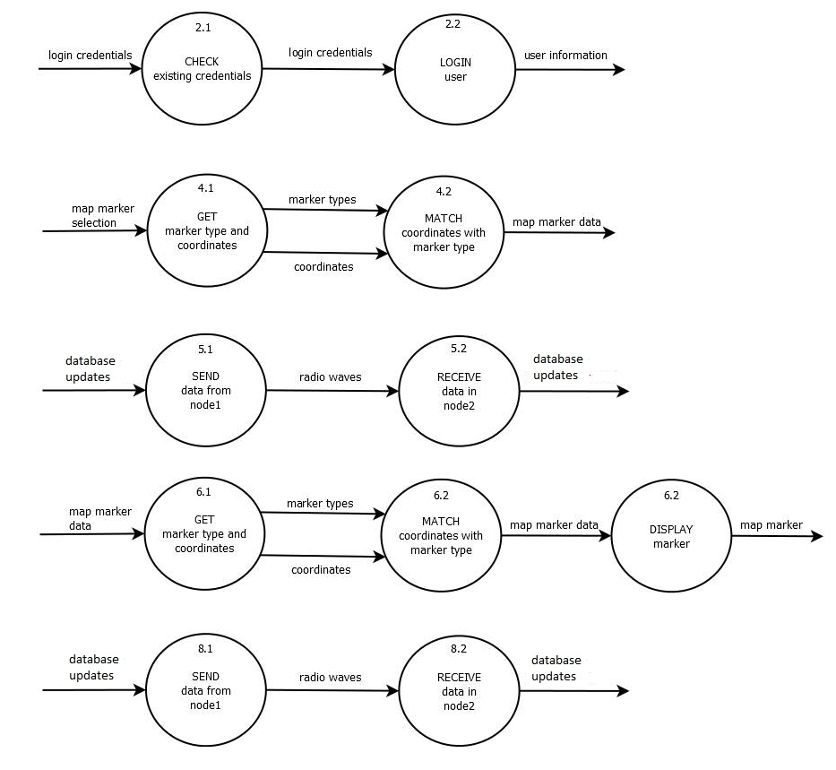

**USE-CASE DIAGRAM**

E-Nodes Mesh Network

Untitled Diagram.png

This is a simplified version of what a user can do with the network.

The E-Nodes is a bare mesh network so it is uncountable how many possible uses there are

**USE-CASE DIAGRAM**

Post-Disaster Emergency Communications System

Untitled Diagram (1).png

Here it is shown how the user can interact with PDECS v1

**SYSTEMS NETWORK DIAGRAM or ARCHITECTURE**

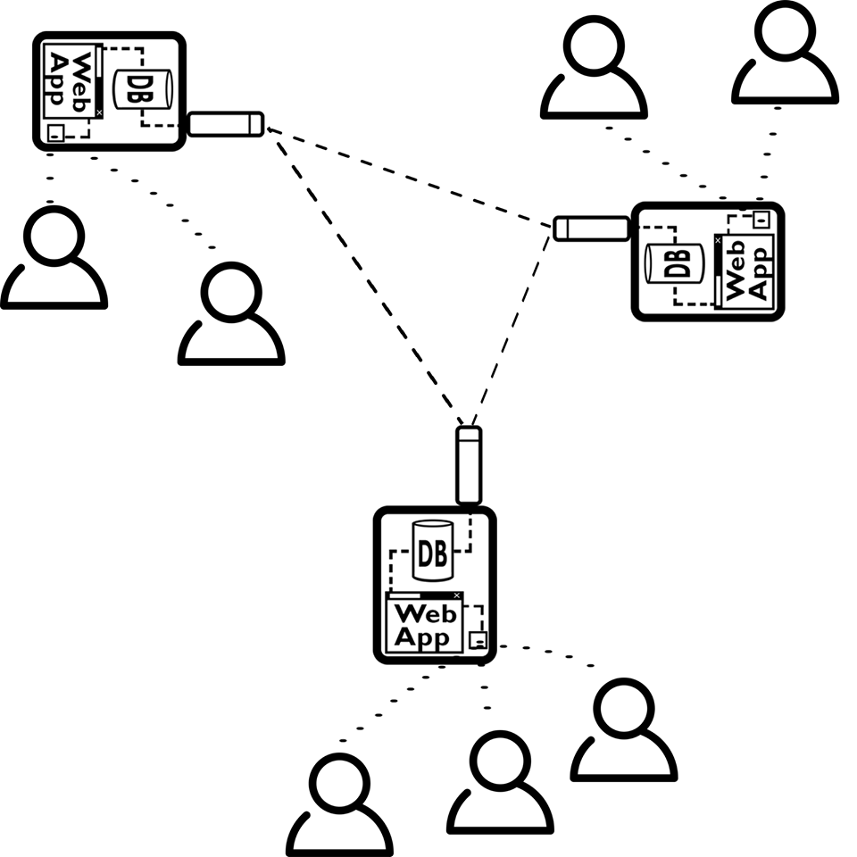

The users of this system are connected to the E-Nodes mesh network through the Wi-Fi access points. The E-Nodes are configured to form a mesh network that deliver the data to the other users by routing data through the nodes of the network**.**