USER MANUAL

Introduction
This user manual help the developers and other researchers to completely know the step by step how the proponents do the result.

Data Gathering

- Using the Import.io software application, the researchers gather data from different networking site such as YouTube, Twitter and Facebook.
- Only on the specific website can import.io sync the data.
- This data containing different column from the data it will gather but the only import column you can remain and save it as .xml to be open in excel file

Cleaning of Data

- The data was clean using notepad++, the researchers delete the following
(,|.|?|_|;|:|"|...|https(Links in Facebook, twitter, YouTube inserted)|+|=|{|}|[|]|/|\|<|>|!|@|#|$|%|^|&|*|(|)|||?+| ðŸ’ª|O_O|âœŒâœŒâœŒ|(Links of pictures)|nâ€“|nâ’|unreadable words (ex.hsxkssfjhj, asdfgh)|~|’|“|)
- To maintain the thought of the word the researchers didn’t delete the dash (-) and the apostrophe (‘).
- Using the special feature of notepad++ the reseaches easily delete, replace the said unnecessary characters (ctrl F, click replace and input to "Find what" the special characters and in "Replace with" just put /t.)
- Transfer to excel

Bag of Words-Unigram Form

- To compress all the words, go to "Find & Select" then choose "Go to Special" then click "ok" then right click and find the “delete” then click then next choose the “Shift cells left” to fill up the empty cell.
- Using the words, the next developers should get the unique words for all the data this will be the attribute.
- Using the unique words or the attribute the next developers should make a frequency for each sentence. Having this formula [=SUMPRODUCT((LEN(rng)-LEN(SUBSTITUTE(rng,txt,"")))/LEN(txt)) ] frequency by each sentence will be easy to count based on the attribute.
- This frequency will be the data later on.
- Bag of Words should be arrange in arff file. And use this format as guide for the sequence of the content.
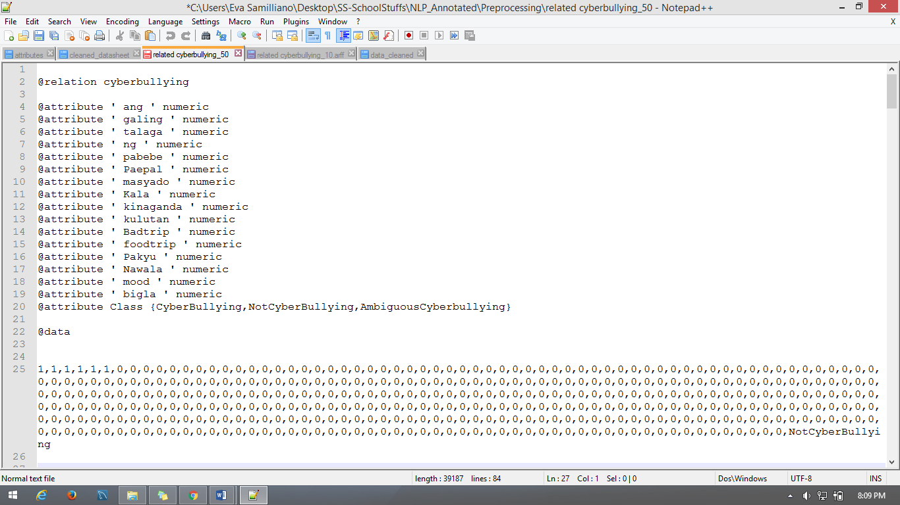
@relation will be the title of the file
@attribute will be the unique words from the data and
@data will be the frequency of the data

Implementing the Data to Weka

- As the file was fully arrange, open the Weka Software Application and upload the file into the arff file, to check the accuracy of the data that the researchers input to the system, go to classify and click the “ function “ and choose “ SMO” and then click the “ Cross Validation fold 10” then click start to run the file.
- To check the prediction of the system, on the “ Result List” area of the Weka right click and choose “Visualize Classifier Error” and save. After saving the file, open the file in notepad++ and observe the result.

