I. Introduction

**1.1 Background of the Problem**

The key to a successful growth is the creation of a system with the function of providing relevant information on a real-time scale to decision-makers of a business. The critical factor to report automation is the ability to detect, record, calculate, and finally inform all entities regarding business-sensitive data.

Which is why, in this case, a decision support notification system must be created to manage business transactions and operations in an orderly,proper and efficient manner. By incorporating the best practices and tools for development, the team will be better equipped to disseminate information and data comprehensively and fully.

**1.2 Statement of the Problem**

How would a system affect the decision making of a business/organization in order to improve efficiency and future transactions?

**1.3 Objectives**

General Objectives   
● To create a working system that would meet the clients requirements   
● To improve the client company’s current business system

Specific Objectives   
● To create a payment tracking system by using a web application for the company and its clients   
● To improve the clients current business system by utilizing a DSS   
● To determine what constitutes a credible client for the DSS parameters

**1.4 Significance**

The result of this study will be beneficial to the following agencies:

● To the Client   
This project was initiated and established in order to create a working system for the Promax Realty Corporation. It will serve to benefit the company’s future by improving and enhancing business transactions, ease the current workflow of the business and better clientele selection. The project will help make the job of the client easier by making the system computerized,thus making human errors less likely to occur/happen.

● To the Tenants   
This project will benefit the current tenants of Promax Realty Corporation. This will help their current business relationship as the project will provide the tenants a faster and easier way to perform applications to the company as well as to be notified or to check their current rental balance.

● To the Future Researchers   
As the current means of performing business transactions are constantly changing, this research can serve to benefit the future developments of decision support systems or other similar researches that may be undertaken by future researchers. This study could be a reference or basis for other researchers that would want to conduct a study in a similar topic.

**1.5 Scope and Limitations**

This project will be used for Promax Realty Corporation. This will benefit and help the company’s business system through a Payment Tracking System that will be further supplemented by a Decision Support System (DSS). The Scope of the Decision Support System will be restricted to the company’s tenant approval decision-making process. Any other applications of the DSS to the business will not be further studied. The team is currently researching and working only on the Payment System. The features of the Decision Support system (DSS) will be applied soon during future studies.

**1.6 Context Diagram**

**Original Context Diagram**

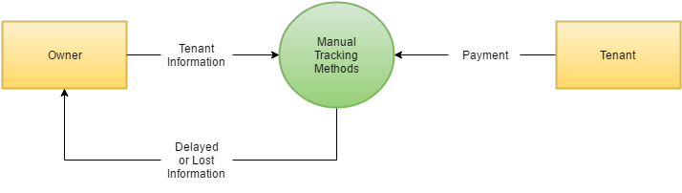

**Proposed Context Diagram**

