

**Project Management Plan**

**for**

Promax Decision Support System

**Prepared by:**

John Lloyd Briones

Denzel Oribiana

Victor Manuel Serrano

Alexander Alfonsin Tison

**Table of Contents**

**Overview** **3**

Project Purpose, Objectives, and Success Criteria 3

Project Deliverables 4

Assumptions, Dependencies, and Constraints 5

Evolution of the Plan 5

**Project Organization** **6**

External Interfaces 6

Internal Structure 6

Roles and Responsibilities 7

**Managerial Process Plans** **8**

Start-Up Plans 8

Estimation Plan 8

Staffing Plan 9

Staff Training Plan 10

Resource Acquisition Plan 10

Project Commitments 11

Work Plan 12

Control Plan 13

Data Control Plan 13

Requirements Control Plan 13

Schedule Control Plan 14

Budget Control Plan 16

Communication, Tracking, and Reporting Plan 16

Risk Management Plan 17

Issue Resolution Plan 18

Project Close-Out Plan 18

**Technical Process Plans** **19**

Process Model 19

Methods, Tools, and Techniques 19

Configuration Management Plan 20

Quality Assurance Plan 20

Documentation Plan 21

Process Improvement Plan 21

# Overview

The project aims to create a payment system supplemented with a decision support system for Promax Realty Corporation. The goal of the project is to improve the company’s current business system and improve their functionalities. The project is considered successful when the team has turned over the completed project to the company. Major Deliverables include the working system and project documentation. The project must conform to the business practices of the company and must follow the company’s regulations.

## Project Purpose, Objectives, and Success Criteria

The purpose of the project is to create a working payment system for Promax Realty Corporation; The System includes a Payment Module, System Database and Decision Support module. The System will follow the business practices of the company and must conform to the requirements and needs of the client. The needs of the client include a working payment system to replace their current paper-based systems, which will be done by the accomplishment of the project. The project aims to increase work efficiency by 30% and lessen work time by 20%. The success criteria of the client involve the accomplishment of the working system and must show results within the next 2 years. Listed below are the general and specific objectives of the project:

General Objectives:

The team aims to improve the client company's current business system. Through the development of a payment system that will replace the paper-based system. The system would increase efficiency and effectiveness in the company’s workflow and further improve the payment system with the integration of a Decision Support Module.

Specific Objectives:

* To develop a payment module that would track and report payments of the tenants of the company
* To create a data entry module that would store the information of each tenants for every properties of the company.
* To develop a printing module that would print reports and receipts of the company’s transactions.
* To design a dashboard module that would show reports, charts and statistical data that can be used to improve the decision-making process of the company.

As for the scope, the system consists of four different modules namely the payment module, the data entry module, the printing module and the dashboard module. The dashboard module contains all the reports that the client needs such as property earnings, contracts status, available units, income chart and the recently added tenants. The data sets used in this project follows the format that Promax Realty Corporation uses in their day-to-day operations.

The Project will be designed only for the use of the project owner and their authorized users. Tenants will have no interaction with the system apart from their usual interactions with PRC. Maintenance of the system would not be part of the team’s project.  The DSS will be restricted to the contents of the dashboard module. No other implementations of the DSS will be researched unless deemed necessary.

## Project Deliverables

Listed below are the major items to be delivered to the customers, subcontractors, integrators, or other parties*.*

|  |  |  |  |  |
| --- | --- | --- | --- | --- |
| **Deliverable** | **Recipients** | **Delivery Date** | **Delivery Method** | **Comments** |
| Project Proposal | Stakeholders | January 20, 2017 | Meeting | Project Initiation/Discussion of requirements |
| Roles and Responsibilities | Project Team | January 23, 2017 | Meeting | Assigning of tasks and responsibilities |
| Work Breakdown Structure | Project Team | January 26, 2017 | Meeting,  Presentation | Discuss tasks and assignments |
| Gantt Chart | Project Team | January 25, 2017 | Email | Schedule of completion of each task |
| Kick-off Meeting | Project Team | January 27, 2017 | Meeting | Discuss the ideas and plans for the project |
| Quality Plan | Project Team | February 1, 2017 | Email | Create the plan for testing the quality of the software |
| System Design | Stakeholders | February 10, 2017 | Meeting,  Presentation | Present initial system design and diagrams |
| Project Status Report | Stakeholders | Weekly | Email | Reports progress of the project |
| Project Prototype | Project Team, Stakeholders | March 22, 2017 | Presentation | Presents the project prototype |
| Test Execution Reports and Logs | Project Team | After every test iteration | Email | Documentation of Test Execution |
| Final Project Report | Project Team,  Stakeholders | April 4, 2017 | Presentation | Presentation of final project report |

## Assumptions, Dependencies, and Constraints

Listed in the tables below are the identified Assumptions, Dependencies and Constraints of the Project.

|  |  |
| --- | --- |
| **Assumption** | **Description** |
| AS-1 | Project will only have at most 2 users |
| AS-2 | Computers where the system will be implemented are provided for |
| AS-3 | Cooperation of the stakeholders is a necessity for project’s success |

|  |  |
| --- | --- |
| **Dependency** | **Description** |
| D-1 | Promax must provide necessary information and datasets |
| D-2 | The system’s objective,purpose and scope are clearly defined |
| D-3 | The client’s specific requirement for the system should be identified |

|  |  |
| --- | --- |
| **Constraints** | **Description** |
| C-1 | The project must be completed at minimal costs |
| C-2 | The project should be completed within three months |

## 

## Evolution of the Plan

The scheduling of every task in the project is documented in the work breakdown structure. Changes during the initiation phase must be accommodated before the release of the final project proposal. During the planning, development and monitoring phases a weekly team meeting and a Bi-weekly client meeting will be conducted. During these 2 meetings the project team will evaluate whether the project is on track. When the need arises in the case of a delay or a rescheduling of project due to the changes made by the client or project team. The schedule will be adjusted in order to accommodate the changes deliberated during the meetings.

# Project Organization

## External Interfaces

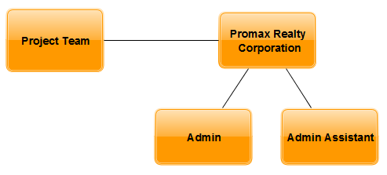

## Internal Structure

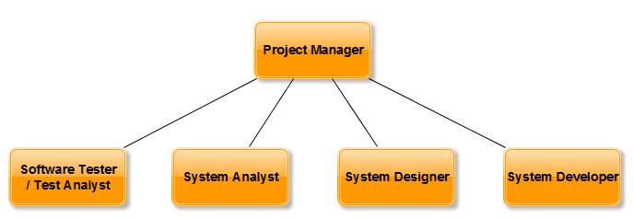

## Roles and Responsibilities

Listed below in the table the major project team roles and the individuals who will fill these roles, along with the specific responsibilities those individuals will have.

|  |  |  |  |
| --- | --- | --- | --- |
| Name | Role/s | Responsibilities | Contact Details |
| Alexander Alfonsin Tison | Software Tester/ Test Analyst | Performs Testing and Quality assurance on the project | aatison@student.apc.edu.ph |
| John Lloyd Briones | Project Manager  System Developer | Responsible for the project’s success  Responsible for the development of the system | obbriones@student.apc.edu.ph |
| Denzel Oribiana | System Designer | Responsible for designing the workflow of the system | dforibiana@student.apc.edu.ph |
| Victor Serrano | System Analyst | Responsible for creating and designing diagrams | vpserrano@student.apc.edu.ph |

# Managerial Process Plans

This section of the IM/IT Project Management Plan specifies the project management processes for the project. This section defines the plans for project startup, risk management, project work, project tracking and project closeout.

## Start-Up Plans

The project is intended for PROMAX Realty Corporation. The project would ensure efficiency and effectivity throughout the corporation’s daily activities by following the plans below:

### Estimation Plan

Listed below are the project estimates that will help or guide the project team.

|  |  |  |
| --- | --- | --- |
| Action | Time | Participants |
| Initialization | 10 days | Project team, client |
| Planning | 10 days | Project team, adviser/consultant |
| Execution | 35 days | Team, client, adviser/consultant |
| Monitoring and Controlling | 40 days | Project team |
| Implementation and Project Closing | 5 days | Client, Project Team |

### Staffing Plan

Listed below are the roles and their responsibility in the project, as well as the required skills, duration and staffs needed in each position*.*

|  |  |  |  |  |  |
| --- | --- | --- | --- | --- | --- |
| Role | Project Responsibility | Required skills | Number of Staff | Estimate Start Date | Duration |
| Project Manager | * Leads the team * Responsible for the success of the project * Ensure that project is on track * Coordinates with the team and project stakeholders | * Good leadership skills, can manage the project team very well. * Good communicating and negotiating skills, must be able to express himself fully and effectively * Stable under pressure and does not panic. | 1 | January 23, 2017 | 3 months |
| System Analyst | * Prepare project documents and status reports * Assists project management phases such as planning and execution | * Strong data management, communication, and data analysis skills * Good communicating and facilitating skills, can assist in handling projects | 1 | January 23, 2017 | 3 months |
| System Designer | * Assists in project design and development activities based on customer requirements. * Creates design layouts and sketches according to company standards and daily operations | * Can provide creative and logical ideas for the project. | 1 | February 6, 2017 | 35 days |
| Software Tester/ Test Analyst | * Ensures the quality of the system * Looks on areas on the system that needs improvement. * Tests the system bugs and inconsistencies | * Excellent technical skills * Good problem solving skills * Has good communication skills. | 1 | March 23 2017 | 2 days |

### Staff Training Plan

* Project Staff
* The staff involved in completing the project were already trained and knowledgeable so it was decided that no training for the staff would be required. The responsibilities and tasks of the staff are discussed briefly every meeting for them to be guided.
* End- Users
* The staff of Promax Realty Corporation will be verbally instructed on the usage of the system. A presentation will be performed in order to showcase the process and basic functionalities of the system and will then be taught hands-on after the presentation.

### Resource Acquisition Plan

The table below shows what are the resources needed and how and when it would be attained. The table also shows the possible scenarios that might hinder the team from having the resources.

|  |  |  |  |
| --- | --- | --- | --- |
| Resource | Acquisition Process | Phase | Constraints |
| Human Resource | Pre-assigned | Planning | System should be completed without hiring additional workers due to the budget |
| Hardware | Available Tools | Execution | The system should be done using the available hardware. |
| Software | Download/ Open Source | Execution | The project team can’t use softwares for the system that requires additional cost.. |

### Project Commitments

This shows the assigned person to each commitments in the project development and to whom it is made to.

|  |  |  |  |
| --- | --- | --- | --- |
| **Commitment** | **Made By** | **Made To** | **Due Date** |
| Project Plan | Project Manager | Stakeholders | February 6, 2017 |
| Project Team and Stakeholders Meeting | Project Team | Stakeholders | Weekly |
| System Design | System Designer | Client | February 10, 2017 |
| System Prototype | System Developer | Stakeholders | March 22, 2017 |
| Testing of the System | Software Tester/ Test Analyst | Stakeholders | March 28, 2017 |
| Documentation | Project Team | Project Team | Weekly |

## Work Plan

This presents the work activities required to produce the project’s major deliverables, including contents and timing of the activities. A work breakdown structure was used to depict the work activities, corresponding deliverables, and the relationships among the activities*.*

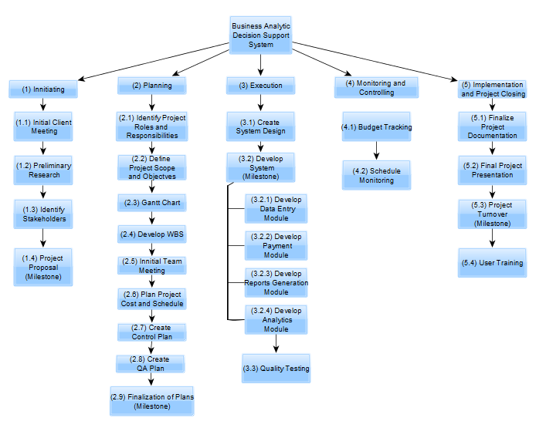

## Control Plan

This section describes how the project will control and report on the project status and activities.Also, This section provides the control plan of the project. Included are the data control plan, requirements control plan, schedule control plan, budget control plan, communication, tracking and reporting plan and metrics collection plan.

### Data Control Plan

|  |  |  |  |
| --- | --- | --- | --- |
| **Group** | **Document** | **Privacy** | **Mechanism** |
| **Initiating** | * Project Proposal | Project Team/Client | Documented after obtaining requirements and Objectives |
| **Planning** | * Project Scope Statement * Gantt Chart * Work Breakdown Structure * Control Plan * Quality Assurance Plan * Technical Process Plan * Use Cases | Project Team/Client    Project Team  Project Team    Project Team/Client  Project Team/Client  Project Team  Project Team | Documented after Initial Team Meeting and preliminary Research |
| **Execution** | * System Design * System Source Code * System Prototype | Project Team/Client  Project Team  Project Team | Documented after Development |
| **Monitoring and Controlling** | * Status Reports * Test Cases * Test Logs * Test Execution Reports | Client  Project Team  Project Team  Project Team/Client | Documented after Quality Testing |
| **Project Implementation and Closing** | * Final Project Documentation | Project Team/Client | Documented after Project Turnover |

### Requirements Control Plan

The project will be developed based on the requirements obtained from the client. The project team must align the system to these requirements throughout the project. Changes in requirements can be done but only after deliberation during a meeting.The project manager has the responsibility to assess and communicate the changes to the requirements should the need arise.

### Schedule Control Plan

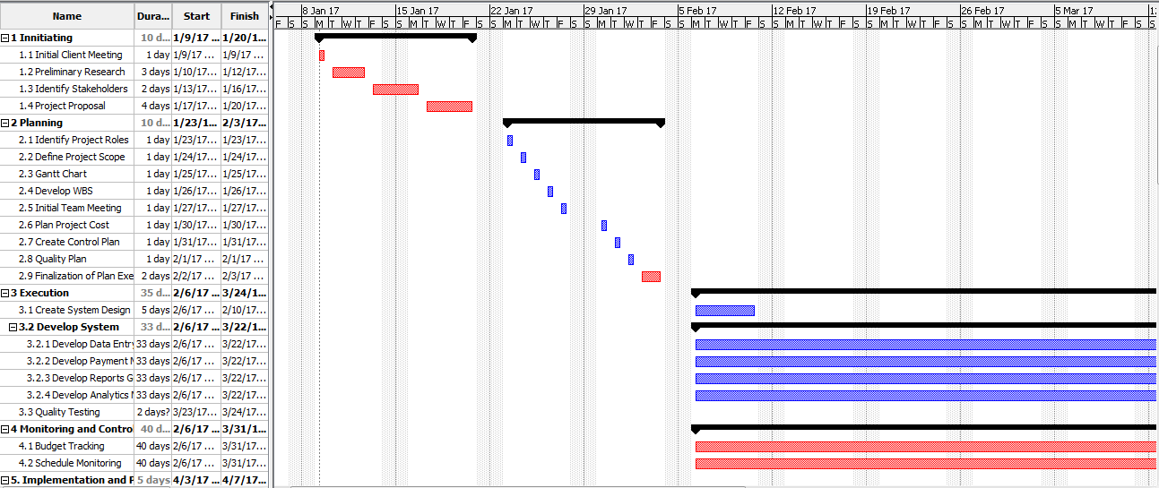

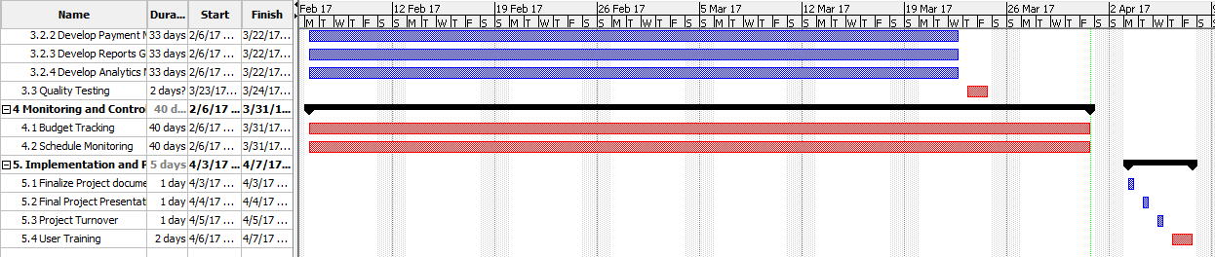

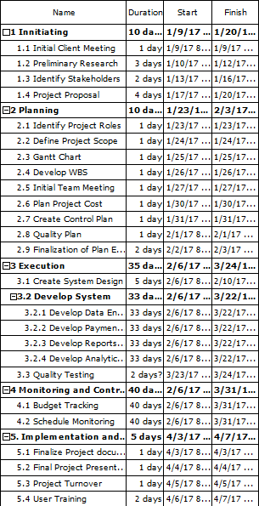

### Budget Control Plan

|  |  |  |  |  |  |
| --- | --- | --- | --- | --- | --- |
| Process | Cost | Man-Days | No. of items | Subtotals | Total |
| Human Resource/ Project Management cost(s): |  |  |  |  | P 483,231.23 |
| Project Manager | P 3,713.00 | 65 | 1 | P 241,345.00 |  |
| System Developer | P 3,006.15 | 33 | 1 | P 99,202.95 |  |
| System Analyst | P 1,717.95 | 65 | 1 | P 111,666.75 |  |
| System Designer | P 875.05 | 33 | 1 | P 28,876.65 |  |
| Test Analyst/ Quality Control | P 1,069.94 | 2 | 1 | P 2,139.88 |  |
| Hardware cost(s): |  |  |  |  | P 50,500.00 |
| Laptop | P 20,000.00 |  | 1 | P 20,000.00 |  |
| Desktop | P 25,000.00 |  | 1 | P25,000.00 |  |
| Printer | P 5,500.00 |  | 1 | P 5,500.00 |  |
| Local Host Web Server | P 0.00 |  |  | P 0.00 |  |
| Software cost(s): |  |  |  |  | P 0.00 |
| XAMPP | P 0.00 |  | 1 | P 0.00 |  |
| Composer | P 0.00 |  | 1 | P 0.00 |  |
| Laravel | P 0.00 |  | 1 | P 0.00 |  |
| Sublime Text 2 | P 0.00 |  |  |  |  |
| Total project cost: |  |  |  |  | P 533,731.23 |

### Communication, Tracking, and Reporting Plan

|  |  |  |  |  |
| --- | --- | --- | --- | --- |
| **Type of Communication** | **Communication Schedule** | **Typical Communication Mechanism** | **Who Initiates** | **Recipient** |
| Team Meeting | weekly | Meeting | Project Manager | Project Team |
| Client Meeting | bi-weekly | Meeting | Project Manager | Client |
| Status Report | weekly | E-mail | Project Manager | Project Adviser, Client |
| Project Review | Monthly | Meeting | Project Manager | Project Team |
| Requirement Changes | when changes are necessary | Meeting | Client | Project Team |

## Risk Management Plan

|  |  |  |  |  |
| --- | --- | --- | --- | --- |
| Project Risk | Risk Description | Risk Level L/M/H | Likelihood of Event | Mitigation strategy |
| Hardware Failure | Failure of desktop or a laptop | High | 20% | Full system backup every month and  Hardware Maintenance |
| Power Supply | When the electricity of pc or battery of laptop shuts down | High | 10% | Backup power supply  Provide Generator |
| Abrupt Major Changes in Plan | An unexpected major change about the system and needs to be fixed right away | Medium | 10% | Double check documents every week in order to avoid mistakes that can lead to major changes. |
| Account Inaccessibility | User cannot login due to wrong credentials or information inputted to the system.  User cannot login because of forgotten password | Low | 5% | Reserve admin account |
| Software Malfunction | The Software that have been developed malfunctioned due to unforeseen circumstance | Low | 5% | Periodic System Maintenance |
| Data Mismanagement | Data have been lost due to human error | High | 10% | Usage of recent system Backup |

## Issue Resolution Plan

When issues arise a team meeting will be held in order to plan out how to resolve these issues. The project manager will facilitate this. If the issues are related to the system, the project developer and Quality Assurance analyst will be put in charge of the resolution of the issue If needed the client will be contacted in order to explain the current issue.

## Project Close-Out Plan

To finalize the project’s completion a project close-out plan is required.To formally close the project the following deliverables are required:

- Final project documentation

- Project reports

- Final Project Presentation

- Completed System

# Technical Process Plans

## Process Model

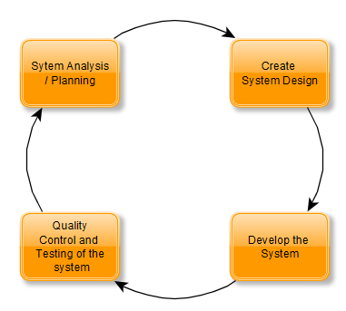

## Methods, Tools, and Techniques

|  |  |
| --- | --- |
| Method/s | Used Tools |
| Documentation | Microsoft Word - used for status reports, project proposal, test plan, etc.  Project Libre - used for Gantt Chart  Yed Graph Editor - used for making diagrams |
| Software | PhpMyAdmin  MySQL  Gitbush  Laravel  Sublime Text 2 |
| Hardware | Laptop or Desktop: HP Pavilion 15 CPU: Intel i5, OS: Windows 10, 4gb RAM memory, 500gb internal storage  Printer |
| Coding Development | PHP,CSS,HTML are the programming languages used to develop the system |

## Configuration Management Plan

The Configuration Management will be done by the Project Manager, Project Analyst and Project Developer. Project manager will be responsible for the management of all project deliverables and will also be responsible for the communications with the client when changes occur. The Project Analyst is responsible for the application of configuration changes particularly for the project documentation and Quality Control Measures. The Project Developer will be responsible for changes concerning the System and its Source Code. Project Documentation and Test Execution Reports will be submitted to the Project Manager for CM tasks. System Source Code will be uploaded on GitHub in order to keep accurate records of each new system version this also will be managed by the Project Manager. For every Documentation Revision all previous versions of the documentation will be kept, with each new revision being monitored in the papers revision history. All documents will have a version number as part of the document name in order to maintain version control of the documentation.

## Quality Assurance Plan

|  |  |  |
| --- | --- | --- |
| **Quality Assurance Task** | **Description** | **Personnel Responsible** |
| **System Design Review** | Evaluates system design if requirements are achieved | Project Manager/System Designer |
| **System Prototype Review** | Evaluates System prototype for user friendliness | Project Manager/System Developer |
| **System Testing** | Testing of System Functionalities for errors and potential issues | Software Tester/ Test Analyst |
| **Hardware Testing** | Testing of Hardware components | Test Analyst |
| **Application Technicality** | Troubleshooting of System | System Developer |

## Documentation Plan

|  |  |  |  |  |  |
| --- | --- | --- | --- | --- | --- |
| **Document** | **Template or Standard** | **Created By** | **Reviewed By** | **Target Date** | **Distribution** |
| Project Proposal | Microsoft Word | Project Team | Project Manager | January 20,2017 | Client |
| Work Breakdown Structure | Project Libre | Project Team | Project Team | January 26,2017 | Project Manager |
| Gantt Chart | Project Libre | Project Team | Project Manager | January 25,2017 | Project Manager |
| SWOT Analysis | Microsoft Word | Project Team | Project Team | January 25,2017 | Project Manager |
| Status Reports | Microsoft Word | Project Manager | Client | Weekly | Client |
| Final Project Documentation | Microsoft Word | Project Team | Project Manager | April 3,2017 | Project Team and Client |
| Test Plan | Microsoft Word | Software Tester | Project Manager | February 1,2017 | Project Team |
| Diagrams | Yed Graph Editor | System Analyst | Project Team | February 10, 2017 | Project Team |

## Process Improvement Plan

When needed to improve the process of the project. The project manager will review the documented processes of the project and from there decide which areas would need improvement with efficiency as the priority when making an improvement. All changes done must be documented should the need for future review be required.

**Revision History**

|  |  |  |  |
| --- | --- | --- | --- |
| **Name** | **Date** | **Reason for Changes** | **Version** |
| John Lloyd Briones | 03/31/17 | Initial Draft | 1.0 draft 1 |
| Denzel Oribiana | 04/01/17 | Revisions | 1.0 draft 2 |
| John Lloyd Briones | 04/02/17 | Revisions | 1.0 draft 3 |