Victor Manuel Serrano

Quality

SS141

Use Cases:

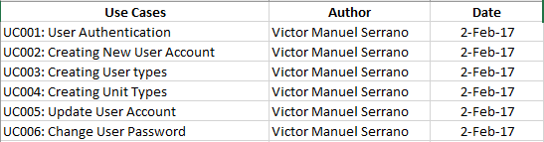

Test Case and Test Executed:

