Aurelio Talag

Quality

SS141

Use Cases:

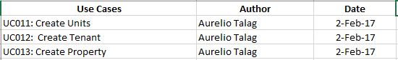

Test Cases and Test Executed:

