

**Project Status Report**

**Project Name: APC Student Assistant System**

**Department: Bachelor of Science and Computing and Information Technology**

**Focus Area:** **Student Assistant Students**

**Product/Process:** **In progress of updating all general information of our system**

**Prepared By:**

|  |  |
| --- | --- |
| **Document Owner(s)** | **Project/Organization Role** |
| Abrera, Jenna Ann B. | Project Documenter/Designer |
| Cruz, Lorenz Matthew M. | Project Developer |
| Romero, Jun Kimuel C. | Project Manager/Web Developer |
| Tomas, Gener Joseph G. | Project Analyst/Developer |

**Project Status Report Version Control**

|  |  |  |  |
| --- | --- | --- | --- |
| **Version** | **Date** | **Author** | **Change Description** |
| 3.0 | 10/17/16 | Romero, Jun Kimuel | Document created |
| 2.7  2.8  2.9  3.1 | 10/17/16  10/17/16  10/17/16  10/17/16 | Abrera, Jenna Ann  Cruz, Lorenz Matthew  Romero, Jun Kimuel  Tomas, Gener Joseph | * Finishing the Work Breakdown Schedule and Activity List * Working on prototype * Working on prototype * Finishing the Work Breakdown Schedule and Activity List |

**TABLE OF CONTENTS**

1 PROJECT STATUS REPORT PURPOSE 3

PROJECT STATUS REPORT 3

1.1 Project Status Report Details 3

1.2 Project Status Report 4

2 PROJECT STATUS REPORT APPROVALS 7

3 APPENDICES 8

3.1 Document Guidelines 8

3.2 Project Status Report Sections Omitted 8

# PROJECT STATUS REPORT PURPOSE

Accomplishing the work breakdown schedule and activity list. Working on the prototype too.

# PROJECT STATUS REPORT

## Project Status Report Details

* Project Description
  + Student Assistant who perform their given task for their scholar funding.
* Budget Report

O To contribute at least 50 pesos each member per week for the expenses for the project.

* Risk Management Report

O If we don’t meet the expectation of our professor.

O If we don’t have progress on the prototype.

* Issues Report

o Due to conflict of our classes, we don’t meet much as a group.

o Not participating in the group.

* Project recommendations to ensure success including lessons learned.
  + Just focus to the project and stay patience as much as possible.

## Project Status Report

|  |  |  |
| --- | --- | --- |
| **APC Student Assistant System** | | |
| Prepared by:  Abrera, Cruz, Romero, and Tomas | Date:  10/17/16 | Reporting Period:  10/17/16 to 10/20/16 |
| Project Overall Status:  Ongoing to finish our work breakdown schedule and activity list. Working on the prototype as well. | | |
| Project Summary:  This project will help the Disciplinary Office Head to minimize the time of checking the paper of each student and also to be able to record all the information that the student will pass for their Student Assistant task. | | |

|  |  |  |  |  |  |
| --- | --- | --- | --- | --- | --- |
| **Milestone Deliverables performance reporting over last period** | | | | | |
|  | **Milestone Deliverables** | **Due Date** | **% Completed** | **Deliverable Status** |  |
| Milestone 1 |  | | |
| • Presented our scope & vision and statement of work | 10/13/16 | 100% | **On Schedule** |
| • Presented our scope & vision and statement of work | 10/13/16 | 100% | **On Schedule** |
| • Presented our scope & vision and statement of work | 10/13/16 | 100% | **On Schedule** |
|  | **Milestone Deliverables schedule** | **for completion over next period** | | | |
| **Milestone Deliverables** | **Due Date** | **% Completed** | **Deliverable Status** |  |
| Milestone 1 |  | | |
| • To finish the work breakdown schedule | 10/24/16 | 50% | **On Schedule** |
| • To finish our activity list | 10/24/16 | 70% | **On Schedule** |
| • To finish our gantt chart | 10/24/16 | 10% | **On Schedule** |
|  | **Project impact of milestones** | **success or failure for project remainder** | | | |
| By the patience of each member. |  | It’s a success since we were able to present out scope & vision and statement of work. | |  |

|  |  |  |  |  |  |
| --- | --- | --- | --- | --- | --- |
|  | **Project** **Budget/Financial Status** |  | | | |
| **Budget Item** | **Planned Budget** | **Actual Cost** | **Variance/Explanation** |  |
| Fare (estimated per day) | P 150.00 | P 120.00 | Fare expenses during meeting. |
| Print | P 20.00 | P 17.00 | Expenses in printing the Project Status Report. |

|  |  |  |  |  |  |  |
| --- | --- | --- | --- | --- | --- | --- |
| **Project Risk Management Status** | | | | | | |
|  | **Risk and Description** | **Risk**  **Chance** | **Risk Impact** | **Risk**  **Priority** | **Change from Last Review** |  |
| • If we don’t meet the expectation of our professor. | High | High | High | We should practice to be more logically and intelligently. |
| * If we don’t have progress on the prototype. | High | High | High | We, the members should help each other to be more productive everyday. |
|  | **Project Issue Management Status**   |  |  |  |  |  | | --- | --- | --- | --- | --- | | **Issue and Description** | **Project Impact** | **Target**  **Due Date** | **Issue Status** | **Issue Resolution** | | • Just be focus and be determine to the goals that you need to achieve. | Medium | High | Medium | We should cooperate in the group and try to extend our patience. | | • Not participating in the group. | High | High | High | We should encourage and motivate each other so we can at least have a progress on our project. | | | | | | |

|  |  |  |
| --- | --- | --- |
|  | **Project Recommendations** | |
| * Will the project be completed on time and on budget? Yes * Will the project deliverables be completed within acceptable quality levels? Yes * Are scope change requests being managed successfully? Yes * Are project issues and risks being addressed successfully and mitigated? Yes * Are all customer concerns being addressed successfully? Yes |  |
|  | **Objectives for Next Project Status Review** | |
| If we work with the emotions of guilt and laziness, but in the end work as together the outcome will be more analytical in different kind of perspective. We expect to finish the requirements behind the schedule to have more time to work in our project aside from passing it on time. |  |

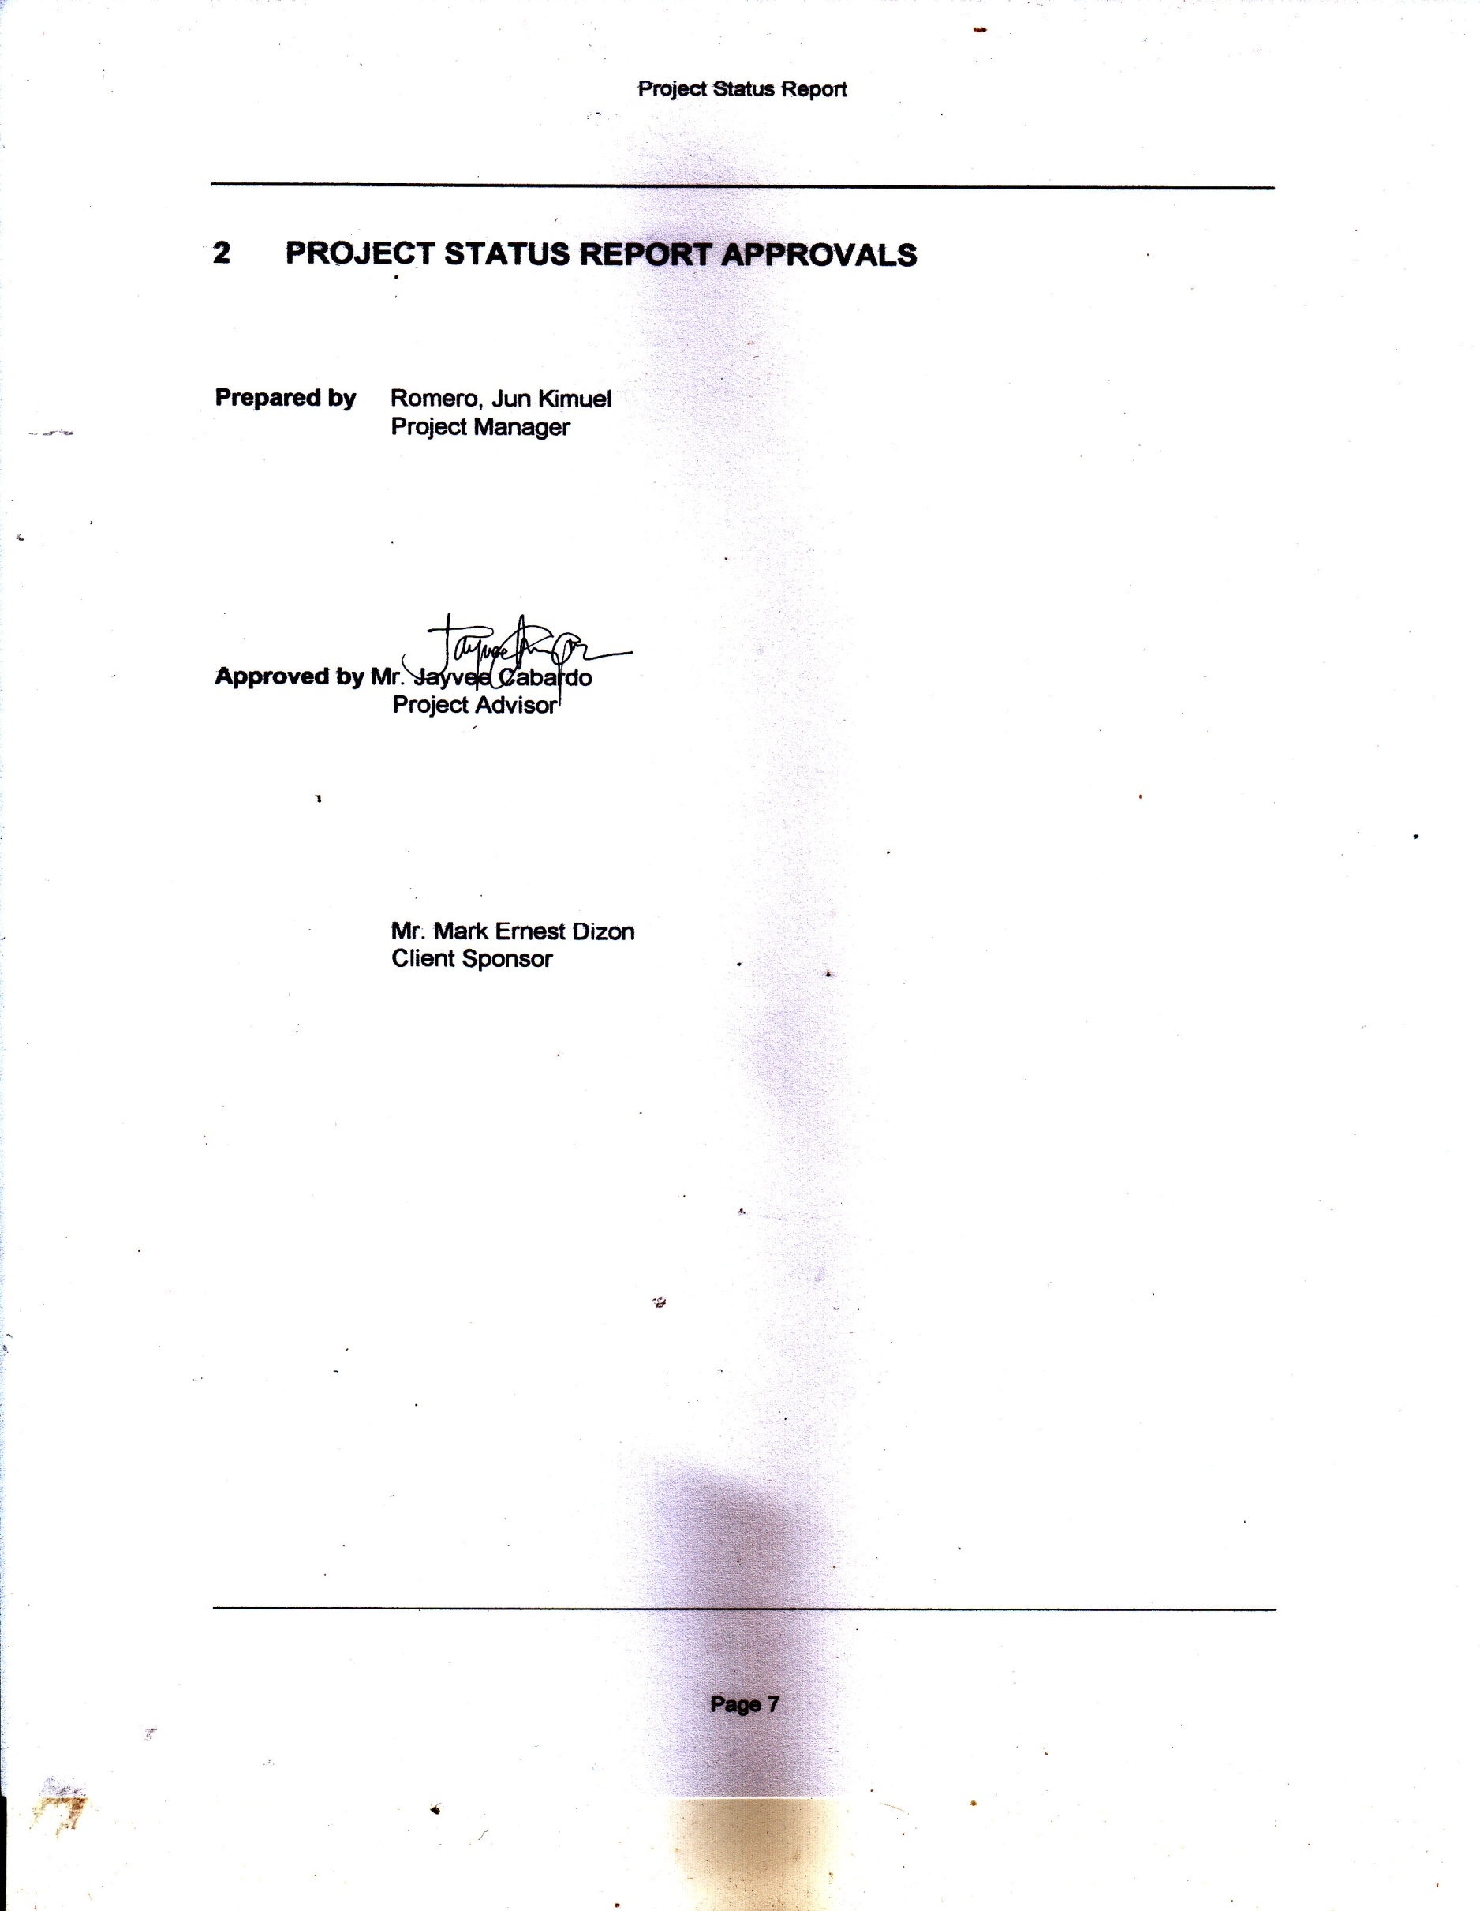

# PROJECT STATUS REPORT APPROVALS

**Prepared by** Romero, Jun Kimuel

Project Manager

**Approved by** Mr. Jayvee Cabardo

Project Advisor

Mr. Mark Ernest Dizon

Client Sponsor

# APPENDICES

## Document Guidelines

## Project Status Report Sections Omitted