

**Project Status Report**



**Project Name:** Asia Pacific College Student Assistant System

**Department:** School of Computing and Information Technologies (**SoCIT**)

**Focus Area:** Applied Project 2 (Csproj)

**Product/Process:** In progress of updating all general information of our system



**Prepared By:**

|  |  |
| --- | --- |
| **Document Owner(s)** | **Project/Organization Role** |
| Abrera, Jenna Ann B. | Project Documenter/Designer |
| Cruz, Lorenz Matthew M. | Project Developer |
| Romero, Jun Kimuel C. | Project Manager/Web Developer |
| Tomas, Gener Joseph G. | Project Analyst/Developer |

**Project Status Report Version Control**

|  |  |  |  |
| --- | --- | --- | --- |
| **Version** | **Date** | **Author** | **Change Description** |
| 4.0 | 11/23/16 | Abrera, Jenna Ann | Updating all projects wiki, GitHub and OneNote |
| 4.1 | 11/23/16 | Romero, Jun Kimuel | Update System and give task to members |
| 4.2 | 11/23/16 | Cruz, Lorenz Matthew | Update remaining document and system |
| 4.3 | 11/23/16 | Tomas, Gener Joseph | Update new diagrams for the system and analyzing the system |

**TABLE OF CONTENTS**

1 PROJECT STATUS REPORT PURPOSE 3

2 PROJECT STATUS REPORT TEMPLATE 3

2.1 PROJECT Status Report Details 3

2.2 PROJECT Status Report Template 4

3 PROJECT STATUS REPORT APPROVALS 7

4 APPENDICES 8

4.1 DOCUMENT Guidelines 8

4.2 PROJECT Status Report Sections Omitted 8

# PROJECT STATUS REPORT PURPOSE

Priority to finish the working system and left documents.



# PROJECT STATUS REPORT TEMPLATE

## Project Status Report Details

* Project Description
  + Student Assistant who perform their given task for their scholar funding.
* Budget Report

O to contribute at least 50 pesos each member per week for the expenses for the project.

* Risk Management Report

O If we are not able to present the documents needed to present during class hours in CSPROJ.

* Issues Report

o Conflicting of other subject requirements.

* Project recommendations to ensure success including lessons learned.
  + We, the members should really know how to manage the time and to divide the task as well.

## 1.2 Project Status Report Template

|  |  |  |
| --- | --- | --- |
| APC Student Assistant System | | |
| Prepared by:  Abrera, Cruz, Romero, and Tomas | Date:  11/23/16 | Reporting Period:  11/21/16 to 11/28/16 |
| Project Overall Status:  We are working with our prototype to finish it and present it completely for our Defense. | | |
| Project Summary:  This project will help the Disciplinary Office Head to minimize the time of checking the paper of each student and also to be able to record all the information that the student will pass for their Student Assistant task. | | |
| **Milestone Deliverables performance reporting over last period**   |  |  |  |  | | --- | --- | --- | --- | | **Milestone Deliverables** | **Due Date** | **% Completed** | **Deliverable Status** | | Milestone 1 | | | | | * Update Diagrams | 11/23/16 | 100% | On Schedule | | * Presented the Quality Plan | 11/24/16 | 100% | On Schedule | | * Working on the prototype | 11/25/16 | 60% | Behind Schedule | | Milestone 2 | | | | |  |  |  |  | |  |  |  |  | |  |  |  |  | | | |
| **Milestone Deliverables scheduled for completion over next period**   |  |  |  |  | | --- | --- | --- | --- | | **Milestone Deliverables** | **Due Date** | **% Completed** | **Deliverable Status** | | Milestone 1 | | | | | * Update System | 12/6/16 | 30% | On Schedule | | * Update WBS, Gantt Chart, and Activity List | 12/6/16 | 30% | On Schedule | | * Update ERD | 11/28/16 | 80% | On Schedule | | Milestone 2 | | | | |  |  |  |  | |  |  |  |  | |  |  |  |  | | | |
| **Project impact of milestone success or failure for project remainder**   |  |  | | --- | --- | | For now, It is a success since our user privileges in our system working correctly according to their specific privileges | We are now currently fixing some bugs in cobalt and also working in the other functions of our system | | | |
| **Project** **Budget/Financial Status**   |  |  |  |  | | --- | --- | --- | --- | | **Budget Item** | **Planned Budget** | **Actual Cost** | **Variance/Explanation** | | Printing Papers | P100.00 | P25.00 | Expenses in printing the Project Status Report. | |  |  |  |  | | | |
| **Project Risk Management Status**   |  |  |  |  |  | | --- | --- | --- | --- | --- | | **Risk and Description** | **Risk Chance** | **Risk Impact** | **Risk Priority** | **Change from Last Review** | | If we are not able to present the documents needed to present during class hours in CSPROJ. | High | High | High | Change the attitude of being lazy to do the requirements. | | Some of the functions in cobalt doesn’t functioning well so we’re trying to fix those bugs. | High | High | High | We should be more careful in fixing the bugs of cobalt because some of the bugs are connected to each other. | | | |
| **Project Issue Management Status**   |  |  |  |  |  | | --- | --- | --- | --- | --- | | **Issue and Description** | **Project Impact** | **Target Due Date** | **Issue Status** | **Issue Resolution** | | Conflicting of other subject requirements. | High | 11/24/16 | Open | Time management and learn how to prioritize which to do first. | | Some members are so busy with their other subject and some are not doesn’t know how to cooperate | High | 11/16/16 | Open | We should be able to divide the task for each other and also to value the subjects and not focusing to one specific subject. | | | |
| **Project Recommendations**   |  | | --- | | * Will the project be completed on time and on budget? Yes * Will the project deliverables be completed within acceptable quality levels? Yes * Are scope change requests being managed successfully? Yes * Are project issues and risks being addressed successfully and mitigated? Yes * Are all customer concerns being addressed successfully? Yes person is assigned to monitor all deliverables. | | | |
| **Objectives for Next Project Status Review**   |  | | --- | | If we work with the emotions of guilt and laziness, but in the end work as together the outcome will be more analytical in different kind of perspective. We expect to finish the requirements behind the schedule to have more time to work in our project aside from passing it on time. | | | |
|  | | |



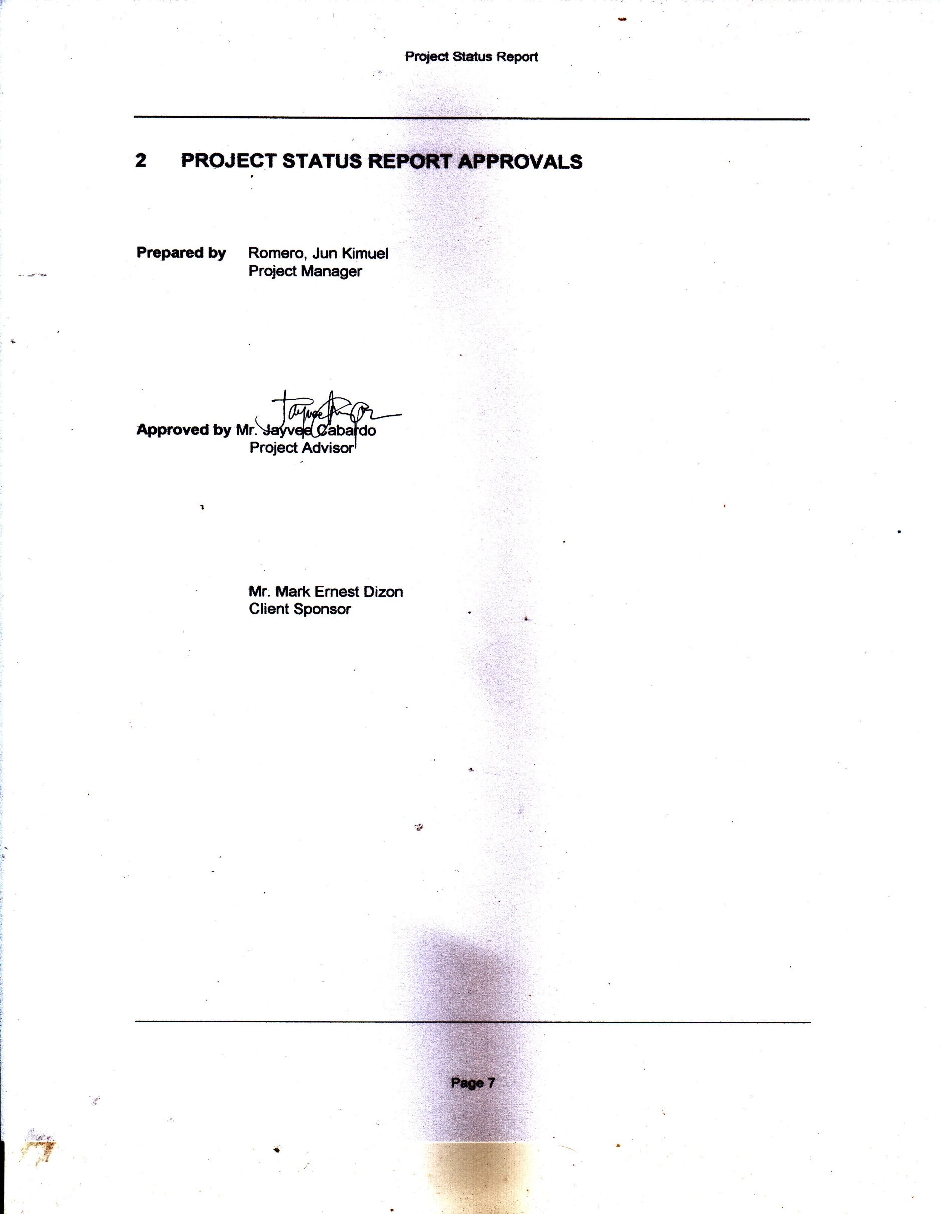

# APPENDICES

## Document Guidelines

## Project Status Report Sections Omitted

