**EVENT TABLE**

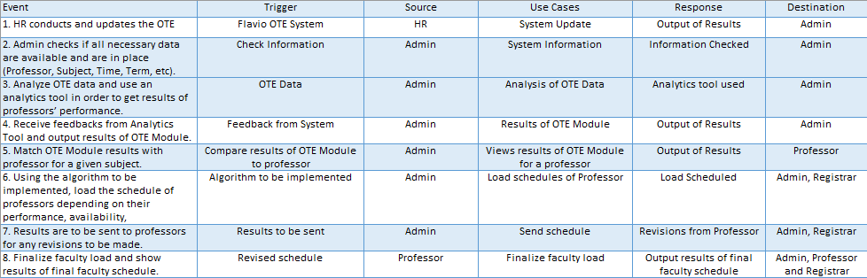

**CONTEXT DIAGRAM**

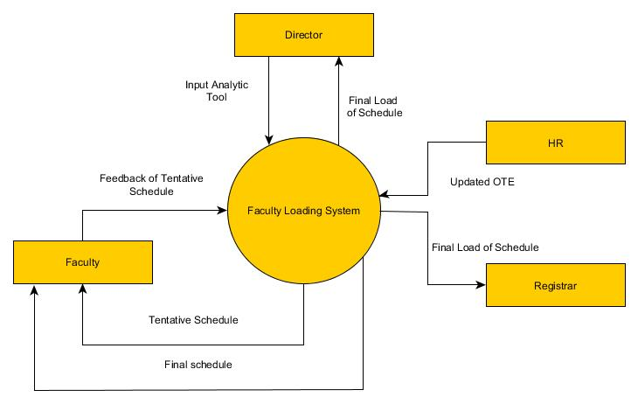

**DATA FLOW DIAGRAM**

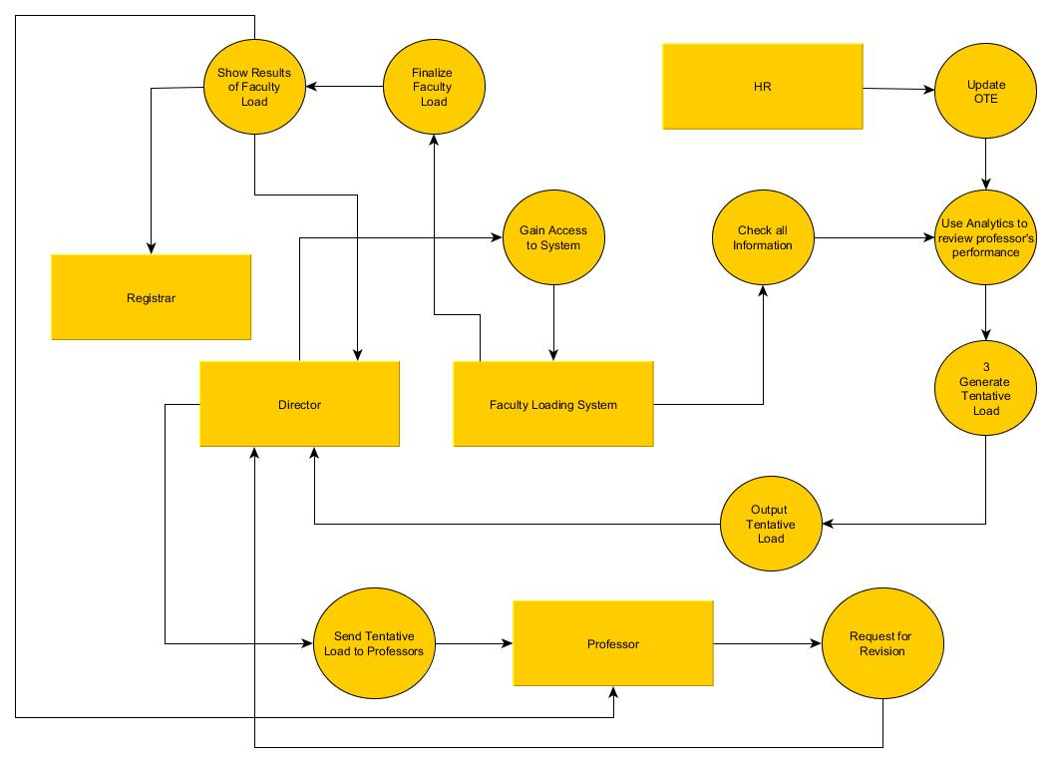

**CONTEXT DIAGRAM**

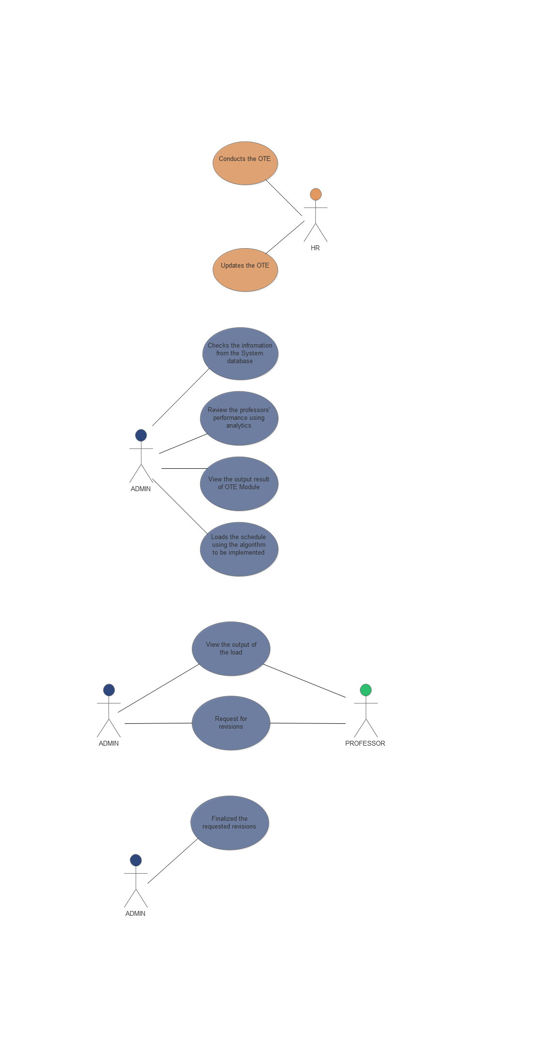

**ENTITY RELATIONSHIP DIAGRAM**

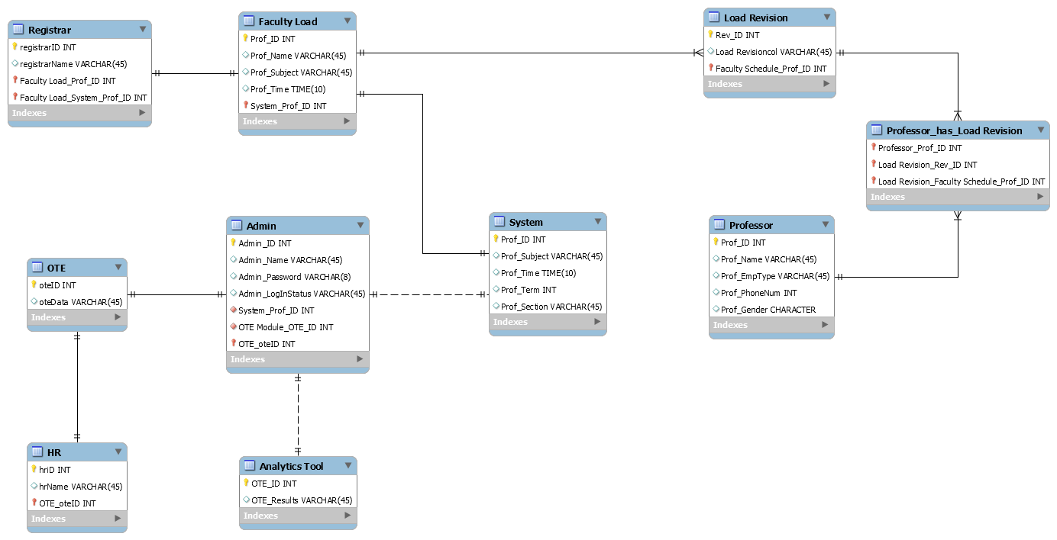

**OBJECT DIAGRAM**

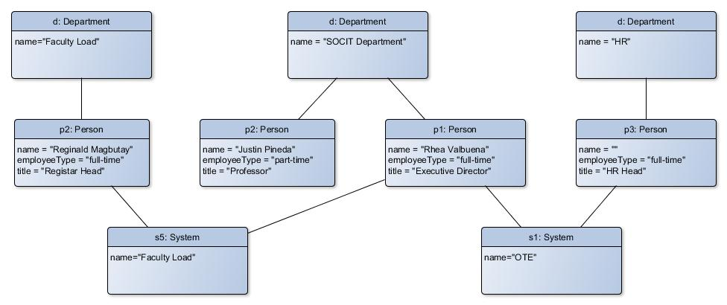

**CLASS DIAGRAM**

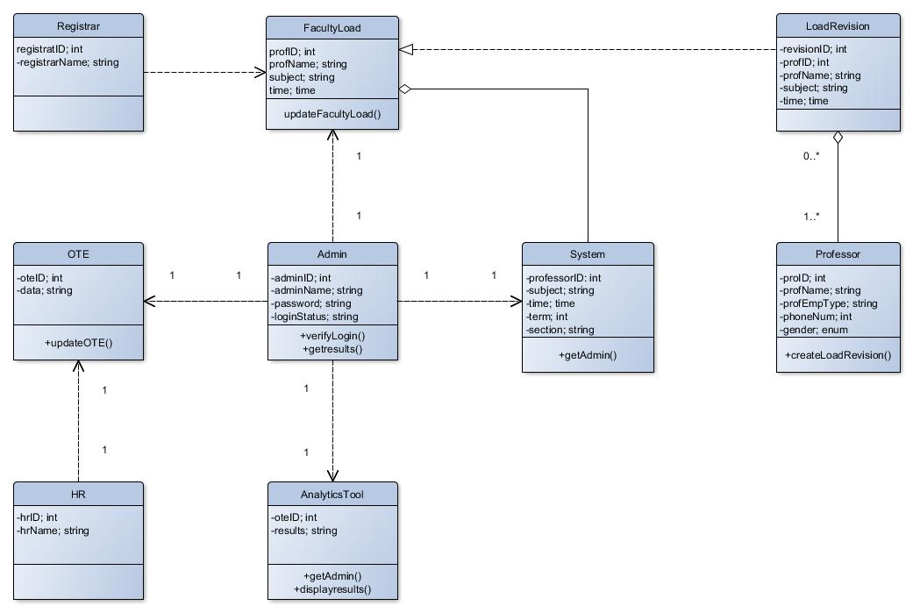

**STATE DIAGRAM**

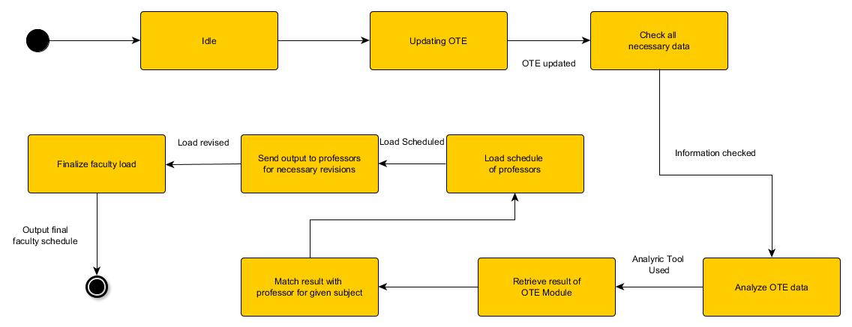

**DEPLOYMENT DIAGRAM**

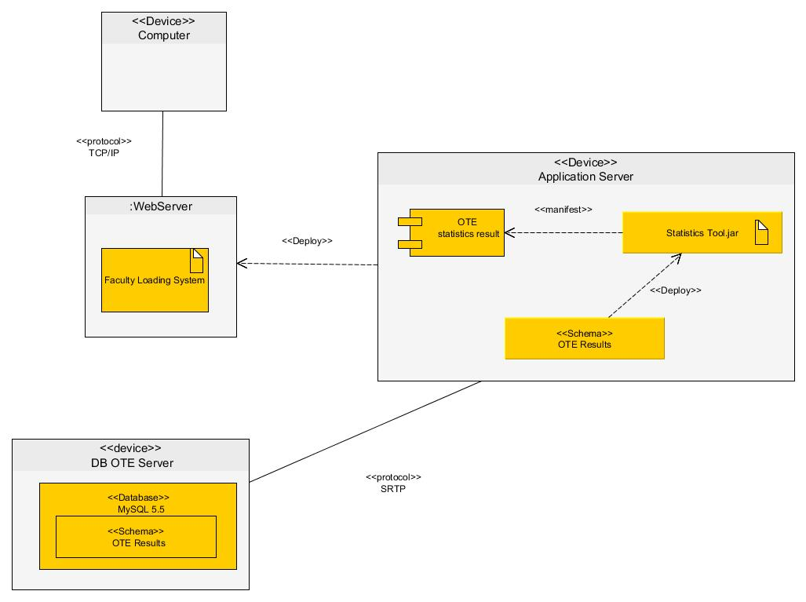

**COMPOSIT STRUCTURE DIAGRAM**

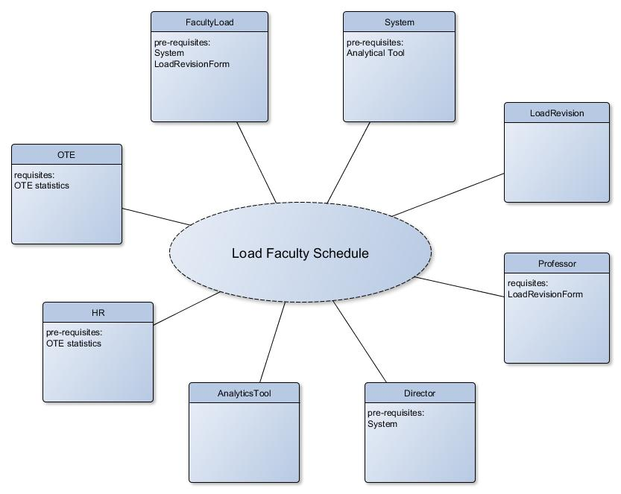

**TIMING DIAGRAM**

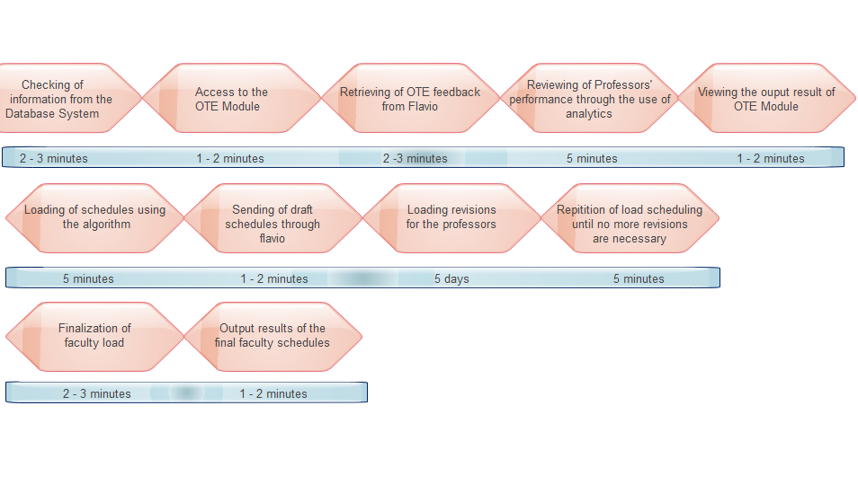

**PACKAGE DIAGRAM**

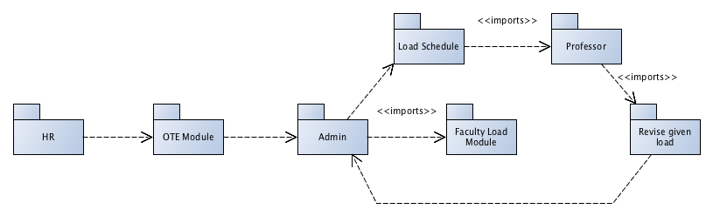

**SEQUENCE DIAGRAM**

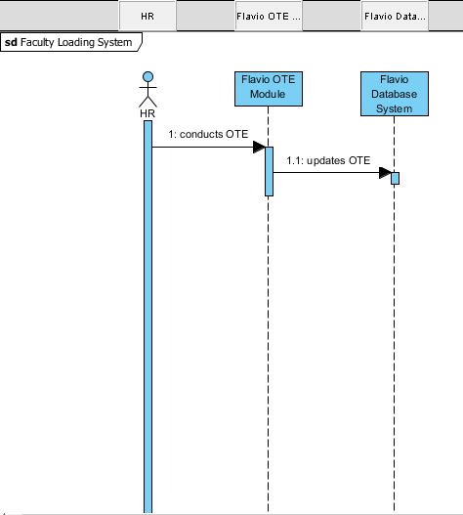

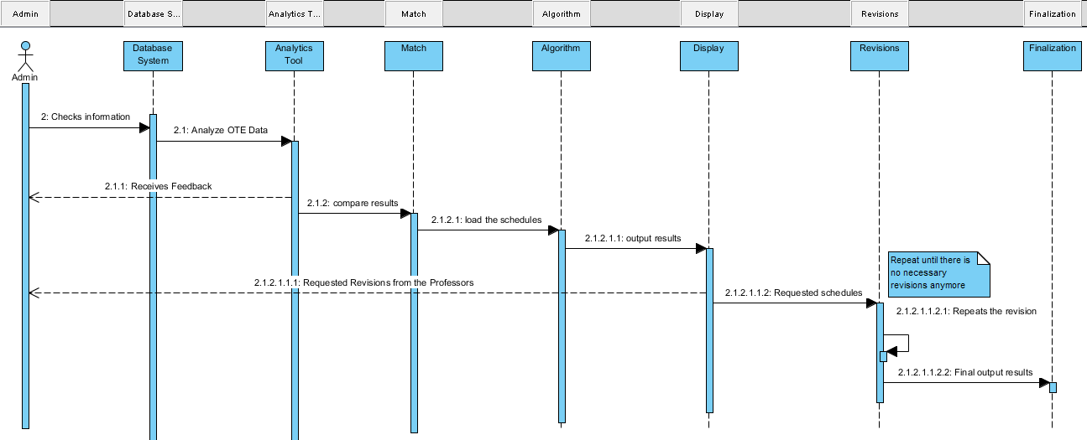

**COMMUNICATION DIAGRAM**

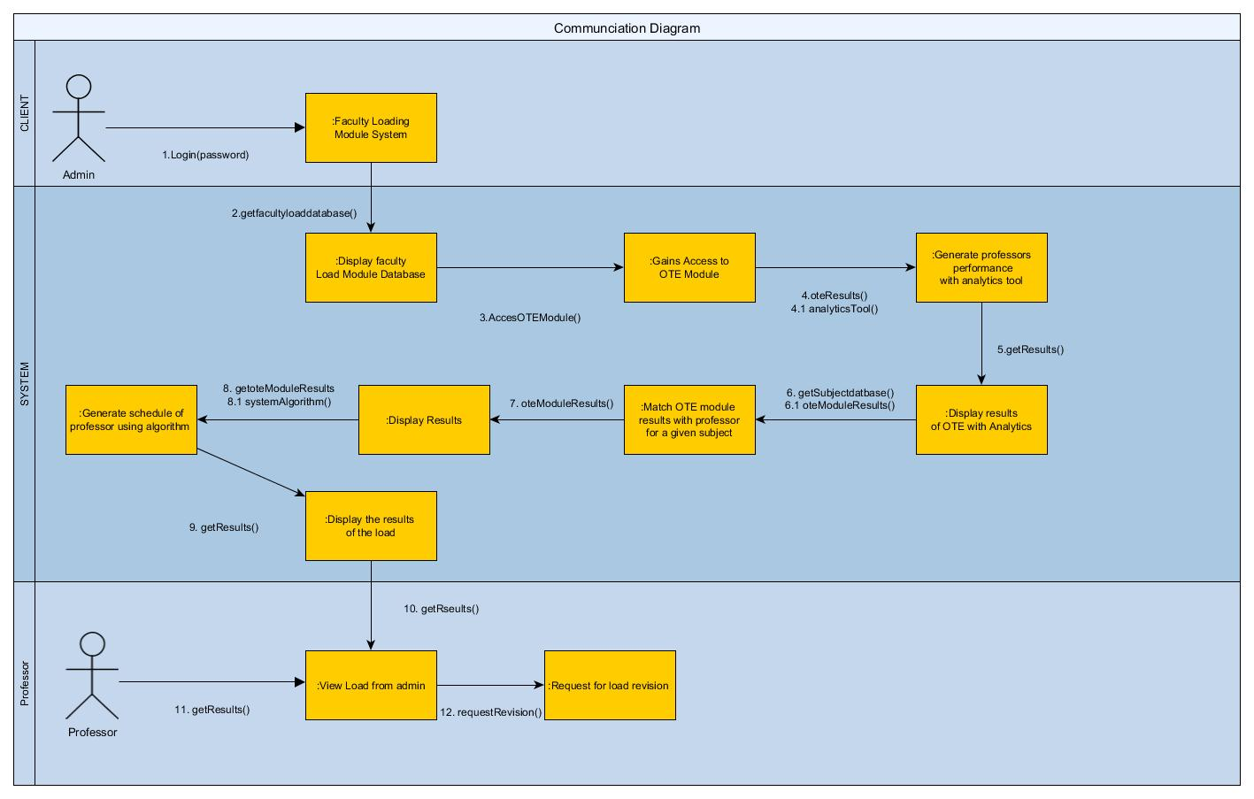

**ACTIVITY DIAGRAM**

