

Asia Pacific College

#3 Humabon Place, Magallanes, Makati City 1232

Graphical Restaurant Reservation System

Members:

Buan, Michael John S.

Caranto, Edric Jon Cleon B.

Carlos, Christian Aleck S.

Professor:

Mr. Manuel Sebastian Sanchez

**General Objectives**

* To develop a restaurant reservation system that has graphics for customers
* To provide a system for restaurants

**Specific Objectives**

* To provide customers a reservation application that has graphics for them to see and choose where they want to be seated
* To create an application for restaurants to easily record and track customer table reservations

**Target Audience**

* Fine Dining Restaurants

**Related Architecture**

* SimpleERB

**Project Description**

Graphical Restaurant Reservation System is an application for restaurants that can be served to customers for their table reservations. Restaurants using this application can manage the restaurant's daily transactions.

**Glossary**

* **Application Program** is a computer program that is created to perform a task for the benefit of the user
* **Customer** is a person or business that buys goods or services from a store or business
* **Fine dining restaurants** are full service restaurants with specific dedicated meal courses
* **Graphics** are visual images or designs on a wall, canvas, or screen and the likes to inform or illustrate
* **System** is a set of connected parts forming a complex whole

**Event Table**

|  |  |  |  |  |  |
| --- | --- | --- | --- | --- | --- |
| EVENT | TRIGGER | SOURCE | USE CASES | RESPONSE | DESTINATION |
| Customer wants to check availability of time slots | Customer inquires on counter | Customer | Shows customer available time slots | Available tables, time slots, and price | Management  Staff |
| Customer reserves a table | Customer chooses a table and time slot | Customer | Requests reservation | Reservation details | Staff |
| Customer wants to change/cancel reservation | Customer inquires at the counter  Phone call from customer | Customer | Updates reservation request | Updated reservation summary and details | Staff  Customer |
| Customer pre-orders food | Customer has accomplishes table reservation | Customer | Pre-orders food | Order details | Staff |
| Customer dines at the restaurant | Customer arrives at their reservation time | Customer | Serves food to customer | Food | Customer |
| Customer pays for his/her transactions | Customer pays the bill | Customer | Pays the bill | Payment details | Customer  Management |
| Produce summary reports | End of month or year | Management | Produces sales/income summary reports | Sales/Income summary reports | Management |

**Use Case Diagram**

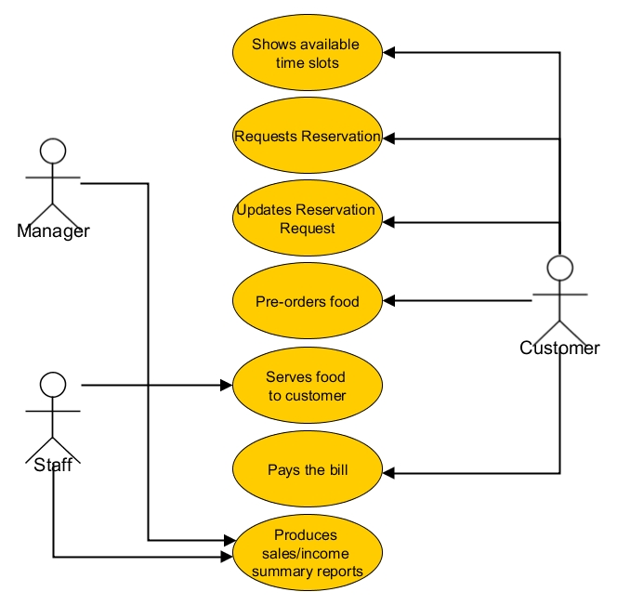

**Use Case Full Descriptions**

|  |  |
| --- | --- |
| Use Case name: | Shows customer available time slots |
| Scenario: | Available time slot inquiry |
| Triggering Event : | Customer inquires at the counter |
| Brief Description: | When the customer approaches and inquires at the counter, in charge staff shows available time and tables; shows record of available time slot and tables |
| Actors: | Staff and Customer |
| Related Use Cases: | Reservation request |
| Stakeholders: | Staff at counter to provide record to customer  Management to provide updated record |
| Precondition: | Customer must exist |
| Post condition: | Updated record from management is already provided.  Customer may start to reserve for a table |
| Flow of Activities: | |  |  | | --- | --- | | Actor | System | | 1. Customer approaches counter for inquiry 2. Staff retrieves record for customer 3. Staff hands the record to the customer 4. Customer views the record 5. Customer inquires for further details | 2.1 Accesses record from system  2.2 Provides hard copy for customer  5.1 Staff refers to system if necessary | |
| Exception Condition: | 1.1 Customer may inquire through a Phone call  1.2 Customer asks for available slots when inquiring through a phone call  3.1 Staff tells customer available schedule for reservation  4.1 Customer inquires for further details through a phone call |

|  |  |
| --- | --- |
| Use Case name: | Requests Reservation |
| Scenario: | Transaction to reserve for a time slot and table |
| Triggering Event : | Customer chooses a table and time slot |
| Brief Description: | When customer has viewed available time slots for reservation process by providing details, the staff records the reservation |
| Actors: | Staff and Customer |
| Related Use Cases: | Shows customer available time slots  Reservation Request Update  Serves Food to Customer |
| Stakeholders: | Staff to record reservation details.  Management to apply reservations. |
| Precondition: | Customer must exist  Customer must have chosen a time slot  Chosen time slot must be available |
| Post condition: | Customers receives a schedule and reservation details |
| Flow of Activities: | |  |  | | --- | --- | | Actor | System | | 1. Customer provides details; including necessary personal details 2. Staff records given details 3. Staff confirms reservation details 4. Customer pays initial deposit for reservation 5. Staff provides reservation details and schedule | 1.1 Shows reservation form  5.1 System prints out reservation details | |
| Exception Condition: | 3.1 If there is a conflict on details   1. Choose another time slot 2. Cancel reservation |

|  |  |
| --- | --- |
| Use Case name: | Updates Reservation Request |
| Scenario: | Customer wants to change his/her reservation preferences |
| Triggering Event : | Customer inquires at the counter; or management receives a phone call from the customer |
| Brief Description: | When a customer has finished his/her reservation request, he/she can change time slot or number of tables reserved based on its availability. |
| Actors: | Customer and management |
| Related Use Cases: | Reservation request and Produce transaction status |
| Stakeholders: | Manager: views the updated reservation details  Staff: Applies necessary changes for the reservation |
| Precondition: | Customer must exist  Customer must have accomplished a previous table reservation request |
| Post condition: | Reservation details for the customer has been updated  Customer and management can view updated reservation details |
| Flow of Activities: | |  |  | | --- | --- | | Actor | System | | 1. Staff receives phone call from the customer 2. Customer requests for reservation changes 3. Staff shows record of available time slot and tables 4. Customer chooses available time slot 5. Staff generates updated reservation summary | 3.1 Shows available preferences  4.1 System updates reservation | |
| Exception Condition: | 4.1 Customer may choose to cancel changes if there is conflict on schedule |

|  |  |
| --- | --- |
| Use Case name: | Pre-orders Food |
| Scenario: | Customer wants to order food after his/her reservation |
| Triggering Event : | Customer has accomplished reservation request |
| Brief Description: | The customer may order food after accomplishing a transaction for table reservation. |
| Actors: | Customer and Staff |
| Related Use Cases: | Reservation request |
| Stakeholders: | Kitchen Staff: prepares from the pre-orders of customer in advance  Customer: Views the reserved seats and the foods ordered |
| Precondition: | Reservation request has been accomplished |
| Post condition: | Staff must confirm the food that the customer has reserved  Kitchen staff receives pre-order details |
| Flow of Activities: | |  |  | | --- | --- | | Actor | System | | 1. Customer request to pre-order food 2. Staff provides menu for the customer 3. Staff records the customer’s order 4. Staff confirms pre-order of customer 5. Customer pays additional initial deposit 6. Staff forwards the customer to the kitchen staff | 2.1 The system displays the menus  3.1 Computes for amount | |
| Exception Condition: | 1.1 Customer may choose to skip pre-order of food  3.1 If food is not available the customer may   1. Cancel food preorder 2. Choose another variant from the menu |

|  |  |
| --- | --- |
| Use Case name: | Serves food to customer |
| Scenario: | Customer will dine at the restaurant |
| Triggering Event : | Customer arrives at the restaurant |
| Brief Description: | Customer arrives to dine at the restaurant, staff assists the customer. |
| Actors: | Customer, Staff |
| Related Use Cases: | Reservation Request  Pre-order food |
| Stakeholders: | Customer to eat at the restaurant  Staff to serve food to customer and process billing payments |
| Precondition: | There must be available table slots for the customers |
| Post condition: | Staff has issued a bill for the customer |
| Flow of Activities: | |  |  | | --- | --- | | Actor | System | | 1. A customer with reservation arrives at the restaurant 2. Staff assists customer to the table 3. Customer orders food 4. Staff records order 5. Staff forwards order to the kitchen staff 6. Kitchen staff prepares food 7. Staff delivers food to the customer’s table | 4.1 Computes total price | |
| Exception Condition: | * 1. If customer with reservation does not arrive  1. Staff will contact customer if he/she can arrive in 15 minutes 2. Give the table to other waiting customers   3.1 Customer has pre-ordered food   1. Go to step 6   3.2 If ordered food is not available:   1. Cancel order; or, 2. Choose another product   7.1 If customer requests for additional order, repeat steps 3-7 |

|  |  |
| --- | --- |
| Use Case name: | Pays the bill |
| Scenario: | Customer pays for his/her transaction |
| Triggering Event : | Customer requests for bill |
| Brief Description: | Customer has finished eating and will pay for the ordered food and services of the management. |
| Actors: | Customer, staff |
| Related Use Cases: | Serves food to customer |
| Stakeholders: | Customer to pay for his/her bills  Staff to process the transaction |
| Precondition: | Customer has ordered food  Customer has bill |
| Post condition: | Customer receives receipt |
| Flow of Activities: | |  |  | | --- | --- | | Actor | System | | 1. Customer requests for the bill 2. Staff bills transaction at the counter 3. Customer finishes payment transaction with credit card 4. Staff provides transaction summary and receipt | 3.1 Transacts payment billing  4.1 System outputs receipt | |
| Exception Condition: | 3.1 If customer credit card payment is invalid:   1. Customer pays using cash |

|  |  |
| --- | --- |
| Use Case name: | Produces Sales/income summary reports |
| Scenario: | Time to produce restaurant’s monthly or yearly sales/income reports |
| Triggering Event : | End of month or year |
| Brief Description: | The management needs to produce the monthly or yearly Sales/Income summary reports. |
| Actors: | Management  Staff |
| Related Use Cases: | Customer pays the bill |
| Stakeholders: | Management: to check and track the sales/income reports in monthly or yearly basis. |
| Precondition: | Manager must exist  Receipts or records must exist |
| Post condition: | Sales/income summary reports are accessible by the manager |
| Flow of Activities: | |  |  | | --- | --- | | Actor | System | | 1. All receipts/invoices are requested 2. Assigned staff records and produces sales/income summary 3. Staff forwards income summary to Manager | 2.1 Summarize income | |
| Exception Condition: | * 1. If produced report has to be changed, staff updates the report and sends it to the manager   2. If manager is not available, forward it to the assistant manager |

**Context Flow Diagram**

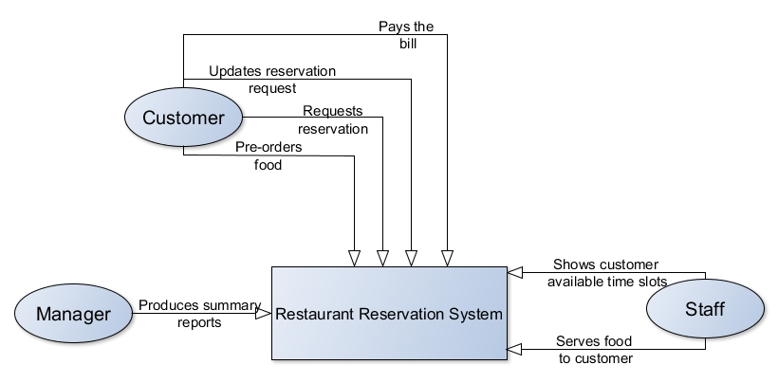

**Data Flow Diagram**

**Level 0**

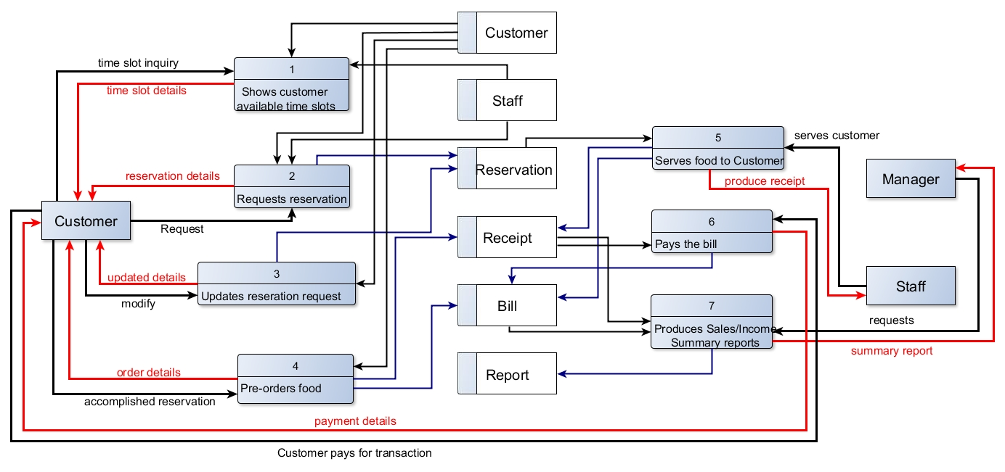

**Level 1**

**Reservation Request**

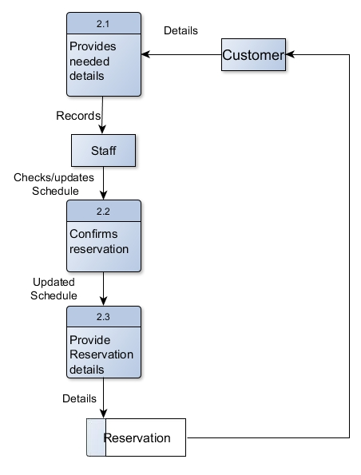

**Reservation Request Update**

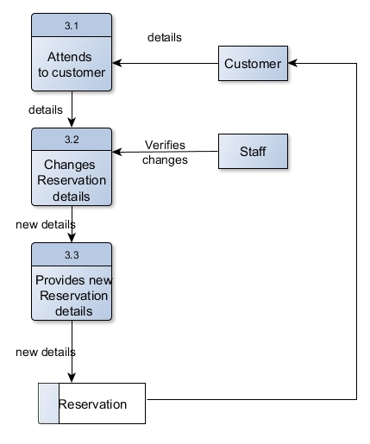

**Entity Relationship Diagram**

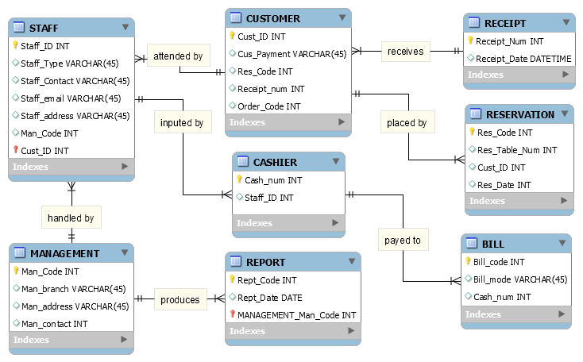

**Activity Diagram**

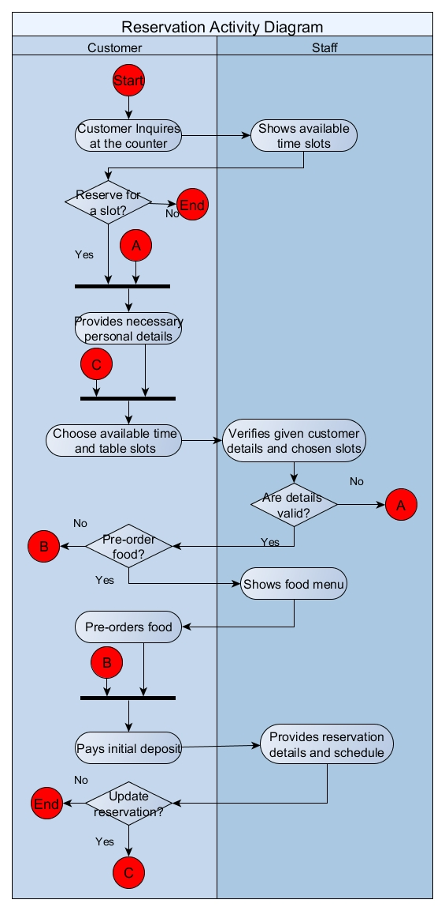

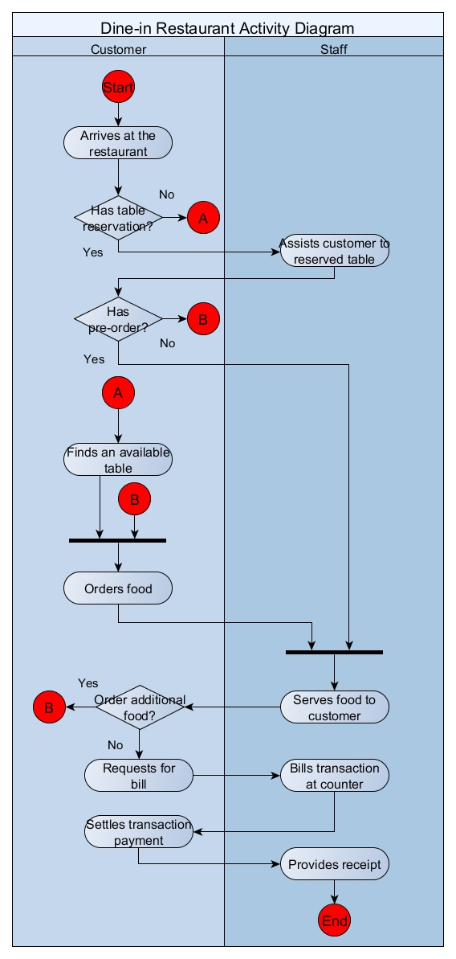

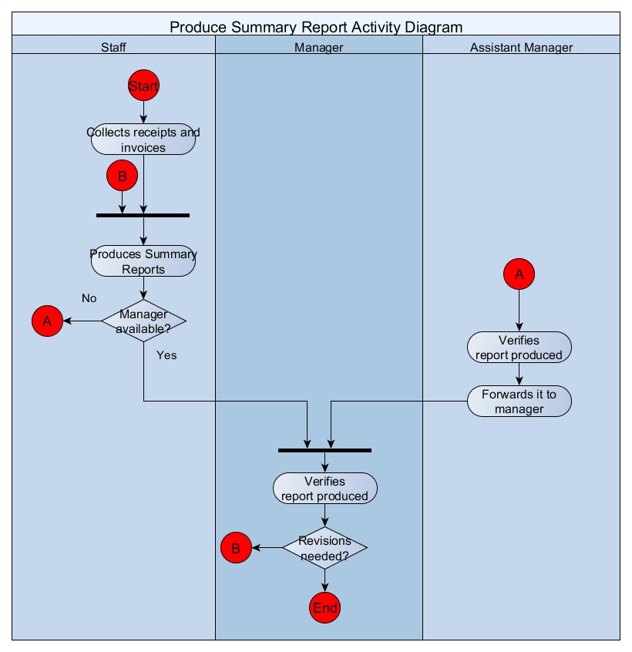

**Data Dictionary**

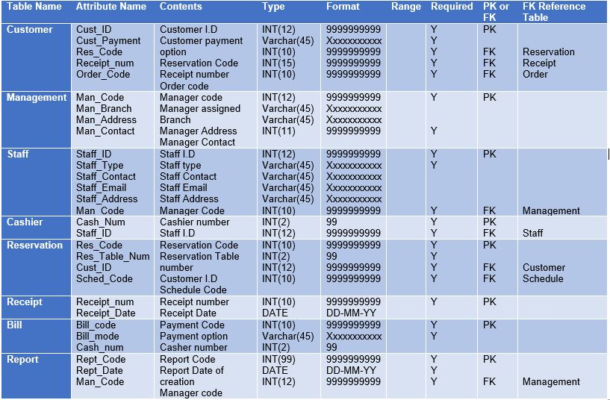

**Project Schedule and Gantt chart**

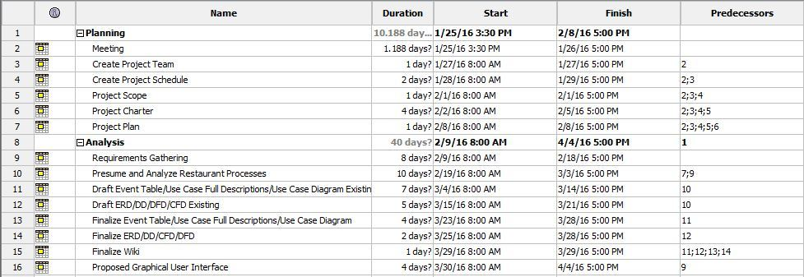

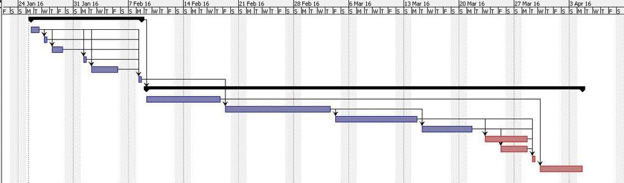

**Work breakdown Structure**

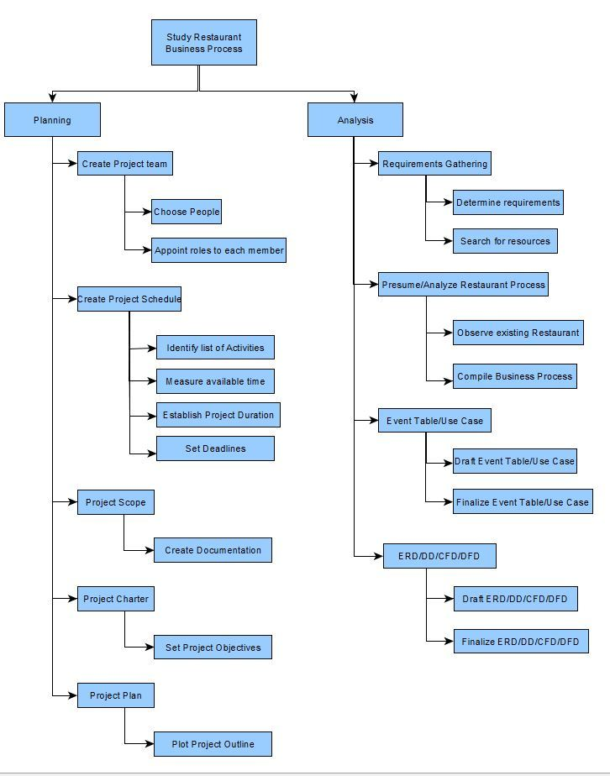

|  |  |  |  |  |  |  |
| --- | --- | --- | --- | --- | --- | --- |
| Activity # | Activity Name | Activity Name Description | # of days | Start Date | Dependency | Milestone |
| 1 | **Planning** | Planning | 10 | 1/25/16 |  |  |
| 2 | Meeting | Planning | 1 | 1/25/16 |  | Details about the project |
| 3 | Create Project Team | Planning | 1 | 1/27/16 | 2 | Project Team members/ position |
| 4 | Create Project Schedule | Planning | 2 | 1/28/16 | 2;3 | Project Schedule |
| 5 | Project Scope | Planning | 1 | 2/1/16 | 2;3;4 | Documentations |
| 6 | Project Charter | Planning | 4 | 2/2/16 | 2;3;4;5 | Project Objectives |
| 7 | Project Plan | Planning | 1 | 2/8/16 | 2;3;4;5;6 | Project Outline |
| 8 | **Analysis** | Analysis | 40 | 2/9/16 |  |  |
| 9 | Requirements Gathering | Analysis | 8 | 2/9/16 |  | Details about the Requirements |
| 10 | Presume and Analyze Restaurant Processes | Analysis | 10 | 2/19/16 | 7;9 | Information about Restaurant Process |
| 11 | Draft Event Table/Use Case Full Descriptions/Use Case Diagram Existing | Analysis | 7 | 3/4/16 | 10 | Event Table and Uses Cases draft |
| 12 | Draft ERD/DD/DFD/CFD Existing | Analysis | 5 | 3/15/16 | 10 | ERD/DD/CFP/DFD Draft |
| 13 | Finalize Event Table/Use Case Full Descriptions/Use Case Diagram | Analysis | 4 | 3/23/16 | 11 | Final outline of Event Table and Use Cases |
| 14 | Finalize ERD/DD/DFD/CFD Existing | Analysis | 2 | 3/25/16 | 12 | Final outline of ERD/DD/DFD/CFD |
| 15 | Finalize Wiki | Analysis | 1 | 3/29/16 | 11;12;13;14 | Final output on wiki |
| 16 | Proposed Graphical User Interface | Analysis | 4 | 3/30/16 | 9 | Screenshots of Proposed system application |

**Screenshots of Proposed System**

