**Software Requirements Specification**

**for**

**Project LSC**

**Enrollment System**

**Version 1.0 approved**

**Prepared by <author>**

**<organization>**

**<date created>**

***Software Requirements Specification for LSC Enrollment System***

**Table of Contents**

|  |  |  |  |
| --- | --- | --- | --- |
| **Table of Contents ..........................................................................................................................** | | | **ii** |
| **Revision History ............................................................................................................................** | | | **ii** |
| **1.** | **Introduction ..............................................................................................................................** | | **1** |
|  | 1.1 | Purpose ............................................................................................................................................ | 1 |
|  | 1.2 | Document Conventions .................................................................................................................... | 1 |
|  | 1.3 | Intended Audience and Reading Suggestions .................................................................................. | 1 |
|  | 1.4 | Product Scope .................................................................................................................................. | 1 |
|  | 1.5 | References ........................................................................................................................................ | 1 |
| **2.** | **Overall Description ..................................................................................................................** | | **2** |
|  | 2.1 | Product Perspective ......................................................................................................................... | 2 |
|  | 2.2 | Product Functions ............................................................................................................................ | 2 |
|  | 2.3 | User Classes and Characteristics ..................................................................................................... | 2 |
|  | 2.4 | Operating Environment .................................................................................................................... | 2 |
|  | 2.5 | Design and Implementation Constraints .......................................................................................... | 2 |
|  | 2.6 | User Documentation ........................................................................................................................ | 2 |
|  | 2.7 | Assumptions and Dependencies ...................................................................................................... | 3 |
| **3.** | **External Interface Requirements ...........................................................................................** | | **3** |
|  | 3.1 | User Interfaces ................................................................................................................................. | 3 |
|  | 3.2 | Hardware Interfaces ......................................................................................................................... | 3 |
|  | 3.3 | Software Interfaces .......................................................................................................................... | 3 |
|  | 3.4 | Communications Interfaces ............................................................................................................. | 3 |
| **4.** | **System Features ........................................................................................................................** | | **4** |
|  | 4.1 | System Feature 1 .............................................................................................................................. | 4 |
|  | 4.2 | System Feature 2 (and so on) ........................................................................................................... | 4 |
| **5.** | **Other Nonfunctional Requirements .......................................................................................** | | **4** |
|  | 5.1 | Performance Requirements .............................................................................................................. | 4 |
|  | 5.2 | Safety Requirements ........................................................................................................................ | 5 |
|  | 5.3 | Security Requirements ..................................................................................................................... | 5 |
|  | 5.4 | Software Quality Attributes ............................................................................................................. | 5 |
|  | 5.5 | Business Rules ................................................................................................................................. | 5 |
| **6.** | **Other Requirements ................................................................................................................** | | **5** |
| **Appendix A: Glossary....................................................................................................................** | | | **5** |
| **Appendix B: Analysis Models .......................................................................................................** | | | **5** |
| **Appendix C: To Be Determined List ............................................................................................** | | | **6** |

**Revision History**

|  |  |  |  |
| --- | --- | --- | --- |
| **Name** | **Date** | **Reason For Changes** | **Version** |
|  |  |  |  |
| Balcena, Danya  Carpio, Aira Joyce  Haboc, Florence Gail | October 22, 2016 |  | 1.0 |
| Balcena, Danya  Carpio, Aira Joyce  Haboc, Florence Gail | November 7, 2016 |  | 1.1 |

**1. Introduction**

**1.1 Purpose**

The Software Requirements Specification is a document that Project Managers and Project Developers may use to identify description and requirements in developing the system which is Loyola Student Center Enrollment System. This document can also use to clarify and organize system requirements such as; project scope, project vision, use cases, user manual, business rules, user interface and system features. This is the version 0.1 of the software requirements specification.

Objectives of Software Requirements Specification.

* Establish the basis agreement between client and project developers
* Provide a basis for realistic estimates of costs and schedules
* Provide detailed information about the system to be developed
* Serve as a basis for enhancement requests

**1.2 Document Conventions**

The document is prepared using Microsoft Word 2016. Used the font type ‘Times New Roman’ for the headings and contents. The font size is 11pt. with “1.0” line spacing. It has used the bold property to set the headings of the document.

**1.3 Intended Audience and Reading Suggestions**

This document is written for the researchers, developers, testers, documentation writers and users involved in LSC Enrollment System to initiation an open discussion for developing the said system. Second Section discusses the description and process that are to be undertaken to bring up about the system. In the third and fourth section, system features and functional requirements are discussed to easily understand the flow of the facility’s service. For the external interface requirements, the logical characteristics of each interface between the system and the users are discussed. Fifth section includes the performance and security of the system that must be implemented or maintain. The specification is also concluded at the sixth section with the reference documents on which this document is based on.

**1.4 Product Scope**

The development of Loyola Student Center Enrollment System is to improve the interface of the system and improve the process of reservation and enrollment of a review class. The improvement of the system will not just benefit the management of Loyola Student Center(LSC) but also the student who wants to avail services offered by LSC. Thus, the enhancement of the system will help the management to lessen paper works for reservation and enrollment processing of a review class, to easily manage the students’ records and transactions and it will serve as the storage of their database for the entered information of each student who wants to enroll or reserve slot of a review class. For the student, it will be easy for them to understand and interact with the system also the academic information in the system are accurate and accessible by the student. While, for the system administrator it includes better web-based tools for accessing the students’ records, secure web access for users’ information in the system, easier to maintain processes, no data redundancy and have privilege to create, read and update data. Loyola Student Center Enrollment System includes various functionalities that would be helpful to LSC Management those are analyzed in the following pages.

**1.5 References**

[1] Minimum Requirements for Web Based Applications. (2016, February 26). Retrieved October 22, 2016, from https://support.skyward.com/DeptDocs/Corporate/IT Services/Public Website/Technical Information/Workstation Requirements/Web Based Workstation Requirements.pdf

**2. Overall Description**

**2.1 Product Perspective**

The LSC Enrollment System is a replacement to the facility’s existing system. It aims to improve the process of the LSC. With that, the developers decided to change and include some features that will help both the facility and its students to extensively save time and effectively reduce costs. The main feature of product is the online reservation and enrollment process. The above diagram shows the main process of the LSC Enrollment System:

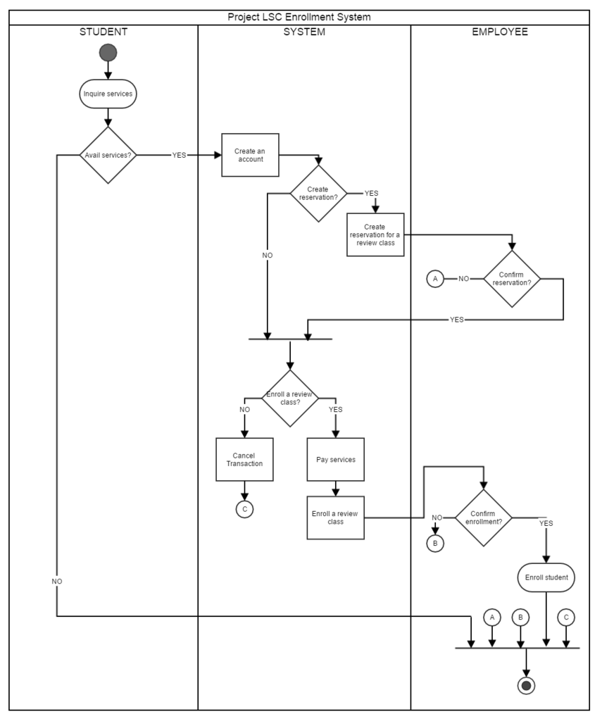

**2.2 Product Functions**

Loyola Student Center Enrollment System provides LSC Management and Student who wants to avail services with the following functions:

* Accurate and accessible academic information
* Access to information of each review class
* Secure web access for users entered information
* Real time access of the users’ information
* Easier to maintain processes
* Better web-based tools for accessing the students’ information
* No data redundancy

The Student wants to enroll or reserve a review class performs the following major functions:

* Student will create a personal account to access the reservation or enrollment form or review class
* Student will fill out the reservation or enrollment form
* Student can view the chosen schedule in his/her account once enrolled or made a reservation
* Student can view the transaction and status of availed service in his/her account
* Student can make payment by attaching the image or scanned deposit slip in his/her account

The System Administrators performs the following major functions:

* Admin verifies students record
* Admin accepts students who wants to reserve or enroll in a review class
* Admin and authorized employees will have a personal account to access the backend system
* Managing the records by creating, reading, adding and updating
* Tracking records by sorting, filtering and searching

**2.3 User Classes and Characteristics**

* System Administrator

The system administrator manages the database. Therefore, the system administrator uses the system frequently. Also, the system administrator is the only one who can access the backend system and must be knowledgeable on how to use the system and how to manage the database e.g. adding and modifying records.

* Students

The student must be knowledgeable on creating and managing their account.

* Faculty and Staff

The only interaction of faculty and staff with the system is to record their information. Hence, the faculty and staff will not use the system frequently.

**2.4 Operating Environment**

For the operating environment of the system, the LSC Enrollment System must meet the following minimum hardware requirements: Dual Core 1.6GHz or faster with RAM: 1 gigabyte (GB) (32-bit) or 2 GB (64-bit). Regarding the browser, system shall support web browser such as: Mozilla Firefox, Google Chrome and Microsoft Edge and it is recommended the browser is in latest version. It must also compatible with most mobile devices including smartphones and tablets. Recommended operating systems are iOS, Android, and Windows Mobile.

**2.5 Design and Implementation Constraints**

CO-1: The Loyola Student Center Enrollment System’s design, code, and functionalities of

transactions shall be adapt the Process of the Current system of LSC.

CO-2: The system shall follow the given requirements of the client.

CO-3: The system should perform validation checks on users input and length constraints.

CO-4: The system created shall be flexible to be integrated with other web service application.

CO-5: The system uses phpmyadmin MySQL for the storage of database.

CO-6: Yii2.0 and Admin LTE and some bootstrap template was used to build the system.

CO-7: PHP, JavaScript and CSS technologies are being integrated in creating the system

interfaces.

**2.6 User Documentation**

Along with the software product, to help people understand the working methodology and usage of the developed prototype system a user manual would be written. It would be written for nontechnical individuals and the terminology that will be used are easy to understand. The user manual includes step-by-step instructions for using the system including conventions, tips for errors and malfunctions, pointers to references documents, and glossary of terms.

**2.7 Assumptions and Dependencies**

AS-1 Less paper-based process for the records of students.

AS-2 Security and maintenance must take place for the better business process.

AS-3 Admin should be familiarized in using the system.

AS-4 The details of every records must be accurately sorted.

AS-5 The user must submit accurate data for the system to generate accurate information

DE-1 The management should be trained and tested in using the system.

DE-2 The number of data that can be handled will depend upon the capacity of database.

DE-3 System performance relies on the facility’s machine and network connection.

DE-4 Accuracy of modification of records depends on the facility’s employee in charge in the system.

**3. External Interface Requirements**

**3.1 User Interfaces**

Some of the system screenshots are being shown in Figure 1,2,3,4,5,6,7 and 8.

Frontend

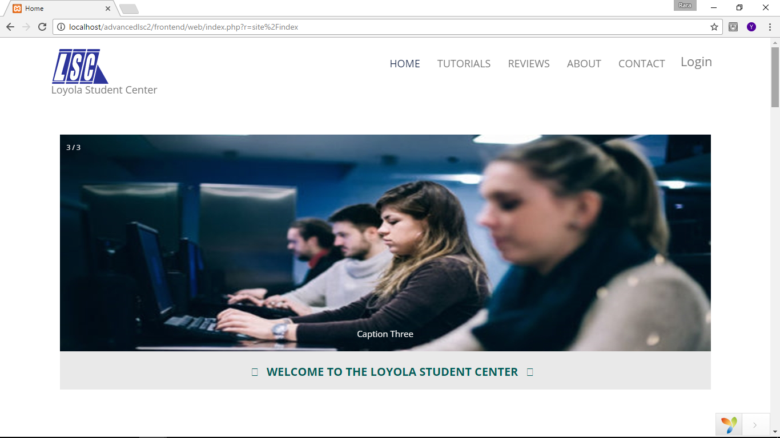

Figure 1. Loyola Student Center Enrollment System: Home Page

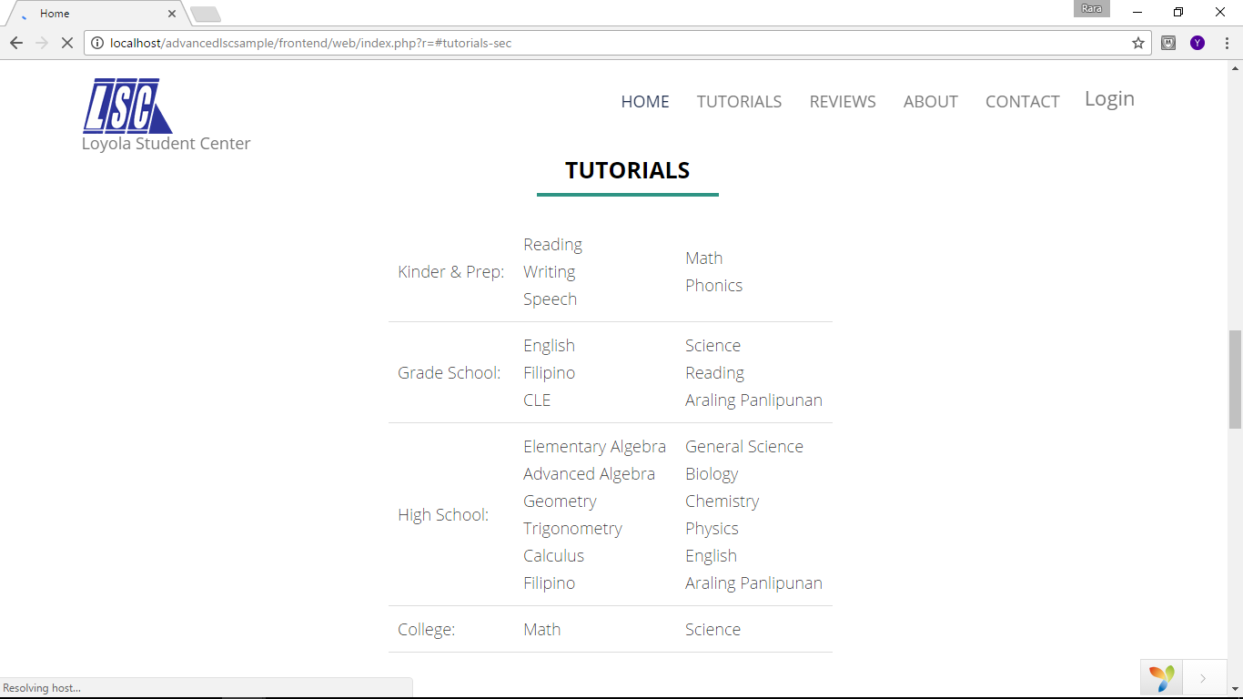

Figure 2. Loyola Student Center Enrollment System: Tutorial Page

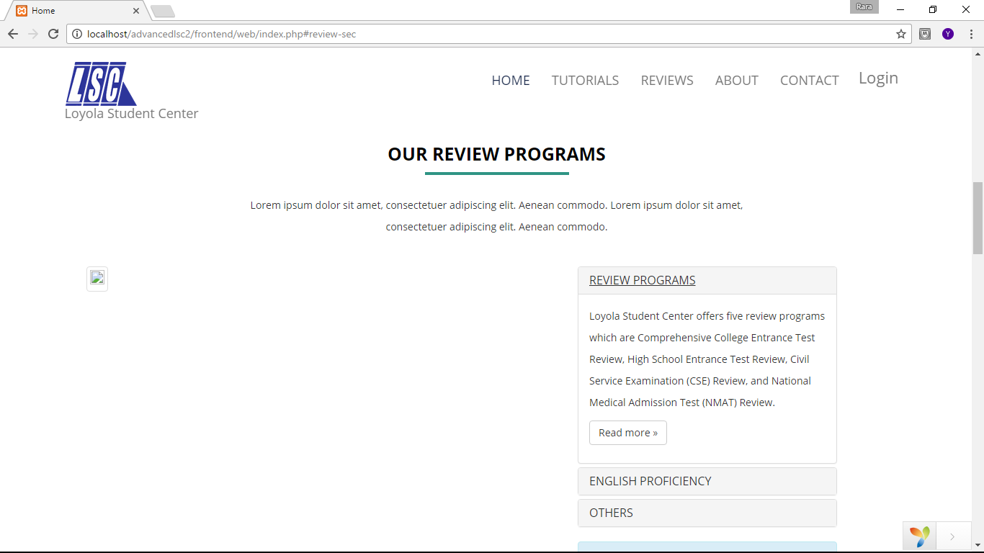

Figure 3. Loyola Student Center Enrollment System: Reviews Page



Figure 4. Loyola Student Center Enrollment System: About LSC Page

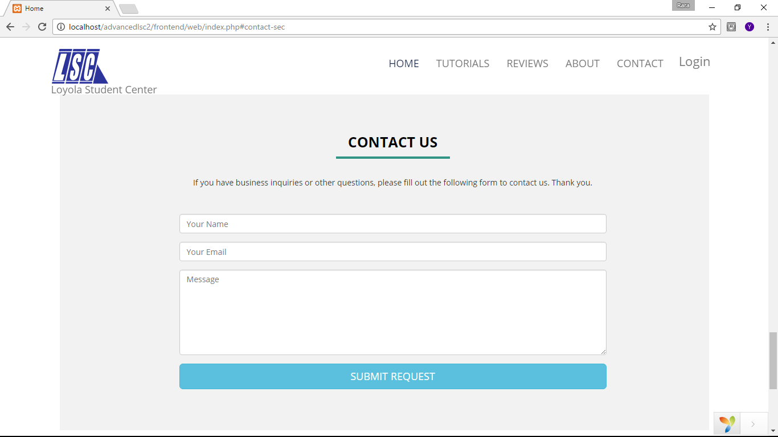

Figure 5. Loyola Student Center Enrollment System: Contact Us Form Page

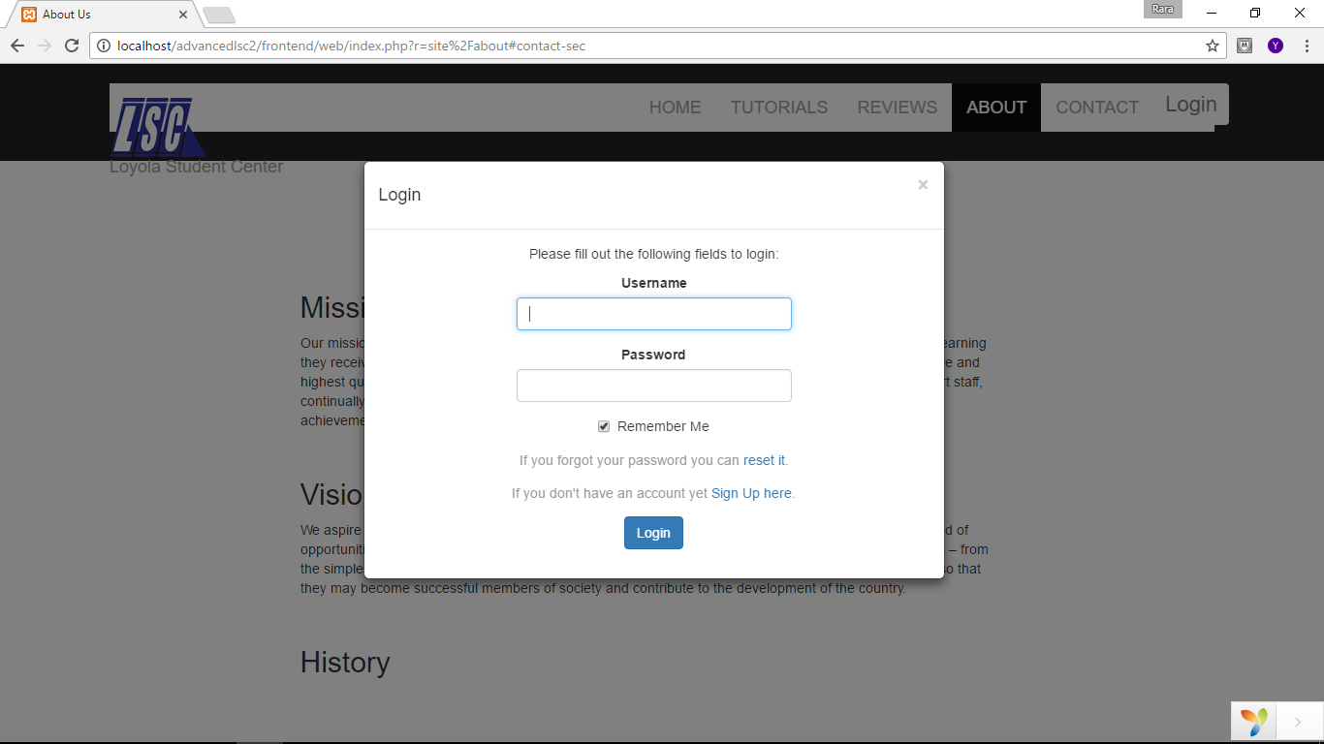

Figure 6. Loyola Student Center Enrollment System: Login Form Page

Backend

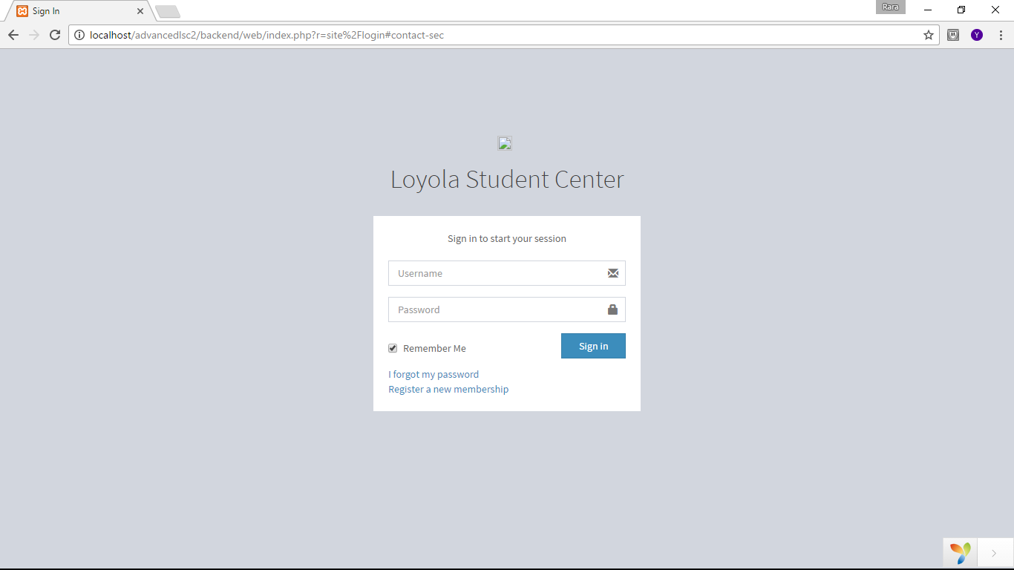

Figure 7. Loyola Student Center Enrollment System: Admin Login Page

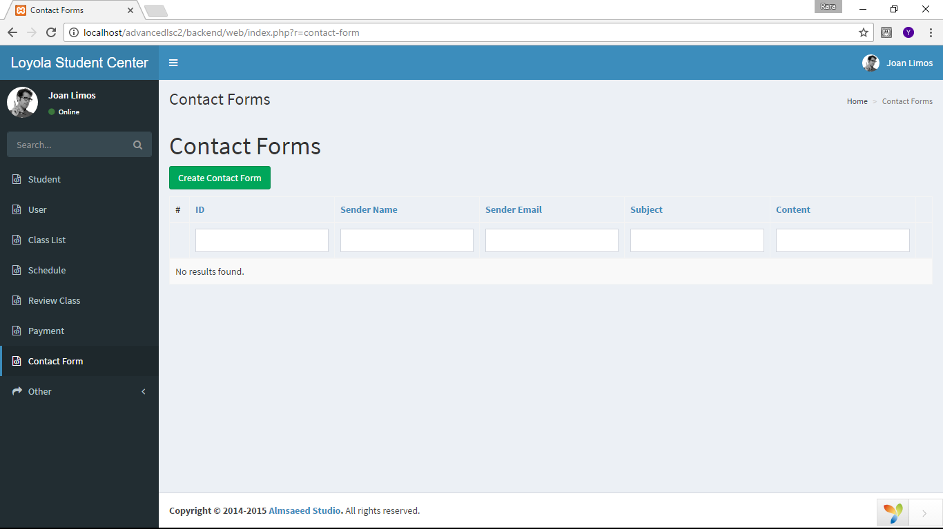

Figure 8. Loyola Student Center Enrollment System: Data Forms and Tables

**3.2 Hardware Interfaces**

Hardware Minimum System Requirement

Processor 2.4 GHZ processor speed

Memory 128 MB RAM (256 MB recommended)

Disk Space 80 GB

Display 800 x 600 colors

**3.3 Software Interfaces**

The data stored in the system are the employees’ data and student data since they must have an account to access the system and avail the service. The students’ data includes the personal information and its availed service.

**3.4 Communications Interfaces**

* Internet connection and a browser are required for several functions of the Loyola Student Center Enrollment System will be executed.

**4. System Features**

**4.1 System Feature 1**

1. Description and Priority

The student must create an account first to reserve or enroll a review class.

1. Stimulus/Response Sequences

Data Flow

4.1.2.1 **Basic Data Flow**

1. User accesses the website and select -> “Log In” button

2. User clicks “Sign Up” hyperlink

3. User fills out the sign up form

4. User verifies his or her email address

5. User chooses “Reserve” button

6. User fills out reservation form

7. User clicks “Submit” button

4.1.2.2 **Alternate Data Flow**

4.1.2.2.1 Alternate Data Flow 1

5. User chooses “Enroll” button

6. User fills out enrollment form

1. Functional Requirements

REQ-1: Hardware device is connected to the internet.

REQ-2: Email address is valid.

**4.2 View Schedule of Review Class**

* + 1. Description and Priority

The student can view the schedule of his or her review class in his or her account.

4.2.2 Stimulus/Response Sequences

Data Flow

4.2.2.1 **Basic Data Flow**

1. User accesses the website -> and selects “Log In” button
2. User fills out log in form
3. User clicks “Account” button from navigation bar
4. User clicks “Schedule” button

4.2.3 Functional Requirements

REQ-1: User is logged in.

REQ-2: User reserved or enrolled a review class.

* 1. **View Transaction Details**

4.3.1 Description and Priority

The student can view the transaction details of his or her review class in his or her account.

4.3.2 Stimulus/Response Sequences

Data Flow

* + - 1. **Basic Data Flow**

1. User accesses the website -> and selects “Log In” button
2. User fills out log in form
3. User clicks “Account” button from navigation bar
4. User clicks “Transactions” button

4.3.3 Functional Requirements

REQ-1: User is logged in.

REQ-2: User reserved or enrolled a review class.

* 1. **Attach Image for Payment**

4.4.1 Description and Priority

The student can pay the reservation and enrollment fee by attaching the scanned or captured image of deposit slip.

4.4.2 Stimulus/Response Sequences

Data Flow

* + - 1. **Basic Data Flow**

1. User accesses the website -> and selects “Log In” button
2. User fills out log in form
3. User clicks “Account” button from navigation bar
4. User clicks “Transactions” button
5. User clicks “Attach Image”
6. User clicks the image to attach
7. User clicks “Select” button

4.4.3 Functional Requirements

REQ-1: User is logged in.

REQ-2: User reserved or enrolled a review class.

REQ-3: User has a scanned or captured image of deposit slip.

1. Description and Priority
2. Stimulus/Response Sequences
3. Functional Requirements

REQ-1:

REQ-2:

**4.5 System Feature 5**

Admin and authorized employees will have a personal account to access the database.

* + 1. Description and Priority

This personal account is their key to manage and view the records of the system.

* + 1. Stimulus/Response Sequences

Basic Data Flow

1. User access the backend system and clicks sign up button.
2. User must fill out the sign up form which are email, username and password and finally clicks sign up button.
   * 1. Functional Requirements

REQ-1: Hardware device must only be connected to the facilities network connection.

REQ-2: The data entered by the user must be valid.

**4.6 System Feature 6**

Managing the records by creating, reading, adding and updating or modifying.

* + 1. Description and Priority

Managing of record is done when a user is signed in and must be done by and/or authorized personnel of the facility.

* + 1. Stimulus/Response Sequences

Basic Data Flow

1. User accesses the backend system and signs in by entering the username and password.
2. User can choose what record he/she will manage by selecting in the left side navigation bar.
3. User can read or view the record by clicking the specific data to redirect the page to the record’s detail.
4. User can create another record
   1. Click Add Record Button
   2. User enters the details needed in form to complete the record
   3. User submits the form to add the record in database.
5. User can update record
   1. User views the record
   2. User clicks the update icon button at the right side of record.
   3. Page must be redirect to editable form of the selected record and updates the details
   4. User clicks Update button to save the updated form.
      1. Functional Requirements

REQ-1: Hardware device must only be connected to the facilities network connection.

REQ-2: The data entered by the user must be valid.

**4.7 System Feature 6**

Tracking records by sorting, filtering and searching.

* + 1. Description and Priority

Tracking of record is done when a user is signed in and must be done by and/or authorized personnel of the facility.

* + 1. Stimulus/Response Sequences

Basic Data Flow

1. User accesses the backend system and signs in by entering the username and password.
2. User can choose what record he/she will manage by selecting in the left side navigation bar.
3. User can search and/or filter by entering the hint word at the textbox located at each to of the data in the records.
4. User filters the records in ascending or descending by clicking the icon at the side of the search bar of the records.
   * 1. Functional Requirements

REQ-1: Hardware device must only be connected to the facilities network connection.

REQ-2: The data entered by the user must be valid.

**5. Other Nonfunctional Requirements**

**5.1 Performance Requirements**

Since the LSC-Enrollment System is a Web-based System it requires that the device that is going to use is connected to the internet. The performance of system relies on the facility’s device and network connection.

**5.2 Safety Requirements**

Student

* When a student created an account, the student should not give his or her account details to others.

System Administrator

* Administrator should not leave his or her account unattended to avoid unauthorized individuals to have access to the system.
* Administrator should do backup the database regularly.

**5.3 Security Requirements**

Regarding the security, system includes email verification for the student to access the enrollment or reservation form. This will help to secure data, to avoid data redundancy and to avoid false identities. For the backend system, system shall be accessible by signed in personnel and only inside the facility’s premises. The system will also be requiring additional services and equipment for the system maintenance and security. With that, the facility will have an obligation to allocate time and budget for additional software or services to prevent potential risks that the facility might encounter when it comes to system security and maintenance.

**5.4 Software Quality Attributes**

* Loyola Student Center Enrollment System is a web-based system so it doesn’t need to be installed. Several transactions of the system can be done if the device is connected to the internet
* The record of the student will be stored even if the student cancelled or already finished the review class.
* Once the LSC-Enrollment System have been developed it will be implemented by LSC Management

**5.5 Business Rules**

* Student will create an account before he/she can reserve or enroll to a review class offered by the LSC.
* Enrolled student can view the transaction, schedule, and status he/she availed. The modification of the detail of which the student created is limited only to the personal information but not to his/her availed service. The payment. They can also can make payment by attaching the image of deposit slip in his/her account.
* Admin and authorized employees will have a personal account to access the database. They can manage the records by creating, reading, adding and updating or modifying. They are also in-charged in the maintenance and security of the system.

**6. Other Requirements**

**Appendix A: Glossary**

Backend - Denoting a subordinate processor or program, not directly accessed by the user, which performs a specialized function on behalf of a main processor or software system.

Data - A collection of facts from which conclusions may be drawn.

Diagram - A drawing intended to explain how something works; a drawing showing the relation between the parts.

Frontend - (of a device or program) directly accessed by the user and allowing access to further devices, programs, or databases.

Hardware - the machines, wiring, and other physical components of a computer or other electronic system.

Operating system - the software that supports a computer's basic functions, such as scheduling tasks, executing applications, and controlling peripherals.

Redundancy - the use of words or data that could be omitted without loss of meaning or function; repetition or superfluity of information.

System - a set of connected things or parts forming a complex whole, in particular.

Tracking - the maintenance of a constant difference in frequency between two or more connected circuits or components.

Use cases - a list of actions or event steps, typically defining the interactions between a role (known in the Unified Modeling Language as an actor) and a system, to achieve a goal. The actor can be a human or other external system.

**Appendix B: Analysis Models**

*<Optionally, include any pertinent analysis models, such as data flow diagrams, class diagrams, state-transition diagrams, or entity-relationship diagrams*.

**Appendix C: To Be Determined List**

*<Collect a numbered list of the TBD (to be determined) references that remain in the SRS so they can be tracked to closure.>*