

Asia Pacific College

#3 Humabon Place, Magallanes, Makati City 1232

Loyola Student Center Enrollment System

Members:

Balcena, Danya P.

Carpio, Aira Joyce A.

Haboc, Florence Gail G.

Professor:

Mr. Manuel Sebastian Sanchez

**Project Authors**

**Professors**

|  |  |  |
| --- | --- | --- |
| Name | Position | E-mail |
| Mr. Manuel Sebastian S. Sanchez | Professor | manuels@apc.edu.ph |

**Advisers**

|  |  |  |
| --- | --- | --- |
| Name | Position | E-mail |
| Mr. Ernesto Boydon | Professor | ernestob@apc.edu.ph |
| Mr. Jojo Castillo | Professor | jojoc@apc.edu.ph |
| Ms. Roselle Wednesday Gardon | Professor | [roselleg@apc.edu.ph](mailto:roselleg@apc.edu.ph) |
| Ms. Maria Teresa Carmela Montemayor | Professor | tessm@apc.edu.ph |
| Mr. Paulo Oblepias | Professor | pauloo@apc.edu.ph |

**Students**

|  |  |  |
| --- | --- | --- |
| Name | Position | E-mail |
| Balcena, Danya P. | Member | dpbalcena@student.apc.du.ph |
| Carpio, Aira Joyce A. | Project Manager | aacarpio@student.apc.du.ph |
| Haboc, Florence Gail G. | Member | fghaboc@student.apc.du.ph |

**General Objectives**

* To create a web and mobile enrollment system for Loyola Student Center
* To ease the problem in managing records on enrolling old and new students

**Specific Objectives**

* To provide the client with a web and mobile application and a database system
* To make it easier for the students of Loyola Student center to enroll and avail of

services LSC offers

* To have a fast and accurate access to records
* To easily manage records
* To prevent records from getting damaged by natural calamities
* To avoid mishandling and redundancy of records

**Target Audience**

* Loyola Student Center Management
* Students of Loyola Student Center
* Parents of the Student

**Cite Related Architecture**

* Enrolment System for Pasay Alliance Christian School
* FABEC Christian School Inc. - Enrollment System
* Xcel Driving School - Client Records/Enrollment Database System
* Fort Bonifacio High School - Enrollment System
* Pembo Elementary School - Enrollment and STS System

**Project Description**

Loyola student center (LSC) is a tutorial and review facility located in Katipunan Avenue. The institution teaches students from Kindergarten to Tertiary education. They also offer review programs such as Comprehensive College Entrance Test Review, High School Entrance Test Review, Civil Service Examination Review, Law Aptitude Examination (LAE)/Law School Admission Test (LSAT) Review, National Medical Admission Test (NMAT) Review etc. Most of the transactions in LSC such as enrollment are recorded on papers. Due to this reason, the developer aims to provide a website and mobile solution which is an Enrollment system for the institution. When students enroll themselves using the online enrollment system, all the information given by them will be saved to the database so that the institution can easily manage and track all the transactions. In addition, it can also help the students enroll easily using their smartphones or computers.

**Glossary**

* LSC - Loyola Student Center
* Web application - is an application program that is stored on a remote server and

delivered over the Internet through a browser interface.

* Mobile Application - most commonly referred to as an app, is a type of application

software designed to run on a mobile device, such as a smartphone or tablet

computer.

* Database - is a computer software application that interacts with the user, other

applications, and the database itself to capture and analyze data. A general

purpose DBMS is designed to allow the definition, creation, querying, update, and

administration of databases.

**Event Table**

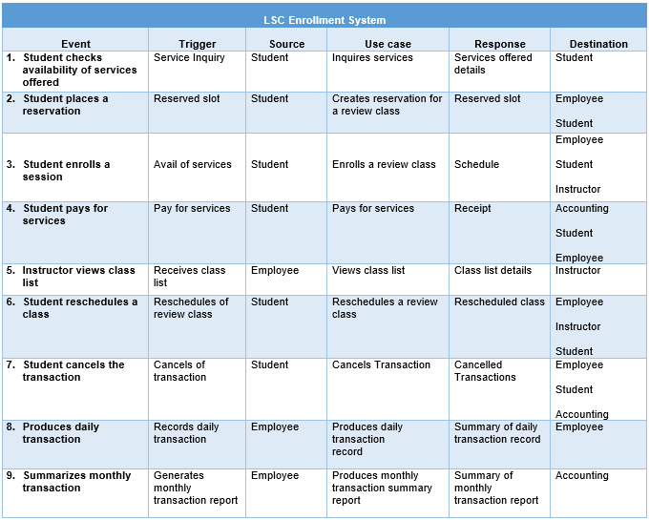

**Use Case Diagram**

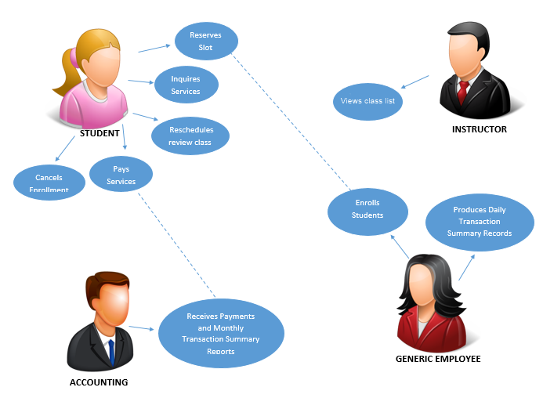

**Use Case Full Description**

|  |  |
| --- | --- |
| Use Case Name: | *Inquires Services* |
| Scenario: | Inquiry of services offered by Loyola Student Center |
| Triggering Event: | Student inquires services offered by Loyola Student Center through the institution’s website |
| Brief Description: | When student inquire the services of Loyola Student Center, he/she will know the details of services the institution offers |
| Actors: | Student |
| Related Uses Cases: | Includes: None |
| Stakeholders: | Student: Accessing website |
| Preconditions: | Student must have access to the internet.  Website of Loyola Student Center must exist. |
| Postconditions: | Information from the website must resolve all of the student’s inquiry. |
| Flow of Activities: | |  |  | | --- | --- | | **Actor** | **System** | | 1. Student accesses the website. 2. Student looks for the details about services offered by the Loyola Student Center. 3. Student decides if he/she wants to avail. 4. Student may reserve a slot if available. | 2.1 Site loads up the information of services.  4.1 Reservation can be done through email or in the institution | |
| Exception Conditions: | * 1. Student will not be able to access the website if his/her end-device is not connected to the internet.   2. Slot reservation is optional |

|  |  |
| --- | --- |
| Use Case Name: | *Creates reservation for a review class* |
| Scenario: | Reservation of slots for a review class |
| Triggering Event: | Student wants to reserve an available slot |
| Brief Description: | When student reserves an available slot for his/her desired review class offered by Loyola Student Center, he/she could secure a slot. |
| Actors: | Student  Employee |
| Related Uses Cases: | Includes: Inquire services, Pay services |
| Stakeholders: | Student: Reserving an available slot  Employee: Accommodates student |
| Preconditions: | Student must know what review class he/she wants to reserve. |
| Postconditions: | Student must have a secured slot for service desired. |
| Flow of Activities: | |  |  | | --- | --- | | **Actor** | **System** | | 1. Student reserves a slot if available. 2. Student must fill out the reservation form. 3. Student pays for reservation fee. 4. Student receives receipt. 5. Employee must record the transaction details. | 5.1 Transaction details includes the student’s information and reservation information. | |
| Exception Conditions: | * 1. If student did not pay for the reservation fee, he/she cannot secure a slot.   2. Student must pay at least 50% of the fee at most 15 working days before selected scheduled of class starts. |

|  |  |
| --- | --- |
| Use Case Name: | *Enrolls a review class* |
| Scenario: | Enrollment for a review class |
| Triggering Event: | Student wants to enroll for a review class offered by Loyola Student Center |
| Brief Description: | When student enrolls, he/she will be enrolled/registered to a review class |
| Actors: | Student  Instructor  Employee |
| Related Uses Cases: | Includes: Inquire services, Pay services |
| Stakeholders: | Student: Creating the new transaction.  Instructor: Receives class list.  Employee: Accommodates the customer. |
| Preconditions: | Student must have a subject he/she wants to enroll |
| Postconditions: | Student should be enrolled after the transaction |
| Flow of Activities: | |  |  | | --- | --- | | **Actor** | **System** | | 1. Student must fill out the registration/enrollment form. 2. Student must accept service conditions. 3. Student must pay the tuition fee. 4. Student receives schedule. 5. Employee adds the student to the class list. 6. Employee must record the transaction details. | 3.1 Student may avail discount or special rate.  6.1 Transaction details includes the student’s information and enrollment information. | |
| Exception Conditions: | * 1. Student may avail discount; he/she may pay the full amount of the discounted fee upon enrollment.      1. Early bird discounts – must pay the full amount upon enrollment.      2. Group discounts – must enroll and pay the full amount at the same time upon enrollment.      3. Special/privilege discounts – must bring original and submit photocopied ID card, and pay the full amount upon enrollment. |

|  |  |
| --- | --- |
| Use Case Name: | *Pays for services* |
| Scenario: | Payment for services |
| Triggering Event: | Student wants to pay for services |
| Brief Description: | When student pays for his/her services, he/she can secure a slot, he/she is officially enrolled, or he /she can pay for the other services availed. |
| Actors: | Student  Employee  Accounting |
| Related Uses Cases: | Includes: Inquire services, Create reservation for a review class, Enroll a review class, Reschedule a review class |
| Stakeholders: | Student: Paying for the slot reserved, tuition fee or other services availed of.  Employee: To update the transaction.  Accounting: Receives payment. |
| Preconditions: | Student must have an existing transaction. |
| Postconditions: | Student must be able to pay his/her services. |
| Flow of Activities: | |  |  | | --- | --- | | **Actor** | **System** | | 1. Student pays for the services. 2. Accounting receives the payment. 3. Student must receive receipt. 4. Employee must update the payment records. | 4.1 Payment records includes the student’s information and availed of services. | |
| Exception Conditions: |  |

|  |  |
| --- | --- |
| Use Case Name: | *Reschedules a review class* |
| Scenario: | Arrangement of make-up classes. |
| Triggering Event: | Student wants to reschedule a class for missed review class. |
| Brief Description: | When student was not able to attend the class, he/she may reschedule the missed class with a fee. |
| Actors: | Student  Employee  Instructor |
| Related Uses Cases: | Includes: Pay services |
| Stakeholders: | Student: Initiates rescheduling of missed class.  Employee: Accommodates student.  Instructor: Reviews the student. |
| Preconditions: | Student must have missed class. |
| Postconditions: | Student must be able to arrange and attend a make-up session. |
| Flow of Activities: | |  |  | | --- | --- | | **Actor** | **System** | | 1. Student arranges a make-up class. 2. Student pays the fee for rescheduling. 3. Employee updates the transaction records 4. Student is reviewed by the instructor in the arranged make-up class. | 2.1 The rate of missed session is 250php/hour.  3.1 Transaction details includes the student’s information. | |
| Exception Conditions: | 2.1 If there is a missed quiz, the student may take the quiz at the fixed rate of 200php.  4.1 If student missed a 4-hour class, he/she should a lot at least 2 hours of class. |

|  |  |
| --- | --- |
| Use Case Name: | *Views class list* |
| Scenario: | Instructor views his/her class list |
| Triggering Event: | Instructor receives his/her class list |
| Brief Description: | When a student enrolls to a particular subject, his/her name will be added to the class list |
| Actors: | Employee  Instructor |
| Related Uses Cases: | Includes: None |
| Stakeholders: | Employee: Generates class list  Instructor: Views the class list |
| Preconditions: | Employee must be able to generate a class list. |
| Postconditions: | Instructor must view his/her class list |
| Flow of Activities: | |  |  | | --- | --- | | **Actor** | **System** | | 1. Employee gives the class list to the instructor 2. Instructor views the class list. | 2.1 Class list includes: name of students, total number of students in class and schedule | |
| Exception Conditions: | 1.1 If the class list is not for the instructor, he/she will not receive it. |

|  |  |
| --- | --- |
| Use Case Name: | *Cancels transaction* |
| Scenario: | Cancellation of transaction |
| Triggering Event: | Student wants to cancel his/her existing transaction |
| Brief Description: | When student cancels his/her transaction, he/she cannot secure a slot or attend the review classes anymore. |
| Actors: | Student  Employee  Accounting |
| Related Uses Cases: | Includes: Enroll a review class or Create reservation for a review class |
| Stakeholders: | Customer: Initiates cancellation of the existing transaction.  Employee: To cancel the transaction.  Accounting: Gives the payment refund. |
| Preconditions: | Student must have existing transaction with the institution. |
| Postconditions: | Student must be able to cancel his/her transaction. |
| Flow of Activities: | |  |  | | --- | --- | | **Actor** | **System** | | 1. Student cancels the transaction. 2. Student may receive his/her refund. 3. Employee removes the student from the class list. 4. Employee updates the transaction details or records. | 4.1 Transaction details includes the student’s information and payment records | |
| Exception Conditions: | * 1. No refund will be given for cancellation of enrollment 6 working days before scheduled class starts.   2. Twenty five (25%) of amount paid will be deducted automatically for the processing fee. |

|  |  |
| --- | --- |
| Use Case Name: | *Produces daily transaction record* |
| Scenario: | Producing summary reports of transaction |
| Triggering Event: | Employee must produce daily transaction record. |
| Brief Description: | Employee must produce the records of the daily transactions. |
| Actors: | Employee |
| Related Uses Cases: | Includes: Create reservation for a review class, Enroll a review class, Reschedule a review class and Cancel transaction. |
| Stakeholders: | Employee: Records the daily transactions and keeps the summary of daily transaction record |
| Preconditions: | There must be a daily transaction. |
| Postconditions: | The summary of daily transactions is produced. |
| Flow of Activities: | |  |  | | --- | --- | | **Actor** | **System** | | 1. Employee compiles the daily transactions. 2. Employee keeps the summary of daily transactions. |  | |
| Exception Conditions: |  |

|  |  |
| --- | --- |
| Use Case Name: | *Produces monthly transaction summary report* |
| Scenario: | Produce monthly transaction summary report |
| Triggering Event: | Generate monthly transaction report |
| Brief Description: | Employee must produce summary report of monthly transaction. |
| Actors: | Employee  Accounting |
| Related Uses Cases: | Includes: Produce daily transaction record |
| Stakeholders: | Employee: Produces the summary reports of monthly transactions.  Accounting: Checks and keeps the summary reports of monthly transactions. |
| Preconditions: | There must be a compilation of daily transactions. |
| Postconditions: | The monthly summary report of compiled daily transaction is produced. |
| Flow of Activities: | |  |  | | --- | --- | | **Actor** | **System** | | 1. Employee gives the monthly summary reports to Accounting.  2. Accounting keeps the monthly summary reports. |  | |
| Exception Conditions: | 1.1 Employee must be able to produce and submit the summary reports of monthly transaction on time. |

**Context Flow Diagram**

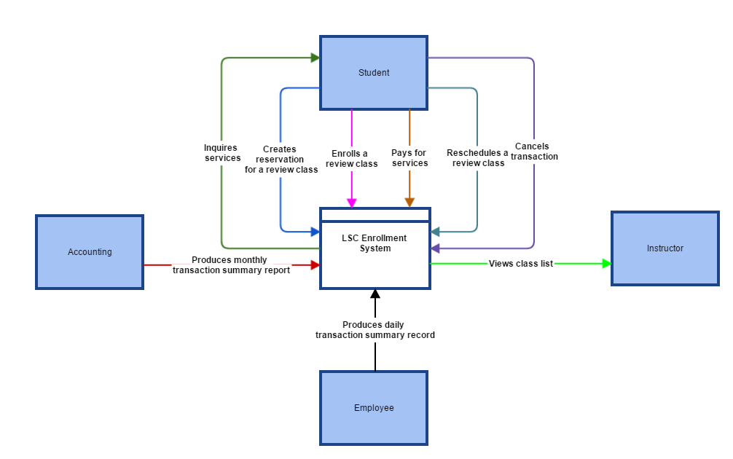

**Data Flow Diagram**

**Level 0**

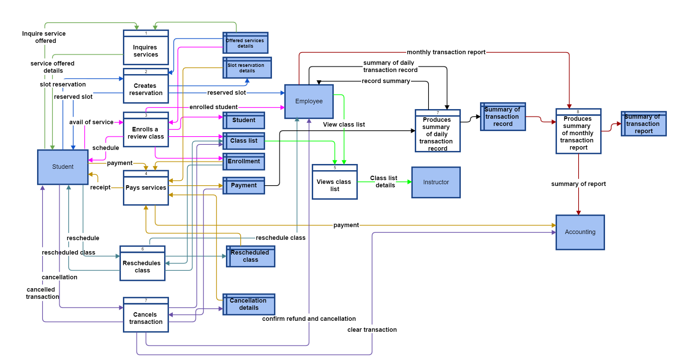

**Level 1**

**Create Reservation**

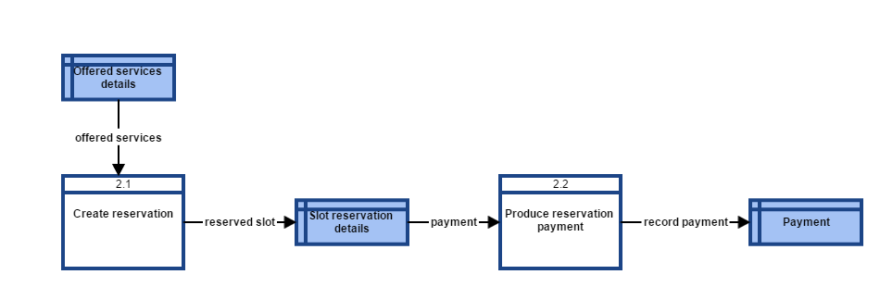

**Enroll**

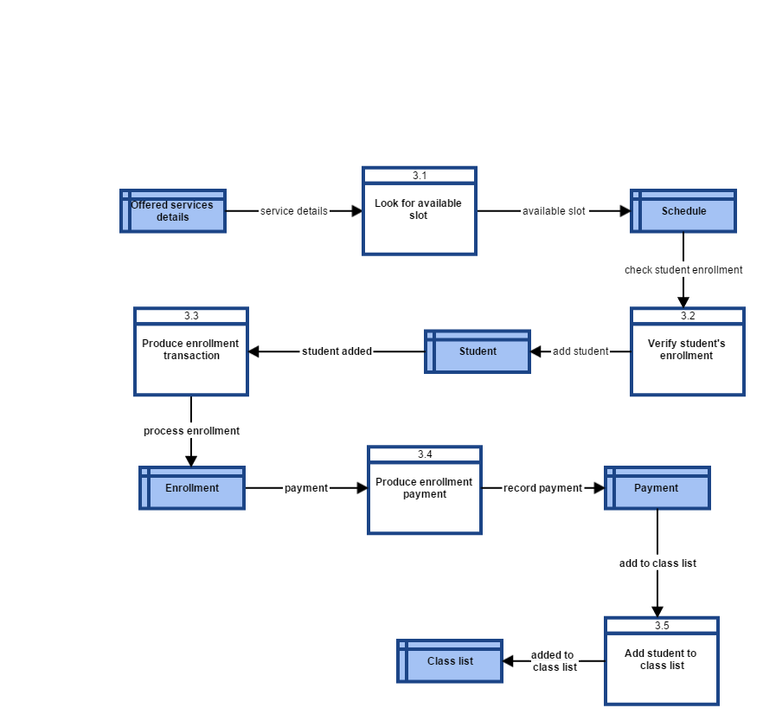

**Reschedule**

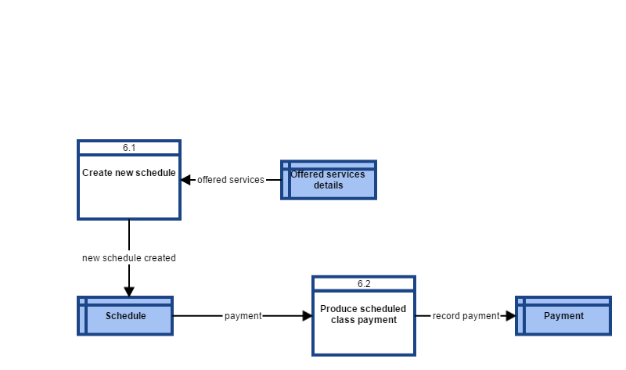

**Cancel Transaction**

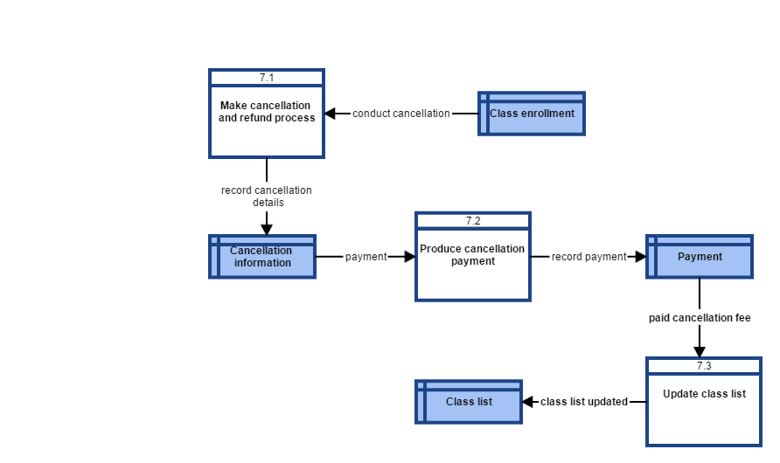

**Entity Relationship Diagram**

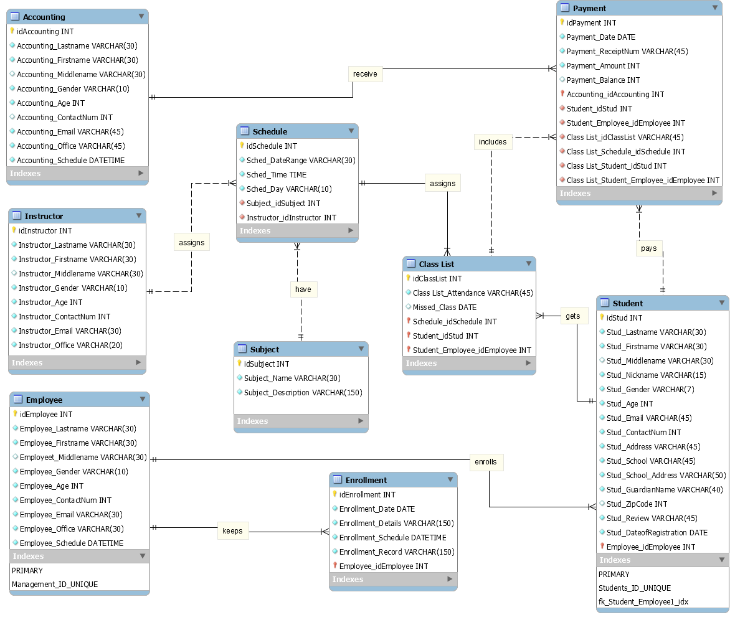

**Data Dictionary**

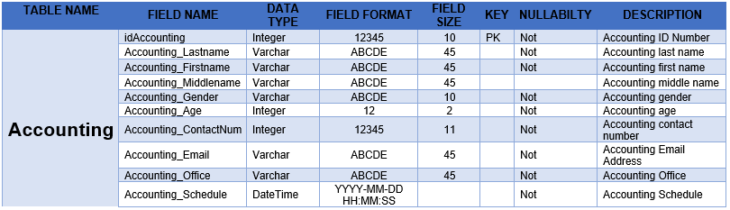

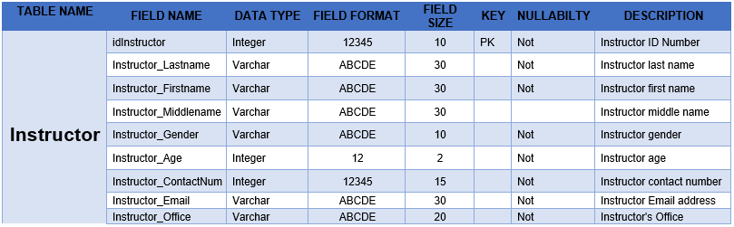

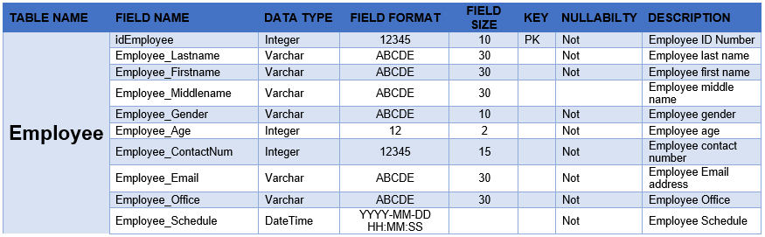

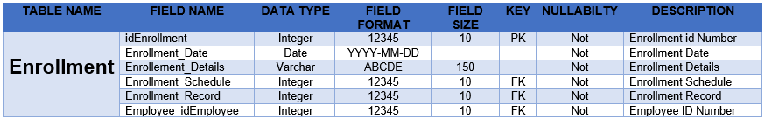

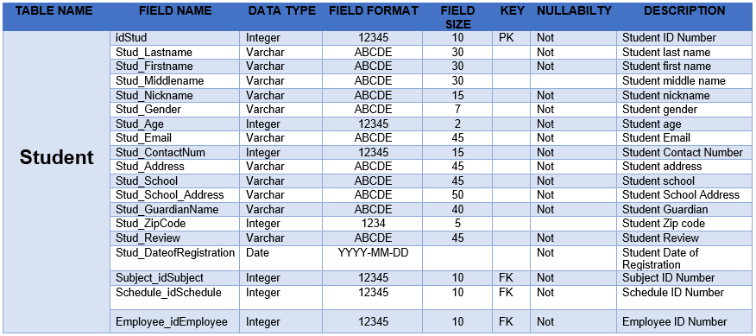

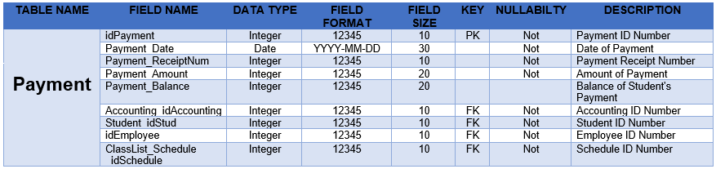

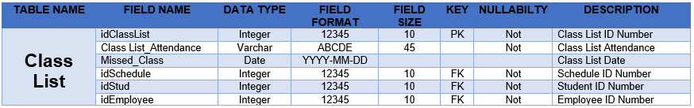

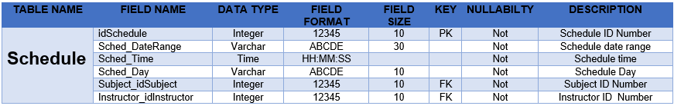

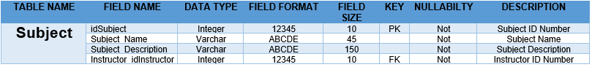

**Gantt Chart/Activity List/WBS**

Gantt Chart

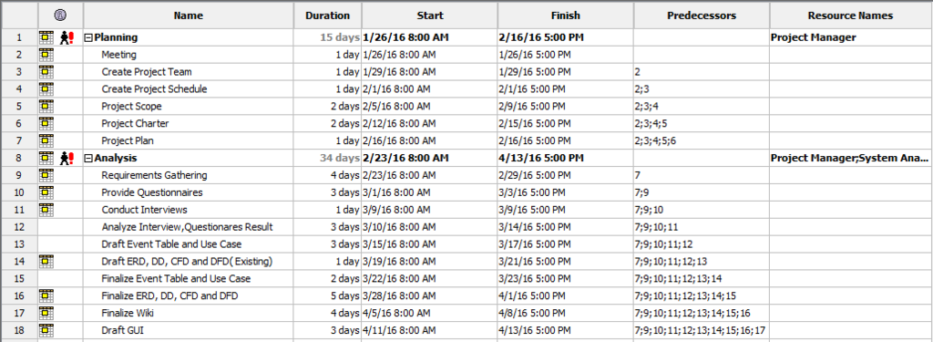

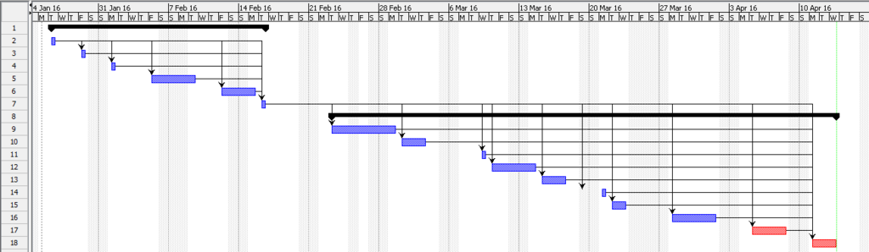

**Activity List**

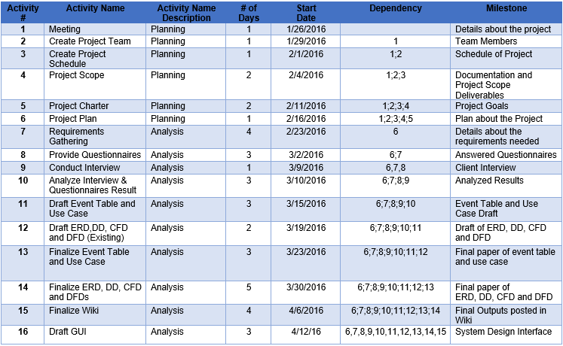

**Work Breakdown Structure**

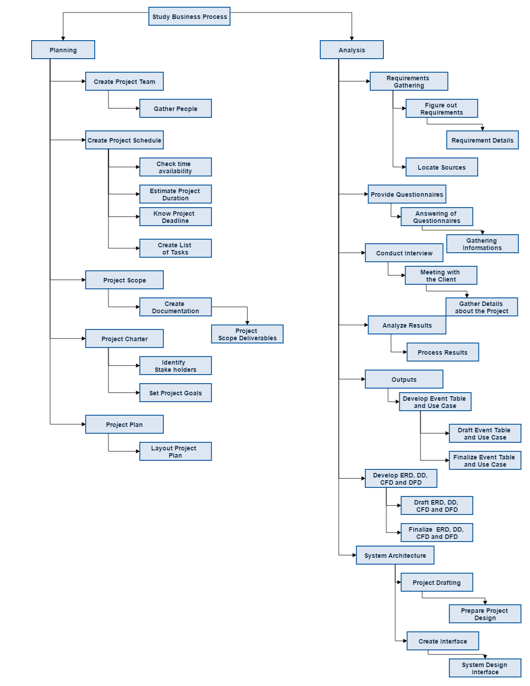

**Screenshot of Proposed System**

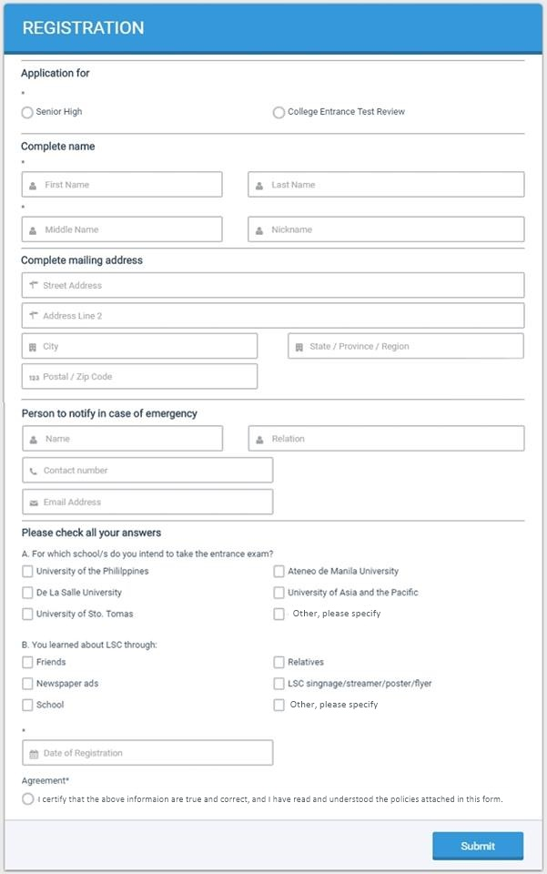

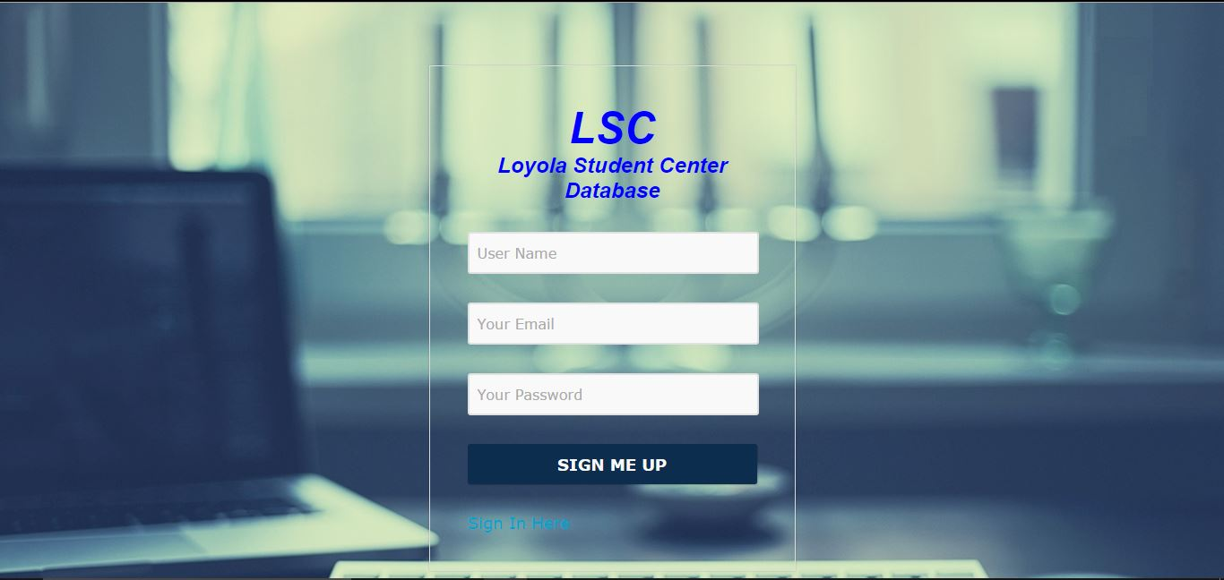

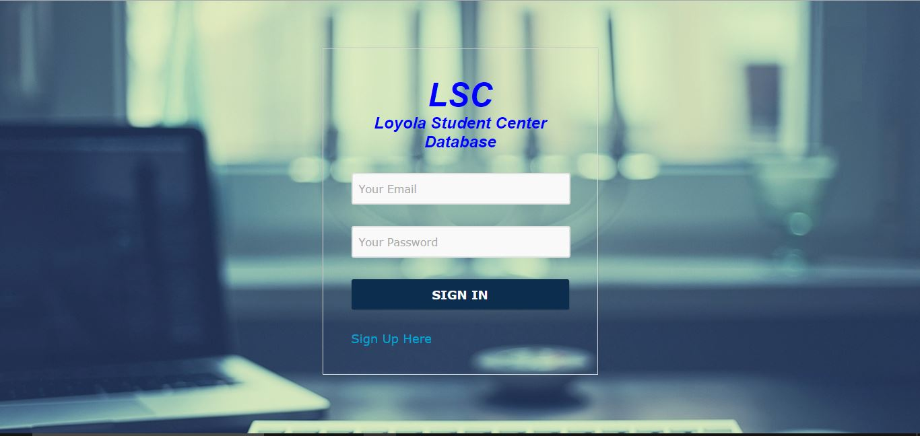

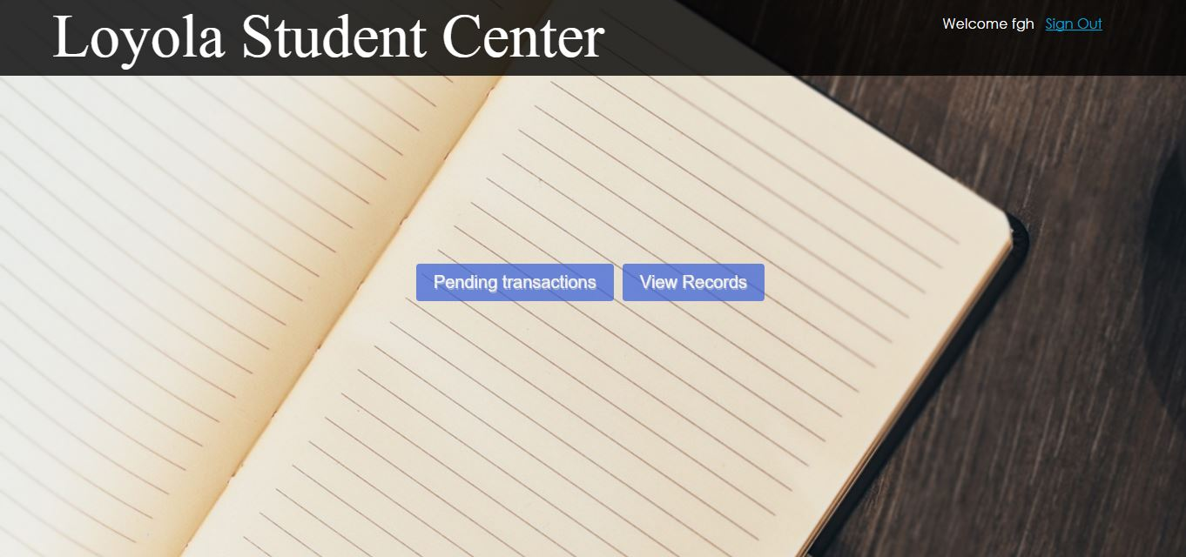

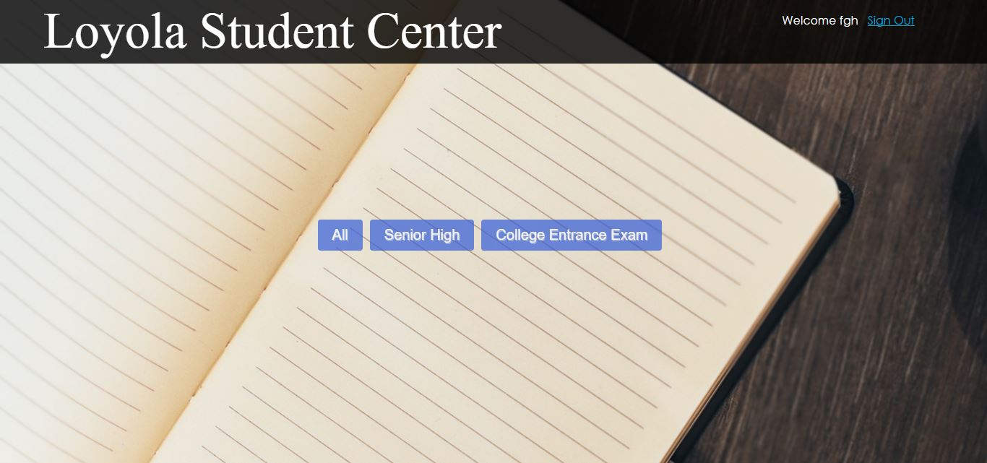

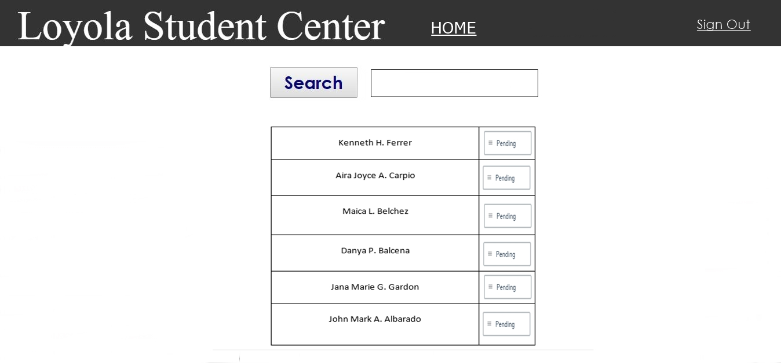

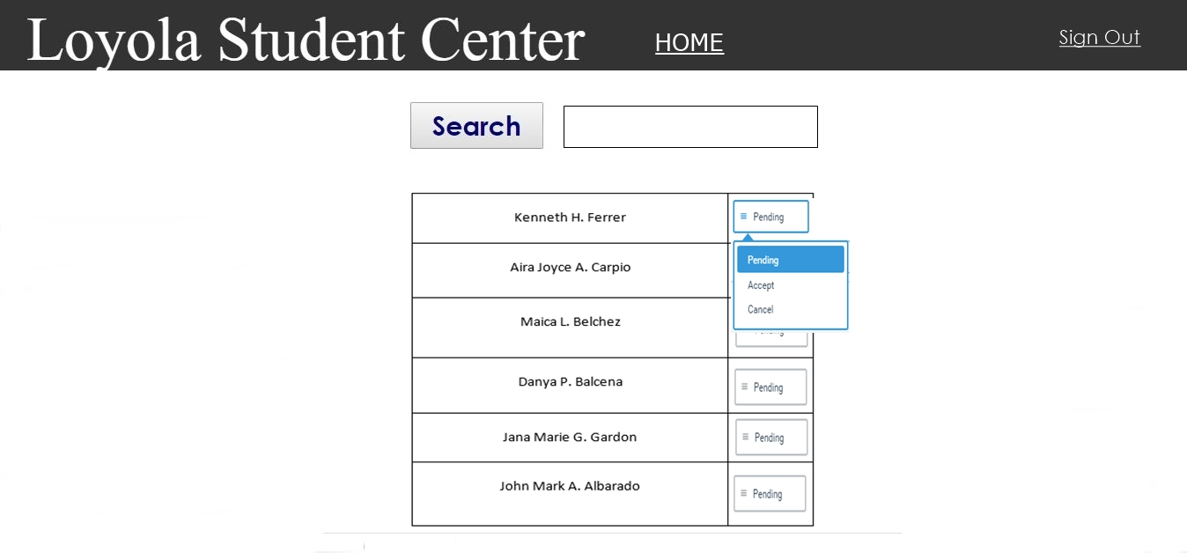

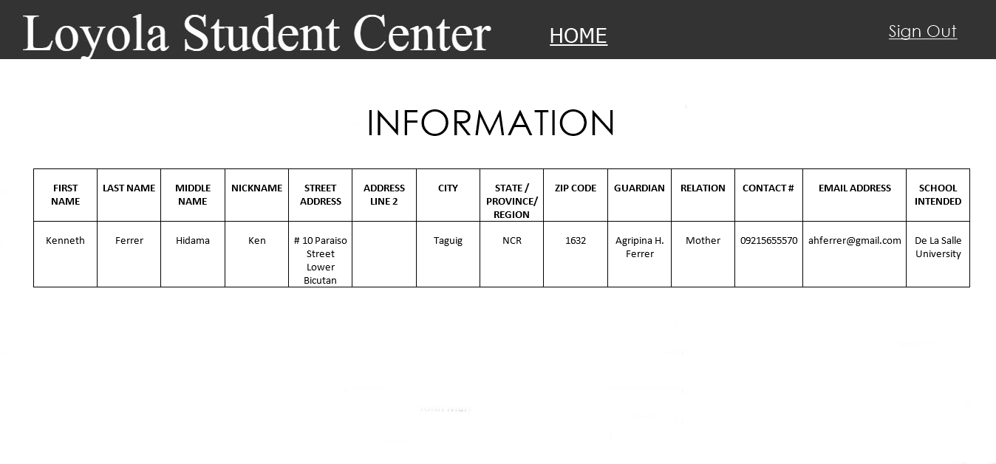

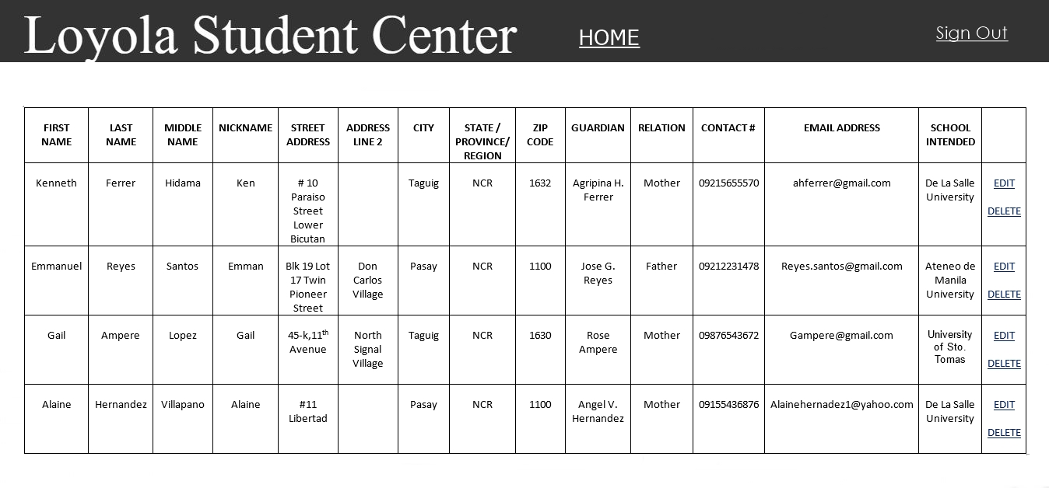

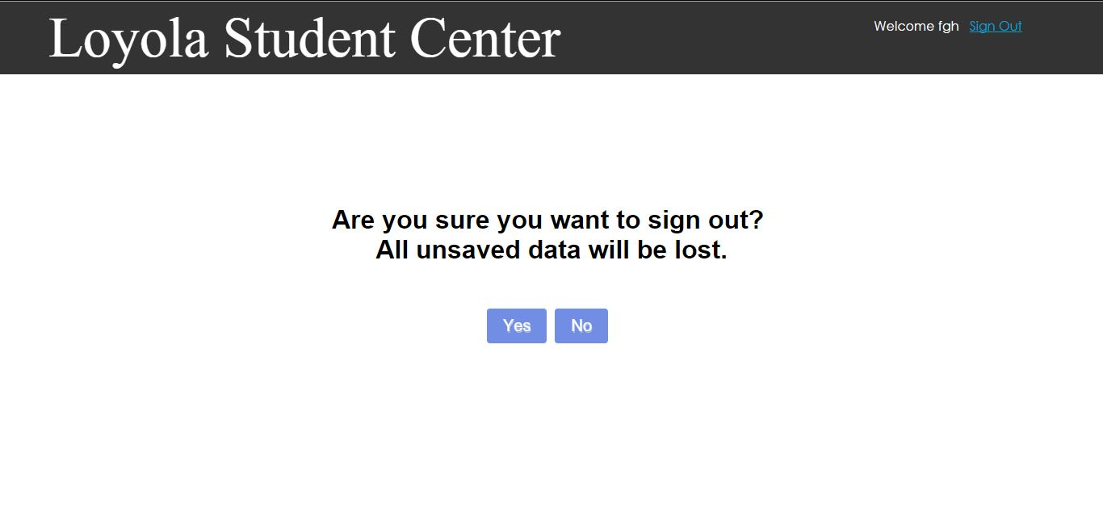



**Project Status Report**



**Project Name:** LSC Project

**Department:** Registrar and Accounting Department

**Focus Area:** Enrollment System

**Product/Process:** Enroll Review Class

**Prepared By:**



|  |  |
| --- | --- |
| **Document Owner(s)** | **Project/Organization Role** |
| Aira Joyce Carpio | Project Manager |
| Danya Balcena | Project Team Member |
| Florence Gail Haboc | Project Team Member |

**Project Status Report Version Control**

|  |  |  |  |
| --- | --- | --- | --- |
| **Version** | **Date** | **Author** | **Change Description** |
| 1.0 | 2/1/2016 | Aira Joyce Carpio | Create Project Schedule and Talk about the project |
| 1.0 | 2/2/2016 | Danya Balcena | Signed Project Adviser Request Form |
| 1.0 | 2/4/2016 | Aira Joyce Carpio  Danya Balcena  Florence Gail Haboc | Project Proposal for Client  Look for a Client |
| 1.0 | 2/9/2016 | Aira Joyce Carpio  Danya Balcena  Florence Gail Haboc | Project Planning |
| 1.0 | 2/12/2016 | Aira Joyce Carpio  Danya Balcena  Florence Gail Haboc | Gathered Information |
| 1.0 | 2/16/2016 | Danya Balcena Aira Joyce Carpio Florence Gail Haboc | Project Meeting |

**TABLE OF CONTENTS**

1 PROJECT STATUS REPORT PURPOSE 3

2 PROJECT STATUS REPORT TEMPLATE 3

2.1 Project Status Report Details 3

2.2 Project Status Report Template 3

3 PROJECT STATUS REPORT APPROVALS 3

4 APPENDICES 3

4.1 Document Guidelines 3

* 1. Project Status Report Sections Omitted 3

# PROJECT STATUS REPORT PURPOSE

The Project Status Report is a document that Project Managers may use as a means of formal regular reporting on the status of a project to key project stakeholders, including the Steering Committee, Project Sponsor, and Senior Manager. Project Status reports can also use to provide a documented history of the project. This can be applied to strengthen lessons learned and to evaluate, review and learn from how the project succeeded and where it may have had difficulties.

Objectives of effective project status reporting include.

* Improve communication of information within the project and across the organization
* To create a record of the project progress
* Improve organizational support for the project
* To determine the improvement of the project
* Simplify the process of gathering and disseminating project information



# PROJECT STATUS REPORT TEMPLATE

## Project Status Report Details

Loyola Student Center (LSC) is a tutorial and review facility located on Katipunan Avenue. The institution tutors’ student from Kindergarten to Tertiary education. They also offer review programs such as Comprehensive College Entrance Test Review, High School Entrance Test Review, Civil Service Examination Review, Law Aptitude Examination (LAE)/Law School Admission Test (LSAT) Review, and National Medical Admission Test (NMAT) Review etc. Most of the transactions done in LSC such as enrollment is recorded on papers, due to this reason our team aims to provide website and mobile solution which is an Enrollment system for the institution. When students enroll themselves using the online enrollment system, all the information given by the student will be saved to the database so that the institution can easily manage and track all the transactions. In addition, it can also help the students enroll easily using their smartphones or computers.

## Project Status Report Template

|  |  |  |
| --- | --- | --- |
| Project Name | | |
| Prepared by:  Aira Joyce Carpio | Date:  **2/16/16** | Reporting Period:  2/1/16 to 02/16/16 |
| Project Overall Status:  The team discussed about the project they want to propose for their client, create project schedule, signed the request form for their project adviser and gathered information for the proposed project. | | |
| Project Summary:  For the first week, the group planned for the project they want to propose for their client. That’s why the team gathered information in order to get more ideas in creating the project. | | |
| **Milestone Deliverables performance reporting over last period**   |  |  |  |  | | --- | --- | --- | --- | | **Milestone Deliverables** | **Due Date** | **% Completed** | **Deliverable Status** | | Milestone 1 | | | | | * Create Project Schedule and Talk about the project | 2/1/16 | 100% | On Schedule | | * Signed project adviser form | 2/2/16 | 90% | On Schedule | | * Look for a client * Project Proposal for Client | 2/4/16 | 70% | On Schedule | | Milestone 2 | | | | | * Project Planning | 2/9/16 | 90% | On Schedule | | * Gathered Information | 2/12/16 | 80% | On Schedule | | * Project Meeting | 2/16/16 | 90% | On Schedule | | | |
| **Milestone Deliverables scheduled for completion over next period**   |  |  |  |  | | --- | --- | --- | --- | | **Milestone Deliverables** | **Due Date** | **% Completed** | **Deliverable Status** | | Milestone 1 | | | | | * Propose Project to Client | 2/25/16 | 70% | On Schedule | | * Provide Questionnaires | 3/2/16 | 80% | On Schedule | | * Conduct Interview | 3/9/16 | 80% | On Schedule | | Milestone 2 | | | | | * Analyzed Interview & Questionnaires Results | 3/11/16 | 70% | On Schedule | | * Event Table | 3/15/16 | 70% | On Schedule | | * Use Case | 3/16/16 | 70% | On Schedule | | | |
| **Project impact of milestone success or failure for project remainder**   |  |  | | --- | --- | | The team does not have client yet. | The team is still waiting for the approval of their possible clients. | | | |
| **Project** **Budget/Financial Status**   |  |  |  |  | | --- | --- | --- | --- | | **Budget Item** | **Planned Budget** | **Actual Cost** | **Variance/Explanation** | | N/A | N/A | N/A | N/A | | N/A | N/A | N/A | N/A | | | |
| **Project Risk Management Status**   |  |  |  |  |  | | --- | --- | --- | --- | --- | | **Risk and Description** | **Risk Chance** | **Risk Impact** | **Risk Priority** | **Change from Last Review** | | * Changing Project | High | High | High | Possible client did not approve to be team’s client | | * Changing Legal Requirements | High | High | High | Since the team changed the project, we rushed to complete the requirements that were behind schedule | | | |
| **Project Issue Management Status**   |  |  |  |  |  | | --- | --- | --- | --- | --- | | **Issue and Description** | **Project Impact** | **Target Due Date** | **Issue Status** | **Issue Resolution** | | Interviewed the client recommended by our adviser | High | 3/9/16 | Open | Client Interview | | Immediately started the requirements | High | 3/11/16 | Open | Start doing the requirements | | | |
| **Project Recommendations**   |  | | --- | | The Group should consult to their adviser and professor more often to ensure that all documentations created by the group is precise and it include legitimate information. Also the group should talk to their client with regards to the project that they are doing, in order prevent possible issues that the group may encounter in doing the projects. | | | |
| **Objectives for Next Project Status Review**   |  | | --- | | Related project information for this project   * Gathered Information * Loyola Student Center Transaction Details * Use Case * Event Table * Site * http://projects2.apc.edu.ph/wiki/index.php/Project_-_LSC | |  | | | |
| **Related Project Information**   |  | | --- | | N/A | | | |





**Project Status Report**



**Project Name:** LSC Project

**Department:** Registrar and Accounting Department

**Focus Area:** Enrollment System

**Product/Process:** Enroll Review Class



**Prepared By:**

|  |  |
| --- | --- |
| **Document Owner(s)** | **Project/Organization Role** |
| Aira Joyce Carpio | Project Manager |
| Danya Balcena | Project Team Member |
| Florence Gail Haboc | Project Team Member |

**Project Status Report Version Control**

|  |  |  |  |
| --- | --- | --- | --- |
| **Version** | **Date** | **Author** | **Change Description** |
| 2.0 | 2/25/2016 | Aira Joyce Carpio  Danya Balcena  Florence Gail Habox | Propose Project to Client |
| 2.0 | 3/2/2016 | Aira Joyce Carpio  Danya Balcena  Florence Gail Habox | Provide Questionnaires |
| 2.0 | 3/9/2016 | Aira Joyce Carpio  Danya Balcena  Florence Gail Haboc | Client Interview |
| 2.0 | 3/11/2016 | Aira Joyce Carpio  Danya Balcena  Florence Gail Haboc | Analyzed Interview &  Questionnaires Results |
| 2.0 | 3/15/2016 | Danya Balcena | Event Table |
| 2.0 | 3/16/2016 | Danya Balcena | Use Case |

**TABLE OF CONTENTS**

1 PROJECT STATUS REPORT PURPOSE 3

2 PROJECT STATUS REPORT TEMPLATE 3

2.1 Project Status Report Details 3

2.2 Project Status Report Template 3

3 PROJECT STATUS REPORT APPROVALS 3

4 APPENDICES 3

4.1 Document Guidelines 3

4.2 Project Status Report Sections Omitted 3

# PROJECT STATUS REPORT PURPOSE

The Project Status Report is a document that Project Managers may use as a means of formal regular reporting on the status of a project to key project stakeholders, including the Steering Committee, Project Sponsor, and Senior Manager. Project Status reports can also use to provide a documented history of the project. This can be applied to strengthen lessons learned and to evaluate, review and learn from how the project succeeded and where it may have had difficulties.

Objectives of effective project status reporting include.

* Improve communication of information within the project and across the organization
* To create a record of the project progress
* Improve organizational support for the project
* To determine the improvement of the project
* Simplify the process of gathering and disseminating project information



# PROJECT STATUS REPORT TEMPLATE

## Project Status Report Details

Loyola Student Center (LSC) is a tutorial and review facility located on Katipunan Avenue. The institution tutors’ student from Kindergarten to Tertiary education. They also offer review programs such as Comprehensive College Entrance Test Review, High School Entrance Test Review, Civil Service Examination Review, Law Aptitude Examination (LAE)/Law School Admission Test (LSAT) Review, and National Medical Admission Test (NMAT) Review etc. Most of the transactions done in LSC such as enrollment is recorded on papers, due to this reason our team aims to provide website and mobile solution which is an Enrollment system for the institution. When students enroll themselves using the online enrollment system, all the information given by the student will be saved to the database so that the institution can easily manage and track all the transactions. In addition, it can also help the students enroll easily using their smartphones or computers.

## Project Status Report Template

|  |  |  |
| --- | --- | --- |
| Project Name | | |
| Prepared by:  Aira Joyce Carpio | Date:  **2/25/16** | Reporting Period:  02/25/16 to 03/16/16 |
| Project Overall Status:  The group analyzed the information they gathered in order for them to create an accurate event table and use cases where it shows the transaction details of Loyola Student Center. Draft of event table and use case were passed on time. | | |
| Project Summary:  For the second week, the group formulated the event table and use cases for the process of transaction in Loyola Student Center. | | |
| **Milestone Deliverables performance reporting over last period**   |  |  |  |  | | --- | --- | --- | --- | | **Milestone Deliverables** | **Due Date** | **% Completed** | **Deliverable Status** | | Milestone 1 | | | | | * Propose Project for client | 2/25/16 | 90% | On Schedule | | Provide Questionnaires | 3/2/16 | 85% | On Schedule | | * Client Interview | 3/9/16 | 90% | On Schedule | | Milestone 2 | | | | | * Analyzed Interview & Questionnaires Results | 3/11/16 | 80% | On Schedule | | * Event Table | 3/15/16 | 80% | On Schedule | | * Use Case | 3/16/16 | 80% | On Schedule | | | |
| **Milestone Deliverables scheduled for completion over next period**   |  |  |  |  | | --- | --- | --- | --- | | **Milestone Deliverables** | **Due Date** | **% Completed** | **Deliverable Status** | | Milestone 1 | | | | | * Event Table (Existing) | 3/18/16 | 90% | On Schedule | | * Use Case | 3/18/16 | 90% | On Schedule | | * Use Case Full Description | 3/18/16 | 90% | On Schedule | | Milestone 2 | | | | | * Entity Relationship Diagram | 3/19/16 | 70% | On Schedule | | * Data Dictionary | 3/19/16 | 70% | On Schedule | | * Context Flow Diagram | 3/19/16 | 70% | On Schedule | | | |
| **Project impact of milestone success or failure for project remainder**   |  |  | | --- | --- | | Event table and use cases are necessary to identify the existing enrollment transactions of Loyola Student Center. | The Existing transaction of Loyola Student Center was fully analyzed in the Event table and use cases. | | | |
| **Project** **Budget/Financial Status**   |  |  |  |  | | --- | --- | --- | --- | | **Budget Item** | **Planned Budget** | **Actual Cost** | **Variance/Explanation** | | N/A | N/A | N/A | N/A | | N/A | N/A | N/A | N/A | | | |
| **Project Risk Management Status**   |  |  |  |  |  | | --- | --- | --- | --- | --- | | **Risk and Description** | **Risk Chance** | **Risk Impact** | **Risk Priority** | **Change from Last Review** | | Organizational and Cultural Feasibility   * Event Table * Use Case | Medium | Medium | Medium | Every institution have their own business transaction, therefore system must be flexible and based on the transaction details of the institution | | Schedule feasibility   * Project Schedule | Low | Low | Medium | Since the team changed the project, we rushed to complete the requirements that were behind schedule | | | |
| **Project Issue Management Status**   |  |  |  |  |  | | --- | --- | --- | --- | --- | | **Issue and Description** | **Project Impact** | **Target Due Date** | **Issue Status** | **Issue Resolution** | | Asks the client regarding to the transaction details of their institution | High | 3/9/16 | Open | Client Interview | | | |
| **Project Recommendations**   |  | | --- | | The Group should consult to their adviser and professor more often to ensure that all documentations created by the group is precise and it include legitimate information. Also the group should talk to their client with regards to the project that they are doing, in order to prevent possible issues that the group may encounter in doing the projects. Also, the group should know the transaction details of their client in order for them to create an accurate documentations that the group will be submit to their advisers, professor, panel and to their client. | | | |
| **Objectives for Next Project Status Review**   |  | | --- | | Related project information for this project   * Event Table * Use Case * Use Case Diagram * Loyola Student Center Transaction Details * Loyola Student Center Service Offered * Site   http://projects2.apc.edu.ph/wiki/index.php/Project_-_LSC | | | |
| **Related Project Information**   |  | | --- | | N/A | | | |





**Project Status Report**



**Project Name:** LSC Project

**Department:** Registrar and Accounting Department

**Focus Area:** Enrollment System

**Product/Process:** Enroll Review Class



**Prepared By:**

|  |  |
| --- | --- |
| **Document Owner(s)** | **Project/Organization Role** |
| Aira Joyce Carpio | Project Manager |
| Danya Balcena | Project Team Member |
| Florence Gail Haboc | Project Team Member |

**Project Status Report Version Control**

|  |  |  |  |
| --- | --- | --- | --- |
| **Version** | **Date** | **Author** | **Change Description** |
| 3.0 | 3/18/2016 | Danya Balcena | Event Table (Existing) |
| 3.0 | 3/18/2016 | Danya Balcena | Use Case |
| 3.0 | 3/18/2016 | Danya Balcena | Use Case Full Description |
| 3.0 | 3/19/2016 | Aira Joyce Carpio | Entity Relationship Diagram (Existing) |
| 3.0 | 3/20/2016 | Aira Joyce Carpio | Data Dictionary |
| 3.0 | 3/20/2016 | Florence Gail Haboc | Context Flow Diagram |

**TABLE OF CONTENTS**

1 PROJECT STATUS REPORT PURPOSE 3

2 PROJECT STATUS REPORT TEMPLATE 3

2.1 Project Status Report Details 3

2.2 Project Status Report Template 3

3 PROJECT STATUS REPORT APPROVALS 3

4 APPENDICES 3

4.1 Document Guidelines 3

4.2 Project Status Report Sections Omitted 3

# PROJECT STATUS REPORT PURPOSE

The Project Status Report is a document that Project Managers may use as a means of formal regular reporting on the status of a project to key project stakeholders, including the Steering Committee, Project Sponsor, and Senior Manager. Project Status reports can also use to provide a documented history of the project. This can be applied to strengthen lessons learned and to evaluate, review and learn from how the project succeeded and where it may have had difficulties.

Objectives of effective project status reporting include.

* Improve communication of information within the project and across the organization
* To create a record of the project progress
* Improve organizational support for the project
* To determine the improvement of the project
* Simplify the process of gathering and disseminating project information



# PROJECT STATUS REPORT TEMPLATE

## Project Status Report Details

Loyola Student Center (LSC) is a tutorial and review facility located on Katipunan Avenue. The institution tutors’ student from Kindergarten to Tertiary education. They also offer review programs such as Comprehensive College Entrance Test Review, High School Entrance Test Review, Civil Service Examination Review, Law Aptitude Examination (LAE)/Law School Admission Test (LSAT) Review, and National Medical Admission Test (NMAT) Review etc. Most of the transactions done in LSC such as enrollment is recorded on papers, due to this reason our team aims to provide website and mobile solution which is an Enrollment system for the institution. When students enroll themselves using the online enrollment system, all the information given by the student will be saved to the database so that the institution can easily manage and track all the transactions. In addition, it can also help the students enroll easily using their smartphones or computers.

## Project Status Report Template

|  |  |  |
| --- | --- | --- |
| Project Name | | |
| Prepared by:  Aira Joyce Carpio | Date:  **3/18/16** | Reporting Period:  3/18//16 to 03/22/16 |
| Project Overall Status:  The group gathered the information about the institution’s transaction details, terms and condition, and forms that they are using in terms of their services. Also, Event Table, Use Case Full description, Entity Relationship Diagram, Data Dictionary and Context Flow Diagram were passed on time. | | |
| Project Summary:  For the third week, the group finalized their Event Table, Use Case full description and they produce  Entity Relationship Diagram, Data Dictionary and Context Flow Diagram to identify the data needed In every transaction. | | |
| **Milestone Deliverables performance reporting over last period**   |  |  |  |  | | --- | --- | --- | --- | | **Milestone Deliverables** | **Due Date** | **% Completed** | **Deliverable Status** | | Milestone 1 | | | | | * Event Table (Existing) | 3/18/16 | 95% | On Schedule | | Use Case | 3/18/16 | 95% | On Schedule | | * Use Case Full Description | 3/18/16 | 90% | On Schedule | | Milestone 2 | | | | | * Entity Relationship Diagram | 3/19/16 | 80% | On Schedule | | * Data Dictionary | 3/20/16 | 80% | On Schedule | | * Context Flow Diagram | 3/20/16 | 80% | On Schedule | | | |
| **Milestone Deliverables scheduled for completion over next period**   |  |  |  |  | | --- | --- | --- | --- | | **Milestone Deliverables** | **Due Date** | **% Completed** | **Deliverable Status** | | Milestone 1 | | | | | * Data Flow Diagram | 3/21/16 | 75% | On Schedule | | * Finalize Event Table | 3/23/16 | 85% | On Schedule | | * Finalize Use Case | 3/23/16 | 85% | On Schedule | | Milestone 2 | | | | | * Finalize Entity Relationship Diagram | 3/19/16 | 70% | On Schedule | | * Finalize Data Dictionary | 3/19/16 | 70% | On Schedule | | * Finalize Context Flow Diagram | 3/19/16 | 70% | On Schedule | | | |
| **Project impact of milestone success or failure for project remainder**   |  |  | | --- | --- | | Finalizing the Event table and use cases full description were identified, because the institution presented their transaction details, terms and conditions. | The Existing transaction of Loyola Student center were fully explained in the Event Table and Use cases full description. Also, the group created the Entity Relationship Diagram, Data Dictionary and Context Flow Diagram. | | | |
| **Project** **Budget/Financial Status**   |  |  |  |  | | --- | --- | --- | --- | | **Budget Item** | **Planned Budget** | **Actual Cost** | **Variance/Explanation** | | N/A | N/A | N/A | N/A | | N/A | N/A | N/A | N/A | | | |
| **Project Risk Management Status**   |  |  |  |  |  | | --- | --- | --- | --- | --- | | **Risk and Description** | **Risk Chance** | **Risk Impact** | **Risk Priority** | **Change from Last Review** | | Organizational and Cultural Feasibility   * Event Table * Use Case Full Description * Entity Relationship Diagram * Data Dictionary * Context Flow Diagram | Medium | Medium | Medium | Every institution has their own business transaction, therefore system must be flexible and it must be based on the transaction details of the institution. The Group need the forms, terms and condition of the institution. | | Schedule feasibility   * Project Schedule | Low | Low | Medium | Project Schedule may not be realistic | | | |
| **Project Issue Management Status**   |  |  |  |  |  | | --- | --- | --- | --- | --- | | **Issue and Description** | **Project Impact** | **Target Due Date** | **Issue Status** | **Issue Resolution** | | The Information identified on the final documents was based on the information given by the institution | High | 3/18/16 | Open | Talk about the project with the client | | | |
| **Project Recommendations**   |  | | --- | | The Group should consult to their adviser and professor more often to ensure that all documentations created by the group is precise and it include legitimate information. Also the group should talk to their client with regards to the project that they are doing, in order to prevent possible issues that the group may encounter in doing the projects. Also, the group should know the transaction details of their client in order for them to create an accurate documentations that the group will be submit to their advisers, professor, panel and to their client. | | | |
| **Objectives for Next Project Status Review**   |  |  | | --- | --- | | Related project information for this project   * Event Table * Use Case Full Description * Use Case Diagram * Entity Relationship Diagram * Data Dictionary * Context Flow Diagram * Loyola Student Center Transaction Details * Loyola Student Center Service Offered * Loyola Student Center Registration Forms * Loyola Student Center Terms and Conditions * Site   http://projects2.apc.edu.ph/wiki/index.php/Project_-_LSC |  | | | |
| **Related Project Information**   |  | | --- | | N/A | | | |



**Project Status Report**



**Project Name:** LSC Project

**Department:** Registrar and Accounting Department

**Focus Area:** Enrollment System

**Product/Process:** Enroll Review Class



**Prepared By:**

|  |  |
| --- | --- |
| **Document Owner(s)** | **Project/Organization Role** |
| Aira Joyce Carpio | Project Manager |
| Danya Balcena | Project Team Member |
| Florence Gail Haboc | Project Team Member |

**Project Status Report Version Control**

|  |  |  |  |
| --- | --- | --- | --- |
| **Version** | **Date** | **Author** | **Change Description** |
| 4.0 | 3/30/2016 | Aira Joyce Carpio | Finalize Entity Relationship Diagram |
| 4.0 | 3/30/2016 | Aira Joyce Carpio | Finalize Data Dictionary |
| 4.0 | 3/31/2016 | Florence Gail Haboc | Finalize Context Flow Diagram |
| 4.0 | 4/1/2016 | Florence Gail Haboc | Finalize Data Flow Diagram |
| 4.0 | 4/6/2016 | Aira Joyce Carpio  Danya Balcena  Florence Gail Haboc | Finalize Wiki |
| 4.0 | 4/12/2016 | Aira Joyce Carpio  Danya Balcena  Florence Gail Haboc | Draft GUI |

**TABLE OF CONTENTS**

1 PROJECT STATUS REPORT PURPOSE 3

2 PROJECT STATUS REPORT TEMPLATE 3

2.1 Project Status Report Details 3

2.2 Project Status Report Template 3

3 PROJECT STATUS REPORT APPROVALS 3

4 APPENDICES 3

4.1 Document Guidelines 3

4.2 Project Status Report Sections Omitted 3

# PROJECT STATUS REPORT PURPOSE

The Project Status Report is a document that Project Managers may use as a means of formal regular reporting on the status of a project to key project stakeholders, including the Steering Committee, Project Sponsor, and Senior Manager. Project Status reports can also use to provide a documented history of the project. This can be applied to strengthen lessons learned and to evaluate, review and learn from how the project succeeded and where it may have had difficulties.

Objectives of effective project status reporting include.

* Improve communication of information within the project and across the organization
* To create a record of the project progress
* Improve organizational support for the project
* To determine the improvement of the project
* Simplify the process of gathering and disseminating project information



# PROJECT STATUS REPORT TEMPLATE

## Project Status Report Details

Loyola Student Center (LSC) is a tutorial and review facility located on Katipunan Avenue. The institution tutors’ student from Kindergarten to Tertiary education. They also offer review programs such as Comprehensive College Entrance Test Review, High School Entrance Test Review, Civil Service Examination Review, Law Aptitude Examination (LAE)/Law School Admission Test (LSAT) Review, and National Medical Admission Test (NMAT) Review etc. Most of the transactions done in LSC such as enrollment is recorded on papers, due to this reason our team aims to provide website and mobile solution which is an Enrollment system for the institution. When students enroll themselves using the online enrollment system, all the information given by the student will be saved to the database so that the institution can easily manage and track all the transactions. In addition, it can also help the students enroll easily using their smartphones or computers.

## Project Status Report Template

|  |  |  |
| --- | --- | --- |
| Project Name | | |
| Prepared by:  Aira Joyce Carpio | Date:  **3/30/16** | Reporting Period:  3/30/16 to 4/12/16 |
| Project Overall Status:  The group finalized the ERD, Data Dictionary, Context Flow Diagram, Data Flow Diagram and Wiki page for their final documentation. | | |
| Project Summary:  For the fourth week, the group updates the ERD, Data Dictionary, Context Flow Diagram and Data Flow Diagram for their final documentation. Also, the group started doing the prototype of the LSC enrollment form. | | |
| **Milestone Deliverables performance reporting over last period**   |  |  |  |  | | --- | --- | --- | --- | | **Milestone Deliverables** | **Due Date** | **% Completed** | **Deliverable Status** | | Milestone 1 | | | | | * Finalize Entity Relationship Diagram | 3/30/2016 | 90% | On Schedule | | Finalize Data Dictionary | 3/30/2016 | 90% | On Schedule | | * Finalize Context Flow Diagram | 3/31/2016 | 90% | On Schedule | | Milestone 2 | | | | | * Finalize Data Flow Diagram | 4/1/2016 | 90% | On Schedule | | * Finalize Wiki | 4/6/2016 | 85% | On Schedule | | * Draft GUI | 4/12/2016 | 85% | On Schedule | | | |
| **Milestone Deliverables scheduled for completion over next period**   |  |  |  |  | | --- | --- | --- | --- | | **Milestone Deliverables** | **Due Date** | **% Completed** | **Deliverable Status** | | Milestone 1 | | | | | * Finalize Entity Relationship Diagram | 3/31/2016 | 95% | On Schedule | | * Finalize Data Dictionary | 3/31/2016 | 95% | On Schedule | | * Finalize Context Flow Diagram | 4/1/2016 | 95% | On Schedule | | Milestone 2 | | | | | * Finalize Data Flow Diagram | 4/4/2016 | 95% | On Schedule | | * Finalize Wiki | 4/8/2016 | 100% | On Schedule | | * Draft GUI | 4/14/2016 | 95% | On Schedule | | | |
| **Project impact of milestone success or failure for project remainder**   |  |  | | --- | --- | | The Team finalized the ERD, Data Dictionary, Context Flow Diagram, Data Flow Diagram and Wiki page. Also, the team started doing the prototype of the Loyola Student Center Enrollment System. | The service transaction process and required data in enrolling in Loyola student center was showed in Entity Relationship Diagram, Data Dictionary, Context Flow Diagram and Data Flow Diagram. | | | |
| **Project** **Budget/Financial Status**   |  |  |  |  | | --- | --- | --- | --- | | **Budget Item** | **Planned Budget** | **Actual Cost** | **Variance/Explanation** | | N/A | N/A | N/A | N/A | | N/A | N/A | N/A | N/A | | | |
| **Project Risk Management Status**   |  |  |  |  |  | | --- | --- | --- | --- | --- | | **Risk and Description** | **Risk Chance** | **Risk Impact** | **Risk Priority** | **Change from Last Review** | | Resource Feasibility   * Team member availability * Support staff time and availability * Team member skills level on doing diagrams and System Interface Design | Medium | Medium | Medium | Team member doing the final requirements for their project. Which include the following:   * Event Table * Use Case Full Description * Entity Relationship Diagram * Data Dictionary * Context Flow Diagram * Data Flow Diagram * Prototype | | Schedule Feasibility   * Project Schedule | Medium | Medium | Medium | Project Schedule may not be realistic | | | |
| **Project Issue Management Status**   |  |  |  |  |  | | --- | --- | --- | --- | --- | | **Issue and Description** | **Project Impact** | **Target Due Date** | **Issue Status** | **Issue Resolution** | | The Information identified on the final documents was based on the information given by the institution | High | 3/18/16 | Open | Talk about the project with the client | | | |
| **Project Recommendations**   |  | | --- | | The Group should consult to their adviser and professor more often to ensure that all documentations created by the group is precise and it include legitimate information. Also the group should talk to their client with regards to the project that they are doing, in order to prevent possible issues that the group may encounter in doing the projects. Also, the group should know the transaction details of their client in order for them to create an accurate documentation that the group will be submit to their advisers, professor, panel and to their client. Information stated on the final document must be realistic and based on the information given by the institution. | | | |
| **Objectives for Next Project Status Review**   |  | | --- | | Related project information for this project   * Event Table * Use Case Full Description * Use Case Diagram * Entity Relationship Diagram * Data Dictionary * Context Flow Diagram * Data Flow Diagram * Prototype/ Draft GUI * Loyola Student Center Transaction Details * Loyola Student Center Service Offered * Loyola Student Center Registration Forms * Loyola Student Center Terms and Conditions * Site   http://projects2.apc.edu.ph/wiki/index.php/Project_-_LSC | | | |
| **Related Project Information**   |  | | --- | | N/A | | | |

