Project Design

**Screen 1:** Welcome Screen

This is the first screen that will be displayed. Pressing the Login button will display the Log-in Screen (Screen 2)

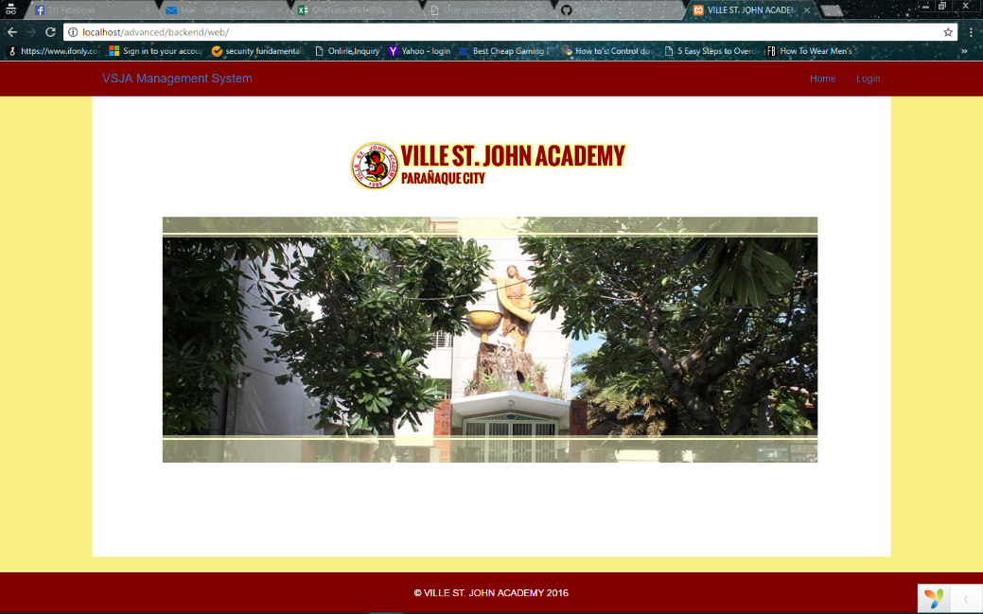

**Screen 2:** Log-in Screen

This is the screen wherein the student input their UserID and Password.

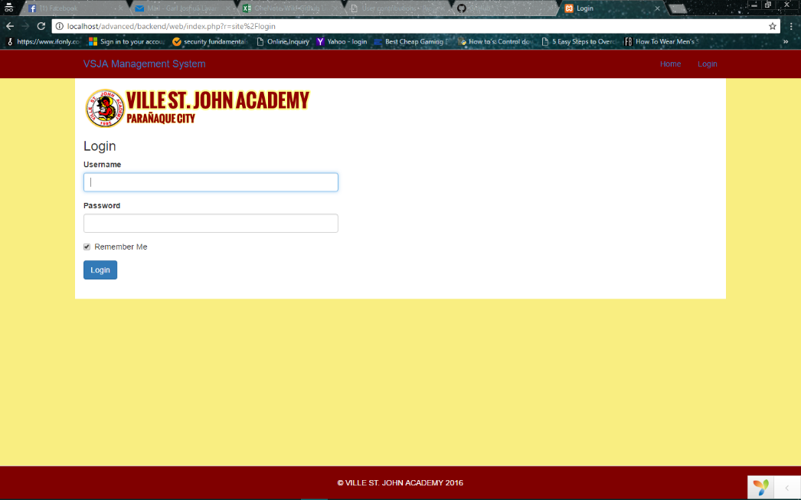

**Screen 3:** Main Menu Screen

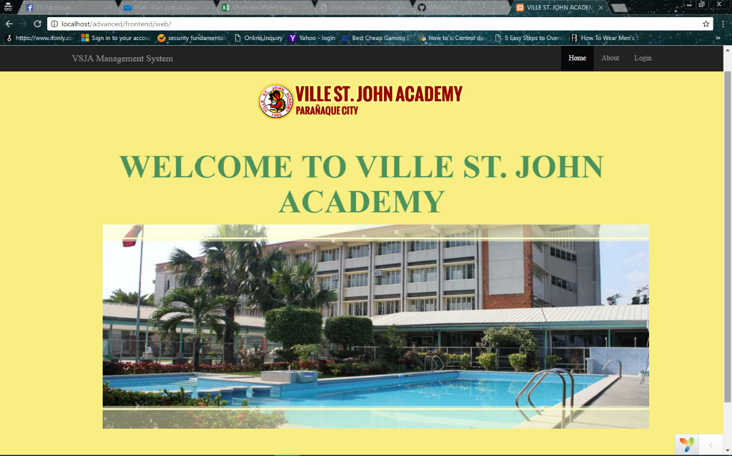The Main Menu screen displays the options that the user can choose from (Main menu screen)

Welcome (Student Name)

**Screen 4 : Login Screen**

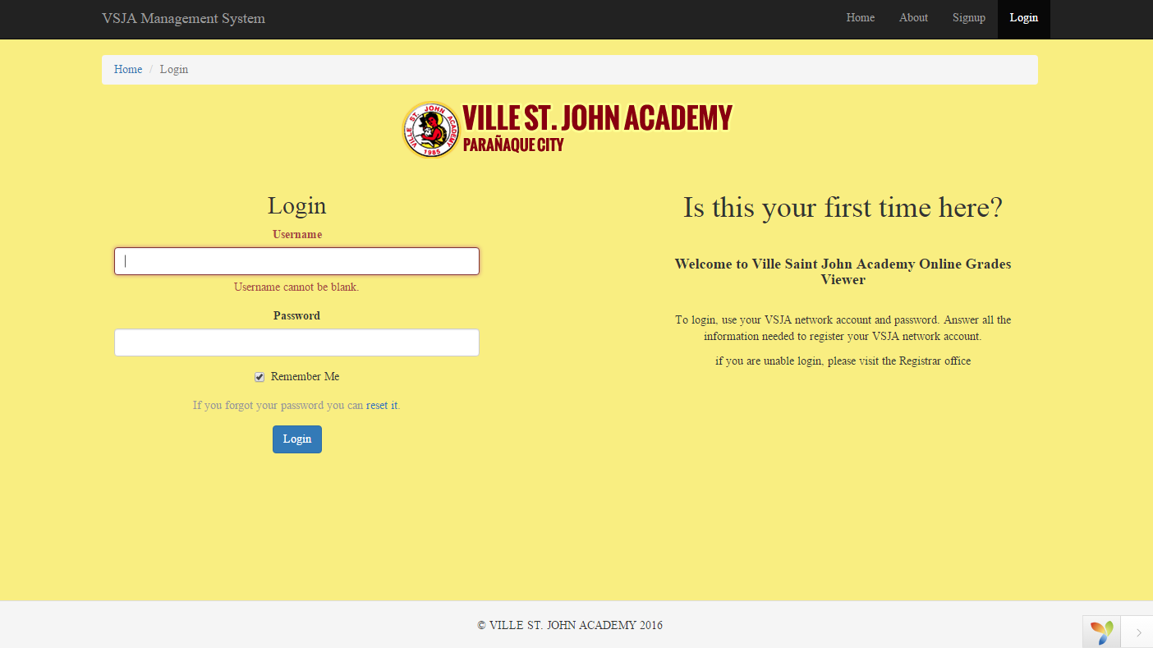

**Screen 5: Sign-in**

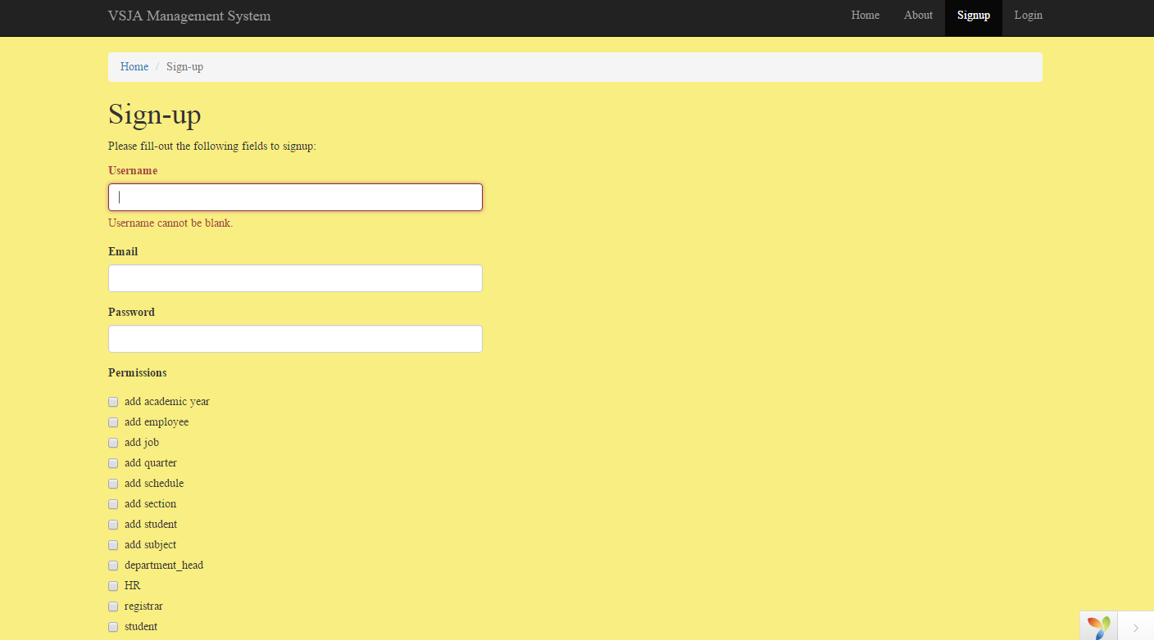

**Screen 6:** Student Info

This is where the student can view their Personal Info

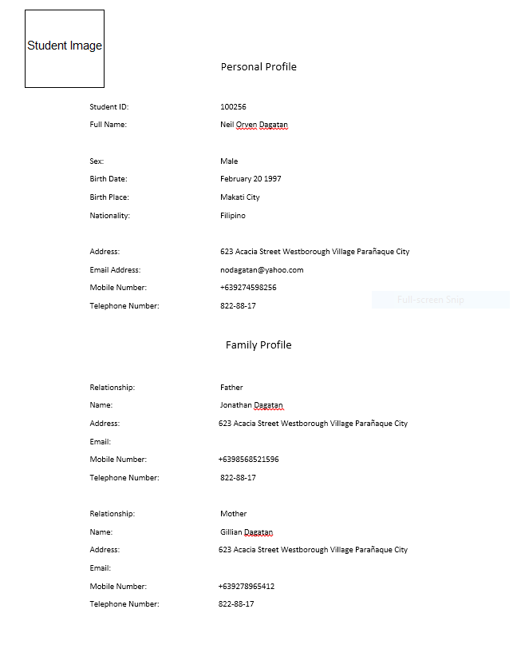

**Screen 7: About**

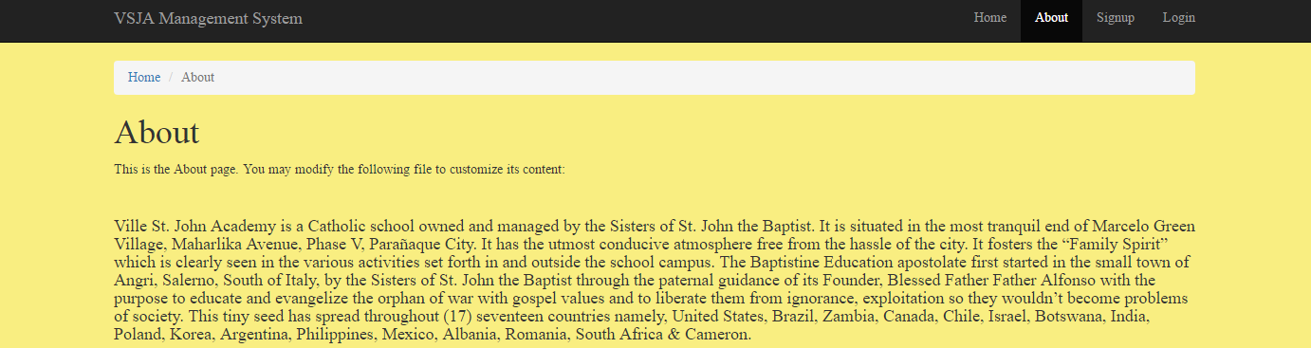

**Screen 8: Login in backend**

