

**Project Status Report**



**Project Name:** Data Corruption Recovery

**Department:** SoCit

**Focus Area:** Security

**Product/Process:**



**Prepared By:**

|  |  |
| --- | --- |
| **Document Owner(s)** | **Project/Organization Role** |
| Kent Michael Miculob | Project Manager/Project Analyst |
| Maria Letty Laureta | Project Researcher/ Designer |
| Reginald John Steven Alberca | Project Researcher |

**Project Status Report Version Control**

|  |  |  |  |
| --- | --- | --- | --- |
| **Version** | **Date** | **Author** | **Change Description** |
| 1.0 | 04/13/16 | Project Team | Document created |
| 1.1 | 6/23/16 | Kent Michael Miculob | * Updates the overall document |
| 1.2 | 7/2/16 | Kent Michael Miculob | * Updates Milestone 1 and 2 * Updates Budget Report |
| 1.3 | 7/9/16 | Maria Letty Laureta | * Change the Milestone 1 and 2 |
| 1.4 | 7/16/16 | Maria Letty Laureta | * Updates the Milestone 1 and 2 |
| 1.5 | 7/25/16 | Kent Michael Miculob | * Updates the Milestone 1 and 2 |

**TABLE OF CONTENTS**

[1 PROJECT STATUS REPORT PURPOSE 3](#_Toc77392557)

[2 PROJECT STATUS REPORT TEMPLATE 3](#_Toc77392558)

[2.1 Project Status Report Details 3](#_Toc77392559)

[2.2 Project Status Report Template 3](#_Toc77392560)

[3 PROJECT STATUS REPORT APPROVALS Error! Bookmark not defined.](#_Toc77392561)

[4 APPENDICES 8](#_Toc77392562)

[4.1 Document Guidelines 8](#_Toc77392563)

[4.2 Project Status Report Sections Omitted 8](#_Toc77392564)

# PROJECT STATUS REPORT PURPOSE

[Replace this text with a summary of the report′s purpose in reference to your specific project needs, or use the sample text below.]

The Project Status Report is a document that Project Managers may use as a means of formal regular reporting on the status of a project to key project stakeholders, including the Steering Committee, Project Sponsor, and Senior Manager.



# PROJECT STATUS REPORT TEMPLATE

## Project Status Report Details

The team is now focused on the details for the expected output of the researched paper, they are now currently looking for more information that could aid them understanding the problem far better than the past created paper.

* [Status of the Project]
  + The project is focused on data corruption prevention detection and response tool.
  + So far the team had created a diagram that could help them visualizing the process of the expected product or output.
  + So far the deliverable had been issued on schedule.
* Risk management report: So far the identified risks are being studied by the team to prevent or lessen the impact.
* Issue Report – The team’s issues are handled properly.

## Project Status Report Template

|  |  |  |
| --- | --- | --- |
| Data Corruption Recovery | | |
| Prepared By:  Kent Michael Miculob | Date:  July 25, 2016 | Reporting Period:  July 16 2016 to July 25, 2016 |
| Project Overall Status:  The project undergone major revisions with on the diagrams. | | |
| Project Summary:  [Replace this text with a brief statement of project performance not covered in the remainder of the report.] | | |
| **Milestone Deliverables performance reporting over last period**   |  |  |  |  |  | | --- | --- | --- | --- | --- | | **Milestone Deliverables** | **Due Date** | **% Completed** | | **Deliverable Status** | | Milestone 1 | | | | | | * Revise All diagrams | July 23, 2016 | | 100% | On Schedule | | * Paper Revisions | July 23, 2016 | | 100% | Ahead of Schedule | | * Adviser Consultation | July 20,2016 | | 100% | On Schedule | |  | | | | | |  |  |  | |  | |  |  |  | |  | | | |
| **Milestone Deliverables scheduled for completion over next period**   |  |  |  |  | | --- | --- | --- | --- | | **Milestone Deliverables** | **Due Date** | **% Completed** | **Deliverable Status** | | Milestone 1 | | | | | Authentication Module | 8/02/16 |  |  | |  |  |  |  | | Milestone 2 | | | | |  |  |  |  | |  |  |  |  | | | |
| **Project impact of milestone success or failure for project remainder**   |  |  | | --- | --- | | Since there were some milestones that weren’t finished last week, the workload was added to this week’s milestone and might affect the succeeding milestone, but we will do our best to cope up with this. |  | | | |
| **Project** **Budget/Financial Status**   |  |  |  |  | | --- | --- | --- | --- | | **Budget Item** | **Planned Budget** | **Actual Cost** | **Variance/Explanation** | |  |  |  |  | |  |  |  |  | | | |
| **Project Risk Management Status**   |  |  |  |  |  | | --- | --- | --- | --- | --- | | **Risk and Description** | **Risk Chance** | **Risk Impact** | **Risk Priority** | **Change from Last Review** | | [Description of Risk]   * Being delayed on project implementation due to series of revisions. | Low | High | High | All the diagrams were now revised, the only thing we need to do is to consult with the Professor. | | [Description of Risk] |  |  |  |  | | | |
| **Project Issue Management Status**   |  |  |  |  |  | | --- | --- | --- | --- | --- | | **Issue and Description** | **Project Impact** | **Target Due Date** | **Issue Status** | **Issue Resolution** | | * Lack of understanding on using some diagrams | High | 07/2316 | Closed | Read other materials to be able to understand the concept of every diagram | |  |  |  | Closed |  | | | |
| **Project Recommendations**   |  | | --- | | * Will the project be completed on time and on budget?   -Yes, based on the team’s performance it can be done on time without any budget issues, since there are only few things that requires money.   * Will the project deliverables be completed within acceptable quality levels?   -Yes, the paper are divided to all the members, but it doesn’t mean that if they done their part they will do nothing, everyone will help each other on making the requirements so it can be finished a head or on schedule with acceptable quality.     * Are scope change requests being managed successfully? * Yes, the requests and scopes were now handle successfully after the last revision of the paper happened this week.      * Are project issues and risks being addressed successfully and mitigated? * Yes. The issues were address successfully with the members of the group. | |  | | | |
| **Objectives for Next Project Status Review**   |  | | --- | | The team aims for the next status review to be 100% efficient on doing their milestones and submit everything ahead or on schedule. The team will avoid having behind schedule milestone since it can affect the future status. | | | |
| **Related Project Information**   |  | | --- | |  | | | |
|  | | |



# PROJECT STATUS REPORT APPROVALS

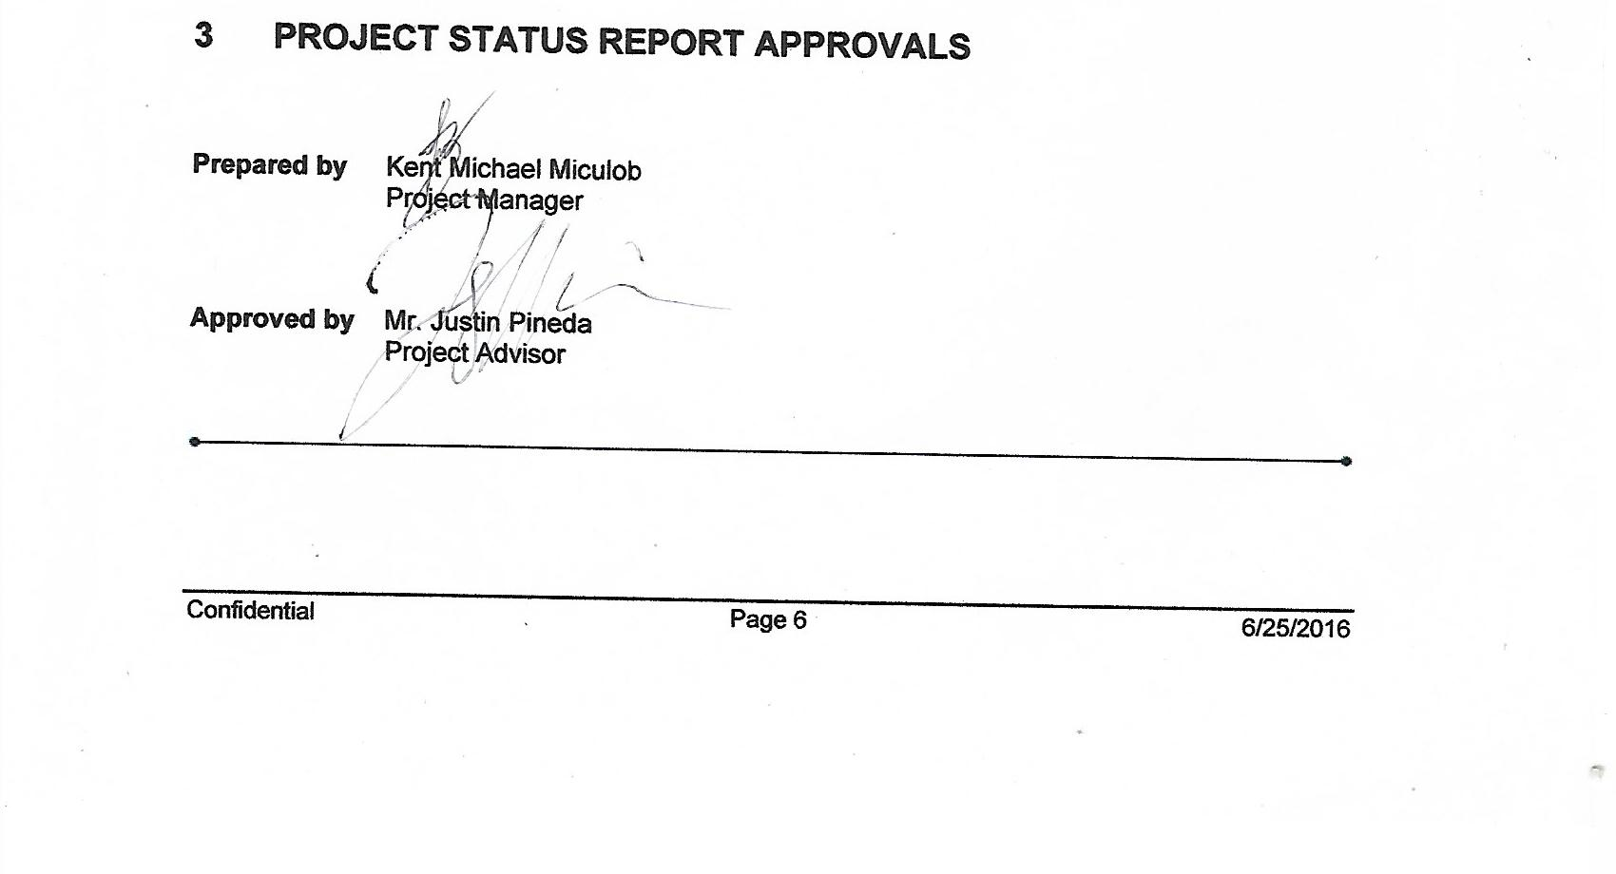



# APPENDICES

## Document Guidelines

1. [Project Title](http://projects2.apc.edu.ph/wiki/index.php/Project_-_Data_corruption_recovery_-_116" \l "Project_Title)
2. [Project Members](http://projects2.apc.edu.ph/wiki/index.php/Project_-_Data_corruption_recovery_-_116#Project_Members)
   * [Project Consultant](http://projects2.apc.edu.ph/wiki/index.php/Project_-_Data_corruption_recovery_-_116#Project_Consultant)
   * [Project Adviser](http://projects2.apc.edu.ph/wiki/index.php/Project_-_Data_corruption_recovery_-_116#Project_Adviser)
   * [Project Team](http://projects2.apc.edu.ph/wiki/index.php/Project_-_Data_corruption_recovery_-_116#Project_Team)
3. [Introduction](http://projects2.apc.edu.ph/wiki/index.php/Project_-_Data_corruption_recovery_-_116#I.__Introduction)
   * [Background of the Problem](http://projects2.apc.edu.ph/wiki/index.php/Project_-_Data_corruption_recovery_-_116#Background_of_the_Problem)
     + [System Model of File Repair](http://projects2.apc.edu.ph/wiki/index.php/Project_-_Data_corruption_recovery_-_116#System_Model_of_File_Repair)
   * [Statement of the Problem](http://projects2.apc.edu.ph/wiki/index.php/Project_-_Data_corruption_recovery_-_116#Statement_of_the_Problem)
   * [Objectives](http://projects2.apc.edu.ph/wiki/index.php/Project_-_Data_corruption_recovery_-_116#Objectives)
     + [General](http://projects2.apc.edu.ph/wiki/index.php/Project_-_Data_corruption_recovery_-_116#General)
     + [Specific](http://projects2.apc.edu.ph/wiki/index.php/Project_-_Data_corruption_recovery_-_116#Specific)
   * [Significance](http://projects2.apc.edu.ph/wiki/index.php/Project_-_Data_corruption_recovery_-_116#Significance)
   * [Scope and Limitations](http://projects2.apc.edu.ph/wiki/index.php/Project_-_Data_corruption_recovery_-_116#Scope_and_Limitations)
   * [System Model](http://projects2.apc.edu.ph/wiki/index.php/Project_-_Data_corruption_recovery_-_116#System_Model)
4. [Related Literature/Related Studies](http://projects2.apc.edu.ph/wiki/index.php/Project_-_Data_corruption_recovery_-_116#II.__Related_Literature.2FRelated_Studies)
5. [List of Figures, List of Tables, List of Notations](http://projects2.apc.edu.ph/wiki/index.php/Project_-_Data_corruption_recovery_-_116#III.List_of_Figures.2C_List_of_Tables.2C_List_of_Notations)
   * [Project Specifications](http://projects2.apc.edu.ph/wiki/index.php/Project_-_Data_corruption_recovery_-_116#Project_Specifications)
     + [Flowchart](http://projects2.apc.edu.ph/wiki/index.php/Project_-_Data_corruption_recovery_-_116#Flowchart)
   * [Entity-Relationship Diagram](http://projects2.apc.edu.ph/wiki/index.php/Project_-_Data_corruption_recovery_-_116#Entity-Relationship_Diagram)
   * [Data Dictionary](http://projects2.apc.edu.ph/wiki/index.php/Project_-_Data_corruption_recovery_-_116#Data_Dictionary)
6. [Appendices](http://projects2.apc.edu.ph/wiki/index.php/Project_-_Data_corruption_recovery_-_116#IV._Appendices)
   * [System Model](http://projects2.apc.edu.ph/wiki/index.php/Project_-_Data_corruption_recovery_-_116#System_Model_2)
     + [Bibliography](http://projects2.apc.edu.ph/wiki/index.php/Project_-_Data_corruption_recovery_-_116#Bibliography)

## Project Status Report Sections Omitted

