I. Introduction

1.1 Project Context

Wealth Securities Inc. (WSI) has ranked among the top 20 brokerages in the Philippines since its incorporation in November 1986. The company caters to both retail and institutional clients in the Philippines and overseas. One of the important parts of their system is portfolio management. Portfolio management is the art and science of making decisions about investment and portfolio management system displays the necessary stock information for the client.

Mobile interaction is popularly used in online system and with that we could establish that there is a need to incorporate the portfolio management system into mobile devices to cope up with the advancement in technology.

1.2 Purpose and Description

Purpose

The purpose of the project is to create a mobile platform prototype for the portfolio management system of Wealth Securities Inc.

Description

This project would provide the following functionalities:

1. Quick access to client’s portfolio

2. Access to historical stock information

3. Chart generation

4. Device Flexibility

5. Increased end-user productivity

1.3 Objectives

The objective of this project is to create a portfolio management system that would allow the client to view their portfolio, view stock quotes, and view charts.

The proposed portfolio management system must be designed to provide a friendly interface for the client and must be designed to be compatible to desktop and mobile usage. As the list of problems unfolds, several common sources are likely to be discovered.

When trying to develop solutions, the team must look for the source of the problems. There are many cases of database systems that failed to satisfy the end-users because they are designed to treat the symptoms of the problems rather than their source. (Abuzo, 2015)

The team’s job is to make sure that the portfolio management corresponds to those envisioned by the end-users. In any case, the team must begin to address the following questions:

• What other functionalities that could be added to the system?

• Will the proposed system satisfy the needs of the company and its clients?

1.4 Scope and Limitations

The scope of this project is to create a prototype mobile platform for the portfolio management system of Wealth Securities Inc. Specifically the team will develop the viewing functionality of portfolio and stock quote; and Market interpretation through charts.

The proposed prototype of portfolio management system is also subject to boundaries known as "limits", which affects the systems functionality and performance. Specifically the system is limited to the stock quote information, and for the sample portfolio information given by Wealth Securities Inc. The system cannot generate or display information without the necessary data needed.

But unfortunately, in the real world, a system often must be designed around the client’s vision. Thus, the scope and limitations become the factors that force the design into specific mold, and the team's job is to design the best system possible within those constraints. (Abuzo, 2015)

Note that problem definitions and the objectives sometimes must be reshaped to meet the system scope and limitations.

## II. Review of Related Literature/Study

In ways similar to other companies, transaction is all the events that take place on a daily basis in an organization. Transaction processing system (TPS) is required to capture and process those transactions to update data on the fundamental operations of an organization. According to Mahajan, a professor of Information technology in Amity University, the essence of a transaction processing program is that it manages data that must be left in a consistent state. This type of integrity must always be provided to the data and transaction processing.  
Portfolio Management systems pioneered many concepts in distributed computing and fault-tolerance computing which introduced data for reliability, availability, and performance. Most importantly, they introduced the transaction ACID properties— atomicity, consistency, isolation, and durability (JGray and AReuter, 1992)  
  
According to the study conducted by International Business Times, it takes more than customer service and discounts. Investors look for mobile platforms to let them trade from anywhere, or sophisticated education resources to help them navigate tricky markets. They surveyed investors to find out the top online brokerage firms.  
  
Charles Schwab took the top spot in for trade reliability and research tools, but its top spot in Mobile Platform Trading distinguishes it from the rest of the list. Clients can use the Schwab Mobile app to view real-time market data, place trades and even watch a live stream of CNBC from their smartphone or tablet.  
  
Fidelity’s high rank is thanks to its top spot in the portfolio analysis and investment research categories. The Boston-based firm placed in the top five in nine out of 12 categories including equity trading tools, research tools and customer service. Investors can compare up to four stocks at a time using up to 147 different traits with Fidelity’s tools. About a quarter of the mutual funds and about 6 percent of the ETS are commission-free for online customers. 

Bloomberg app incorporated the mentioned properties of a transaction processing system and created a mobile platform for its users. It provides instant access to global business and finance news, market data and portfolio tracking tools. Local Companies just like FirstMetroSec, Philstocks, and Col Financials already made similar mobile application and web-based platform for their online brokerage firm.

Philstocks Mobile is the first and only online stock trading application officially reviewed by securities regulatory institutions it features an online trading platform that is suited for traders on-the-go, instant buying and selling of stocks, easy portfolio access, and latest feeds on market information from Philippines Stock Exchange (PSE).

Col Financials HTML5 mobile platform lets you access your trading account wherever you go. Trade stocks and options in real-time. Real-time streaming quotes. Access your account portfolio and transaction history at ease.

**Context diagram**

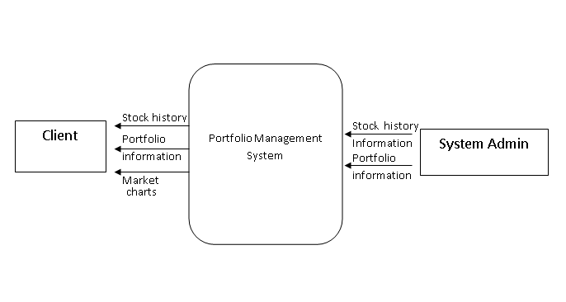

**DFD lvl 0**

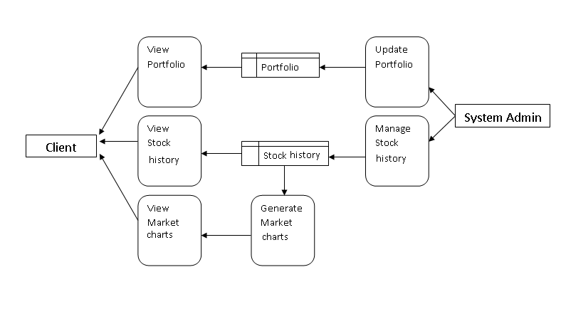

**ERD Diagram**

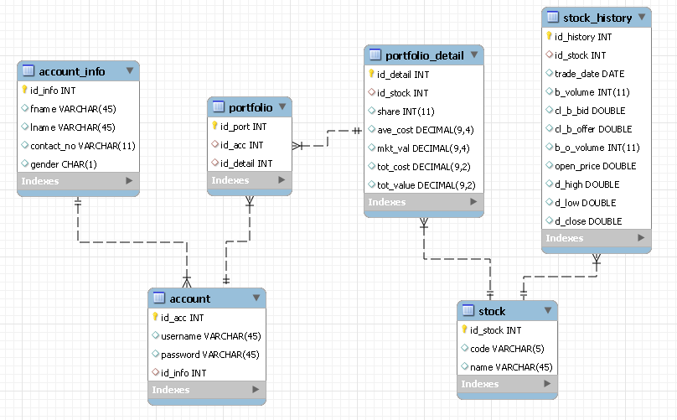

**Event Table**

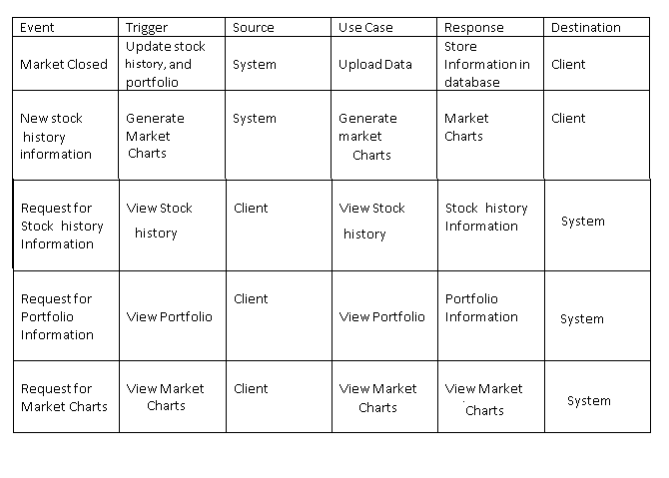

**Class Diagram**

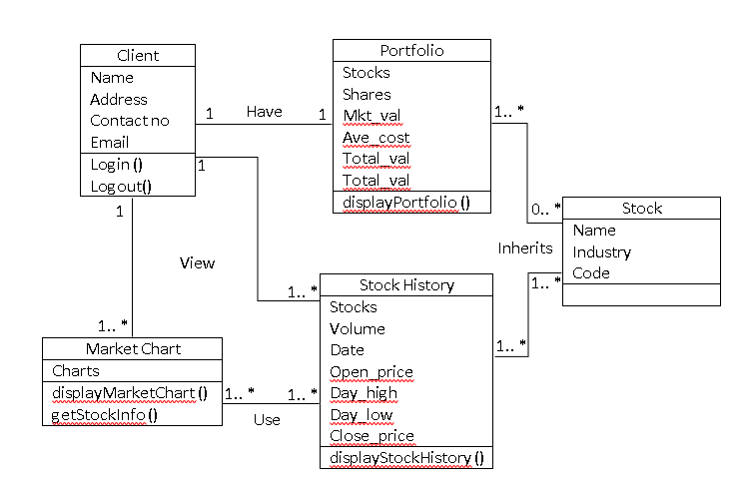

**Sequence diagram**

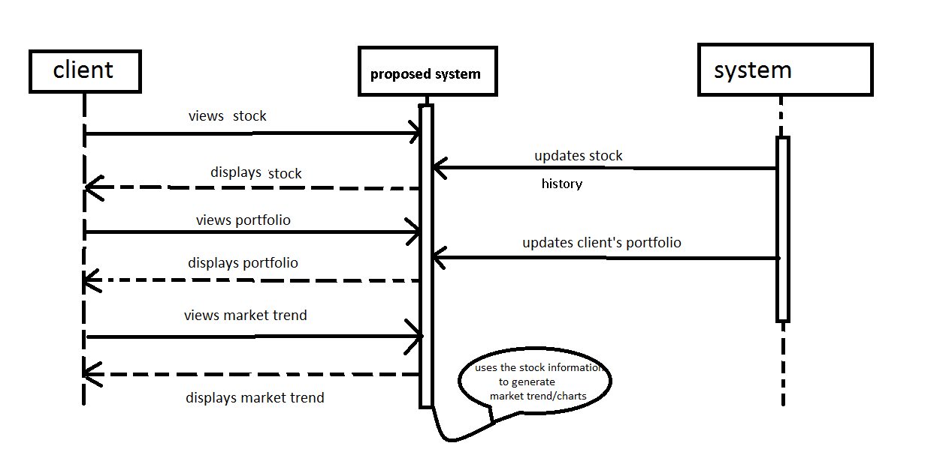

**Activity Diagram:**

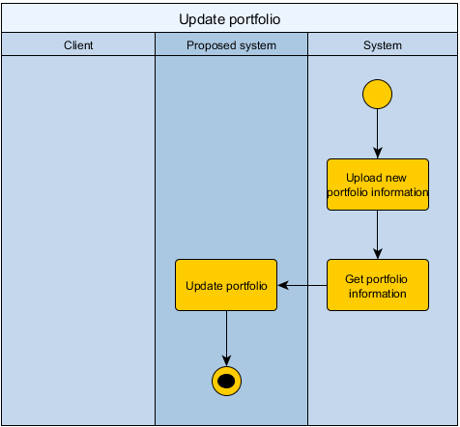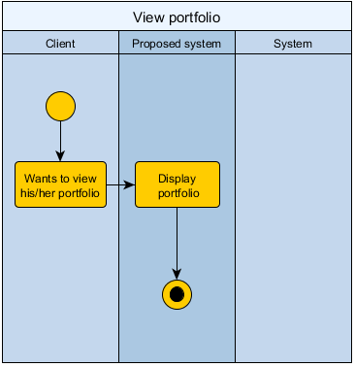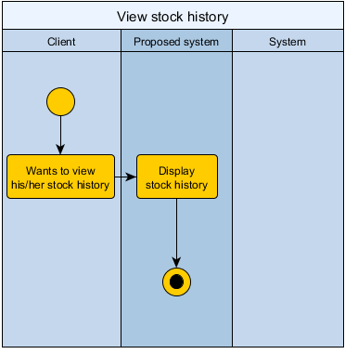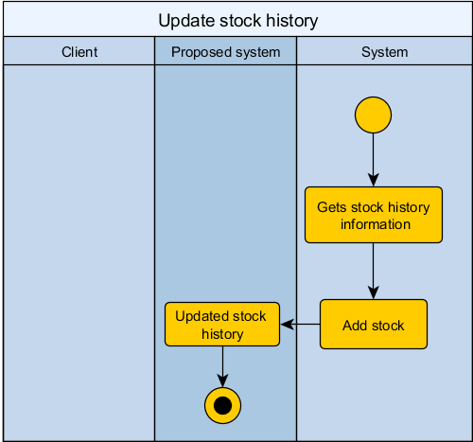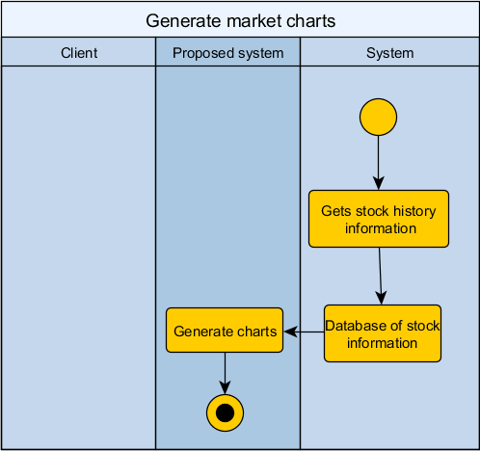

**Use case diagram**

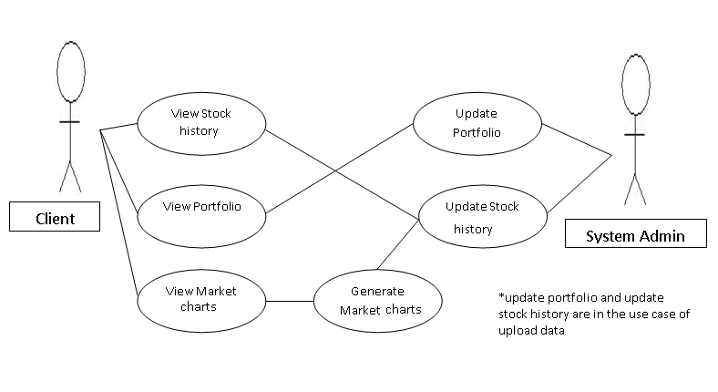

**Use case full description:**

|  |  |  |
| --- | --- | --- |
| Use Case Name: | View Stock history | |
| Scenario: | Client wants to view the stock history | |
| Triggering Event: | View stock history | |
| Brief Description: | Proposed system will display stock history information | |
| Actors: | Client | |
| Related Use Cases: | Update Stock history | |
| Stakeholders: | Proposed system | |
| Preconditions: | Client is logged into his/her account and selects the “view portfolio” option. | |
| Postconditions: | The stock information of a company requested by the client will be displayed | |
| Flow of Activities: | Actor | System |
| 1. Client selects the “view portfolio” option.  1.1 Investor select company stock. | 1.1 System will display stock information of the selected company |
| Exception Conditions: | The requested data may not be displayed because of the system crash or network problem. | |

|  |  |  |
| --- | --- | --- |
| Use Case Name: | View portfolio | |
| Scenario: | Client is wants to view his/her portfolio | |
| Triggering Event: | Display Portfolio | |
| Brief Description: | The system will display client’s portfolio information | |
| Actors: | Client | |
| Related Use Cases: | Update portfolio | |
| Stakeholders: | Proposed system | |
| Preconditions: | Client is logged into his/her account and selects the “view portfolio” option. | |
| Post conditions: | The portfolio requested by the client will be displayed | |
| Flow of Activities: | Actor | System |
| 1. Client selects the “view portfolio” option. | 1.1 The Client’s portfolio is displayed on the screen. |
| Exception Conditions: | The client’s portfolio may be empty. | |

|  |  |  |
| --- | --- | --- |
| Use Case Name: | Update portfolio | |
| Scenario: | New portfolio information is generated | |
| Triggering Event: | Update portfolio | |
| Brief Description: | The proposed system will update the client’s portfolio | |
| Actors: | Proposed system, Current System | |
| Related Use Cases: | View portfolio | |
| Stakeholders: | Proposed System | |
| Preconditions: | Current portfolio information would be uploaded from the proposed system. | |
| Postconditions: | Client’s portfolio would be updated | |
| Flow of Activities: | Actor | System |
| 1. Current system generate portfolio information.  2. Upload portfolio information to the proposed system | 2.1 System updates the client’s portfolio information |
| Exception Conditions: |  | |

|  |  |  |
| --- | --- | --- |
| Use Case Name: | Update stock history | |
| Scenario: | New stock information is generated | |
| Triggering Event: | Update stock history | |
| Brief Description: | The proposed system will update stock history | |
| Actors: | Current system, Proposed System | |
| Related Use Cases: | View stock history, Generate market charts | |
| Stakeholders: | Proposed System | |
| Preconditions: | Stock history information would be uploaded from the proposed system. | |
| Postconditions: | New stock history information will be added to the record | |
| Flow of Activities: | Actor | System |
| 1. Current system generate stock history information.  2. Upload stock information to the proposed system | 2.1 System will add stock history information. |
| Exception Conditions: |  | |

|  |  |  |
| --- | --- | --- |
| Use Case Name: | View market charts | |
| Scenario: | Client wants to view market charts | |
| Triggering Event: | View market charts | |
| Brief Description: | Investor will be able to view the market charts | |
| Actors: | Client | |
| Related Use Cases: | Generate index market | |
| Stakeholders: | Proposed system | |
| Preconditions: | Client is logged into his/her account and selects the “view index market” option. | |
| Postconditions: | Proposed system displays market chart. | |
| Flow of Activities: | Actor | System |
| 1. Client selects the “view charts” option.  1.1 Client selects the “chart” option.  1 .2 Investor select company stock. | 2. The market chart of the selected company will be displayed on the screen. |
| Exception Conditions: |  | |

|  |  |  |
| --- | --- | --- |
| Use Case Name: | Generate market charts | |
| Scenario: | The stock history update | |
| Triggering Event: | Generate market chart | |
| Brief Description: | Proposed system will be able to generate index market | |
| Actors: | Proposed system | |
| Related Use Cases: | View market charts | |
| Stakeholders: | Client | |
| Preconditions: | New stock information is uploaded | |
| Postconditions: | Formulas and algorithms is applied to data to create market charts | |
| Flow of Activities: | Actor | System |
|  | 1.System will get new stock information.  1.1 System will apply statistical treatment to the data  1.2 System will generate charts |
| Exception Conditions: |  | |

**Communication diagram**

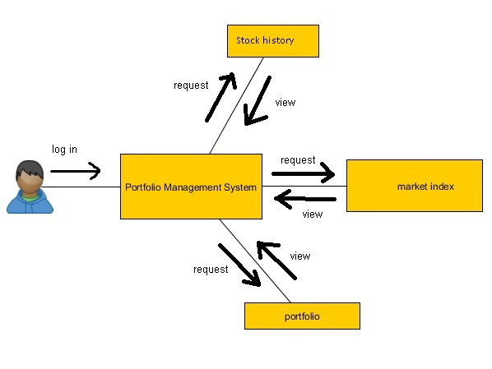

**Component diagram**

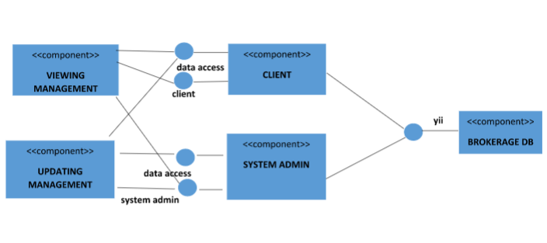

**Package diagram**

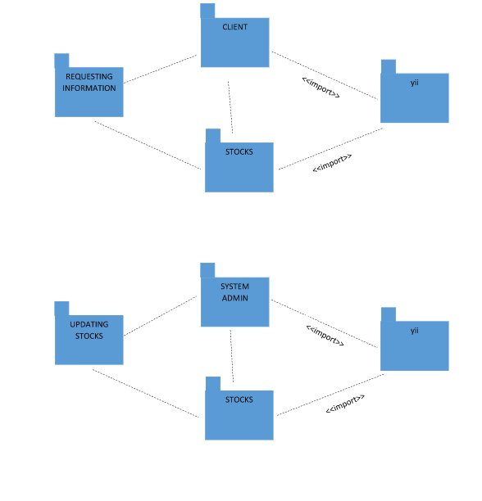

**State diagram**

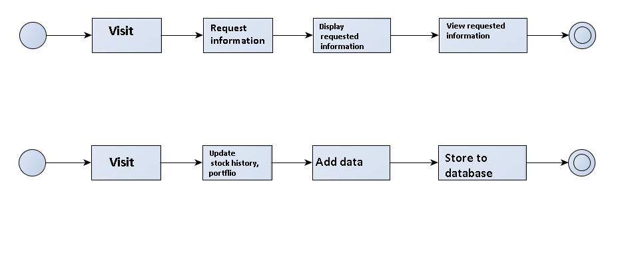**Composite diagram**

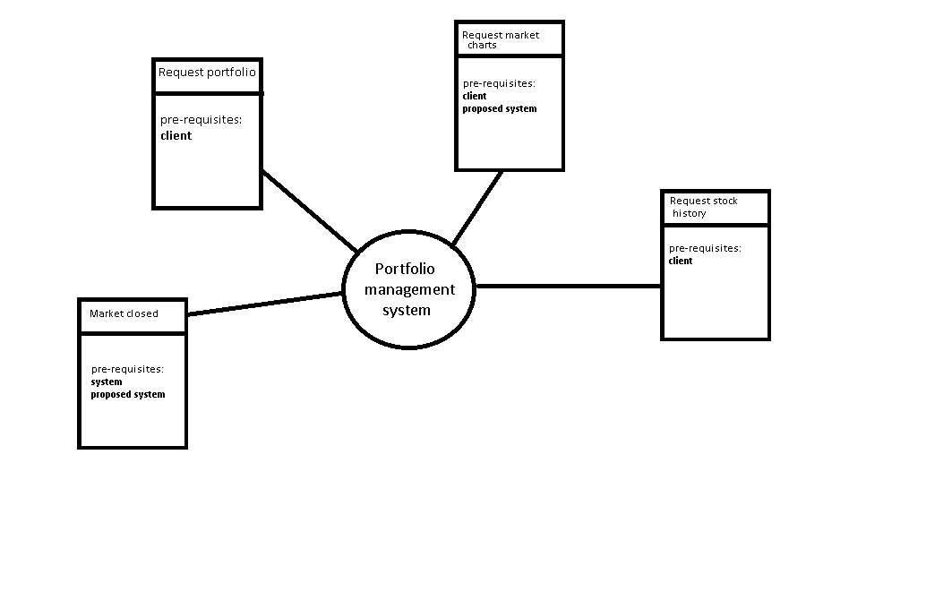

**Deployment diagram**

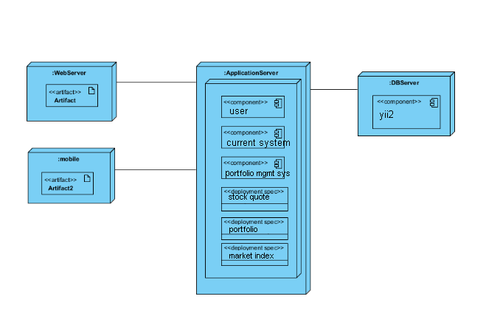

**Object diagram**

