

Asia Pacific College

School of Computing and Information Technology

System Analysis and Detailed Design

**SM Hotels Service Request Management System**

Submitted by:

Lurenne Tangi

Project Manager / Documenter

Kenneth Abuel

Project Developer / Analyst

Submitted to:

Ms. Sebastian Sanchez

Professor

Date:

8/31/2017

Table of Contents

**Executive Summary**1

List of Figures and Notations1

**1.0 Introduction**2

Project Context2

Purpose and Description3

Objectives3

Scope and Limitations4

**2.0 Review Related System**5-13

**3.0 Technical Background**14

Software Requirements14-15

Hardware Requirements15-16

**4.0 Methodology**17

Context Diagram17

4.1.1 Diagram Level 018

4.1.2 Diagram Level 319

4.2 Entity Relationship Diagram20

4.3 Data Dictionary21

4.4 Activity Diagram22

4.5 Gap Analysis23

4.6 Use Case Diagram24

4.7 Other Diagrams

4.7.1 Composite Diagram25

4.7.2 Component Diagram26

4.7.3 Deployment Diagram27

4.7.4 Interaction Overview Diagram28

4.7.5 Sequence Diagram29

4.7.6 State Machine Diagram30

4.7.7 Use Case Package Diagram31

4.7.8 Object Diagram32

4.7.9 Class Diagram33

**5.0 Appendices**33

Relevant Source Code34

Screenshots35

Sample Generated Outputs36

Curriculum Vitae37

**References**38-39

**Executive Summary**

Our client told us that they are using Microsoft Excel to input the details of the request of the Hotel Guest. The team thinks that they needed us to change the system they’re using. Our system has different functions that can make the Request department use it easier. Our system is more detailed, more user friendly and easier to use than Microsoft Excel that they are using currently.

Our client also needs a web based system that is actually related to our system that uses Web based system and not required to use a Mobile app. So our team thinks that our system will be a good match for their needs so they can work a lot easier than before.

Team’s objective is to improve the system of the Taal Vista Hotel’s Service Request System and we think our system can definitely improve their system in a better way. That’s the only objective that are we looking for to improve their system and the rest is good.

Our team recommended our system to be their main system so that they can have a better system use for requesting needs of a hotel guest.

# **List of Figures, List of Tables, List of Notations**

1. Context Diagram
2. Diagram Level 0 and Level 1
3. Object Diagram
4. Class Diagram
5. Communication Diagram
6. Sequence Diagram
7. State Machine Diagram
8. Composite Structure Diagram
9. Interaction Over Diagram
10. Deployment Diagram
11. Component Diagram
12. Use Case Package Diagram
13. ERD Diagram
14. Activity Diagram
15. Use Case Diagram
16. Data Dictionary

**CHAPTER I**

**Introduction**

* 1. **Project Context**

Shoemart Hotels and Conventions Corporation was established to address the vast potential of tourism in the country. It is now developing and operating hotels and convention centers all throughout the archipelago with a current portfolio of 1,514 rooms housed in the Taal Vista Hotel, Pico Sands Hotel, Park Inn by Radisson in Davao, Park Inn by Radisson in Clark and a deluxe 5-star hotel, Conrad Manila, located at Mall Of Asia Complex. (SM Prime, 2016) All these allow guests to experience luxury and the world-renowned Filipino hospitality, made more memorable by the natural beauty. Also SHMCC operates convention centers and trade halls through SMX Convention Center, which has become a popular venue for both locals and international events.

When it comes to having an efficiency and a better performance in a hotel management, upgrading to a Hotel Management System is an excellent way to do because hotels can no longer achieve best service by relying on spreadsheets or old software.

Hotel Service Management system would provide the employees an ease of work and providing a better experience to the customers because the Service Request Management System can automate the handling of guest requests and thus ensuring high quality service and high staff productivity.

* 1. **Purpose and Description**

The team’s purpose is to identify what are the features of the current system, the problems of the departments that they are experiencing in delivering service management and to find a way on how the hotel are going to provide a better way of having a service management.

The team also need to focus on problems that the hotels encounter while providing service management in order to develop the most suitable hotel service management system that they need so that it would reduce service management errors and hotel’s customer service department will have more efficient way of servicing their hotel guest

* 1. **Objectives**

**General Objective**

The project aims to improve the service request handling of the SM Hotels by developing an automated system that will handle and monitor the service request of the hotel guest. This will help the SM hotels in improving their monitoring of services requested by their hotel guest.

**Specific Objective**

* To develop an automated system that will electronically assign the guest service request to their employees.
* To have an organize list of service requested details that can help to minimize the delays of rendering the service to the hotel guest also to avoid confusion to prevent wrong requested item deliveries
* To generate a summary reports for the common services that are being requested by the hotel guest which can be viewed by daily and monthly basis.

**Scope and Limitations**

The scope of this study is to improve the current system of the SM Hotels for the handling of the requested service of their hotel guest. With a better system it will improve the way of providing service management in SM Hotels. The study is limited only to the different departments that provides services to the hotel guests, also the reports statistics which is needed by the quality assurance department of the SM Hotels.

**CHAPTER II**

**Review of Related Systems**

**2.0 Requested Systems**

Other companies are using automated systems for their hotels and convention systems, automated systems help to facilitate the hotel and conventions management and their personnel all through a single piece of software. This automated system can replace the old-fashioned paper based methods that can slow the process of the hotel and convention centers. There are several systems that can be used as a reference for the project.

Know Service can automate the handling of guest’s requests, complaints and the maintenance jobs, thus ensuring high quality service and high staff productivity. They also have the same function that we will use in our proposed system because the requests details are logged in either by hotel staff by the guests using an interactive guest application.

Opera Property Management System is a comprehensive and scalable solution that comes in three levels (Premium, Standard, and Lite) and also available for both cloud and installed deployment. The system also provides the same function as the Know Service but also include more functions that can be used in improving the Hotel Management.

Hotelogix is well known for its booking system but it also has request system that the other people don’t know.

eZee Frontdesk by eZee Technosys, this automated system is focusing on bookings reservation management system but it also has had a rate management that tracks the inventory of the hotel. Aside from booking, it also features the allocation of request service.

roomMaster by InnQuest, is a booking engine for the room reservation. Aside from that, it is also used for requesting for the pillows, beddings and etc.

MSI CloudPM developed by MSI, is a cloud based PMS that is used to look for hotel reservation of room. This PMS also accepting a request from the hotel guest.

CloudPM saves money by eliminating capital expenditures for property technology, increasing the operating efficiencies and eliminating pricey on-property hardware requirements. It also features the allocation of request service.

Frontdesk is one of the most popular system for hotels because of having an easy to use interface, customizable availability calendar and having a personalized profile for their guests and travel agent. With a one simple screen, it provides everything you need just like requesting for your needs in order to enjoy you stay in the hotel

Hostpos runs a well-established customer based installed. The work is organized around a common project that reunites all necessary resources which are totally guaranteed by the business areas in order to be able to give the client best expectations. Hostpos is composed of different department like reservation, requesting and housekeeping.

Rezlynx PMS is a fully configurable, PCI compliant property management system to enable any sized hotel or group to manage their bookings and operations efficiently and profitably. Operations are accepting of request of the hotel guest and also the housekeeping job who will handle the request of the customer.

RDPWin can consequently send messages to all visitors, proprietors, travel specialists and gatherings who reserve a spot. These affirmations can be totally redone for the coveted data and appearance. It is also the same format for the request system that will use an web based system.

Maestro PMS has risen as a top level arrangement supplier of hotel innovation arrangements and prides itself on an extraordinary customer mind benefit record that has for quite some time been perceived for giving customers the innovation arrangements that fit both their operational and administration needs. This PMS has the same record as our Requested system goes on.

Skyware Hospitality Solutions, serving the hospitality industry with 24/7 service and state-of-the-art technology, is widely recognized for providing hotels, resorts, and management companies with flexible software solutions. Skyware is in need of property that’s why they used a requested system for it and pass it to housekeeping department to do the job.

Hoteliga is a cloud-based inn administration framework that enables you to perform effortlessly the day by day elements of your lodging. It has a simplest approach for the reservation job and it makes the housekeeping and requested system job easier.

Cloud-based property management system with a booking engine and channel management. Also has a range of additional modules to increase the efficiency of your hotel management. This PMS is all-around it accepts request from Hotel Guest, do the reservation job and many more.

Elina provides a full set of Property Management, Revenue, Marketing and Sales Management tools as well as Stakeholder Management and Reporting and Analytics, enabling you to spend less time on daily operations, and spend more time with your guests and growing your business.

Genkan is a complete cloud based solution for holiday rental, short term and vacation property management. The solution incorporates all the required tools such as email and SMS Marketing, Inventory management, trust accounting, Survey, payment gateways, inspections in one 'Real Time' software solution plus being multi lingual and multi-currency. Real estate agents and holiday rental managers who are in the business of managing short term and holiday vacation short term rental property. It also features the allocation of request service.

Cloudbeds connects your property to hundreds of channels with real-time, two-way integration. We are the no-sweat, all-in-one hotel management system that makes you more money, saves time, and makes guests happier. It works best for small to medium-sized independent property owners including but not limited to, hotels, hostels, bed and breakfasts, inns, vacation rentals, apartments, campgrounds and more. It also features the allocation of request service.

RezOvation Web is the leading web-based Bed & Breakfast software designed to provide Innkeepers with the tools to save them time, increase their occupancy, and provide them with the freedom and peace of mind to run their business online securely from anywhere. It also features the allocation of request service.

KWHotel is a hotel management software designed for small and medium accommodation facilities. This is suited for hotels, hostels, B&B’s villas and any other small – medium accommodation facilities. It also features the allocation of request service.

Bookalet is an online booking management system for owners and agents to manage every aspect of renting out holiday accommodations. It is used for vacation and holiday rentals. It also features the allocation of request service.

Magna Timeshare Software or enterprise timeshare software for timeshare resorts with ASP or server on-site models. Sales automation, tour appointment automation, minivac management, sales contracts, tour commissions, OPC commissions, sales commissions, mortgage and finance automation and management, Real-time web based reports, statistical reports, and KPI reports. Sistem Otel PMS is an on premise hotel management solution for hotel businesses of all sizes. The solution is compatible with windows operating systems and offers support for multiple languages. Hotel software includes sales, reservation, cashier, POS, front desk and back office modules for hotels and hotel chains. It also features the allocation of request service.

Open Hotel PMS is a PMS that was used for reservation of rooms and foods that also uses request system for the requested foods and beverages.

Smart Hotel Software is a software that uses a request system the same as our system that our team uses.

Rezserve is more on reserving a room but it also uses request system as other features of this PMS.

iRez Systems has developed a reservations system that is openly definable and customizable to match your unique and specific business needs. Rezware has easy to use state of the art features developed with industry standard tools, for a variety of platforms ranging from multi-user Windows based computers, to internet, and enterprise based reservations capabilities. It also features the allocation of request service.

Hotel Management is highly integrated that can help hotels automate the entire gamut of operations with maximum ease. Monk HMS is suitable for small midsize large and group of hotels also resorts boutique hotels. It also features the allocation of request service.

WinHMS Express is created by Winsar Infosoft that uses by Hotels Lodge Resorts Guest house SPA Golf Banquet Motels. It is easy to use and intuitive in every way. WINHMS aims at simplifying and speeding up hotel management and accounting needs. It also features the allocation of request service.

RezEasy Cloud PMS & Booking Engine is a powerful web based Property Management System designed to meet all of your front and back office needs. Includes commission-free Booking Engine &Agent/Corporate Client module. The system is mobile-friendly and includes a mobile optimized booking engine plus PC and Tablet interfaces for the Front Desk system. It also features the allocation of request service.

I-Pro Booking System are experts in the vacation rental industry providing a streamlined solution to allow you to manage your rental business whether you have 1 property or over 500 properties. Track Leads, Manage Bookings via phone, email or online, manage payments, invoices. It also features the allocation of request service.

Corrigo CMMS property management is created by Corrigo that is used in commercial property management, residential property management, hospitality property management, parking management, and municipal properties. Corrigo also accepting a request from the hotel guest.

Mirage Hotel systems is completely integrated property management solution for hotels, motels, inns, and resorts. It also features the allocation of request service.

Guardian is created by ofek technologies that is fully integrated suite of hotel automation products consisting of modules that can be easily added or expanded. It also features the allocation of request service.

Protel PMS is used by innovative hotels, from large multi-site to smaller independents, who rely on technology to do most of the heavy-lifting in their daily operations. We have ideal product variations for all-comers. This is an all-in-one hotel management solution from small individual hotels to large international hotel chains. It also features the allocation of request service.

HoteloPro is a web-based hotel management solution built specifically for small hotels, inns, bed and breakfasts (B&Bs), guest houses, and vacation apartments. HoteloPro makes it easy for small hoteliers to organize their business, save time, and acquire more clients. It is used by small hotels, inns, bed and breakfasts (B&B’s), guest houses, and vacation rentals. It also features the allocation of request service.

Hospitality property management solution offering full front of house features and reporting, room management, E-POS, menu costing, stock control, Inventory and asset management, full accounting and reporting all seamlessly integrated into one user friendly, real time effective system. It is an ideal solution for SME property owners and managers wanting to have real time access to reports on the various aspects of their business for informed decision making. It also features the allocation of request service.

SMS|Host is created by Springer-Miller Systems that is used by Luxury Hotels and Resorts Mountain and Ski resorts condo timeshare hotel golf resort beach resort wellness resorts and retreats. It also features the allocation of request service.

Resort Manager is created by Little Fish Technologies which is used by Hospitality industry including Villas, Hotels, Resorts, Restaurants, Boutiques and other retail outlets. This is a premium one-stop solution for all operational system needs for small/medium-sized hotels, villa complexes, golf courses and resorts. It also features the allocation of request service.

Guest Centrix is a flexible and tailorable hospitality property management solution for hotels and resorts of all sizes. It also features the allocation of request service.

Clerk is the perfect online tool designed for hotel management in the cloud. Keep track of your hotel from anywhere. Nice and Simple. It allows people to manage bookings, stays, arrivals, departures, closing sales, and all the important operations of your hotel, quickly and efficiently, so you can spend less time managing and more time paying attention to your customers. It also features the allocation of request service.

Innkey PMS is the next generation property management system, which automates your business with an easy-to-use enterprise platform that provides centralized controls and reporting while enabling each property to run at maximum efficiency. It also features the allocation of request service.

**CHAPTER III**

**Technical Background**

1. **Software Requirements:**

**Client interface**

**Google Chrome**

Chrome is a free Internet browser officially released by Google. Chrome offers tight integration with Google sites and services, such as YouTube and Gmail, and manages its system resources differently than other browsers. Its V8 JavaScript engine was developed from scratch at Google, and may improve experience on script-heavy websites and applications.

**Mozilla Firefox**

Firefox supports most basic Web standards including HTML, XML, XHTML, CSS (with extensions), JavaScript, DOM, MathML, SVG, XSLT and XPath.

**Web Framework**

**Yii Framework**

Yii is a high-performance, component-based PHP framework for developing large-scale Web applications rapidly. It enables maximum reusability in Web programming and can significantly accelerate your Web application development process.

**Client Operating System**

**Windows OS**

The most widely used operating system for desktop and laptop computers. Developed by Microsoft, Windows primarily runs on x86-based computers. Windows provides a graphical user interface and desktop environment in which applications are displayed in resizable, movable windows on screen.

**Programming Language**

**PHP**

PHP is a server-side-scripting language designed primarily for web development but also used as a general-purpose programming language. PHP code may be embedded into [HTML](https://en.wikipedia.org/wiki/HTML) or HTML5 [markup](https://en.wikipedia.org/wiki/Markup_language), or it can be used in combination with various [web template systems](https://en.wikipedia.org/wiki/Web_template_system), web content management systems and web frameworks.

**Database**

**MySQL**

For our Database we will useMySQL, it is a free, open-source database management system that has been around for years. It is very stable and has a big community that helps maintain, debug and upgrade it

1. **Hardware Requirements:**

**Client Computer and Server**

A computer will be the device that would be used to access the implemented automated system. The minimum requirements were based on the research that the researchers made.

Computer

Operating System : Windows 7 or higher

Processor : Dual-core 2.5 GHz or higher

RAM : 4GB

Internal Storage : Minimum of 500GB

**Mobile Phone**

The Mobile Phone will be used for the Push Notification, the Push Notification will notify the Service Employee if there’s a new Service Request that has been assigned to the Service Employee.

**CHAPTER IV**

**Methodology**

**4.1 Context Diagram**

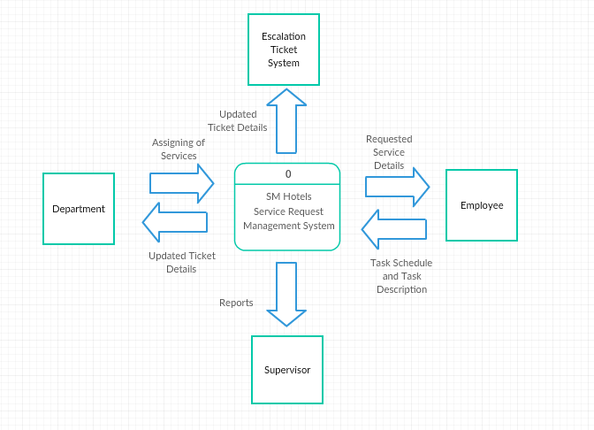

Figure 1: Context Data Flow Diagram for the SM Hotels Service Request Management System

When a hotel guest makes a request the responsible employee for handling the request will input the requested service in the system, the department head can assign a service employee that will render the service to the hotel guest. If the hotel guest is not satisfied or has a complaint to the service the updated ticket details will be forward to the escalation ticket system. The reports will provided for the supervisor which is needed for their statistics and data archives.

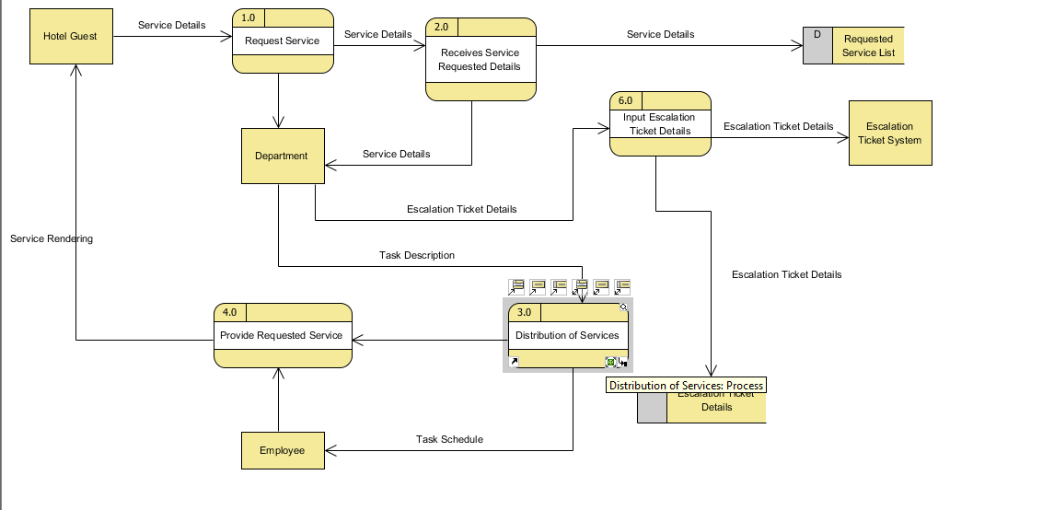**4.1.1 Diagram Level 0**

Figure 1.1: Diagram Level 0 for the SM Hotels Service Request Management

The Diagram Level 0 shows that when the Hotel Guest makes a request, the requested service details will be received by a specific Department and the details will be recorded into the system. The department staff will find an available Service Employee then the staff will assign the service to an available Service Employee then the requested service will be provided to the Hotel Guest. After the service requested has been provided, the operator of the system will update the details in the SRMS.

**4.1 2 Diagram Level 3 Distribution of services**

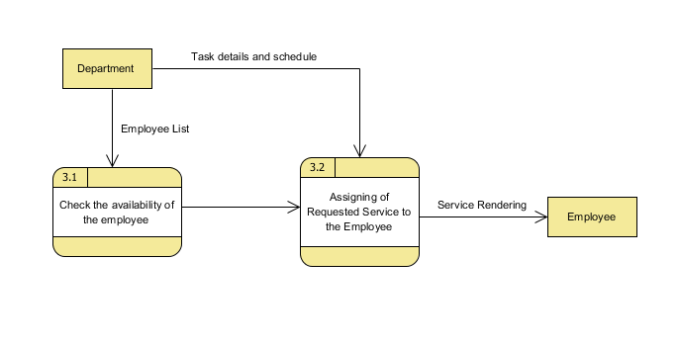

Figure 1.2: Level 1 Diagram

Figure 1.2 shows the process of allocation of services that will be provided for the request of the hotel guest. After the Customer Service Department prepares the service requested, they will check first the availability of their Service Employee if there is someone who is available then they will allocate the requested service to the Service Employee.

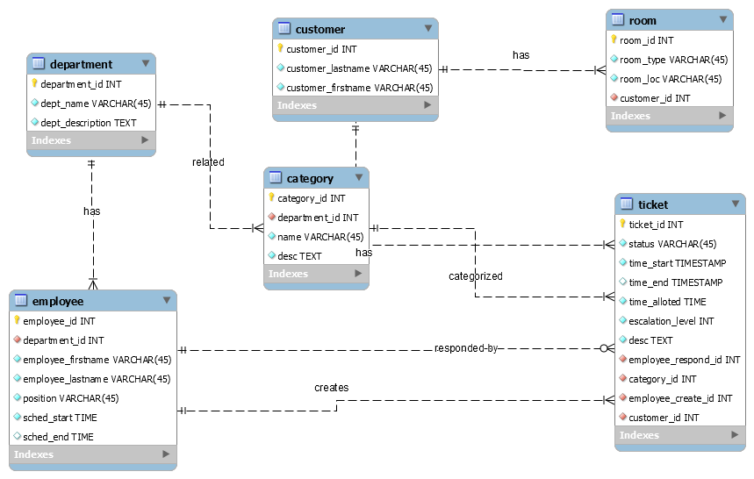**4.2 Entity Relationship Diagram**

Figure 2: Entity Relationship Diagram of the SM Hotels Service Request Management System

The Entity Relationship Diagram consist of 5 entities, a hotel guest has 1 to many rooms and when a hotel guest makes a request it generates a ticket. A department has 1 to many employees and an employee inputs the details of the requested service of the hotel guest, also an employee is the one who renders the service to the hotel guest. Each ticket is categorized by a specific department.

**4.3 Data Dictionary for the Entity Relationship Diagram**

|  |  |  |  |  |
| --- | --- | --- | --- | --- |
| Table Name | Attribute Name | Type | Field Length | Constraints |
| Department | department_id  dept_name  dept_description | INT  VARCHAR  VARCHAR | 45  TEXT | Primary Key  Not Null  Not Null |
| Customer | customer_id  customer_lastname  customer_firstname | INT  VARCHAR  VARCHAR | 45  45 | Primary Key  Not Null |
| Employee | employee_id  employee_firstname  employee_lastname  position  department_id  sched_start  sched_end | INT  VARCHAR  VARCHAR  INT  TIME  TIME | 45  45 | Primary Key Not Null  Not Null Foreign Key |
| Ticket | ticket_id  status  time_start  time_end  time_alloted  escalation_level  desc  employee_respond_id  category_id  customer_id  employee_create_id | INT  VARCHAR  VARCHAR  DATETIME  DATETIME  INT  TEXT  INT  INT  INT  INT | 45  20 | Primary Key  Not Null  Not Null  Not Null  Not Null  Not Null / Foreign Key  Foreign Key  Foreign Key  Foreign Key  Foreign Key |
| Room | room_id  room_type  room_loc | INT  VARCHAR  VARCHAR | 45  45 | Primary Key |
| Category | category_id  Name  Desc  deparment_id | INT  VARCHAR  TEXT | 45 | Primary Key |

**4.4 Activity Diagram**

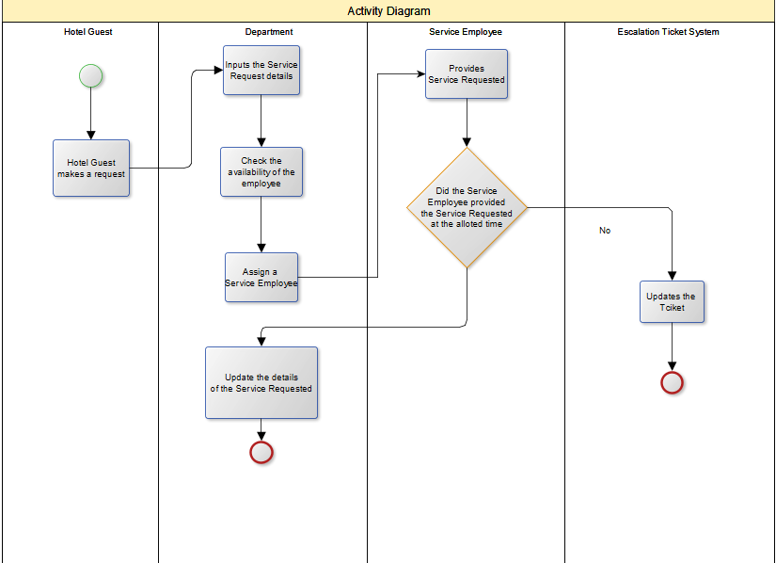

Figure 4: Activity Diagram for the SM Hotels Service Request Management System

The activity diagram shows that when a hotel guest makes a request for a service, the requested service details will be received by a specific department for its specific services, while preparing the requested service a staff will check the availability of a Service Employee then if there is an available Service Employee the Service Employee will be assigned to provide the requested service by the Hotel Guest. The Service Employee also needs to provide a summary report after providing the requested service.

**4.5 Gap Analysis**

|  |  |  |
| --- | --- | --- |
| **User Requirements** | **Current System** | **Proposed System** |
| **The Service Requested details must be inputted properly** | The details of the Service Requested are currently inputted on Microsoft Excel | There will be a detailed form that you can easily input the details of Service Requested |
| **The operator and the customer service department can see the details and the status of the requested service.** | Needs to rely on the assigned service employee to find out what are the necessary service requested details. | A dashboard that will show the on-going, pending service request and the details of the requested service. |
| **A system that can record summary reports** | Reports are done through Microsoft Word and they are not sorted out | The system will show the details of the summary report |
| **Assigning of employees must be accurate.** | There are no current accurate list of currently available service employee | All available and non-available employee will be displayed in the system |

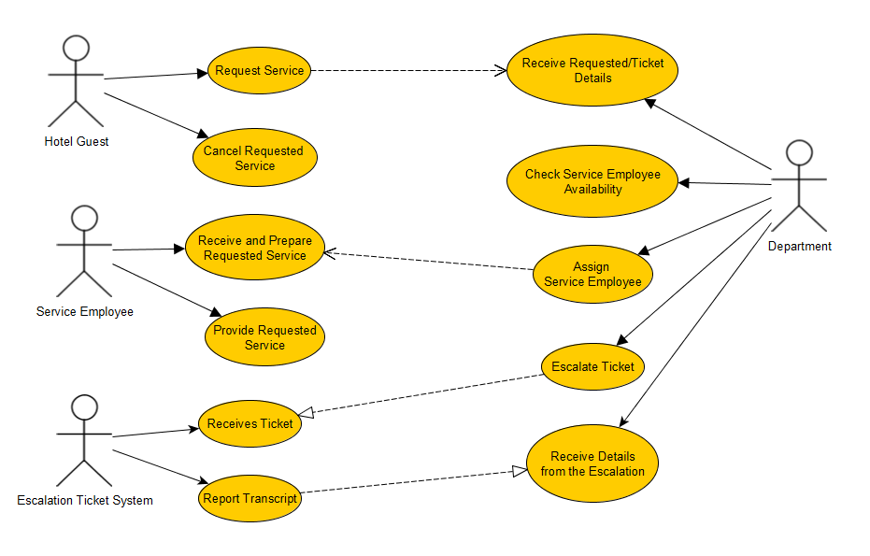**4.6 Use Case**

**4.7 Other Diagrams**

**4.7.1 Composite Diagram**

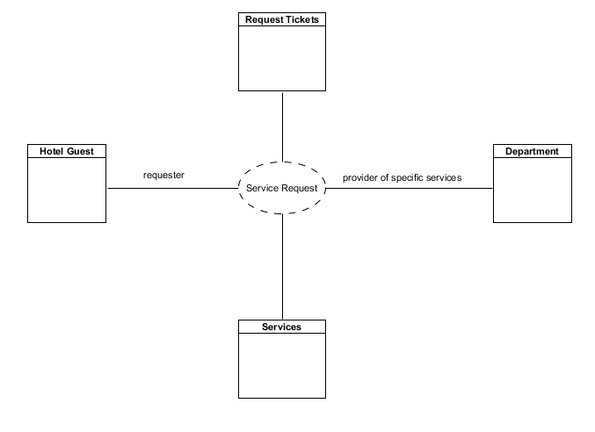

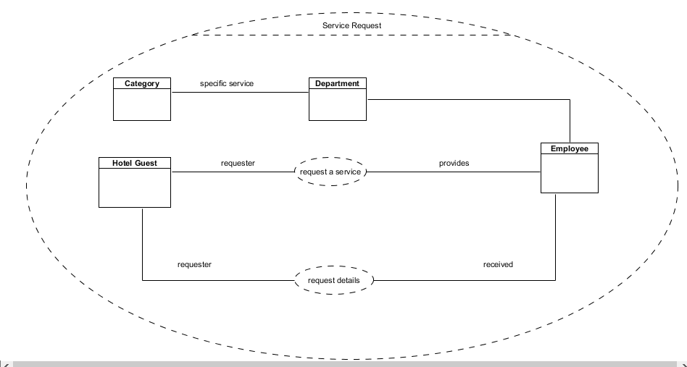

**4.7.2 Component Diagram**

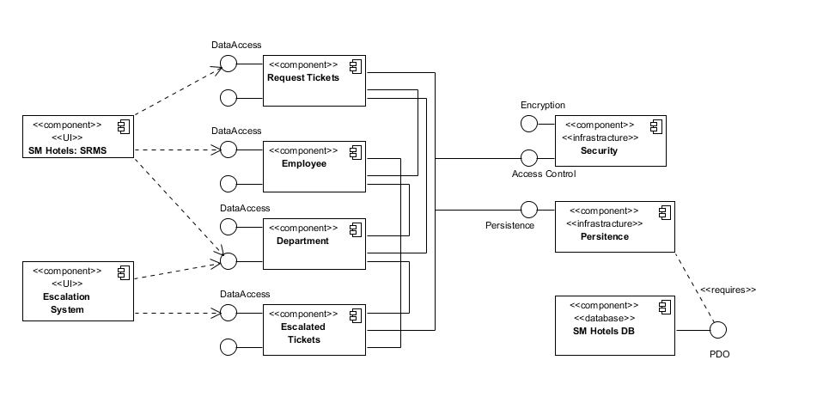

**4.7.3 Deployment Diagram**

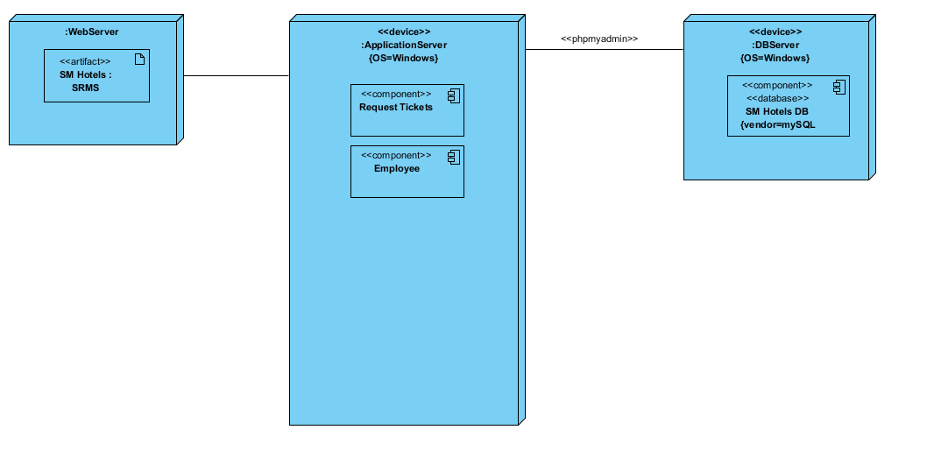

**4.7.4 Interaction Overview Diagram**

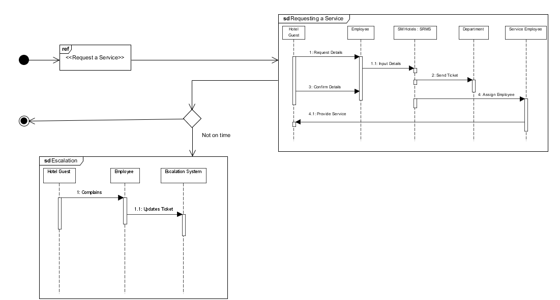

**4.7.5 Sequence Diagram**

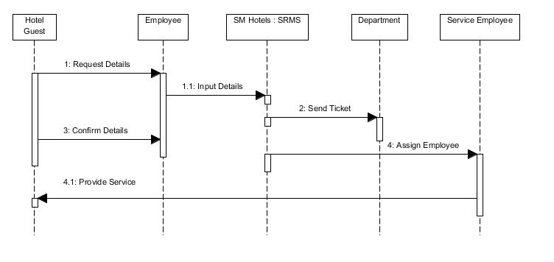

**4.7.6 State Machine Diagram**

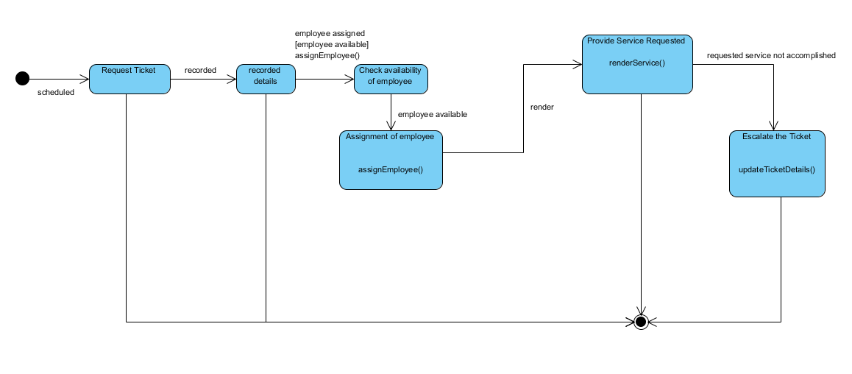

**4.7.7 Use Case Package Diagram**

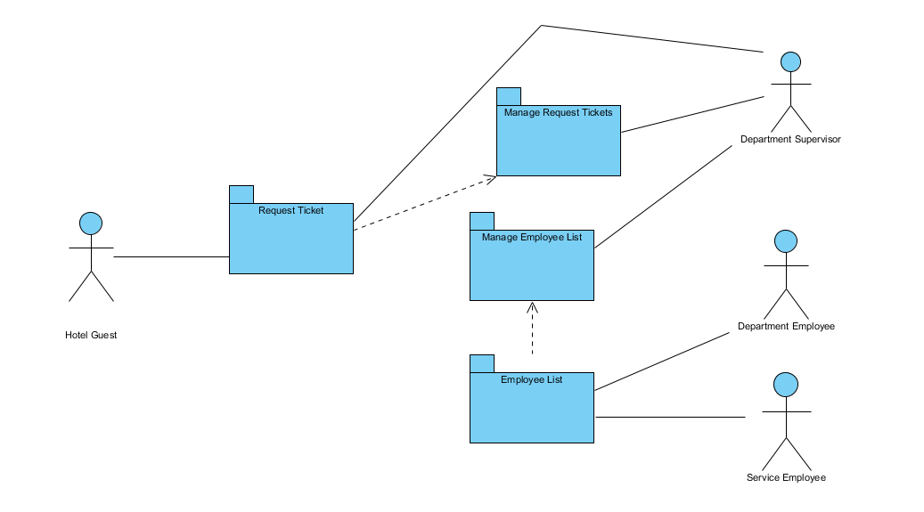

**4.8 Object Diagram**

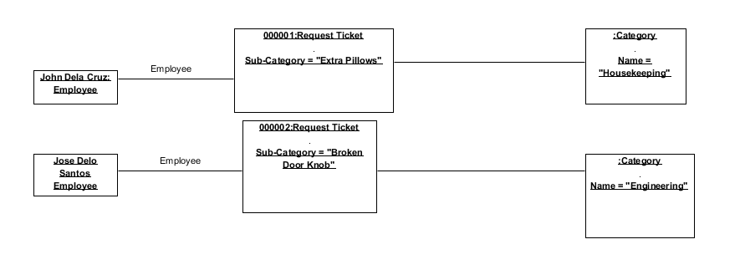

**4.9 Class Diagram**

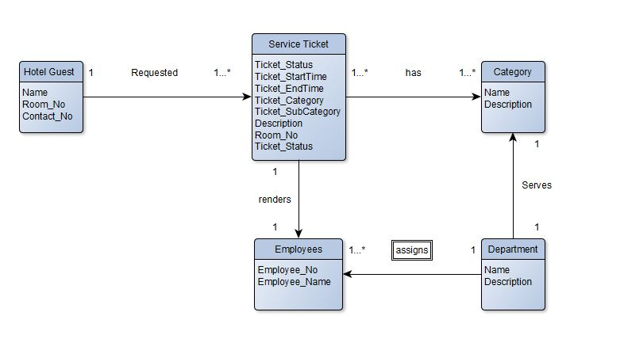

**CHAPTER V**

**Appendices**

**Relevant Source Code**

**Screenshots**

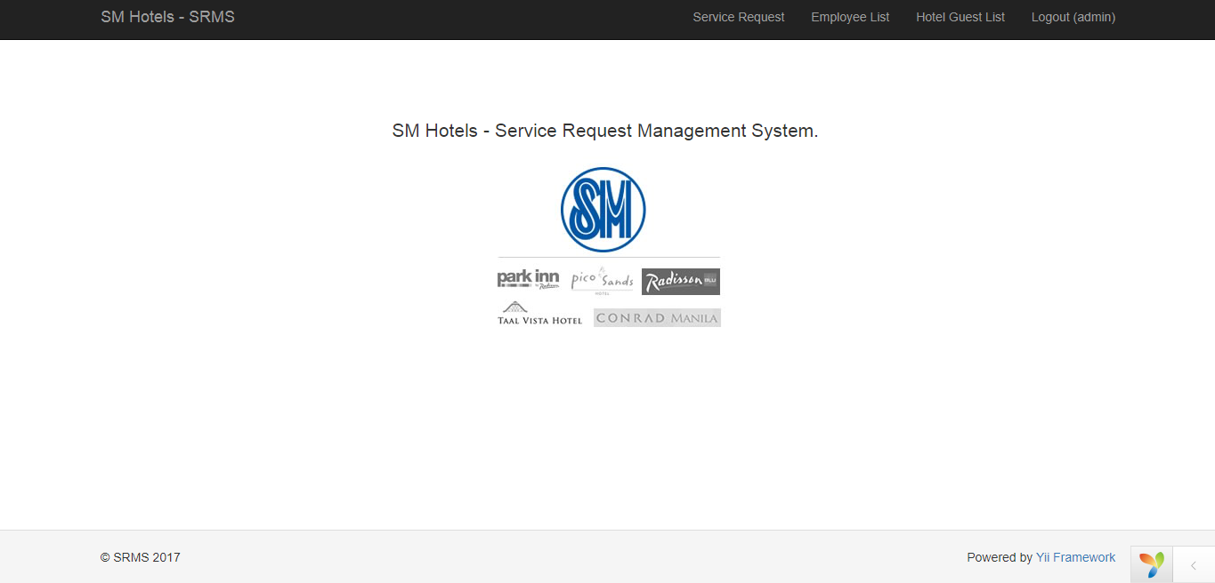

Figure 5.2.1: The Main Menu

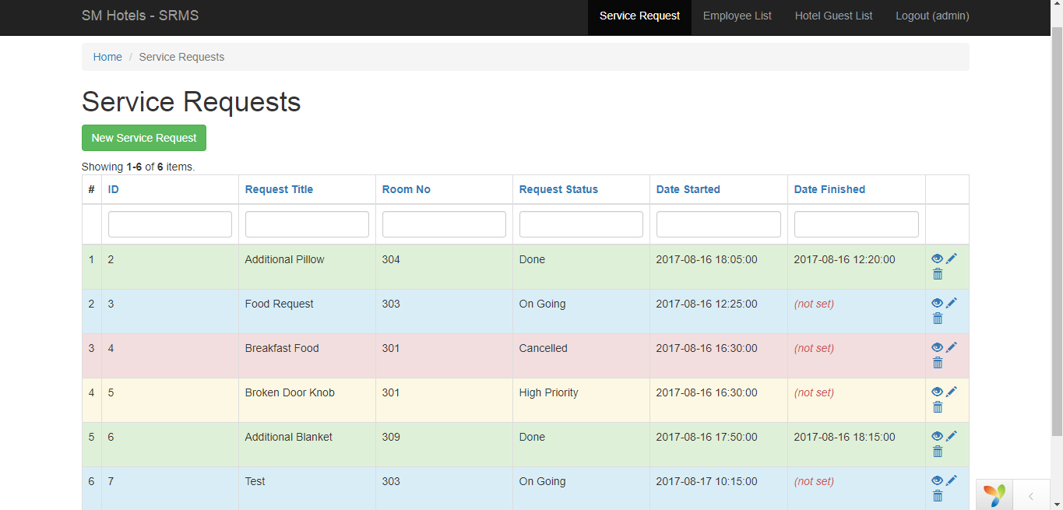

Figure 5.2.2: The summary report of the requested items and the Service Request menu

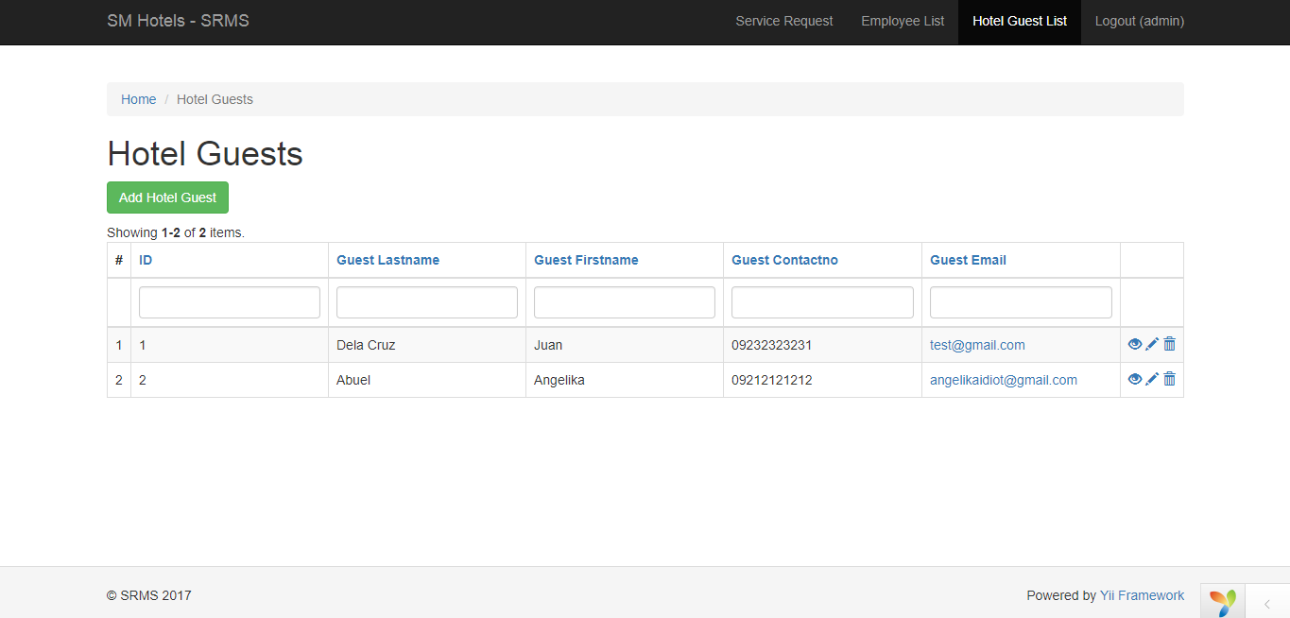

Figure 5.2.3: The Hotel Guest List

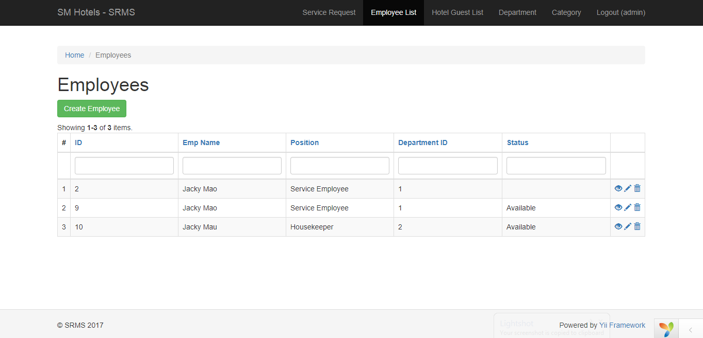

Figure 5.2.4: The Employee List

**Github Repository Link:**

https://github.com/lrenetngi/apc_sysadd_mi151_05/

**References**

Know Cross (2017). Know Cross Service [online]. Available: http://www.knowcross.com/know-service/ (2017)

Oracle (2017). Oracle Hospitality for Hotels – Opera Property [online]. Available: https://www.oracle.com/industries/hospitality/products/opera-property-services/index.html (2017)

Hotelogix (2017). Hotelogix Online PMS [online]. Available: http://www.hotelogix.com/ (2017)

eZee (2012). eZee PMS [online]. Available: http://www.ezeefrontdesk.com/ (2017)

Roommaster (2017). Roommaster inQuest software [online]. Available: http://roommaster.com (2017)

Frontdesk Anywhere (2017). Frontdesk Anywhere Hotel Management Software [online]. Available: http://www.frontdeskanywhere.com/features/hotel-management-software (2017)

HostPMS (2014). Hostpos [online] Available: http://hostpms.com/en/solutions/hotel-management-systems/hostpos (2017)

Guestline (2016). Rezlynx Guestline PMS [online] Available: https://www.guestline.com/products/operational-solutions/rezlynx-pms.html (2017)

ResortData (2017). RDPWin [online] Available: http://www.resortdata.com/rdpwin/ (2017)

Maestro (2015). Maestro PMS [online] Available: http://www.maestropms.com/?q=company-profile (2017)

Skyware (2009). Skyware Hospitality Solutions [online] Available: http://www.skywaresystems.com/about/index.html (2017)

Hoteliga (2014). Hoteliga [online] Available: http://www.hoteliga.com/en/faq (2017)

Clock (1996). ClockPMS [online] Available: https://www.clock-software.com/company-aboutus/index.html (2017)

Elina (2007). Elina Property Management [online] Available: https://www.elinapms.com/about-us/ (2017)

Genkan (2010). Genkan [online] Available: https://www.genkan.com.au/wp/genkan/history-genkan/ (2017)

CloudBeds (2017). CloudBeds PMS [online] Available: https://www.cloudbeds.com/our-story/ (2017)

ResOvation (2017). RezOvation Web [online] Available: https://www.rezovation.com/about

KWHotel (2017). KWHotel PMS [online] Available: http://kwhotel.com/en/about-us/

Bookalet (2017). BookaletPMS [online]. Available: https://www.bookalet.co.uk/aboutus (2017)

MagnaTimeshare (2017). Magna Timeshare Software [online]. Available: https://www.magnatimesharesoftware.com/about-us/ (2017)

SistemHotel (2005). Sistem Hotel PMS [online]. Available: http://www.sistemhotelsoftware.com/ (2017)

OpenHotel (2017). Open Hotel PMS [online]. Available: https://openhotel.com/pms.cfm (2017)

Smart Hotel (2017). Smart Hotel Software [online]. Available: http://www.smarthotelsoftware.com/html/support.html (2017)

Ibelsa (2017). The All-in-one PMS [online]. Available: https://www.ibelsa.com/en/help-support/overview/ (2017)

Kott (2017). Hospitality Management [online]. Available: http://www.kottsoftware.com/About/GEN-About.aspx (2017)

Capterra (2017). Keepmebooked PMS [online]. Available: http://www.capterra.com/hospitality-property-management-software/spotlight/101333/Keepmebooked/Keepmebooked (2017)

Hoteline (2017). HotelinePMS [online]. Available: http://hotelline.biz/ (2017)

Rezserve (2004). Rezserve PMS [online]. Available: http://www.rezserve.com/our-team/ (2017)

Rezware (1992). IRez [online]. Available: http://www.rezware.com/about.html (2017)

Monkport (2017). Monk HMS [online]. Available: http://www.monkport.com/hotel-management-software.html (2017)

Winsar Infosoft (2015). WinHMS Express [online]. Available: http://www.winhms.com/aboutus.html (2017)

Hallisoft (2015). RezEasy Cloud PMS [online]. Available: https://hallisoft.com/RezEasy_Cloud/ (2017)

Ipo-software (2017). I-Pro Booking System [online]. Available: https://www.ipro-software.com/about-us/ (2017)

Corrigo (2017). Corrigo CMMS [online]. Available: http://www.corrigo.com/about-corrigo/ (2017)

Mirage Hotel (1985). Mirage Hotel Systems [online]. Available:

http://www.miragehotelsystems.com/about-us-hotel-software/ (2017)

Ofek (1994). Guardian PMS [online]. Available: http://www.ofek.co.in/company.html (2017)

Protel (2017). Protel PMS [online]. Available: http://www.protel.net/company/ (2017)

HoteloPro (2011). HoteloPro PMS [online]. Available: https://www.hotelopro.com/reservations-management.html (2017)

Panstrat (2016). Hospitality Property Management [online]. Available: http://www.panstrat.co.za/about-us/ (2017)

SpringMiller (1984). SMS|Host PMS [online]. Available: http://www.springermiller.com/about/ (2017)

LittleFishcom (2000). ResortManager PMS [online]. Available: http://www.littlefishcom.net/About-Us (2017)

CMSHospitality (1983) GuestCentrix PMS [online]. Available: https://www.cmshospitality.com/about/ (2017)

ClerkHotel (2017). Clerk PMS [online]. Available: http://www.clerkhotel.com/management/ (2017)

Innkey (2017). Innkey PMS [online}. Available: https://www.innkeypms.net/Home/AboutUs (2017)

Mancloud (2016). ManCloud PMS [online]. Available: https://www.mancloud.eu/en (2017)

IHotellligence (2009). IHotel PMS [online]. Available: http://www.ihotelligence.com/index.php/sample-page/our-company/ (2017)