

**Susan Ice Store**

**Members:**

Daggao Ban Adrian

Potoza, Rhodney

Potian, Leonard

Valdez, Nelaine kriscel

**Submitted to:**

Ms. Rhea-Luz Valbuena

Table of Contents

Business Case 4

Purpose 4

Project Overview 4

Objectives of the Proposed System 4

Org Chart 4

Roles and Responsibilities 5

Cost & Benefits 5

Constraints & Limitations 5

Risk Management 6

Metrics/Success Factors 6

Review of related software 6

SOFTWARE REQUIREMENTS SPECIFICATION CHECKLIST 7

Diagrams 9

Use-case Diagram 9

Use-case narrative 10

Browse Website 10

Sign Up 11

Login 12

Order 13

Check Order 14

Log in 15

Notify 16

Update inventory 17

Send Customer Details 18

Deliver Product 19

Pay 20

Function Decomposition Diagram 21

Class Diagram 22

Sequence Diagrams 23

Sequence diagram browse website 24

Sequence Diagram Sign up 24

Sequence Diagram Login 25

Sequence Diagram Order 25

Sequence Diagram Check Order 26

Sequence Diagram Log in 26

Sequence Diagram Notify 27

Sequence Diagram Update Inventory 27

Sequence Diagram Send Customer Details 28

Sequence Diagram Deliver Product 28

Sequence Diagram Pay 29

State Transition Diagram 30

Activity Diagram 31

Context Flow Diagram 32

Data Flow Diagram 33

Entity Relationship Diagram, 34

# Business Case

# Purpose

This paper will describe and explain the objectives and deliverables of the proposed system. Furthermore, this paper will also explain the limitations and requirements of the proposed system.

# Project Overview

Susan Ice Store is a store owned by a single person. The said store only sells its products through the owner's store. The proposed system that will created would give the owner of Susan ice store her very own website wherein she would be able to transact with her customers through the orders created and shown to her by the system. The project is all about an inventory system and a web base system.

# Objectives of the Proposed System

The objective of the proposed system is to give the business its very own website and inventory system, increase the business process by 3%, and to make the owner fast track inventory and transaction.

They can also check if there is a stock of what kind of ice they want

# Org Chart

# Roles and Responsibilities

* Project Manager – Guides the team check all the requirements and helps every member to complete their task that is assigned to them.
* System Analyst – Focuses on analyzing important aspects of the project and ensures that the procedures are correct and the project meets the requirements.
* Document Manager – Maintains the documentation and provides data to be finalized by the project analyst and manager.
* System Developer - work with the Project Manager on defining and executing development requirements.

# Cost & Benefits

The possible cost in developing the system are the following:

* **Web hosting services** - $5.56/month
* **Desktop -** ₱15,000
* **Server** –₱44,500.00

Benefits

* Easy access to store
* Reduced overheads
* Potential Rapid growth
* Widen store range
* Get new customer

# Constraints & Limitations

* The system will be PC based only.
* The system has a maximum limit of users due to server issues.
* The team will be focusing on the function of the proposed system.
* The client will be trained on how to use the proposed system.

# Risk Management

|  |  |  |  |
| --- | --- | --- | --- |
| Risk | Probability | Impact (1-5) | Response |
| **Human Errors** | 75% | 3 | * User manuals * Train users |
| **System Vulnerability** | 95% | 5 | * Incident Documentation * Incident Response * Update firmware * System monitoring |

# Metrics/Success Factors

The success factor of the system it will increased the income increased to 5%.  
We can measure the success factor by comparing the old data and the new data.

# Review of related software

|  |  |  |
| --- | --- | --- |
|  | **Globe Inventory and ordering system** | **Susan Ice store inventory and ordering system** |
| Description | Cost effective and highly innovative inventory management gives you instant access to stock levels. | Susan ice store inventory system will help the owner of the store to track orders and inventory |
| Feature | * Allow you to order supplies based on the most current data * Minimize overstocking * Gives better control over your supply chain * Allows orders online or via SMS | * Order Management * Inventory Management * Sales Management * Reports Module * Allow orders online |

# SOFTWARE REQUIREMENTS SPECIFICATION CHECKLIST

|  |  |  |  |  |
| --- | --- | --- | --- | --- |
|  | ASSIGNED TO | YES | NO | REMARKS |
| **Output**  ✓ The website must report online volume statistics every four hours, and hourly during peak periods.  ✓ The website must have a product information for the customers and easy to recognize.  ✓The website must remind the owner if there is an order.  ✓ The inventory system must produce a daily report showing the product number, quantity on hand, quantity allocated, quantity available, and unit cost of all sorted by product number.  ✓ The purchasing system must provide suppliers with up-to-date specifications.  ✓ The sales tracking system must produce a daily fast-moving-item report, listing all products that exceed the forecasted sales volume grouped by size and how many order and reorder status. | System Analyst  System Developer  System Developer  Document manager  Document manager  System analyst  System Analyst  Document Manager |  |  |  |
| **Input**  ✓ The website must check the owner login information and also the employee ID.  ✓ The customer should put their complete details so that the owner recognizes the easier  ✓ Each input form must include date, time, product order, customer number, and address.  ✓ The Billing process must be shown in the website when the customer chooses their orders. | System Developer  System Developer  System Analyst  System Analyst |  |  |  |
| **Process**  ✓ The customer records system must calculate the total orders at the end of the day.  ✓ The supplier products must have calculated by the database for them to avoid the shortage of the product.  ✓ The transaction of this system is first you put your order and then personal information then send to the owner.  ✓ The prescription system must automatically generate an insurance claim form. | Document Manager  System analyst  System Analyst  Document Manager |  |  |  |
| **Performance**  ✓ The system must support 30 to 500 users online simultaneously.  ✓ The response of the website depends in the internet connection of the user.  ✓ The system must be operational seven days a week, 365 days a year.  ✓ The customer records are important for the owner to know how they ordering in the store.  ✓ The customer records system must produce order list for them to verify their order.  **Control**  ✓ The system must provide logon security at the operating system level and at the application level.  ✓ The system must maintain security for the users order to make them feel better for the store.  ✓ All transactions must have record in the database of the system.  ✓ The system must create an error log file that includes the error type, description, and time. | System Developer  System Analyst  System Developer/System Analyst  System Analyst  Document Manager  Document Managers  System Developer  System Developer  System Analyst  Document Manager |  |  |  |

# Diagrams

# Use-case Diagram

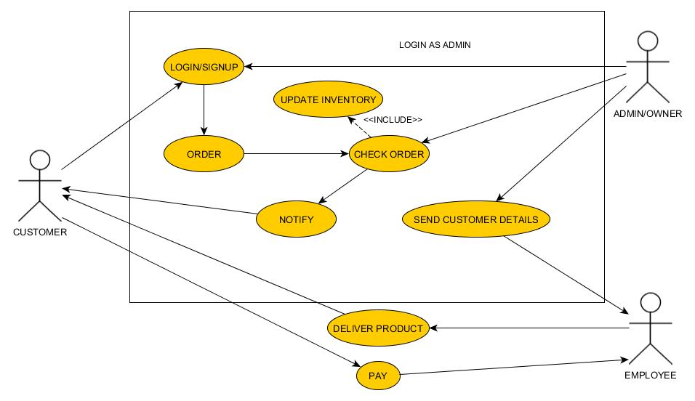

# Use-case narrative

# Login/Signup

|  |  |
| --- | --- |
| **Name** | Login |
| **Actor** | Customer |
| **Description** | Customer need to login to be able to order |
| **Basic Flow** | 1.Customer input login information.  2. login successful |
| **Alternative Flow** | 2.1 Login unsuccessful  2.1a. Login information is wrong.  2.1b. Connection Problem.  2.1c. Customer not yet registered.  2.2 Customer click register now.  2.3 Customer input name and other required field in order to create account  2.4 Website check registration form  2.5 Account will be added to database  2.6 Customer can now login |
| **Pre-condition** | Customer must input correct login information |
| **Post-condition** | Customer can order |
| **Assumptions** | **Customer wants to order product.** |

# Order

|  |  |
| --- | --- |
| **Name** | Order |
| **Actor** | Customer |
| **Description** | Customer place order |
| **Basic Flow** | 1. After customer browse the site and found what he/she wants. 2. Click the product. 3. The site will give order form. 4. Customer fill up order form. 5. Send order request. 6. Request sent. |
| **Alternative Flow** | * 1. Can’t send request   6.1a There is a problem with the connection  6.1b Customer did not fill up all the required field.  6.2 Customer send another request  6.3 Customer will now wait for confirmation |
| **Pre-condition** | Customer must click the product he or she wants |
| **Post-condition** | Customer will wait for order |
| **Assumptions** | **There is a problem with the server or connection that’s why the system can’t send request.** |

# Check Order

|  |  |
| --- | --- |
| **Name** | Check order |
| **Actor** | Owner |
| **Description** | Owner will check the order |
| **Basic Flow** | 1. Owner will check the order 2. Owner will check the inventory if there are still stocks 3. Owner will validate the order 4. Owner will give order to employee 5. Employee will deliver the product |
| **Alternative Flow** | 2.1. There is no stock left.  2.2. Owner will contact customer.  2.3 Owner will cancel order. |
| **Pre-condition** | Customer must order to the site and complete the requirements |
| **Post-condition** | Orders will be delivered |
| **Assumptions** | **Customer ordered a product** |

# Login/Signup

|  |  |
| --- | --- |
| **Name** | Login/Signup |
| **Actor** | Owner |
| **Description** | This is a login/signup for admin/owner |
| **Basic Flow** | 1.Owner input login information  2.Owner access inventory  3.Owner checks stocks  4.Owner checks orders |
| **Alternative Flow** | 1.1 Can’t login  1.1a. Login information is wrong  1.2 Owner put login information again.  1.3 Login information correct  1.4 Proceed to basic flow number 2 |
| **Pre-condition** | Owner must input correct login information |
| **Post-condition** | Owner can check stocks and orders |
| **Assumptions** | **Owner wants to check stocks.** |

# Notify

|  |  |
| --- | --- |
| **Name** | Notify |
| **Actor** | Owner |
| **Description** | Owner verified the order |
| **Basic Flow** | 1.Owner check inventory  2.Owner check or verify order  3. Owner send notification to customer  4. Notification sent |
| **Alternative Flow** | 4.1 Can’t send notification  2a. There is a problem with connection.  4.2 Owner send another notification  4.3. System proceed to step 4 in basic flow |
| **Pre-condition** | Owner must check order details |
| **Post-condition** | Owner can send notification properly |
| **Assumptions** | **Someone ordered** |

# Update inventory

|  |  |
| --- | --- |
| **Name** | Update Inventory |
| **Actor** | Owner |
| **Description** | Owner check stocks. |
| **Basic Flow** | 1. Owner log in.  2. Owner check stocks.  3. Owner saw there is only a few stocks left.  4. Owner will order/buy stocks  5. Owner update inventory. |
| **Alternative Flow** | 3.1 There is still lot of stocks left.  3.2 Owner will proceed to step 5 in basic flow |
| **Pre-condition** | Owner must login. |
| **Post-condition** | Owner check and update stocks. |
| **Assumptions** | **Owner wants to check stocks** |

# Send Customer Details

|  |  |
| --- | --- |
| **Name** | Send Customer Details |
| **Actor** | Owner |
| **Description** | Owner is done checking customer order. |
| **Basic Flow** | 1. Owner verified and approved order. 2. Owner send customer details to employee |
| **Alternative Flow** | 1.1 Owner Declined order  1.2 Owner will not send anything to employee |
| **Pre-condition** | There must be a customer order request |
| **Post-condition** | Owner can send details to employee for delivery |
| **Assumptions** | **Owner wants to check stocks** |
|  |  |

# Deliver Product

|  |  |
| --- | --- |
| **Name** | Deliver Product |
| **Actor** | Employee |
| **Description** | Employee get a customer details from owner |
| **Basic Flow** | 1. Employee received customer and order details from owner 2. Employee packed the order 3. Employee Deliver product. |
| **Alternative Flow** | 1.1 Employee Did not received any customer details or order details   1. Employee will not deliver anything 2. Employee will continue making different kind of ice. |
| **Pre-condition** | There must be an approved order. |
| **Post-condition** | Employee will deliver product |
| **Assumptions** | **There is a customer order need to be delivered** |

# Pay

|  |  |
| --- | --- |
| **Name** | Pay |
| **Actor** | Customer |
| **Description** | Payment process |
| **Basic Flow** | 1. Customer received product. 2. Customer pay to the employee Via Cash on delivery |
| **Alternative Flow** | 1.1Customer did not received anything  1.1a. Customer did not order anything  1.1b. Order has been declined |
| **Pre-condition** | Customer must order something. |
| **Post-condition** | Customer order will be delivered. |
| **Assumptions** |  |

# Function Decomposition Diagram

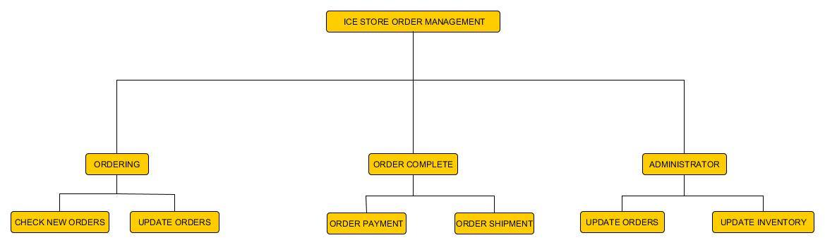

This diagram shows the different functions that happened inside the proposed system

# Class Diagram

This diagram provides an overview of the target system by describing the objects and classes inside the system and the relationships between them, in this diagram it also shows what the class can do

# Sequence Diagrams

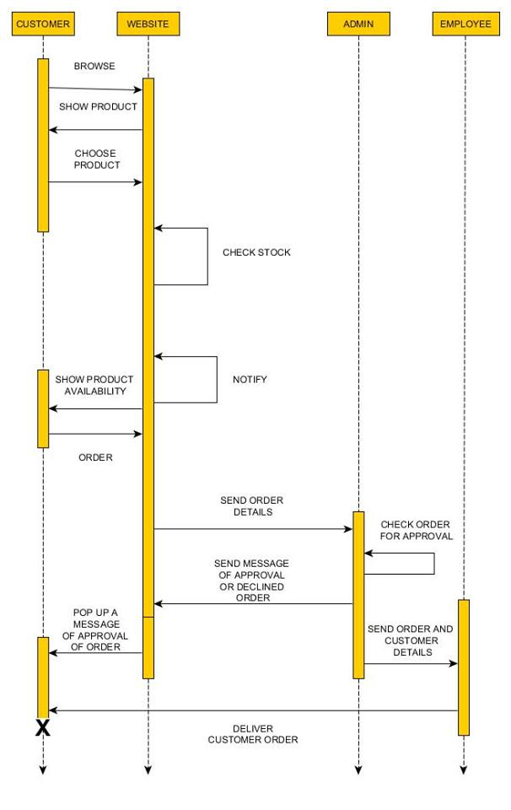 The sequence diagram models the collaboration of objects based on time sequence. It shows how the objects interact with others in a particular scenario of use case

# Sequence Diagram Sign up

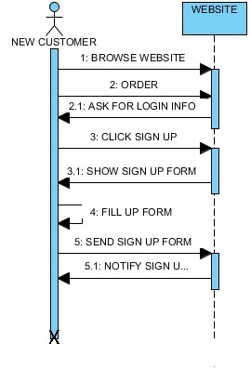

# Sequence Diagram Login

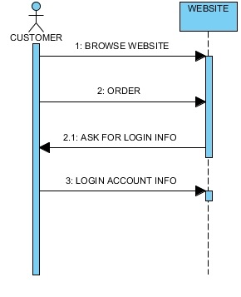

# Sequence Diagram Order

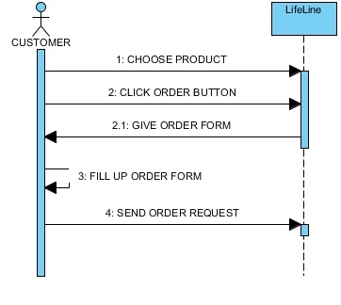

# C:\Users\BAN\Desktop\Projects\SYSADD1\New folder\Sequence Diagram5.jpgSequence Diagram Check Order

# Sequence DiagramC:\Users\BAN\Desktop\Projects\SYSADD1\New folder\Sequence Diagram6.jpg Login for admin

# Sequence Diagram Notify

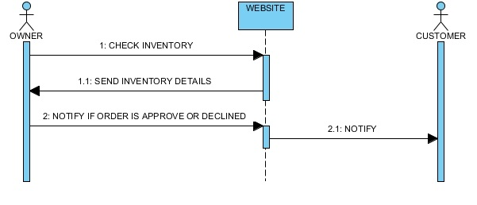

# Sequence Diagram Update Inventory

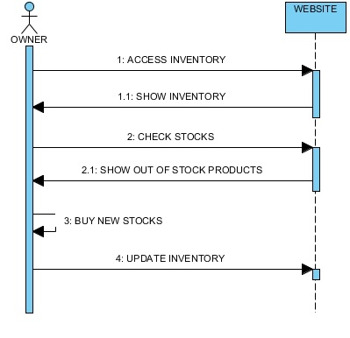

# C:\Users\BAN\Desktop\Projects\SYSADD1\New folder\Sequence Diagram9.jpgSequence Diagram Send Customer Details

# C:\Users\BAN\Desktop\Projects\SYSADD1\New folder\Sequence Diagram10.jpgSequence Diagram Deliver Product

# Sequence Diagram Pay

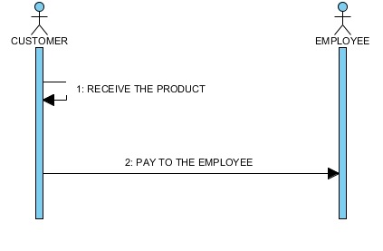

# State Transition Diagram

State transition diagram can show the different state of an entity also how an entity responds to various events by changing from one state to another.

# Activity Diagram

. The activity diagram can help to describe the flow of control of the target system, in this diagram the team shows the flow when a customer is browsing website and orders product

# Context Flow Diagram

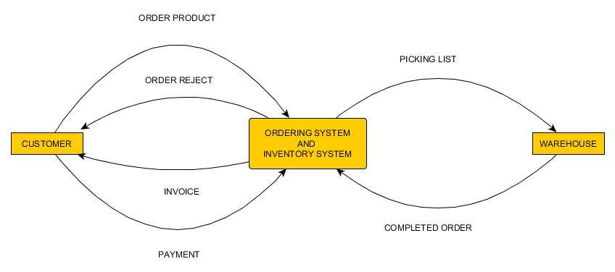

The Context Diagram shows the system under consideration as a single high-level process and then shows the relationship that the system has with other external entities. This diagram shows the different input to the system and the output of the system.

# Data Flow Diagram

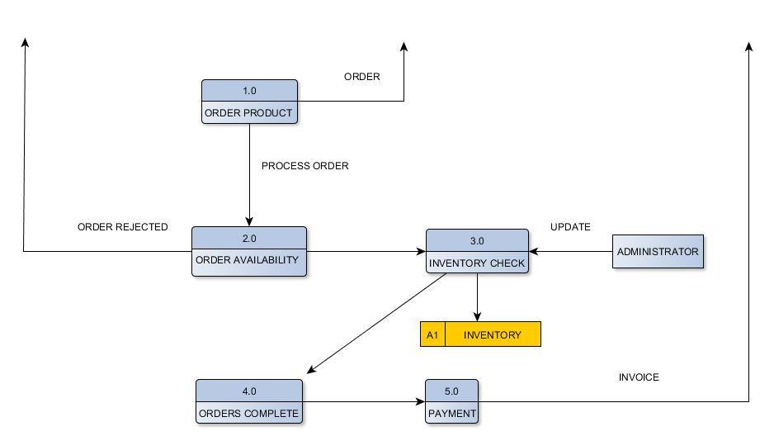

Data flow diagram maps out the flow of information for any process or system. This diagram shows the flow inside the ordering system.

# Entity Relationship Diagram,

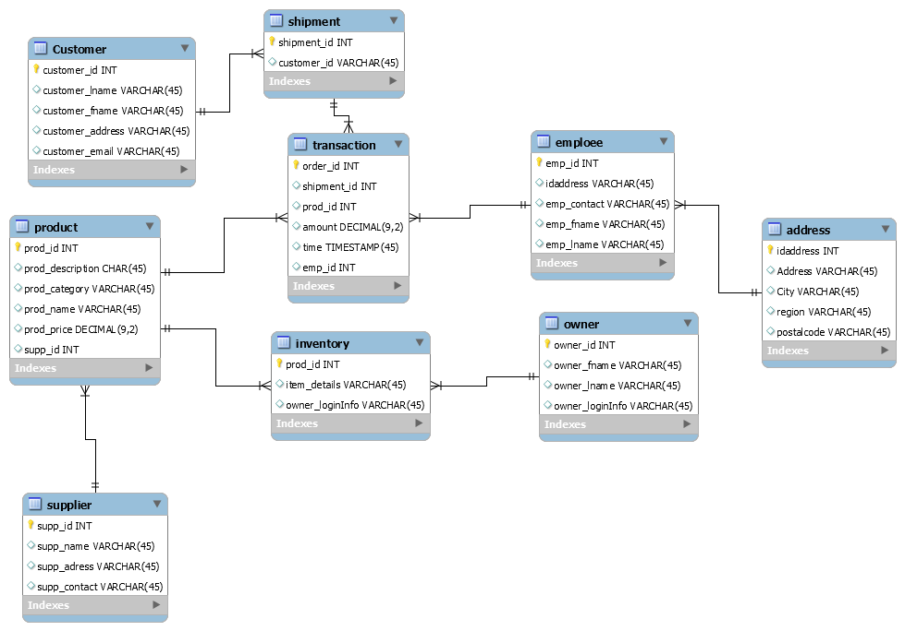

# Data Dictionary

|  |  |  |  |
| --- | --- | --- | --- |
| Column Name | Name | Type | Null |
| Customer_id | Customer ID | INT | NO |
| Customer_lname | Customer last name | VARCHAR | NO |
| Customer_fname | Customer first name | VARCHAR | NO |
| Customer_address | Customer address | VARCHAR | NO |
| Customer_email | Customer email address | VARCHAR | NO |
| Shipment_id | Shipment ID | VARCHAR | NO |
| prod_id | Product ID | INT | NO |
| prod_description | Product description | VARCHAR | NO |
| prod_category | Product category | VARCHAR | NO |
| prod_name | Product name | VARCHAR | NO |
| prod_price | Product price | DECIMAL | NO |
| supp_id | Supplier ID | INT | NO |
| supp_name | Supplier name | VARCHAR | NO |
| supp_address | Supplier address | VARCHAR | NO |
| supp_contact | Supplier contact | VARCHAR | NO |
| Item_details | Item details | VARCHAR | NO |
| Owner_loginInfo | Owner login information | VARCHAR | NO |
| Owner_id | Owner ID | INT | NO |
| Owner_fname | Owner first name | VARCHAR | NO |
| Owner_lname | Owner last name | VARCHAR | NO |
| Owner_loginInfo | Owner login information | VARCHAR | NO |
| emp_id | Employee ID | INT | NO |
| emp_address | Employee Address | VARCHAR | NO |
| emp_contact | Employee contact | VARCHAR | NO |
| emp_fname | Employee first name | VARCHAR | NO |
| emp_lname | Employee last name | VARCHAR | NO |
| idaddress | Address ID | INT | NO |
| address | Address | VARCHAR | NO |
| City | City | VARCHAR | NO |
| Region | Region | VARCHAR | NO |
| Postalcode | Postal code | VARCHAR | NO |
| Amount | Order amount | DECIMAL | NO |
| time | Order time | TIME | NO |

# Initial Design

