

**SUSAN ICE STORE**

**ORDERING AND INVENTORY SYSTEM**

**Members:**

**Potian, Leonard**

**Valdez, Nelaine Kriscel**

**Final Document Submitted in Fulfilment of the**

**Requirements for the Course of CSPROJ2**

**Asia Pacific College**

**Date Created:**

**August 20, 2017**

**Submitted to:**

**Manuel Sebastian Sanchez**

**CSPROJ Instructor**

Contents

Executive Summary 4

Introduction 4

1.Project Context 4

2.Purpose and Description 4

3.General Objectives 4

4.Scope and Limitations 4

Review of Related Literature/Systems 5

Technical Background 6

Methodology, Results and Discussion 7

1.Requirements Analysis 7

2.Requirements Documentation 7

3.Design of Software, Systems, Product, and/or Processes 7

4.Development and Testing, where applicable 7

Appendices 8

Diagrams 11

Figure 1.0 Use-case 11

Figure 1.1 Use-case Narrative 12

Figure 1.1.1 Order 12

Figure 1.1.2 Fill-out Personal Info 12

Figure 1.1.3 Check Order 13

Figure 1.1.4 Login 13

Figure 1.1.5 Notify 14

Figure 1.1.6 Update inventory 14

Figure 1.1.7 Send Customer Details 15

Figure 1.1.8 Deliver Product 15

Figure 1.1.9 Pay 16

Figure 2.0 Function Decomposition Diagram 17

Figure 3.0 Class Diagram 18

Figure 4.0Sequence Diagrams 19

Figure 4.1 Sequence Diagram Order 20

Figure 4.2 Sequence Diagram Fill-out Personal Info 21

Figure 4.3 Sequence Diagram Check Order 22

Figure 4.4 Sequence Diagram Notify 22

Figure 4.5 Sequence Diagram Update Inventory 23

Figure 4.6 Sequence Diagram Send Customer Details 23

Figure 4.7 Sequence Diagram Deliver Product 24

Figure 4.8 Sequence Diagram Pay 24

Figure 5.0 State Transition Diagram 25

Figure 5.0 Activity Diagram 26

Figure 6.0 Context Flow Diagram 27

Figure 7.0 Data Flow Diagram 28

Figure 8.0 Entity Relationship Diagram 29

Software Requirements Specification 30

Introduction 32

Overall Description 33

External Interface Requirements 34

System Features 35

Functional Requirements 35

Other Nonfunctional Requirements 36

Other Requirements 36

Vision and Scope Document 37

Business Requirements 39

Vision of the Solution 40

Scope and Limitations 40

Business Context 41

User Manual 43

Change Management Plan 46

Introduction 47

Change Management Approach 47

Definitions of Change 47

Change Control Board 48

Roles and Responsibilities 48

Change Control Process 49

Sponsor Acceptance 49

Quality Plan 50

Introduction 50

Project Contractual Information 50

Scope of Work and Quality Objectives 51

Project Organisation 51

Project Duration and Scheduling 52

Deliverables 53

Progress Status Report 55

Review of Quality Plan 61

Document and Record Control 61

Additional Information 61

**Executive Summary**

Susan Ice Store is owned by a single person. The said store only sells its products through a physical store. The proposed system would give the owner of Susan ice store an ordering system. This is an online ordering system where she would be able to transact with her customers through the orders created. The project is all about an ordering and inventory system.

**Introduction**

**1.Project Context**

Susan Ice Store is one of the top Ice store in Pasay City. They are delivering all kinds of ice in some variety stores, eatery, and schools around Pasay area. Ordering management is a computer-based software application for ordering online. The inventory system help track the orders, and inventory of the product. This software will organize the information and data that the Store manually records on paper.

**2.Purpose and Description**

* To gain more customers by deploying the website.
* To improve sales by ordering via web-application.
* To make the ordering and inventory transactions faster and convenient.

**3.General Objectives**

* To implement the system to the store
* To provide the client with ease in the transaction of her business.
* To attract her loyal customers to use Web-based system.
* To train her employees on this new system.

**4.Scope and Limitations**

The team will be focusing on the function of the proposed system. And the client will be trained on how to use the web-based system. The system will run on desktop and laptop only.  And it has a maximum limit of users’ due to server issues.

The scopes of the proposed system are ordering system and inventory system. The system will only work for the citizens in Villamor area only. The ordering system covers the ordering process and the inventory system can update orders and stocks of the product.

**Review of Related Literature/Systems**

|  |  |  |  |  |
| --- | --- | --- | --- | --- |
|  | **Globe Inventory and Ordering System** | **Susan Ice Store Inventory and Ordering System** | **Sales Binder Online Inventory Management Software** | **Menufy Restaurant Online Ordering System** |
| **Description** | Cost effective and highly innovative inventory management that provides instant access to stock levels. | Susan Ice Store Inventory System will help the owner of the store track orders and   inventory | SalesBinder is an all-in-one online inventory management system that is easy to use. Organize your customers, sales leads, purchase orders, estimates, invoices and much more. Plus, there is nothing to install. | Menufy is a Restaurant Online Ordering System that deliver foods to the customer for free. |
| **Feature** | * Allows users to order supplies based on the most current data * Minimize overstocking * Gives better control over the supply chain * Allows orders online or via SMS | * Order Management * Inventory Management * Sales Management * Reports Module * Allow orders online | * Purchase Orders * Customers information * Report Module * Customer Permissions * Inventory Management for tracking orders | * Free online Ordering website * SMS (text message), fax, and email notifications * Order history reporting * web-friendly |

**Technical Background**

**Software Environment**

1.Programming Languages

* PHP
* CSS
* HTML

2.Specific Software

XAMPP CONTROL PANEL

3.PHPMyAdmin

**Web-based Server System Requirements**

**1.Minimum Hardware Requirements**

* Processor**:** Dual Core CPU 1.5GHz
* Instruction Set**:** 32-bit
* RAM: 2GB
* HDD: 250GB

**2.Operating System**

* Windows 7 SP1 (32-bit/64-bit); OR
* Microsoft Windows Server 2008 SP2 (32-bit); OR
* Microsoft Windows Server 2012 (64-bit)

**3.Database Requirements**

* XAMPP Control Panel

**4.Server**

* Apache

**Methodology, Results and Discussion**

**1.Requirements Analysis**

Online ordering services are websites set up for customer to select from interactive menus provided so as the ordering process can take place. For ordering to take place, any sorts of internet capable PC which support complex web pages are used.

**2.Requirements Documentation**

This requirements document states the requirements for the ordering system.

The product prototype provides user account creation, user login and owner privilege to check the user account the prototype also can encrypt password.

**3.Design of Software, Systems, Product, and/or Processes**

The programming used by the team is HTML, PHP AND CSS.. Each table in the database are generated with create, read, update and delete (C.R.U.D). To achieve the main function of the prototype, the model, view and controller of the framework are modified.

**4.Development and Testing, where applicable**

The developers performed the agile development where the team undergo iterations to improve the system based on the needs of the client.

Features tested:

* + Admin privilege to manage the inventory
  + Order auto compute
  + Admin updated inventory
  + Easy to order
  1. **Description of the Prototype, where applicable**

The prototype that the team developed can create account with encrypted password for each user and admin privilege to manage user and admin accounts. Unfortunately, there are still modules that are not completed but will be completed on the next phase or course.

4.2 **Implementation Plan (Infrastructure/Deployment) where needed**

The first phase of the implementation plan is the discovery analysis of the problem. In this phase the team set initial meetings and consultation with their adviser to identify the problems and needs of the client.

Second is the design phase, In this phase the team planned about the user interface of the system. The team will also be working on the configuration of the new system.

Third phase is the development phase, In this stage of the implementation plan, the system will program and deployed with its functionality.

Fourth phase is the iteration stage, In this stage the system will be test by client with the development team to check if there are improvement needed.

Fifth stage is the deployment stage This is where the team will deploy the system to be use by the users.

**Appendices**

Order Form

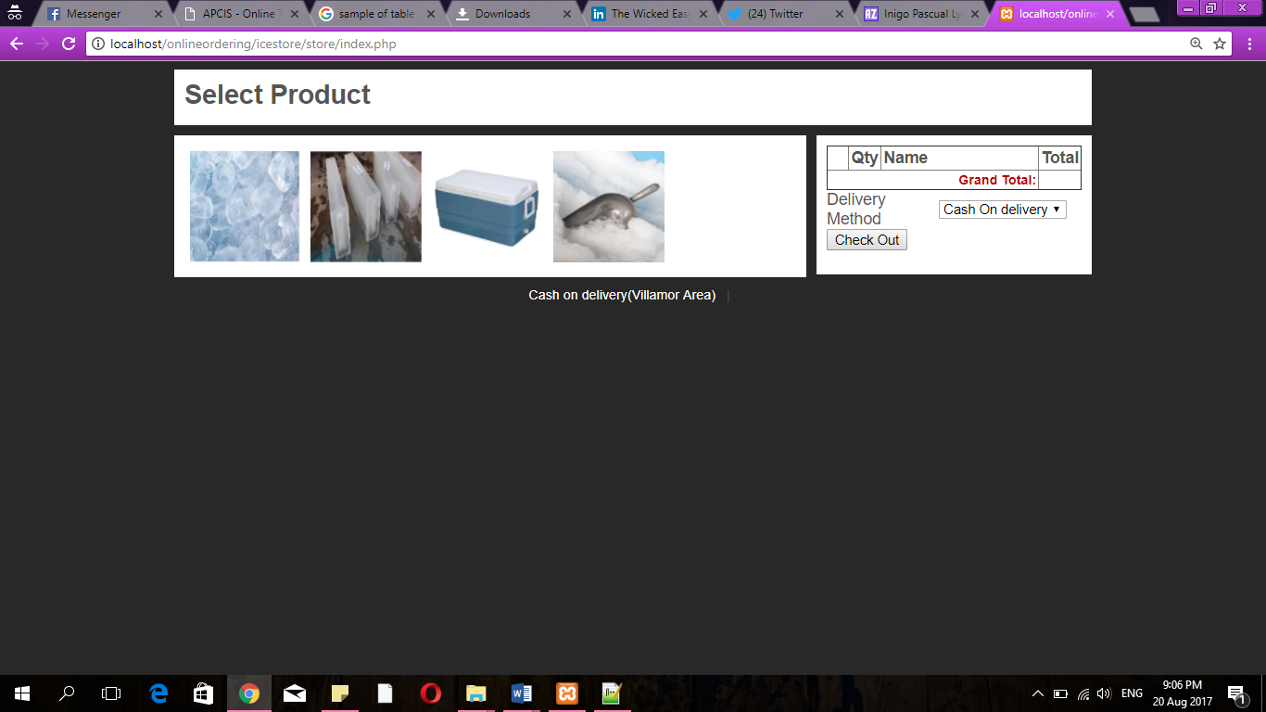

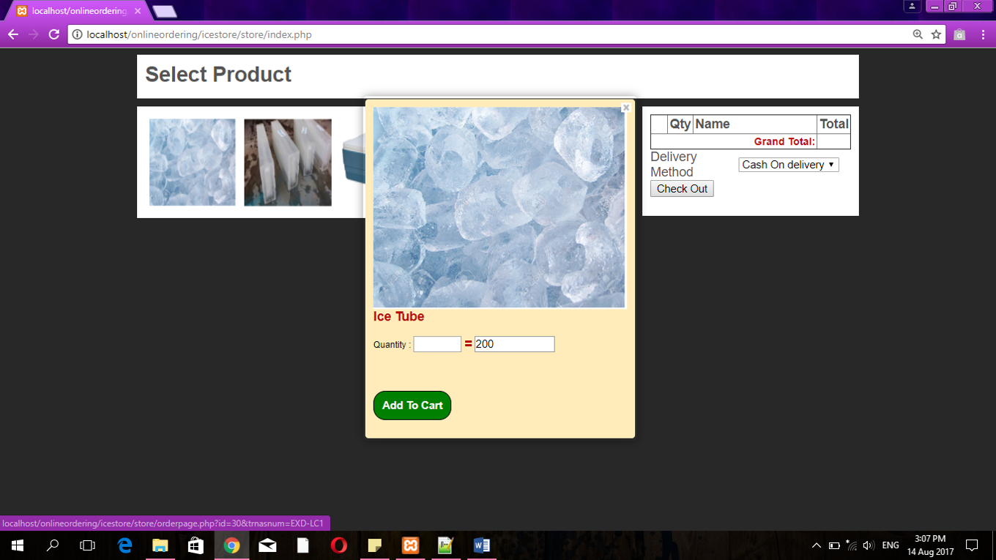

About Us

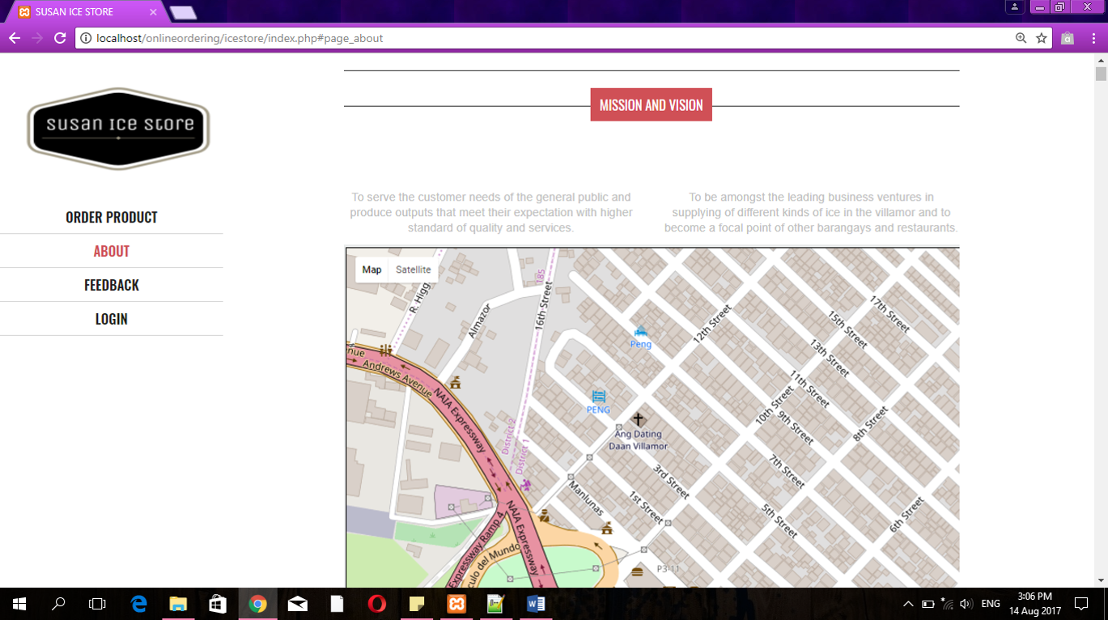

Feedback Form

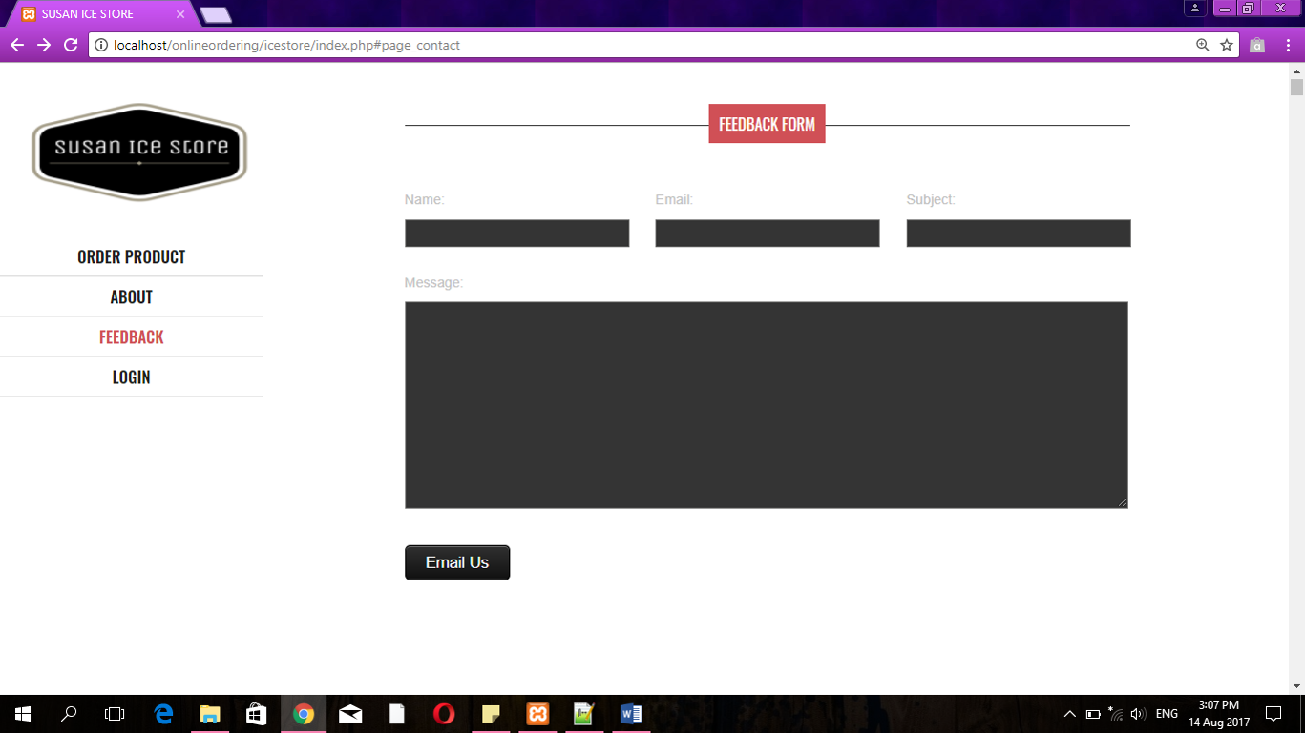

Admin Panel

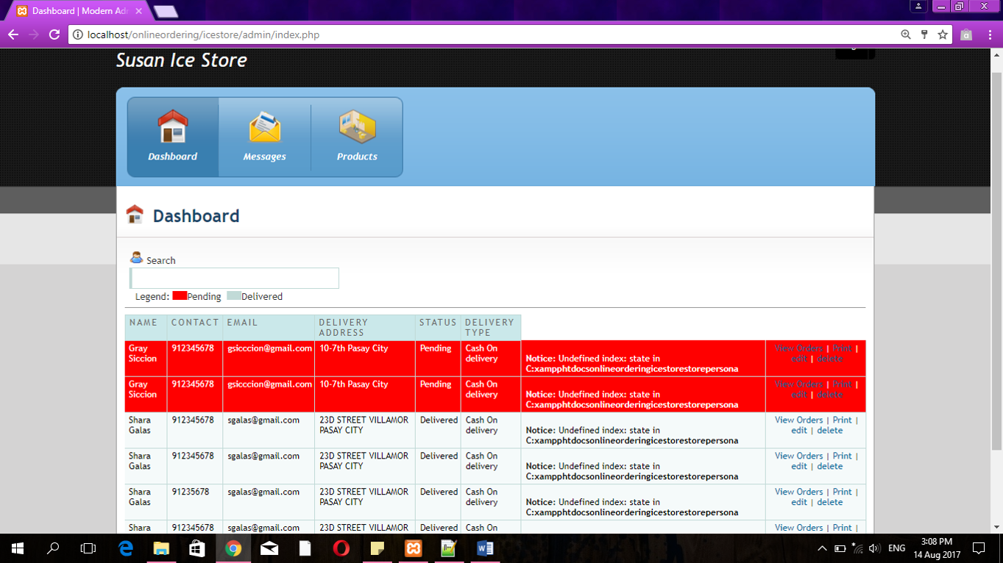

**Diagrams**

Figure 1.0 Use-case

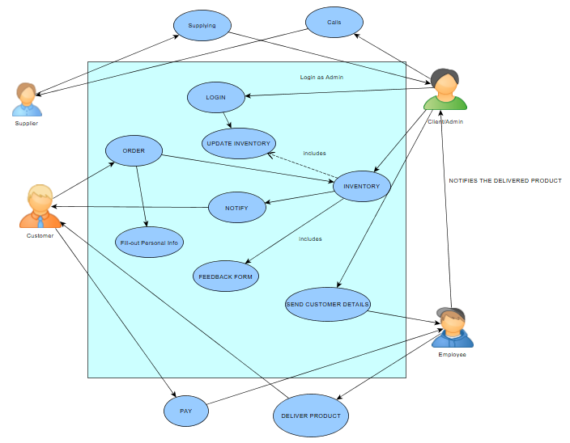

Figure 1.1 Use-case Narrative

Figure 1.1.1 Order

|  |  |
| --- | --- |
| **Name** | Order |
| **Actor** | Customer |
| **Description** | Customer place order |
| **Basic Flow** | 1. Click the product. 2. The site will give order form. 3. Customer fill up order form. 4. The customer will see the total orders 5. Request sent. |
| **Alternative Flow** | * 1. Can’t send request   1.1a There is a problem with the connection  1.1b Customer did not fill up all the required field.       2. Customer send another request       3. Admin will not receive the customer’s order |
| **Pre-condition** | Customer must click the product he or she wants |
| **Post-condition** | Customer will wait for order |
| **Assumptions** | **There is a problem with the server or connection that’s why the system can’t send request.** |

Figure 1.1.2 Fill-out Personal Info

|  |  |
| --- | --- |
| **Name** | Fill-out Personal Info |
| **Actor** | Customer |
| **Description** | Customer will fill-out their personal info |
| **Basic Flow** | 1. Customer will submit their personal info 2. Admin will receive the customer details 3. Admin will update the customer’s order status |
| **Alternative Flow** | 1.Customer did not fill-up the personal info form  2.Admin did not receive any orders from the customer |
| **Pre-condition** | The admin will approve the order |
| **Post-condition** | The admin will send a message to the customer for success order |
| **Assumptions** | **The admin will inform the employee for the orders** |

Figure 1.1.3 Check Order

|  |  |
| --- | --- |
| **Name** | Check order |
| **Actor** | Owner |
| **Description** | Owner will check the order |
| **Basic Flow** | 1. Owner will check the order 2. Owner will check the inventory if there are stocks 3. Owner will validate the order 4. Owner will give order to employee 5. Employee will deliver the product |
| **Alternative Flow** | 2.1. There is no stock left.        2.2. Owner will contact customer.        2.3 Owner will cancel order. |
| **Pre-condition** | Customer must order to the site and complete the requirements |
| **Post-condition** | Orders will be delivered |
| **Assumptions** | **Customer ordered a product** |

Figure 1.1.4 Login

|  |  |
| --- | --- |
| **Name** | Login |
| **Actor** | Client |
| **Description** | This is a login/signup for Admin/Client |
| **Basic Flow** | 1.Admin input login information  2. Admin access inventory  3. Admin checks stocks  4. Admin checks orders |
| **Alternative Flow** | 1.1 Admin Can’t login  1.1a. Login information is wrong.  1.2 Admin put login information again.  1.3 Login information correct.  1.4 Proceed to basic flow number 2 |
| **Pre-condition** | Admin must input correct login information |
| **Post-condition** | Admin can check stocks and orders |
| **Assumptions** | Admin **wants to check stocks.** |

Figure 1.1.5 Notify

|  |  |
| --- | --- |
| **Name** | Notify |
| **Actor** | Admin |
| **Description** | Admin verified the order |
| **Basic Flow** | 1. Admin check inventory  2. Admin check or verify order  3. Admin send notification to customer  4. Notification sent |
| **Alternative Flow** | 4.1 Can’t send notification  4.1a. There is a problem with connection.  4.2 Admin send another notification  4.3. System proceed to step 4 in basic flow |
| **Pre-condition** | Admin must check order details |
| **Post-condition** | Admin can send notification properly |
| **Assumptions** | **Someone ordered** |

Figure 1.1.6 Update inventory

|  |  |
| --- | --- |
| **Name** | Update Inventory |
| **Actor** | Admin |
| **Description** | Admin check stocks. |
| **Basic Flow** | 1. Admin log in.  2. Admin check stocks.  3. Admin will see if there is only a few stocks left.  4. Admin will order/buy stocks  5. Admin update inventory. |
| **Alternative Flow** | 3.1 There is still lot of stocks left.  3.2 Admin will proceed to step 5 in basic flow |
| **Pre-condition** | Admin must login. |
| **Post-condition** | Admin check and update stocks. |
| **Assumptions** | Admin **wants to check stocks** |

Figure 1.1.7 Send Customer Details

|  |  |
| --- | --- |
| **Name** | Send Customer Details |
| **Actor** | Admin |
| **Description** | Admin is done checking customer order. |
| **Basic Flow** | 1. Admin verified and approved order. 2. Admin send customer details to employee |
| **Alternative Flow** | 1.1 Admin Declined order        1.2 Admin will not send anything to employee |
| **Pre-condition** | There must be a customer order request |
| **Post-condition** | Admin can send details to employee for delivery |
| **Assumptions** | Admin **wants to check stocks** |
|  |  |

Figure 1.1.8 Deliver Product

|  |  |
| --- | --- |
| **Name** | Deliver Product |
| **Actor** | Employee |
| **Description** | Employee get a customer details from Admin |
| **Basic Flow** | 1. Employee received customer and order details from Admin 2. Employee packed the order 3. Employee Deliver product. |
| **Alternative Flow** | 1.1 Employee Did not received any customer details or order details   1. Employee will not deliver anything 2. Employee will continue making different kind of ice. |
| **Pre-condition** | There must be an approved order. |
| **Post-condition** | Employee will deliver product |
| **Assumptions** | **There is a customer order need to be delivered** |

Figure 1.1.9 Pay

|  |  |
| --- | --- |
| **Name** | Pay |
| **Actor** | Customer |
| **Description** | Payment process |
| **Basic Flow** | 1. Customer received product. 2. Customer pay to the employee Via Cash On Delivery |
| **Alternative Flow** | 1.1 Customer did not receive anything  1.1a. Customer did not order anything  1.1b. Order has been declined |
| **Pre-condition** | Customer must order something. |
| **Post-condition** | Customer order will be delivered. |
| **Assumptions** |  |

Figure 2.0 Function Decomposition Diagram

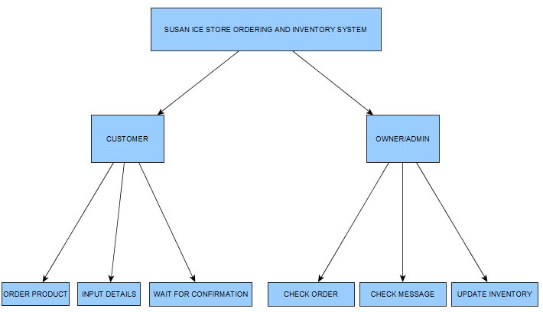

This diagram shows the different functions that happened inside the proposed system

Figure 3.0 Class Diagram

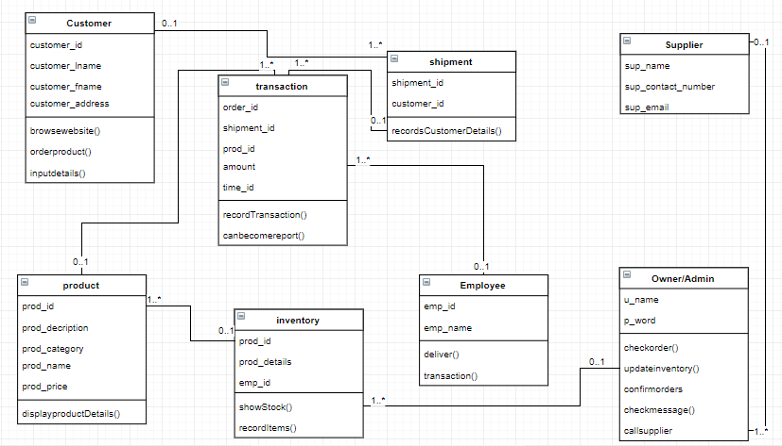

This diagram provides an overview of the target system by describing the objects and classes inside the system and the relationships between them, in this diagram it also shows what the class can do.

Figure 4.0Sequence Diagrams

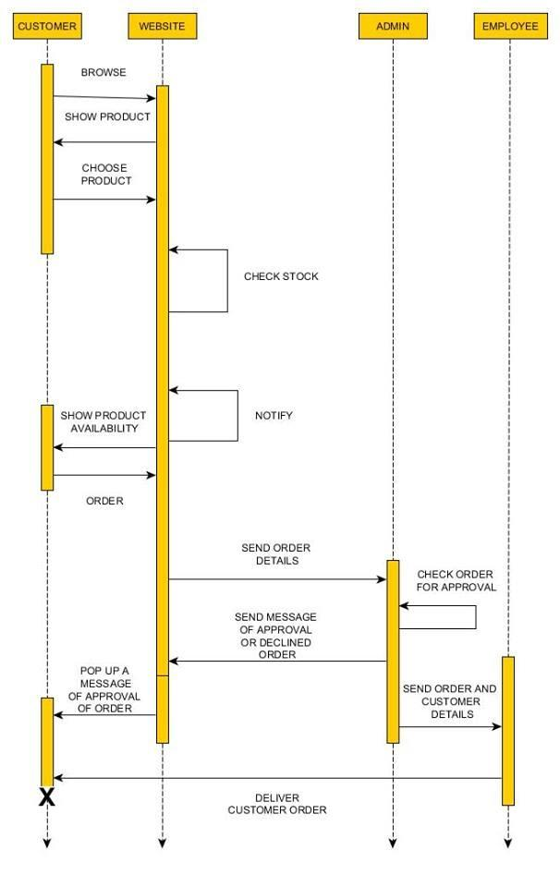The sequence diagram shows the collaboration of objects based on time sequence. It shows how the objects interact with others in a scenario of use case

Figure 4.1 Sequence Diagram Order

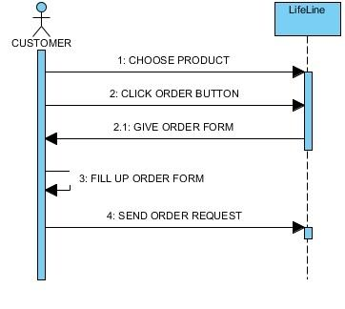

Figure 4.2 Sequence Diagram Fill-out Personal Info

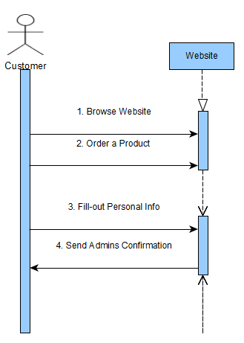

Figure 4.3 Sequence Diagram Check Order

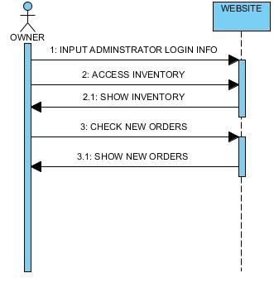

Figure 4.4 Sequence Diagram Notify

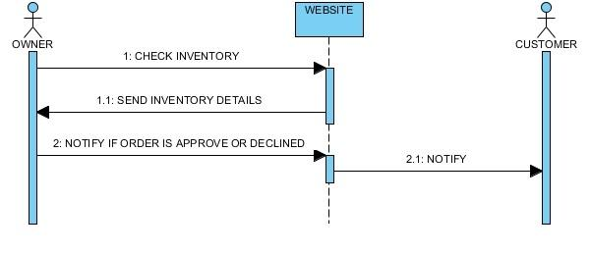

Figure 4.5 Sequence Diagram Update Inventory

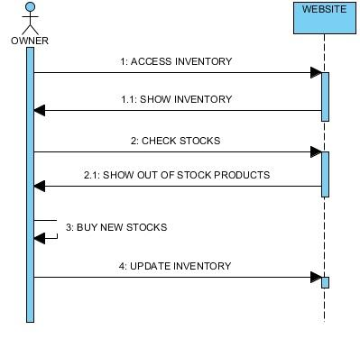

Figure 4.6 Sequence Diagram Send Customer Details

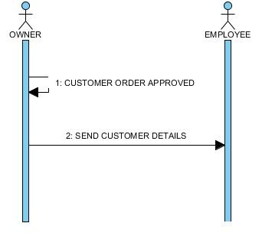

Figure 4.7 Sequence Diagram Deliver Product

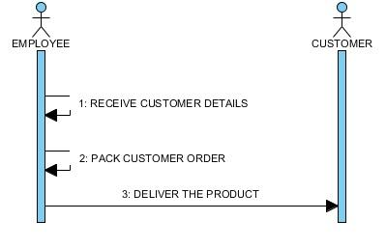

Figure 4.8 Sequence Diagram Pay

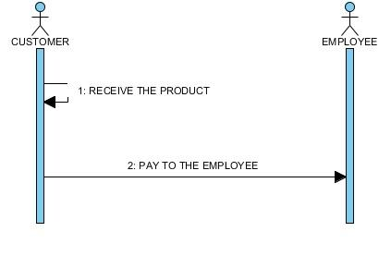

**Figure 5.0 State Transition Diagram**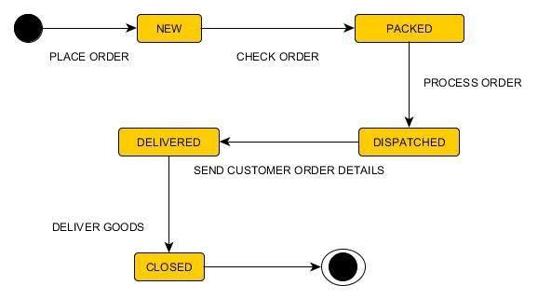

State transition diagram shows the different state of an entity also how an entity responds to various events by changing from one state to another.

Figure 5.0 Activity Diagram

Customer Using the Website

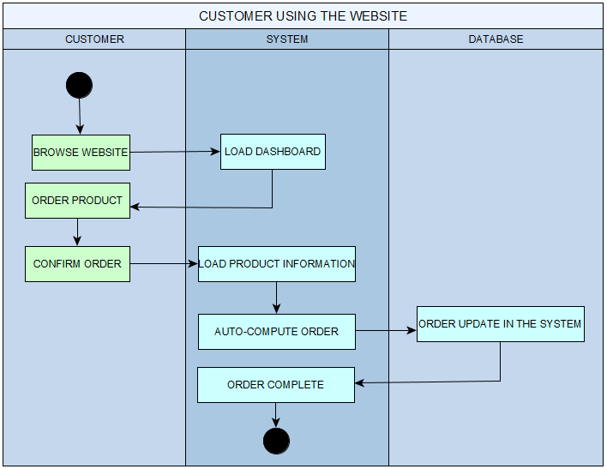

The activity diagram describes the flow of control of the target system, this diagram shows the flow when a customer is browsing website and ordering a product.

Admin Using the Website  
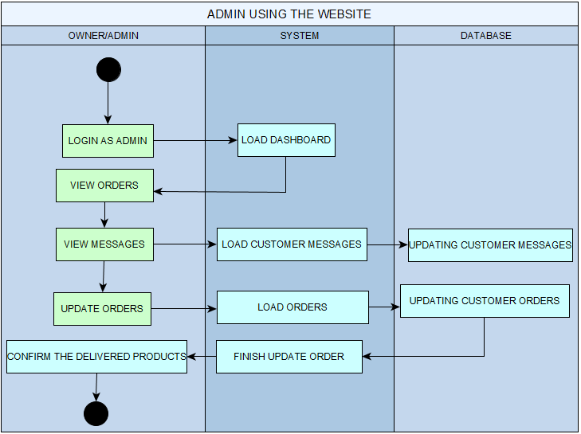

Figure 6.0 Context Flow Diagram

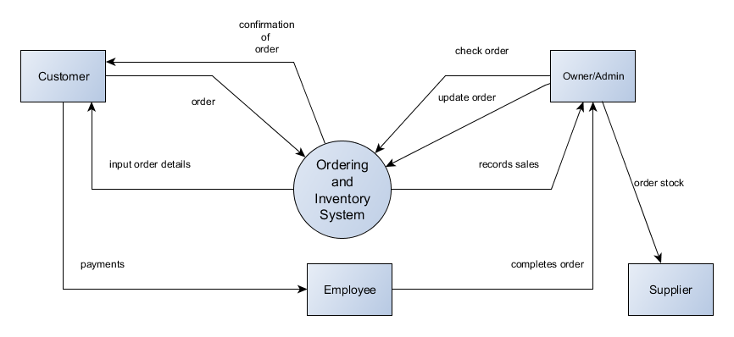

The Context Diagram shows the system under consideration as a single high-level process and then shows the relationship that the system has with other external entities. This diagram shows the different input to the system and the output of the system.

Figure 7.0 Data Flow Diagram

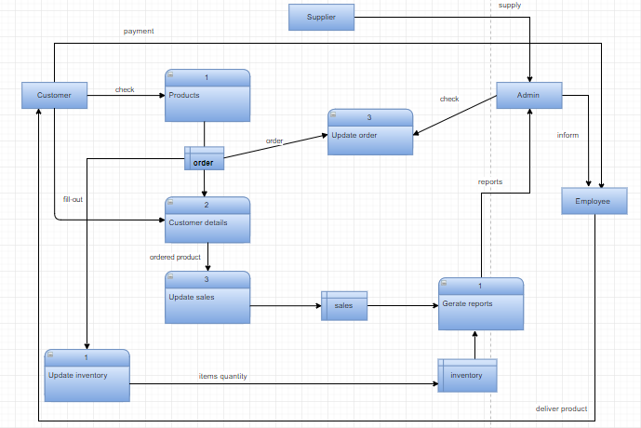

Data flow diagram maps out the flow of information for any process or system. This diagram shows the flow inside the ordering system.

Figure 8.0 Entity Relationship Diagram

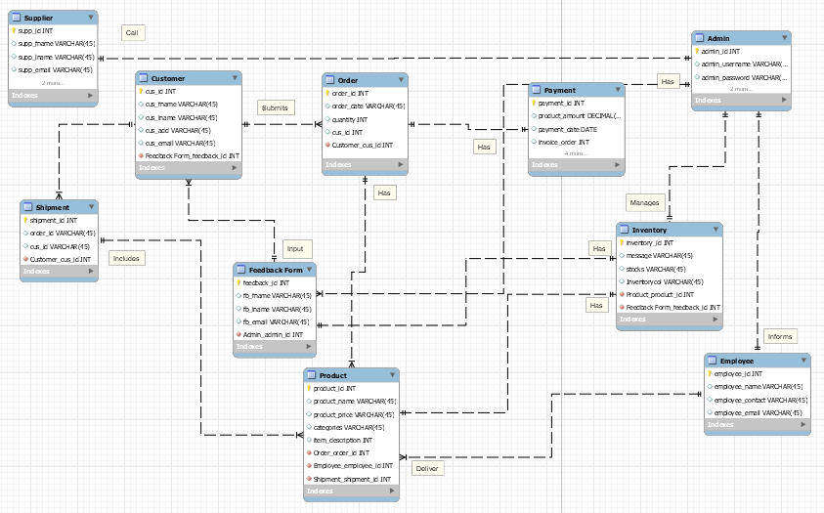

**Software Requirements** **Specification**

**for**

**Susan Ice Store**

**Ordering and Inventory System**

**Version 1.2 approved**

**Prepared by:**

**Leonard Potian**

**Nelaine Valdez**

**CSPROJ**

**Revision History**

|  |  |  |  |
| --- | --- | --- | --- |
| **Name** | **Date** | **Reason for Changes** | **Version** |
| Leonard Potian |  | Initial Draft | 1.0 |
|  |  |  |  |
|  |  |  |  |

**1. Introduction**

**1.1 Purpose**

* To gain more customers by deploying the website.
* To improve sales by attracting customers to order online.
* To make the ordering and inventory transactions faster and convenient.

**1.2 Document Conventions**

The application that the team used in this document is Microsoft Word 2016 with the font Arial and size 12. The heading Times new roman size 14.

**1.3 Intended Audience and Reading Suggestions**

The document is intended for the developers, project manager, users, testers and documentation writers. The system requirements specification contains the functionality of the system and the guidelines for the developer of the system. This technical document and the terms should be understood by the readers.

**1.4 Product Scope**

The project scope is to expand the business range from the current area to the outside of it. And to make ordering convenient for their customers by using the website. And the team will add more features which the users can easily use the website like the user have to input their information to register to the website.

**1.5 References**

Development Requirements Feb 20, 2017 from [www.exinfm.com/training/M2C3/srs_template.doc](http://www.exinfm.com/training/M2C3/srs_template.doc)   

**2. Overall Description**

**2.1 Product Perspective**

The product of Susan Ice Store is for some variety store, school, eatery, around Villamor Air Base, Pasay City only. The team can expand the range of the business by developing a modern website that the customers/users can use.

**2.2 Product Functions**

The major function of the website is an ordering and inventory system. In the ordering system, the users can place their orders and send it to the admin or the owner.

**2.3 User Classes and Characteristics**

The users of this product are some persons at a legal age, businessmen/women, and vendors in the stores. Before the team release the website, the team will have the tutorial of the website in the store and will invite the customer of the business.

**2.4 Operating Environment**

The software that the system developer will be using is HTML, CSS, PHP, and database server.

**2.5 Design and Implementation Constraints**

The issues that will limit the options for the developed is the database server, the website is limited to 30-500 users simultaneously. But the developer will make the website updated when the client using it.

**2.6 User Documentation**

The documentation that was used is Software Requirements Specification the project need to implement. Finally compared the software of the globe inventory and ordering system.

**2.7 Assumptions and Dependencies**

The system will be accessible online. The system has the procedure of the store However, this system is more organized compared to its manual counterpart. The developers assume that there are extra documents that will be added so that the software requirements will be fully understood by the user.

**3. External Interface Requirements**

**3.1 User Interfaces**

In the user interface of the website is when you browse the website you will proceed to the ordering level of the website and that’s the time the customer will input their details. And there will be a response to through email.

**3.2 Hardware Interfaces**

The Hardware that the system need is at least Quad Core CPU 1.5GHz minimum, a 2GB RAM.

**3.3 Software Interfaces**

The software of the project is HTML, CSS, PHP and database server with the updated version. The operating system that will implement is Windows 8 that can handle all the applications without error. Plus, windows are easy to use.

**3.4 Communications Interfaces**

The communication functions of this website, web browser, e-mail and database server to communicate with the customers. The system will be needing an internet connection in able to run properly.

**4. System Features**

* 1. **Add User**

4.1.1 Description and Priority

This feature is for customers who want to order online. This is a high priority in the project because it is one of the main functions of the system.

**4.2 Manage Inventory**

4.2.1 Description and Priority

This feature is for the admin if she wants to add product or check the stocks. This is also a high priority because one of the features is to give the owner of the store the privilege to manage the inventory.

4.2.2 Stimulus/Response Sequences

First the admin will log on to the system and the system will confirm if the login information is correct, if the information is correct she can now manage the inventory system of the website.

**4.3 Order**

4.2.1 Description and Priority

This feature is for customers who want to order a product. This is one of the main feature of the system because the system is not just a inventory management system. It is also an online ordering system. This is a high priority feature.

4.2.2 Stimulus/Response Sequences

First the user must choose a product that the user wants to order. After that, the system will give the instructions to the customers to complete the transactions.

**5. Functional Requirements**

The System aims to provide an efficient interface to the user for managing orders, it shall also provide the admin varied options for managing the inventory through various functions in hand. The ingredient levels are continuously monitored based on their usage and are checked for the threshold levels in the inventory and accordingly. The user is alerted about low levels of certain ingredients. The design is such that the user does not have to manually update the inventory every time, the System does if for the user.

**6. Other Nonfunctional Requirements**

Because the design patterns of the Online Ordering System are pretty much the standard for a web application, the non-functional requirements of the system are very straightforward. Although written using Google Web Toolkit, the application is cross-compiled to HTML, along with a PHP backend, all of which are supported by any reasonably well-maintained web server, although I would recommend Apache2, and particularly the free XAMPP distribution.

All the application data is stored in a MySQL database, and therefore a MySQL server must also be installed on the host computer. As with Apache, this software is freely available and can be installed and run under most operating systems.

The server hardware can be any computer capable of running both the web and database servers and handling the expected traffic. For an ordering system that is not expecting to see much web traffic, or possibly doing only a limited test run, an average personal computer may be appropriate. Once the site starts generating more hits, though, it will likely be necessary to upgrade to a dedicated host to ensure proper performance. The exact cutoffs will need to be determined through a more thorough stress testing of the system.

**7. Other Requirements**

**Security requirements**

Access to the database should be restricted to people that are required to view information. Passwords and ID’s should be regulated to be at least a certain length.

Requirement Planning

Requirement Documentation

Design of the software, systems and the process

Developing and Testing the system

Implementation Plan and Results

**Vision and Scope Document**

**for**

**Susan Ice Store**

**Version 1.0 approved**

Prepared by:

Leonard Potian

Nelaine Valdez

**CSPROJ**

**June 17 2017**

**Revision History**

|  |  |  |  |
| --- | --- | --- | --- |
| **Name** | **Date** | **Reason For Changes** | **Version** |
| Leonard Potian | 6/17/17 | Revision on improvement of the system | 1.0 |
|  |  |  |  |

**Business Requirements**

The Susan Ice Store Ordering and Inventory system is a web-based system that helps the client to improve her sales and to make the transaction faster using the website. It also helps the customer/users to order easily via online. The system will automate the new way of ordering using website. The project will be approved once the system is functioning smoothly.

**1.1.**  **Background**

Susan Ice Store is a store owned by a single person. The said store only sells its products through the owner's store. The proposed system would give the owner of Susan ice store her very own website wherein she would be able to transact with her customers through the orders created and shown to her by the system. The system would help the owner to expand the business.

**1.2. Business Opportunity**

Base to the owner the problem is the speed of transaction, and the client want to expand her business because for now the business is just delivering product in Villamor area. There are many web base ordering systems out there but the closest to our system would be competing with is the Globe Inventory and ordering system. Globe inventory and Ordering System is a cost efficient and highly innovative inventory management. The problem with this system is there are features that are not necessary for our client. The problems that cannot be solve with the product is the transaction speed and the potential growth of the business. This system will fit in with the market trends, because as you can see technology is evolving fast and almost everything you want to buy can be ordered online and we are now living in the internet era.

**1.3. Business Objectives and Success Criteria**

To operate web based ordering and inventory system which will help the client to ease her business by using the website. She can check all the transactions entering her website. The website will be user friendly for the customers because it was easy to use. To make their orders easier than the last system. The admin/client can easily access if she has an internet connection. She can view, update, and inform the customers if the transaction is finished.

**1.4. Customer or Market Needs**

The website will be available for the people around the said area. It will need an internet connection. The customer must register an account to access the website. The admin/owner can see all the transactions entering the website and she can check, delete, and update the website. These are the following that requires for the system:

* PC Server
* Database
* Internet access
* Approval of Client

**1.5. Business Risks**

The purpose of developing this project is to help the client to increase the sales of her business, and gain more customers. The part of the process will be the training.

**Vision of the Solution**

The system can solve the long-term problem of the store; the developer will make it easier to the users to use the system. Using the website, it will be easy for both the customer and the client to make the transaction.

**2.1. Vision Statement**

The team decided to improve the sales of the store and make the transaction faster using the website. The project programmer wants to ease the life of the users using the website and deliver the products faster than the last procedure.

**2.2. Major Features**

The Major Functions of the website are:

* Ordering System
* Inventory System for the Server/Client
* Client Server System
* Feedback form for Customer

**2.3. Assumptions and Dependencies**

The project that they will implement to the client is easier to use because it is web-based system compared to last procedure that the store was using where they have write down on paper all the transactions entering to the store.

**Scope and Limitations**

* The system will be PC based only.
* The system has a maximum limit of users due to server issues.
* The team will be focusing on the function of the proposed system.
* The client will be trained on how to use the proposed system.
* The proposed system will be web based.

**3.1. Scope of Initial Release**

The Susan Ice Store Ordering and Inventory System includes the ordering level which the customers/user can order easily and send the order to the server which the client will be using. The inventory part where the client/server can check, update, and delete the orders and product. But the customers/users will need to register their account first before they order.

**3.2. Scope of Subsequent Releases**

If the system is approved by the client and its functioning smoothly, the team will implement it in the store.

**3.3. Limitations and Exclusions**

The limitations for the system is the team will not be using or developing a mobile application. Stakeholders might not anticipate because the team will be using is a web-based system.

**Business Context**

**4.1. Stakeholder Profiles**

|  |  |  |  |  |
| --- | --- | --- | --- | --- |
| ***Stakeholder*** | ***Major Value*** | ***Attitudes*** | ***Major Interests*** | ***Constraints*** |
| *Owner* | *increased revenue* | *see product as avenue to 25% increase in market share* | *richer feature set than competitors; time to market* | *Can provide money for using the system* |
| *Customers* | *fewer errors in work* | *highly receptive, but expect high usability* | *automatic error correction; ease of use; high reliability* | *must run on low-end workstations* |
| *The Team* | *quick access to data* | *resistant unless product is keystroke-compatible with current system* | *ability to handle much larger database than current system; easy to learn* | *no budget for retraining* |

**4.2. Project Priorities**

|  |  |  |  |
| --- | --- | --- | --- |
| ***Dimension*** | ***Driver (state objective)*** | ***Constraint (state limits)*** | ***Degree of Freedom (state allowable range)*** |
| *Schedule* | *release 1.0 will be available at the end of the semester.* | *Time constraint* | *90% of the utility functions must be done.* |
| *Features* | *The system working properly* | *Budget and time* | *70-80% of high priority features must be included in release 1.0* |
| *Quality* | *Provides easy ordering system for the customers* | *Errors and bugs in the system* | *90-95% of user acceptance tests must pass for release 1.0, 95-98% for release 1.1* |
| *Staff* | *The team learn what the system aiming and must be complete on time.* | *maximum team size is 6 developers + 4 testers* | *95-100% of allowable time should be achieve for release 1.0* |
| *Cost* | *The overall budget for the project must in maximum.* | *Max. budget* | *budget overrun up to 15% acceptable without executive review* |

**4. 3. Operating Environment**

The Susan Ice Store Ordering and Inventory System can be accessed using internet. The functionality of the system is available only for the who lives in the Pasay City. All data coming from the customers will be collected and saved in the database server. The inventory system will track the orders and update the client if the ordered item is out of stock. The system will be used by limited customers.

**USER MANUAL**

* System Overview

The application is a web-based system that allows customer to order online and allows the admin to track and manage inventory and orders, admin also have the privilege to make other account as admins.

* Application

The application is a minimalistic web-based system

* User Security and Privacy

The website uses md5 hash for password. The admin can access the inventory manage users and inventory can also make an employee become admin the admin also has a privilege to update orders. Everyone can access the website.

* User Operating Procedures

The operating process of the website is the customer can register their account to enter to the ordering level and then the admin will read their information then confirm the account of the customers.

* Site Map
  + 1. Ordering System via Online
    2. Inventory System for Client/Server
    3. Tracking Sales
    4. Client/Server System
    5. Feedback form for the customers

CLIENT/ADMIN MANUAL:

* Introduction
* Sign-up Account
* Check Inventory
* Approve Orders
* Check Messages
* Update Orders

Introduction

Client/Admin has an access to add, remove, and update the website.

Sign-up Account

Client/Admin should Sign-up his/her account to access the server

Check Inventory

Client/Admin can see all the transactions happening in his/her website using the inventory level.

Approve Orders

Client/Admin should approve the orders of the customer to confirm that their order is complete.

Check Messages

The admin can browse the messages coming from the customers.

Update Orders

The client will update orders to the employees and then the employees will deliver to the customers.

CUSTOMER/USER MANUAL:

* Introduction
* Submit Information
* Order Form
* Complete Order
* Personal Information Form

Introduction

Customers/User can easily order in the store using the website.

Order Form

Customers/User can order easily with the value of the product if their account is approved by the admin.

Complete Order

Customers/User should finalize their orders and send to the admin then the admin will confirm it.

Personal Information Form

Customers/User will input their information after they order and the admin will see the order.



**CHANGE MANAGEMENT PLAN**

**SUSAN ICE STORE ORDERING AND INVENTORY SYSTEM**

**SUSAN ICE STORE**

**MANLUNAS STREET, VILLAMOR PASAY CITY**

**CITY, 1309 ZIP CODE**

**DATE**

**August 20, 2017**

Introduction

The Change Management Plan was created for the ordering and inventory system of Susan Ice Store to manage the changes that the group will be doing in the project. The purpose of changes, what changes will be implement and the change management process. The client will submit a request changes that she wants for the project.

**Change Management APPROACH**

The Susan Ice Store will implement to the client once is approved by our advisers. The adviser will review all the modules that running to the system and check it if its working or not.

The Change Management approach for the Susan Ice Store is consists of three areas:

* Determine what change must be done
* How the system works in the store
* Manage the scope and limitation of the project

The Change Management process has been designed to make sure this approach is followed for all changes. By using this approach methodology, the IS Project Team will prevent unnecessary change from occurring and focus its resources only on beneficial changes within the project scope.

**Definitions Of Change**

There are several types of changes which may be requested and considered for the Susan Ice Store Ordering and Inventory System. Depending on the extent and type of proposed changes, changes project documentation and the communication of these changes will be required to include any approved changes into the project plan and ensure all stakeholders are notified. Types of changes include:

* Scheduling Changes: this change will target the scheduling of implementing the project to the client. Step by step process which gives the teams time to develop the system.
* Budget Changes: This changes is about the budget that the client need to use the system and it will be expensive but when she gains profit it will back the money to her.
* Scope Changes: changes that will impact to the project which is the scope of the project will be in Villamor area only. This changes may require the others documentations like WBS, project scope statement etc.

The project manager must ensure that any approved changes are communicated to the project stakeholders. Additionally, as changes are approved, the project manager must ensure that the changes are captured in the project documentation where necessary. These document updates must then be communicated to the project team and stakeholders as well.

**Change Control Board**

The Change Control Board (CCB) is the approval authority for all proposed change requests pertaining to the Susan Ice Store Ordering and Inventory System. The purpose of the CCB is to review all change requests, determine their impacts on the project risk, scope, cost, and schedule, and to approve or deny each change request. The following chart provides a list of the CCB members for the IS Project:

|  |  |  |
| --- | --- | --- |
| **Name** | **Position** | **CCB Role** |
| Leonard Potian | Project/Document Manager | STUDENT |
| Nelaine Valdez | Programmer/Consultant | STUDENT |

**Roles and Responsibilities**

.

The following are the roles and responsibilities for all change management efforts related to the Susan Ice Store Ordering and Inventory System:

Client:

* Approve all changes to system and budget needed.
* Approve all changes to schedule baseline
* Approve any changes in project scope

Project Manager:

* Receive and log all change requests from project stakeholders
* Conduct preliminary risk, cost, schedule, scope analysis of change prior to CCB
* Seek clarification from change requestors on any open issues or concerns
* Make documentation revisions/edits as necessary for all approved changes

Project Programmer:

* Develop the system that the client needs.
* Submit all the changes in the system.
* Provide all applicable information and detail on the system.
* Provide feedback forms for the customers.

**Change Control Progress**

The Change Control Process for the Susan Ice Store Ordering and Inventory System will follow the organizational standard change process for all projects. The project manager has overall responsibility for executing the change management process for each change request.

1. Submit the change request to the client (Group) – the team will request a talk to the client in short time and get the advice that the team wants.
2. Implement the ordering and inventory system to the website (Group) – the team change the online ordering to ordering because the client request it.
3. Evaluate the problems that the client facing (Group) – when the group talk to the client they ask the problems and difficulties that the client is experiencing so the team took note of that and applied to the system.

**Sponsor Acceptance**

Approved by the Project Sponsor:

__________________________________________ Date: ___________________

<Project Sponsor>

<Project Sponsor Title>

**Quality Plan**

*SUSAN ICE STORE ORDERING AND INVENTORY SYSTEM*

**1. Introduction**

Susan Ice Store is one of the top Ice stores in Pasay City. They are delivering all kinds of ice in some variety stores, eatery, and schools around Pasay area. Ordering management is a computer-based software application for ordering online. The inventory system helps to track the orders, and stocks of the product. This software will organize the information and data that the Store manually records on paper.

**2. Project Contractual Information**

|  |  |
| --- | --- |
| Project: | *SUSAN ICE STORE ORDERING AND INVENTORY SYSTEM* |
| Project Number: | 1 |
| Programme Co-ordinator: | Jayvee Cabardo |
| Principal Investigators(s): | *Sebastian Sanchez* |

**3. Scope of Work and Quality Objectives**

|  |  |
| --- | --- |
| Scope of work: | The team will be focusing on the function of the proposed system. And the client will be trained on how to use the web-based system. The system will run on desktop and laptop only.  And it has a maximum of limit of users due to server issues.  The scopes of the proposed system are ordering system and inventory system. The system will only work for the citizens in Villamor area only. The ordering system covers the ordering process and the inventory system can update orders and stocks of the product. |
|  |  |

**4. Project Organisation**

|  |  |
| --- | --- |
| Project Manager: | *Leonard Potian* |
| Programmer: | *Nelaine Valdez* |
| Quality Assurance: | *Name and position of person responsible for QA and nominated deputy* |
|  |  |
| Subcontractors: | *Leonard Potian, Nelaine Valdez* |
| User Community: | *Susana Potian(CLIENT)* |
| Technical Reviews: | *Nelaine Valdez(Programmer)*  *Leonard Potian(System Analyst)* |

**5. Project Duration and Scheduling**

|  |  |
| --- | --- |
| Start Date: | June 06, 2017 |
| Completion Date: | August 23, 2017 |
| Scheduling of Activities: |  |

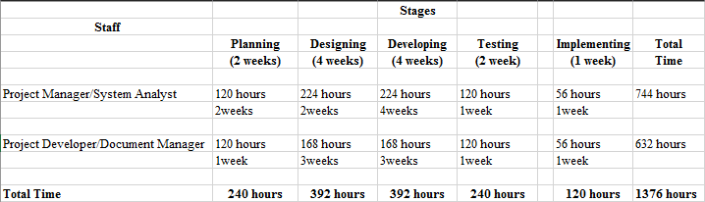

|  |  |  |
| --- | --- | --- |
| Week | Number of days | Activities |
| 1st  week | 3 to 6 days | The team plan how to develop our system. |
| 2nd week | 2 days | The team meet with our client to gather information for our system. |
| 3rd week | 3 days | The team analyze the problem of the client for system developing. |
| 4th week | 5 days | The team will design and research about the system. |
| 5th week | 6 days | The team will start to develop the system by coding and researching. |
| 6th week | 5 days | Research other systems and get an idea. |
| 7th week | 6 days | Coding and testing the system. |
| 8th week | 6 days | Add more design and functionalities to our system. |
| 9th week | 4 days | Improving and updating the system. |
| 10th week | 3 days | Testing and implementing the system. |
| 11th week | 4 days | Maintenance and updating the system. |
| 12th week |  | PROJECT PRESENTATION. |

**6. Deliverables**

Deliverables specified for the project include:

1. An acceptable Quality Plan
2. An acceptable Data Management Plan (*Appendix YY*)
3. Etc.



**Project Status Report**



**Project Name: SUSAN ICE STORE ORDERING AND INVENTORY SYSTEM**

**Department:**

**Focus Area:**

**Product/Process:**



**Prepared By:**

|  |  |
| --- | --- |
| **Document Owner(s)** | **Project/Organization Role** |
| Leonard Potian | Project Manager/System Analyst |
| Nelaine Valdez | Document Manager/Programmer |
|  |  |

**Project Status Report Version Control**

|  |  |  |  |
| --- | --- | --- | --- |
| **Version** | **Date** | **Author** | **Change Description** |
| 1.0 | 8/16/17 | Nelaine Valdez | Submission of Diagrams |
| 1.1 | 8/16/17 | Leonard Potian | Submission of Change Management Plan and Quality Plan |
|  |  |  |  |
|  |  |  |  |

**TABLE OF CONTENTS**

**1** **PROJECT STATUS REPORT PURPOSE 3**

**2** **PROJECT STATUS REPORT TEMPLATE 3**

2.1 Project Status Report Details 3

2.2 Project Status Report Template 3

**3** **PROJECT STATUS REPORT APPROVALS 3**

**4** **APPENDICES 3**

4.1 Document Guidelines 3

4.2 Project Status Report Sections Omitted 3

**PROJECT STATUS REPORT PURPOSE**

The purpose of this Progress report is submission of Diagrams, Change management plan and quality plan.

**PROJECT STATUS REPORT TEMPLATE**

**Project Status Report Details**

This is the 9th progress report of our project and we continue to improve it.

* + Our system is all about ordering and inventory system.
  + 90% improvement of the system
  + Diagrams
  + Change Management Plan
  + Quality Plan

**2.2 Project Status Report**

|  |  |  |  |  |  |  |  |
| --- | --- | --- | --- | --- | --- | --- | --- |
| **Susan Ice Store** | | | | | | | |
| Prepared By:  Leonard Potian | | Date:  8/8/17 | | | Reporting Period:  8/9/2017 to 7/16/2017 | | |
| Project Overall Status:  We finished almost 90% of our system | | | | | | | |
| Project Summary:  All milestone for the last meeting have been submitted. | | | | | | | |
| **Milestone Deliverables performance reporting over last period** | | | | | | | |
|  | **Milestone Deliverables** | | **Due Date** | **% Completed** | | **Deliverable Status** |  |
| Milestone 1 | | | | | |
| • Chapter 1 | | 6/18/17 | 100% | | [**On Schedule**] |
| • Status Report1 | | 6/21/17 | 100% | | Behind Schedule |
| • Adviser Form | | 6/21/17 | 100% | | Behind Schedule |
| **Milestone Deliverables scheduled for completion over next period** | | | | | | | |
|  | **Milestone Deliverables** | | **Due Date** | **% Completed** | | **Deliverable Status** |  |
| Milestone 2 | | | | | |
| • SWOT analysis | | 6/7/17 | 100% | | [**On Schedule**] |
|  |  | |  |  | |  |  |

Project Status Report

|  |  |  |  |
| --- | --- | --- | --- |
| Business case | 10/05/2016 | 100% | [Behind Schedule] |
| Milestone Deliverables scheduled for completion over next period   |  |  |  |  | | --- | --- | --- | --- | | Milestone Deliverables | Due Date | % Completed | Deliverable Status | | Milestone 3 |  |  |  | | FDD | 6/21/17 | 100% | [On Schedule] | | SRSC | 6/21/17 | 100% | [On Schedule] |   Milestone Deliverables scheduled for completion over next period   |  |  |  |  | | --- | --- | --- | --- | | Milestone Deliverables | Due Date | % Completed | Deliverable Status | | Milestone 4 |  |  |  | | Status Report for  CSPROJ | 6/28/17 | 100% | [On Schedule] | | Submit all papers and documents during sysadd1 and sysadd2 | 1/16/2017 | 100% | [On Schedule] |   Milestone Deliverables scheduled for completion over next period   |  |  |  |  | | --- | --- | --- | --- | | Milestone Deliverables | Due Date | % Completed | Deliverable Status | | Milestone 5 |  |  |  | | Second status report | 6/28/17 | 100% | [On Schedule] | | Activity list | 6/28/2017 | 100% | [On Schedule] | | SOW | 6/28/2017 | 100% | [In progress] |   Milestone Deliverables scheduled for completion over next period   |  |  |  |  | | --- | --- | --- | --- | | Milestone Deliverables | Due Date | % Completed | Deliverable Status | | Milestone 6 |  |  |  | | Activity list | 6/28/2017 | 100% | [On Schedule] | | Gantt Chart | 6/28/2017 | 100% | [On Schedule] | | WBS | 6/28/2017 | 100% | [On Schedule] | | Activity per phase | 6/28/17 | 100% | [On Schedule] | | | | |

|  |  |  |  |  |  |  |  |  |  |  |  |  |  |  |  |  |  |  |  |  |  |  |  |  |  |  |  |  |  |  |  |  |  |  |  |  |  |  |  |  |  |  |  |  |  |  |  |  |  |  |  |  |
| --- | --- | --- | --- | --- | --- | --- | --- | --- | --- | --- | --- | --- | --- | --- | --- | --- | --- | --- | --- | --- | --- | --- | --- | --- | --- | --- | --- | --- | --- | --- | --- | --- | --- | --- | --- | --- | --- | --- | --- | --- | --- | --- | --- | --- | --- | --- | --- | --- | --- | --- | --- | --- |
| **Milestone Deliverables scheduled for completion over next period**   |  |  |  |  | | --- | --- | --- | --- | | **Milestone Deliverables** | **Due Date** | **% Completed** | **Deliverable Status** | | Milestone 7 |  |  |  | | • Estimation | 7/5/17 | 100% | [**On Schedule**] | | • Prototype | 7/7/17 | 90% | [**On Schedule**] |     **Milestone Deliverables scheduled for completion over next period**   |  |  |  |  | | --- | --- | --- | --- | | **Milestone Deliverables** | **Due Date** | **% Completed** | **Deliverable Status** | | Milestone 8 |  |  |  | | • SRS | 7/15/17 | 100% | [**On Schedule**] | | • Prototype | 7/15/17 | 90% | On progress | | • Database | 7/17/17 | 80% | On progress |      |  |  |  |  | | --- | --- | --- | --- | | **Milestone Deliverables** | **Due Date** | **% Completed** | **Deliverable Status** | | Milestone 9 |  |  |  | | • Prototype | 8/5/17 | 90% | On progress | | • Database | 8/5/17 | 80% | On progress | |

**PROJECT STATUS REPORT A****PPROVALS**

**Prepared by** Leonard Potian

Project Manager

**Approved by** __________________________________

Project Advisor



**7. Review of Quality Plan**

*This quality plan of Susan Ice Sore Ordering and Inventory System is implementing the documents of the project and the process reports.*

**8. Document and Record Control**

*Arrangements for the control and storage of project documents, records and data should be specified, including the distribution of the Quality Plan and Data Management Plan to all members of SUSAN ICE STORE ORDERING AND INVENTORY SYSTEM. Distribution lists for reports and other deliverables may also be listed.*

*The Quality Plan and Data Management Plan will be issued to all members of the SUSAN ICE STORE ORDERING AND INVENTORY SYSTEM.*

*Project Progress Reports will be issued to the following:*

*List of names.*

*SOFTWARE REQUIREMENTS SPECIFICATIONS*

*VISION AND SCOPE DOCUMENT*

*CHANGE MANAGEMENT PLAN*

*DIAGRAMS OF THE SYSTEM*

**9. Additional Information**

*SUSAN ICE STORE ORDERING AND INVENTORY SYSTEM TECHNICAL REQUIREMENTS*

1. *Ordering System*
2. *Inventory System*
3. *Feedback Form*
4. *Auto Compute Orders*
5. *C.R.U.D. process*