USER MANUAL

- System Overview
The application is a web-based system that allows customer to order online and allows the admin to track and manage inventory and orders, admin also have the privilege to make other account as admins.

- Application
The application is a minimalistic web-based system.

- Dialog Flow
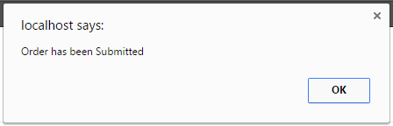
The picture means that the order of the Customer/User has been submitted.

- User Security and Privacy
The website uses md5 hash for password. The admin can access the inventory manage users and inventory can also make an employee become admin the admin also has a privilege to remove user. Everyone can access the website but only registered user can order.

- User Operating Procedures
The operating process of the website is the customer can register their account to enter to the ordering level and then the admin will read their information then confirm the account of the customers.

- Site Map
Ordering System via Online
Inventory System for Client/Server
Report Module
Client/Server System

CLIENT/ADMIN MANUAL:

- Introduction
- Sign-up Account
- Check Inventory
- Add User
- Remove User
- Approve Orders

Introduction

Client/Admin has an access to add, remove, and update the website.

Sign-up Account

Client/Admin should Sign-up his/her account to access the server

Check Inventory

Client/Admin can see all the transactions happening in his/her website using the inventory level.

Add user

Client/Admin can directly add users into the system. To add a user the Admin should go to settings > add user and fill up all the information needed.

Remove User

Client/Admin can not only add users into the system but also remove existing users. To remove a user the Admin should go to settings > remove user and select the user to be removed from the system.

Approve Orders

Client/Admin should approve the orders of the customer to confirm that their order is complete.

CUSTOMER/USER MANUAL:

- Introduction
- Register Account
- Submit Information
- Order Form
- Complete Order

Introduction

Customers/User can easily order in the store using the website.

Register Account

Customers/User should register their account to go to the ordering level.

Submit Information

Customers/User will submit their all information for the admin to confirm it.

Order Form

Customers/User can order easily with the value of the product if their account is approved by the admin.

Complete Order

Customers/User should finalize their orders and send to the admin then the admin will confirm it.

