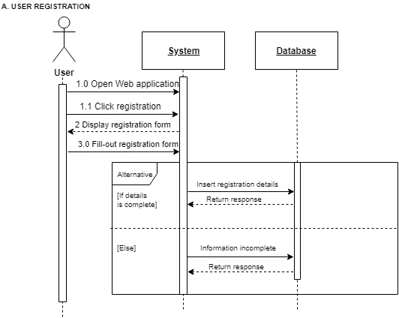**1.0 USER REGISTRATION**

**1.1 Create Test Question**

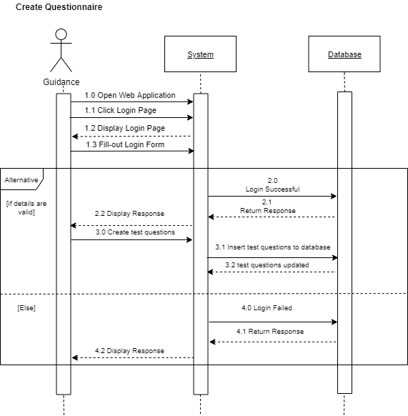

**1.3 Edit Questionnaire**

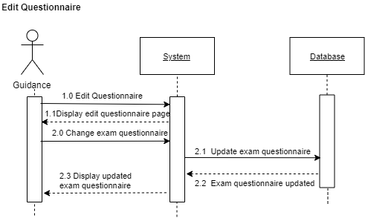

**1.4 Take examination**

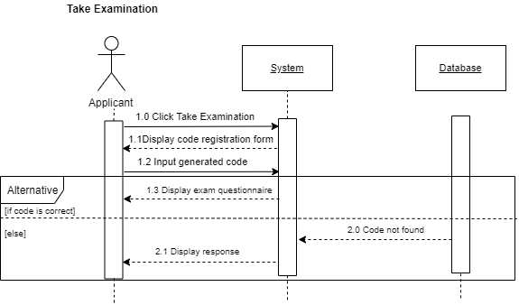

**1.5 GUIDANCE CREATE ACCOUNT**

