# Crowd Funding for Aruga at Kalinga Foundation Inc.

Project Documentation Submitted

To the Faculty of School of

Computing and Information Technologies Of

Asia Pacific College

In Partial Fulfillment of the Requirements for the subject

Applied Projects 2 or Software Development

By  
Jorome Mortera  
Abigail Malapo  
Jovin Go  
Darryl Naval

Table of Contents

Crowd Funding for Aruga at Kalinga Foundation Inc. 1

**Executive Summary** 4

**I. Introduction** 5

1.1 Project Context 5

1.2 Purpose and Description 5

1.3 Objectives 5

1.3.1 General Objectives 5

1.3.2 Specific Objectives 5

1.4 Scope and Limitations 6

1.4.1 Scope 6

1.4.2 Limitations 6

**II. Review of Related Literature/Systems** 6

**III. Technical Background** 10

**IV. Methodology, Results and Discussion** 11

4.1 Requirements Analysis 11

4.2 Requirements Documentation 11

4.3 Design of Software, Systems, Product, and/or Processes 11

4.4 Description of the Prototype, where applicable 14

4.5 Implementation Plan (Infrastructure/Deployment) where needed 14

**V. Appendices** 15

Business Requirements 16

Background 16

Business Opportunity 16

Business Objectives and Success Criteria 17

Customer or Market Needs 17

Business Risks 17

Vision of the Solution 17

Vision Statement 17

Major Features 17

Assumptions and Dependencies 18

Scope and Limitations 18

Scope of Initial Release 18

Scope of Subsequent Releases 18

Limitations and Exclusions 18

Business Context 19

Stakeholder Profiles 19

Project Priorities 20

Operating Environment 20

Introduction 22

Purpose 22

Document Conventions 22

Intended Audience and Reading Suggestions 22

Purpose 22

Board of directors 22

Accountant 22

Summary reports for financial purposes 22

IT Personnel 22

Website maintenance 22

Donor/Viewer 22

Product Scope 22

Overall Description 23

Product Perspective 23

Product Functions 24

User Classes and Characteristics 24

Operating Environment 25

Design and Implementation Constraints 25

User Documentation 25

Assumptions and Dependencies 25

External Interface Requirements 26

User Interfaces 26

Hardware Interfaces 26

Software Interfaces 26

Communications Interfaces 27

System Features 27

Advertising 27

Other Nonfunctional Requirements 27

Safety Requirements 27

Security Requirements 27

Software Quality Attributes 28

Business Rules 28

# Executive Summary

Aruga at Kalinga Foundation is an organization run by priest in laymen that has a purpose of helping the poor people to survive from their everyday needs. This foundation gives help to children who wants to continue on their studies by providing scholarship, giving music lesson, creating feeding program and giving shelter to homeless people.

This project will be announced by the priest after the mass and he will provide every detail and information. Interested donor will approach the priest and give their donation personally to the priest or through money carrier under the name of the priest and through Facebook.

The style of Aruga at Kalinga Foundation for their project for a cause only focus on their vicinity, people who went to church only knew their project in result only small amount will raise. The foundation to a wide range promotion; They need to have their own crowd funding site to be able raise enough money for their project

# Introduction

## Project Context

Foundation’s current process when it comes to advertising their projects is just through Mass announcements, Facebook post and by word of mouth.

## Purpose and Description

For the charity to gain their goal, they want us to create a crowd funding website. It is like a fund raising but it is Internet based. The website contains all activities and needs. There is a donation button so that the person who is far and willing to donate will have an easy access through it. Another purpose of this website is for easy advertising.

## Objectives

## General Objectives

## To create a crowd funding website with system as what the client wants and here the activities of the project and the progress will be shown. And using this website people will know what the foundations objective is and charity works. Another main objective is through this website the foundation encourages people to donate.

## **Specific Objectives**

## A website that contains all the project and its description

* + A website that has a login for donor and admin

## A website that shows the profile of the donor and admin

* + A website that allows the donor to donate
  + A website that generates reports

## Scope and Limitations

## Scope

* The website will show the easiest way to donate.
* Fun and interactive website for the donors.
* The system will gather all the necessary information from the donor.
* Transparency of each project.
* The website is a username and password protected.
* The website will show the full details about the project.

## Limitations

* The system requires Internet connection.
* Only administrators can add and post a project.
* The website will only show the address of the project or event but not the exact location like in google maps.

# Review of Related Literature/Systems

The design that we gathered in a related system specifically in Kickstarter.com:

* Slideshow of photos – because in showing the photos of the project we want is like in Facebook you just have to click the arrow buttons to view the next and previous photo.



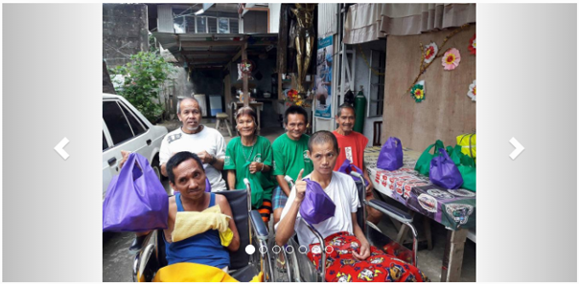

* Sign up – in our system you can see the simple form to sign up for an account to be part of the project.

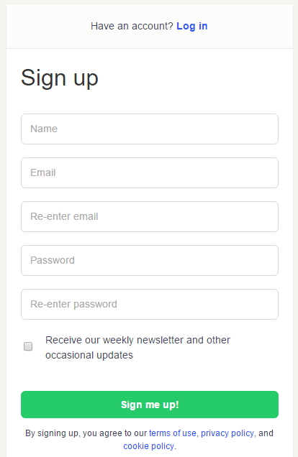

* Choosing the project – we can also see here in our project a small square but not like in Kickstarter they had a picture in every project they show.

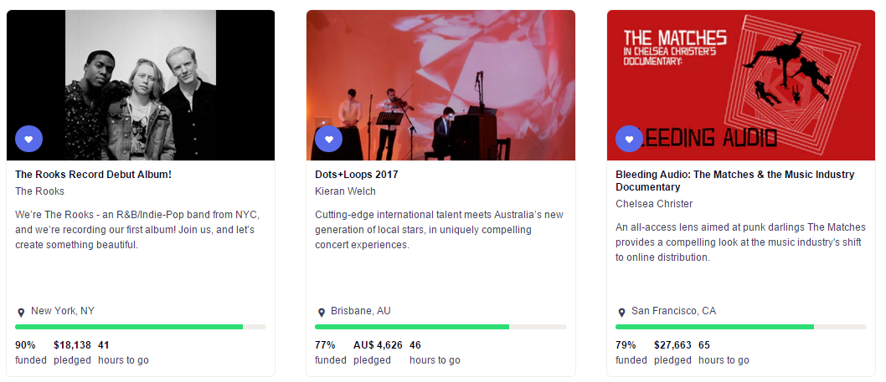

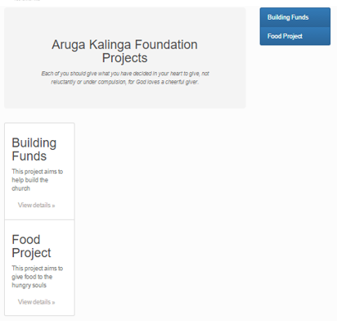

* Project Information – after clicking the project tile it will direct the user to a page that will show the full information about the project. The user will also see pictures about the project and our team is working on posting a video about each project.

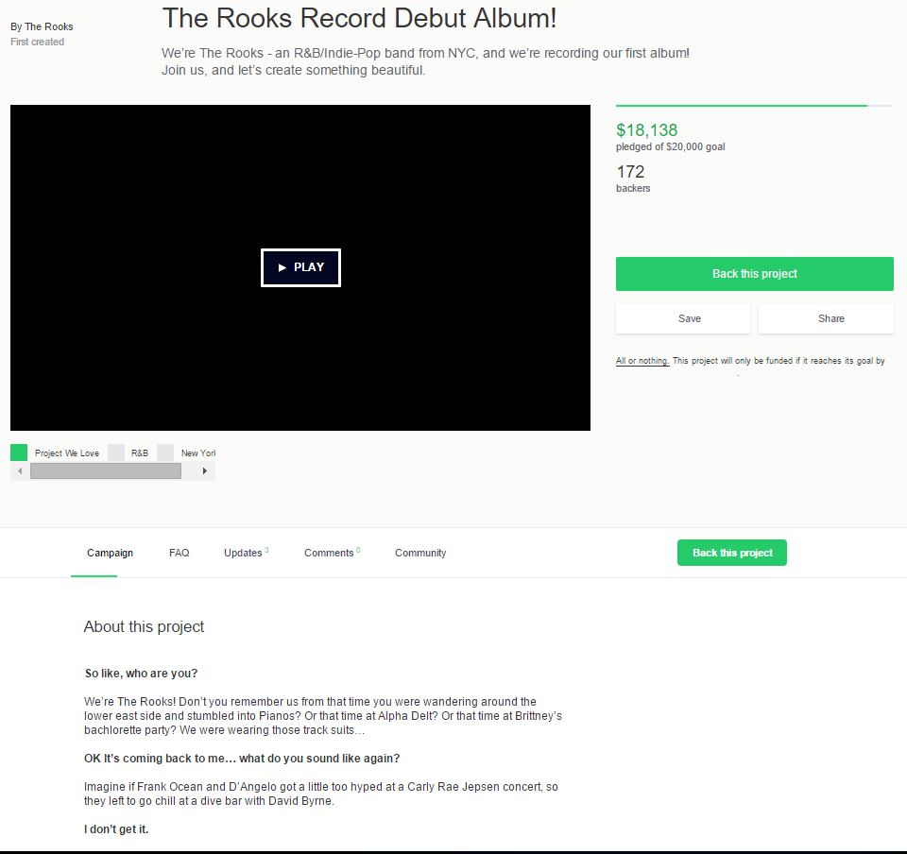

# Technical Background

The GUI of our website was done by using MongoDB for the database. While for the framework is Mean and Node.js, PHP, HTML and CSS is used for coding the website.

MongoDB – is a free and open source platform, document oriented database program. It is classified as NoSQL database program. It uses JSON-like documents with schemas.

Mean – a open source JavaScript software stack for building web application.

Node.js – is an open source cross-platform JavaScript environment for developing and allows the creation of web servers and networking tools.

PHP – (Hypertext Preprocessor) is an open source scripting language that is suited for web development

HTML – (Hypertext Markup Language) is a computer language that allows website creation

CSS – is a style sheet language used for describing the presentation of a document written in a markup language

# Methodology, Results and Discussion

## Requirements Analysis

After our interview with the client, the group found out the problem and came up with possible solution that our system can provide. The problem of our client is how they can collect money to fund their projects and how they can advertise it like how can other people who is far away from the place to know that they are having a project to help the community. With the help of our team, the problem that they will encounter will be resolved.

## Requirements Documentation

* The system will show/ advertise the project of the foundation
* The system will show a transparency report
* The system will show a milestone report
* The system includes creating account features for possible donor
* The system allows donors to donate

## Design of Software, Systems, Product, and/or Processes

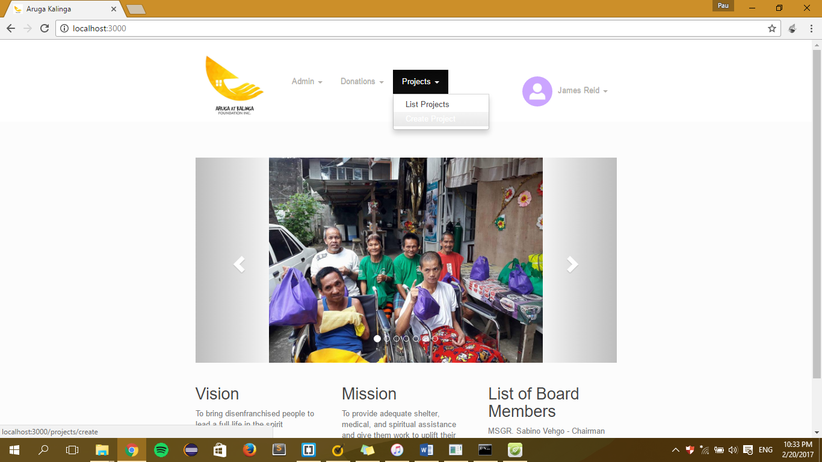

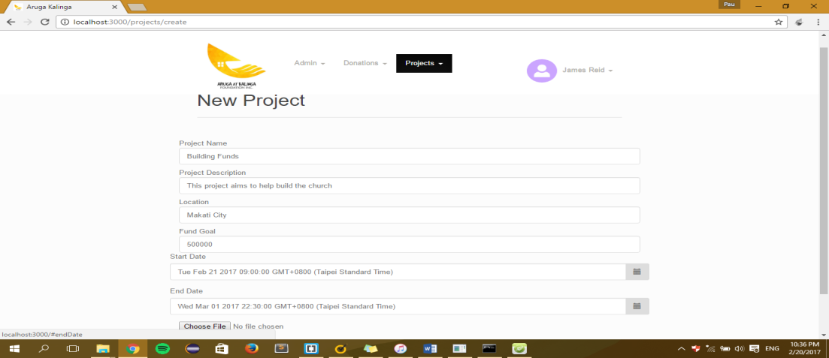

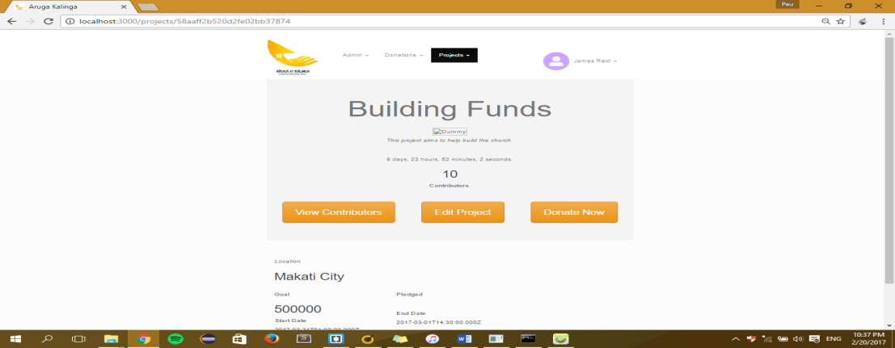

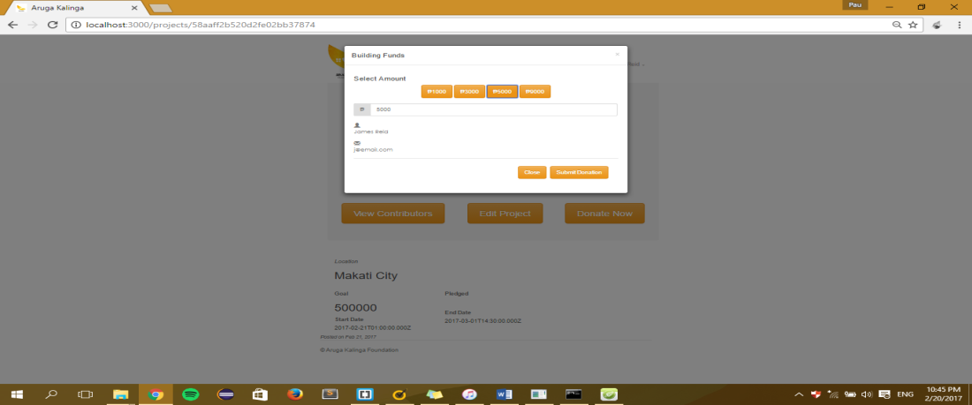

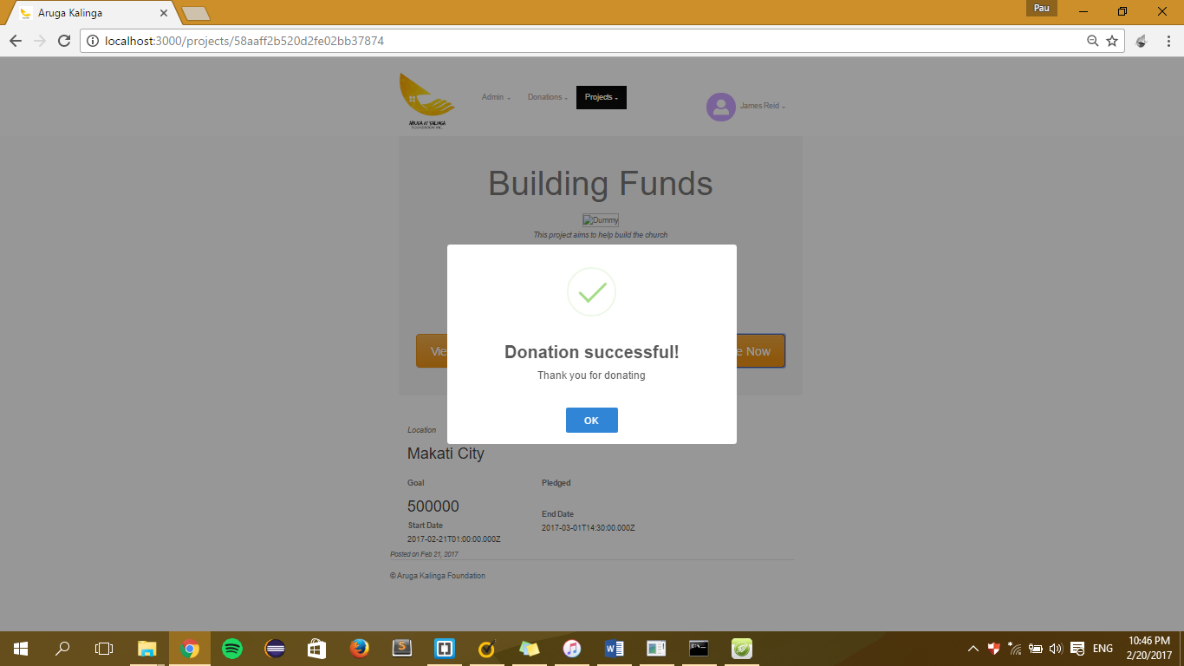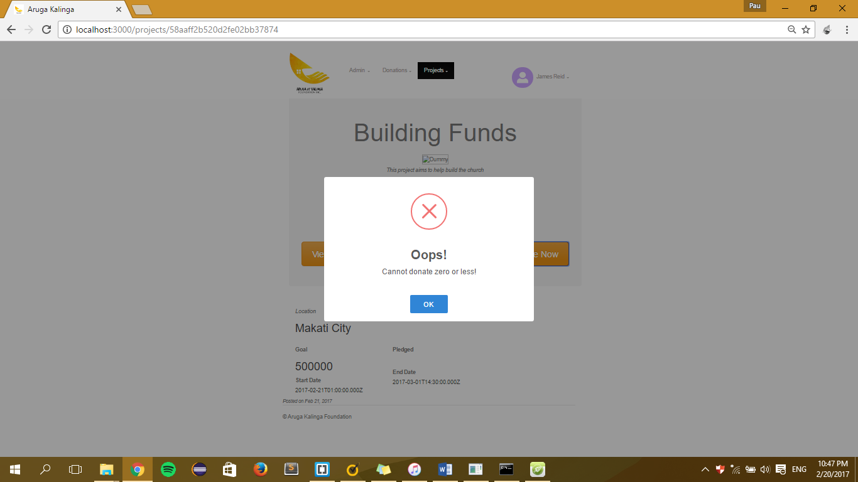

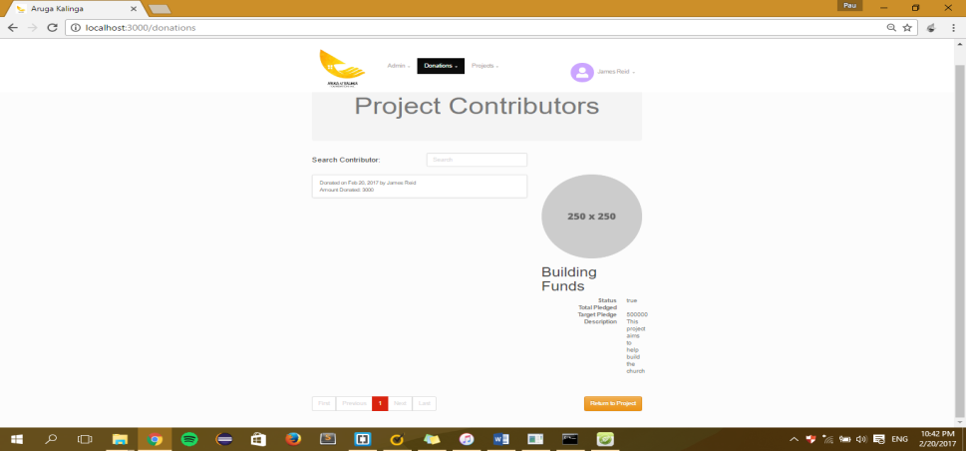

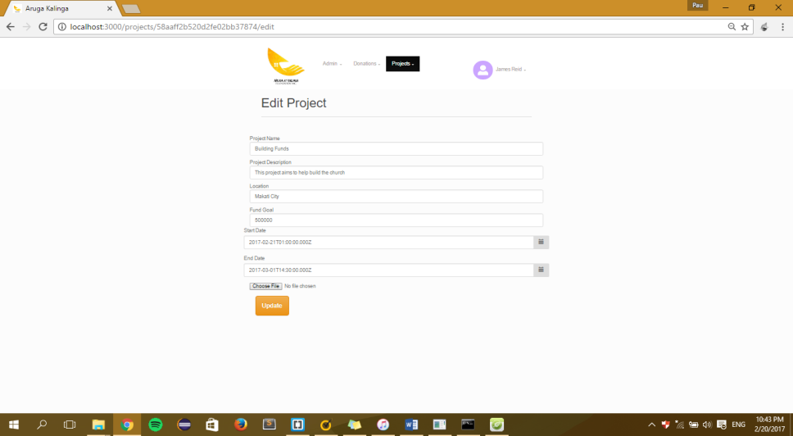

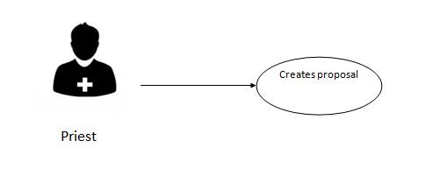

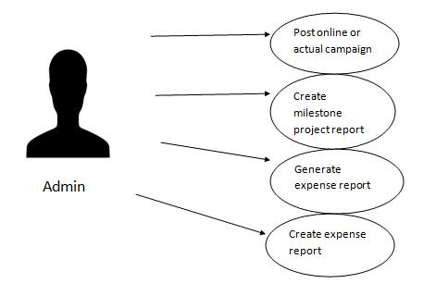

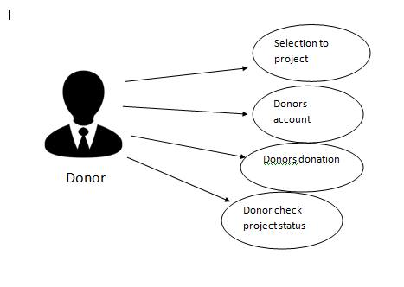

## Description of the Prototype, where applicable

Aruga at Kalinga Foundation Inc. is a crowd funding website that will help poor people. The feature of our website has log in account for possible donors and it will show transparency report.

## Implementation Plan (Infrastructure/Deployment) where needed

As our website will be implemented, it will be given to the Aruga at Kalinga Foundation Inc. The user/donor can access the system but with different workflow. The administrators task is to update the website, add and delete information.

# Appendices

* 1. Vision and Scope

Vision and Scope Document

for

Aruga at Kalinga Foundation Inc.

Version 1.0 approved

Prepared by   
  
Mortera, Jorome  
Malapo, Abigail  
Go, Jovin  
Naval, Darryl

January 18, 2017

# Business Requirements

## Background

Aruga at Kalinga Foundation is an organization run by a priest that has a purpose of helping the people to survive from their everyday needs. This foundation gives help to the children who wants to continue on their studies by providing scholarship program, giving music lesson, provide feeding program and giving shelter for the homeless.

This project is announced by the priest after every mass and explain the detail and information. Interested persons will approach the priest and give their donation personally to the priest or through money carrier under the name of the priest.

The style of Aruga at Kalinga Foundation in their project for a cause only focus on their vicinity, people who went to church only knew their project in result only small amount will be raise. The foundation need a wide range promotion; they need to have their own crowd funding site to be able raise enough money for their project.

The priest from Marikina comes with the idea of creating a project which is crowd funding site. Creating a crowd funding site for a cause that will help the people from different places in the Philippines by asking them to donate any certain amount of money in or in kind through the use of technology which is the internet.

The foundation will be needing the following: personnel (admin, accountant, IT personnel), Internet connection

## Business Opportunity

The tools use by the Aruga at Kalinga Foundation for their project for a cause is verbal information, through Mass and Facebook post and share by the priest, his friends and followers.

Now we came up with the idea of crowd funding through the help of the Internet, we will provide a crowd funding site that will help them to promote their project and to be able to raise enough amount of money from different people all over the world by accessing the website. So it will help the foundation to find and attract more people to donate because it is accessible via internet. Also for the donors it is the easiest way they can donate by accessing the website, browse for a charity project then they will need to sign up so that donors can donate money.

Crowd funding will help them to achieve their mission to help person’s and built a home for the homeless. People will donate through bank transaction and package courier for in kind donations.

## Business Objectives and Success Criteria

* For the foundation’s project to reach possible donors
* To encourage donor to donate
* Give the exact and appropriate details of the project progress
* For the foundation to achieve their goal

## Customer or Market Needs

For the current process project will announce by the priest after the mass and explain the detail and information. Interested donor will approach the priest and give their donation personally. The product will increase the project advertisement.

## Business Risks

In this project the biggest issue that we will face is, how the donation process will implement because in this project will be needing different types of process. Another thing is that the release of every project has no assurance of the because budget that will be coming from the donation. And most of all, how the people who’s willing to donate will trust the project. They might think that these crowd funding is just a scam

# Vision of the Solution

The website will help and promote Aruga at Kalinga foundation succeed on their mission.

Under this website it will contain every project of the foundation, all donation can be send through bank transaction and the amount that is being donated to that project will appear on that project information. Also this website has a report status for every project and it can be monitored by admin.

## Vision Statement

Our team wants to achieve the following:

* Worldwide advertisement of the projects
* Budget quota
* Project Progress

## Major Features

* Transparency
* Interactive website
* Different ways of donating
* Security
* Accomplishment report

## Assumptions and Dependencies

In order to use the application, the user must have the following: stable internet connection for accessing the website and donating purposes, for the foundation they must have a knowledgeable personnel for the system and transparency maintenance.

# Scope and Limitations

This website aims to reach possible donors worldwide. It can be advertised through social media by share buttons or pasting the website URL in a post. Showing the transparency to donors by letting them know what is the progress of the project and the specific amount donated to a project.

## Scope of Initial Release

* The website will show the easiest way to donate.
* Fun and interactive website for the donors.
* The system will gather all the necessary information with regard form the donor.
* Transparency of each project.
* The website is a username and password protected.
* The website will show the full details about the project.

## Scope of Subsequent Releases

In further releases we want to improve the donating side of our project. Having other payment options like (M Lhuillier, Cebuana Lhuillier, Western Union, LBC, and etc) and through load payments. And on the other hand the shipping for non-monetary donations.

## Limitations and Exclusions

* The system requires internet connection.
* Only administrators can add and post a project.
* The website will only show the address of the project or event but not the exact location like in google maps

# Business Context

## Stakeholder Profiles

Stakeholders will do the following task

* improved productivity
* reduced rework
* cost and donation reports
* automation of previously manual tasks
* ability to perform entirely new tasks or functions
* improved usability or reduced frustration level compared to current applications

|  |  |  |  |  |
| --- | --- | --- | --- | --- |
| **Stakeholder** | **Major Value** | **Attitudes** | **Major Interests** | **Constraints** |
| Owner | Increase project production/success | Project success will go higher | Worldwide advertisement | Donations |
| Accountant | Donation and expense report | Highly receptive, but expect high usability | To give the accurate report | Does not care in other work |
| IT personnel / Admin | Quick access to data | Resistant unless product is keystroke-compatible with current system | Ability to handle much larger database than current system; easy to learn | No budget for retraining and hiring another personnel |

## Project Priorities

|  |  |  |  |
| --- | --- | --- | --- |
| **Dimension** | **Driver (state objective)** | **Constraint (state limits)** | **Degree of Freedom (state allowable range)** |
| Schedule | release 1.0 to be available by 1.1 by on or before the end February 2017, release of 2.0 to be available mid March 2017 and the 3.0 will be on the end of March | Time Constraints | 90 – 100% of the Crowd Funding System must be done |
| Features | All functions must working properly |  | 70-80% of high priority features must be included in release 3.0 |
| Quality | Provides the foundation a website that has a donate, summary reports, and announcements | Donation might not yet work properly. Bugs are expected to occur at the release of 1.0 and 2.0 | 90-95% of user acceptance tests must pass for release 2.0, 95-98% for release 3.0 |
| Staff |  | maximum team size is 3 developers + 4 testers | The 90 – 100% of the allowable time should achieve for release 3.0 |
| Cost | Must not exceed the maximum budget | Maximum budget | budget overrun up to 15% acceptable without executive review |

## Operating Environment

* System is built with Mean and Node both front end and back end
* Database is powered by MongoDB
  1. System Requirements Specification

**Software Requirements**

**Specification**

**for**

**Aruga’t Kalinga Inc.**

**Version 1.0 approved**

**Prepared by**

**Mortera, Jorome**

**Malapo, Abigail**

**Go, Jovin**

**Naval, Darryl**

**Asia Pacific College**

**08 February 2017**

**Copyright © 1999 by Karl E. Wiegers. Permission is granted to use, modify, and distribute this document. Software Requirements Specification for  
 Aruga at Kalinga Foundation**

# Introduction

## Purpose

Aruga’t Kalinga Foundation Inc. is a foundation that is run by a priest from Immaculate Concepcion church. They decided to create their website for advertising their project and aiming for $ 1 million dollars. First, how will the project be advertised, second is who are the donor that will donate for the project, third, will show transparency of donation and lastly will generate reports for every projects.

## Document Conventions

* **Project tabs**
  + When user clicks it, different projects will appear
* **Log in**
  + User can view and edit their profile, also this log in feature it has the privilege to donate
* **Sign up** 
  + For user to have their account
* **Donation tab**
  + Only a user who has an account can donate
* **About Us**
  + This part will show what the website is all about and its purposes

## Intended Audience and Reading Suggestions

|  |  |
| --- | --- |
| Role | Purpose |
| Board of directors | Owner |
| Accountant | Summary reports for financial purposes |
| IT Personnel | Website maintenance |
| User | Donor/Viewer |

## 

## Product Scope

This project will have a website that shows every project’s information of the foundation, another is it has the easiest way to donate by just creating your account and clicking the donation button, so in return for every donation receive they will show transparency of donation and the status for every project by posting pictures, videos and announcements.

# Overall Description

## Product Perspective

## Current

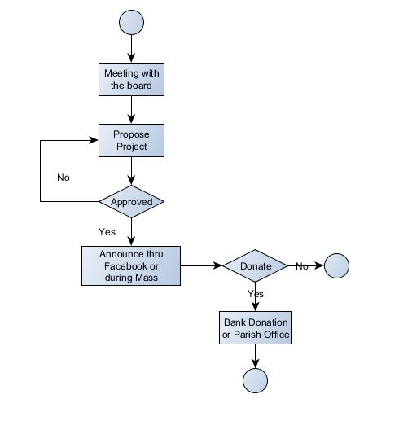

PROPOSED  
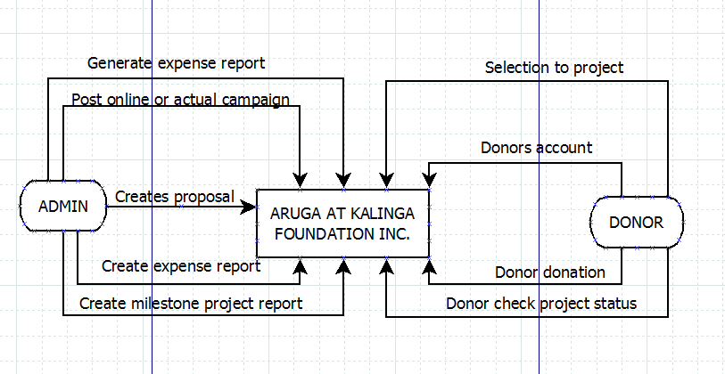

## Product Functions

**Website**

* Give all information about the project
* Transparency of donations
* Progress of each project

**User**

* Create an account
* Give information that is needed
* Choose a project

## User Classes and Characteristics

For this project there are 2 types of user Admin and Donor

* Admin – He or she will serve as the organizer of the website like posting, updating, reporting, and monitoring.
* Donor or Possible Donor – He or she can view the project, if he or she is interested he or she is required to create an account for him or her to donate.

## Operating Environment

OE_1 operate with any web browser and It is recommended that it is in the latest version.  
OE_2: operate on Windows, iOS, and Linux   
OE_3: Minimum hardware requirements: Dual Core 1.6GHz of faster. RAM: 1 gigabyte (GB) (32-bit) or 2 GB (64-bit).

## Design and Implementation Constraints

DaIC_1: The system uses MongoDB for the database.  
DaIC_2: The system uses Mean & Node to build the system.  
DaIC_3: PHP, CSS, HTML and JavaScript are being combined in creating the system

## User Documentation

## Assumptions and Dependencies

* The admin can update the information in the system
* The transparency report will show on the website
* The system relies on the internet access
* When donor has an account there is profile page that contains personal information

# External Interface Requirements

## User Interfaces

Frontend

Main Page

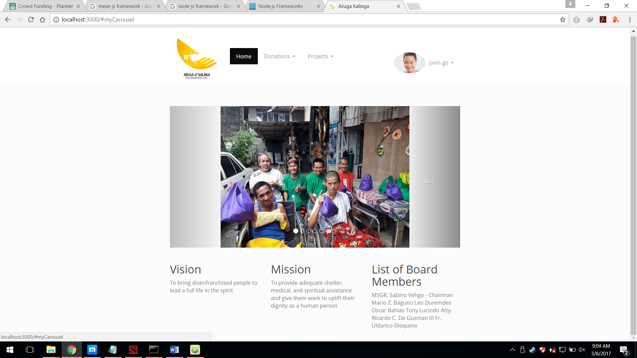

This is the sample main page for the users and possible donors. It contains the Home Page, Donations and Project. Home page is where the users or donor click the button where he/she redirect to the main page. In the donations button it will show the donation process then for the projects button it will show the list of all projects of the foundation. Also in the main page you can see the vision, mission and list of board members of the foundation.

## Hardware Interfaces

For client side:  
**Hardware**: Minimum System Requirement  
**Processor**: at least 1.3 GHz processor or faster  
**Memory**: 1GB RAM (2 GB recommended)  
**Disk Space**: 80GB or above  
**Screen resolution**: at least 800 x 600 colors or above

## Software Interfaces

* It can be used in Windows, Linux, iOS, Android
* The database in use is MongoDB
* The output of the software will need a browser (e.g. Chrome, Internet Explorer, Firefox) for viewing it.

## Communications Interfaces

* It should need an internet connection and a browser are required

# System Features

## Advertising

* Attract visitors: use social media and email to get people to learn about your project.
* Convert visitors into backers: use the right content and right rewards to persuade users to take action.
* Convert backers into promoters: do not abandon your backers once they have donated —rather, keep in touch and encourage them to spread the word about your project.
* Bitly.com allows you to see how popular your shared links have become. It offers a free link-shortening service that, when added to any URL, shows stats like referral sources related to that unique link. Use every time you share your project and you will be able to track the activity surrounding your project views and shares.
* Update all your social media profiles (e.g., Twitter, Facebook, Instagram) to include a link to your campaign.

**4.1.2 Stimulus/Response Sequences**

* **Stimulus**: The admin advertises the project specially our website in social media.
* **Response**: The interested donors or viewers will go to our website to learn the basic information of our projects.

**4.1.3 Functional Requirements**

REQ-1: The admin should be connected to the internet  
 REQ-2: The admin should be connected to social media

# Other Nonfunctional Requirements

## Safety Requirements

Project Arugat Kalinga is a donation website that uses credit card number. Therefor only the admin can access the names, credit card number, amount of donation. All private information should be secured well and all of these information should only be in one place.

## Security Requirements

The security requirements for Project Arugat Kalinga is that all Administrators should never print, copy or any other forms to duplicate a private information of the donors. The solution is that limit the administration access.

## Software Quality Attributes

**5.4.1 Security**

* The website will run a firewall security
* The website should be secured and safe from DDoS attacks**.**

**5.4.2 Reliability**

* The website should be understandable
* Easy to use
* Shall protect its private information

**5.4.3 Scalability**

Measuring scalability in terms of users/performance rather than number of additional nodes in our network we will help maintain focus on the true purpose of scaling on our web application

**5.4.4 Availability**

The website should be available to anyone and 24 hours and 7 days a week

**5.4.5 Responsiveness**

* to achieve the fast response of the website, the website shall be ad-free, less quality picture and maintained

## Business Rules

The Project will be used by everyone but specifically for donors, staff and administration. The user should create an account to be a donor and access the donation page. The administrator is the responsible on the private information that the donor has given. While the accountant is responsible on handling the money that was donated.

* Donor has logged in
* The donor accesses the project list
* The donor will select which project that he/she will donate.
* The donor will now input how much money he/she will donate
* The administrator will confirm
* Then the accountant will hold the donation money until the project ends
  1. Process/Data/Information Flow

