

Asia Pacific College

School of Computing and Information Technologies

**Dash-R-Come**

In Partial Fulfillment of the Requirements for the Subject Applied Project for IT-MI

Submitted by:

Hurley M. Evangelista (Project Manager)

Emmanuel S. Devera (Project Developer)

Alyssa Anne F. Fernandez (Project Analyst)

Miguel Enrico L. Matawaran (Project Analyst)

Submitted to:

Mr. Manuel Sebastian Sanchez

March 6, 2018

**ASIA PACIFIC COLLEGE**

# Approval Sheet

Dash-R-Come

Prepared and Submitted by:

In Partial Fulfilment of the Requirements for the Degree of

Bachelor of Science in Information Technology

Examined and Recommended for Acceptance and Approval for Research/Capstone Presentation

Mr. Jayvee Cabardo

Adviser

Panel of Judges

___________________________

Chairperson

Panel Members

___________________________ ___________________________

Panel Member Panel Member

Acceptance and Approved in partial fulfillment of the requirements for the degree of Bachelor of Science

_______________________________

Executive Director

School of Computing and Information Technologies

**Table of Contents**

Executive Summary........................................................................................................................1

Chapter 1 Introduction...................................................................................................................2

1.0 Introduction............................................................................................................................2

1.1 Project Context….....................................................................................................................2

1.2 Purpose and Description…………..............................................................................................3

1.3 Objectives...............................................................................................................................3

1.4 Scope and Limitations………………………………………………………………………………………………………..3

Chapter II Review of Related Systems………………………………………………………………………………………. 4

2.0 Review of Related System………………………………………………………..………………………………………..4

Chapter III Technical Background……………………………………………………………………………………………...6

3.1 Software Development Requirements………………………………………..……………………………………..6

3.2 Hardware Requirements for Users………………………………………………..……………………………………7

3.3 Programming Language Needed to Apply…………………………………………………………………………..7

Chapter IV Methodology, Results, and Discussion……………………………………………………………………..8

4.1 Requirements Analysis……………………………………………………………………………………..………………..8

4.1.1 Conceptual Framework………………………………………………………………………………..……………….8

4.1.2 Data Flow Diagram……………………………………………………………..………………………..……………...8

4.1.2.1 Context Diagram……………………………………………………………………………………………….……..8

4.1.2.2 Diagram 0…………………………………………………………………………………………………………..…….9

4.1.2.3 Functional Decomposition Diagram………………………………………………………………..………..9

4.1.3 Database (UID / User ID String)……………………………………………………………………………………10

4.1.4 Class Diagram………………………………………………………………………………………………………………10

4.1.5 Object Diagram………………………………………………………………………………….………………………..11

4.1.6 Composite Diagram…………………………………………………………………………………….……………….11

4.1.7 Activity Diagram………………………………………………………………………………………………….……….12

4.1.8 Sequence Diagram………………………………………………..…………………………………………………….13

4.1.9 Deployment Diagram……………………………………………………………………………………….………...14

4.1.10 Communication Diagram……………………………………………………………………………...…………..15

4.1.11 Timing Diagram……………………………………………………………………………………..….………………16

4.1.12 Component Diagram…………………………………………………………………………………………………16

4.1.13 Package Diagram……………………………………………………………………………………………………...17

4.1.14 State Diagram…………………………………………………………………………………………………………..17

4.1.15 Interaction Overview Diagram………………………………………………………………………............18

4.2 Requirement Documentation………………………………………………………………………………………….21

4.2.1 Use Case Diagram……………………………………………………………………………………………………...21

4.2.2 Use Case Narrative Report…………………………………………………………………………………………22

4.3 Gap Analysis……………………………………………………………………………………………………………….....35

4.4 Design of Software, Systems, Product, and /or Process………………………………………………….36

4.5 Development and Testing, where applicable………………………………………………………………….40

Chapter V Conclusion and Recommendations………………………………………………………………………..41

Chapter VI Appendices…………………………………………………………………………………………………………..42

6.0 Appendices………………………………………………………………………………………………………………………42

6.1 Relevant Source Code………………………………………………………………………………………………………..42

6.2 Evaluation Tool or Test Documents…………………………………………………………………………………...43

6.3 Sample Input/Output/Reports……………………………………………………………………………………………58

6.4 Users Guide………………………………………………………………………………………………………………………..59

6.5 Curriculum Vitae………………………………………………………………………………………………………………..60

6.6 Screen Layouts…………………………………………………………………………………………………………………..64

6.7 Pictures showcasing the data gathering, investigation done……………………………………………...64

**List of Figures, List of Tables, List of Notations**

Figure 4.1.2 Data Flow Diagram…………………………………………………………………………………………………8

Figure 4.1.2.1 Context Diagram…………………………………………………………………………………………………8

Figure 4.1.2.2 Diagram 0………………………………………………………………………………………………………..…9

Figure 4.1.2.3 Functional Decomposition Diagram……………………………………………………………….……9

Figure 4.1.3 Database (UID / User ID String)………………………………………………………….…………………10

Figure 4.1.4 Class Diagram…………………………………………………………………………………………….…………10

Figure 4.1.5 Object Diagram……………………………………………………………………………………………….……11

Figure 4.1.6 Composite Diagram………………………………………………………………………………………………11

Figure 4.1.7 Activity Diagram……………………………………………………………………………….………………….12

Figure 4.1.8 Sequence Diagram……………………………………………………………………………………………….13

Figure 4.1.9 Deployment Diagram…………………………………………………………………………..………………14

Figure 4.1.10 Communication Diagram……………………………………………………………………………..……15

Figure 4.1.11 Timing Diagram…………………………………………………………………………………………………16

Figure 4.1.12 Component Diagram……………………………………………………………..…………………………16

Figure 4.1.13 Package Diagram……………………………………………………………………………………………...17

Figure 4.1.14 State Diagram………………………………………………………………………………..…………………17

Figure 4.1.15 Interaction Overview Diagram…………………………………………………………………….……18

Figure 4.2 Requirement Documentation…………………………………………….………………………………….21

Figure 4.2.1 Use Case Diagram………………………………………………………………………..……………………..21

Figure 4.2.2 Use Case Narrative Report………………………………………………….………………………………22

Figure 4.2.1 Use Case Diagram……………………………………………………………………………………………….21

Figure 4.2.2 Use Case Narrative Report……………………………………………………………………………….…22

Table 4.4 Design of Software, Systems, Product, and /or Process……………………..…………………..36

Table 6.3 Sample Input/Output/Reports………………………………………………………………..………………58

# Executive Summary

The proposed project is an incident reporting system. The team aims to develop a system that could help not just Barangay Magallanes, but also other Government Agencies such as the Philippine National Police (PNP) and Bureau of Fire Protection (BFP) expand their services in terms of receiving incident reports or complaints and to reduce the fake incident report cases.

On January 2018, the group conducted an interview with Mr. Jesus Sumandal, one of the Desk Officers of Barangay Magallanes, the group asked about what is the current way or the process of the Barangay in receiving incident reports. Mr. Sumandal said that they entertain incident reports through their Hotline or walk-in. The problem with receiving incident reports through their Hotline is that they could not verify if the incident really occurred. He added that most of the incident report that they receive are prank or fake reports.

They wanted to solve this issue because it costs them manpower, gasoline, time and effort.

The team found the said problem as an opportunity to improve or innovate. Using the Incident Reporting System, Barangay Magallanes and other Government Agencies will be able to verify an incident report by the time they received an incident report, the incident report is sent through an android device and forwarded to the web server, together with the incident report details such as time, date, and location.

**Chapter I**

**Introduction**

# Introduction

## **1.1 Project Context**

Makati is a city in the Philippines’ Metro Manila region and the country’s financial hub. It is known for the skyscrapers and shopping malls of the Makati Central Business District, and for Ayala Triangle Gardens, an area dotted with trees and sculptures. The proposed project is an Incident Management System that is designed Government Agencies and Local Government Units, specifically for now, Barangay Magallanes.

On January 2018, the team conducted an interview with Colonel Candido Ruiz, Head of the Barangay Hall Security and to Mr. Jesus Sumandal, one of the 3 Desk Officers of Barangay Magallanes. Both of them mentioned a same issue or problem that Barangay Magallanes and other Government Agencies or Local Government Units encounter, they added that Barangay Magallanes employees are not technology specialist people, so the group explained everything about the project.

According to Colonel Ruiz, their Barangay has all the equipment needed for the project implementation such as Desktop Computers, Internet connection and the people who are going to manipulate the system. During the interview, the group asked if Barangay Magallanes have an existing system, Mr. Sumandal said that they are using a database where they encode and store the incident reports.

Mr. Jesus Sumandal added one of the Desk Officers of Barangay Magallanes, said that one problem that needs to be solved or taken action are the prank callers. Mr. Sumandal mentioned that they are being bothered by the prank callers because, once they receive a report, they send troops to the reported incident area to verify the report.

In the group’s proposed system, it is the other way around. The Government Agencies or Local Government Units can verify the incident if it really occurred by the time they receive the incident report using the video or picture that was uploaded by the user. The group aims to develop a system that could help not just Barangay Magallanes, but also other Government Agencies such as Philippine National Police (PNP), Bureau of Fire Protection (BFP) to reduce receiving false or prank reports. The proposed project allows the user to send a detailed incident report to the Barangay Magallanes by providing a video footage of an incident with specific details such as the type of incident, location, and time. The Barangay is responsible for verifying the incident report. Once the report is verified, if the incident is not covered by their jurisdiction, they will call the nearest concerned agency.

## **1.2 Purpose and Description**

The Incident Reporting System uses an online database to store incident reports like videos, pictures from the user. It is a mobile application that can be used to report accidents, crime, and fire incidents. Using the mobile application, the user can send a picture or video footage of an incident to the Barangay Magallanes. The video footage needs to be verified by the Barangay Magallanes employee, if the incident is within the Barangay’s Jurisdiction, then they are the ones to respond, if not, they will call the nearest concerned agency.

The purpose of the project is to provide the client a system that could help them get a real and detailed incident reports using the mobile application. Also, to provide the client an updated record of incidents that could be used in crime statistics purposes.

## **1.3 Objectives**

* To provide the client a detailed incident report from the users with the use of the mobile application.
* To help the Barangay and other Government Agencies reduce the fake incident reporting cases with the use of the mobile application and web server.
* To provide evidence or supporting details when reporting an incident to the client.

## **1.4 Scope and Limitations**

* Internet Connection
* The Barangay Magallanes will be covered by the project.
* Barangay personnel are allowed to respond if the incident is covered by their jurisdiction
* If the incident happens to be far or not covered by the Barangay’s jurisdiction, then the Barangay shall call the nearest concerned agency.
* If the user does not have an internet connection or data connection, then the user cannot use the mobile application.
* The mobile application requires internet connection or mobile data to be used.
* The target users of the mobile application are the following; motorists, bystanders, constituents, android device users.
* The user must have a picture or video footage of an incident.
* The user can use the dashboard camera or android device in filming an incident
* If the user used a dashboard camera, the user has to transfer the video from the dashboard camera to the android device through the Bluetooth feature or transferring the dashboard cameras’ SD card to the android device.
* The mobile application has 4 main features which are the following. Video Recorder, Video Trimmer, List of Hotlines and Video Cutter.

**Chapter II**

**Review of Related Systems**

# 2.0 Review of Related Literature or Systems

2.1 iWrecked - Nobody would want to get involved in an accident, but, a fact that accidents do occur every single day remains. If you are ever caught in an accident, you would want an application such as iWrecked, to key in and keep a history of the complete relevant details, preview and send accident reports, and look for towing services.

JohnnyJet (2017, August) Retrieved from <https://www.johnnyjet.com/travel-app-of-the-week-iwrecked>

2.2 Spotted Incident Reporter - Spotted incident reporter application is a local crime track, report and information on stolen cars and accidents. Spotted incident reporter application is a local crime track, report and information on stolen cars and accidents. For example, a car was stolen 6 minutes ago, you had the power to fight back to the thieves who stolen the car by posting the incident in the app, including the pictures of the stolen property or car.

APKfilez (2017, August) Retrieved from <https://apkfilez.pw/io-applickable-spotted-apk/>

2.3 Incident Reporter - Incident reporter is an online cloud-based that is available anywhere. By using this application, you can communicate and document incidents. The features of this. The application is using a global positioning system, customizable interface, past report of the user can easily retrieve, and it uses SMS. Our application can find you. The nearest local government unit by our artificial intelligence system, it would require enabling your GPS in your device. It also lets the user to be notified upon the uploaded incident video report when it reaches to the agency. You must also have a data or an internet connection to use the application to find the nearest local government unit.

Technolgy APKpure (2017, August) Retrieved from <https://apkpure.com/incident-reporter/com.magikminds.marbles.plugins.incidentreporte>

2.4 Incident Reporter - Used by healthcare, security firms, education, business, non-profit organizations and government. It has a web based and mobile application that deploy on the Microsoft Azure cloud. The application offers live incident reports and notifications that allow you to monitor issues in real time. Build trust among your team members. It has a free trial but after the trial the pay version of the application will charge to the business or individuals.

Microsoft Store (April, 2018) Retrieved from https://appsource.microsoft.com/en-us/product/web-apps/emappetizer.291b60c4-dc1c-4879-888a-063f586c1d46?tab=Overview

2.5 Incident Management - one of the key pillars of achievement and ensuring a clean an environment. It allows the public to report acts of violations of environmental law.

Google Play Store (January 2018) Retrieved from <https://play.google.com/store/apps/details?id=ke.co.gravity.nema&hl=en>

**Chapter III**

**Technical Background**

# 3.0 Technical Background

This chapter shows the software and hardware needed for the system development and implementation.

**3.1 Software Development Requirements:**

3.1.1 Android Studio

-Built based on JetBrains' IntelliJ IDEA software and designed specifically for Android application development. It is developed by Google that is based on the Linux kernel which are similarly deployed on a traditional computer system.

Firebase Database

-Firebase Real time database is a cloud hosted database that supports multiple platforms, Android, iOS and Web. All the data are stored in JSON format and any changes in data, reflects immediately by performing a sync across all the platforms & devices. This allows us to build more flexible real-time apps easily with minimal effort.

Firebase Authentication

-It aims to make building secure authentication systems easy. It also provides end-to-end identity solution, supporting Gmail, Github and Facebook.

Firebase Cloud

-is a powerful, simple, and cost-effective object storage service built for Google scale. The Firebase SDKs for Cloud Storage add Google security to file uploads and downloads for your Firebase apps, regardless of network quality.

## **3.2 Hardware Requirements for Users:**

* Operating system runs at least Android Lollipop or higher version.
* ·At least 1GB RAM or higher
* 4 “screen or longer
* ·1500 mAh battery or higher
* Android devices - A handheld device that will be used by the motorist to upload the video or picture that was captured from the dash camera.
* Computer - A device that acknowledges data and controls it for some outcome based on the program or set of instructions on how the information is to be handled.
* WiFi / Router - To be used on different purposes such as data transmission and wireless communication.

* 1. **Programming Language Needed to Apply:**

3.3.1 Java

-is the innovation of decision for building applications utilizing structured codes that can be executed on cell phones and this is what the group will mainly use for developing the mobile application that will serve as the interface between the user and the system. In addition to, it is a general-purpose computer programming language and has been in existence for over 2 decades.

3.3.2 NoSQL

-a mechanism for storage and retrieval of data that is modeled in means other than tabular relations used in relational database. A wide variety of different database technologies that were developed in response to the demands presented in building modern applications.

**Chapter IV**

**Methodology, Results, and Discussion**

## **Requirements Analysis**

The group aims to develop a mobile application for Incident Reporting System. The user must register to the mobile application to have a verified account. To register, the user can either link his or her Gmail account (Google Account) or create a new account.

**4.1.1 Conceptual Framework**

**4.1.2 Data Flow Diagram**

**4.1.2.1 Context Diagram**

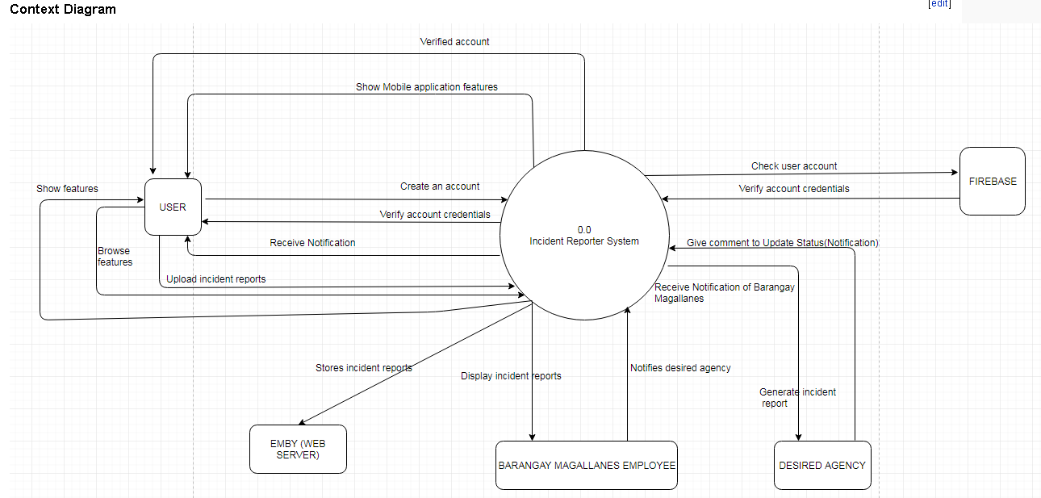

**4****.1.2.2 Diagram 0**

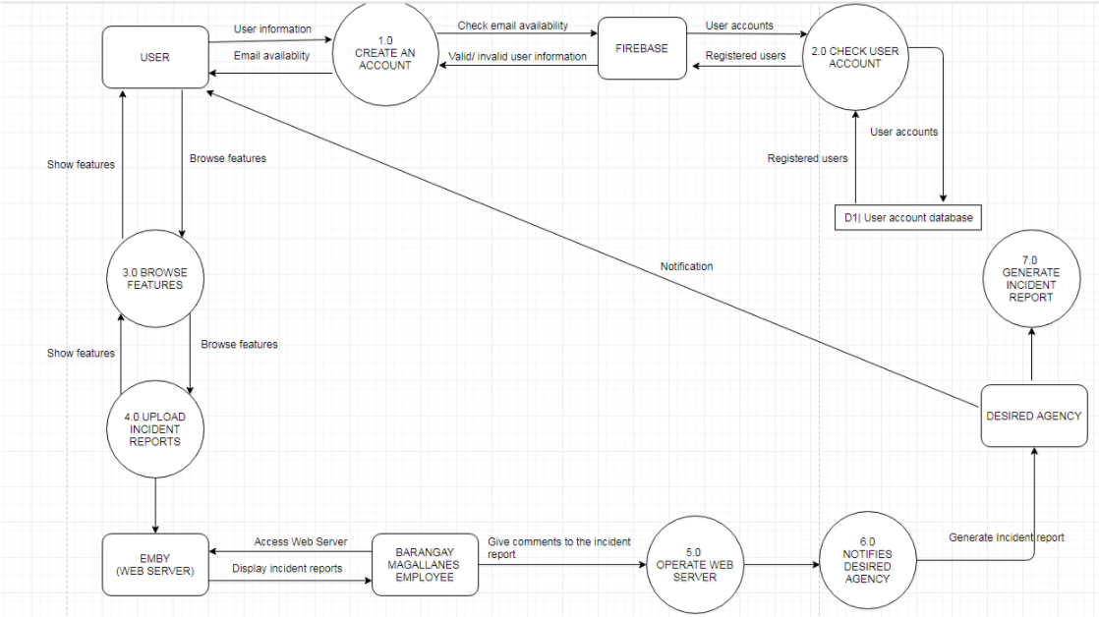

**4.1.2.3 Functional Decomposition Diagram**

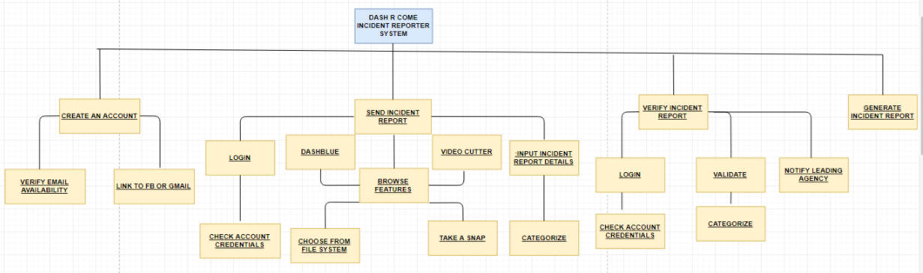

**4.1.3 Database (UID / User ID String)**

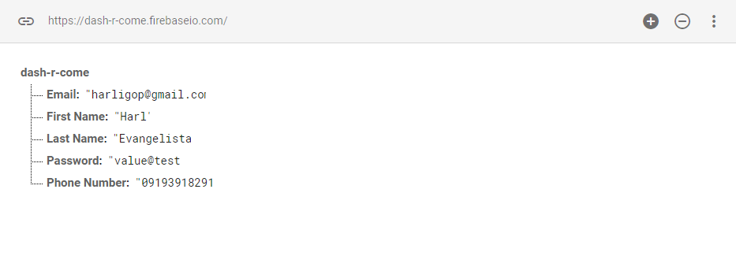

**4.1.4 Class Diagram**

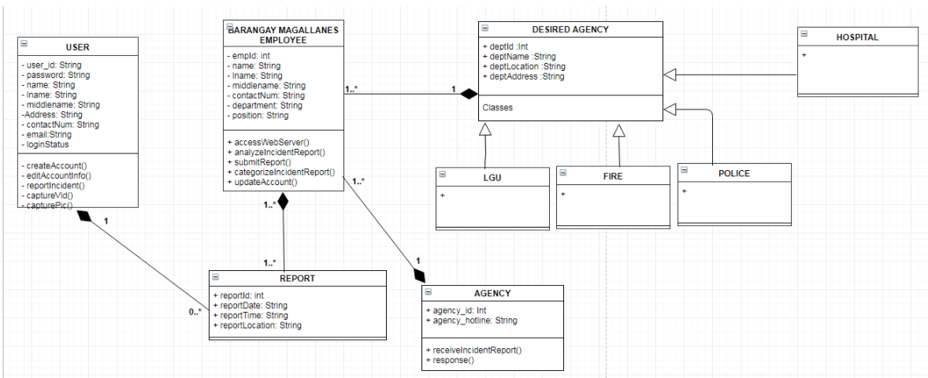

**4.1.5 Object Diagram**

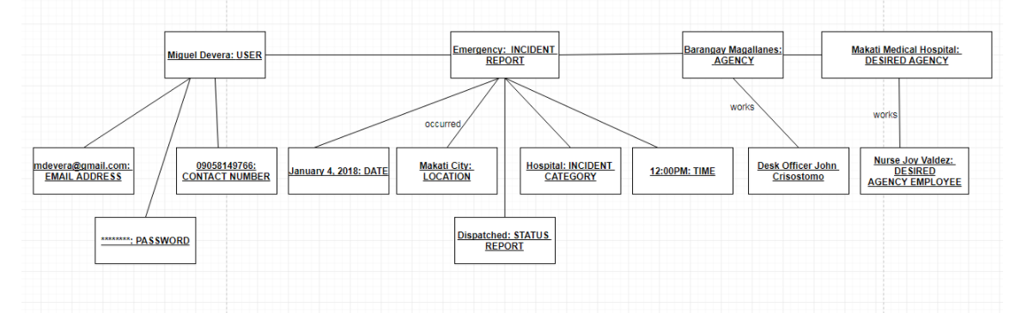

**4.1.6 Composite Diagram**

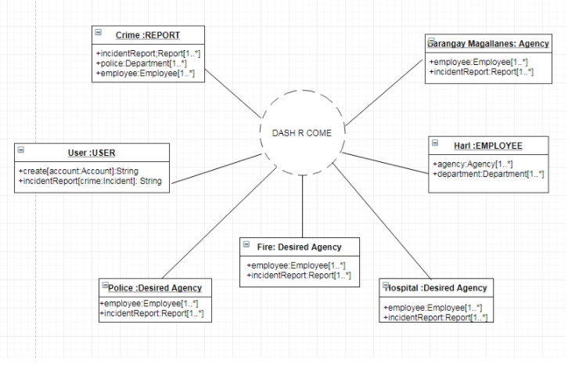

**4.1.7 Activity Diagram**

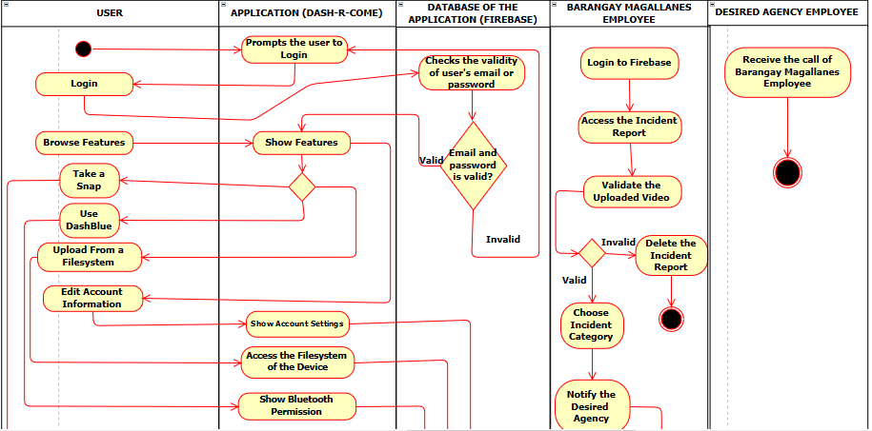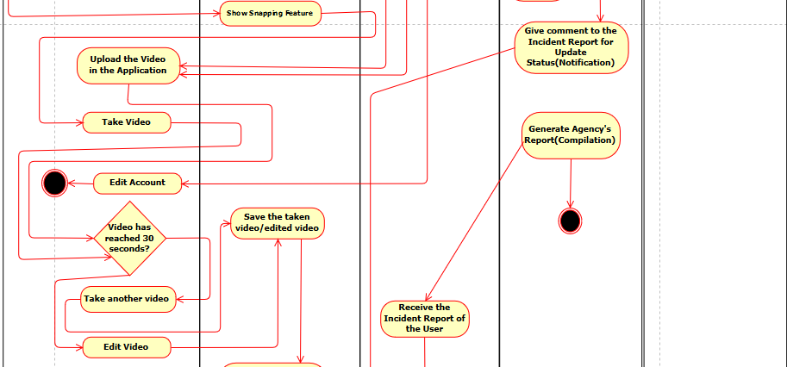

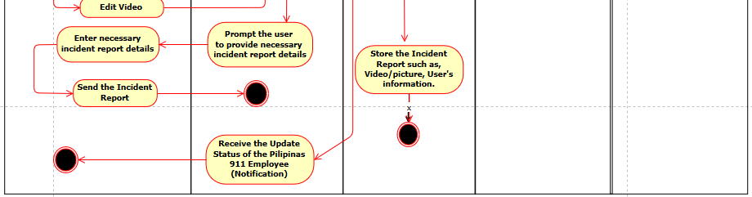

**4.1.8 Sequence Diagram**

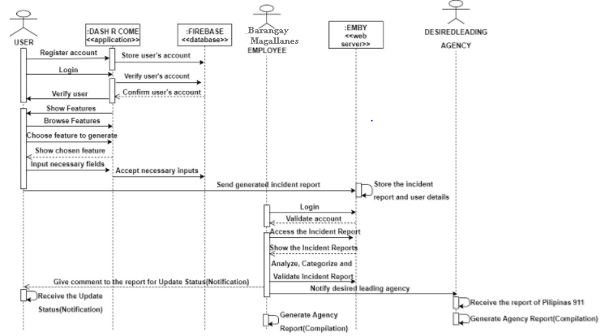

**4.1.9 Deployment Diagram**

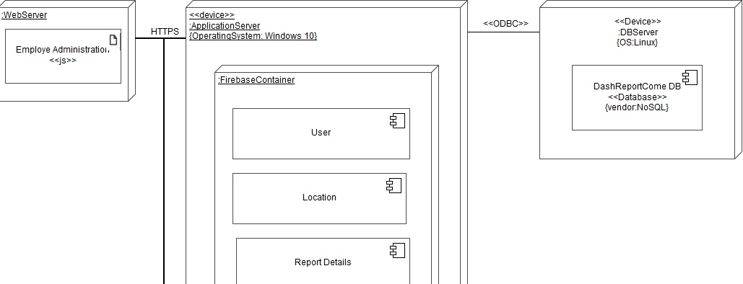

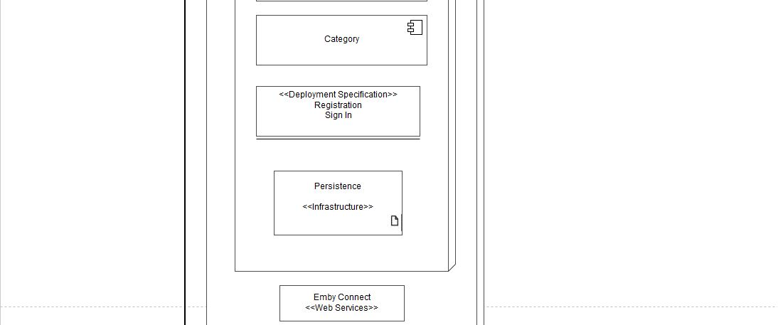

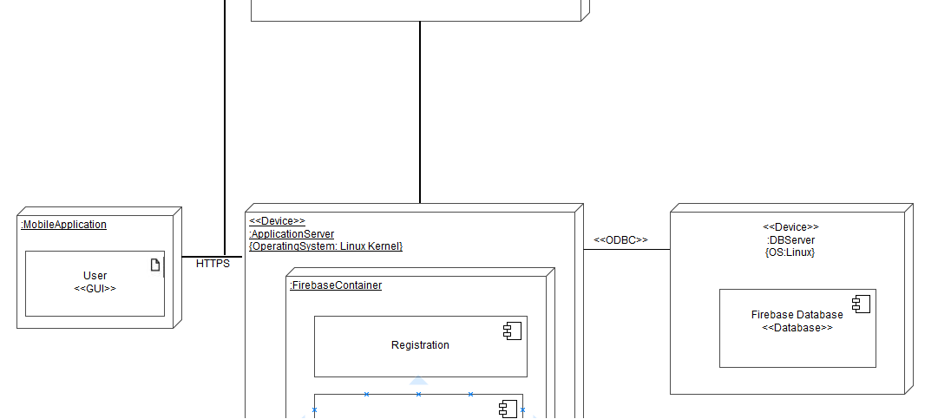

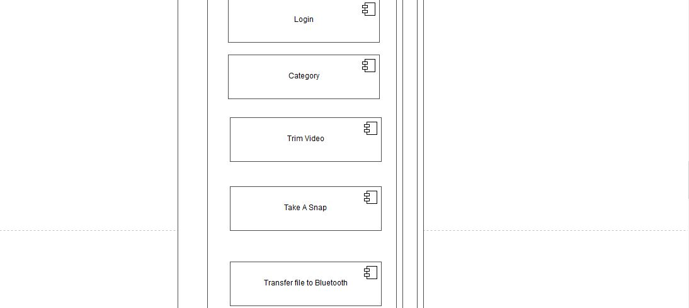

**4.1.10 Communication Diagram**

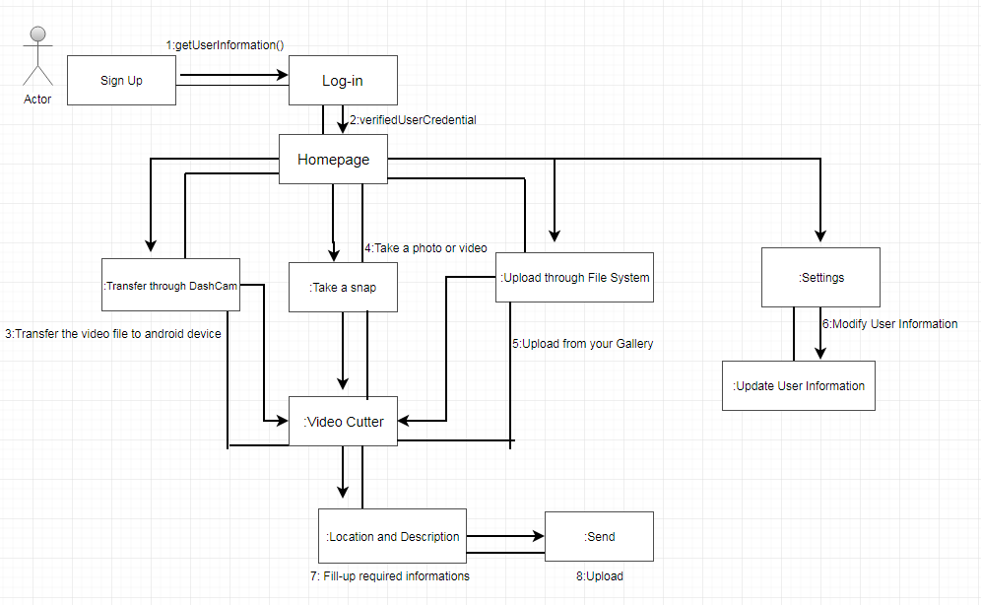

**4.1.11 Timing Diagram**

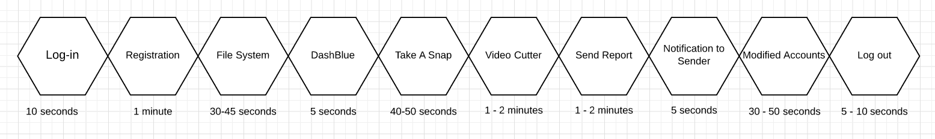

**4.1.12 Component Diagram**

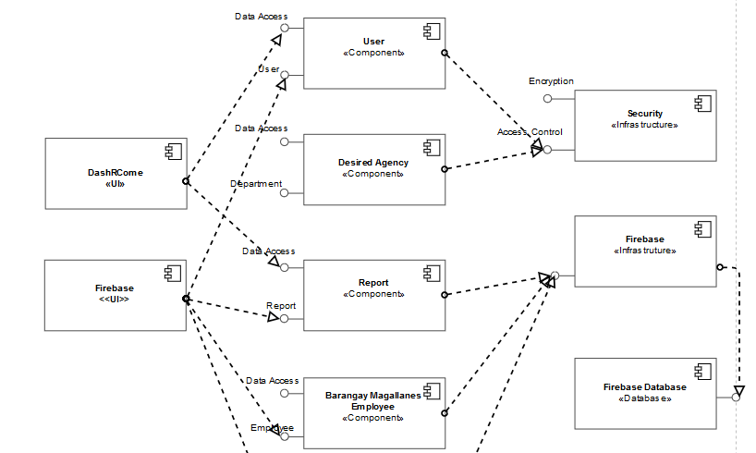



**4.1.13 Package Diagram**

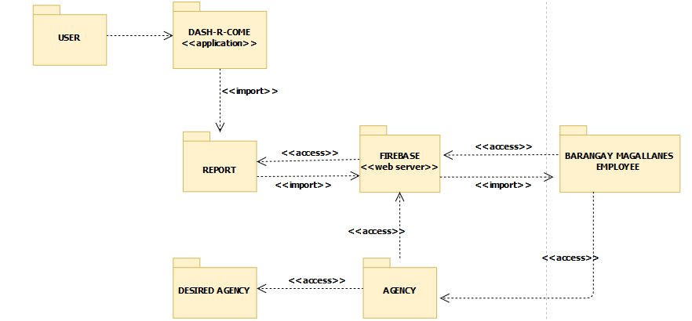

**4.1.14 State Diagram**

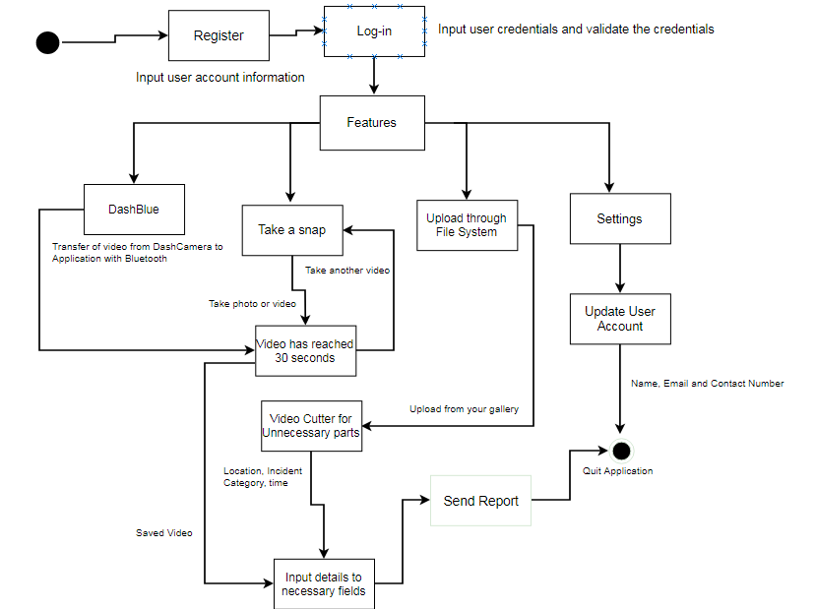

**4.1.15 Interaction Overview Diagram**

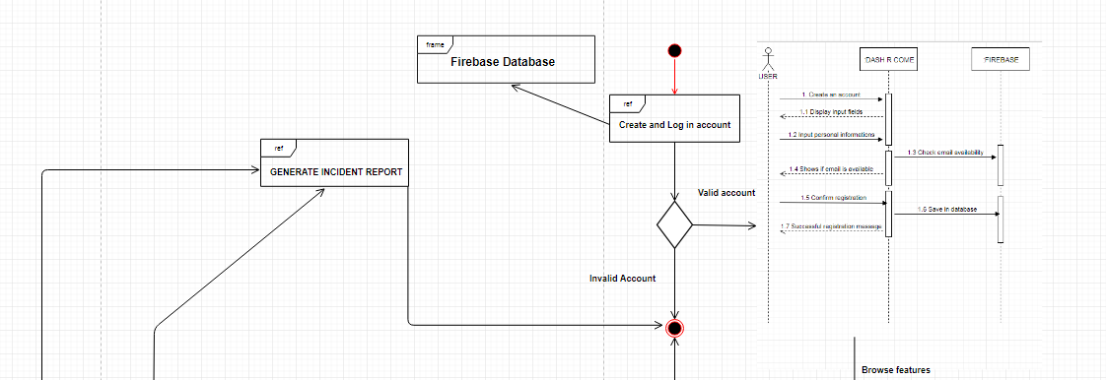

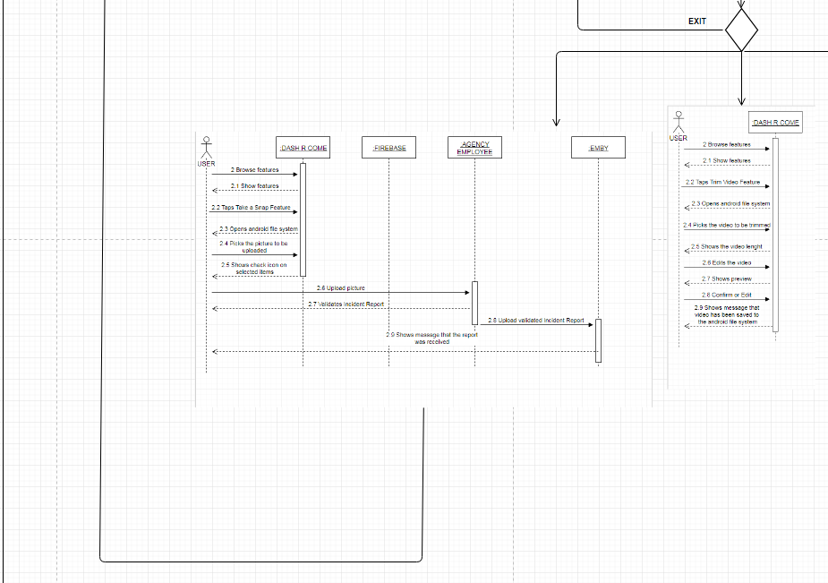

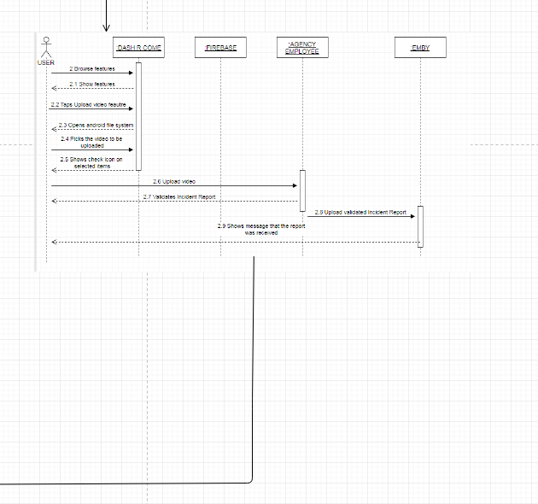

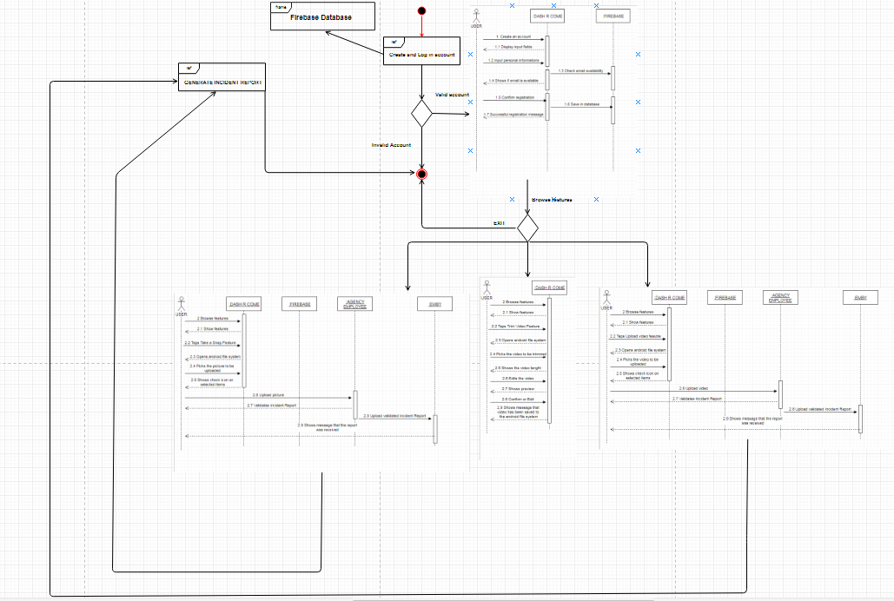

## **Requirements Documentation**

**4.2.1 Use Case Diagram**

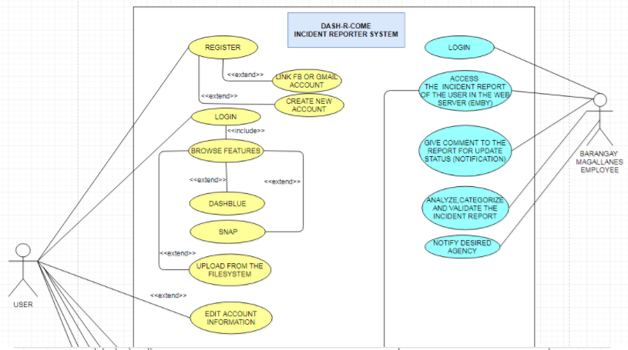

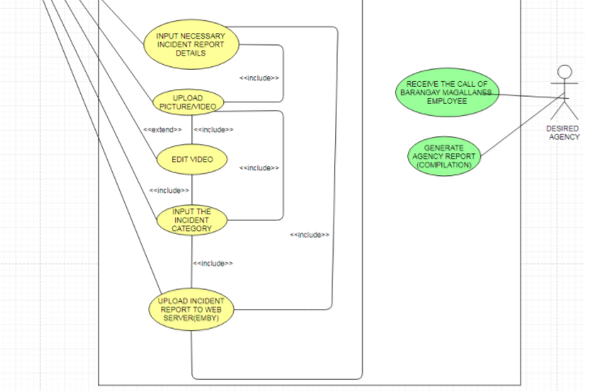

\

**4.2.2 Use Case Narrative Report**

|  |  |  |
| --- | --- | --- |
| Use Case Name: | Create an account | |
| Scenario: | User wants to create an account | |
| Triggering Event: | Registration | |
| Brief Description: | User wants to create an account to use the mobile application. | |
| Actors: | User | |
| Related Use Case: | Browse features, edit account information, edit video, upload incident report to google drive. | |
| Stakeholders: | User | |
| Preconditions: | • The user must install the mobile application to his or her android device.  • The user must register to the system.  • The user must have internet access to use the system. | |
| Postconditions: | The system will store the data entered by the user to the firebase database. | |
|  |  | |
| Flow of Activities: | Actor | System |
| 1. The user connects to Wi-Fi or Data connection.  2. The user opens the mobile application.  3. The user taps the Create an account button.  4. The user fills up the required fields.  5. The user submits the registration form. | 1.1 The system displays an error message if the user does not have internet connectivity.  2.1 The system displays the create account page  3.1 The system verifies if the entered information is available  4.1 The system displays a successful message if the user has successfully registered to the system. |
| Exception Conditions: | The user must install the mobile application to his or her android device.  The user must be registered  The user must have internet connection | |

|  |  |  |
| --- | --- | --- |
| Use Case Name: | Browse Features | |
| Scenario: | The user wants to try the mobile application features | |
| Triggering Event: | The user is a new user | |
| Brief Description: | The user is not familiar with the mobile application, so he or she wants to try the features. | |
| Actors: | User | |
| Related Use Case: | Create an account, Upload from the file system, edit account information, edit video, Upload Incident Report. | |
| Stakeholders: | User | |
| Preconditions: | • The user must install the mobile application to his or her android device.  • The user must register to the system.  • The user must have internet access to use the system. | |
| Postconditions: | • The user must be able to view and browse the features. | |
| Flow of Activities: | Actor | System |
| 1. The user connects to the Internet.  2. The user logs in to the mobile application.  3. The user taps different features. | 1.1 The system displays an error message if the user does not have internet connectivity.  2.1 The system displays the home page of the mobile application. |
| Exception Conditions: | The user must install the mobile application to his/ her android device.  The user must be registered  The user must have internet connection | |

|  |  |  |
| --- | --- | --- |
| Use Case Name: | Edit account information | |
| Scenario: | The user wants to change his or her current account password. | |
| Triggering Event: | The user forgot his current account password. | |
| Brief Description: | The user cannot remember his/ her current account password. | |
| Actors: | User | |
| Related Use Case: | Create an account | |
| Stakeholders: | User | |
| Preconditions: | •The user must install the mobile application to his/ her android device.  •The user must be registered  •The user must have internet connection  •The user must input his or her email address that he or she used in registration. | |
| Postconditions: | • The user must receive an email from the system that will let the user to change his or her current account password. | |
| Flow of Activities: | Actor | System |
| 1. The user connects to the Internet.  2. The user logs in to the mobile application.  3. The user taps the retrieve password button.  4. The user enters the email used in registration. | 1.1 The system displays an error message if the user does not have internet connectivity.  2.1 The system displays the home page of the mobile application.  3.1 The system displays a screen that asks for old email address.  4.1 The system sends an email to the user that will let the user change his/her current account password. |
| Exception Conditions: | •The user must install the mobile application to his/ her android device.  •The user must be registered  •The user must have internet connection  •The user must enter his/her email address used in registration. | |

|  |  |  |
| --- | --- | --- |
| Use Case Name: | Edit video | |
| Scenario: | The user wants to trim the video footage he/she captured. | |
| Triggering Event: | The video is too long.  Lots of unnecessary parts. | |
| Brief Description: | The user wants to trim the video to reduce the data that will be consumed in uploading the video. | |
| Actors: | User | |
| Related Use Case: | Create account, Browse features | |
| Stakeholders: | User | |
| Preconditions: | •The user must install the mobile application to his/ her android device.  •The user must be registered  •The user must have internet connection  •The user must have video footage captured either using android device or dashboard camera. | |
| Postconditions: | • The user must be able to reduce the file size | |
| Flow of Activities: | Actor | System |
| 1. The user opens up video cutter  2. The user saves the video to the android file system. | 1.The cut of the unnecessary part will be saved  2.It can be played on the android file system. |
| Exception Conditions: | •The user must have internet connection.  •The user can use the video cutter. | |

|  |  |  |
| --- | --- | --- |
| Use Case Name: | Upload Video or Picture | |
| Scenario: | The user wants to report an incident. | |
| Triggering Event: | The user was able to film an incident | |
| Brief Description: | The user captured an incident and wants to report. | |
| Actors: | User | |
| Related Use Case: | Create account, Browse features | |
| Stakeholders: | User, Agency, Leading agency | |
| Preconditions: | •The user must install the mobile application to his/ her android device.  •The user must be registered  •The user must have internet connection  •The user must have video footage captured either using android device or dashboard camera. | |
| Postconditions: | • The user must provide or input the needed information before uploading to google drive. | |
| Flow of Activities: | Actor | System |
| 1. The user connects to the Internet.  2. The user login to the mobile application.  3. The user taps the upload from file system button.  4 The user picks the video or picture to be uploaded to google drive.  5. The user confirms his or her action. | 1.1 The system displays an error message if the user does not have internet connectivity.  2.1 The system displays the home page of the mobile application.  3.1 The system displays the android file system  4.1 The system selects the video/ picture tapped by the user.  5.1 The system uploads the video or picture to google drive. |
| Exception Conditions: | •The user must install the mobile application to his or her android device.  •The user must be registered  •The user must have internet connection  •The user must provide the required information  •The user must have a video or picture of an incident | |

|  |  |  |
| --- | --- | --- |
| Use Case Name: | Validate Incident Report | |
| Scenario: | The Barangay Magallanes employee received an incident report | |
| Triggering Event: | Validate Incident Report | |
| Brief Description: | The Barangay Magallanes employee will validate the incident report | |
| Actors: | User, Barangay Magallanes employee | |
| Related Use Case: | Upload picture or video, edit video | |
| Stakeholders: | User, Agency, Leading agency | |
| Preconditions: | • The Barangay Magallanes must have an account and login to the firebase.  • The Barangay Magallanes must validate the incident report | |
| Postconditions: | • The Barangay Magallanes employee must be able to validate the report.  • The Barangay Magallanes employee must be able to view the incident report in the firebase.  • The Barangay Magallanes employee must notify the user once the report is validated. | |
| Flow of Activities: | Actor | System |
| 1. The Barangay Magallanes employee must be logged in to google drive.  2. The Barangay Magallanes employee will categorize the incident report if the report is valid, otherwise, the incident report will be deleted. | * 1. The system lists the incident reports filtered by category. |
| Exception Conditions: | • If the report of the user is fake. | |

|  |  |  |
| --- | --- | --- |
| Use Case Name: | Notify leading agency | |
| Scenario: | The incident report is validated | |
| Triggering Event: | An incident is reported. | |
| Brief Description: | The Barangay Magallanes employee notifies the leading agency. | |
| Actors: | Barangay Magallanes employee, leading agency, user | |
| Related Use Case: | Validate Incident Report | |
| Stakeholders: | User, Agency, Leading agency | |
| Preconditions: | • The Barangay Magallanes employee must have validated the incident report  • The Barangay Magallanes employee must notify the leading agency. | |
| Postconditions: | • The leading agency must respond to the incident.  • Both the Barangay Magallanes and leading agency must generate an incident report. | |
| Flow of Activities: | Actor | System |
| 1. The Barangay Magallanes employee validates the incident report  2. The Barangay Magallanes employee notifies the leading agency.  3. Both the Barangay Magallanes agency and leading agency must generate an incident report. | 1.1 The system displays the list of incident reports arranged to its category. |
| Exception Conditions: | • The leading agency’s resources are broken. | |

|  |  |  |
| --- | --- | --- |
| Use Case Name: | Generate Incident Report | |
| Scenario: | The incident report is validated | |
| Triggering Event: | An incident report was solved. | |
| Brief Description: | An incident report was solved. | |
| Actors: | Barangay Magallanes employee, leading agency | |
| Related Use Case: | Validate Incident Report, Notify leading agency | |
| Stakeholders: | User, Agency, Leading agency | |
| Preconditions: | • The incident report must be solved. | |
| Postconditions: | • Both Barangay Magallanes agency and leading agency must generate an incident report. | |
| Flow of Activities: | Actor | System |
| 1. Barangay Magallanes employee notifies the leading agency  2. Leading agency responds to the incident report. | 1.Leading agency response to the barangay magallanes according to the matter of the incident.  2.Leading agency gathered information from the barangay magallanes to respond according to the report. |
| Exception Conditions: | 1. If the location of the incident is not in the city or place where they're usually operated. | |

## **Gap Analysis**

|  |  |  |  |
| --- | --- | --- | --- |
| Dash-R-Come | | | |
| User Requirements | Current System | Goal | Proposed Changes |
| 1.To be able to report an incident | A reporting application lacks notification to the user who uploaded the incident. | To have a detailed incident report to help government agencies verify if an incident really happened. | The mobile application will provide the list of Hotlines of Makati City Government Agencies, Video trimmer, Video uploader and Video Camera |

## **Design of Software, Systems, Product, and/or Processes**

**Index Screen**

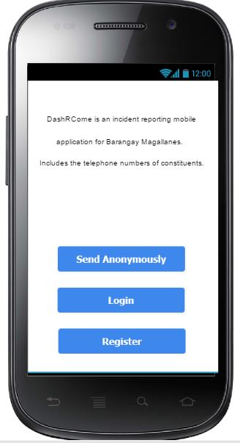

**Login and Signup Screen**

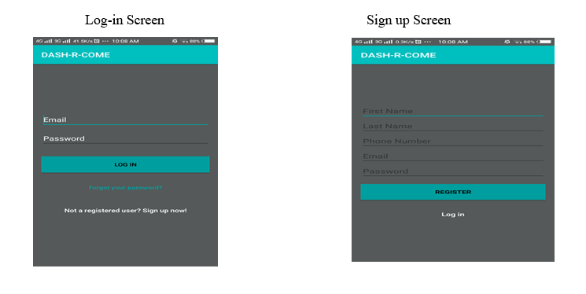

**Capture Video and Upload from File System Screens**

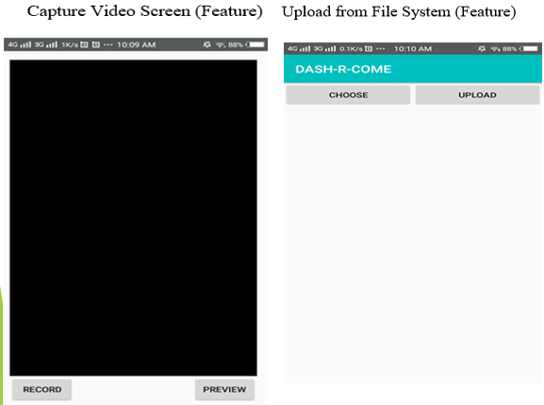

**Forgot password and Home Screen**

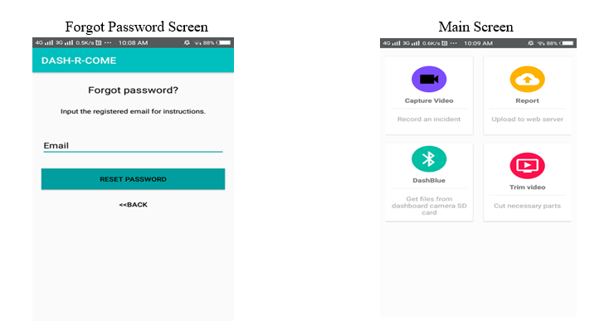

**File System**

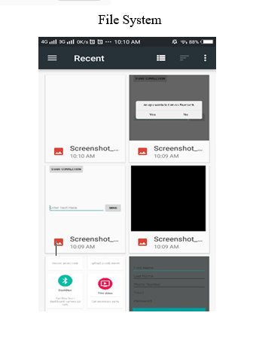

**Authentication**

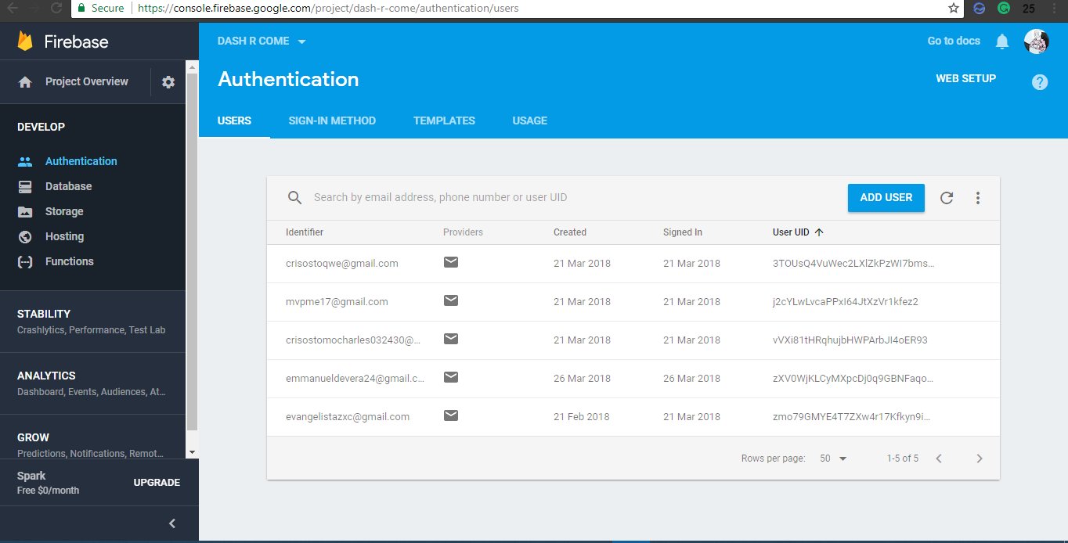

**Database**

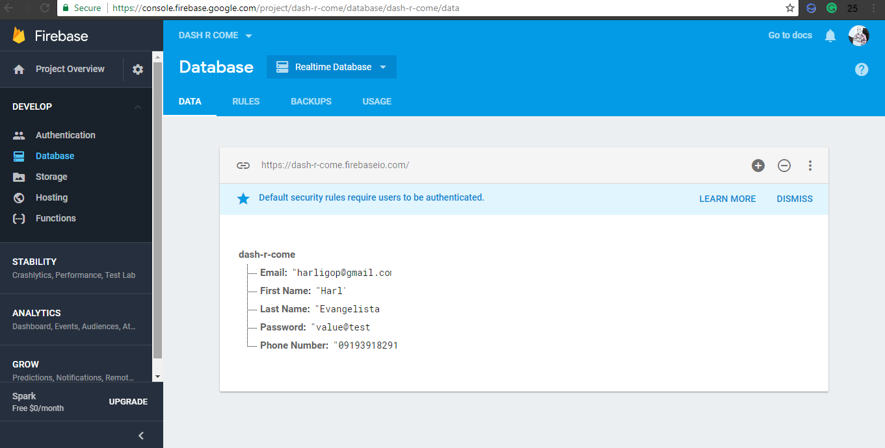

**Storage**

A screenshot of a social media post

Description generated with very high confidence

A screenshot of a social media post

Description generated with very high confidence

## **Development and Testing, where applicable**

The prototype that the team will be developing is powered by Android Studio and Firebase. Android Studio is the main tool for developing android application. It provides the fastest and efficient way to build a mobile application. Firebase a restful online file storage web service for storing and accessing data on Google’s infrastructure. The prototype would enable the developers to create the proposed project. System testing gains the developers to verify that the system will handle all input data properly, both valid and invalid.

**Chapter V**

# Conclusions and Recommendations

In today’s times, reporting a crime, traffic accident, or accusing someone of a crime is hard to investigate if there is no evidence. A mobile application like Dash-R-Come could serve as an alternative tool in capturing and reporting an incident. Our proposed system aims to help the client get a real-time and detailed incident reports. Since the client’s biggest problem are prank reports. Using the proposed system, the client will be able to avoid deploying their people unusably to respond to prank reports. Since there will be employees Barangay Magallanes that will be monitored and analyzing and the incident reports, it can assure that prank reports may lessen.

**Chapter VI**

**Appendices**

# Appendices

**6.1 Relevant Source Code**

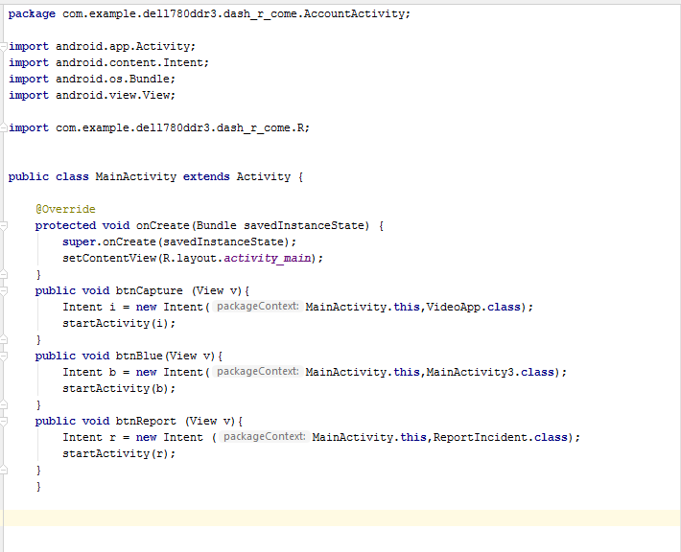

**6.2 Evaluation Tool or Test Documents**

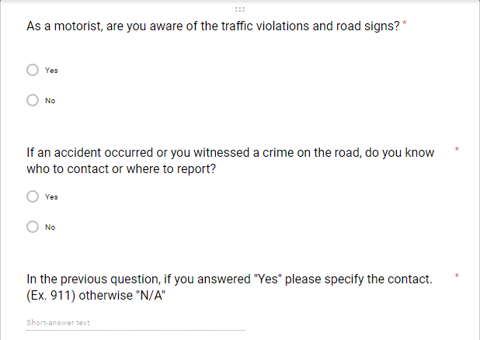

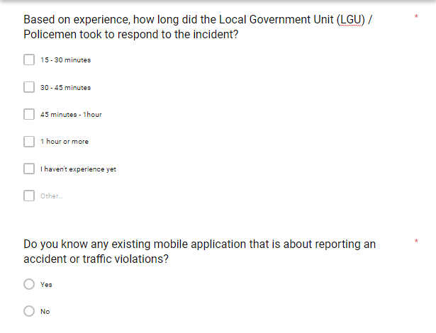

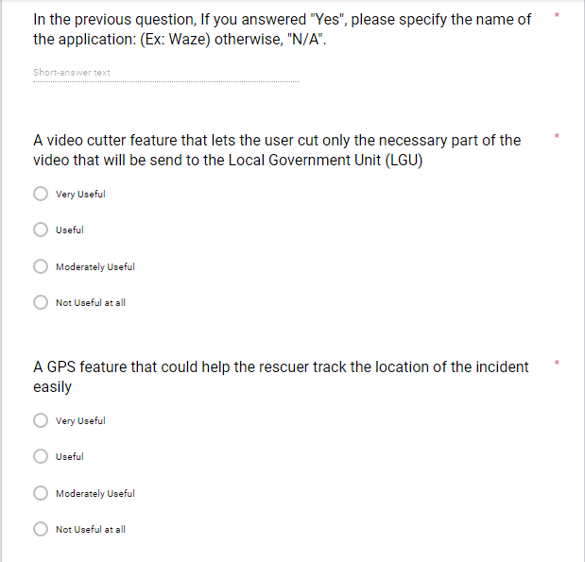

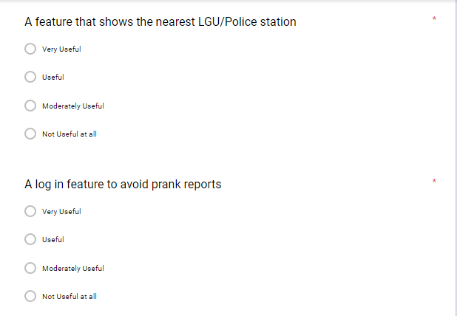

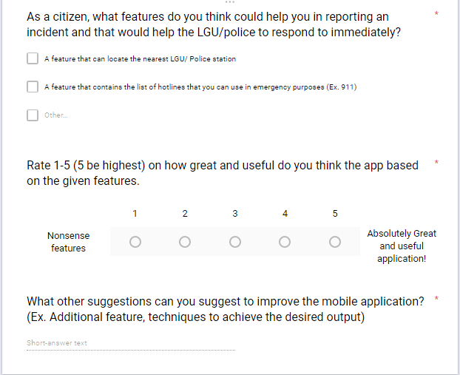

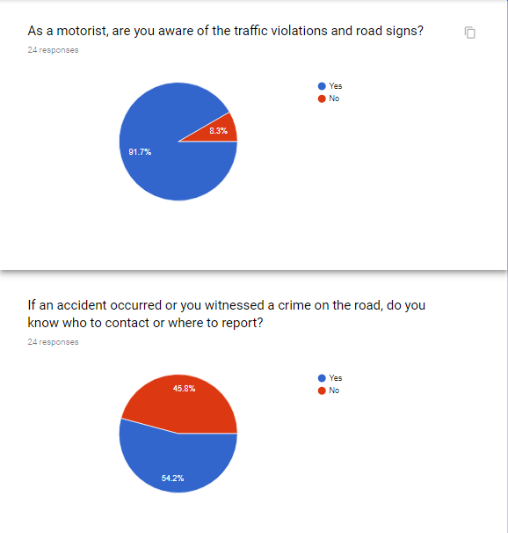

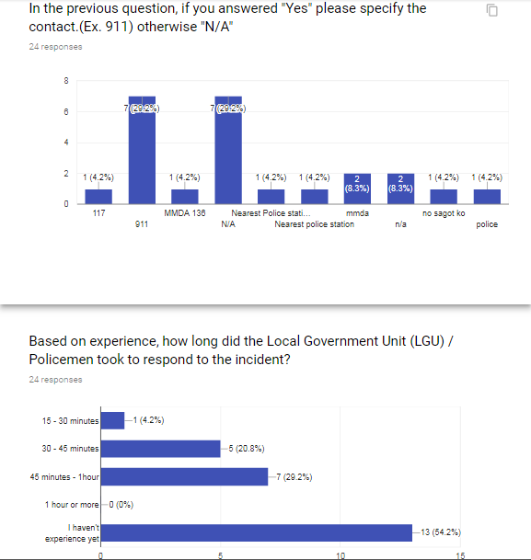

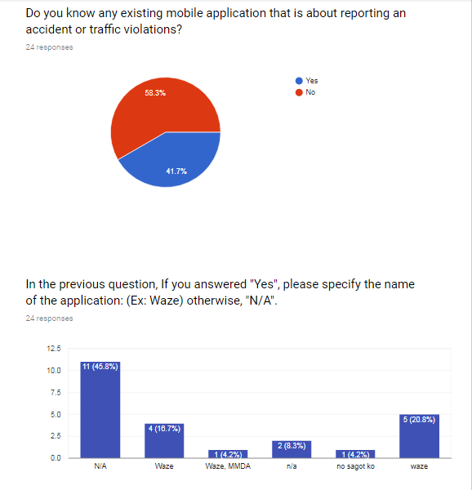

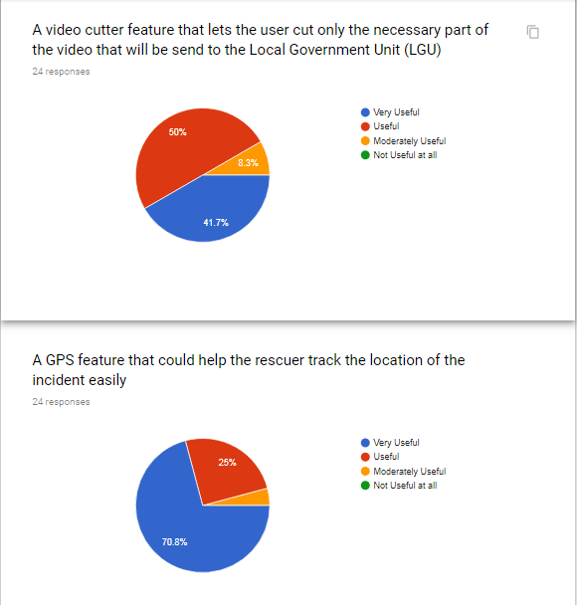

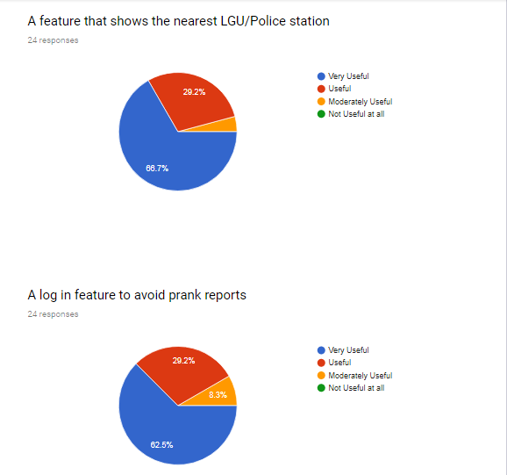

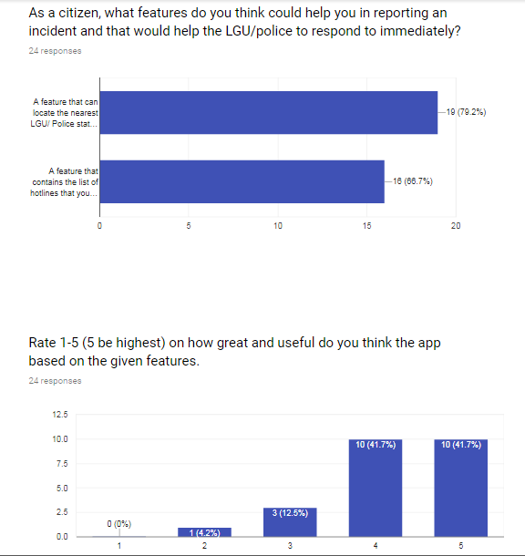

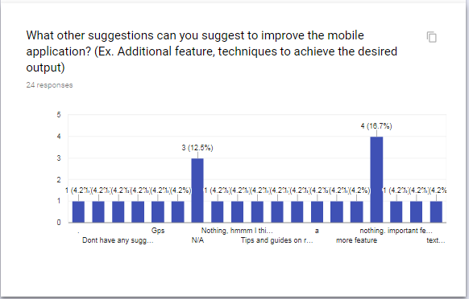

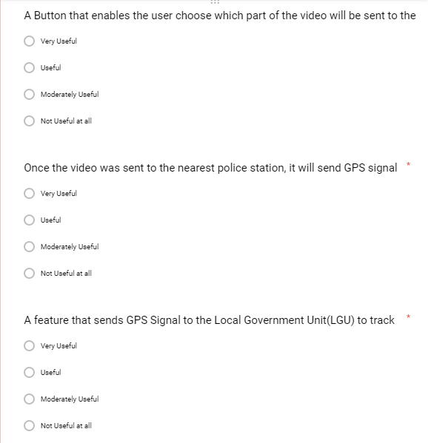





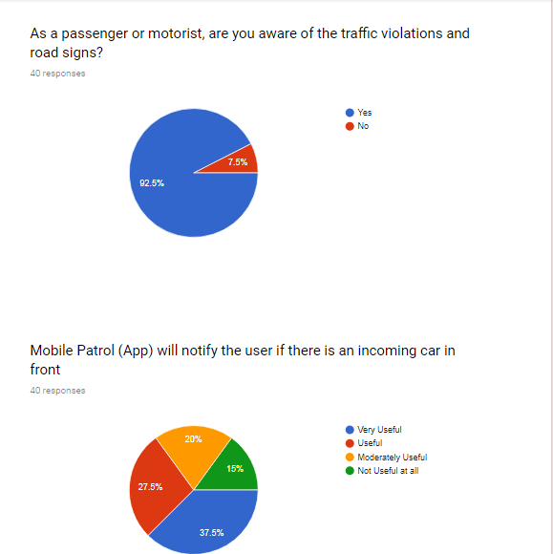

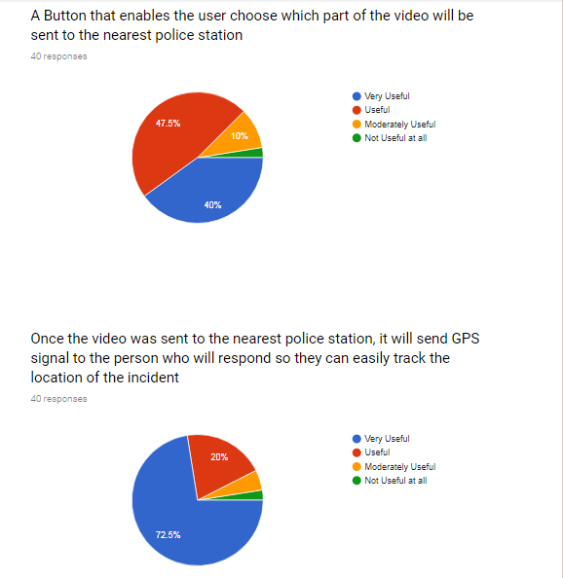

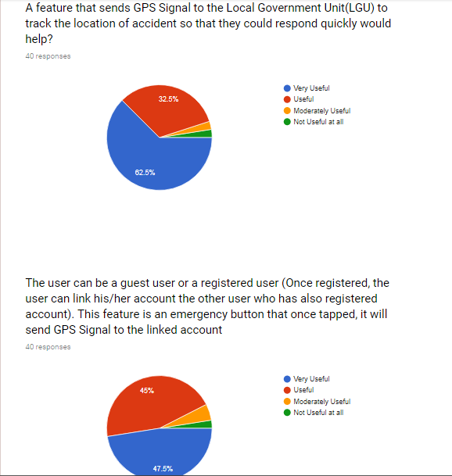

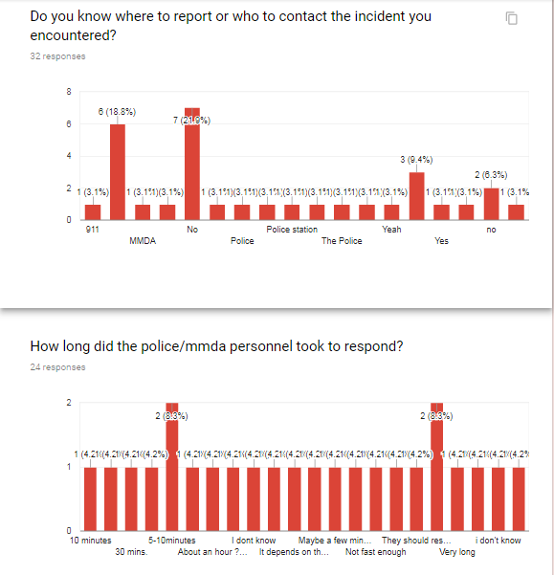

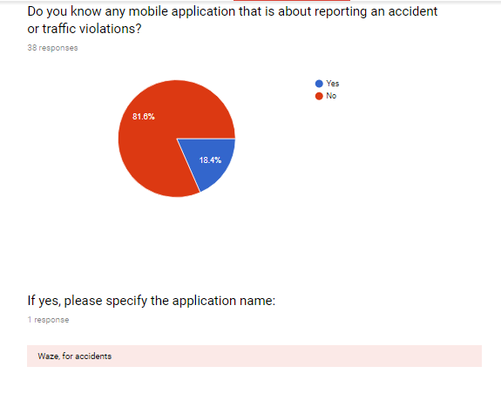

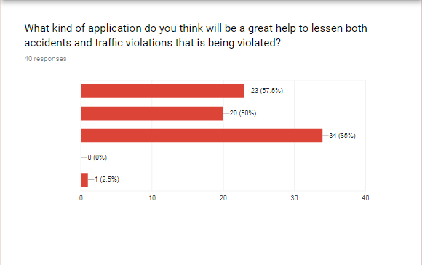

/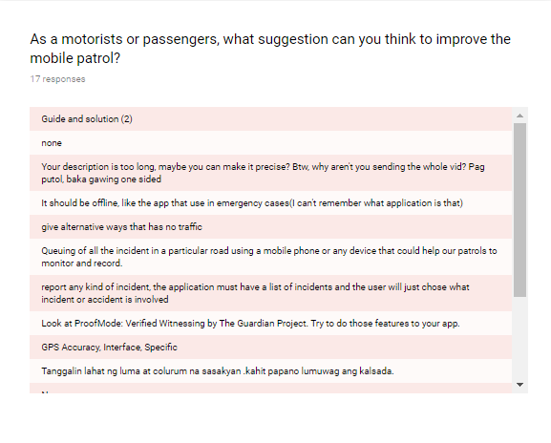

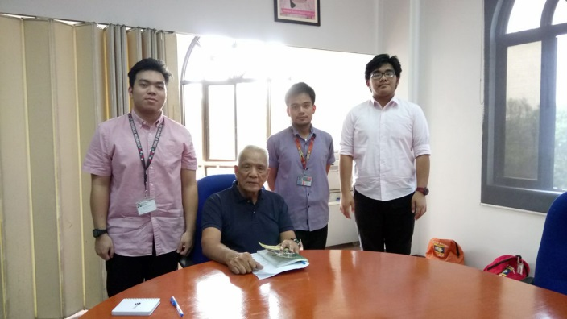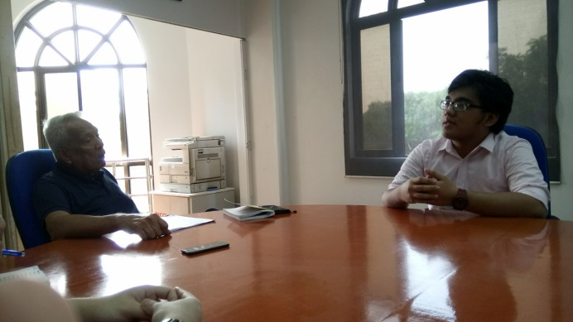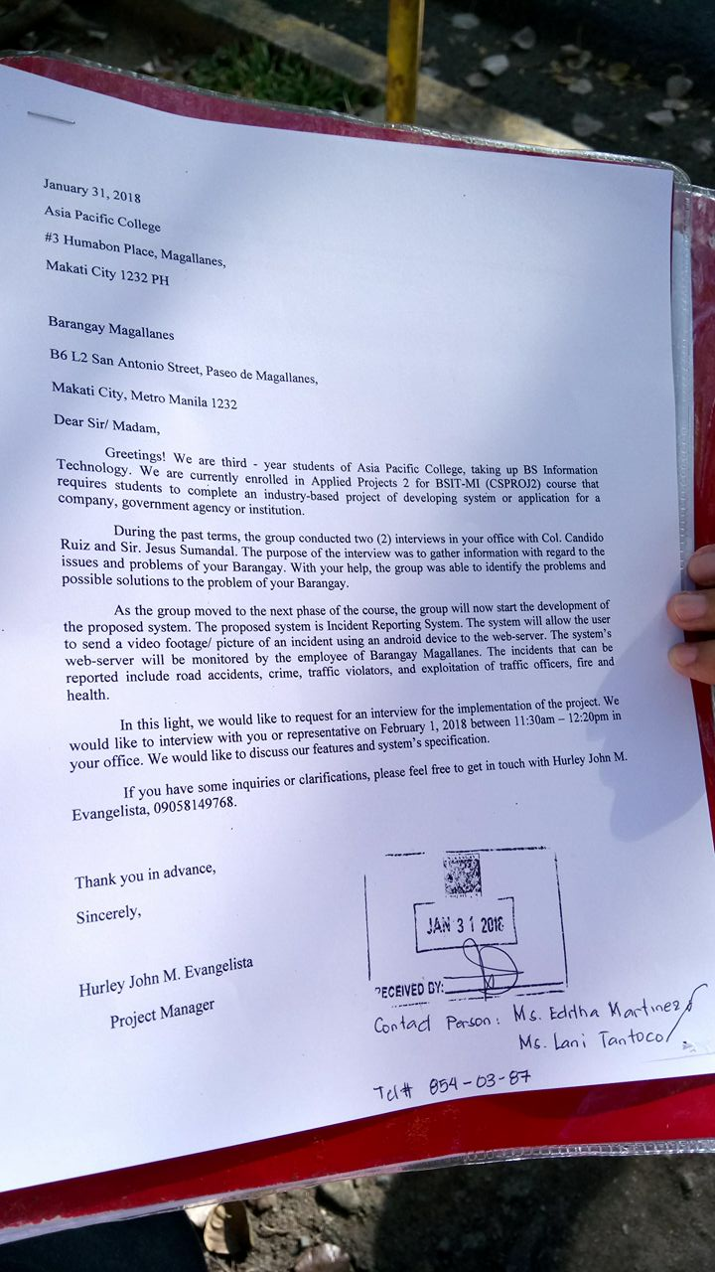

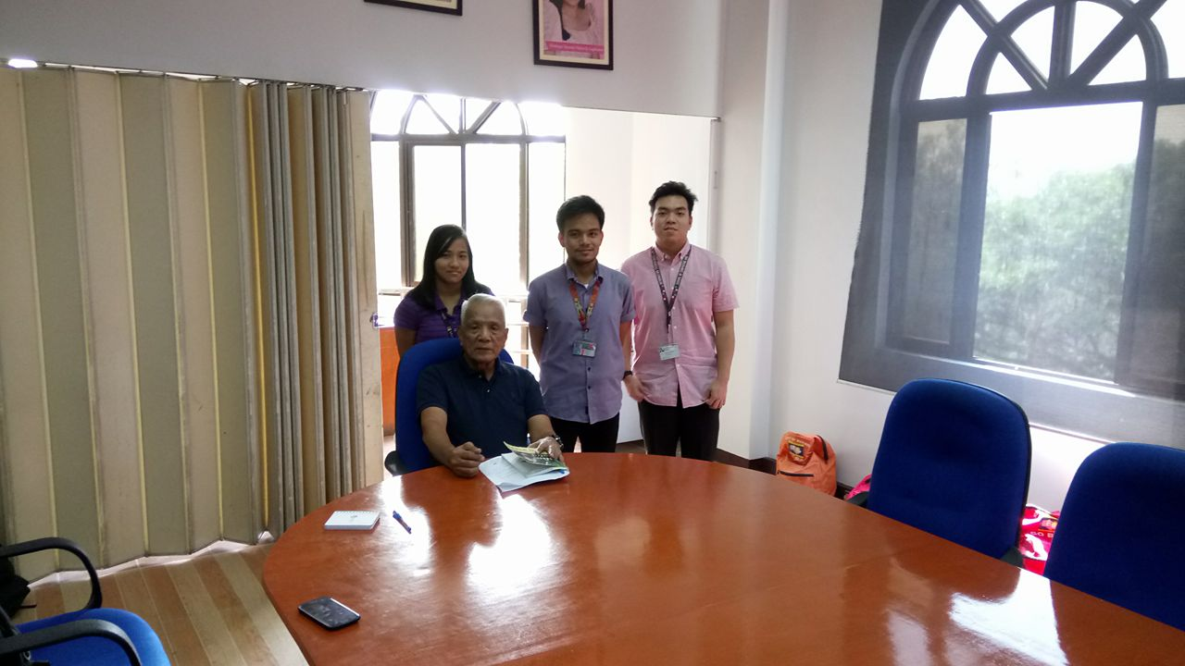

**6.3** **Sample input/output/Reports**

**INPUT**

The user register and login to the mobile application.



**OUTPUT**

The mobile application will go to home screen activity.

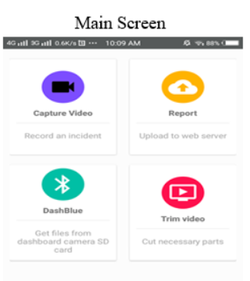

**6.4 Users Guide**

The Dash-R-Come allows user to send incident report. The mobile application also provides hotlines to its own specific constituents. The application saves incident report either video or picture to firebase. The mobile application runs on android devices

**Step 1**

Register – the user needs to provide information required by the mobile application

Send Anonymously – The user can send anonymously and can some mobile application features

Logging in – The user must input his or her email and password to login to the mobile application.

**Step 2**

Features – The mobile application has 4 main features, the “video recorder”, “video uploader”, “list of hotlines”, and “video trimmer”.

**Step 3**

The firebase database serves as a database of the system. Also, it is responsible for the user authentication

**6.5 Curriculum Vitae**

Personal Details

|  |  |
| --- | --- |
| Name: | Hurley John M. Evangelista |
| Complete Address: | MEQ U-2B BNS Fort Bonifacio, Taguig City |
| Contact Number | 09058149768 |
| Email Address: | [hmevangelista@student.apc.edu.ph](mailto:hmevangelista@student.apc.edu.ph) |



Educational Background

|  |  |
| --- | --- |
| Educational Attainment: | Asia Pacific College, Magallanes Makati City  Bachelor of Science in Information Technology with specialization in Mobile and Internet Technology  2015 - Present  Total Concept Integrated School - High School  Villamor Air Base Elementary School - Elementary |

Relevant Skills:

|  |  |
| --- | --- |
| Skills: | Android Programming  Web Programming  MySQL Programming |

Personal Details

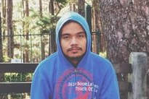

|  |  |
| --- | --- |
| Name: | Emmanuel Devera |
| Complete Address: | BLDG P USUSAN TAGUIG CITY |
| Contact Number | 09955573433 |
| Email Address: | [esdevera@student.apc.edu.ph](mailto:esdevera@student.apc.edu.ph)  BERTdevera28@protonmail.com |

Educational Background

|  |  |
| --- | --- |
| Educational Attainment: | Asia Pacific College, Magallanes Makati City  Bachelor of Science in Information Technology with specialization in Mobile and Internet Technology  2015 - Present  MCA Montessori School - High School  Nasugbu West Central School - Elementary |

Relevant Skills:

|  |  |
| --- | --- |
| Skills: | *SQL Programming  *C++ Programming  *Computer Security  *Network Security  *Web Designing |

Personal Details



|  |  |
| --- | --- |
| Name: | Alyssa Anne F. Fernandez |
| Complete Address: | Blk 9 Lot26 Burnham Park, Road 6, Talon 5, Teresa Subd. Las Pinas City |
| Contact Number | 09167449709 |
| Email Address: | [affernandez@student.apc.edu.ph](mailto:affernandez@student.apc.edu.ph) |

Educational Background

|  |  |
| --- | --- |
| Educational Attainment: | Asia Pacific College, Magallanes Makati City  Bachelor of Science in Information Technology with specialization in Mobile and Internet Technology  2014- Present  Pasay City South High School - High School  Villamor Air Base Elementary School - Elementary |

Relevant Skills:

|  |  |
| --- | --- |
| Skills: | * Android Programming * Web Programming * MySQL Programming * Java Programming |

Personal Details



|  |  |
| --- | --- |
| Name: | Miguel Enrico Matawaran |
| Complete Address: | 465G Protacio St. Pasay City |
| Contact Number | 09156410317 |
| Email Address: | [mlmatawaran@student.apc.edu.ph](mailto:mlmatawaran@student.apc.edu.ph) |

Educational Background

|  |  |
| --- | --- |
| Educational Attainment: | Asia Pacific College, Magallanes Makati City  Bachelor of Science in Information Technology with specialization in Mobile and Internet Technology  2015 - Present  San Isidro Catholic School - High School and Elementary |

Relevant Skills:

|  |  |
| --- | --- |
| Skills: | * Android Programming * Web Programming |

**6.6 Screen layouts**



**6.7** **Pictures showcasing the data gathering, investigation done (e.g. floor plan, layout, building, etc.)**

## **Results of the Interview**

As the group identifies the factors that will help to improve the process in developing the proposed system, the group conducted an interview in Barangay Magallanes that contains 15 questions and lasted for 20 minutes, questions that includes the interviewee’s personal information, rules and regulations of Makati City traffic and common traffic problems and crimes that they usually encounter in their area. The data below is the result of the interview that the group conducted.

The name of the interviewee is Sir Jesus Sumandal, he is one of the Desk Officers in Barangay Magallanes. The Desk Officer is the one who receives complaints; also, he is in-charge in deploying people in an incident.

They can respond to all kinds of crimes and incident in the City of Makati. It is possible to respond in that area, we asked. He told us that if the concern is in our area. We can respond with the participation in NDCC. The barangay of Magallanes Makati has some different divisions such as; Peace and Order, Accounting, Social Service, Health Clinic, Infrastructure, and Educational & Culture

They process the incident report as follows; Get the following information. Details of the incident, Description of the suspect, information about the complainant, what is the thing stolen, if the complainant will not file against the complainant and if the thing stolen has a big amount; How do they validate the report, The Barangay Officer will know if the complainant is lying or not, first in the interview. If the complaint is true, they will endorse it to CDI and do their process

They have allotted budget and resources. They have Wi-Fi connection and computers and a database. The team also asked the commonly committed crime in the Makati area. Sir Sumandal mentioned that, it is snatching and most victims’ APC students.