

Asia Pacific College

School of Computing and Information Technologies

Magallanes, Makati City

Dash-R-Come

Submitted by:

Hurley Evangelista - Project Manager

Emmanuel Devera - Project Developer

Alyssa Fernandez - Project Analyst

Miguel Matawaran - Project Analyst

Submitted to:

Mr. Manuel Sebastian Sanchez

(Professor)

Mr. Jayvee Cabardo  
(Project Adviser)

Ms. Sheng Naviamos

(Project Consultant)

February 27, 2018

Contents

Executive Summary1

1.1 Project Context 1

1.5 Scope and Limitations 2

II. Review of Related Software/ Systems 3

III. Technical Background 4

Hardware Requirements: 4

Programming Language Requirements: 5

IV. Methodology, Results and Discussion 6

4.1 Gap Analysis…………………………………………………………………………………………6

4.2 Requirement Analysis 6

4.3 Software Requirements Specification (SRS) 7

4.4 Design of Software, Systems, Product, and/or Processes 9

Login Screen…………………………………………………………………………………………......9

Successful Registration Screen…………………………………………………………………………10

Login Failed Screen…………………………………………………………………………………….11

Home Screen……………………………………………………………………………………………12

File System……………………………………………………………………………………………..13

Modified User's Account……………………………………………………………………………….14

Logout Screen…………………………………………………………………………………………..16

Development and Testing 17

a.Event Table 17

b. Functional Decomposition Diagram (FDD) 20

c. Data Flow Diagram (DFD) 21

d. User ID String (UID / Database) 23

f. Object Diagram 25

g. Composite Diagram 26

h. Use Case Diagram 27

j. Activity Diagram 44

5.1 Results of the Interview 56

**Executive Summary**

The proposed project is an incident reporting system. The team aims to help Barangay Magallanes expand their services in terms of receiving incident reports or complaints. Barangay Magallanes receives incident reports and complaints using their hotline. The problem in their current system, according to Police Chief Inspector Samuel Melchor Fernandez, is that the agency cannot verify if the report is true. The team found this as an opportunity for the project implementation. Using the proposed system, Barangay Magallanes will receive a picture or video of the incident online. For the user side, the user is the one sending the incident report to the firebase. Which will be monitored by the Barangay Magallanes employee.  The Barangay Magallanes employee will call for the nearest concerned agency.

**I. Introduction**

**1.1 Project Context**

The proposed project is an Incident Reporting System. The system allows the user to send a video footage or picture of an incident using android device to the system’s firebase with a description of the incident. The firebase will be manned by the Barangay Magallanes employees. The mobile application is named DASH-R-COME, the mobile application name was composed from the objective before which was to respond quickly. The mobile application runs in Android devices. Incident includes road accident, crime, traffic violators, and exploitation of traffic officers. The user must have a video footage or picture of an incident captured in either using a dashboard camera or android devices. The user is required to have an Internet connection or mobile data to use the mobile application.

The process of the application, If the user used a dashboard camera to capture the video, then, the user should transfer the video footage or picture to the android device using Bluetooth of dashboard camera, it’s only applicable if the dashboard camera has a Bluetooth feature. Otherwise, the user must transfer the memory card of dashboard camera to the android device and save the video footage or picture to the android device’s file system, such as Gallery. If the user used an Android device in capturing a video footage or picture of an incident, then the user can simply save the video footage or picture to the android device’s file system.

The video cutter feature, where the user can cut unnecessary clip. The importance of cutting the unnecessary part is less consumption of the memory and less-usage of mobile data or Wi-Fi connection. If the user used the feature of ‘Take a snap’ feature, it will only limit to 30 seconds, after 30 seconds the user can either delete or save the captured video footage, thereafter the user can take another 30 seconds video footage. After the user has the video footage or picture saved in his/her android device, then the user can upload the video footage or picture to the system’s web server or google cloud storage using the mobile application. The uploaded video will be analyzed by the person in-charge of monitoring the web server or google cloud storage in Barangay Magallanes. Analyzing the video means to categorize the incident type, such as crime, traffic violators, and exploitation of traffic officers, fire. After analyzing the incident report, the employee in-charge will generate an incident report which will be forwarded to the leading designated agency.

**1.2 Purpose and Description**

DASH-R-COME is a mobile application that can be used to report accidents, crime, and fire incidents. The application can also serve as evidence in times of involvement in a situation such as road accident. Using the proposed system, the user can send a picture or video footage of an incident to the firebase using any Android device. The system’s firebase will be operated by the Barangay Magallanes employee.

The purpose of the project is to provide the client a system that could help them get a real-time events or incident reports using the report of the user. Also, to provide the client an updated record of incidents that could be used in crime statistics purposes.

**1.3 Objectives**

* To expand the scope of Barangay Magallanes services in terms of receiving incident reports.
* To provide evidence or supporting details when reporting an incident to the client.

**1.4 Application’s Features**

* Login system feature to authenticate the user and to avoid fake reporters.
* A video cutter feature to reduce the file size and data that will be consumed.
* Take a snap feature that allows user to send only a picture of an event.
* DashCamBlue feature that allows user to transfer the video footage of the incident from the dashboard camera to the android device.

## **1.5 Scope and Limitations**

The scope of the project is the Barangay Magallanes. The group target users of the mobile application are the motorists, bystanders, constituents and android device users. For the user to use the mobile application, the user must register to the mobile application and must have an internet connection or mobile data. Also, the user must have a picture or video footage of the incident captured that will be uploaded later to firebase, which is being operated by Barangay Magallanes employee. In capturing pictures or videos, the user has three options, first, the user can use dashboard camera and transfer to the android device with its Bluetooth feature (the two devices must have a Bluetooth capability), second, if the user had captured the video footage with his/her android device, it must save in the android’s file system such as, Gallery and upload in the application from the file system, and third, the ‘take a snap’ feature to directly capture the video footage in the application that has 30 seconds limitations. If the user does not have an internet connection, then the application cannot be used to emergency. The project will not be covering the responding part of Barangay Magallanes and the desired leading agency. The proposed project is only limited in generating incident report that will be forwarded to the desired leading agency.

# **II. Review of Related Software/ Systems**

2.1 iWrecked - Nobody would want to get involved in an accident, but, a fact that accidents do occur every single day remains. If you are ever caught in an accident, you would want an application such as iWrecked, to key in and keep a history of the complete relevant details, preview and send accident reports, and look for towing services.

The group aims to provide a button that has the telephone of the agency in the application to respond quickly, and to provide evidence handling and to send help to the user as quickly as possible.

JohnnyJet (2017, August) Retrieved from https://www.johnnyjet.com/travel-app-of-the-week-iwrecked

2.2 Spotted Incident Reporter - Spotted incident reporter application is a local crime track, report and information on stolen cars and accidents. Spotted incident reporter application is a local crime track, report and information on stolen cars and accidents. For example, a car was stolen 6 minutes ago, you had the power to fight back to the thieves who stolen the car by posting the incident in the app, including the pictures of the stolen property or car. A feature of Global positioning system (GPS) that track the location of the said event.

Also, the team's proposed application provides evidence handling such as the location, day, time, and video or picture of the incident occurred, then sends directly to the desired agency that would respond to the reported incident by the user.

APKfilez (2017, August) Retrieved from <https://apkfilez.pw/io-applickable-spotted-apk/>

2.3 Incident Reporter - Incident reporter is an online cloud-based that is available anywhere. By using this application, you can communicate and document incidents. The features of this. The application is using a global positioning system, customizable interface, past report of the user can easily retrieve, and it uses SMS. Our application can find you The nearest local government unit by our artificial intelligence system, it would require to enable your GPS in your device. It also lets the user to be notified upon the uploaded incident video report when it reaches to the agency. You must also have a data or an internet connection to use the application in order to find the nearest local government unit.

Technolgy APKpure (2017, August) Retrieved from https://apkpure.com/incident-reporter/com.magikminds.marbles.plugins.incidentreporter

## **III. Technical Background**

The group considered the technology that a must in developing the project. This section shows the availability of the following requirements in developing the proposed project.

**Software Requirements:**

* Android Studio - Built based on JetBrains' IntelliJ IDEA software and designed specifically for Android application development. It is developed by Google that is based on the Linux kernel which are similarly deployed on a traditional computer system.
* Firebase Database – Firebase Real time database is a cloud hosted database that supports multiple platforms, Android, iOS and Web. All the data are stored in JSON format and any changes in data, reflects immediately by performing a sync across all the platforms & devices. This allows us to build more flexible real-time apps easily with minimal effort
* Firebase Authentication – it aims to make building secure authentication systems easy. It also provides end-to-end identity solution, supporting gmail, github and facebook.
* Firebase Cloud - is a powerful, simple, and cost-effective object storage service built for Google scale. The Firebase SDKs for Cloud Storage add Google security to file uploads and downloads for your Firebase apps, regardless of network quality.

## **Hardware Requirements:**

* Operating system runs at least Android Lollipop or higher.
* ·At least 1GB RAM
* 4 “screen
* ·1500 mAh battery
* Android devices - A handheld device that will be used by the motorist to upload the video or picture that was captured from the dash camera.
* Computer - A device that acknowledges data and controls it for some outcome based on the program or set of instructions on how the information is to be handled.
* WiFi / Router - To be used on different purposes such as data transmission and wireless communication.

## **Programming Language Requirements:**

* Java - is the innovation of decision for building applications utilizing structured codes that can be executed on cell phones and this is what the group will mainly use for developing the mobile application that will serve as the interface between the user and the system. In addition to, it is a general-purpose computer programming language and has been in existence for over 2 decades.
* NoSQL - a mechanism for storage and retrieval of data that is modeled in means other than tabular relations used in relational database. A wide variety of different database technologies that were developed in response to the demands presented in building modern applications.

# **IV. Methodology, Results and Discussion**

## **4.1 Gap Analysis**

|  |  |  |  |
| --- | --- | --- | --- |
| Dash-R-Come | | | |
| User Requirements | Current System | Goal | Proposed Changes |
| 1.To be able to report an incident | A reporting application lacks notification to the user who uploaded the incident. | To have an evidence and help local government units. | Dash-R-Come will provide a Bluetooth handshake connection and file system where users can upload either of these two |

## **4.2 Requirement Analysis**

The group aims to develop a mobile application for Incident Reporting System. The user must register to the mobile application to have a verified account. To register, the user can either link his or her Gmail account (Google Account) or create a new account. After the successful registration, the user must login to use the application. There are four (4) choices, the DashCamBlue, Take a snap, Upload through the file system and Settings. The DashCamBlue is a feature that needs a dashboard camera that has Bluetooth. The application will request for the permission to turn on the Bluetooth to transfer the file that is stored in the dashboard camera. Take a snap will be directly to the android device’s camera, either captures a video or picture. Once the user gets a video footage of an incident, the user can use the video cutter feature of the mobile application to cut the unnecessary parts. Upload through the file system, the user will choose a picture or a video of an incident to send to the agency from the file system of the android device. The settings contain edit full name, update email, and update phone number and logout.

## **4.3 Software Requirements Specification (SRS)**

|  |  |  |  |  |
| --- | --- | --- | --- | --- |
|  | ASSIGNED TO | YES | NO | REMARKS |
| Output  ✓ The mobile application will display a message if the user has successfully registered to the mobile application.    ✓ The mobile application will display a message if the user has successfully sent the video to the firebase.  ✓ The agency must send feedback to the user.  ✓ The employee monitoring the firebase must leave a comment to the picture/ video he/she has validated. |  |  |  |  |
| Input    ✓ The user must be connected to Wi-Fi or Mobile data to open the mobile application.  ✓ The user must have a video to be sent to the Barangay Magallanes.  ✓ Each input field must be complete. Such as, name, contact number, and email address  ✓ The user can cut the video using the mobile applications’ feature.    ✓ The user can transfer the video captured using a dashboard camera to the android device.    ✓ A confirmation window to provide the user a confirmation of his/her action. |  |  |  |  |
| Process  ✓The user must be connected to the internet or mobile data.  ✓The user must register to use the mobile application.  ✓The user must upload the video footage or picture of an incident filmed using android device or dashboard camera to the firebase.  ✓ The employee assigned to the firebase will identify the type of incident that was uploaded to the firebase cloud storage.  ✓ The employee assigned to the firebase will generate an incident report which will be forwarded to the desired agency |  |  |  |  |
| Performance  ✓The device must be an android device with an Operating System (OS) minimum of Lollipop.  ✓The system must be online 24/7  ✓ The system must be responsive  Control  ✓ The system must provide a login system to avoid prank reporters and the login should take 15-30 seconds.  ✓ The system must maintain user integrity.    ✓ The user must allow the camera, Bluetooth, cellular data and Wi-Fi connection permission for the mobile application.    ✓ The users must read the play store policies against the potential harmful or threat party software. |  |  |  |  |

## **4.4 Design of Software, Systems, Product, and/or Processes**

## Log-in Screen Registration Screen

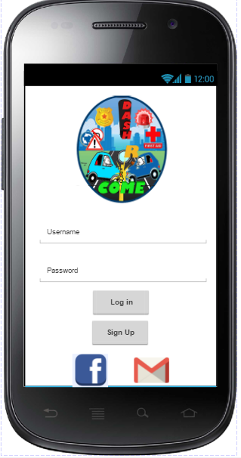 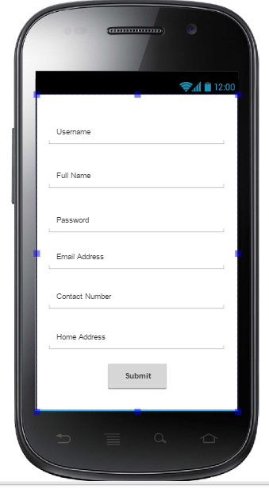

Successful Registration

Screen Link Facebook Account

to application Screen

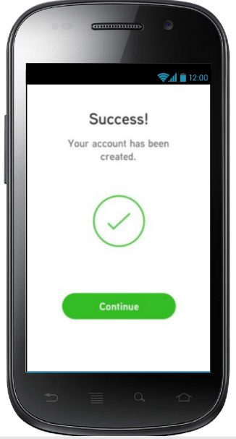 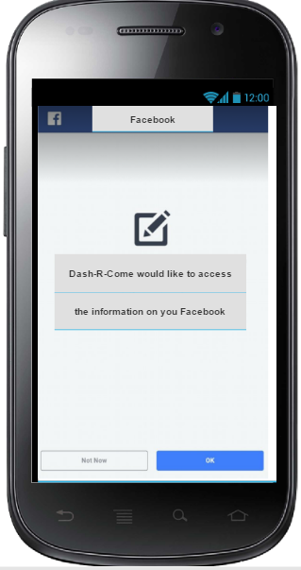

Link Account from GMAIL Log-in Failed Screen

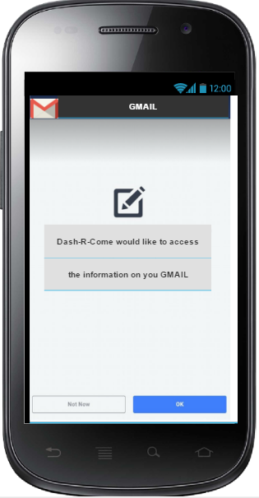 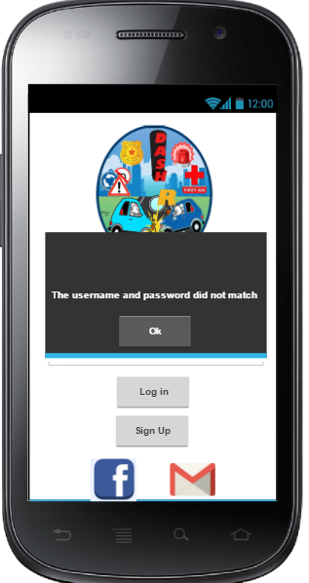

Home Screen Bluetooth Permission Screen

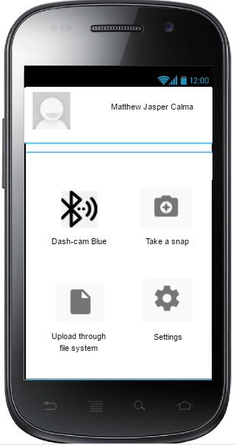 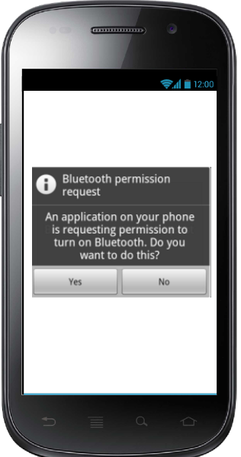

Take a Snap File System

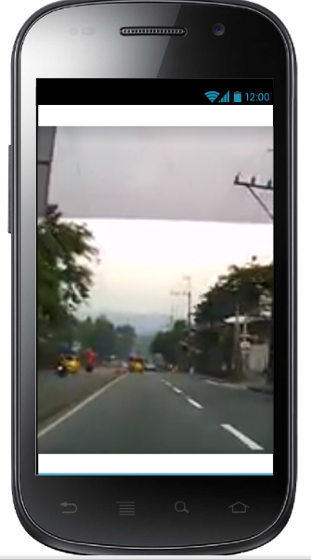 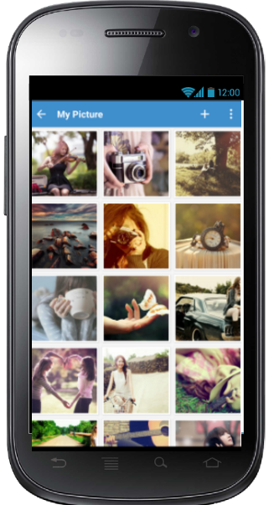

Modified User’s Account

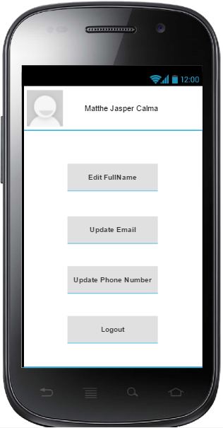 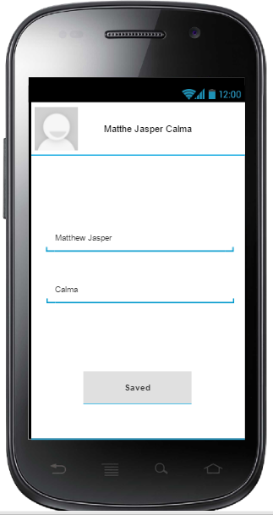

Modifier User’s Account (continued)

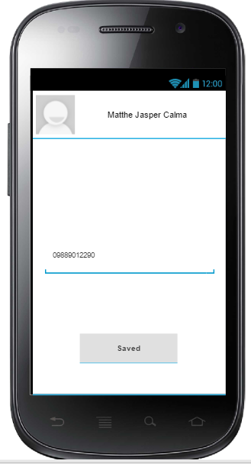 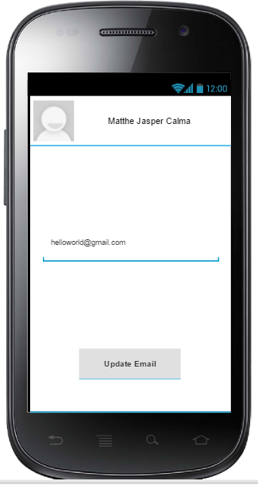

Log out Activity

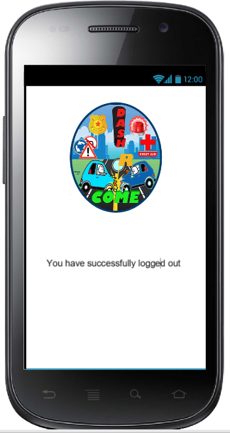

## **Development and Testing**

The prototype that the team will be developing is powered by Android Studio and Firebase. Android Studio is the main tool for developing android application. It provides the fastest and efficient way to build a mobile application. Firebase a restful online file storage web service for storing and accessing data on Google’s infrastructure. The prototype would enable the developers to create the proposed project. System testing gains the developers to verify that the system will handle all input data properly, both valid and invalid.

### **Event Table**

|  |  |  |  |  |  |
| --- | --- | --- | --- | --- | --- |
| Event | Trigger | Source | Use Case/ Activity | Response | Destination |
| User wants to Login to the Mobile Application | User wants to use mobile application features | User | Display Login Fields | Displays main screen after a successful login. | User |
| User wants to upload either picture or video footage | An incident happened | User | The mobile application displays the features of the application. | The user will be able to report on the Barangay Magallanes. | Firebase |
| User wants to trim the video | The uploaded video has big file size/video is too long | User | Gets the uploaded video footage | The mobile application features the video cutter. | Android file system |
| Captured Video has reached 30 seconds | User used the camera video. | User | Stop automatically after the Video footage has reached 30 seconds | Displays Delete or Take another message box. | Mobile Application |
| Barangay Magallanes employee received an incident report | An incident report has been uploaded to the Firebase | User | Prompts the employee to Log in to the Firebase | Firebase Cloud Storage displays the incident reports. | Firebase Cloud Storage |
| Barangay Magallanes must validate and analyze the incident report. | Barangay Magallanes had successfully log in to the Google Mail and has access the Firebase. | User | Firebase Cloud Storage displays the Incident Report of the User. | Validate and Analyze, if it is validated it will take an immediate action | Firebase Cloud Storage |
| Barangay Magallanes employee must give notification to the sender. | Barangay Magallanes employee had notified the desired leading agency. | Barangay Magallanes employee | Displays the comment section in the Incident Report and gets the comment of the employee | Notification to the user | User |
| User should receive a notification indicating the update status of his or her submitted report. | The agency had analyzed and validated the incident report submitted by the user. | Barangay Magallanes Employee | The Barangay Magallanes employee should comment to the firebase user. | Barangay Magallanes employee displays the update status of the report of the user. | User |
| Desired leading agency employee received a report from Barangay Magallanes and wants to Login to the Firebase. | Barangay Magallanes notified the desired leading agency. | Barangay Magallanes Employee | Prompts the employee to Login to the Google Mail | Response according to the report | Location of the incident |
| Barangay Magallanes or Leading Agencies generated a report. | An incident has been reported. | User | Displays the generating an agency report fields | Incident has been reported and constituents are responding according to the location. | Barangay Magallanes or Leading Agencies. |

### 

### **b. Functional Decomposition Diagram (FDD)**

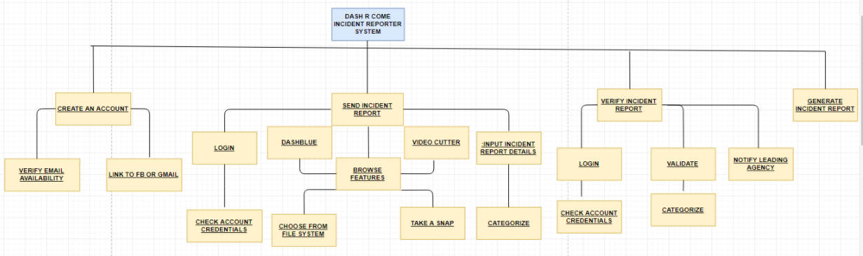

### **c. Data Flow Diagram (DFD)**

#### **Context Diagram**

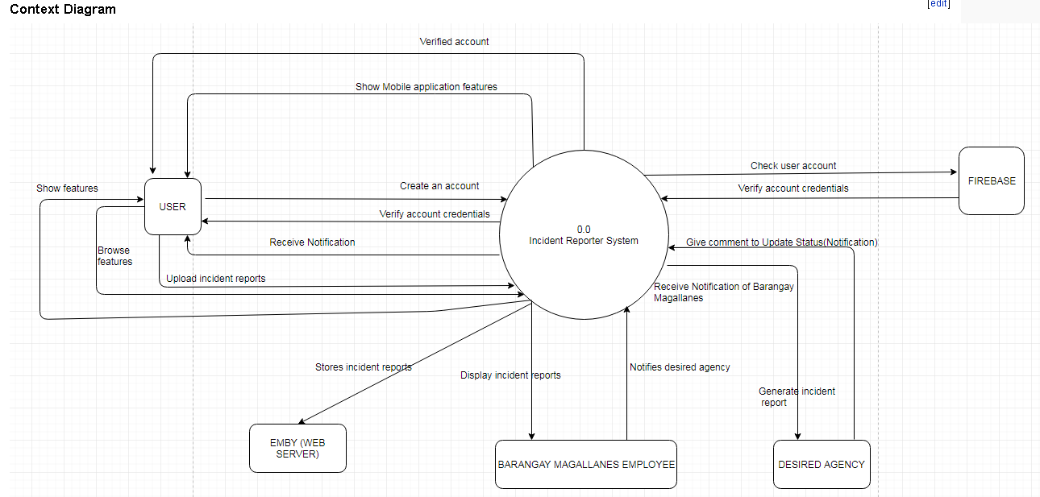

#### **Diagram 0**

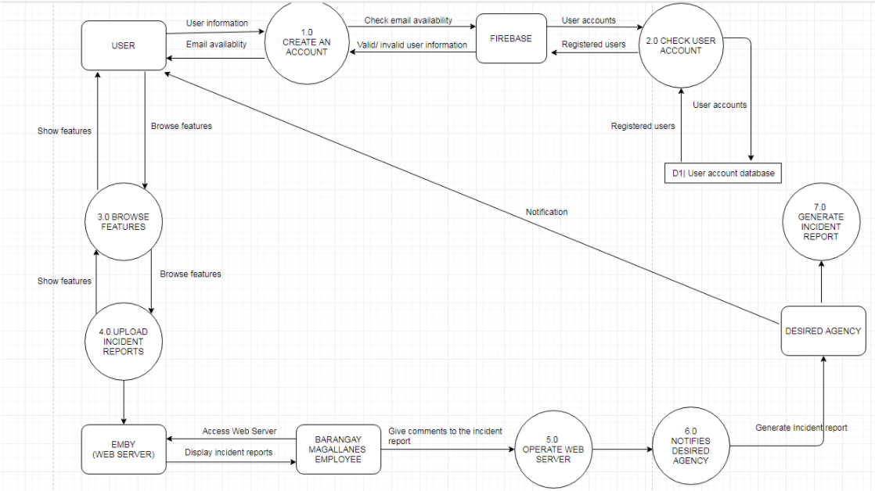

### **d. User ID String (UID / Database)**

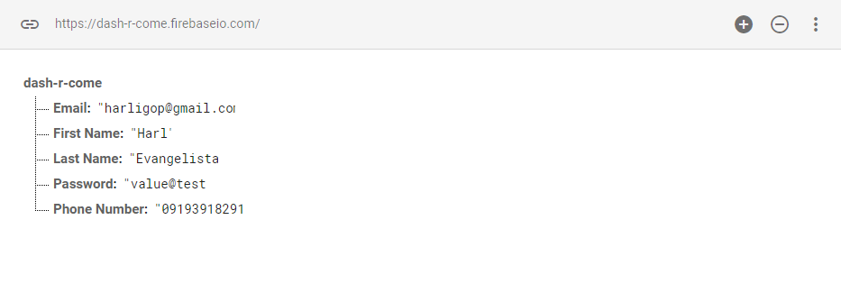

**e. Class Diagram**

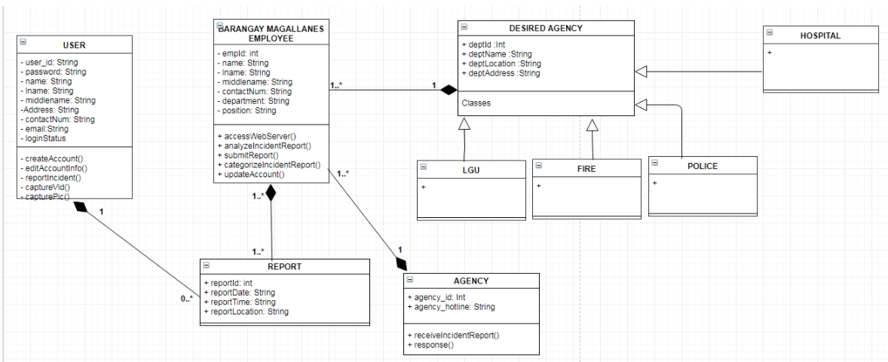

### **f. Object Diagram**

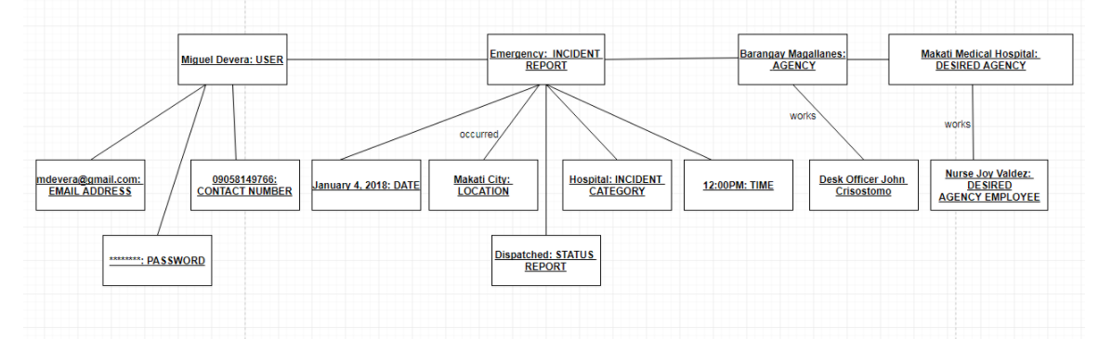

### **g. Composite Diagram**

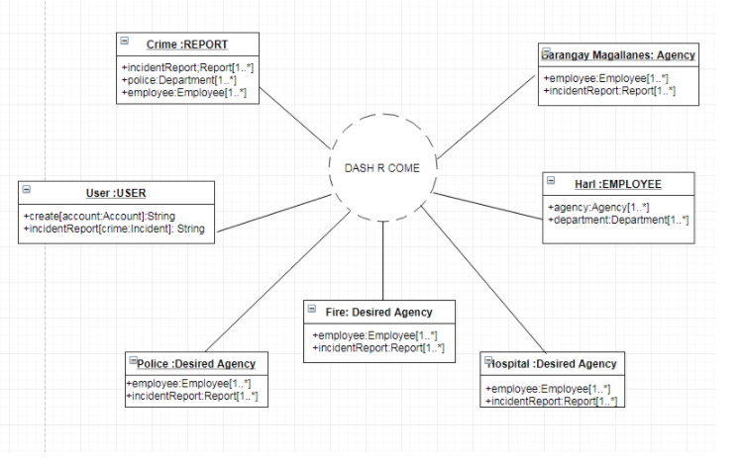

### **h. Use Case Diagram**

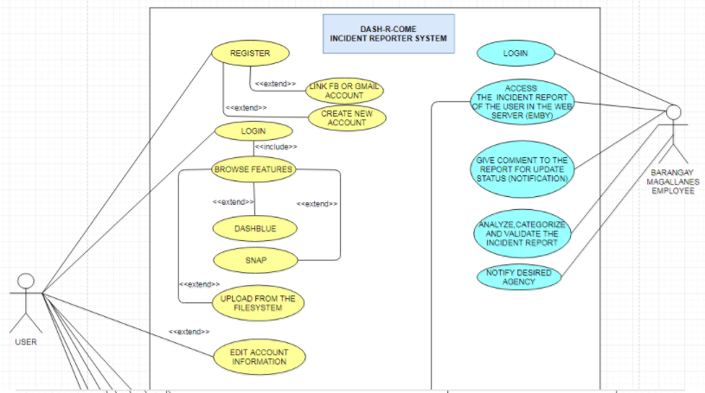

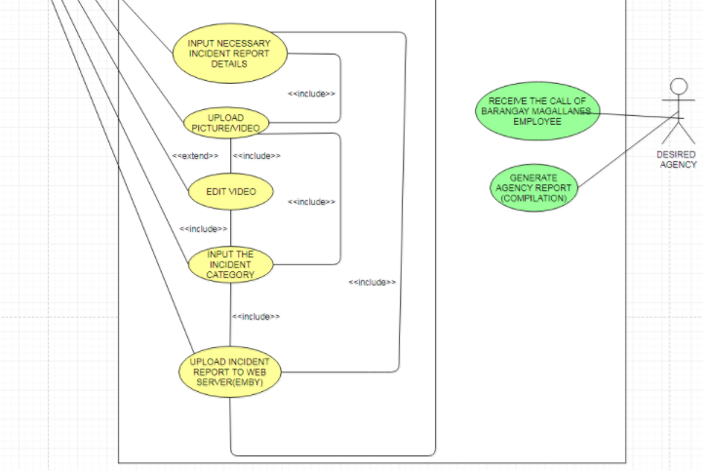

**i. Use-Case Full Description**

|  |  |  |
| --- | --- | --- |
| Use Case Name: | Create an account | |
| Scenario: | User wants to create an account | |
| Triggering Event: | Registration | |
| Brief Description: | User wants to create an account to use the mobile application. | |
| Actors: | User | |
| Related Use Case: | Browse features, edit account information, edit video, upload incident report to google drive. | |
| Stakeholders: | User | |
| Preconditions: | • The user must install the mobile application to his or her android device.  • The user must register to the system.  • The user must have internet access to use the system. | |
| Postconditions: | The system will store the data entered by the user to the firebase database. | |
|  |  | |
| Flow of Activities: | Actor | System |
| 1. The user connects to Wi-Fi or Data connection.  2. The user opens the mobile application.  3. The user taps the Create an account button.  4. The user fills up the required fields.  5. The user submits the registration form. | 1.1 The system displays an error message if the user does not have internet connectivity.  2.1 The system displays the create account page  3.1 The system verifies if the entered information is available  4.1 The system displays a successful message if the user has successfully registered to the system. |
| Exception Conditions: | The user must install the mobile application to his or her android device.  The user must be registered  The user must have internet connection | |

|  |  |  |
| --- | --- | --- |
| Use Case Name: | Browse Features | |
| Scenario: | The user wants to try the mobile application features | |
| Triggering Event: | The user is a new user | |
| Brief Description: | The user is not familiar with the mobile application, so he or she wants to try the features. | |
| Actors: | User | |
| Related Use Case: | Create an account, Upload from the file system, edit account information, edit video, Upload Incident Report. | |
| Stakeholders: | User | |
| Preconditions: | • The user must install the mobile application to his or her android device.  • The user must register to the system.  • The user must have internet access to use the system. | |
| Postconditions: | • The user must be able to view and browse the features. | |
| Flow of Activities: | Actor | System |
| 1. The user connects to the Internet.  2. The user logs in to the mobile application.  3. The user taps different features. | 1.1 The system displays an error message if the user does not have internet connectivity.  2.1 The system displays the home page of the mobile application. |
| Exception Conditions: | The user must install the mobile application to his/ her android device.  The user must be registered  The user must have internet connection | |

|  |  |  |
| --- | --- | --- |
| Use Case Name: | Edit account information | |
| Scenario: | The user wants to change his or her current account password. | |
| Triggering Event: | The user forgot his current account password. | |
| Brief Description: | The user cannot remember his/ her current account password. | |
| Actors: | User | |
| Related Use Case: | Create an account | |
| Stakeholders: | User | |
| Preconditions: | •The user must install the mobile application to his/ her android device.  •The user must be registered  •The user must have internet connection  •The user must input his or her email address that he or she used in registration. | |
| Postconditions: | • The user must receive an email from the system that will let the user to change his or her current account password. | |
| Flow of Activities: | Actor | System |
| 1. The user connects to the Internet.  2. The user logs in to the mobile application.  3. The user taps the retrieve password button.  4. The user enters the email used in registration. | 1.1 The system displays an error message if the user does not have internet connectivity.  2.1 The system displays the home page of the mobile application.  3.1 The system displays a screen that asks for old email address.  4.1 The system sends an email to the user that will let the user change his/her current account password. |
| Exception Conditions: | •The user must install the mobile application to his/ her android device.  •The user must be registered  •The user must have internet connection  •The user must enter his/her email address used in registration. | |

|  |  |  |
| --- | --- | --- |
| Use Case Name: | Edit video | |
| Scenario: | The user wants to trim the video footage he/she captured. | |
| Triggering Event: | The video is too long.  Lots of unnecessary parts. | |
| Brief Description: | The user wants to trim the video to reduce the data that will be consumed in uploading the video. | |
| Actors: | User | |
| Related Use Case: | Create account, Browse features | |
| Stakeholders: | User | |
| Preconditions: | •The user must install the mobile application to his/ her android device.  •The user must be registered  •The user must have internet connection  •The user must have video footage captured either using android device or dashboard camera. | |
| Postconditions: | • The user must be able to reduce the file size | |
| Flow of Activities: | Actor | System |
| 1. The user opens up video cutter  2. The user saves the video to the android file system. | 1.The cut of the unnecessary part will be saved  2.It can be played on the android file system. |
| Exception Conditions: | •The user must have internet connection.  •The user can use the video cutter. | |

|  |  |  |
| --- | --- | --- |
| Use Case Name: | Upload Video or Picture | |
| Scenario: | The user wants to report an incident. | |
| Triggering Event: | The user was able to film an incident | |
| Brief Description: | The user captured an incident and wants to report. | |
| Actors: | User | |
| Related Use Case: | Create account, Browse features | |
| Stakeholders: | User, Agency, Leading agency | |
| Preconditions: | •The user must install the mobile application to his/ her android device.  •The user must be registered  •The user must have internet connection  •The user must have video footage captured either using android device or dashboard camera. | |
| Postconditions: | • The user must provide or input the needed information before uploading to google drive. | |
| Flow of Activities: | Actor | System |
| 1. The user connects to the Internet.  2. The user login to the mobile application.  3. The user taps the upload from file system button.  4 The user picks the video or picture to be uploaded to google drive.  5. The user confirms his or her action. | 1.1 The system displays an error message if the user does not have internet connectivity.  2.1 The system displays the home page of the mobile application.  3.1 The system displays the android file system  4.1 The system selects the video/ picture tapped by the user.  5.1 The system uploads the video or picture to google drive. |
| Exception Conditions: | •The user must install the mobile application to his or her android device.  •The user must be registered  •The user must have internet connection  •The user must provide the required information  •The user must have a video or picture of an incident | |

|  |  |  |
| --- | --- | --- |
| Use Case Name: | Validate Incident Report | |
| Scenario: | The Barangay Magallanes employee received an incident report | |
| Triggering Event: | Validate Incident Report | |
| Brief Description: | The Barangay Magallanes employee will validate the incident report | |
| Actors: | User, Barangay Magallanes employee | |
| Related Use Case: | Upload picture or video, edit video | |
| Stakeholders: | User, Agency, Leading agency | |
| Preconditions: | • The Barangay Magallanes must have an account and login to the firebase.  • The Barangay Magallanes must validate the incident report | |
| Postconditions: | • The Barangay Magallanes employee must be able to validate the report.  • The Barangay Magallanes employee must be able to view the incident report in the firebase.  • The Barangay Magallanes employee must notify the user once the report is validated. | |
| Flow of Activities: | Actor | System |
| 1. The Barangay Magallanes employee must be logged in to google drive.  2. The Barangay Magallanes employee will categorize the incident report if the report is valid, otherwise, the incident report will be deleted. | * 1. The system lists the incident reports filtered by category. |
| Exception Conditions: | • If the report of the user is fake. | |

|  |  |  |
| --- | --- | --- |
| Use Case Name: | Notify leading agency | |
| Scenario: | The incident report is validated | |
| Triggering Event: | An incident is reported. | |
| Brief Description: | The Barangay Magallanes employee notifies the leading agency. | |
| Actors: | Barangay Magallanes employee, leading agency, user | |
| Related Use Case: | Validate Incident Report | |
| Stakeholders: | User, Agency, Leading agency | |
| Preconditions: | • The Barangay Magallanes employee must have validated the incident report  • The Barangay Magallanes employee must notify the leading agency. | |
| Postconditions: | • The leading agency must respond to the incident.  • Both the Barangay Magallanes and leading agency must generate an incident report. | |
| Flow of Activities: | Actor | System |
| 1. The Barangay Magallanes employee validates the incident report  2. The Barangay Magallanes employee notifies the leading agency.  3. Both the Barangay Magallanes agency and leading agency must generate an incident report. | 1.1 The system displays the list of incident reports arranged to its category. |
| Exception Conditions: | • The leading agency’s resources are broken. | |

|  |  |  |
| --- | --- | --- |
| Use Case Name: | Generate Incident Report | |
| Scenario: | The incident report is validated | |
| Triggering Event: | An incident report was solved. | |
| Brief Description: | An incident report was solved. | |
| Actors: | Barangay Magallanes employee, leading agency | |
| Related Use Case: | Validate Incident Report, Notify leading agency | |
| Stakeholders: | User, Agency, Leading agency | |
| Preconditions: | • The incident report must be solved. | |
| Postconditions: | • Both Barangay Magallanes agency and leading agency must generate an incident report. | |
| Flow of Activities: | Actor | System |
| 1. Barangay Magallanes employee notifies the leading agency  2. Leading agency responds to the incident report. | 1.Leading agency response to the barangay magallanes according to the matter of the incident.  2.Leading agency gathered information from the barangay magallanes to respond according to the report. |
| Exception Conditions: | 1. If the location of the incident is not in the city or place where they're usually operated. | |

### **j. Activity Diagram**

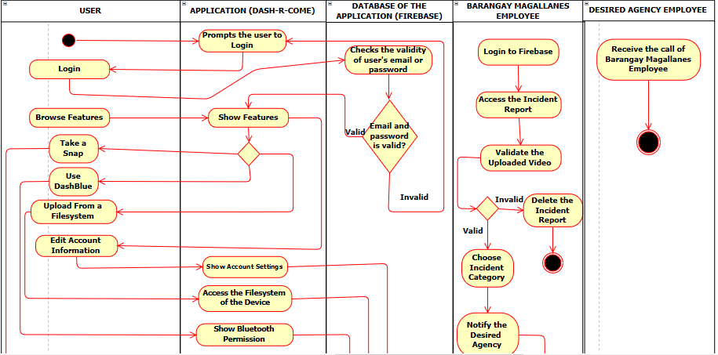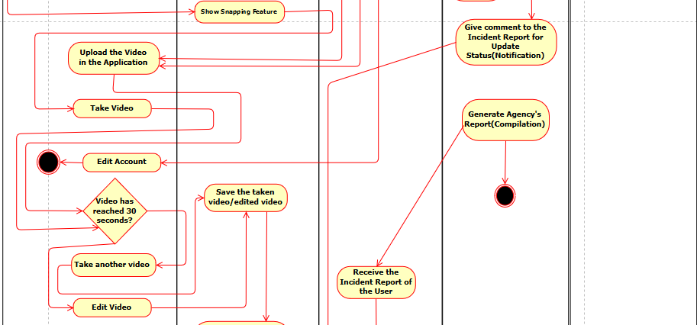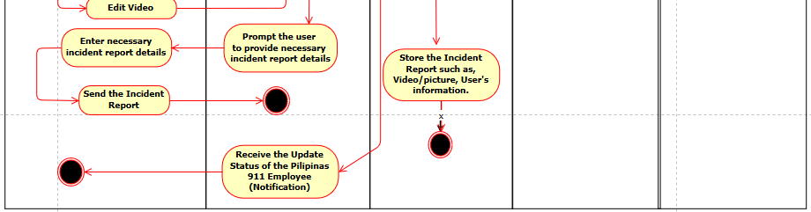

**k. Sequence Diagram**

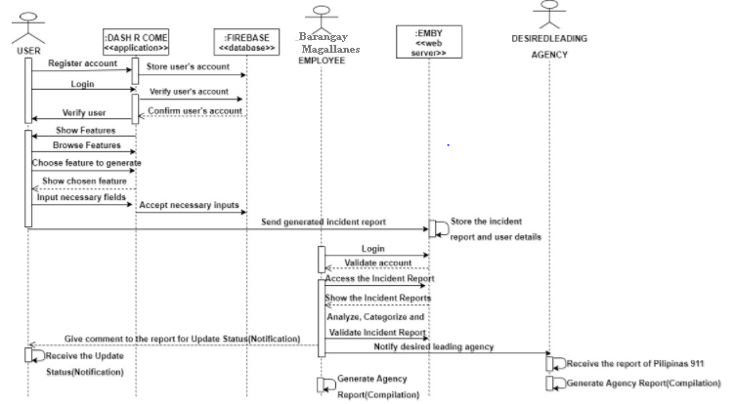

**l. Deployment Diagram**

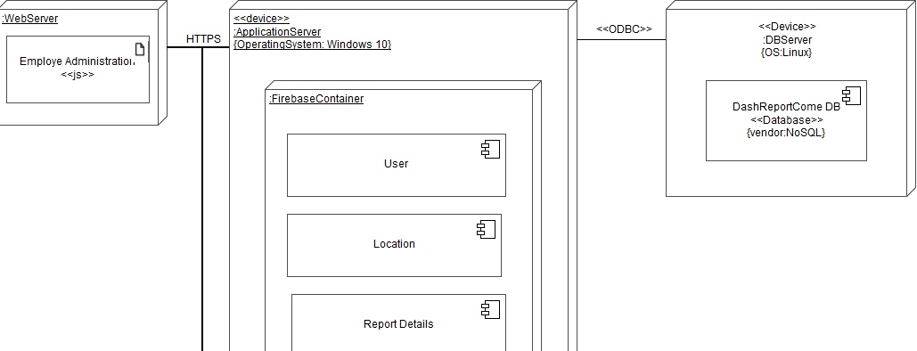

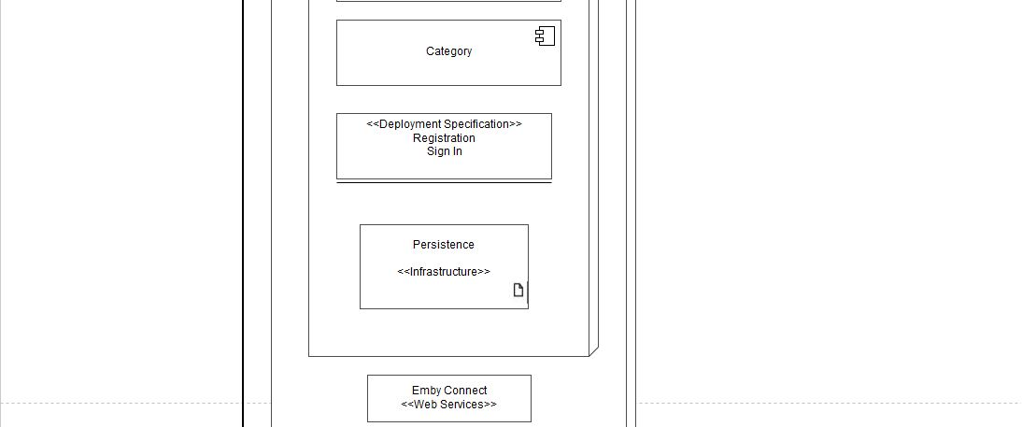

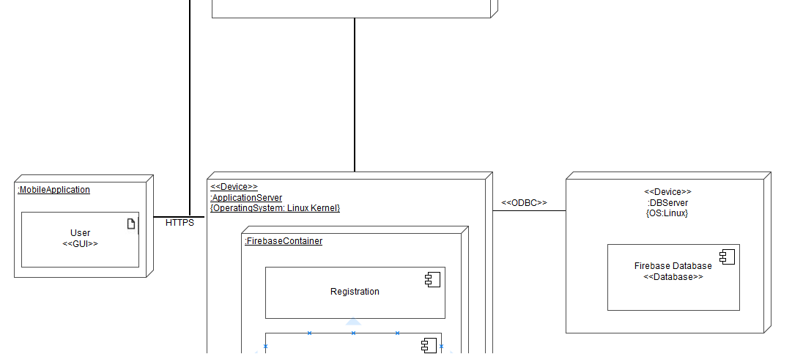

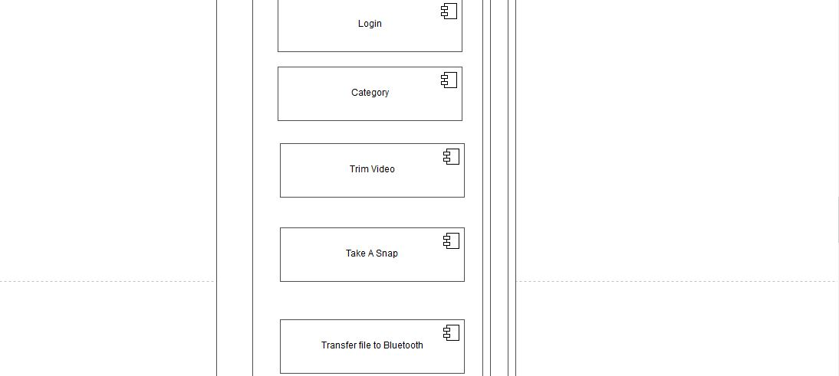



**m. Communication Diagram**

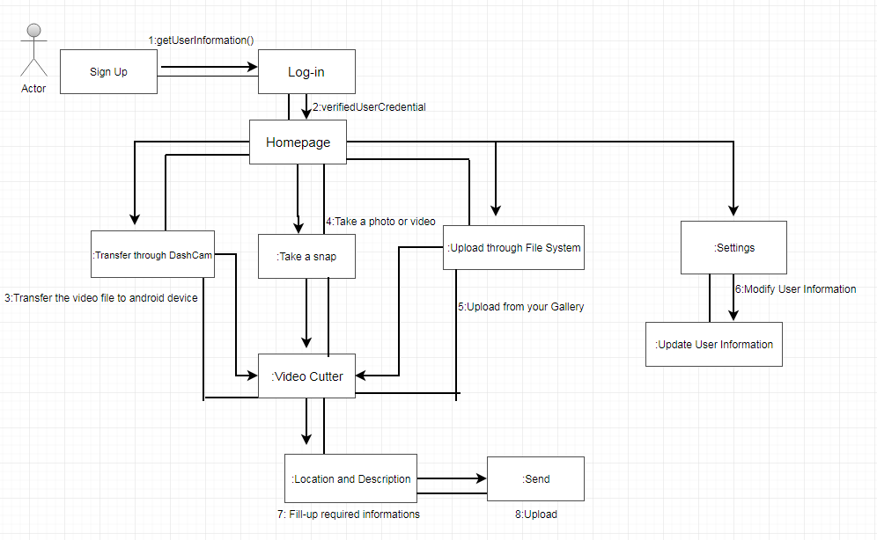

**n. Timing Diagram**

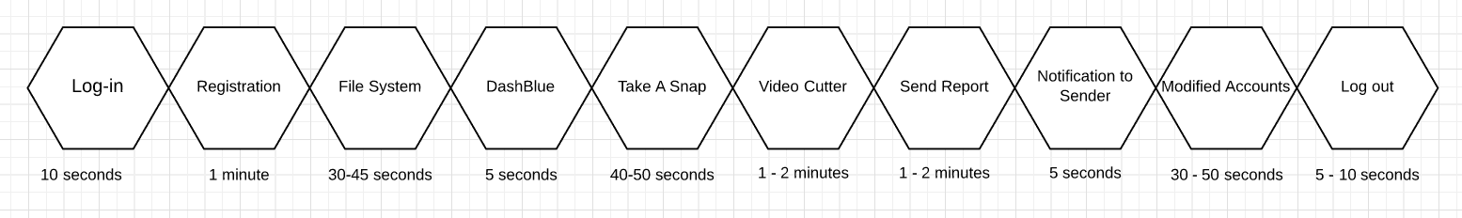

**o. Component Diagram**

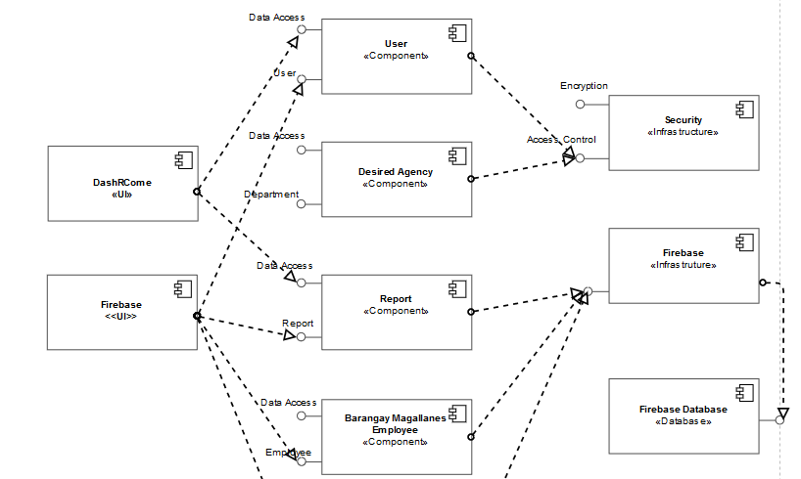

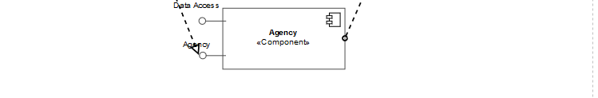

**p. Package Diagram**

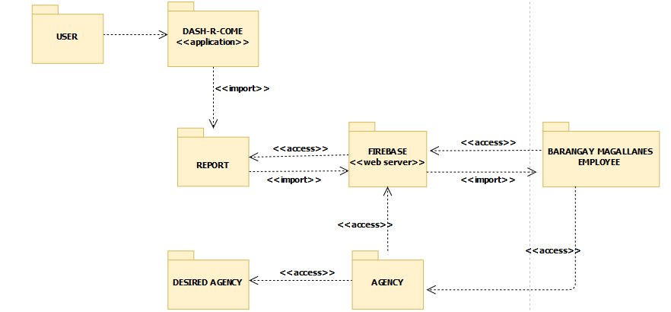

**q. State Diagram**

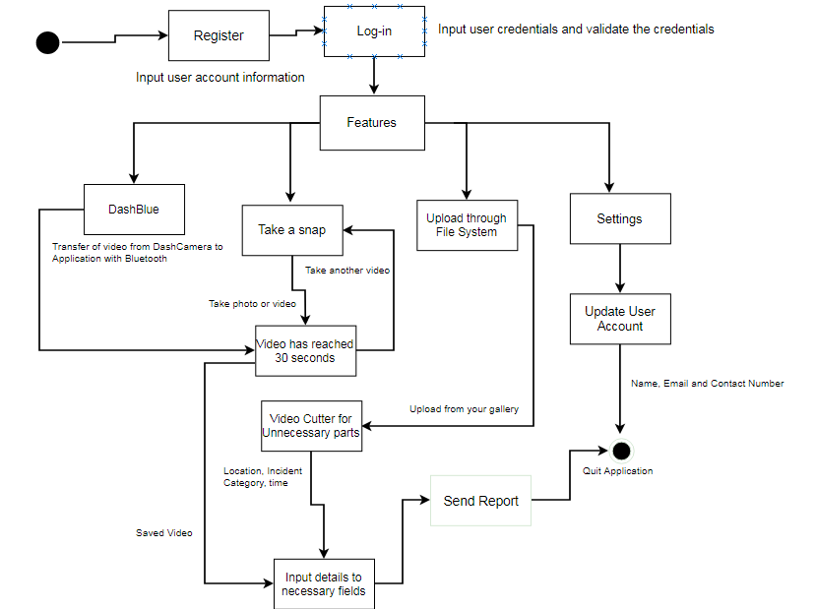

**r. Interaction Overview Diagram**

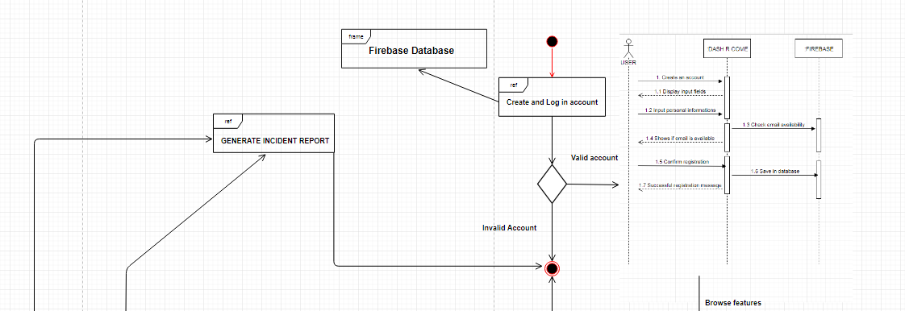

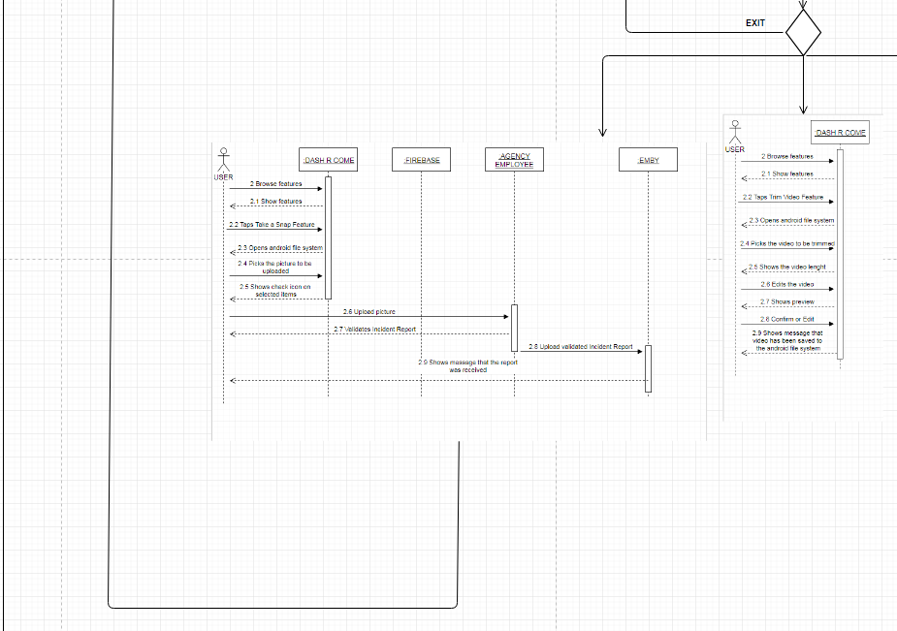

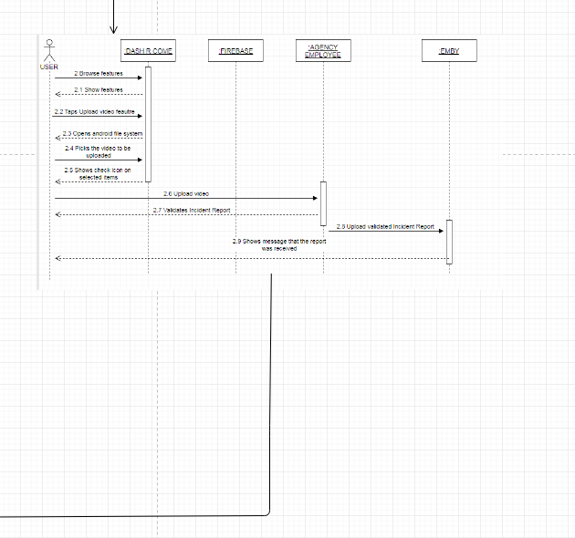

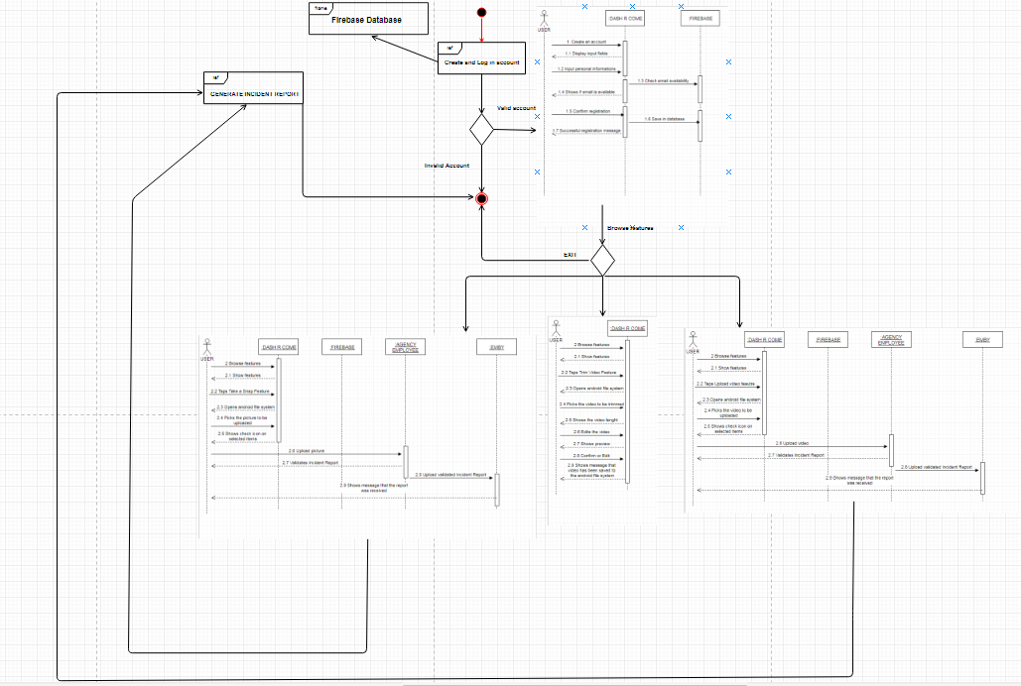

**V. Conclusions and Recommendation**

In today’s times, reporting a crime, traffic accident, or accusing someone of a crime is hard to investigate if there is no evidence. A mobile application like Dash-R-Come could serve as an alternative tool in capturing and reporting an incident. Our proposed system aims to help the client get a real-time and detailed incident reports. Since the client’s biggest problem are prank reports. Using the proposed system, the client will be able to avoid deploying their people unusably to respond to prank reports. Since there will be employees Barangay Magallanes that will be monitored and analyzing and the incident reports, it can assure that prank reports may lessen.

## **5.1 Results of the Interview**

As the group identifies the factors that will help to improve the process in developing the proposed system, the group conducted an interview in Barangay Magallanes that contains 15 questions and lasted for 20 minutes, questions that includes the interviewee’s personal information, rules and regulations of Makati City traffic and common traffic problems and crimes that they usually encounter in their area. The data below is the result of the interview that the group conducted.

The name of the interviewee is Sir Jesus Sumandal, he is one of the Desk Officers in Barangay Magallanes. The Desk Officer is the one who receives complaints; also, he is in-charge in deploying people in an incident.

They can respond to all kinds of crimes and incident in the City of Makati. It is possible to respond in that area, we asked. He told us that if the concern is in our area. We can respond with the participation in NDCC. The barangay of Magallanes Makati has some different divisions such as; Peace and Order, Accounting, Social Service, Health Clinic, Infrastructure, and Educational & Culture

They process the incident report as follows; Get the following information. Details of the incident, Description of the suspect, information about the complainant, what is the thing stolen, if the complainant will not file against the complainant and if the thing stolen has a big amount; How do they validate the report, The Barangay Officer will know if the complainant is lying or not, first in the interview. If the complaint is true, they will endorse it to CDI and do their process

They have allotted budget and resources. They have Wi-Fi connection and computers and a database. The team also asked the commonly committed crime in the Makati area. Sir Sumandal mentioned that, it is snatching and most victims’ APC students.