

Asia Pacific College

School of Computing and Information Technologies

Magallanes, Makati City

**Dash-R-Come**

**Submitted by:**

Hurley Evangelista - Project Manager

Emmanuel Devera - Programmer

Alyssa Fernandez - Documentation

Miguel Matawaran - Project Analyst

**Submitted to:**

Ms. Rhea-Luz Valbuena

Mr. Manuel Sanchez

(Professors)

Mr. Jayvee Cabardo  
Project Adviser

Kenneth Mariano

Project Consultant

November 7, 2017

* **TABLE OF CONTENTS**

Executive Summary 3

I. Introduction 4

1.1 Project Context 4

1.2 Purpose and Description 5

1.3 Objectives 5

1.4 Scope and Limitations 6

II. Review of Related Literature/Systems 6

III. Technical Background 8

Hardware needed: 9

Programming Language needed to develop the application: 9

IV. Methodology, Results and Discussion 10

4.1 Requirement Analysis 10

4.2 Software Requirements Specification (SRS) 11

4.3 Design of Software, Systems, Product, and/or Processes 14

Log-in Screen Registration Screen 14

Development and Testing 29

a. Event Table 29

b. Functional Decomposition Diagram (FDD) 32

c. Data Flow Diagram (DFD) 33

D. Entity Relation Diagram (With Data Dictionary) 34

E. Data Dictionary 35

F. Class Diagram 38

G. Object Diagram 39

H. Use Case Diagram 40

I. Activity Diagram 48

J. Sequence Diagram 49

V. Conclusions and Recommendation 50

VI. Appendices 50

Results of the Interview 50

Results of the Survey 51

Change Request 51

# **Executive Summary**

People cannot simply avoid an accident, or crime or any kinds of incidents. The primary objective of the team’s project is to create a mobile application that will help the Local Government Unit (LGU) to have an evidence of the incident and provide detailed information concerning the incident has occurred.

The team was able to conduct several interview with the respective Col Candido Ruiz and Jesus Sumandal. Retired Police Candido Ruiz being the head of the Barangay Magallanes and Jesus Sumandal the head desk officer.

Dash-R-Come aims help the LGU to respond promptly to the incident happened. Its’ features will be a button that has a 911, Global Positioning System (GPS) to locate where the incident happened and Notification that ensure the report has been sent.

# **I. Introduction**

Makati City is a city in the Philippines. It is known for the skyscrapers, shopping malls, Makati central business district, Ayala triangle and many more.

## **1.1 Project Context**

The proposed project is an Incident Reporter System; the mobile application runs in Android devices. Incident includes road accident, crime, traffic violators, and exploitation of traffic officers. DASH-R-COME is the project name, the user must have a video captured in either using dash camera or mobile devices and Internet connection or mobile data to send the video and to use the features of the application.

The process of the application, If the user used a dashboard camera to capture the video then, the user should transfer the video to android device using Bluetooth of both devices (if the dashboard camera has bluetooth feature), dashboard camera and android devices. Otherwise, the user can transfer the memory card of dashboard camera to their android device and save the video to the android devices folder such as Gallery. Other way, the user has captured the video to the mobile device then, the user should save it in mobile device’s folder such as Gallery.

After the user has the video saved in his/her android device, then the user can upload the video to the server. Uploaded video will be analyzed by the person in-charge of monitoring the server, analyzing the video such as, type of incident reported by the user. After generating a report, the employee in-charge will send the report to the designated agency in response to the user.

## **1.2 Purpose and Description**

DASH-R-COME is a mobile application that can be used to report a road accident, crime and fire incident. The application can also serve as an evidence in times of involvement in a situation like accident. Using the proposed application, the user can send a picture or video footage of an incident to the proposed project’s website, which will be accessible to the government agencies of Makati City: Barangay, Police, Hospital, Fire bureau.

The purpose of the project is to provide the client a system that could help them get a detailed events or incident report using the report of the user. Also, to provide the client an updated record of incidents that they could use in future purposes.

**1.3 Objectives**

* To help the user to report crime and vehicular accident without difficulty.
* To help agencies (Barangay, Police, Hospital, Fire bureau) to keep track of the accidents and crimes that occurred.
* To provide the rescuer a detailed information concerning the incident that has occurred.
* To provide evidence or supporting details when reporting an incident.

## **1.4 Scope and Limitations**

The project’s scope are places in Makati City. The group target users are the motorists, bystanders, constituents and android device users. The user must first register to the app and have an internet connection or mobile data. The user must have a picture or video footage of the incident that will be uploaded later on to the web server, which will be monitored by the agency. In capturing pictures or videos, the user can use A dashboard camera or any android devices. If the user does not have an internet connection, then the application cannot be used in an emergency situation, instead, the user can use the 911 Button Feature of the app to directly call the 911 Agency in a condition that the user is logged in.

In addition to the project's scope, generating an incident report and sending to the server, which will access by the Agency. Responding process is out of the project's scope. The project only aims to generate a report and give the report to the Agency and the rest will be in Agency's power.

# **II. Review of Related Literature/Systems**

2.1 **iWrecked** - nobody would want to get involved in an accident, but, a fact that accidents do occur every single day remains. If you are ever caught in an accident, you would want an application such as iWrecked, to key in and keep a history of the complete relevant details, preview and send accident reports, and look for towing services.

The group aims to provide a button that has the telephone of the agency in the application in order to respond quickly, and to provide evidence handling and to send help to the user as quickly as possible.

2.2 **Spotted Incident Reporter** - Spotted incident reporter application is a local crime track, report and information on stolen cars and accidents. Spotted incident reporter application is a local crime track, report and information on stolen cars and accidents. For example, a car was stolen 6 minutes ago, you had the power to fight back to the thieves who stolen the car by posting the incident in the app, including the pictures of the stolen property or car. A feature of Global positioning system (GPS) that track the location of the said event.

Also, the team's proposed application provides evidence handling such as The location, day, time, and video or picture of the incident occurred, then sends directly to the desired agency that would respond to the reported incident by the user.

2.3 **Incident Reporter** - Incident reporter is an online cloud-based that is available anywhere. By using this application, you can communicate and document incidents. The features of this the application is using a global positioning system, customizable interface, past report of the user can easily retrieve, and it uses SMS. Our application can find you the nearest local government unit by our artificial intelligence system, it would require enabling your GPS in your device. It also lets the user to be notified upon the uploaded incident video report when it reaches to the agency. You must also have a data or an internet connection to use the application in order to find the nearest local government unit.

# **III. Technical Background**

The group considered the things or technology that a must in developing the project. In this part shows the availability of the following requirements or needed software and things in developing the application and the reason we chose the following:

**Software needed:**

* Android Studio - Built based on JetBrains' IntelliJ IDEA software and designed specifically for Android application development. It is developed by Google that is based on the Linux kernel which are similarly deployed on a traditional computer system.
* MySQL - is a freely available open source Relational Database Management System (RDBMS) that uses Structured Query Language (SQL). SQL is the most popular language for adding, accessing, and managing content in a database.
* Emby - is a media management server that allows you to synchronize media libraries, watched status, and watch progress between compatible devices. It is an open source software created by Emby Team.

## **Hardware needed:**

Android devices - A handheld device that will be used by the motorist to upload the video or picture that was captured from the dash camera.

* Operating system runs at least Android 4.0 (Ice Cream sandwich) or later.
* ·At least 1GB RAM
* 4 “screen
* ·1500 mAh battery

Computer - A device that acknowledges data and controls it for some outcome based on the program or set of instructions on how the information is to be handled.

WiFi / Router - To be used on different purposes such as data transmission and wireless communication.

## **Programming Language needed to develop the application:**

* Java - is the innovation of decision for building applications utilizing structured codes that can be executed on cell phones and this is what the group will mainly use for developing the mobile application that will serve as the interface between the user and the system. In addition to, it is a general-purpose computer programming language and has been in existence for over 2 decades.

Android Apps Development, Web application Development, Big Data and Others are the most common applications of Java.

* SQL (Structured Query Language) - is a systematized programming language utilized for managing relational databases and performing different operations on the information given. The proponents of the project are planning to use SQL to create online database where the users of our project will store the videos.

# **IV. Methodology, Results and Discussion**

## **4.1 Requirement Analysis**

The developers are going to make a mobile application that design as an incident reporter application. The user must register for the application in order to have a verified account. To register, the user can either link his/her facebook and gmail account or create a new account. After the registration has been successful, the user can login in order to use the application. There are four choices, the Dash-cam blue, Take a snap, Upload through the file system and Settings. The dash-cam blue needs a dash camera that has a Bluetooth. The application will request for the permission to turn on the Bluetooth in order to transfer the file that has been saved in the dash camera. Take a snap will be directly to the camera, either you take a video or picture. If the user took the video of a specific incident, there will be a video cutter to cut the unnecessary parts. Upload through the file system, the user will choose a picture or a video of an incident to send to the agency. The settings contained edit full name, update email, update phone number and logout.

## **4.2 Software Requirements Specification (SRS)**

|  |  |  |  |  |
| --- | --- | --- | --- | --- |
|  | ASSIGNED TO | YES | NO | REMARKS |
| **Output**  ✓ The mobile application displays a message if the user successfully registers or login to the application    ✓ The incident reporting system must show a location where the incident happened    ✓ The application must have a notification that the user has successfully uploaded a video or picture.    ✓ The agency must send a message or notification to the sender of the video / user |  |  |  |  |
| **Input**    ✓ The user must be connected to Wi-Fi or Mobile data to be enabled to send the picture or video.    ✓ The user must have a video to be sent to the agency.    ✓ Mobile Application must have the logged-in and register activity    ✓ Mobile Application must provide a map    ✓ Each input field must be complete. Such as, name, contact number, address and email    ✓ Mobile Application's features such video cutter to cut the unnecessary part of the video to be send to the web server**.**    ✓ A button that once tapped, it directly calls 911 for emergency-situation.    ✓ A confirmation window to provide the user a confirmation of his/her action. |  |  |  |  |
| **Process**    ✓ The person manipulating the web server will identify the type of incident that was uploaded to the web server.    ✓ Once the incident type has been identified by the person who in charge on the web server, a report must be created to be forwarded to the desired agency. |  |  |  |  |
| **Performance**    ✓ The phone must be android and the application’s minimum Operating System(OS) is KitKat.  ✓ The system must support online users simultaneously.    ✓ The system must be responsive  **Control**  ✓ The system must provide a login system to avoid prank reporters[RV1] and the login should take 15-30 seconds.    ✓ The system must maintain user integrity.    ✓ The user must allow the camera, Bluetooth, cellular data and Wi-Fi connection permission for the mobile application.    ✓ The users must read the play store policies against the potential harmful or threat party software. |  |  |  |  |

## **4.3 Design of Software, Systems, Product, and/or Processes**

## Log-in Screen Registration Screen

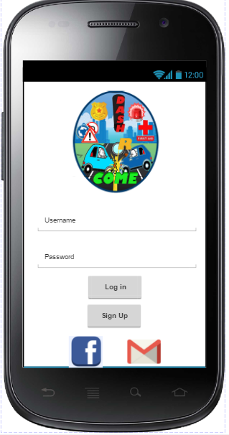 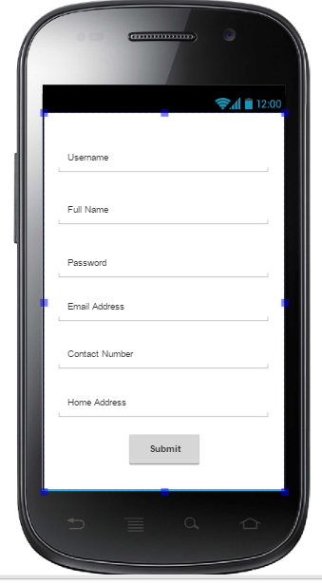

Successful Registration Screen Link Facebook Account

to application Screen

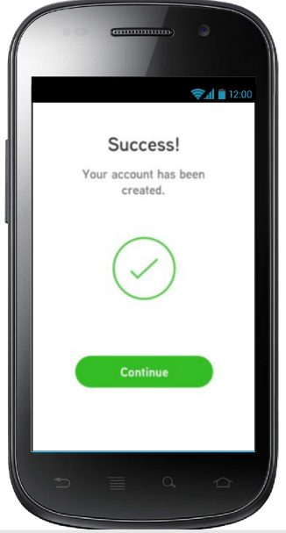 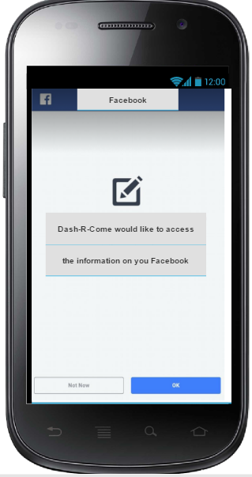

Link Account from GMAIL Log-in Failed Screen

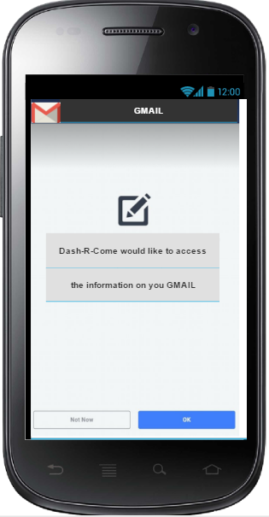 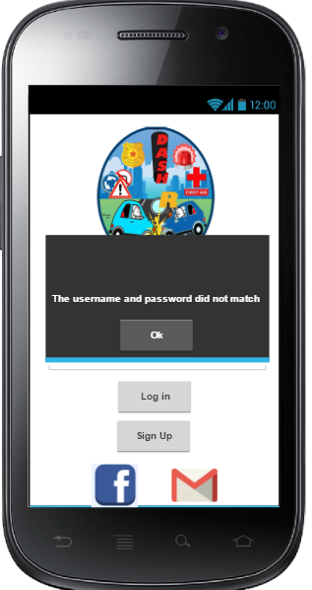

Home Screen Bluetooth permission Screen

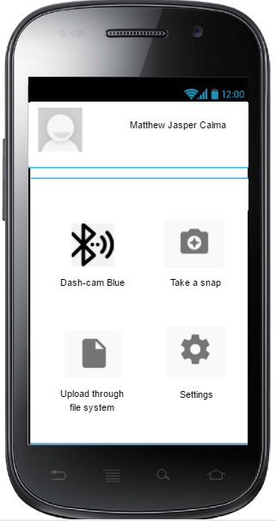 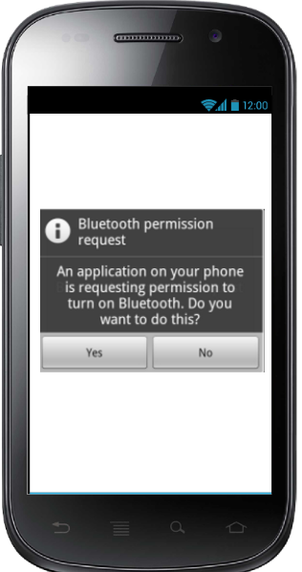

Uploading from a File system Screen

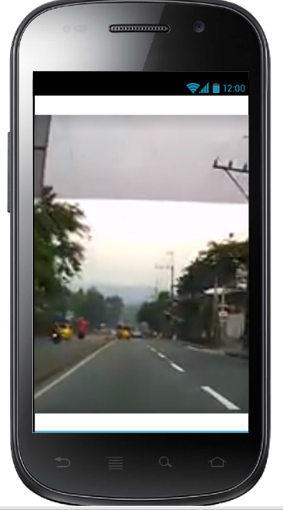 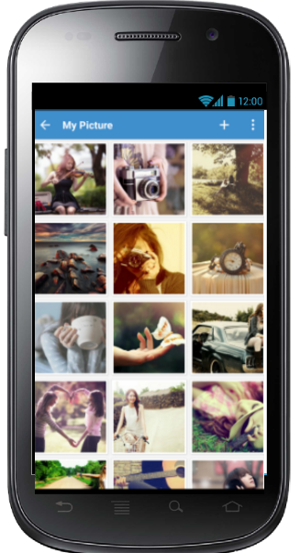

Settings Screen and Editing Name Screen

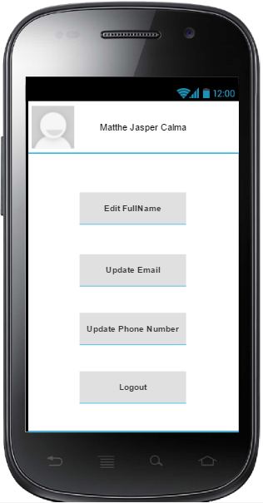 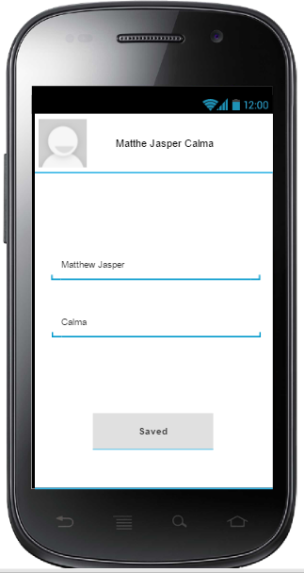

Editing Contact Number and Email Screen

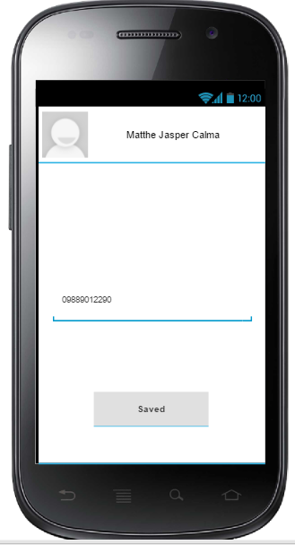 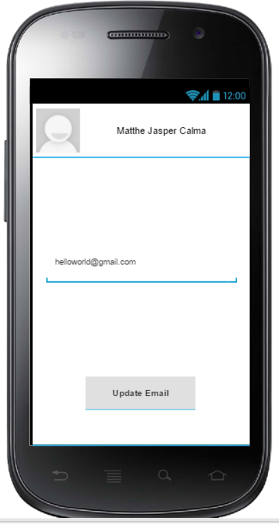

Logged out Screen

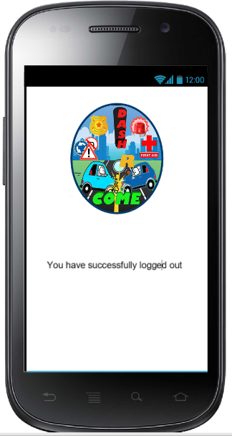

**Administrator Using Emby Web Application**

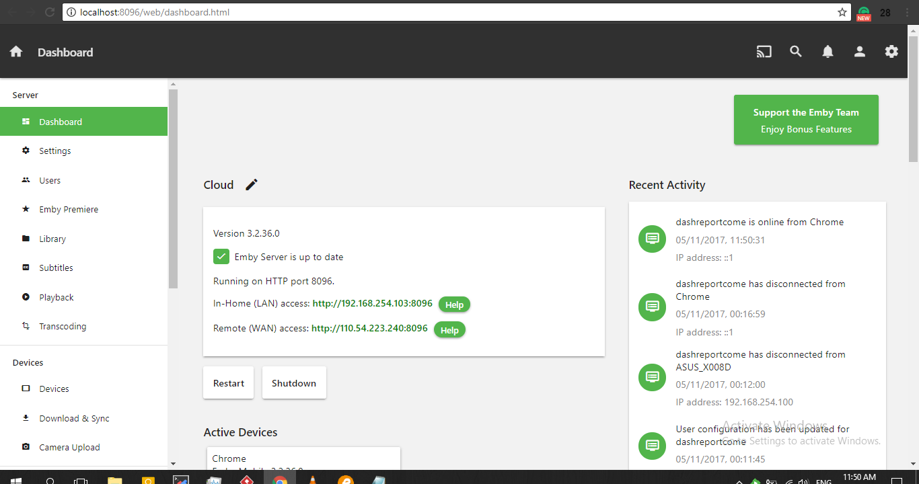

The Dashboard of Emby - It has WAN (Wide Area Network) and LAN (Local Area Network)

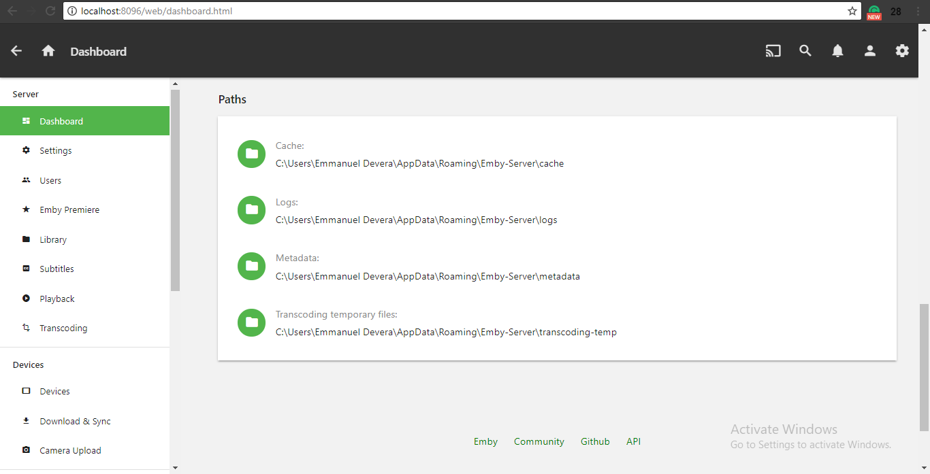

**Server Logs**

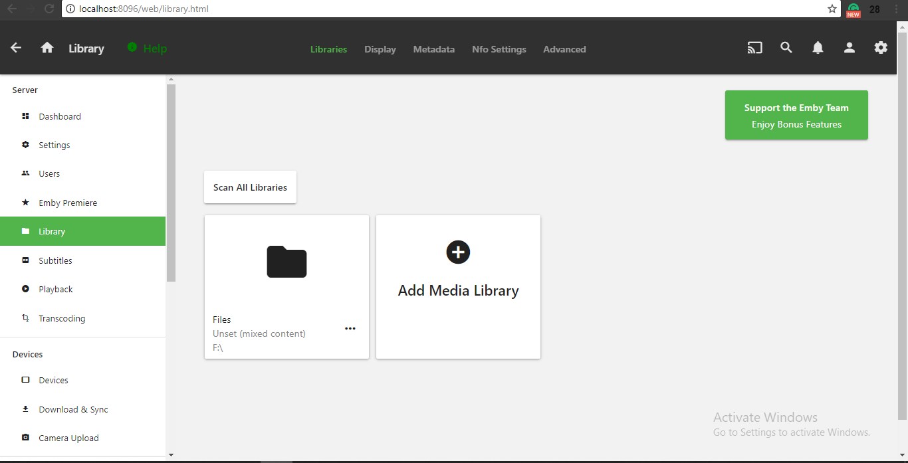

**The folder where the pictures and videos were stored**

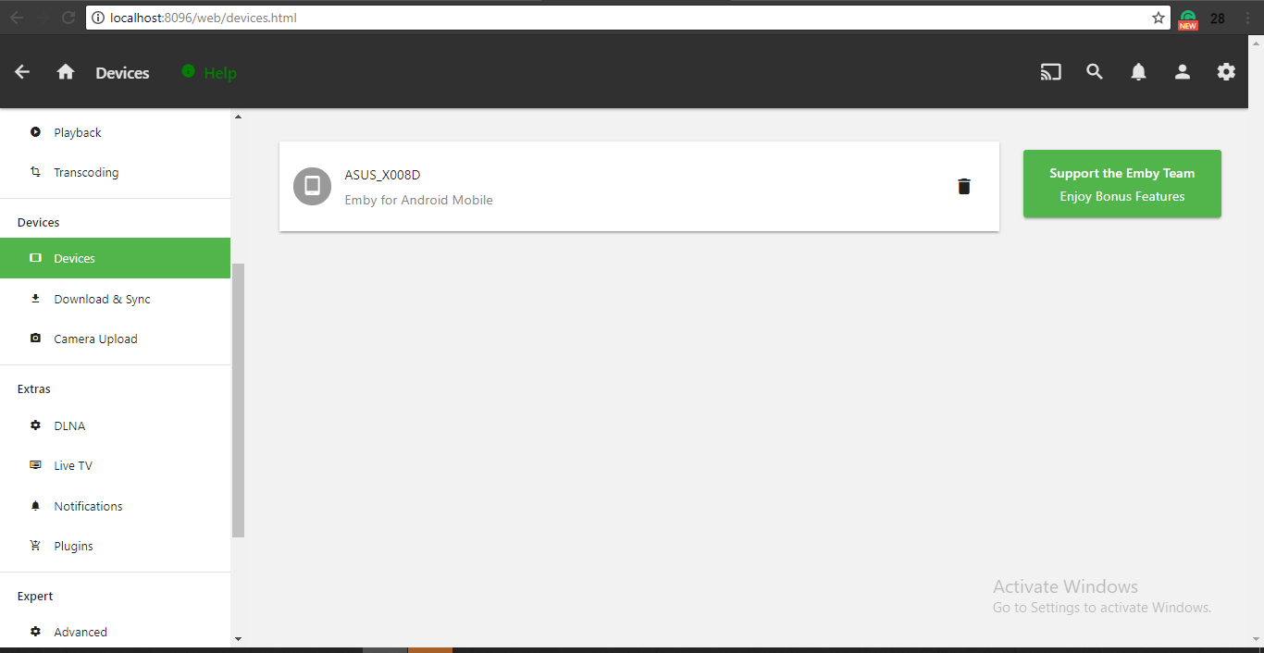

**Devices that connected to the Emby Server**

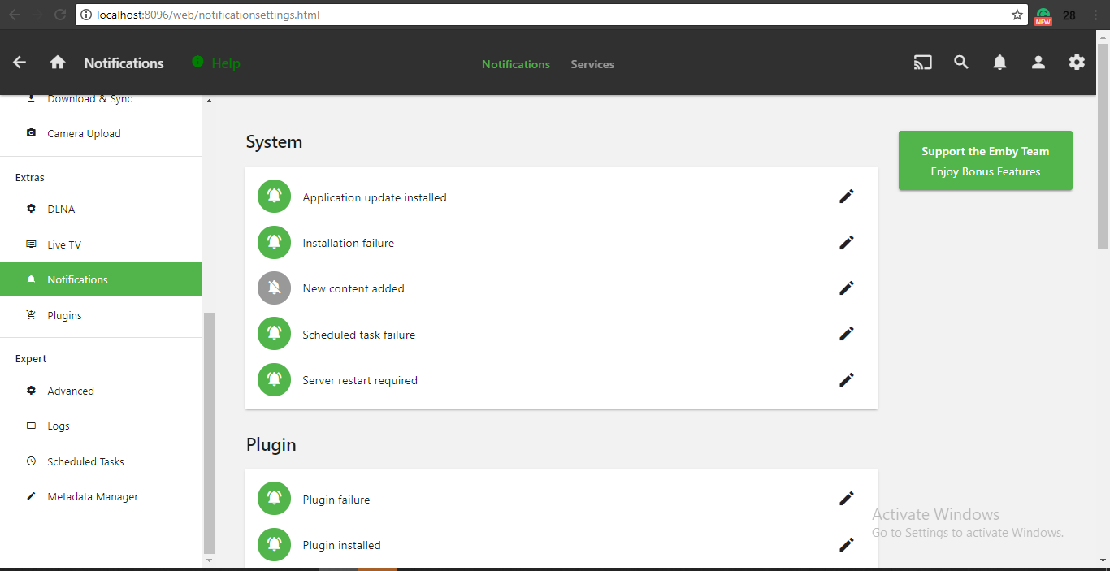

**System Features Part 1**

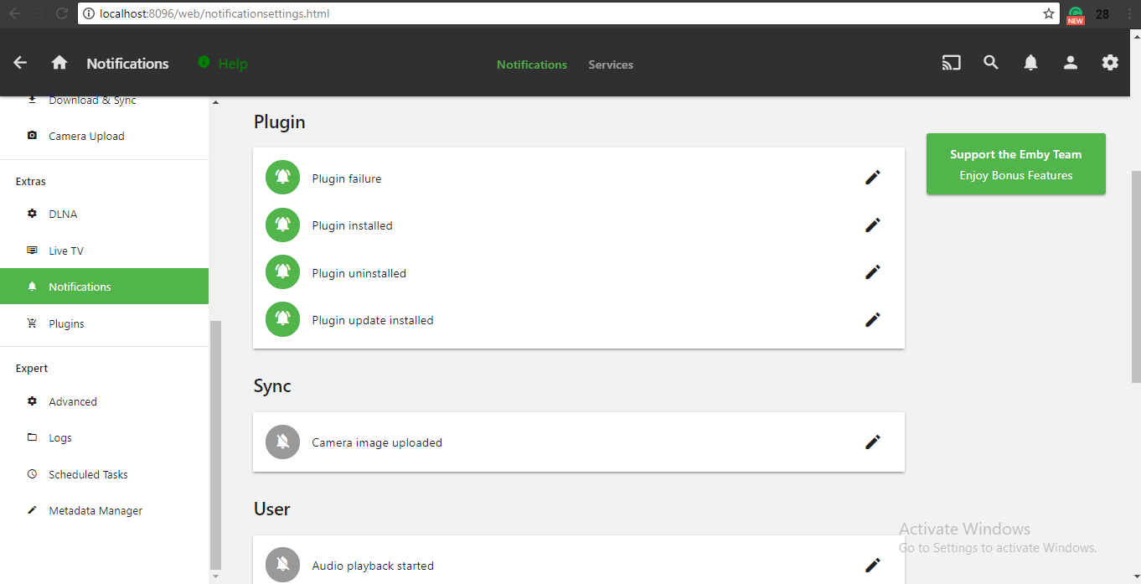

**System Features Part 2**

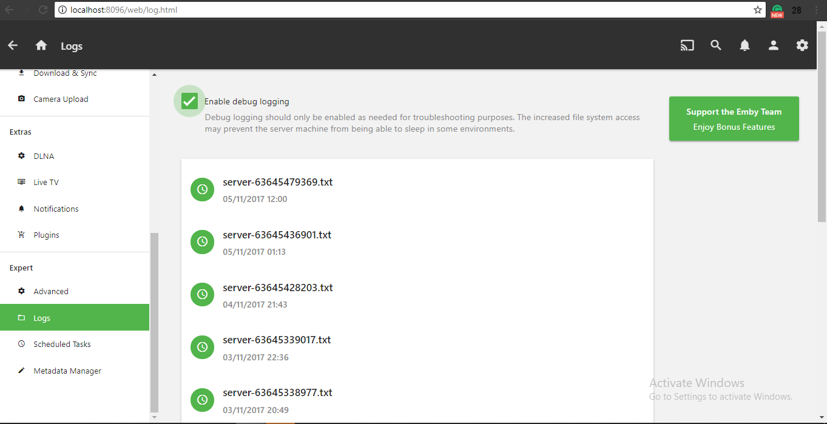

Server logs contained what was the date the user accessed and what time the user accessed

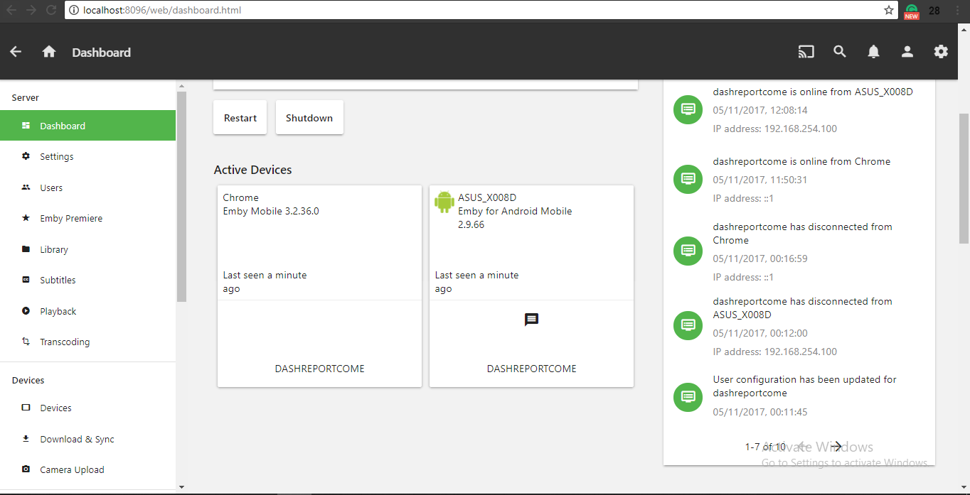

**Real-time Monitoring of Active Devices**

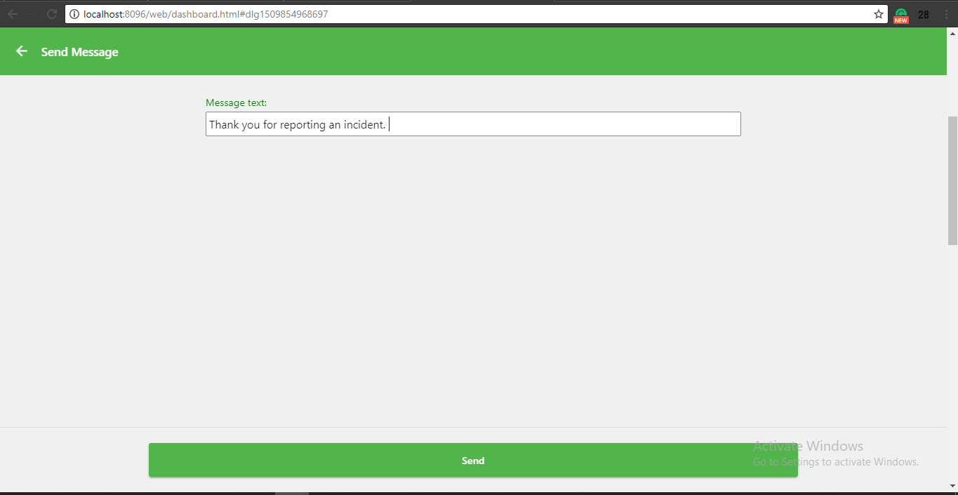

Administrator Message Panel - Message the specific user if the report has been taken an action

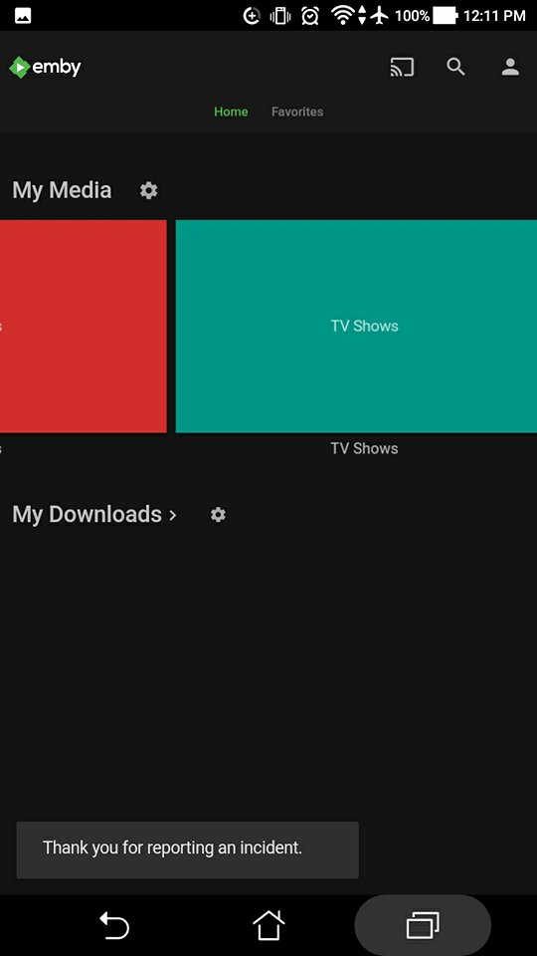 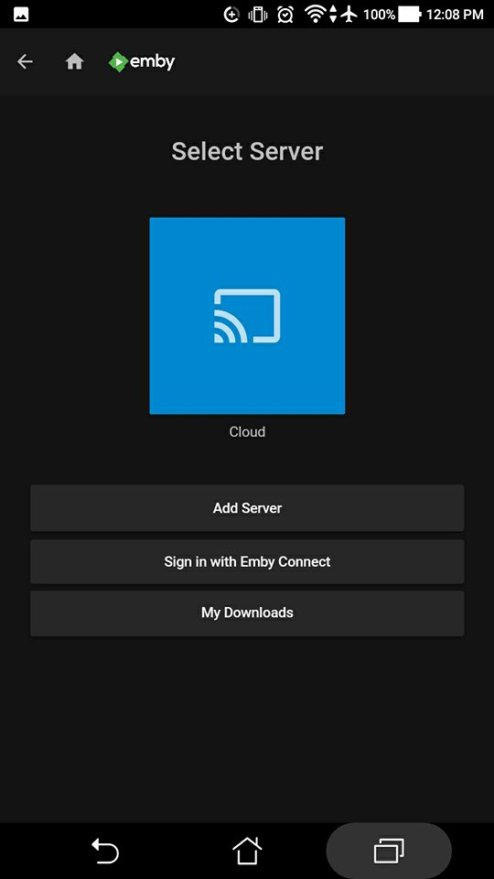

**User received the message**

Personal Computer of the Agency that serve as a media server. The administrator can monitor through the admin mobile application

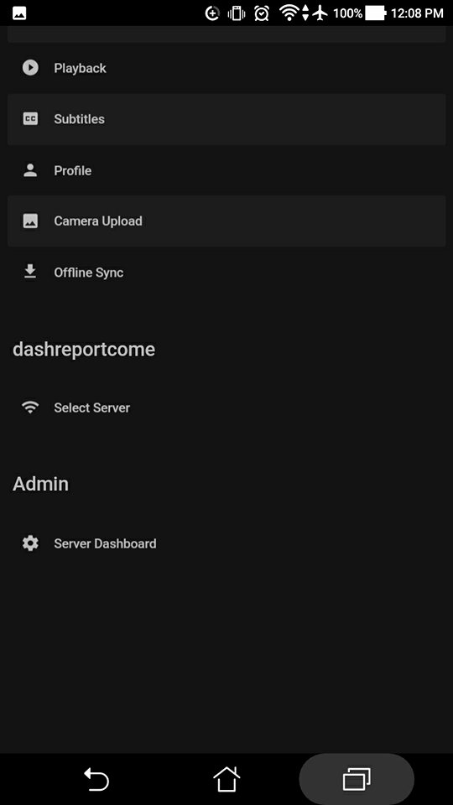 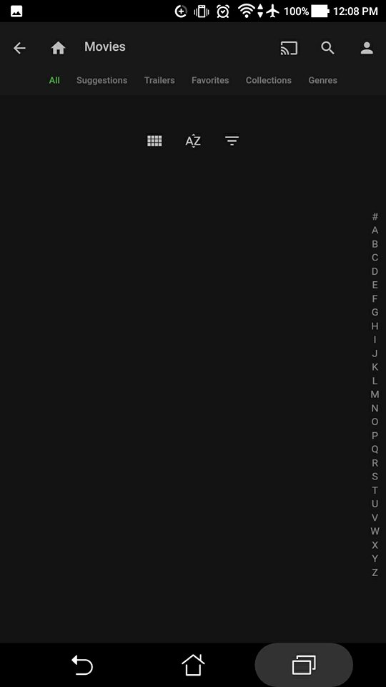

**Settings and the ascending or descending order of files.**

## **Development and Testing**

The prototype that the team will be developing is powered by Android Studio and Emby API. Android Studio is the mainly use tools for developing android application. It provides the fastest and efficient way to build an application. Emby Application Programming Interface (API) is directly and as part of the integration. Determine if they meet the functionality, reliability, performance and security. The prototype would enable the developers to create the propose project. System testing gains the developers to verify that the system will handle all input data properly, both valid and invalid.

### **Event Table**

|  |  |  |  |  |  |
| --- | --- | --- | --- | --- | --- |
| **Event** | **Trigger** | **Source** | **Use Case/ Activity** | **Response** | **Destination** |
| User wants to Register | Application has started | Mobile Application User | Prompts the user to choose to either to Create a new account or use Facebook or GMAIL account to Register | Displays creating a new account process or Linking account process | Mobile Application |
| User must enter other required information | User has been registered | Mobile Application User | Prompts the user to enter the other required information such as Contact Number, Location. | NONE | Emby server |
| User wants to upload either picture or video | User has been registered and user entered the other required information | Mobile Application User | Gets the uploaded or video | Displays the editing/cutting feature of the application or Displays the Incident Category. | Mobile Application |
| User must cut the unnecessary part of the uploaded video | A video was uploaded in the application | Mobile Application User | Gets the edited video | NONE | Emby Server |
| User must choose the Incident Category | Incident report has been made in the mobile application | Mobile Application User | Gets the edited video or picture and User’s information and other required information | Displays the Incident Category choices. | Emby Server |
| User wants to send the completed Incident Report | Incident report has been completed in the mobile application | Mobile Application User | Gets the completed incident report | Prompts the user to confirm his/ her action to either Send or Cancel via confirmation window | Emby Server |
| Agency must access the Emby server | An incident report has been sent by a user | Agency | Prompts the Agency personnel to Log in. | Displays the incident reports by category and with user’s information and other required information entered by the user. | NONE? Or User? |
| User must receive a notification indicating the update status of his/her submitted incident report | The Agency accessed the incident report made by the user | Agency | Gets the input made by the agency and send as a notification. (Updated Status of Incident Report) | Updated Status of the Incident Report for Notification | User |
| Agency wants to generate a report regarding the incident report reported | An incident report has been dispatched | Agency | Displays the incident report | The generated incident report with additional information such as Remarks. | Other System of the Agency |

### **b. Functional Decomposition Diagram (FDD)**

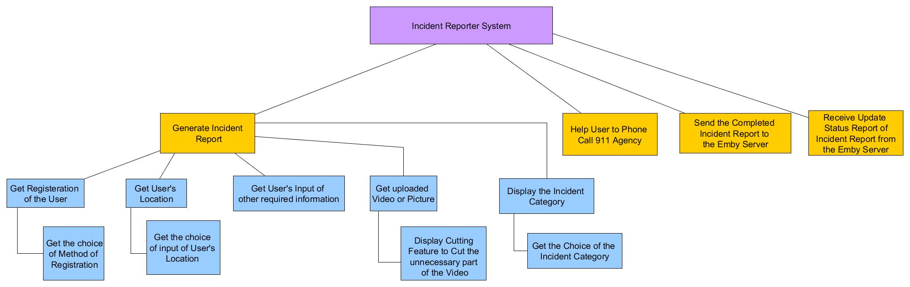

### **c. Data Flow Diagram (DFD)**

#### **LEVEL 0 Diagram**

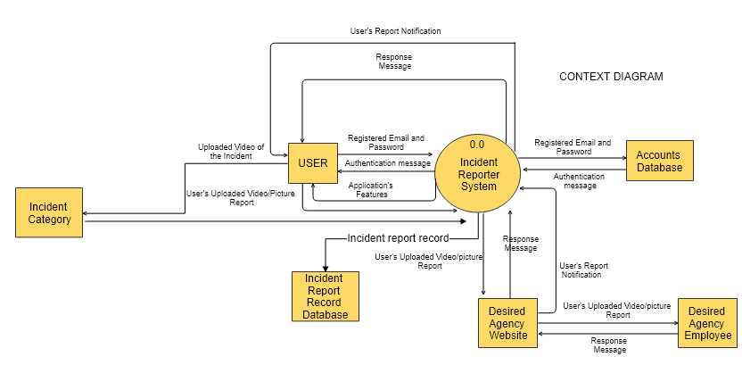

#### **LEVEL 1 Diagram**

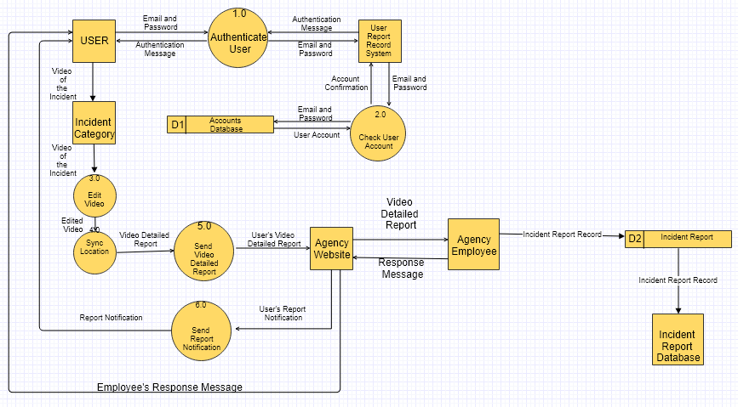

### **D. Entity Relation Diagram (With Data Dictionary)**

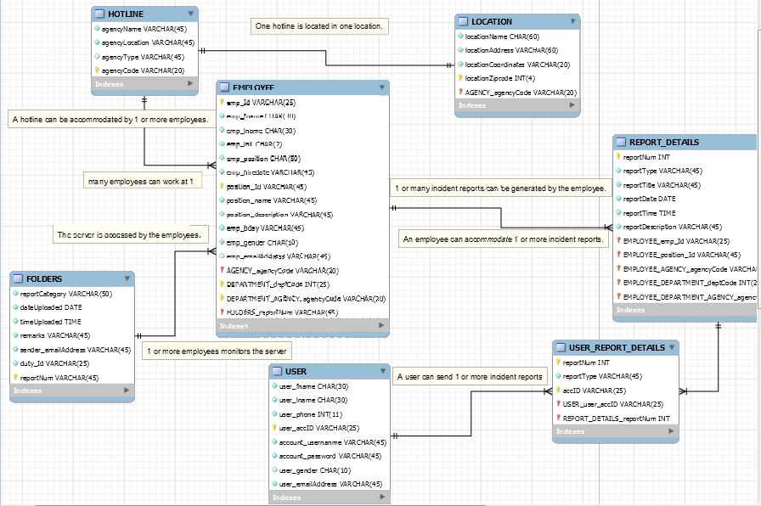

### **E. Data Dictionary**

#### **USER**

|  |  |  |
| --- | --- | --- |
| Field Name | Caption | Data Type |
| user_fname | User First Name | CHAR(30) |
| user_lname | User Last Name | CHAR(30) |
| user_phone | User Contact Number | INT(11) |
| user_accID | Account Identification | VARCHAR(25) |
| account_usernanme | Account Username | VARCHAR(45) |
| account_password | Account Password | VARCHAR(45) |
| user_gender | User gender | CHAR(10) |
| user_emailAddress | User Email address | VARCHAR(45) |

#### **LOCATION**

|  |  |  |
| --- | --- | --- |
| Field Name | Caption | Data Type |
| locationName | Location Name | CHAR(60) |
| locationAddress | Location Address | VARCHAR(60) |
| locationCoordinates | Location coordinates | VARCHAR(20) |
| locationZipcode | Location postal code | INT(4) |

#### **HOTLINE**

|  |  |  |
| --- | --- | --- |
| Field Name | Caption | Data Type |
| agencyCode | Agency Identification | INT |
| agencyName | Agency Name | VARCHAR(45) |
| agencyAddress | Agency Address | VARCHAR(45) |
| agencyType | Agency Type | VARCHAR(45) |
| agencyLocation | Agency Location | VARCHAR(45) |

#### **REPORT DETAILS**

|  |  |  |
| --- | --- | --- |
| Field Name | Caption | Data Type |
| reportNum | Incident report number | INT |
| reportType | Incident report category | VARCHAR(45) |
| reportTitle | Incident report title | VARCHAR(45) |
| reportDate | Date reported | DATE(mm/dd/yy) |
| reportTime | Time reported | TIME(HH:MM:SS) |
| reportDescription | Incident report details description | VARCHAR(45) |

#### **EMPLOYEE**

|  |  |  |
| --- | --- | --- |
| Field Name | Caption | Data Type |
| emp_Id | Employee Number | VARCHAR(25) |
| emp_fname | Employee First Name | CHAR(30) |
| emp_lname | Employee Last Name | CHAR(30) |
| emp_init | Employee Middle Initial | CHAR(2) |
| emp_posititon | Employee Position | CHAR(50) |
| emp_hiredate | Employee Hire Date | DATE(MM:DD:YY) |
| position_description | Employee Job description | VARCHAR(45) |
| emp_bday | Employee birth date | VARCHAR(45) |
| emp_gender | Employee gender | CHAR(10) |
| emp_emailAddress | Employee email Address | VARCHAR(45) |

#### **FOLDERS**

|  |  |  |
| --- | --- | --- |
| Field Name | Caption | Data Type |
| reportCategory | Type of Report | VARCHAR(50) |
| dateUploaded | Date Uploaded | DATE |
| timeUploaded | Time Uploaded | TIME |
| remarks | Comment of Employee | VARCHAR(45) |
| sender_emailAddress | User email address | VARCHAR(45) |
| duty_Id | Employee Id number | VARCHAR(25) |
| caseNum | Incident report number | INT |

### **F. Class Diagram**

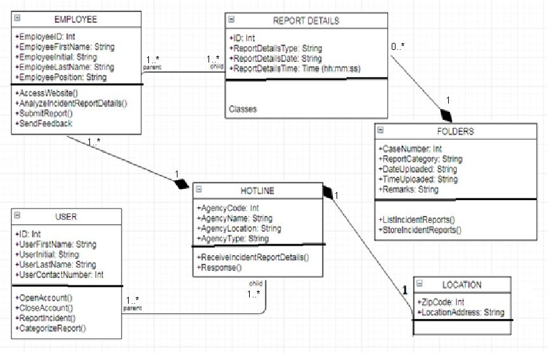

### **G. Object Diagram**

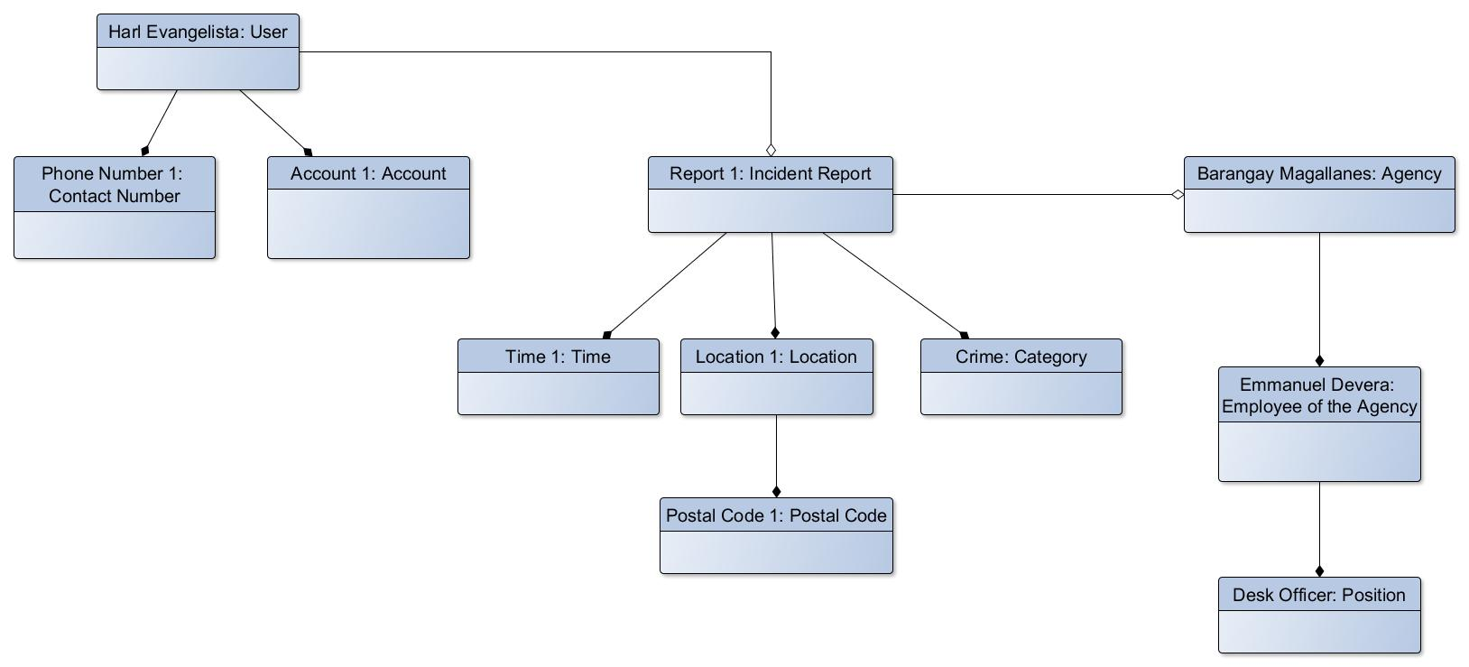

### **H. Use Case Diagram**

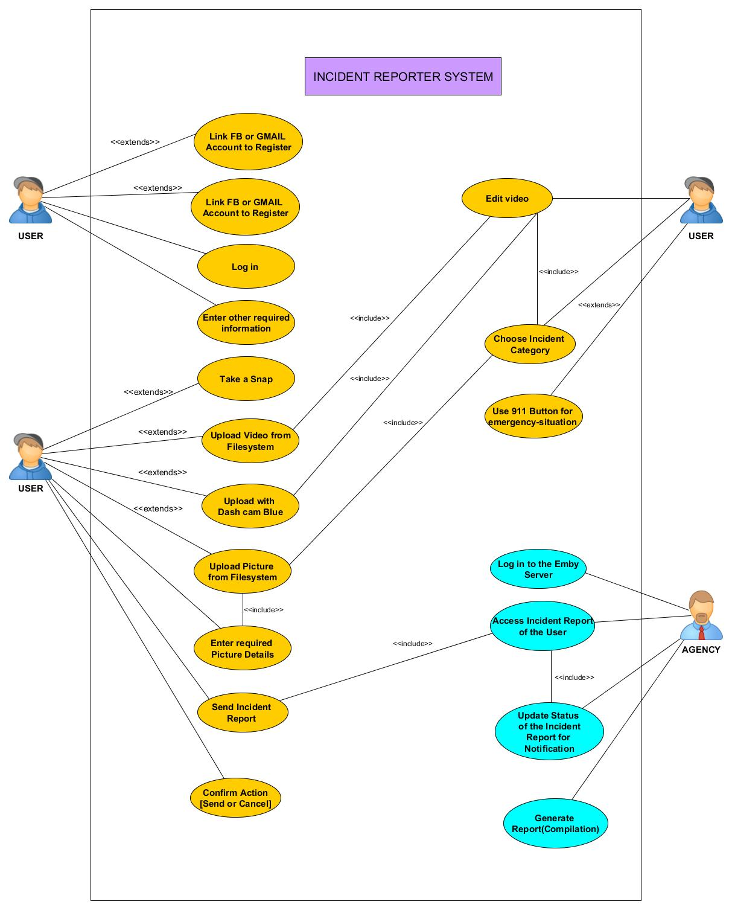

**H. Use-Case Full Description**

|  |  |  |
| --- | --- | --- |
| Use Case Name: | Emergency | |
| Scenario: | Taps emergency button (911) | |
| Triggering Event: | User wants to call 911 | |
| Brief Description: | 911 button is a feature that can be used in emergency. The user can contact 911 by tapping the emergency button. | |
| Actors: | App user | |
| Related Use Case: |  | |
| Stakeholders: | 911 agency: to answer the call and to respond on the incident | |
| Preconditions: | The user must login to use the feature.  The user must have internet connection or mobile data to dial 911.  The user must press the emergency button to dial 911.  The 911 employee must record the details of the caller. | |
| Postconditions: | The 911 employee must respond to the caller.  A report must be created. | |
| Flow of Activities: | Actor | System |
| 1. User taps the emergency button.  2. 911 employee answers the call.  3. 911 employee must record the details of the caller. | 1. Directly calls 911.  2. Respond to caller |
| Exception Conditions: | The user must be registered  The user must log in  The user must have internet connection  The user must be connected to internet or mobile data to use the emergency button feature. | |

|  |  |  |
| --- | --- | --- |
| Use Case Name: | Report an Incident | |
| Scenario: | The user wants to report an incident. | |
| Triggering Event: | Incident has to be reported | |
| Brief Description: | The user wants to report an incident to the mobile app. | |
| Actors: | User, Mobile app database, Agency | |
| Related Use Case: |  | |
| Stakeholders: |  | |
| Preconditions: | The user must have internet connection or mobile data to report an incident.  The user must register to use the application.  The user must have a video to upload. | |
| Postconditions: | The system must be online 24/7 | |
| Flow of Activities: | Actor | System |
| 1. User uploads chooses which video to upload  2. The user uploads the video  3. The database system receives the report. | 1. Shows the whole video  2. Receives notification of report |
| Exception Conditions: | The user must register to log in  The user must log in to report  The user must have internet connection to upload | |

|  |  |  |
| --- | --- | --- |
| Use Case Name: | Incident Report | |
| Scenario: | LGU employee receives a report | |
| Triggering Event: | The agency receives a report | |
| Brief Description: | When the agency receives a report, the employee in the agency verifies the report if it is valid | |
| Actors: | App user  Agency employee | |
| Related Use Case: |  | |
| Stakeholders: |  | |
| Preconditions: | The user must create an account  The user must log in  The user must send a video to the server  The user must upload the video to its category  The user must have internet connection | |
| Postconditions: | The system must be online 24/7 | |
| Flow of Activities: | Application | User |
| 1. Prompts the user to login after registration  2. Prompts user to enter location  2.2 get location  3. Prompt to enter other required information  3.2 Get User’s output  4. Display Home Screen  8. Get edited video | 1.1 Login  3.1 Enter other information  5. Save video with edit button  6. User to edit video  7. Edit and save video  9. Display confirmation window  10. Receive update status  11. End Session |
| Exception Conditions: | 2.1 the user will have option whether to enter the location in a textbox or user his/her GPS  4.1 Displays 3 options of uploading the report  6.1 user has option to choose a cutting video feature  9.1 the application will prompt the user to send or cancel the report | |

|  |  |  |
| --- | --- | --- |
| Use Case Name: | Categorize incident | |
| Scenario: | The agency generates the incident report details | |
| Triggering Event: | The user sends video | |
| Brief Description: | The user has to choose the right category of the incident before sending the video of the incident | |
| Actors: | App user  Agency employee | |
| Related Use Case: |  | |
| Stakeholders: |  | |
| Preconditions: | The user must send a video to the server  The user must upload the video to its category  The user may or may not cut the video | |
| Postconditions: | The system must be online 24/7 | |
| Flow of Activities: | Actor | System |
| 5. The user sent a video  6. The employee in the server receives the video  7. The employee will analyze the video  8. The employee will generate an incident report details | 1. Sends notification to the sender (app user) |
| Exception Conditions: | The video must be validated by the employee manipulating the server.  The user must be registered  The user must log in  The user must have internet connection | |

### **I. Activity Diagram**

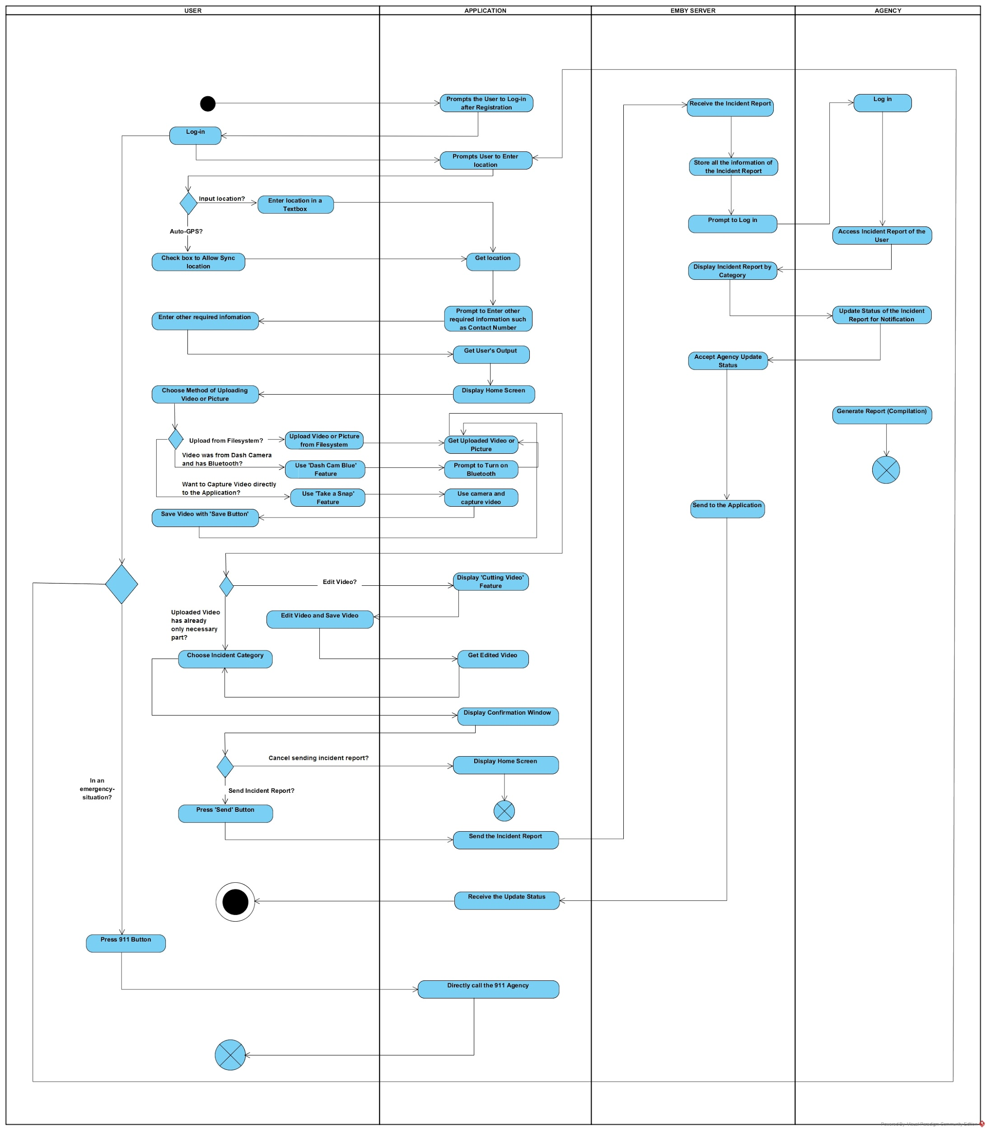

### **J. Sequence Diagram**

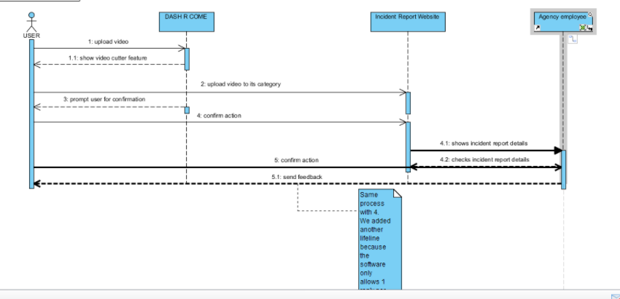

### 

# **V. Conclusions and Recommendation**

**5.1 Conclusion**

# Reporting a crime, traffic accident, or accusing of someone to a crime is hard to investigate if there is no evidence. A mobile application like DASH-R-COME could serve as an alternative tool in capturing and reporting an incident.

# **VI. Appendices**

## **Results of the Interview**

As the group identifies the factors that will help to improve the process in developing the application, the group conducted an interview in Barangay Magallanes that contains 15 questions and lasted for 20 minutes, questions that includes the interviewee’s personal information, rules and regulations of Makati City traffic and common traffic problems and crimes that they usually encounter in their area. The data below is the result of the interview that the group conducted.

The name of the interviewee is Sir Jesus Sumandal, his position is a desk officer. A Desk Officer is the one who receives the complaints, commands his comrade and assign tasks, he is also the one in charge of answering phone calls when the head is out.

Sir Sumandal’s job can respond to all kinds of crimes and incident. In the City of Makati, they are a Skyways, we asked, if it is possible to respond in that area. He told us that “as long as the concern is in our area. We can respond any incident happened but, later on, we have to indorse it to NDCC.” The barangay of Magallanes Makati has a different division. Like Peace and Order, Accounting, Social Service, Health Clinic, Infrastructure, and Educational & Culture

They process the incident report as follows; They will get the following information. Details of the incident, Description of the suspect, information about the complainant, what is the thing stolen, if the complainant will not file against the complainant and if the thing stolen has a big amount.

They validate the report as follows; The Barangay Officer will know if the complainant is lying or not, first thing in the interview. If the complaint is true, they will endorse it to CDI and do their process

They have allotted budget and resource. They have Wi-Fi connection and computers and a database. We also asked the commonly committed crime in the Makati area. He said that, it is snatching and most victims’ APC students.

## **Results of the Survey**

Aside from doing an interview, the group also conducted an online survey that asks about the respondent’s knowledge about traffic rules and regulation, and if they know where and how to report to police / LGU in case of emergency and the proposed mobile application’s features.

# **Change Request**

|  |  |  |  |
| --- | --- | --- | --- |
| **ORIGINAL PROPOSAL** | **WHAT CHANGE?** | **WHY?** | **WHEN?** |
| Name of the Application: Dash Come | Dash-R-Come | We had change the process of the application and we matched the process of the application to the name of the application. | Finals during INTSDEV Course |
| Process of the Application:  User will upload the video of the incident after he/she cut the unnecessary part of the video then, it will be send to the database.    The employee in the agency who monitors the database will analyze the report of the user and afterwards, the employee will generate a report to be send in the desired agency, Hospital as an example.    And the personnel in the desired agency will process the generated report sent and will rescue. | User will upload the video of the incident after he/she cut the unnecessary part of the video then, it will be upload to the server, including the details of the video, information of the sender/user.    The server can access by anyone in the agency and will do the agency’s process to respond to the user. | As suggested by Sir Jayvee Cabardo, the group members saw as it can have an improvement of the application and will give the application …. | During Midterms in SYSADD1 and SYSADD2 Course |
| No incident category | Incident Category in the application and the server added | As suggested by Sir Jayvee and Sir Sean Sanchez to add a category of the incident report for the desired agency to be able to identify a specific incident happened and which agency is needed to respond to the user. | During Midterms in SYSADD1 and SYSADD2 Course |
| The application has the process of: if the user does not have an internet connection then it will just save the uploaded video in the device and will automatically send the video to the database. | Removed the process mentioned in the left side row. | As Sir Sean Sanchez checked our Event table, he suggested that the said process is impossible in the making. | During midterms in SYSADD1 and SYSADD2 Course. |