# Makati Police Office Wanted and Missing Database System

Project Documentation Submitted

To the Faculty of School of

Computer Science and Information Technology

Of

Asia Pacific College

In Partial Fulfillment of the Requirements for the subject

Applied Projects 2

By

Ablaza, Paul Alexis C.

Alonzo, Miguel Carlo R.   
Sonico, Patricia Belle M.

**Table of Contents**

Page no

Makati Police Office Wanted and Missing Database System 1

I. Narrative 3

A. Executive Summary 3

B. Introduction 3

1. Client Profile 3

2. Project Organization 3

a. Project Team 3

c. Project Adviser(s) 4

3. Client’s Mission and Objectives 4

4. Project Objectives General Objectives 4

5. Purpose of the Project 4

6. Rationale of the Project 5

a. The Current Process Flow 5

b. User Information Needs 5

c. How the Information is Being Processed 5

C. Systems Features and Functions 6

1. Software Environment 6

a. Programming Languages 6

b. Specific Software 6

c. Web Server Application 6

d. Operating System 6

2. Hardware Environment 6

3. Networking and Security 6

a. Security 6

b. Server 6

2. Application System Modules 6

a. Record Missing and Wanted Person 6

b. Generate Reports 7

c. Identify Warrant of Arrest 7

II. System Diagrams and Screenshots 7

A. Data Flow Diagrams 7

1. Context Level Data Flow Diagram 7

2. Level 0 Data Flow Diagram 8

B. UML Diagrams 8

C. Entity – Relationship Diagram 16

D. Data Dictionary 16

E. Screenshots 19

F. Lessons Learn 20

III. Appendices 20

# Narrative

## Executive Summary

The Makati Police Office Wanted and Missing Database System is a project that handles processing of wanted and missing people information. Up until now, MPO is keeping the wanted and missing people records by writing in log sheets, so the project team proposed to create an automated system that will fit the client’s needs in terms of managing the records. The proposal was approved in June 2014, and will now be presented for completion.  
  
The MPO Wanted and Missing Database System will be used for creating, updating, posting, and securing the records. Upon the completion of the proposed project, the client will be able to make use of the system in a more efficient way.

## Introduction

The Makati Police Office Wanted and Missing Database System is a proposed project for MPO to have an easier way of disseminating information to the citizens and external offices.

### Client Profile

##### Makati City Police Station SPD-NCRPO Location: Ayala Avenue Extension Corner Yakal Street, Makati City, Philippines

##### Reycon Lalaan Garduque, (PESE) Police Chief Inspector Chief, Intelligence Unit and Chief, Station Investigation & Detective Management Section (SIDMS)

### Project Organization

### Project Team

Ablaza, Paul Alexis C.  
BSCS-SS

Project Developer

Alonzo, Miguel Carlo R.

BSCSIT  
Project Programmer

Sonico, Patricia Belle M.

BSCS-SS

Project Manager

* 1. **Project Professor**

Mr. Manuel Sebastian S. Sanchez  
SoCSIT Faculty

### Project Adviser(s)

Ms. Tess Montemayor  
SoCSIT Faculty, ITRO  
  
Mr. Rodel Urani  
SoCSIT Faculty

### Client’s Mission and Objectives

**Vision**  
Imploring the aid of the almighty by 2030, the Makati City Police station shall be a highly capable, effective, and credible police service working in partnership with a responsive community towards the attainment of a safer place to live work and do business.

**Mission**

The PNP shall enforce the law, prevent and control crimes, maintain peace and order, and ensure public safety and internal security with the active support of the community.

### Project Objectives General Objectives

* To automate MPO’s process of recording information
* To create a reliable system that will fit MPO’s needs

**Specific Objectives**

* To create a database for the records of wanted and missing people
* To secure the information in the database

### Purpose of the Project

The purpose of the project is to introduce a system that will handle data processing like creating, updating, and keeping the records of wanted and missing people. Through this system, MPO will be able to save time and effort in managing the records, and will be able to secure the information.

### Rationale of the Project

### The Current Process Flow

##### Wanted Person Record

MAPSA will request a warrant of arrest then court will issue the warrant of arrest to MAPSA. MAPSA will create the wanted person record then post it in the master list. MAPSA can search for the wanted person records in the database; and when MAPSA captures the wanted person, they will update the wanted person record in the database.

##### Missing Person Record

Citizen will file a missing person report then MAPSA will create the missing person record and post it in the master list. MAPSA can search for the missing person records in the database; and when MAPSA finds the missing person, they will update the missing person record in the database.

### User Information Needs

* Wanted person record
* Missing person record
* Complainant record

### How the Information is Being Processed

The system will be managing confidential information so authorized users were divided. The police head will be the administrator who’s the only one capable of approving the records created by the officers before being posted at the master list. The officers are capable of creating and updating records, and the citizens are only capable of viewing the records.

## Systems Features and Functions

### Software Environment

### Programming Languages

* PHP – Hypertext Preprocessor

### Specific Software

* MySQL Workbench
* Notepad++
* Visual Paradigm
* Joomla

### Web Server Application

* XAMPP

### Operating System

* Windows XP, Vista, 7, 8

### Hardware Environment

Minimum requirements to run:

Processor (CPU): Intel Core i3 2xxx

Memory: 4 GB RAM

Storage: 500 GB internal hard drive

### Networking and Security

### Security

* Intrusion Detection & Protection
* Port Security
* IP Permit Lists

### Server

* Prevent SQL Injections
* Firewalls
* Antivirus

### Application System Modules

### Record Missing and Wanted Person

* Able to enter missing and wanted person

### Generate Reports

* Able to print out reports

### Identify Warrant of Arrest

* Able to receive Warrant for the Court

# System Diagrams and Screenshots

## Data Flow Diagrams

### Context Level Data Flow Diagram

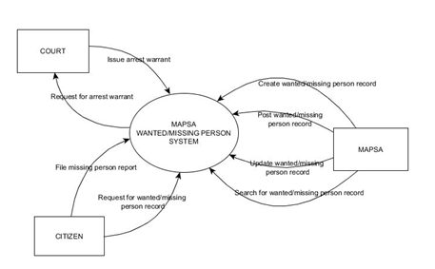

### Level 0 Data Flow Diagram

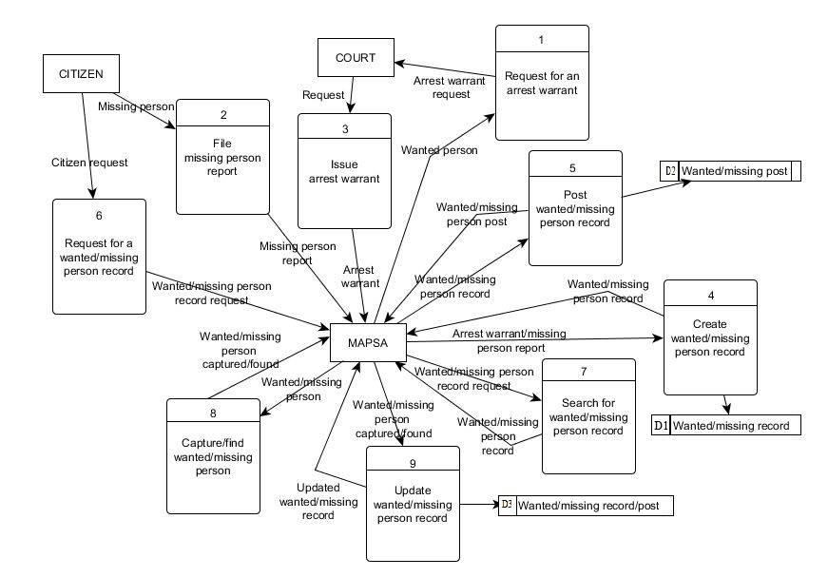

## UML Diagrams

1. Activity Diagram

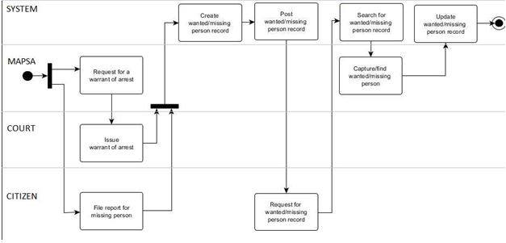

1. Class Diagram

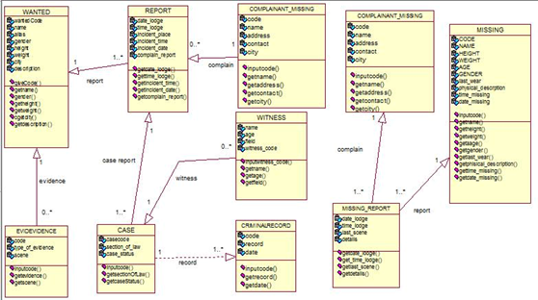

1. Communication Diagram

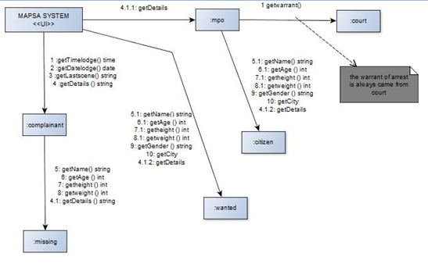

1. Component Diagram

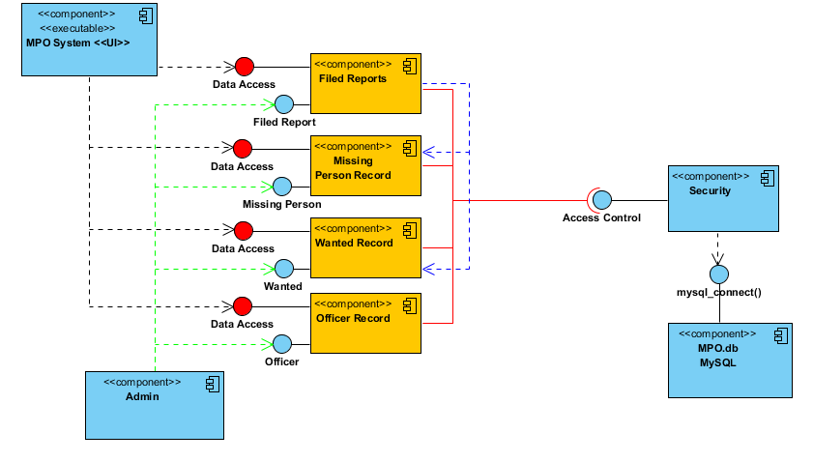

1. Use Case Diagram

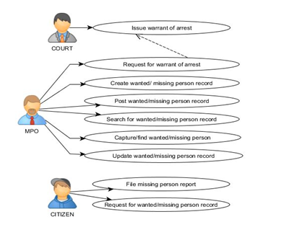

1. Composite Structure Diagram

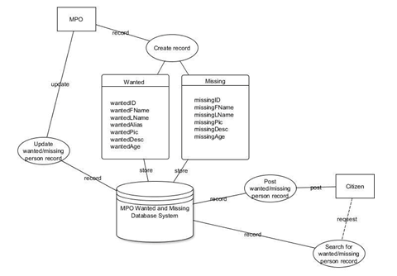

1. Deployment Diagram

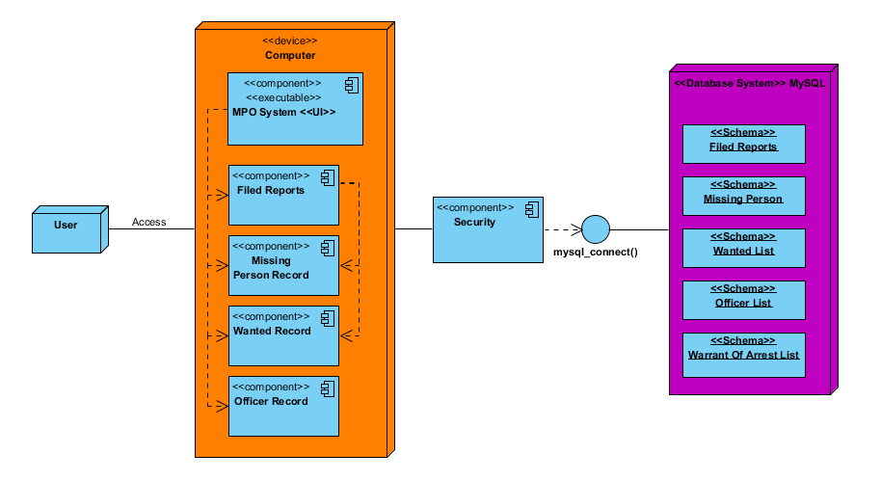

1. Interaction Overview Diagram

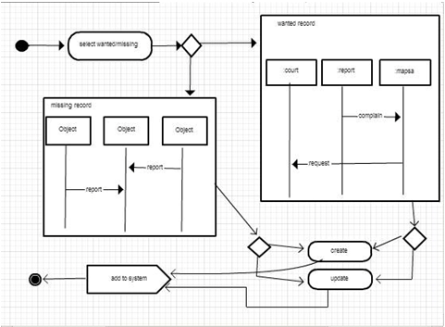

1. Package Diagram

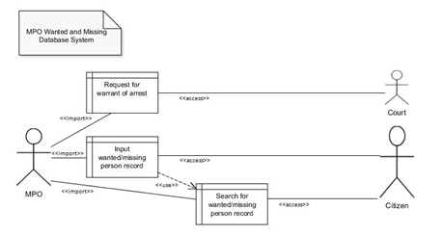

1. Object Diagram

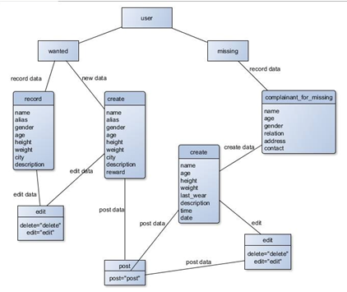

1. Sequence Diagram

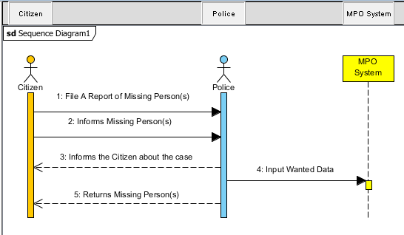



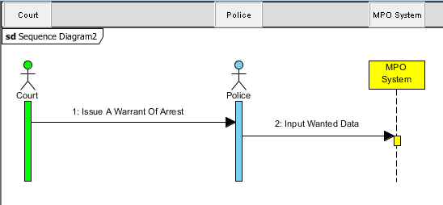

1. State Machine Diagram

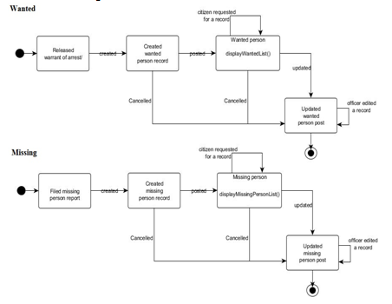

1. Timing Diagram

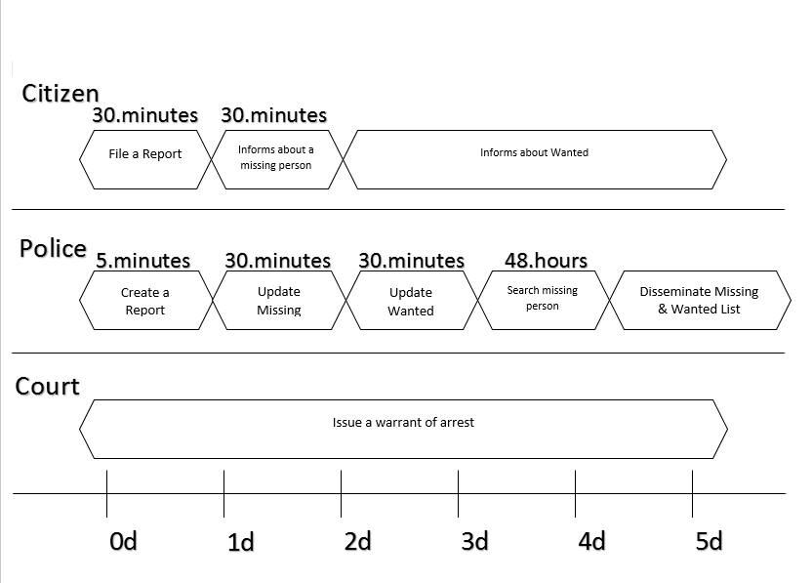

## Entity – Relationship Diagram

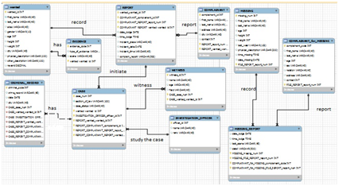

## Data Dictionary

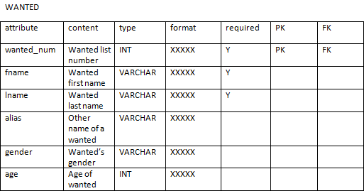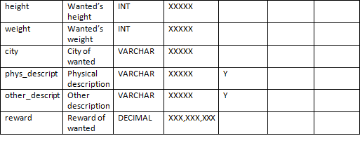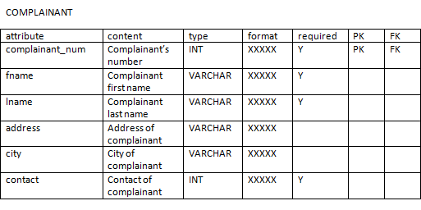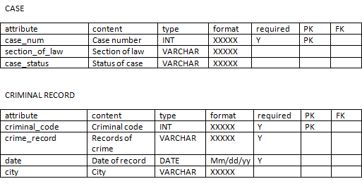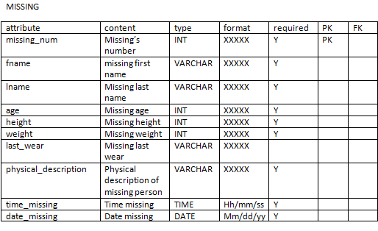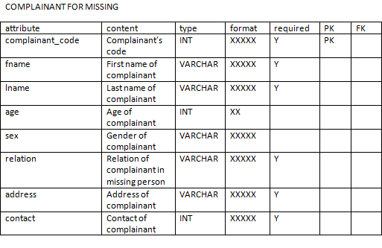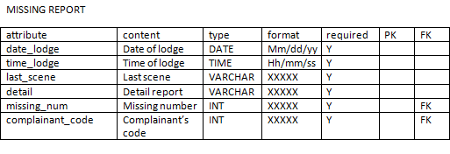

## Screenshots

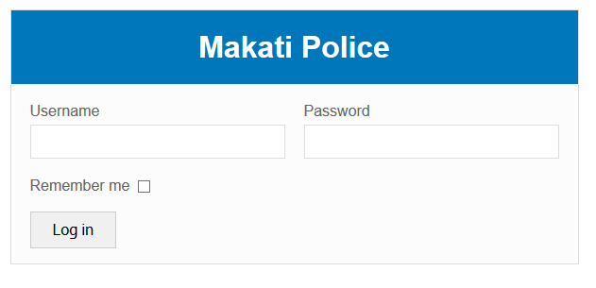

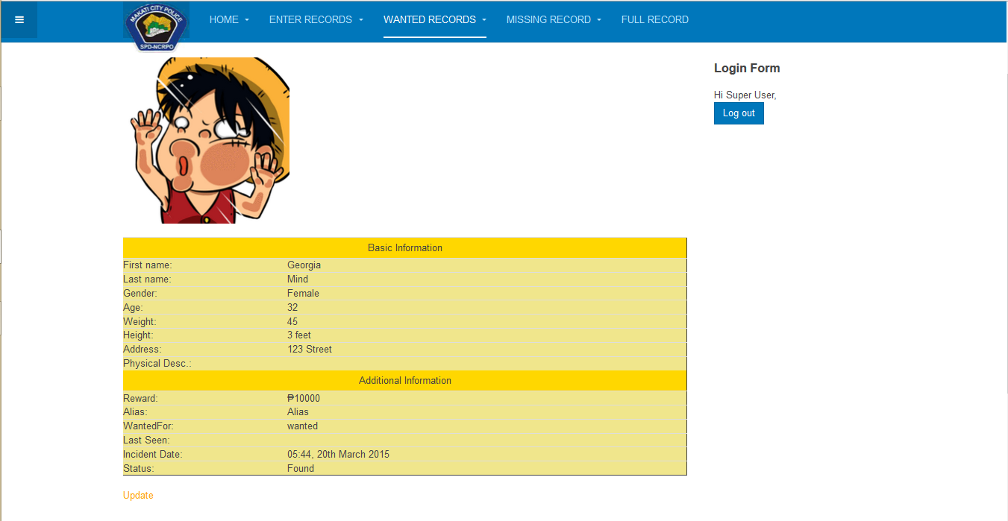

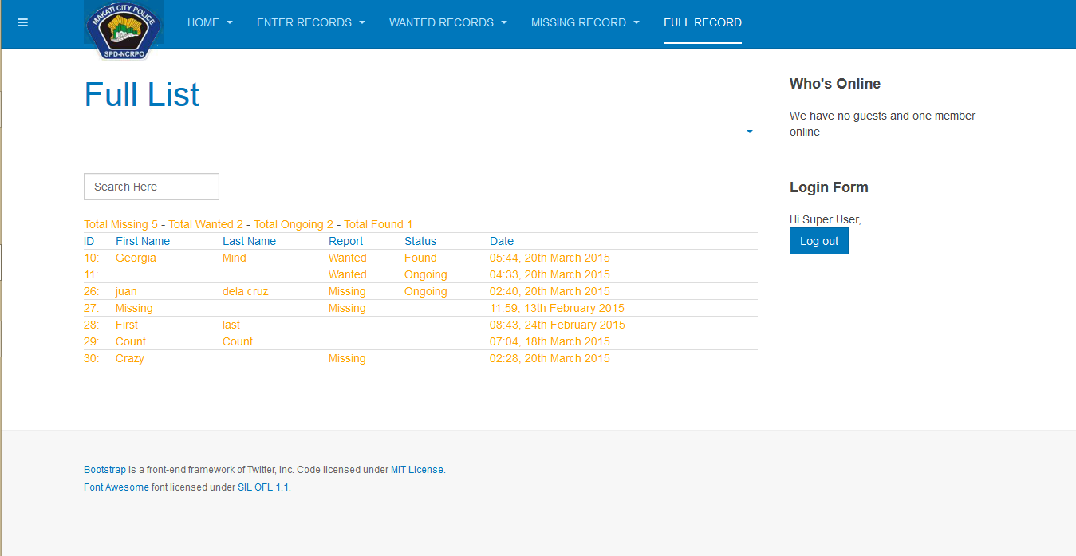

## Lessons Learn

**Ablaza, Paul Alexis C.**  
He learned how to cooperate in a group, and how to present a project in front of the client in a formal way. He also learned that the process of the project must be detailed. He applied the entire lesson that he encountered in the course in developing the system.

**Alonzo, Miguel Carlo R.**

He has established his self-confidence when facing a group of people and client. He learned to manage his time and identify his priorities. He also learned to create a concrete documentation.

**Sonico, Patricia Belle M.**

She learned how to talk and deal with a client, and how to present a project to a client in a way that he will understand the flow of the subject even if he has no background in CS/IT. She also realized the significance of UML diagrams, etc. in developing a system.

# Appendices

Every organization including public offices need technological tools to make everything easier. The database is used to compile the data especially the record of person. This system is created to support the needs of Makati Police Office. With this system, they can easily record the data of the criminal without any manual process. They can easily input the information record of the criminal in this case; they don’t need to worry to wipe the record because the system has a security access which will secure the data of the criminals. By the help of this system it’s easier to control and monitor every pieces of the record by saving the input data.