

**Project LYF**

Project Documentation to be submitted

to the Faculty of School of

Computing and Information Technology

under Asia Pacific College

In partial fulfillment of the Requirements for the Subject

Structure Systems Analysis and Design (SYSADD1)

By:

|  |  |
| --- | --- |
| **Jamie Therese Gahallon** | **John David L. Solomon** |
| Project Manager, System Analyst and Documenter | System Analyst, Project Researcher and  Documenter |

|  |  |
| --- | --- |
| Ms. Marielet Guillermo | Mr. Manuel Sebastian S. Sanchez |
| Project Adviser | Subject Professor |

March 15, 2019

**Executive Summary**

Philippine Institute of Traditional and Alternative Health Care (PITAHC) is a government branch created under the Department of Health. Their vision is described as “People’s health through traditional and alternative health care” which states their desire to inject traditional and alternative medicines to the conventional health care system in the country. PITAHC aims to promote and advocate the use of traditional, alternative, preventive, and curative health care modalities that have been proven safe, effective, cost effective and consistent with government standards on medical practice.

According to an interview with PITAHC's researcher, the main hindrance to achieve this goal is the lack of awareness and knowledge regarding the results of Department of Health's researches on Traditional Medicine. Also, it is difficult for PITAHC to advocate the use of medicinal plants Filipinos find difficult to recognize. Plants are officially identified by the botanists from Bureau of Plant Industry through observation of its physical characteristics. It is also difficult for them to gather necessary information such as plant abundance and location. To accomplish this task, PITAHC sends representatives to every location and manually keep track of medicinal plant population and their locations.

The project aims to support PITAHC in their mandated function of promotion by providing results of their researches, which includes traditional medicine and their clinically approved usage, to users. To further encourage this, the project includes image recognition that could help users identify medicinal plants through image capture of its leaf and shares location to other users upon recognition.

**I. Introduction**

**1.1 Project Context**

The government created Philippine Institute of Traditional and Alternative Health Care as mandated by the Republic Act 8423 “to improve the quality and delivery of health care services to the Filipino people through the development of traditional and alternative health care and its integration into the national health care delivery system”. Philippine Institute of Traditional and Alternative Health Care, or PITAHC, is working under the Department of Health towards this mandated goal. PITAHC envisions itself to lead research, development, promotion and development of standards on traditional and complementary medicines to ensure its accessibility, availability, sustainability and integration into the national health care system.

The project members have interviewed Ms. Ma. Teresa M. Torres, a Science Research Specialist II for PITAHC. According to her, the greatest hindrance towards their goal is the lack of awareness and knowledge regarding traditional and complementary medicine. It is also difficult for PITAHC to advocate use of medicinal plants because some Filipinos can’t recognize them. During the interview, Ms. Torres has explained various physical characteristics of the plants that the general public more often misidentify or how some of these beneficial plants are treated like weeds despite its medicinal benefits. In addition, PITAHC has performed numerous studies proving their effectivity and safety but this information hasn’t reached the general public.

PITAHC also performs regular surveying in various locations at the Philippines to manually keep track of traditional and complementary medicinal plant abundance. They perform this by sending representatives to these areas who manually search and survey the land.

These problems cripple the operation of PITAHC. The team addresses these problems in support of PITAHC towards their mandated function through Lyf.

**1.2 Purpose and Description**

Philippine Institute of Traditional and Alternative Healthcare, or PITAHC, is facing problems on regarding their advocacy and promotion of traditional and contemporary medicine. Their researches, which includes clinic studies and test, has been difficult to disseminate and they are afraid this cause skepticism towards traditional and contemporary medicine.

To address these, the team developed Lyf. Lyf is a system that includes an Android application for users and website for the admin. The android application allows users to register and login. Once account has been created, the user can now access the application’s functions. These includes image recognition trained on the Department of Health’s recommended medicinal plants. The feature helps users to identify plants and explore their medicinal benefits. Users will have to take a photo of its leaf for the system to recognize. Users can also contribute information through the app.

Ms. Ma. Teresa M. Torres, a Science Research Specialist II for PITAHC, has provided the team with the results of their studies to include in the system. Once identified by the app, the location is shared among all users which can be seen through map. Using this function, users can view all shared plant location, or filter the results through plant search. Upon viewing a certain plant location, the user can also view that plant’s details.

The app also contains a plant glossary which users can browse through to access all plant details derived from the studies.

The system’s website allows admin to respond to mislocation reports and requests to add information.The admin can also view all results of image recognition. Most importantly, if new studies and information has to be added to the system, the admin can do so using the website. These changes are visible to the users through the android app.

**1.3 Objectives**

The project is intended to address the problems PITAHC has encountered in performing their mandate and functions. These functions are associated with ensuring accessibility, encouraging research and information sharing, promotion of use of traditional and contemporary medicinal plant. It has been difficult for PITAHC to achieve their mission because of problems on the department’s implementation, such as manual gathering of researches and location surveys, information dissemination and plant identification on the user’s end.

**General Objectives**

* Create a system that will allow identification, information exchange, and location sharing of traditional and contemporary medicinal plant and generate reports for the use of PITAHC.

**Specific Objectives**

* Create an Android application that will allow users to
  + Register and Login
  + Identify plants through Image Recognition
  + Share the location of identified plants
  + View all plant locations
  + Report plant mislocations or incorrect location.
  + Access, add and edit information and researches on traditional and contemporary medicinal plants
* Create a web-based system that will allow admin to
* Login
* Respond to plant mislocations report
* Respond to user requests to add and edit information
* Access, add and edit information and researches on traditional and contemporary medicinal plants
* Access all result of plant identification through image recognition – including not found results.
* Generate reports such as reports on plants species identified over period of time, and/or confined in specific area, and plants not identified by the system.

**1.4 Scope and Limitations**

**Scope**

* The Admin can:
  + Create an account by providing:
    - Name
    - Username
    - Password
    - Email
    - Position
  + Access the Lyf Web Admin Panel
  + Assign Admin role to registered account.
  + Edit account.
  + View all result of image recognition, both successful and failed results.
  + Address mislocation report and remove plant location from Maps.
  + View all admins response to mislocation report.
  + View all plant information shown in plant glossary.
  + Add/Edit plant information in plant glossary.
  + View all requests for add and edit plant information.
  + Change request status to Verified.
  + Delete requests.
* The Users can
  + Create an account by providing:
    - Name
    - Username
    - Password
    - Email
    - Position
  + Access the Lyf App.
  + Edit account.
  + View all locations of successful image recognitions through Maps.
  + Report mislocation or missing in location of plant in Maps.
  + Identify plants by isolating the leaf and capturing an image of it.
  + View the plant glossary and information verified by the admin.
  + Create requests to add information/plant in the plant glossary.
  + Create requests to edit information in the plant glossary.
  + Notified upon verification of requests.

**Limitations**

* The Lyf Web Admin Panel is the responsibility of the client, PITAHC. Admin roles are granted by PITAHC.
* System can only recognized plants which has undergone match training.
* Plants can only be recognized by capturing an image of its leaf.

**II. Review of Related Literature/Systems**

This section discusses other projects related to Lyf. The related projects identified may not have the same implementation of Lyf but are guided by the same concept and background.

**2.1 PlantNet**

PlantNet Plant Idenfication. Retrieved from <https://www.educationalappstore.com/app/plantnet-plant-identification>. This is an image sharing and retrieval application for plants. PlantNet identifies plant through image recognition software. The species and images used to identify plants evolve as contributions from end users increases. The app provides the scientific and English name upon plant recognition.

**2.2 Garden Answers**

Garden Answers Plant Identification. Retrieved from <http://www.gardenanswers.com>. Garden Answers identifies plant through image recognition software. Upon identification, the app provides information on the plant provided by garden and horticulture experts. It also contains a database to find out more information about a plant without prior identification.

**2.3 PlantFinder**

PlantFinder – Plant Identifier. Retrieved from <https://itunes.apple.com/us/app/plantfinder-plant-identifier/id1437376141?mt=8>. Main features of PlantFinder includes plant identification with the camera and access to their flora database. Information provided on the app includes basic information such as scientific and common name, and plant care. This app focuses on plant identification and providing plant care suited for the specific plant.

**2.4 PlantSnap**

PlantSnap. Retrieved from <https://www.plantsnap.com/>. PlantSnap also identifies plant through image recognition. Information provided by PlantSnap focuses more on plant’s classification taxonomy. Upon recognition, PlantSnap also retrieve the location which other users can also see through a map. Users of the free version are limited to a number of ‘snaps’ or image identification per day.

**III. Methodology, Results and Discussion**

**3.1 Gap Analysis**

|  |  |  |
| --- | --- | --- |
| User Requirement | Current Standing | Proposed Action |
| Improve information dissemination by accessing more platforms to reach users. | Information is currently just being posted on PITAHC’s site | Aside from the web, info can now be viewed, accessed via Lyf app. |
| Encourage sharing of information with PITAHC and other citizens/researchers through easy and uncomplicated process of submission | People who want to share their research and have them released through PITAHC has to schedule a meeting with a PITAHC representative. | Information can be submitted through the Lyf app. Users are notified upon verification and approval of PITAHC. Information will then be disseminated and available on the Lyf app. |
| Allow users to identify plants easily | Specimen/plant has to be brought to PITAHC or Bureau of Plant Industry for identiciation | Specimen/plant is identified through the Image Recognition feature of the Lyf app. |
| Gather information on plant population or abundance on locations | PITAHC performs field research, sends representatives to location, and manually keep track of plant population | Location of the identified plants are automatically recorded, available to other Lyf app users and data source of system report for the admin. |

**3.2 Event Table**

|  |  |  |  |  |  |
| --- | --- | --- | --- | --- | --- |
| **Event** | **Trigger** | **Source** | **Use Case** | **Response** | **Destination** |
| A registration form will be shown if the user hasn’t created an account for the app yet (or wants to create a new account for the app) | User registration | User | User Registers | Display Register form | User/System |
| User has photographed a plant for identification | User wants to identify a certain plant | User | Captures Plant Image | System prepares image for identification | System |
| System compares image with training data set | System receives photo | System | Process Image | System displays identified plant match | User |
| System creates report if plant match is not found | Plant cannot be identified by system | System | Create Not Found report | System generates Plant Not Found report | User/System |
| User reports incorrect/missing location | Report from user | User | Create Mislocation report | System generates Mislocation report | User/System |
| User wants to add or edit plant information in the plant glossary | User adds/edits plant information in the plant glossary | User | Create Add/Edit Plant Information Request | System generates Add/Edit Plant Information Request for the admin | Admin/System |
| Admin responds to requests and reports | Requests and reports from user | Admin | Validate Report and Request | Admin validates reports and requests | User/System |
| Admin updates plant glossary | Admin updates plant details in the system | Admin | Update Plant Glossary | System updates plant glossary | System |
| System generates reports | Admin requests for System Reports | Admin | Generate System Reports | System displays reports | Admin/System |

# **3.3 Use Case Full Description**

**3.3.1 User Registers**

|  |  |  |
| --- | --- | --- |
| Use Case Name: | User Registers | |
| Scenario: | A registration form will be shown if the user hasn’t created an account for the app yet (or wants to create a new account for the app) | |
| Triggering Event: | User registration | |
| Brief Description: | If the user hasn’t created an account yet or wants to create a new one, then the user will be directed to the registration screen | |
| Actor/s | * User * System | |
| Related Use Case: | * Login | |
| Stakeholders: | * User * System | |
| Preconditions: | * User must have internet access * User must give permission to internet access on their devices | |
| Post Conditions: | * User account created | |
| Flow of Activities: | User | System |
| 1.0 User selects Register  2.0 User fills out the registration form | 1.1 Directs to Registration  2.1 System creates user account |
| Exception Conditions: | 1. User must fill out all required fields of the registration for,   2.1 User must enter an email and username that doesn’t belong to other registered user. | |

**3.3.2 Login**

|  |  |  |
| --- | --- | --- |
| Use Case Name: | Login | |
| Scenario: | Upon launching the app, the first screen the user will see is the login form | |
| Triggering Event: | App launched | |
| Brief Description: | Launching the app will directly go to the Login screen | |
| Actor/s | * Users * System | |
| Related Use Case: | - | |
| Stakeholders: | * Users * System | |
| Preconditions: | * User must have internet access * User must have an existing Lyf account * User must give permission to internet access on their devices | |
| Post Conditions: | * User is logged in the app * User can access app functions | |
| Flow of Activities: | User | System |
| 1. Launched the app 2. User enters account credentials 3. User logged in | * 1. Directs to Login Screen   2. System verifies credentials   3.1 Display Lyf Home |
| Exception Conditions: | 1. App is not launched.   1.1 No account/create new account  2.0 User entered incorrect credentials. User is redirected to the Login Screen again. | |

**3.3.3 Captures Plant Image**

|  |  |  |
| --- | --- | --- |
| Use Case Name: | Captures Plant Image | |
| Scenario: | User has photographed a plant for identification | |
| Triggering Event: | User wants to identify a certain plant | |
| Brief Description: | User can identify plant by capturing a photo of its leaf. | |
| Actor/s | * Users * System | |
| Related Use Case: | * Log In * User Registers | |
| Stakeholders: | * User * System | |
| Preconditions: | * User’s device must have a camera * User must give permission to camera and internet access. | |
| Post Conditions: | * Photo uploaded for processing | |
| Flow of Activities: | User | System |
| 1.0 User captures photo | 1.1 Upload photo to system |
| Exception Conditions: | 1.0 Permission to access camera not granted by the user.  1.1 Permission to access internet not granted by the user. | |

**3.3.4 Process Image**

|  |  |  |
| --- | --- | --- |
| Use Case Name: | Process Image | |
| Scenario: | System compares image with training data set | |
| Triggering Event: | System receives photo | |
| Brief Description: | Once the image is captured, the system will try to find a match for the captured photo. | |
| Actor/s | * System | |
| Related Use Case: | * Captures Plant Image | |
| Stakeholders: | * User * System | |
| Preconditions: | * User must have photographed a plant | |
| Post Conditions: | * Display result | |
| Flow of Activities: | User | System |
| 1.0 User submits photo for recognition | 1.1 System displays result of image recognition |
| Exception Conditions: | 1.0 Permission to access device location not granted  1.1 Permission to access internet not granted | |

**3.3.5 Create Not Found Report**

|  |  |  |
| --- | --- | --- |
| Use Case Name: | Creates not found report | |
| Scenario: | System creates report if plant match is not found | |
| Triggering Event: | Plant cannot be identified by system | |
| Brief Description: | In cases of no matches in the system’s data set , the system will generate a not found report. | |
| Actor/s | * System | |
| Related Use Case: | * Captures Plant Image * Process Image | |
| Stakeholders: | * User * System | |
| Preconditions: | * System is not able to find a match from the data set | |
| Post Conditions: | * Not found report is created | |
| Flow of Activities: | User | System |
| 1.0 User submits photo for recognition | 1.1 System generates a not found report |
| Exception Conditions: | 1.0 Plant is identified by the system | |

**3.3.6 Create Mislocation Report**

|  |  |  |
| --- | --- | --- |
| Use Case Name: | Create mislocation report | |
| Scenario: | User reports incorrect/missing location | |
| Triggering Event: | Report from user | |
| Brief Description: | User can create mislocation report if locations of plant matches are incorrect or missing. | |
| Actor/s | * System * User | |
| Related Use Case: | * Captures Plant Image * Process Image | |
| Stakeholders: | * User * System * Admin | |
| Preconditions: | * The user must have reported for either incorrect match or mislocation. | |
| Post Conditions: | * Mislocation report generated | |
| Flow of Activities: | User | System |
| 1. User selects a plant location on the map 2. User report the location for mislocation | * 1. System display plant match result, plant information and location details   2.1 System generates a mislocation report. |
| Exception Conditions: |  | |

**3.3.7 Create Add/Edit Information Request**

|  |  |  |
| --- | --- | --- |
| Use Case Name: | Create Add/Edit Plant Information Request | |
| Scenario: | User wants to add or edit plant information in the plant glossary | |
| Triggering Event: | User adds/edits plant information in the plant glossary | |
| Brief Description: | Users can submit requests to add information or edit existing information on the plant glossary | |
| Actor/s | * System * User | |
| Related Use Case: | * Login * Creates not found reports * Create mislocation report | |
| Stakeholders: | * System * Admin | |
| Preconditions: | * The user wants to add or edit information on the plant glossary | |
| Post Conditions: | * An add/edit information request is submitted for the admin to validate. | |
| Flow of Activities: | User | System |
| 1. User selects Add/Edit Information 2. User fills out form | * 1. System displays Add/Edit Information Form   2.1 System submits request for the admin to validate. |
| Exception Conditions: | 1.0 User did not select Add/Edit Information and Cancelled | |

**3.3.8 Validate Report and Request**

|  |  |  |
| --- | --- | --- |
| Use Case Name: | Validate Report and Request | |
| Scenario: | Admin responds to requests and reports | |
| Triggering Event: | Validation from Admin | |
| Brief Description: | Admin checks reports and requests. Admin can update locations as a response to mislocation reports and verify add/edit requests to update the plant glossary. | |
| Actor/s | * Admin * System | |
| Related Use Case: | * Creates not found reports * Create mislocation report * Create Add/Edit Plant Information Request | |
| Stakeholders: | * System | |
| Preconditions: | * Admin must be logged in | |
| Post Conditions: | * System records updated. | |
| Flow of Activities: | Admin | System |
| 1.0 Admin selects Reports/Requests  2.0 Admin selects record to be edited  3.0 Admin make changes to record | 1.1 Display all Reports/Requests  2.1 Display edit record form  3.1 System updates records |
| Exception Conditions: | 3.1 Admin makes no changes to records. | |

**3.3.9 Edits Plant Glossary**

|  |  |  |
| --- | --- | --- |
| Use Case Name: | Edits Plant Glossary | |
| Scenario: | Admin updates plant glossary | |
| Triggering Event: | Admin updates plant details in the system | |
| Brief Description: | Admin can add new findings/information originating from the admin or users to make sure it is up-to-date. | |
| Actor/s | * Admin * System | |
| Related Use Case: | * Login | |
| Stakeholders: | * System | |
| Preconditions: | * Admin must be logged in | |
| Post Conditions: | * Plant Glossary updated | |
| Flow of Activities: | Admin | System |
| 1.0 Admin selects the plant glossary  2.0 Admin selects record to be edited  or creates new plant record  3.03 3.0 Admin make changes to record/  submit new record | 1.0 Display all plant records  2.1 Display edit/create record form  3.1 System updates records |
| Exception Conditions: | 3.0 No information will be added. | |

**3.3.10 Generate System Reports**

|  |  |  |
| --- | --- | --- |
| Use Case Name: | Generate System Reports | |
| Scenario: | System generates reports | |
| Triggering Event: | Admin requests for System Reports | |
| Brief Description: | System can generate reports on summary of requests, reports, identification results and plant location. | |
| Actor/s | * Admin * System | |
| Related Use Case: | * Login | |
| Stakeholders: | * Admin | |
| Preconditions: | * Admin must be logged in | |
| Post Conditions: | * System generates reports | |
| Flow of Activities: | Admin | System |
| 1.0 Admin selects the type of report to request | 1.1 System display the summary/report. |
| Exception Conditions: | 1.0 Admin has not made any selection | |

**IV. Appendices**

**4.1 Use Case Diagram**

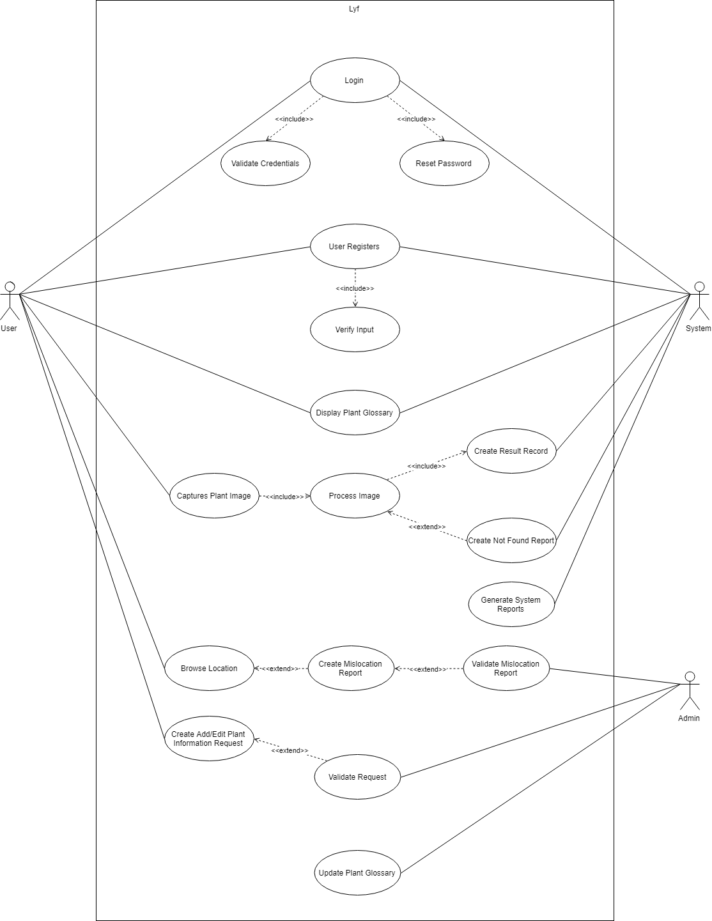

**4.2 Context Diagram**

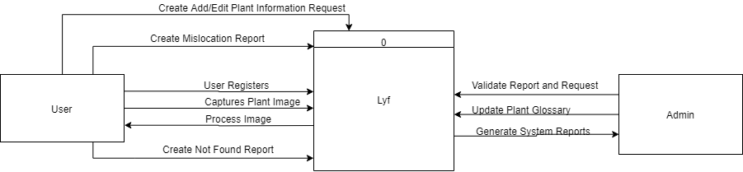

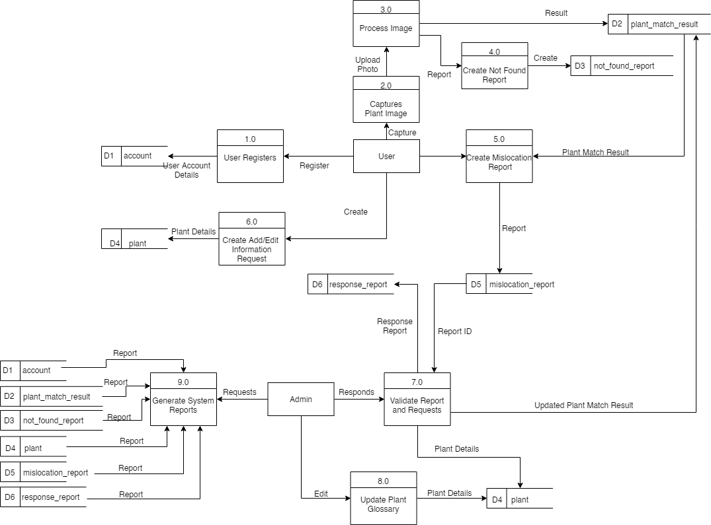**4.3 Data Flow Diagram Level 0**

**4.4 Entity Relationship Diagram**

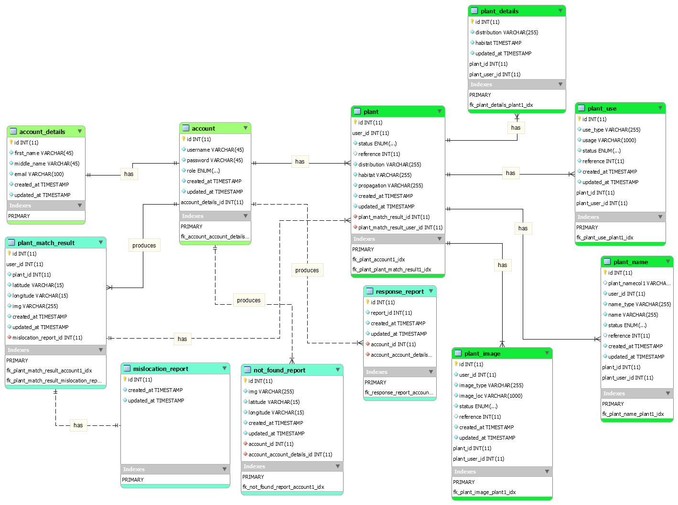

**4.5 Activity Diagram**

**4.5.1 Login/Register**

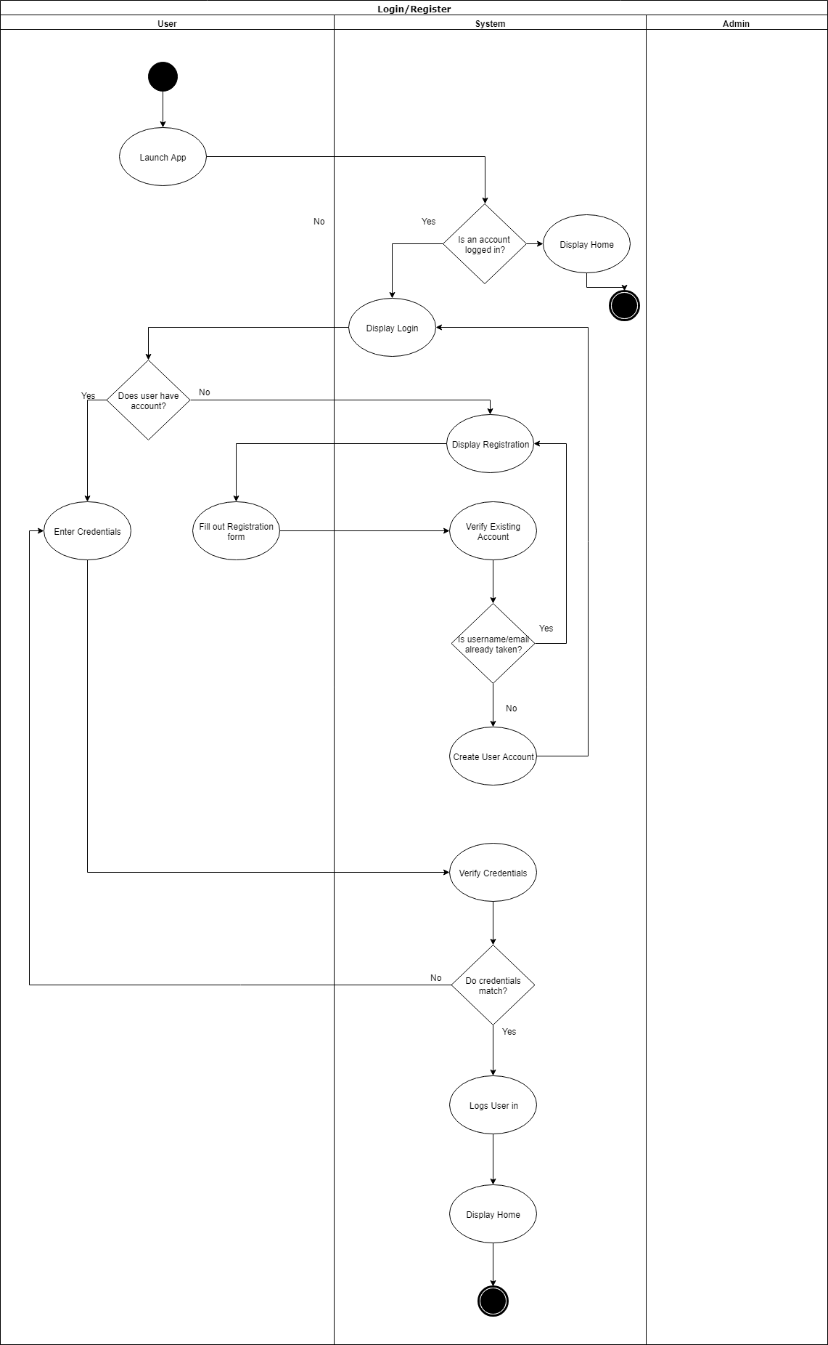

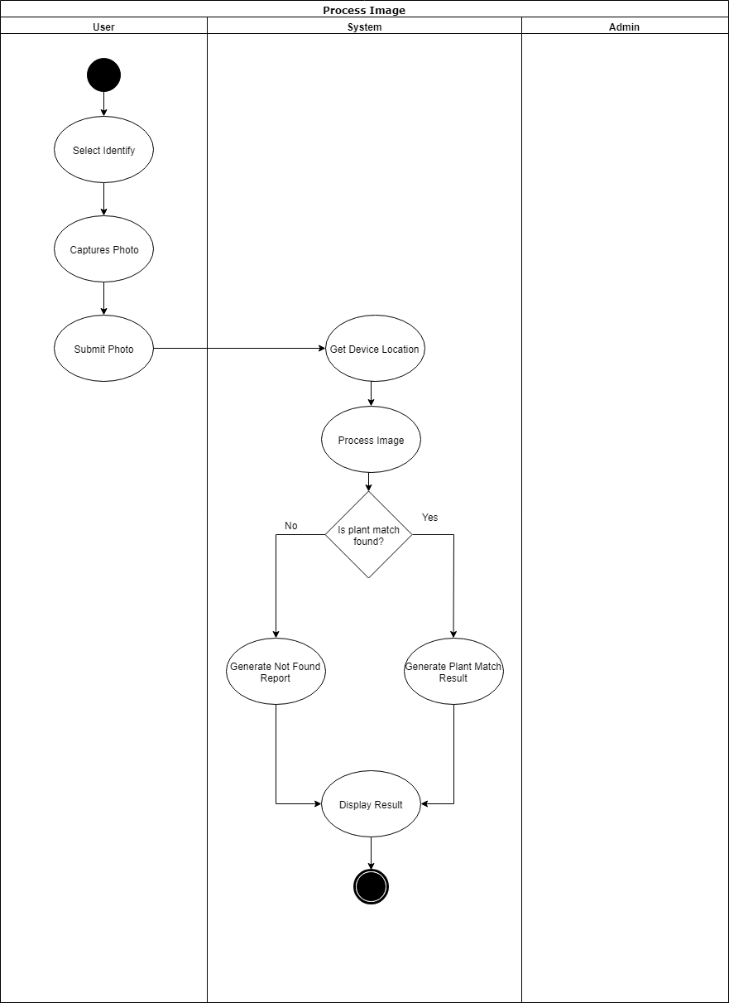**4.5.2 Process Image**

**4.5.3 Add Information**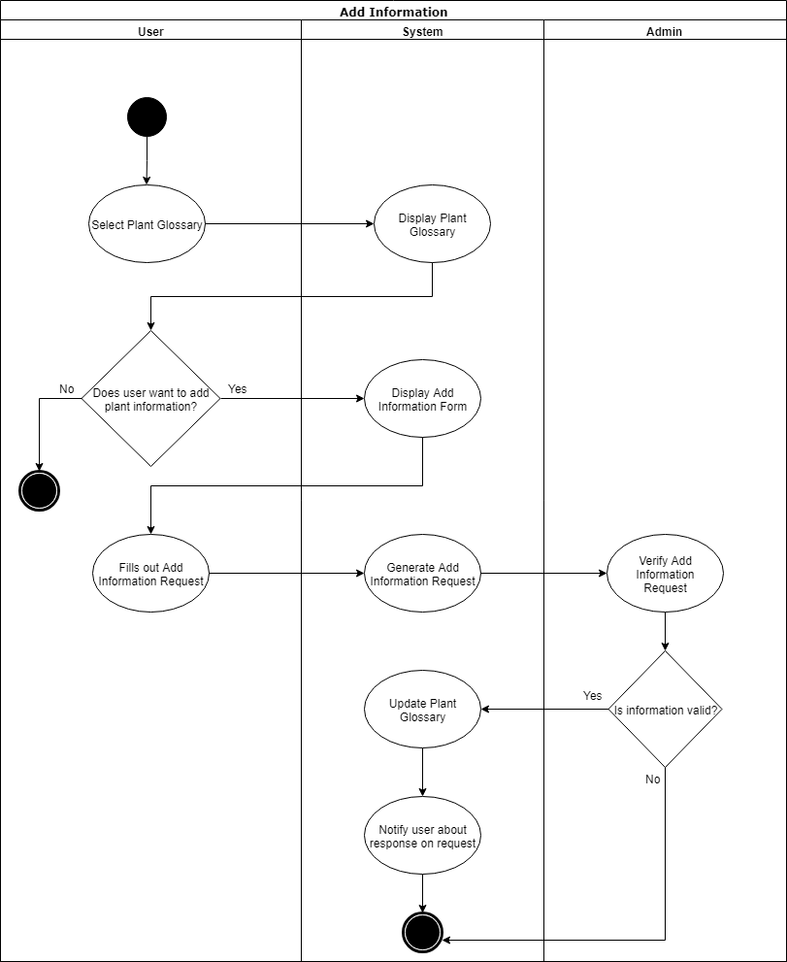

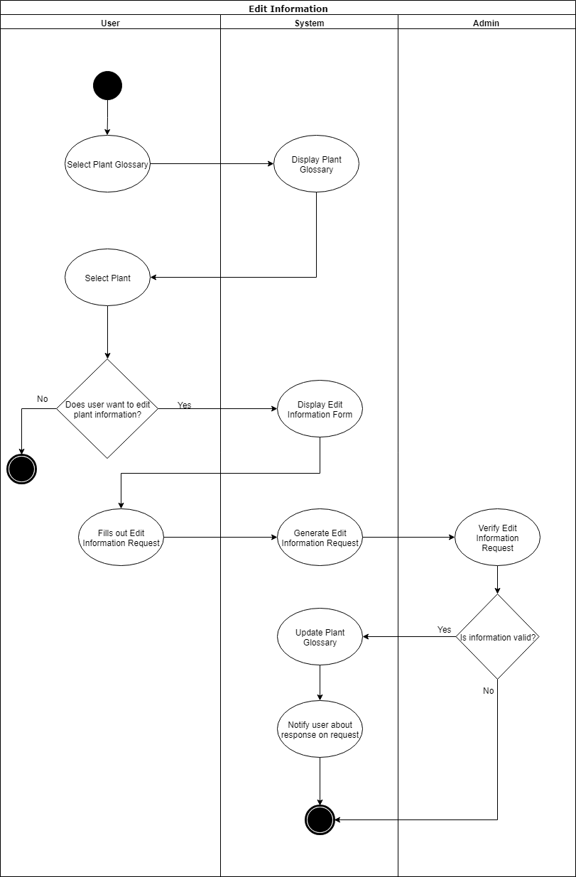**4.5.4 Edit Information**

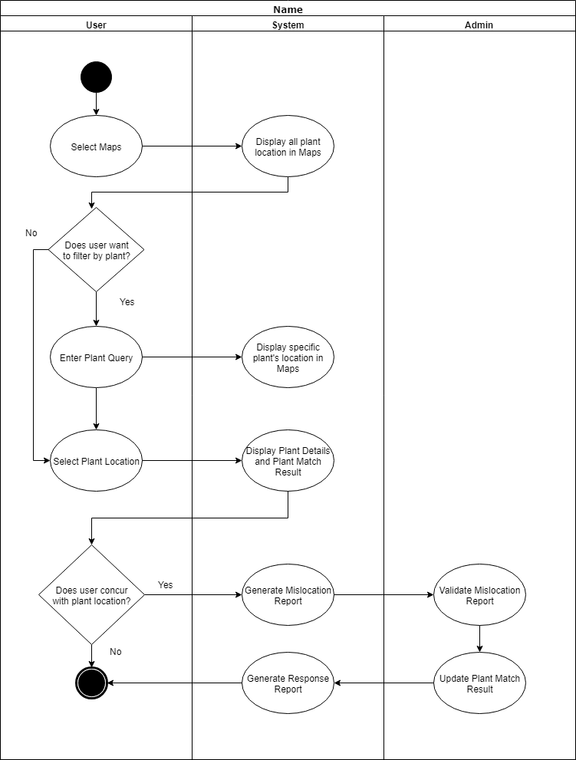**4.5.5 Browse Location**

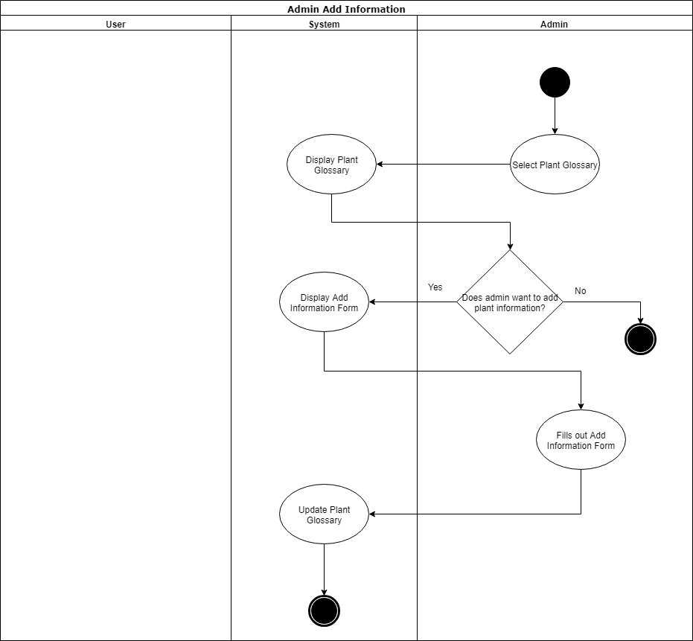**4.5.6 Admin Add Information**

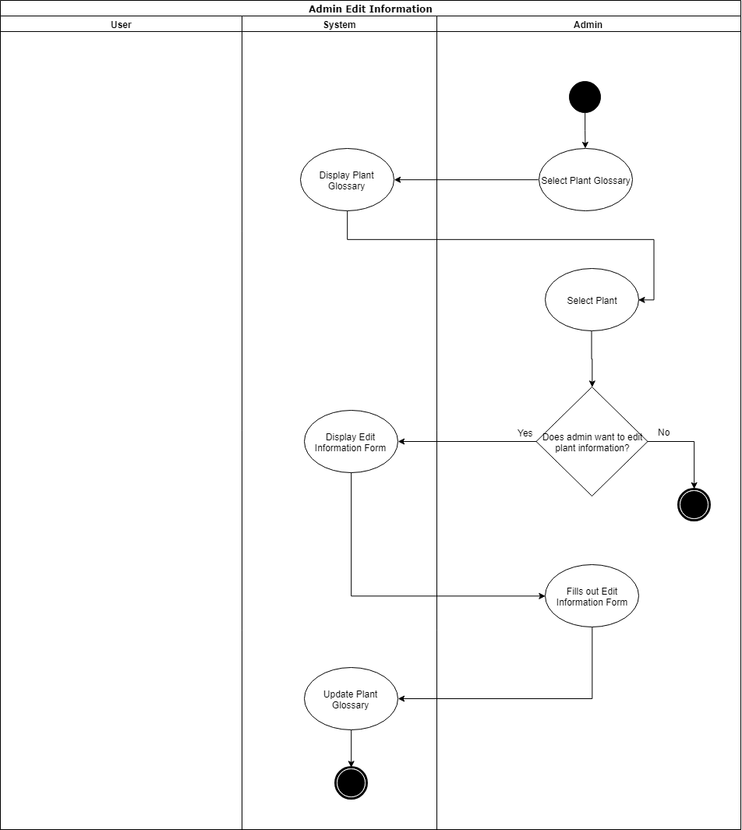**4.5.7 Admin Edit Information**

**4.6 System Sequence Diagram**

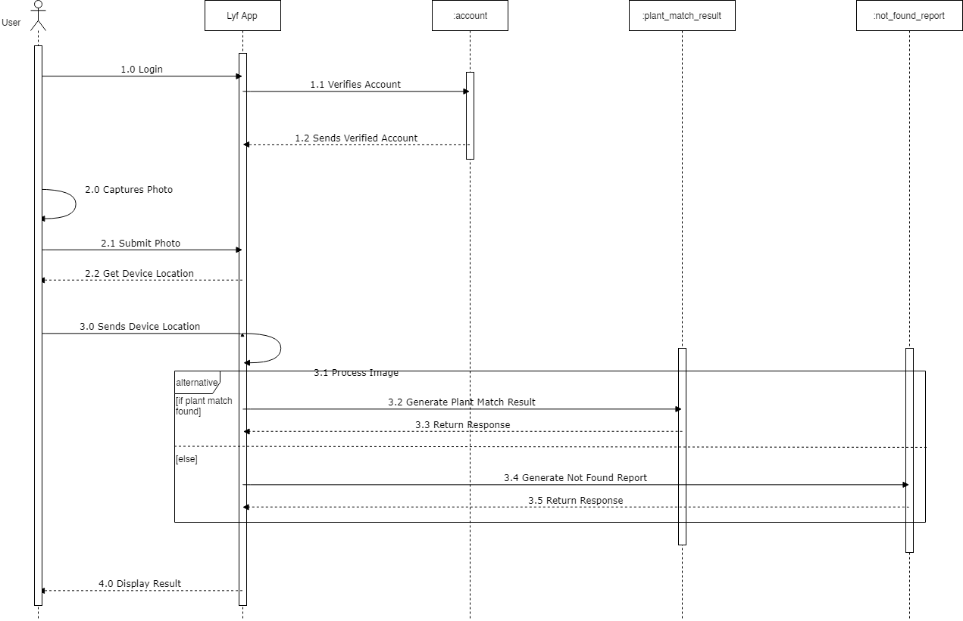**4.6.1 Process Image**

**4.6.2 User Add/Edit Information**

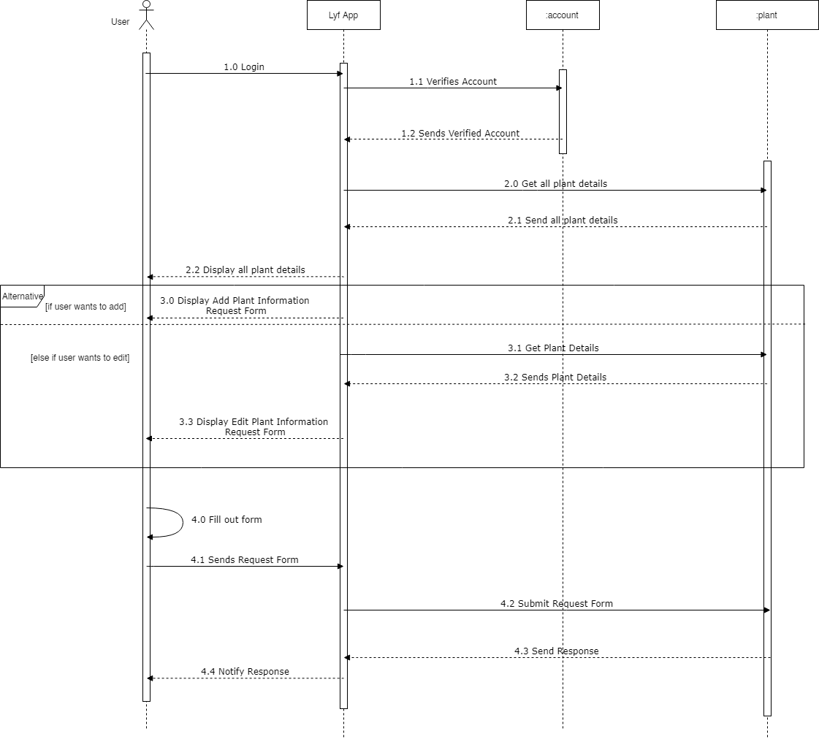

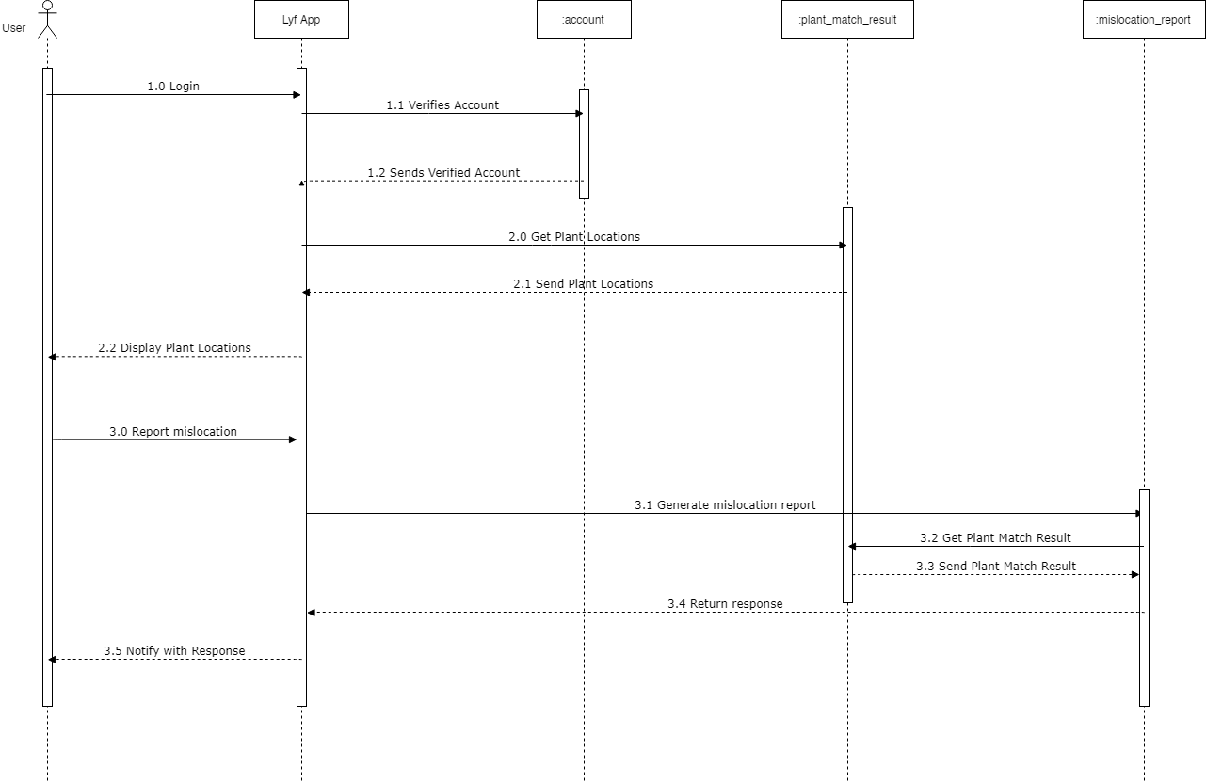**4.6.3 Report Mislocation**

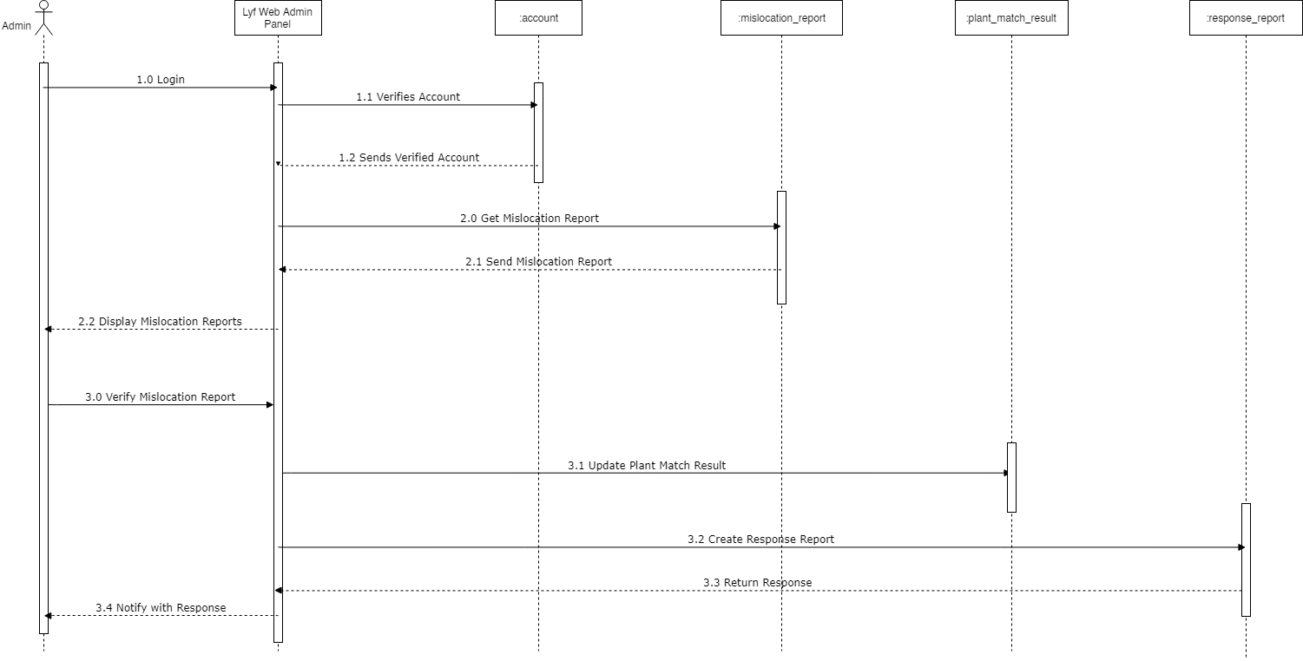**4.6.4 Verify Mislocation**

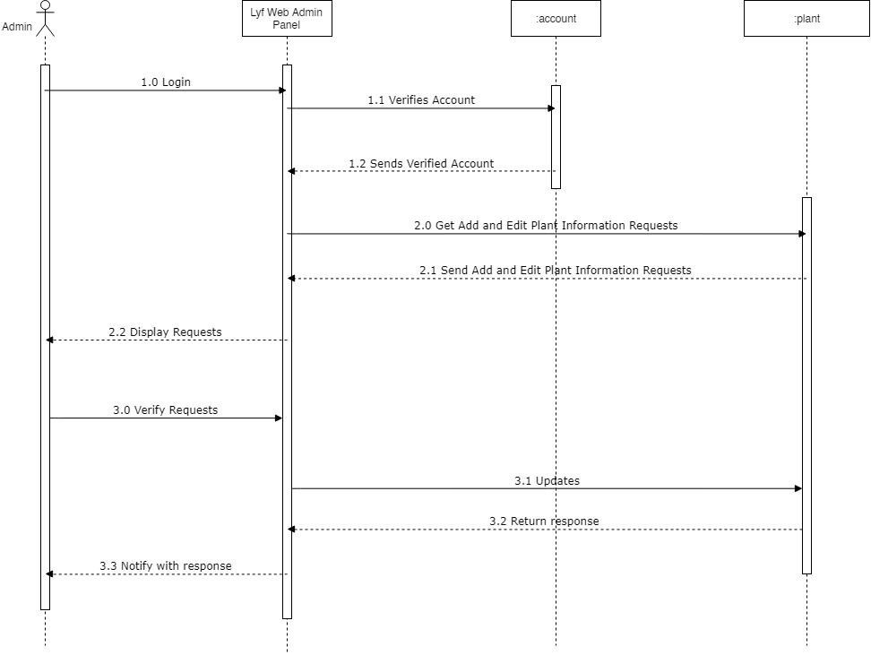**4.6.5 Admin Verify Requests**

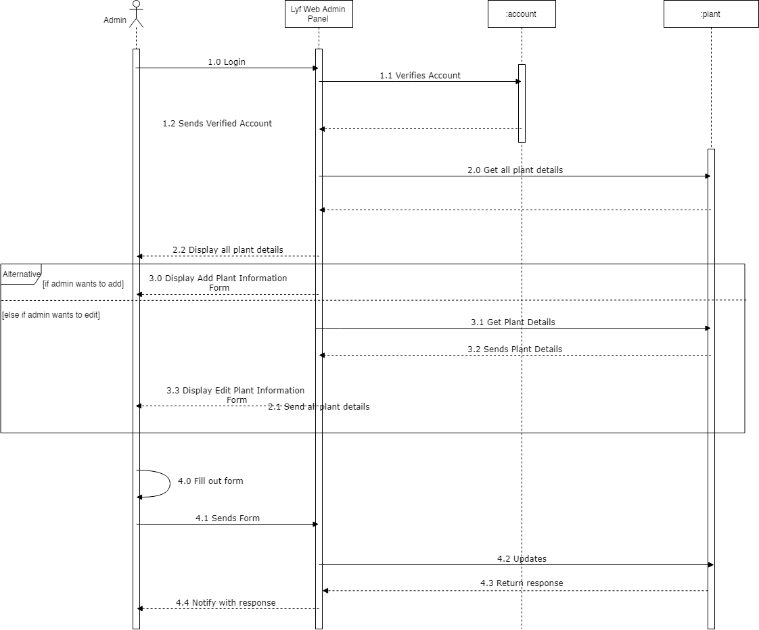**4.6.6 Admin Add/Edit Information**

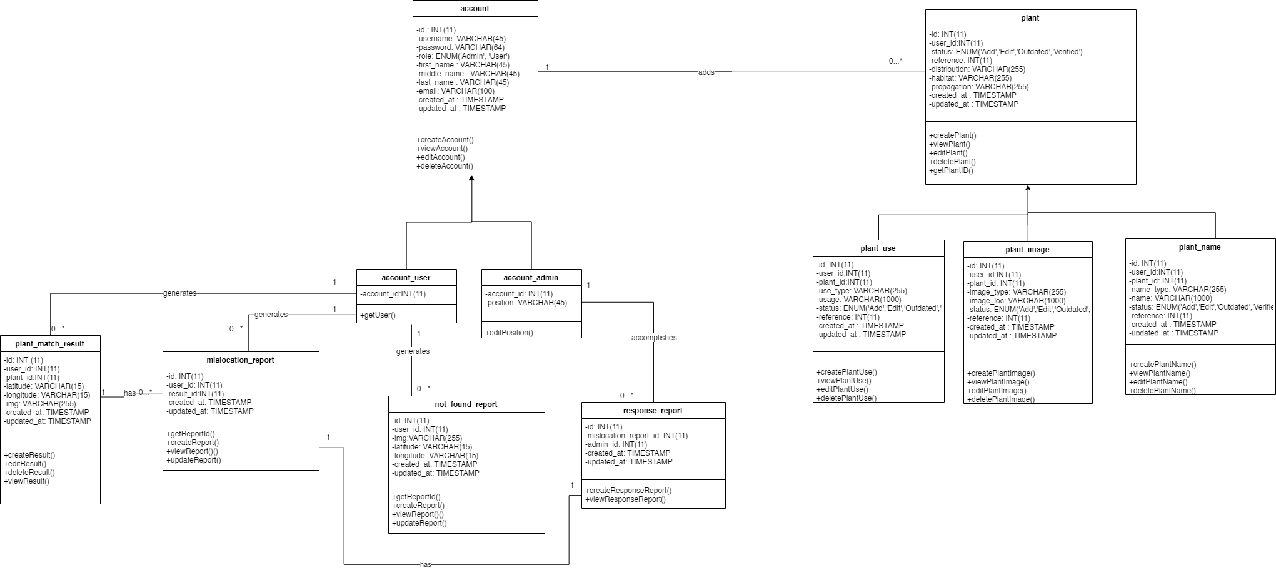**4.6 Class Diagram**

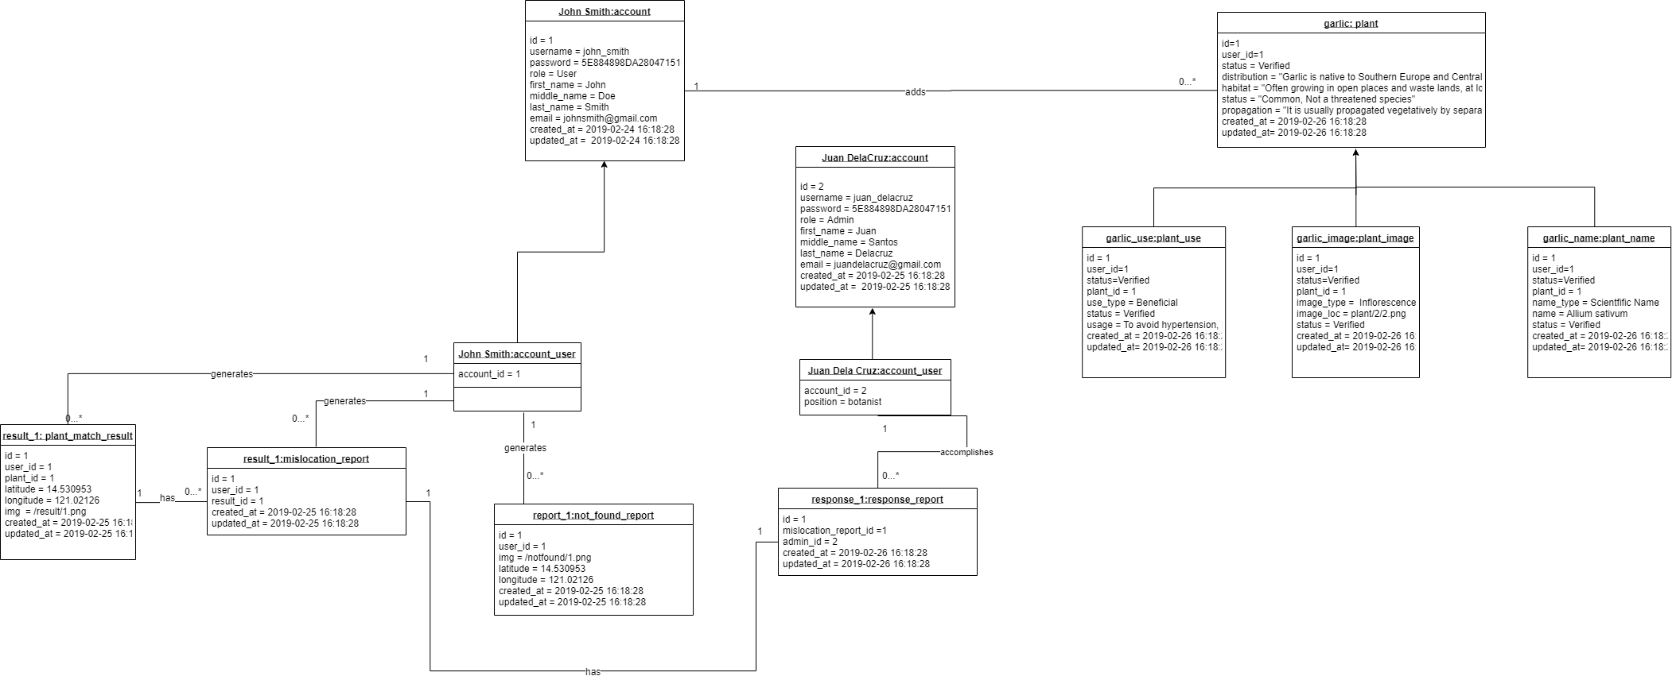**4.7 Object Diagram**

**4.8 State Diagram**

**4.8.1 Account Object**

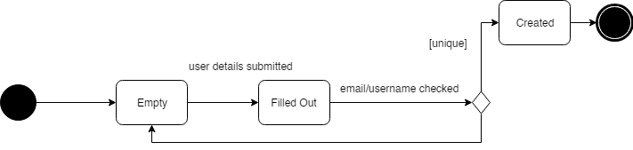

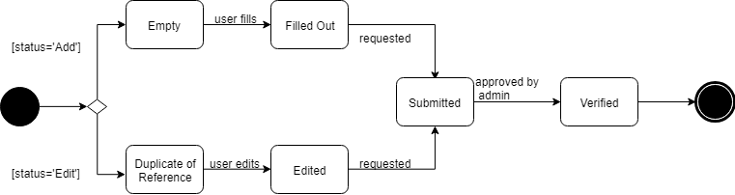**4.8.2 Plant Object**

**4.8.3 Plant Match Result Object**

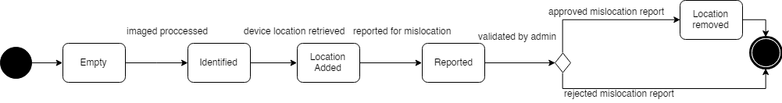

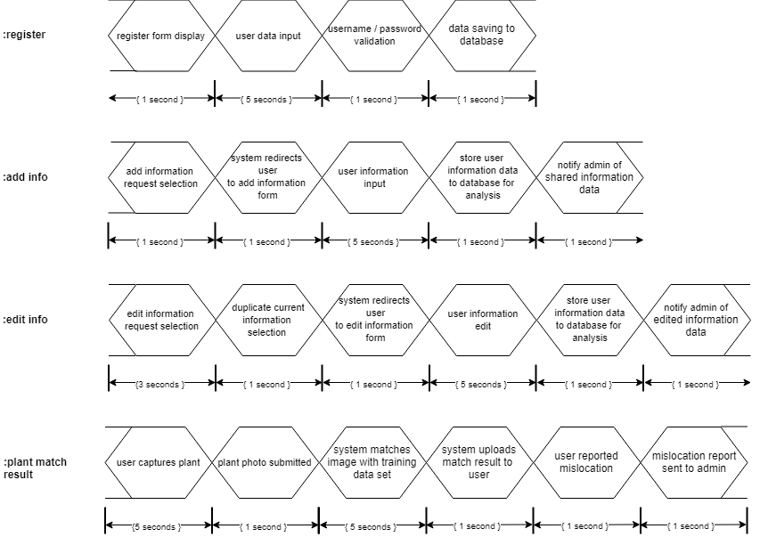**4.9 Timing Diagram**