**Title**

MantisHRM

**Team members: Professor:**

General, Jeri Luther Mr. Manuel Sebastian S. Sanchez

Alpapara, Johann Paul Romero **Project Adviser:**

Siccion, Justine Mark Mr. Jose Eugenio L. Quesada

1. **Introduction**

**Project Context**

MantisHRM is a Human Resource Information System, it focuses on improving the human resource management processes. Its purpose is to remove the Paper-based Leave Application and Tracking, help remove the Manual Employee Performance Evaluation, avoid the significant use of staff time, avoid the Duplication of Effort, and to remove the many instances of Human Error.

The main problem of this project is the need for an affordable, simple, systematic and flexible HR solution that would manage every aspect of its human resources. There is no system yet being used by the client of this project. Therefore, the developers will provide a complete and customizable HR Solution that enables the organization to perform all HR operations with ease.

**Purpose and Description**.

MANTIS Human Resource Information System (MantisHRM) will provide a complete and customizable HR Solution that enables the organization to perform all HR operations with ease. It is expected to have a web-based system that allows employees to update their information, apply for leave, track leave applications, view employee information and more.

A MANTIS Group member, Johann Alpapara, has a connection with the HR Department through his Mother who is working in the HR Department of the City Government of Paranaque prompting the group to take the HR Department of the City Government of Paranaque as a client. With a series of questions asked to the client, the group found out that there are time-consuming activities that are still being practiced by the HR Department that can be fixed by using a Human Resource Management System for the Department’s processes. The developers recommended to the client to develop an HRMS Solution for the use of the HR Department. Through this system, it aims to increase the efficiency of processing information by the HR Department and also aims to reduce the instances of human errors.

**Objectives**

**General Objectives**

* To remove the paper-based processing of information.
* To maximize the use of staff time and energy.
* To avoid the instances of human errors.

**Specific Objectives**

* To have faster processing of information.
* To provide the client with a human resource management system.
* To implement the system to the Human Resources Department.

**Scope and Limitations**

The MantisHRM only covers the processes that are highly needed by the Human Resources Management Department managing namely the Leave and Information of Employees for now but is planned to further add the other different modules to scale the application to a fully working Human Resource Management System. There are 2 modules that are covered by this project so far, namely, the Personnel Information Management Module, and Leave/Time off Management Module. Only the Management and Admins can fully access the system, employees can access the system but is limited to access to only a number of system functions.

1. **Review of Related Literature/Systems**

**OrangeHRM**

OrangeHRM is the world's most popular and used open source human resource management software. The open source OrangeHRM product suite includes an array of modules that provide personal information management (PIM), employee self-service (ESS), leave management, time and attendance tracking (PTO), performance evaluation and recruitment, all at no cost. Today OrangeHRM is being used by over a million users around the world, while larger multinationals have used the open source version and customized the system to meet their human resource management standards & requirements. (Retrieved on July 16, 2016 from <https://www.orangehrm.com/OrangeHRM_AboutUs>)

Orange HRM is a resource management tool for any SMB or enterprise looking for a cost-effective tool to manage a large number of human resources tasks in a Web-based, user-friendly tool. And with the ability to purchase support, add-ons, customizations, and even hosted services, OrangeHRM should appeal to any size business. OrangeHRM solves the often daunting task of managing all aspects of employees/staff and does so without the usual steep learning curve associated with many HRM tools. OrangeHRM is quickly becoming the de facto standard for open source human resource management tools. No matter the size of your business, your human resources department could easily benefit from an OrangeHRM installation. (Retrieved on July 16, 2016, from<http://www.techrepublic.com/blog/product-spotlight/review-orangehrm-human-resource-management-tool/>)

**Sentrifugo**  
 Sentrifugo is an intuitive and easy to use Open Source Human Resource Management Software supported by Sapplica Info Technologies. Designed for flexibility, Sentrifugo is for organizations of different sizes to manage their employee statistics and dynamic data efficiently and effectively. Sentrifugo ideally provides employee self-service, absence management, resource requisition, reports and analytics and other Human resource management tools which can be customized to reflect the unique work flow and processes of an organization. Thus, increasing efficiency of the organization and subsequently integrating and aligning the efforts of HR with the rest of the organization. Sentrifugo is licensed under the terms of GNU General Public License version 3. (Retrieved on July 16, 2016 from <https://sourceforge.net/p/sentrifugo/wiki/Home/>)

Sentrifugo allows the administrator to configure the settings that reflect unique workflow to establish and maintain consistency throughout the application. The employee and site configurations contain all the features that are essential for effective human resource management. Site Preferences, on the other hand, handles the default date-time, currency and password formats for the organization. However, only the privileged users of the application can configure the features at any point of time, to meet the current and future needs of the organization. (Retrieved on July 16, 2016 from <https://sourceforge.net/p/sentrifugo/wiki/Home/>)

**WaypointHR**

WaypointHR provides a flexible Human Resource Information System (HRIS) developed by HR-Fundamentals ltd, primarily for UK, European and US employers. WaypointHR streamlines the process of storing essential personnel records such as employee contact details, job description and salary in an easy and efficient way. WaypointHR is available in two versions the free one and On-Demand. For the free version employee data of the organization is stored in the in-house servers. In case of WaypointHR On-Demand system employee data in stored in their secure data center on the WaypointHR servers. In both versions WaypointHR retain full employee history, and allow the user to create employee records and company reports. WaypointHR features a web based interface. It requires no special or technical skills to use the system. WaypointHR is an open source which would benefit from fast growing community of users, software developers and business professionals. With efforts from all these corners for WaypointHR will surely thrive as a freely available software platform that end users can adopt and rely on. (Retrieved on July 16, 2016 from <http://tech.gaeatimes.com/index.php/archive/waypointhr-overview/>)

**IceHRM**   
 IceHrm is a Human resource management system for small and medium sized organizations. It covers all the basic HRM needs of a company such as leave management, time management and handling employee information. IceHrm is a Human resource management system for small and medium sized organizations. It has a rich UI built with PHP and Java Script. The system is implemented with a modular architecture which makes it extendable and can be customized easily. (Retrieved on July 16, 2016 from <http://blog.icehrm.com/docs/home/#what-is-icehrm> and <http://www.slideshare.net/thilinah1/ice-hrm-administrator-manual>)

1. **Technical Background**

MantisHRM is based on the Open-Source Web Application called OrangeHRM. The system is built on top of symfony. Symfony Framework is the leading PHP framework to create websites and web applications. To connect to data, Apache Web Server and XAMPP Control Panel was used. All the data gathered are stored in a database powered by MySQL.

**IV. Methodology, Results, and Discussion**

**V. Conclusions and Recommendations**

**VI. Appendices**

**6.3 Sample input/output/Reports**

**Use Case Diagram**

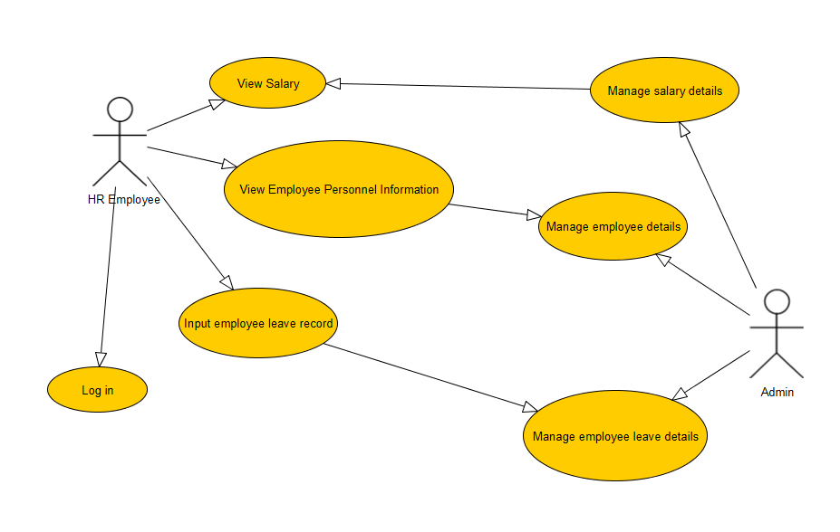

**Event Table**

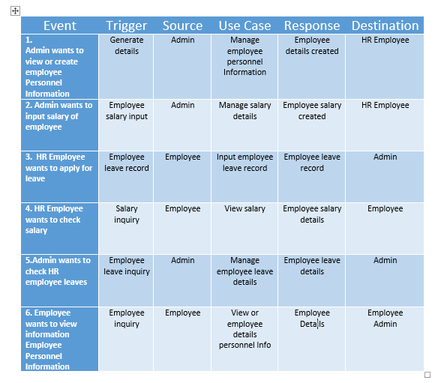

**Use Case Full Description**

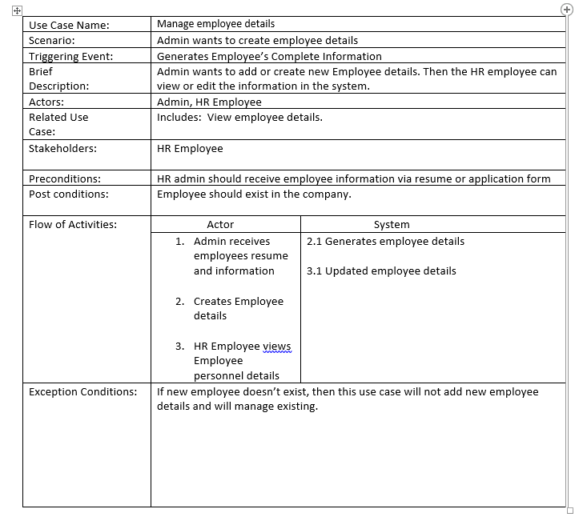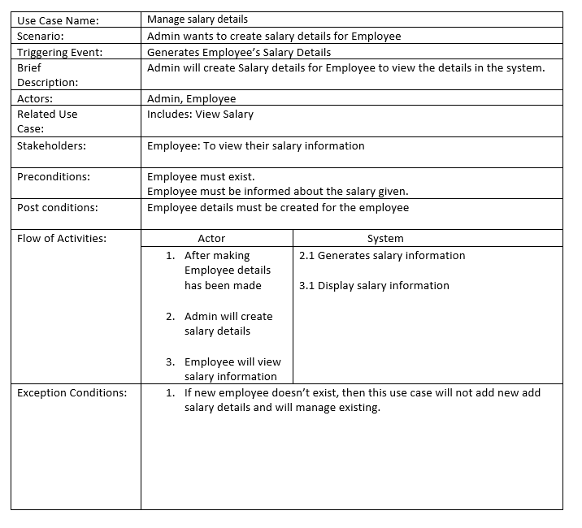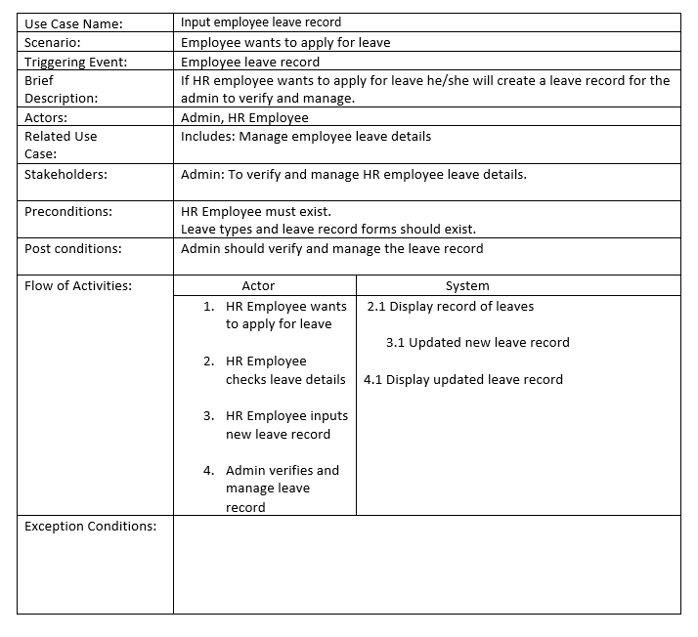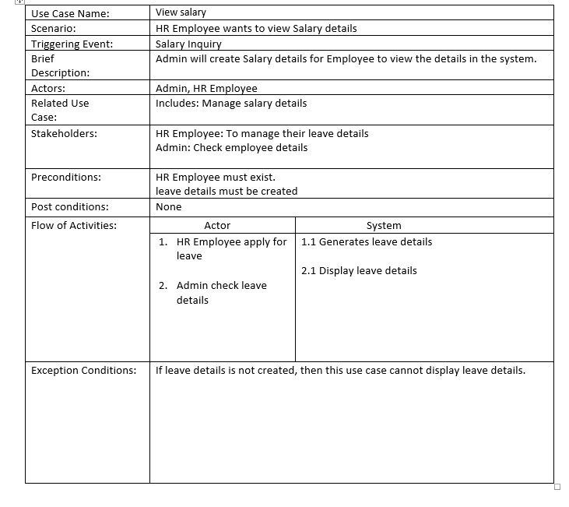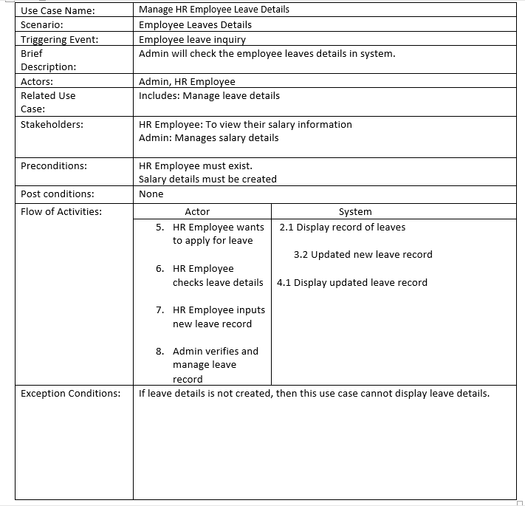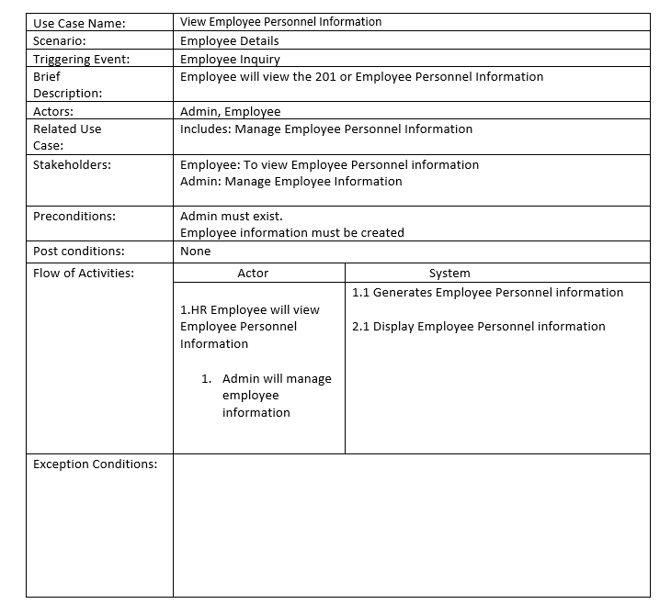

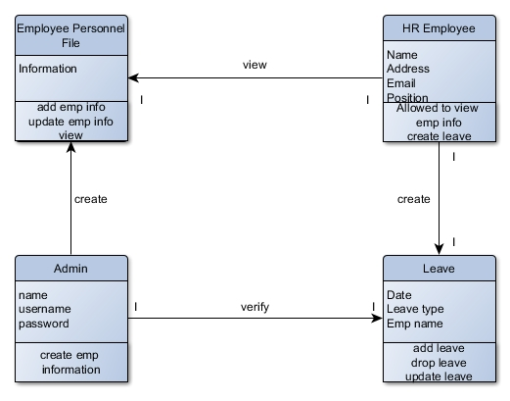**Class Diagram**

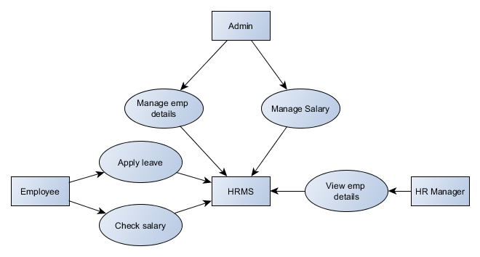**Context Diagram**

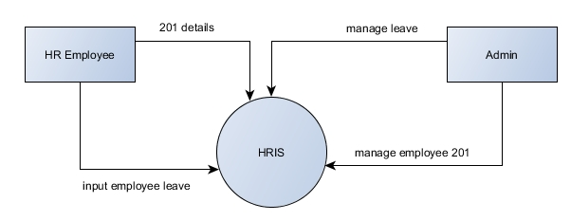**DFD LVL 0**

**ENTITY RELATIONSHIP DIAGRAM**

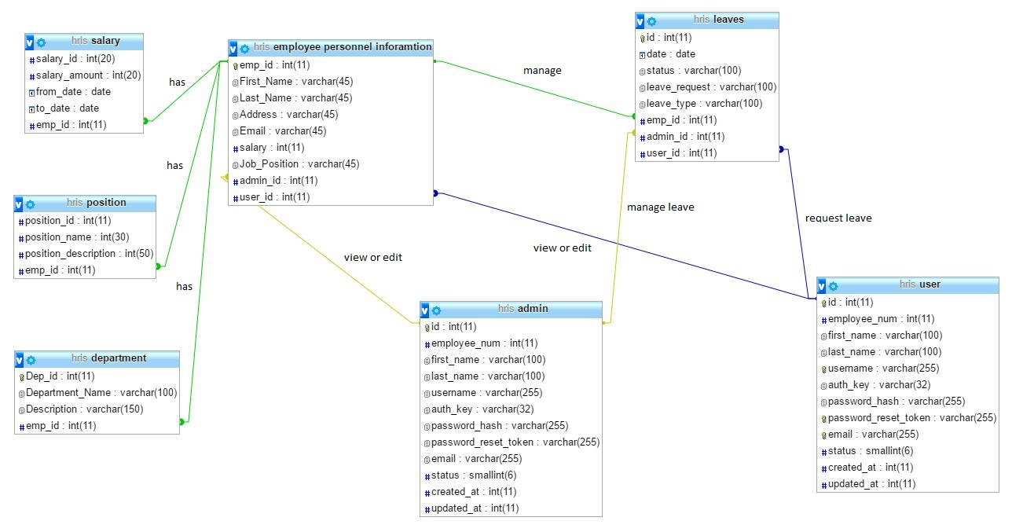

**Composite Structure Diagram**

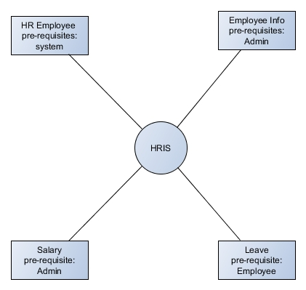

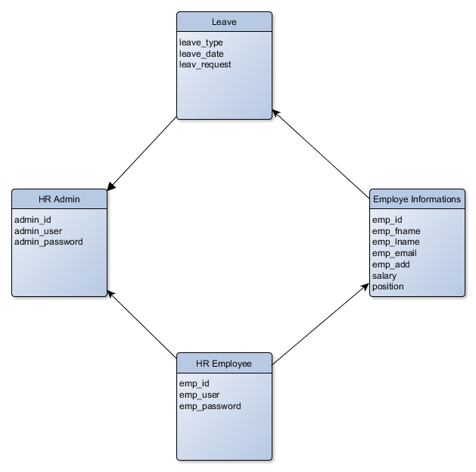**Object Diagram**

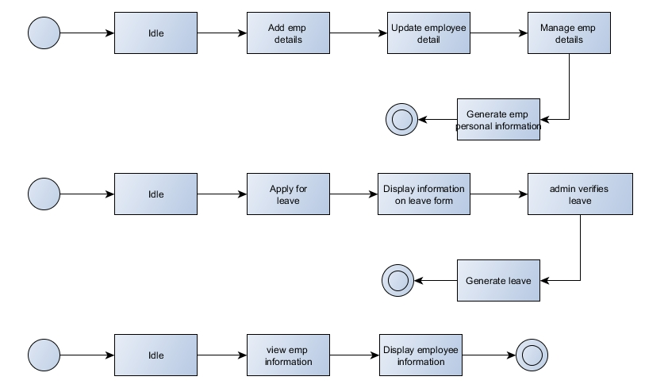**State Diagram**

**Sequence Diagram**

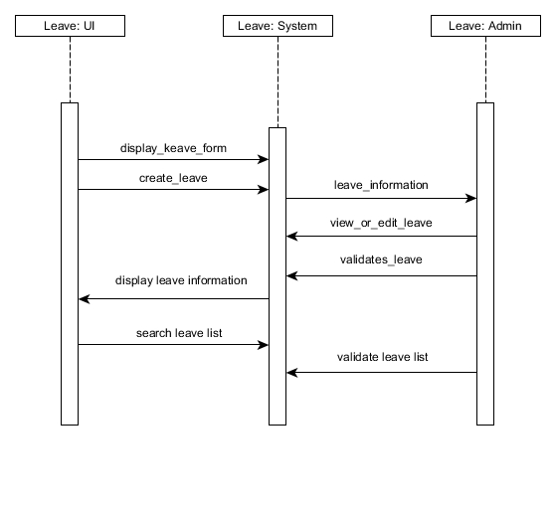

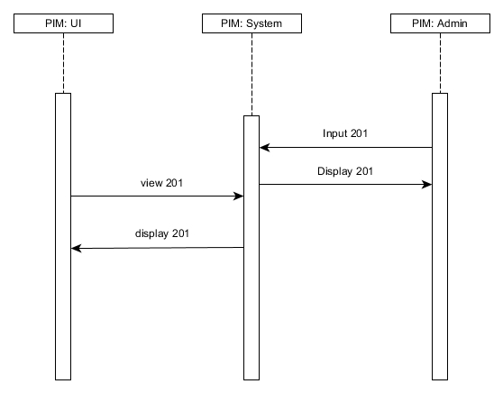

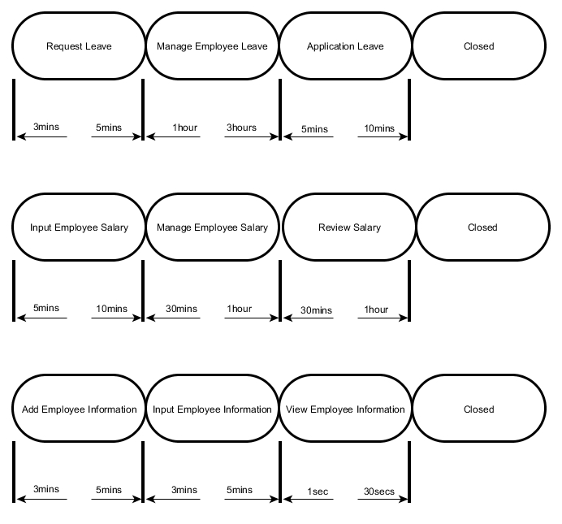**Timing Diagram**

**Activity Diagram**

**Activity Diagram**

