Application & Servlet Containers
A brief introduction to the basic components and concepts behind application containers, why we use containers, and some specifics around the architecture of JBoss EAP, Red Hat’s flagship middleware product.

What is an Application Container?
An application server or container, is a software framework that provides both facilities to create web applications and a server environment to run them.
Typically Application Server Frameworks contain a comprehensive service layer model. An application server acts as a set of components accessible to the software developer through an API defined by the platform itself. For web applications, these components are usually performed in the same running environment as its web server(s). Traditionally, the main job of an application server is to support the construction of dynamic pages to build interactive web applications. However, many application servers target much more than just web page generation: they implement services like clustering, failover, and load-balancing.
In the case of Java application servers, the server behaves like an extended virtual machine for running applications, transparently handling connections to the database on one side, and often connections to the web client on the other. Application servers can help speed up development time and streamline the process by which developers build their applications. They do this by providing a lot of the boilerplate implementation code and abstracting away much of the tedious coding that would be required for a developer to manually implement much of the same functionality from scratch.
Other common features provided by your application server include security features like encryption, exception handling, consolidated logging, and messaging.
Commonly Used Implementations: WebLogic Application Server by Oracle, WebSphere Application Server from IBM and the open source JBoss Enterprise Application Platform (JBoss EAP) by Red Hat.

What is a Servlet Container?
A Servlet container is the component of a web server that interacts with Java servlets. All modern Java based application containers will contain some kind of internal servlet container. JBoss uses Apache Tomcat as it’s servlet container. A servlet container is responsible for managing the lifecycle of servlets, mapping a URL to a particular servlet and ensuring that the URL requester has the correct access rights.
A web container handles client requests for servlets, JavaServer Pages (JSP) files, Java and other types of files that include server-side code. The web container creates servlet instances, loads and unloads servlets, creates and manages request and response objects, and performs other servlet management tasks.
A web container implements the web component contract of the Java EE architecture, specifying a runtime environment for web components that includes security, concurrency, lifecycle management, transaction, deployment, and other services.
Commonly Used Implementations: Tomcat by Apache, Jetty by Eclipse

Web Server and Application Server Interaction ¹
When dealing with web-based requests, before tunneling through to our application server, a client (think a person using a web browser) will always hit a web server first. An application server does not replace the need for a web server, but most modern application servers come with a web server packaged with them (JBoss actually uses Tomcat as both its web server and Servlet container). Despite the application server evolving far beyond a traditional web server, the web server remains a foundational part of the application server architecture.
Web servers are great at doing one thing: serving up files. A web server takes requests from clients, maps that request to a file on the file system, and then sends that file back to the client.
When a client (think a person using a browser) wants an HTML file, a web server can efficiently and reliably find that file and send it back to them. If they request an image, a web server can serve it up to them as well. Say your web server is hosting a zip file or pdf they’d like to download the web server will make that happen.
Unfortunately, web servers lack the ability to execute logic, or make decisions. A web server can serve up static files until the cows come home, but ask a web server to add ‘one plus one’ and you’ll be waiting there for a very, very long time.
If our applications use any images, HTML, .pdf or .zip files, we like to keep all of those static files on the web server. If we need some logic or dynamic content in our applications, we will delegate to our Servlets, JSPs, EJBs and JavaBeans that are running on our application server.

From Web Server to Application Server
When a client makes a request for a JSP or a Servlet, the request initially goes to the web server. The web server reads some configuration files the application server provides, and realizes that the request that came in should be sent to the application server for processing.
The configuration file will typically provide the IP address/port combination of listening application servers. This means the server is ready and waiting for clients to make requests and respond to them. Different ports are used to facilitate various types of communication, but typically HTTP servers listen on ports 80 or 8080 and use port 443 for secure, encrypted HTTPS connection. The web server, using the http protocol, then sends the request to the Application server JVM.
The JVM listening on the appropriate port represents our application server, and the port the JVM listens on can be configured through that JVM’s web container or more specifically in the standalone.xml file in your JBoss configuration.
The web server handles the incoming request, and matches that request to the application server set up to handle the given Servlet or JSP.

Inside the Web Container
Once a dynamic page is requested by a user, the request gets sent from the client (web browser), to the web server, and the web server passes the request to the application server, who in turn invokes and threads the appropriate Servlet. If the Servlet hasn’t been called before, the JVM loads the Servlet and then generates a thread to handle the request.
Servlets are shy little creatures. They sit on the hard drive just minding their own business, and don’t bother anyone until they've been invoked. However, feed a few drinks to those Servlets – get them loaded – and they remain in memory until the party ends, which happens when someone pulls the plug on the application server.

What does our Servlet do?
When programming Servlets, a developer is only limited by their creativity, and more likely, their Java programming skills.
Typically, a Servlet implements some control logic. For example, a Servlet might figure out what a user typed into some text fields in a web-based form. It might then take that information and save it to a database.
Servlets are very commonly used as controllers in a Model View Controller pattern. In essence they usually provide the basic logic needed to facilitate user interaction on a webpage, and then delegate down more complicated tasks to other EJBs. While Servlets can interact directly with a database, they’re not really supposed to. Instead, Servlets are supposed to delegate to a JavaBean or an EJB to do such things. As with any programming using an application server is no different, and a nice separation of concerns is very helpful in developing and maintaining application code.
¹ This section’s content was borrowed from here and modified to fit better within the context of this packet

Advantages of Applications Servers

Data and code integrity
By centralizing business logic on an individual server or on a small number of server machines, updates and upgrades to the application for all users can be guaranteed. There is no risk of old versions of the application accessing or manipulating data in an older, incompatible manner.

Centralized configuration
Changes to the application configuration, such as a move of database server, or system settings, can take place centrally. This also helps alleviate issues related to sharing application code across multiple environments with different hostnames, database servers, database accounts, etc. By maintaining all the environment specific values inside your server configuration instead of your source code, you can easily move the same code through multiple target environments.

Security
A central point through which service-providers can manage access to data and portions of the application itself counts as a security benefit, delegating responsibility for authentication away from the potentially insecure client layer without exposing the database layer.

Performance
By limiting the network traffic to performance-tier traffic the client–server model improves the performance of large applications in heavy usage environments.

Total cost of ownership (TCO)
In combination, the benefits above may result in cost savings to an organization developing enterprise applications. In practice, however, the technical challenges of writing software that conforms to that paradigm, combined with the need for software distribution to distribute client code, somewhat negate these benefits

Transaction Support
A transaction represents a unit of activity in which many updates to resources (on the same or distributed data sources) can be made atomic (as an indivisible unit of work). End-users can benefit from a system-wide standard behaviour, from reduced time to develop, and from reduced costs. As the server does a lot of the tedious code-generation, developers can focus on business logic.

Lab: Installing JBoss EAP 6.4 using the installer and deploying some quickstarts

Prerequisites:
- Java 7 or above installed
- Access to RedHat customer portal

Steps
(bolded steps are steps that require a change from the default settings)
- Download the JBoss EAP 6.4 installer from RedHat Customer portal here
- Double click on the file to run the installer jar
- You should see a language selection, choose your language and hit next
- Accept the terms and conditions and hit Next
- Choose where you would like to install the server and hit Next
- Leave the defaults for which packs to install and hit Next
- Create an admin user and be sure to note the username and password somewhere so you can remember them. Also be sure to follow the password policy. Once complete hit Next
- Select ‘Yes’ on the quickstart screen to install the quick starts we will use these later in the lab, you can leave the default installation path for these and hit Next
- For the maven settings, you can leave the defaults and hit Next
- For the socket bindings you can leave the defaults and hit Next. This controls which ports the server will listen on by default the web port is 8080 and the management port is 9990
- For server launch choose Standalone mode and check the ‘Launch browser after server start up’ option.
- For the logging options select ‘Yes’ to configure the logging, and leave both at INFO level
- For ‘Configure runtime environment’ you can leave it at ‘Perform default configuration’ and press Next
- Review your choices and if all appears right, hit Next
- Once the install finishes, hit next once more, JBoss will now proceed with finalizing the server configuration and start itself up. You should see a new browser window or tab appear with the management console. It will prompt you to log in, enter the username and password you chose during the installation and you should see something like: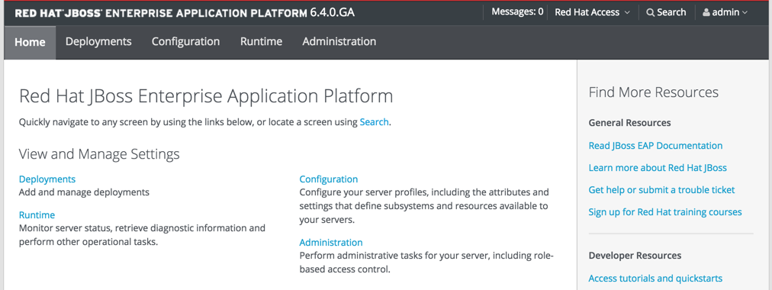
Congratulations you have now successfully installed EAP 6.4 on your local machine. Next, let’s deploy one of the quick starts to our server.

Lab: Hello World Quickstart
- Open a terminal and navigate to the directory you installed EAP into (I will refer to this as $EAP_HOME).
- cd into $EAP_HOME/jboss-eap-6.4.0.GA-quickstarts/helloworld
- Run a mvn clean install jboss-as:deploy to deploy the quickstart to your local EAP server.
  - In case you aren’t familiar with maven, this command will actually deploy any quickstart you see in the $EAP_HOME/jboss-eap-6.4.0.GA-quickstarts directory. You just need to navigate to the directory the quickstart is located in, and run the exact same command. You may want to check the README.md files to see if there is any set up required to deploy the particular quick start you are interested in.
- Navigate to http://localhost:8080/jboss-helloworld and you should see your hello world application.
- Feel free to import this and all the other quickstarts into your DEV studio and view the source code.

More Related Links
JBoss EAP / Wildfly Overview (video)
Slightly Dated Introduction to Application Servers
Difference between JSF and JSP
Middleware - Wikipedia
JBoss EAP Documentation
Java EE 6 Spec

Discussion questions you should be able to answer now:
- Why do we use application containers? What features do they provide for us that allow developers to focus on writing the business logic for their applications?
- What is a servlet, and how does it function to serve web pages to clients?
- Why aren’t all web pages static? What is an example of a scenario where a dynamically constructed page would be necessary in a web application?
- What are some advantages of running your code in an application container? How can these features speed up development time and improve application quality?

