Lab 8: Steganographic Analysis

- Course: FSCT 8561 – Security Applications
- Instructor: Dr. Maryam R. Aliabadi
- Lab Duration: 3 Hours

Overview
In this lab, you simulate an Insider Threat scenario. You are a security analyst tasked with exfiltrating footprinting data covertly. You must hide IP addresses and port scan results inside images (corporate logos or profile pictures) while ensuring minimal visual change and understanding the data capacity limitations of the images.

Learning Objectives
- Understand the binary structure of image pixels
- Use Pillow and Stepic to hide/extract data
- Analyze differences between original and stego images
- Evaluate LSB capacity and limitations

Required Reading & Tutorials
- Mastering Python for Networking and Security – Chapter 14 o https://learning.oreilly.com/library/view/mastering-python-for/9781839217166/
o Source code on: https://github.com/PacktPublishing/Mastering-Python-forNetworking-and-Security-Second-Edition
- Pillow (Python Imaging Library) Tutorial: https://pillow.readthedocs.io/en/stable/
- Stepic Python Module: https://pypi.org/project/stepic/

Environment Setup
- Install required libraries: pip install pillow stepic
- Download the lab assets
  - company_logo.png
  - profile.png
  - python.png
  - python_secrets.png

Part A – Manual LSB Manipulation

Task: Hide 'TARGET:192.168.1.50' inside company_logo.png using manual LSB manipulation.
Steps:
- Run and analyze different functions of the provided code (steganography_LSB.py):
  - set_LSB
  - get_LSB
  - hide_message
  - extract_message
- Manipulate the steganography_LSB.py file to hide 'TARGET:192.168.1.50' inside company_logo.png using manual LSB manipulation 1. Open company_logo.png and convert to RGBA mode.
  - Use getdata() to access pixel array.
  - Use the provided set_LSB() function to hide the string "TARGET:192.168.1.50" in the first 10 pixels.
  - Save the modified image as company_logo_stego.png.
  - Save the file as IP_IN_LSB.py.
  - Run the file.
Output:
- Python script implementing manual LSB hiding (IP_IN_LSB.py)
- Resulting stego image
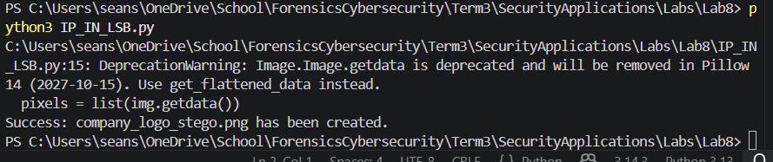

Part B – Stepic
Task: Hide port scan data [80, 443, 3478, 5060] inside profile.png using Stepic.
Exfiltrate port scan results inside a profile picture using Stepic. You have performed a port scan on a conferencing tool (Zoom/Teams local instances). You need to hide the port list [80, 443, 3478, 5060] inside profile.png.
Steps:
- Create exfiltrate.py:
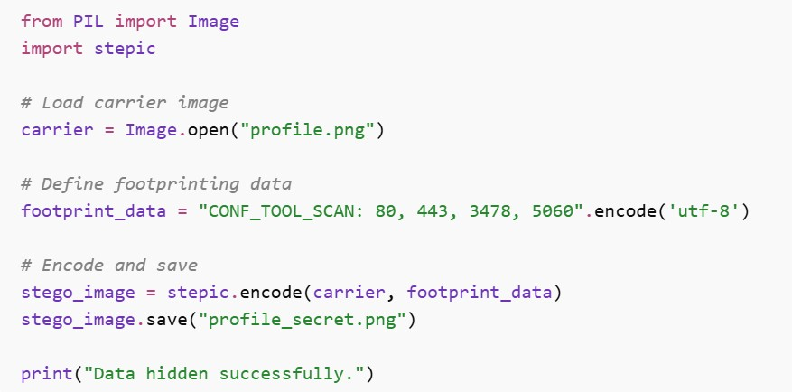
- Run the script to generate profile_secret.png.
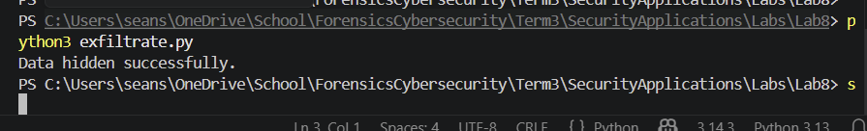

Part C – Verification & Analysis
Extraction: Write a corresponding decode script to recover the hidden port list (decode.py).
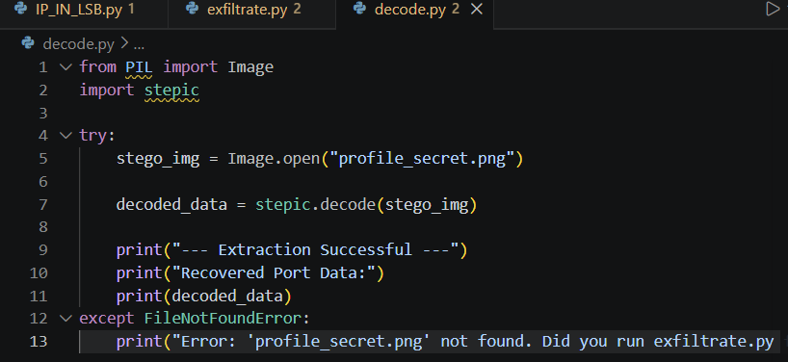
Visual Check: Open profile.png and profile_secret.png in a high-resolution viewer. Can you spot the difference? I don’t see any differences.
File Size Check: Compare the file sizes (bytes). Does hiding data in the LSB significantly change the file size? There is a difference (photo below)
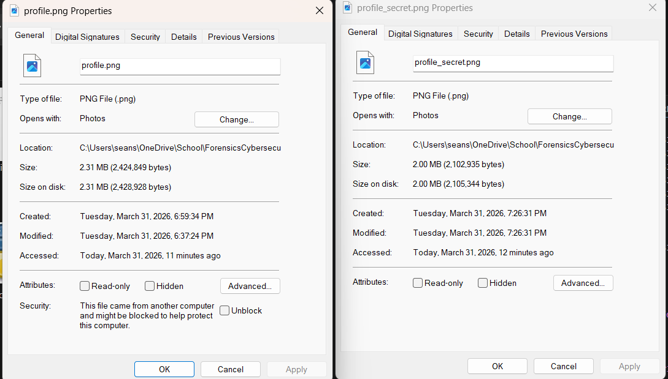

Deliverables
- Stego images:
  - profile_secret.png o company_logo_stego.png
- Python scripts:
  - LSB manual hide (IP_IN_LSB.py) o Stepic decode (decode.py)
BOTH OF THESE ARE ON THE GITHUB (all files in lab 8 folder): https://github.com/seansampson31-glitch/FSCTSecurityApplications.git

- Short Analysis (PDF):
  - Screenshots of running scripts (these are above)
Maximum number of bits for a 100x100 image using LSB = 10,000
4 channels with one bit for hiding so 40,000 bits.
o Why PNG is better for steganography than JPEG (lossless vs lossy) Because lossless is better than lossy as the lossy JPEG would try to save space by removing/destroying the hidden data.
- Filename format: Lab8-FirstName-LastName-StudentNumber.pdf

Grading Rubric (Total: 100 points)
Component | Full Credit | Partial Credit | Minimal/No  Credit | Points
Manual LSB Script | Correctly hides message in first 10 pixels | Minor LSB errors or partial encoding | Missing or incorrect | 25
Stepic Script | Correctly hides and extracts port scan data | Partial success or minor issues | Missing or incorrect | 25
Verification & Analysis | Visual and file size checks complete | Partial analysis | Missing | 25
Lab Report & Short  Analysis and reflections | Complete, clear, correct discussion | Minor missing points | Missing or incomplete | 25

Good Luck!

