2019 Computer Network Final Project cnMessage Report

B04302108 蘇張翔-

1. User & Operator Guide

|  |  |
| --- | --- |
| Register(1) or Sign in(2)? | Type 1 or 2 |
| Register | Type a username which is not used before and type your password twice. |
| Sign in | Type username and password. |
| File(1) or message(2)? | Always return to this query after finishing sending file or message. |
| File | Type the file name such as ’1.txt’.  Supportive for multiple transmission with separating file name by spaces, such as ‘1.txt 2.jpg’. |
| Message | Type the content and receiver name. |

1. Instructions on how to run server & clients  
   One server and two clients.

|  |  |
| --- | --- |
| Server | Client |
| 1. Built a Oracle to store account information ,historical message and off-line message. | 1. Put two clients at different folders. |
| 1. Create a folder named ‘database’ under the path of server.py to store files. | 2. Run at terminals separately. |
| 1. Run at a terminal before clients’ connection. | 3. If you want to send a file, please put the file at the same folder as client.py |

1. System & Program Design

Server:

Recv or send message from or to client

Server: Keep listening from a lient

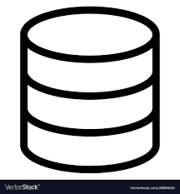

Database: Store account data, historical message, and pending message

Folder: Store file for file transfer

Client:

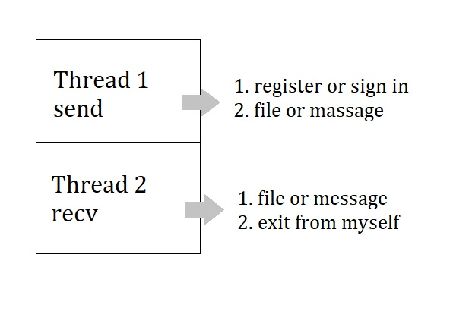  
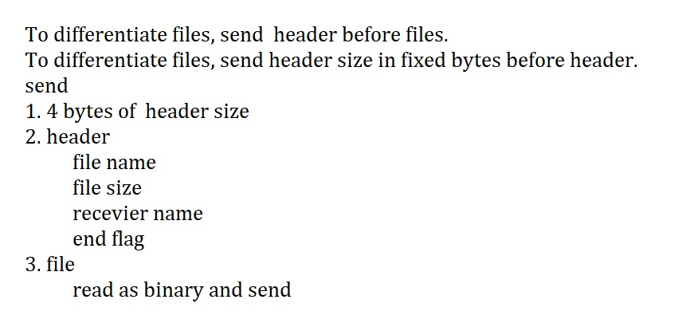

1. Other things you want to say, if any