Project Overview:
This project is a rudimentary version of Minecraft. While the game does not include tools or crafting, the game copies the more simplistic aspects of Minecraft. The player can move around, pick up and put down blocks, jump, and cycle between two different worlds. This game is also in 2D instead of 3D.

Results:
We accomplished what we set out to do. Our game is a simplistic version of Minecraft. When the game starts, it opens into a menu. This menu was an important part of the project because it made the game feel more complete. Once the player enters the game the player is a rectangle that is two blocks tall and one block wide sitting on a field of blocks. The player can move left and right with the A and D keys, as well as jump using W. The blocks can be picked up with the left mouse click, and put down with a right mouse click, just so long as they’re within reach of the player. When blocks are added, they go into the respective slot of the inventory in the top left of the program. The player can also cycle through which type of block they want to place.
It is also very easy to switch between worlds in the game we created. Switching between the worlds is a fun way to mix up the play experience. By pressing 8 or 9 the player can cycle between these world to make a slightly different game experience. The ability to move between the menu screen, world one, and world two, allows for a more complex game experience that seems like a real video game.
The code could easily be altered
Lastly, we added some features that Minecraft does not have to make the game more interesting. For example, we added a trampoline, which makes the player bounce up and down whenever they are standing on it. In addition to this, you can change what your character looks like just by pressing C, which cycles between three characters.

Menu:
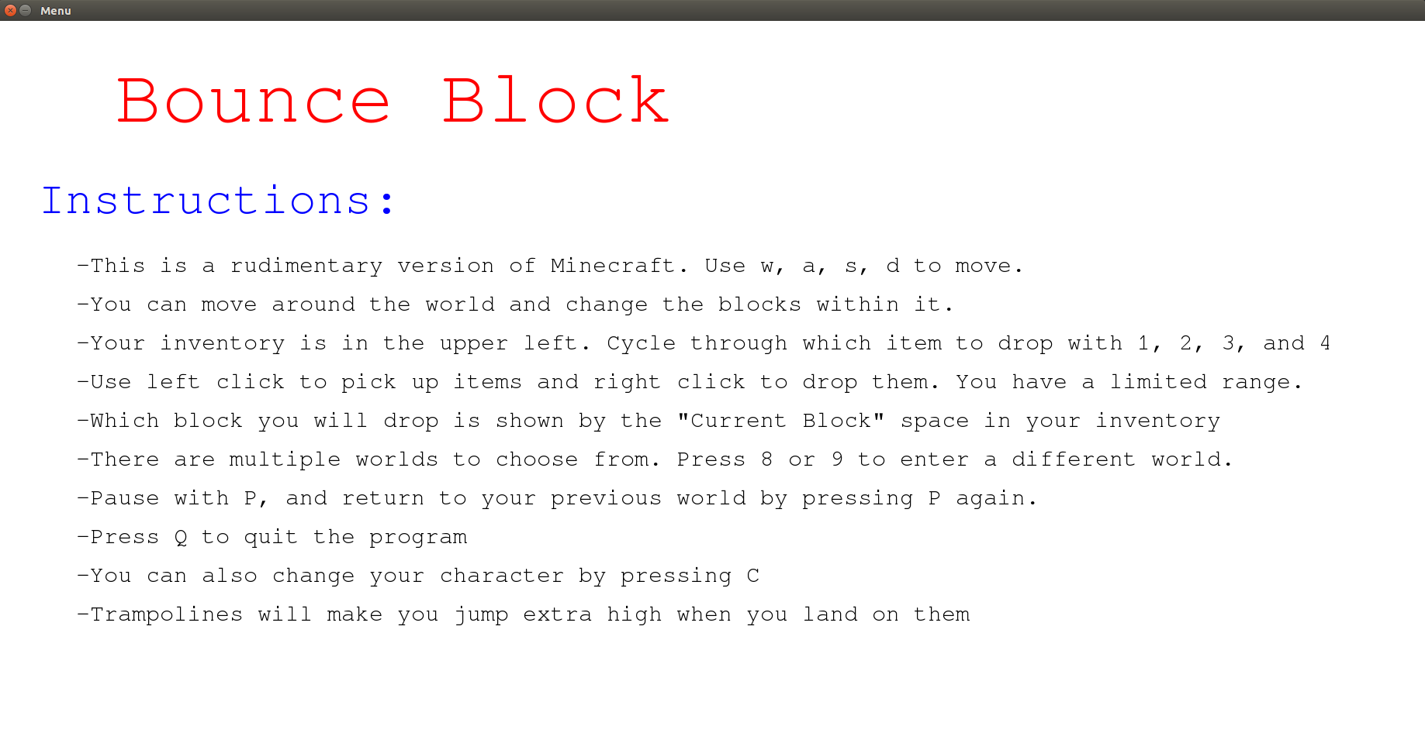

World 1:
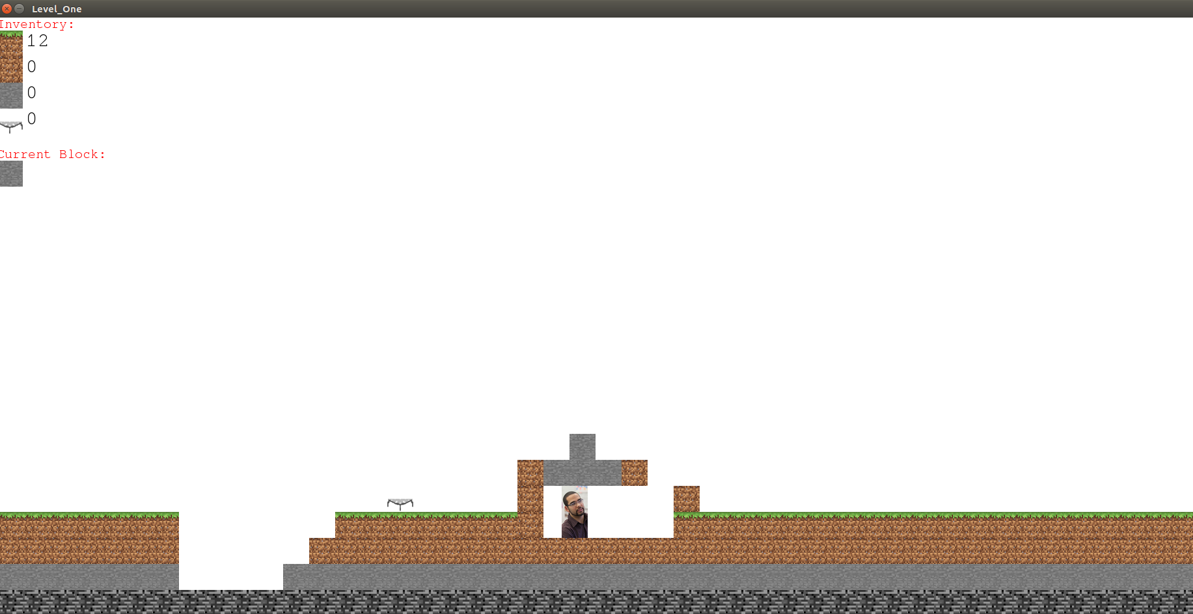

World 2:
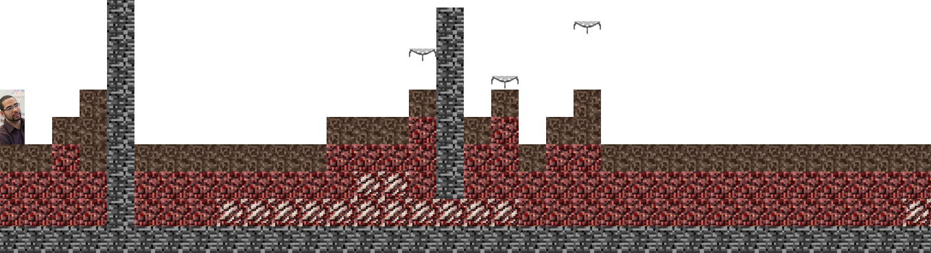
Implementation:
The code was developed in a very object oriented style. One main function was called, which called many other functions and classes. This main function started pygame and called which level the player asked for. From there, all of the movement, collisions, and drawing of the game was split up further into more functions and classes. This was extremely beneficial because many parts of the program were used a multitude of times.
The game was run over a series of iterations as opposed to running continuously. This influenced how the movement and collisions were written. Because of this, the left and right functions were written to move the player left or right by an increment of 4 pixels for every loop in the program. This allowed the collisions to be written in a more concise fashion as well. The left and right collisions were written in order to stop a player from being able to move when the player is exactly touching another block.
A design choice that was made was how to store the blocks in the field. The original idea that we had was to store all of the blocks in a list that could be printed out in each iteration of the program. This is where we had our biggest design consideration. We thought about how difficult it would be to write a collision function if the blocks were in a list. To check for collisions we would have to sort through each block to avoid collisions, which would greatly increase runtime. We thought about how we wanted to avoid this problem. What we decided on was a field matrix. A field matrix is a matrix that has an index for every position on the field that a block could be in. That index is represented by a 0 if no block exists, or a number that represents what type of block it is. This made checking for collisions much easier as we could just check the blocks near the player in the player matrix. This design consideration greatly helped our project.

Reflection:
Our process was successful overall. We successfully scoped what we wanted to do, without leaving ourselves incapable of completing the project. To do this, we kept scoping out what we wanted to do for each iteration. For example, we would write a list of next steps on a white board such as “implement bottom collision” or “add additional levels” . This allowed us to stay organized and keep our objectives in sight. It also kept us on track. If we were ever unsure of what we needed to do to next, we could look at the list for help. This made the development of the program much smoother. In addition, it allowed us to divide up the work. By each picking a task on the board, we were able to understand what the other person was working on without both working on the same part of the project and creating merge errors.
We also did a good job of cutting our losses early in the project. At first we were planning on doing a project involving OpenCV. However, OpenCV had a lot of problems, which set us back at the start of the project. We didn’t give up too early, and spent a reasonable amount of time searching for solutions to OpenCV. Additionally, we didn’t sink all of our time on this part of the project. We knew when we should give up, and we did so, allowing us to develop a well-built game. Overall our process was very successful.

