INDIVIDUAL TRANSITION PLAN
School Year 2025 - 2026

- PERSONAL INFORMATION
Name:  JACOB SKYLER M. MARI | Date of Birth:  FEBRUARY 24, 2018 | LRN:  136872230047
Name of Parents/Guardian:  ROMEO L. MARI & ARGEE S. MOLINA | Current Level of Education:  NON – GRADED (LEVEL 2) | Name of Previous School (if there is):  ___________________  No. of years in school: ____________
Religion: | Gender:  Male | Phone/Contact No.:  09772386385
Current Address:
BLK 133 LOT 28 E. AGUINALDO ST. RIZAL, TAGUIG CITY

Exceptionality:  ADHD | With Assessment: ____  Name of Institution:  ACE MEDICAL CENTER - PATEROS |  | Without Assessment:  ______________
Point of Entry: Please check the point of entry appropriate to the status of the learner.

_______ Transition from home to school
_______ Transition from school to functional life
_______ Transition from SPED Center / SPED Classes to Inclusion Classes
_______ Transition from one grade level to the next grade level
_______ Transition from school to employment or entrepreneurship
_______ Transition from one class to another in the same grade level

- TRANSITION TEAM
Team Members | Name | Contact Details (email and/or phone) | Date started working with team
Special Needs Education Teacher (SNET) | XYLENE JOY T. FELICILDA | 09958216263 | AUGUST 2
Parent/Guardian
Learner

Learner’s current strengths, interests, talents, and skills as observed:

Strengths:
Daily Living Skills: He can perform the following independently: proper hygiene, dressing and undressing and preparing his food and snacks.
Language Development Domain: He can communicate and express himself.
Psychomotor Domain: He can write and copy. He can perform the locomotor – non – locomotor activities.
Cognitive Domain: He can identify letters, numbers 0 to 100, shapes and colors. He can name pictures and objects.
Behavioral Development: He follows instructions but is easily distracted and can finish the task given to him.

Interests: He loves playing playdough and mobile games.

Talents: Dancing

Skills: Speaking

Needs: Behavior Modification, Reading with Comprehension, Spelling

Recommendations based on learner’s potential and need:

- Continue his occupational therapy to reduce his tantrums and unnecessary behavior.
- More reading of books with questions.
- More activity sheets in spelling.

INDIVIDUAL TRANSITION GOAL PLAN

Goal: To improve his reading in CVC words, phrases and sentences.

Entry Point: Transition from home to school (Grade II (Level – II)

Learning Package/s: Functional English

COMPETENCY | ACTIVITIES | TIME FRAME | PERSON RESPONSIBLE | REMARKS
- Read and write short Ee words.  - Read and write short Ee phrases, sentences and stories. | - Show a video presentation about short CVC /Ee/ words.  - The learners will read words, phrases and sentences with short Ee words.  - The learner will write short Ee words, phrases and sentences.  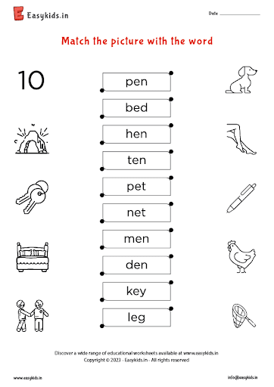  - Provide a worksheet about short Ee words.  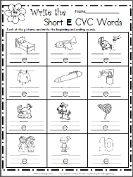 | SECOND QUARTER | Xylene Joy T. Felicilda (Special Needs Education Teacher -SNET)  SNED Learner  Parents
- Read and write short Ii words.  - Read and write short Ii phrases, sentences and stories. | - Show a video presentation about short CVC /Ii/ words.  - The learners will read words, phrases and sentences with short Ii words.  - The learner will write short Ii words, phrases and sentences.  - Provide a worksheet about short Ii words.  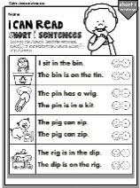  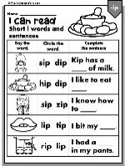  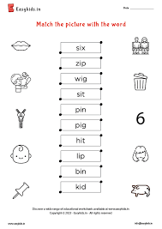
- Read and write short Oo words.  - Read and write short Oo phrases, sentences and stories. | - Show a video presentation about short CVC /Oo/ words.  - The learners will read words, phrases and sentences with short Oo words.  - The learner will write short Oo words, phrases and sentences.    - Provide a worksheet about short Oo words.  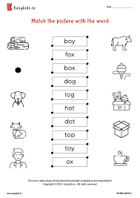  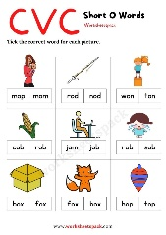  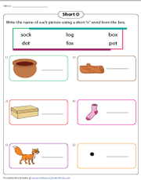
- Read and write short Uu words.  - Read and write short Uu phrases, sentences and stories. | - Show a video presentation about short CVC /Uu/ words.  - The learners will read words, phrases and sentences with short Uu words.  - The learner will write short Uu words, phrases and sentences.  - Provide a worksheet about short Uu words.  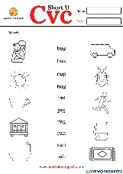  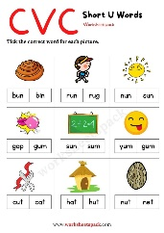

INDIVIDUAL TRANSITION GOAL PLAN

Goal: Mastery of number recognition, comparing of numbers arranging numbers in increasing and decreasing order up to 500 and to understand the concept to ordinal numbers and the value of money.

Entry Point: Transition from home to school (Grade II (Level – II)

Learning Package/s: Functional Math

COMPETENCY | ACTIVITIES | TIME FRAME | PERSON RESPONSIBLE | REMARKS
- Arrange numbers up to 100 in increasing and decreasing order. | - Show a set of numbers and show how to arrange it in increasing order and decreasing order.  - Give more activity in arranging numbers in increasing and decreasing orders up to 100.  - Provide a worksheet about the lesson  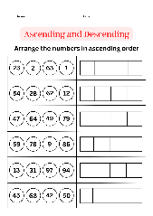  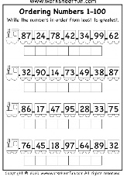  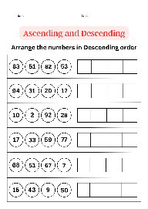  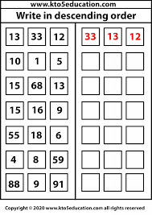 | SECOND QUARTER | Xylene Joy T. Felicilda (Special Needs Education Teacher -SNET)  SNED Learner  Parents
- Compare numbers up to 100 using relation symbols less than (<), more than (>) and as many or equal to (=). | - Discuss to the learner the concept of less than (<), more than (>) and as many or equal to (=).  - Show a varied exercises about comparing numbers.  - Provide a worksheet about the lesson.  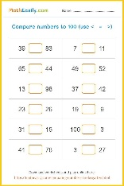  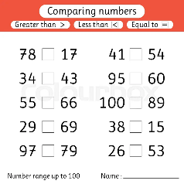  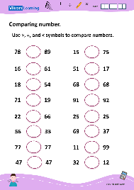  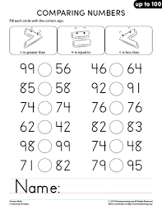
- Read and write numbers up to 500 in symbols and words. | - Show a video presentation about the number of words up to 500.  - Present a PowerPoint presentation showing numbers up to 500.  - The learners will read words up to 500.  - The learners will write numbers up to 500.  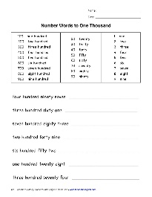  - Provide an activity sheet about words for up to 500.  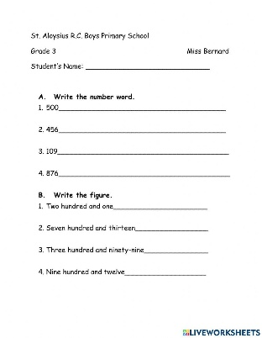
- Arrange numbers up to 500 in increasing and decreasing order. | - Show a set of numbers and show how to arrange it in increasing order and decreasing order.  - Give more activity in arranging numbers in increasing and decreasing orders up to 500.  - Provide a worksheet about the lesson  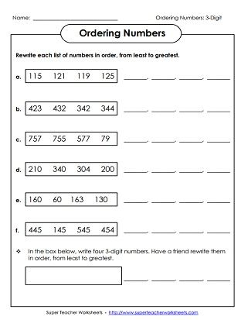  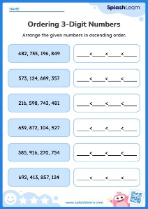  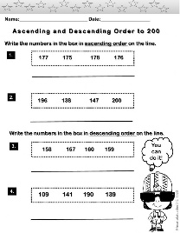  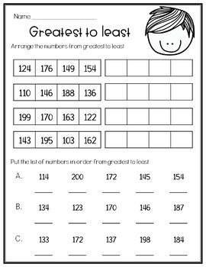
- Compare numbers up to 500 using relation symbols less than (<), more than (>) and as many or equal to (=). | - Discuss to the learner the concept of less than (<), more than (>) and as many or equal to (=).  - Show a varied exercises about comparing numbers.  - Provide a worksheet about the lesson.  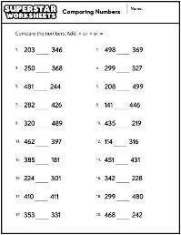  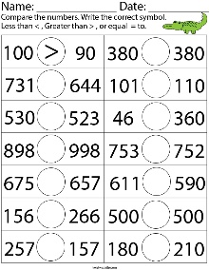
- Read and write ordinal numbers up to 20th. | - Show a video or song about ordinal numbers.  - Present material about the concept of ordinal numbers and discuss to the learner.  - Let the learner read the ordinal numbers and write it in his notebook.  - Show an example of ordinals numbers for him to identify it.  - Provide a worksheet about the lesson.  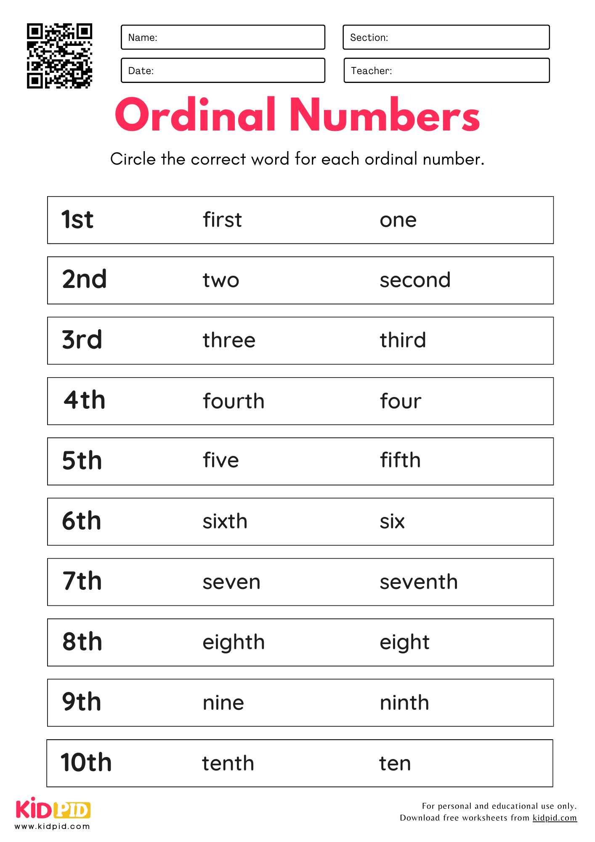  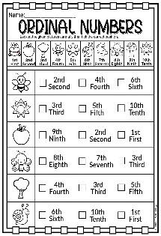  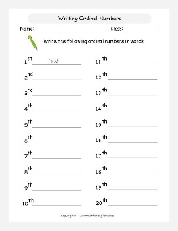  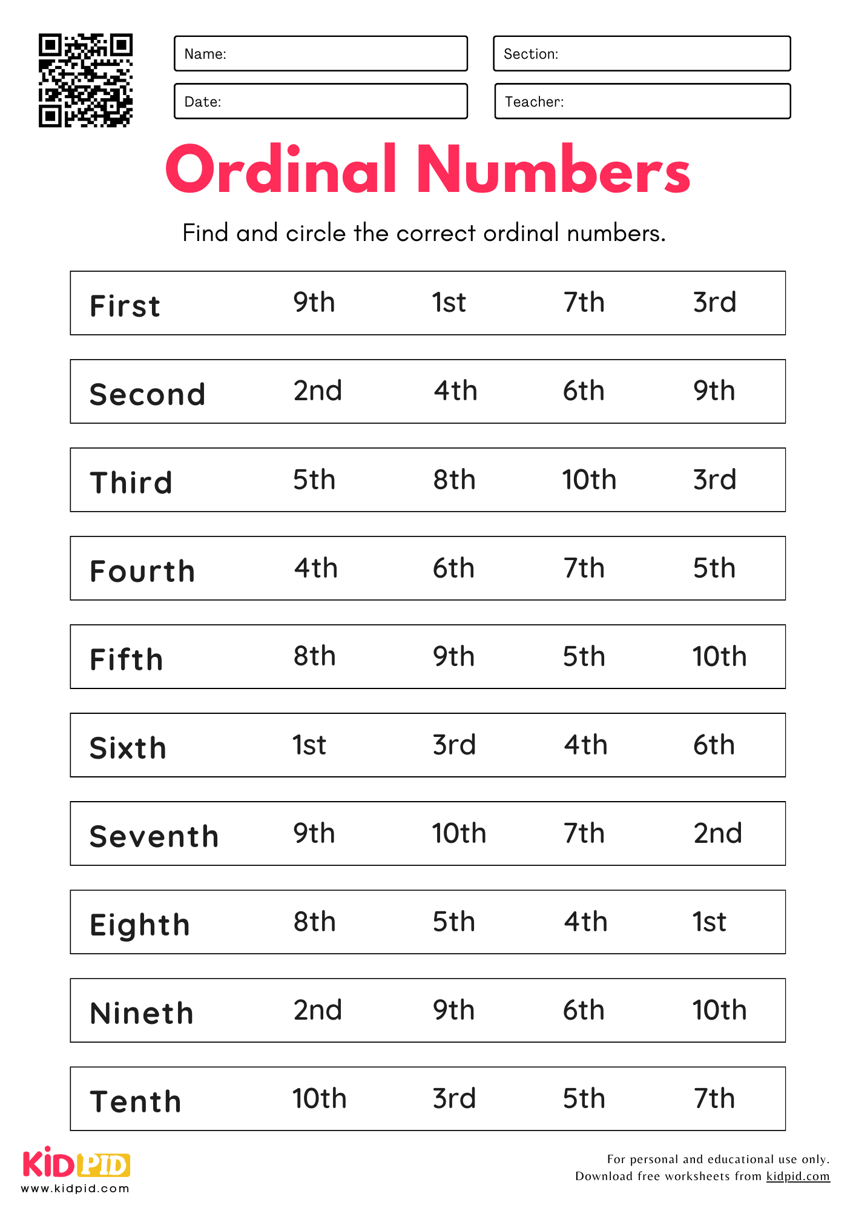
- Read, write, compare and count coins and peso bill up to Php 1000 pesos. | - Show the learner the different coins and peso bill, then discuss the value of it.  - Let the learner recognize the coins and peso bills by reading it.  - Present the coins and peso bill, then the learner will count it.  - Provide a worksheet about the lesson.  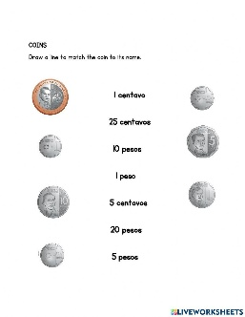  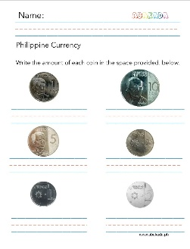  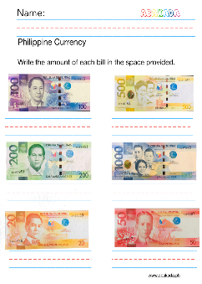  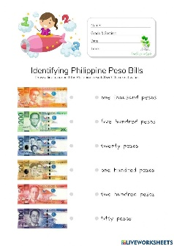

INDIVIDUAL TRANSITION GOAL PLAN

Goal: Identify living and non – living things, tell the different kinds of weather, identify the pet, farm and zoo animals.

Entry Point: Transition from home to school (Grade II (Level – II)

Learning Package/s: Functional Science

COMPETENCY | ACTIVITIES | TIME FRAME | PERSON RESPONSIBLE | REMARKS
- Identity living things.  - Tell/name living things. | - Using a power point presentation, the teacher will discuss living things.  - The LSENs will identify the living things.  - The LSENs will draw or cut a picture of the living things.  - Provide a worksheet about living things.  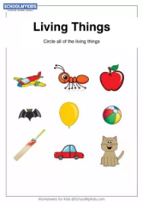  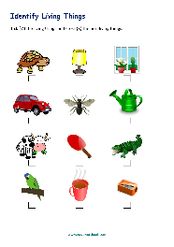 | SECOND QUARTER | Xylene Joy T. Felicilda (Special Needs Education Teacher -SNET)  SNED Learner  Parents
- Identity non-living things.  - Tell/name non - living things. | - Using a power point presentation, the teacher will discuss non-living things.  - The LSENs will identify the non-living things.  - The LSENs will draw or cut a picture of non-living things.  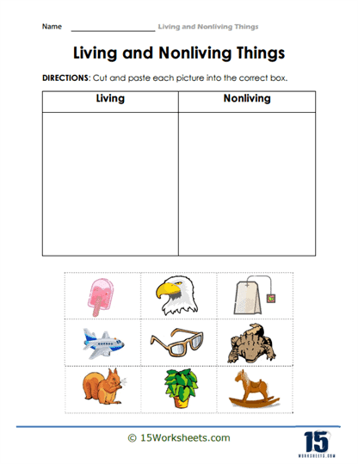  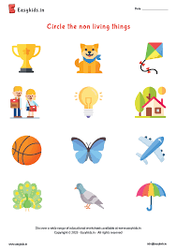  - Provide a worksheet about non-living things.
- Identify the different kinds of weather.  - Tell about the different kinds of weather. | - Show a song about the different kinds of weather.  - Through power point presentation / pictures the learner will identify the different kinds of weather.  - To their science notebook, draw or cut a picture about the different kinds of weather.  - Provide a worksheet about the different kinds of weather.  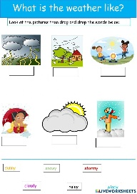  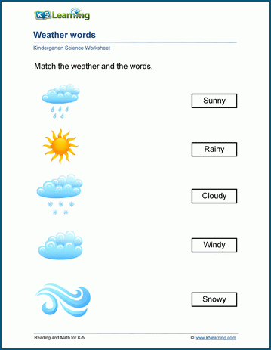
- Identify the activities being done from the different weather.  - Identify the clothes to wear in different weather. | - Show a video presentation about the different activities being done and clothes being used in different weather.  - Show a picture of different activities and clothes to wear in different weather and let the learner identify it.  - Draw or paste a picture of the different activities and clothes to wear in different weather.  - Provide a worksheet about the lesson.  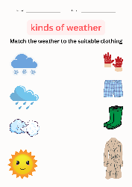  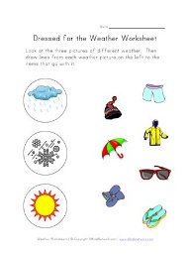  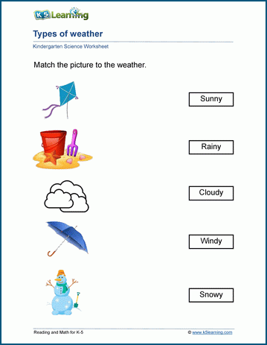  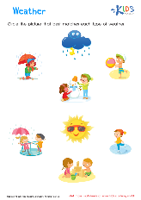
- Identify the animals if they are pets, farm and zoo animals.  - Classify the animals if they are pet, farm and zoo animals. | - Show a video about animals.  - Using a power point and pictures show the different kinds of animals.  - Let the learner identify the animals being shown to them if it is pet, farm and zoo animals.  - Make a mask about animals.  - Draw or cut pictures of the different pet, farm and zoo animals.  - Provide a worksheet about the lesson.  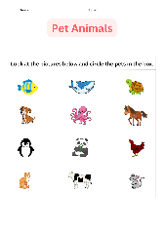  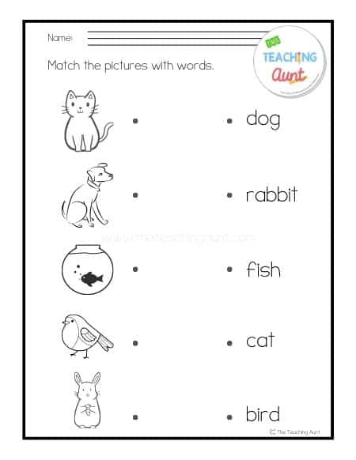  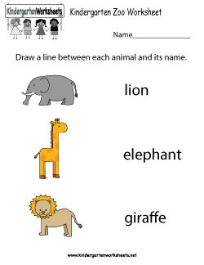  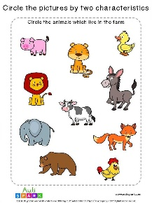  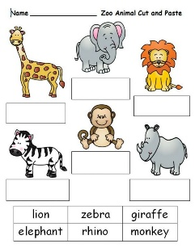

INDIVIDUAL TRANSITION GOAL PLAN

Goal: To become aware of eating healthy and unhealthy food, and practice good eating habits.

Entry Point: Transition from home to school (Grade II (Level – II)

Learning Package/s: Care Skills

COMPETENCY | ACTIVITIES | TIME FRAME | PERSON RESPONSIBLE | REMARKS
- Identify healthy and unhealthy foods. | - Show a video presentation about healthy and unhealthy food.  - Show a picture/real healthy and unhealthy food.  - Let the learner identify the different healthy and unhealthy foods.  - Draw/cut pictures of healthy and unhealthy food.  - Provide a worksheet about the lesson.  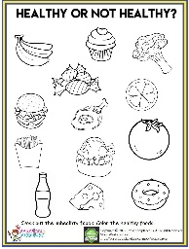  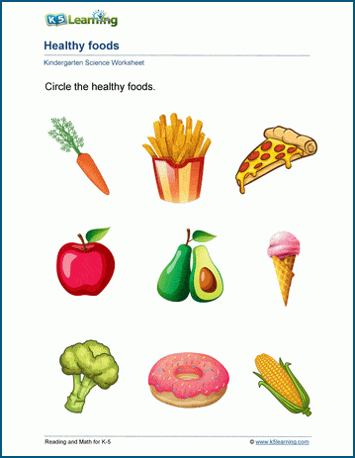  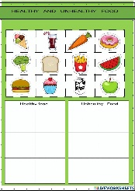  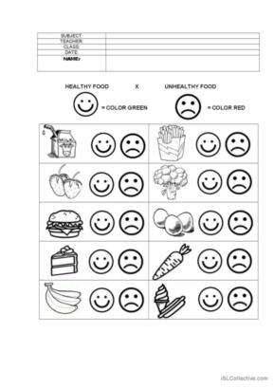 | SECOND QUARTER | Xylene Joy T. Felicilda (Special Needs Education Teacher -SNET)  SNED Learner  Parents
- Determine the effects of eating healthy and unhealthy foods. | - Discuss to them the effects of eating healthy and unhealthy foods.  - Show an example to determine the effects of eating healthy and unhealthy foods.  - Show a video presentation about the effects of eating healthy and unhealthy foods.  - Provide a worksheet/ activity about the lesson.
- Practice good eating habits that help one become healthy. | - Discuss the different good eating habits that help one become healthy.  - Show a video presentation /picture about the different good eating habits.  - Provide a worksheet/activity about the lesson.  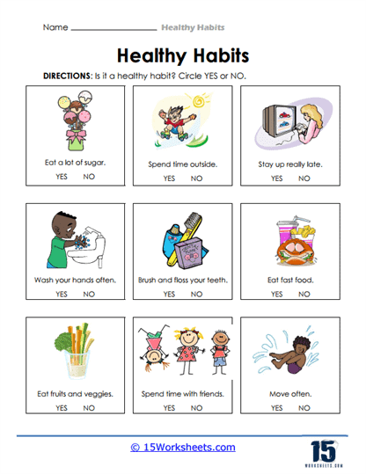  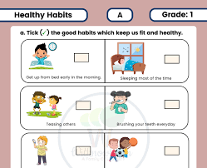
- Identify ways to keep food clean and safe | - Discuss the different ways to keep food clean and safe.  - Show a video presentation about the different ways to keep food clean and safe.  - Provide a worksheet/activity about the lesson.
- Distinguish the ready to eat from those that are raw or that might contain harmful ingredients in food | - Show a video about ready to eat food and raw food.  - Using a picture, discuss to them the difference between ready-to-eat food and raw food.  - Let the learner identify the ready-to-eat food and raw food using pictures and real objects.  - Draw or cut pictures about ready-to-eat food and raw food.  - Provide a worksheet about the lesson.  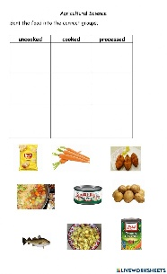  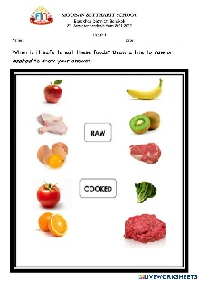

Prepared by:

XYLENE JOY T. FELICILDA
SNET III

Checked by:

ROSEMARIE M. ANTOLIN
Master Teacher I

INDIVIDUAL TRANSITION GOAL PLAN

Goal: To improve her reading comprehension and spelling of words.

Entry Point: Transition from home to school (Grade II (Level – II)

Learning Package/s: Functional English

COMPETENCY | ACTIVITIES | TIME FRAME | PERSON RESPONSIBLE | REMARKS
- Read and write short Oo words.  - Read and write short Oo phrases, sentences and stories. | - Show a video presentation about short CVC /Oo/ words.  - The learners will read words, phrases and sentences with short Oo words.  - The learner will write short Oo words, phrases and sentences.  - Provide a worksheet about short Oo words.      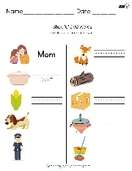    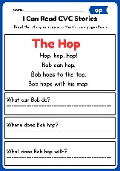  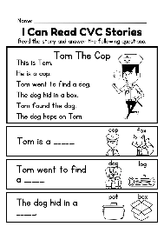 | Third Quarter | SNED Teacher, SNED Learner, Parent/Guardian
- Read and write short Uu words.  - Read and write short Uu phrases, sentences and stories. | - Show a video presentation about short CVC /Uu/ words.  - The learners will read words, phrases and sentences with short Uu words.  - The learner will write short Uu words, phrases and sentences.  - Provide a worksheet about short Uu words.      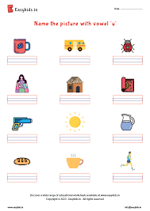  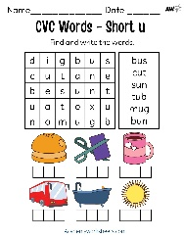  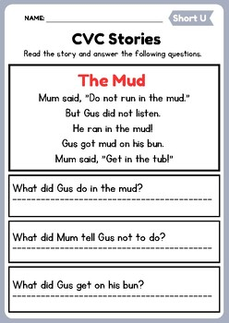  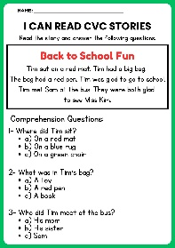
- Read and write long /Aa/ words.  - Read and write long /Aa/ phrases, sentences and stories.  - Read short stories with long /Aa/ words and answer questions about the story. | - Show a video presentation about long /Aa/ words.  - The learners will read words, phrases and sentences with long /Aa/ words.  - The learner will write long /Aa/ words, phrases and sentences.  - Provide a worksheet about long /Aa/ words.  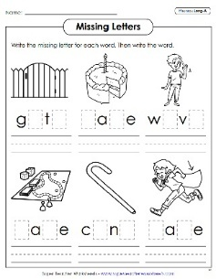  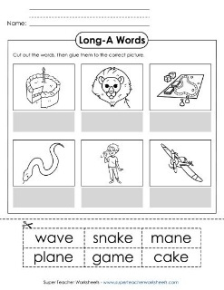  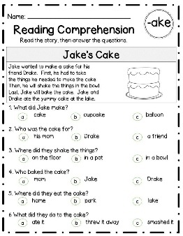  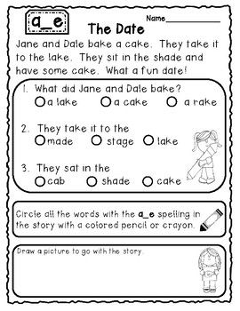
- Read and write long /Ee/ words.  - Read and write long /Ee/ phrases, sentences and stories.  - Read short stories with long /Ee/ words and answer questions about the story. | - Show a video presentation about long /Ee/ words.  - The learners will read words, phrases and sentences with long /Ee/ words.  - The learner will write long /Ee/ words, phrases and sentences.  - Provide a worksheet about long /Ee/ words.  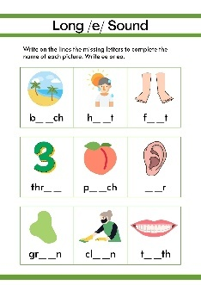  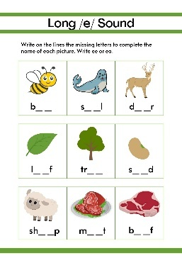  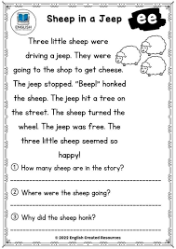  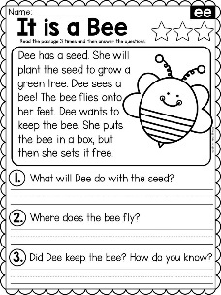  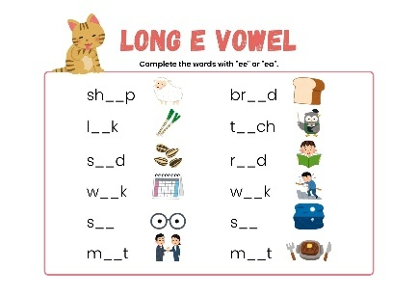
- Read and write long /Ii/ words.  - Read and write long /Ii/ phrases, sentences and stories.  - Read short stories with long /Ii/ words and answer questions about the story. | - Show a video presentation about long /Ii/ words.  - The learners will read words, phrases and sentences with long /Ii/ words.  - The learner will write long /Ii/ words, phrases and sentences.  - Provide a worksheet about long /Ii/ words.  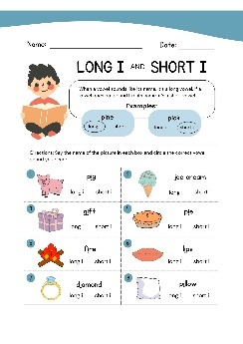  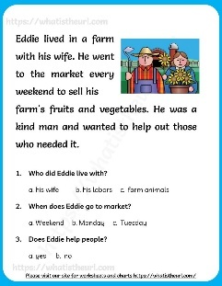  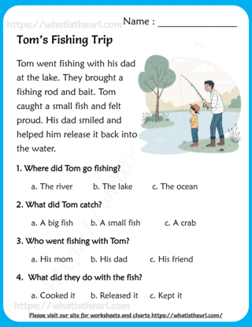  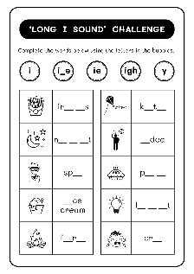

INDIVIDUAL TRANSITION GOAL PLAN

Goal: Mastery of number recognition, comparing of numbers arranging numbers in increasing and decreasing order up to 500 and to understand the concept to ordinal numbers and the value of money.

Entry Point: Transition from home to school (Grade II (Level – II)

Learning Package/s: Functional Math

COMPETENCY | ACTIVITIES | TIME FRAME | PERSON RESPONSIBLE | REMARKS
- Compare numbers up to 100 using relation symbols less than (<), more than (>) and as many or equal to (=). | - Discuss to the learner the concept of less than (<), more than (>) and as many or equal to (=).  - Show a varied exercises about comparing numbers.  - Provide a worksheet about the lesson.         | THIRD QUARTER | SNED TEACHER, SNED LEARNER, PARENT/GUARDIAN
- Compare numbers up to 500 using relation symbols less than (<), more than (>) and as many or equal to (=). | - Discuss to the learner the concept of less than (<), more than (>) and as many or equal to (=).  - Show a varied exercises about comparing numbers.  - Provide a worksheet about the lesson.    
- Read and write ordinal numbers up to 20th. | - Show a video or song about ordinal numbers.  - Present material about the concept of ordinal numbers and discuss to the learner.  - Let the learner read the ordinal numbers and write it in his notebook.  - Show an example of ordinals numbers for him to identify it.  - Provide a worksheet about the lesson.        
- Read, write, compare and count coins and peso bill up to Php 1000 pesos. | - Show the learner the different coins and peso bill, then discuss the value of it.  - Let the learner recognize the coins and peso bills by reading it.  - Present the coins and peso bill, then the learner will count it.  - Provide a worksheet about the lesson.        
- Tell time in hour and minutes. | - Show the learner a video presentation about telling time.  - Discuss to the learner the short and long hand.  - Present to the learner on how to tell the time.  - Provide a worksheet about the lesson.  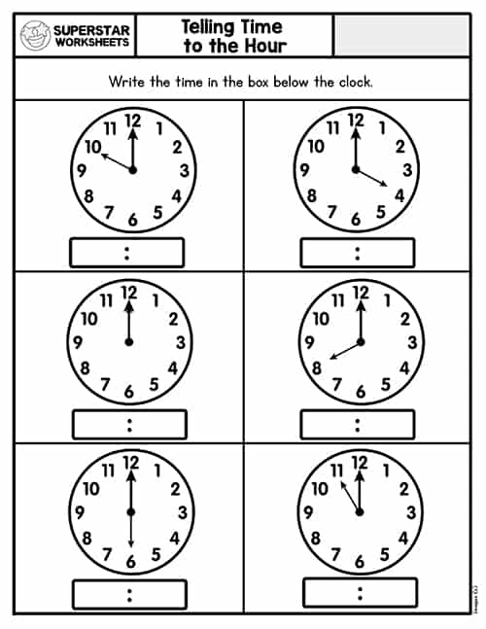  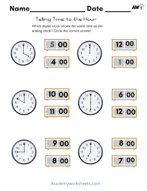  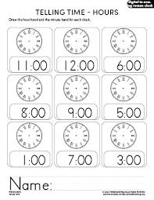  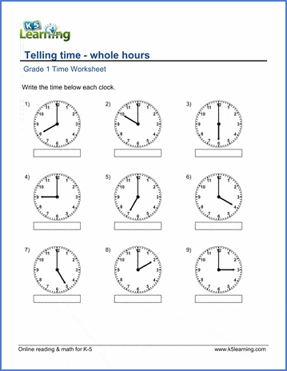  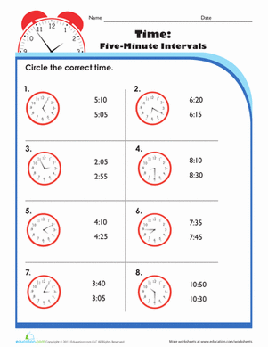  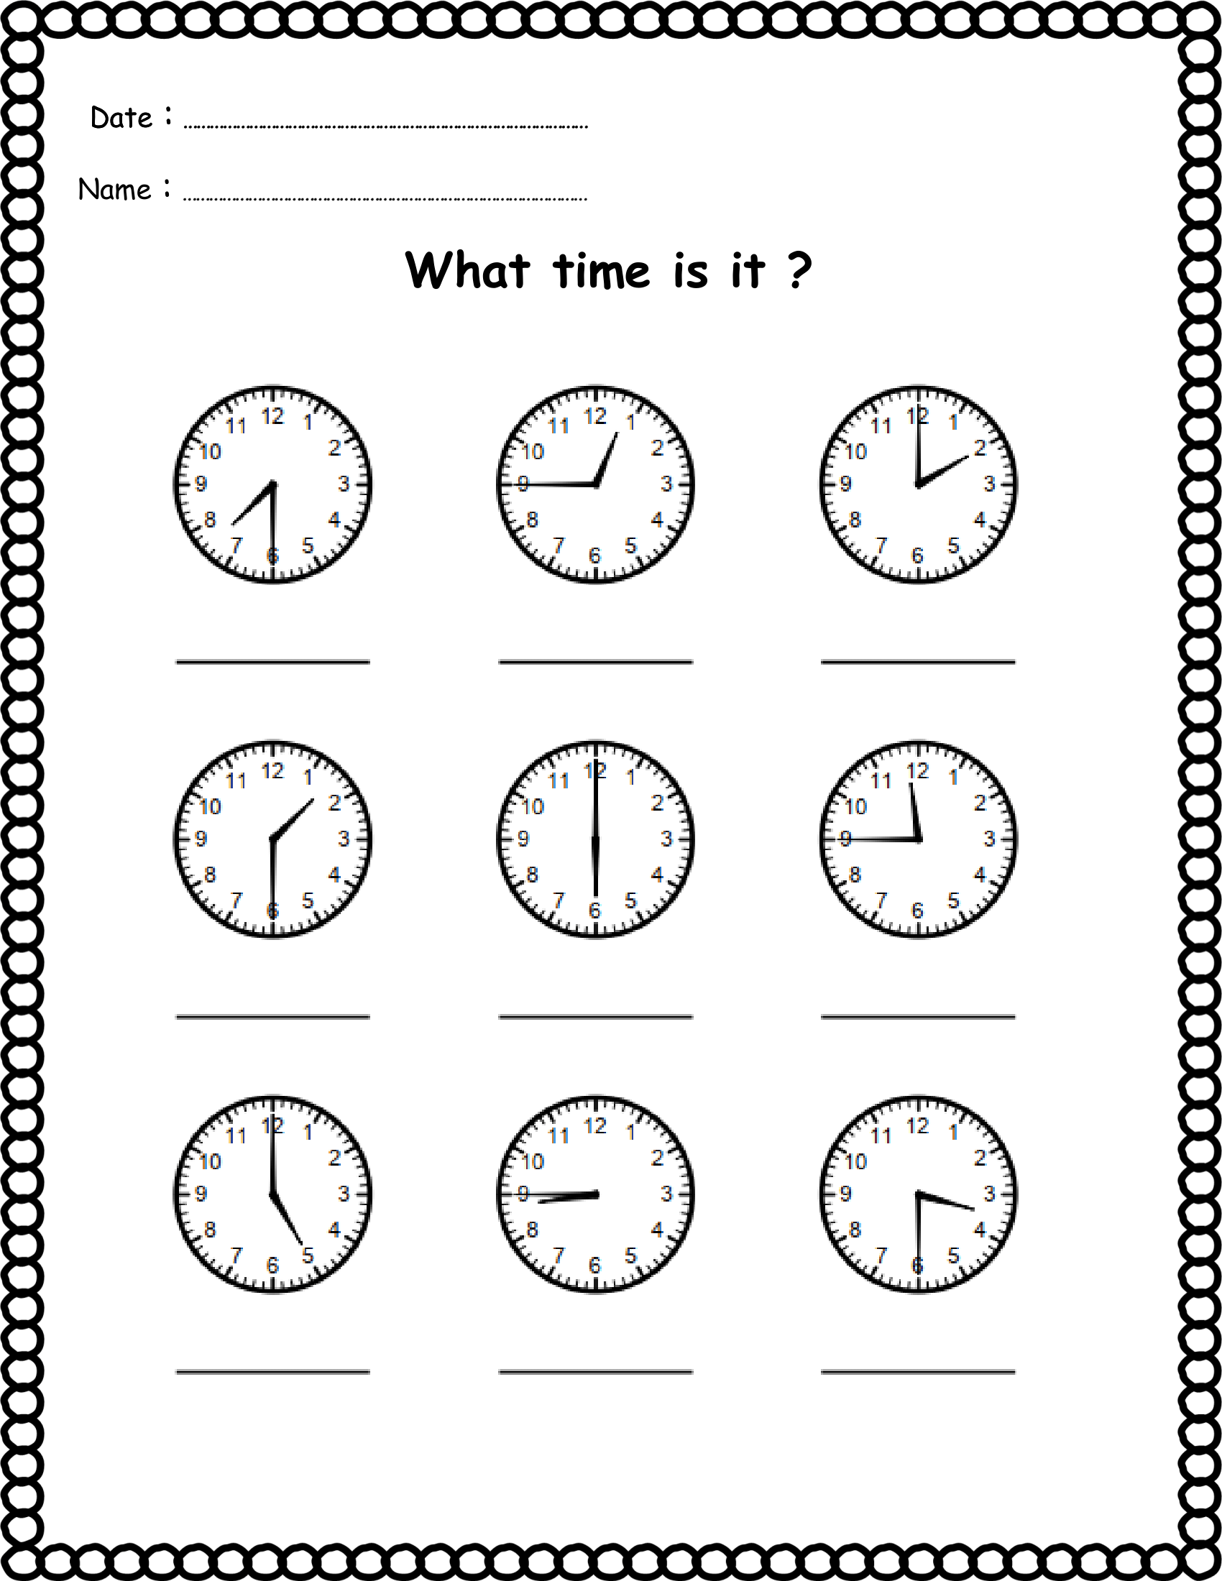

INDIVIDUAL TRANSITION GOAL PLAN

Goal: Identify living and non – living things, tell the different kinds of weather, identify the pet, farm and zoo animals.

Entry Point: Transition from home to school (Grade II (Level – I)

Learning Package/s: Functional Science

COMPETENCY | ACTIVITIES | TIME FRAME | PERSON RESPONSIBLE | REMARKS
- Identify the activities being done from the different weather.  - Identify the clothes to wear in different weather. | - Show a video presentation about the different activities being done and clothes being used in different weather.  - Show a picture of different activities and clothes to wear in different weather and let the learner identify it.  - Draw or paste a picture of the different activities and clothes to wear in different weather.  - Provide a worksheet about the lesson.         | Third Quarter | SNED Teacher, SNED Learner, Parent/Guardian
- Identify the animals if they are pets, farm and zoo animals.  - Classify the animals if they are pet, farm and zoo animals. | - Show a video about animals.  - Using a power point and pictures show the different kinds of animals.  - Let the learner identify the animals being shown to them if it is pet, farm and zoo animals.  - Make a mask about animals.  - Draw or cut pictures of the different pets, farm and zoo animals.  - Provide a worksheet about the lesson.          
- Identify the needs of the animals. | - Prepare pictures or cards with different animals and their needs. (food, water, shelter, love)  - Show also a video presentation about the needs of the animals.  - To her science notebook, cut/draw a picture of the needs of animals.  - Provide a worksheet about the needs of the animals.  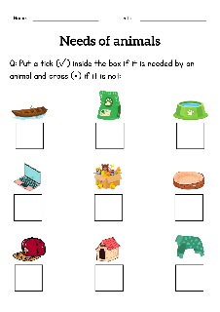  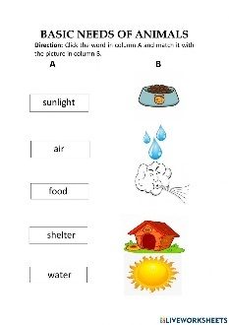
- Identify the animals and their young’s. | - Show a video presentation about the animals and their youngs.  - Create a matching game with pictures of adult animals and their babies.  - Prepare pictures or cards with different animals and their young. Have students sort the cards into families.  - To their science notebook, draw/cut pictures of adult animals and their babies.  - Provide a worksheet about the animals and their youngs.  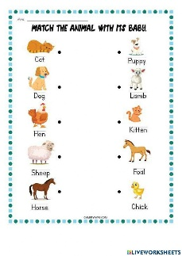  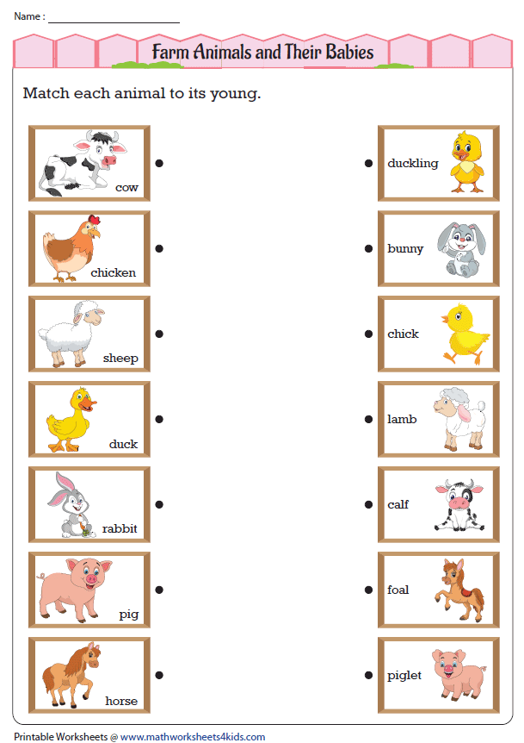

INDIVIDUAL TRANSITION GOAL PLAN

Goal: To become aware of eating healthy and unhealthy food, and practice good eating habits.

Entry Point: Transition from home to school (Grade II (Level – I)

Learning Package/s: Care Skills

COMPETENCY | ACTIVITIES | TIME FRAME | PERSON RESPONSIBLE | REMARKS
- Identify ways to keep food clean and safe | - Discuss the different ways to keep food clean and safe.  - Show a video presentation about the different ways to keep food clean and safe.  - Provide a worksheet/activity about the lesson. | Third Quarter | SNED Teacher, SNED Learner, Parent/Guardian
- Distinguish the ready to eat from those that are raw or that might contain harmful ingredients in food | - Show a video about ready to eat food and raw food.  - Using a picture, discuss to them the difference between ready-to-eat food and raw food.  - Let the learner identify the ready-to-eat food and raw food using pictures and real objects.  - Draw or cut pictures about ready-to-eat food and raw food.  - Provide a worksheet about the lesson.    

Prepared by:

XYLENE JOY T. FELICILDA
SNET III

Checked by:

ROSEMARIE M. ANTOLIN
Master Teacher I

