

INTERN ASSESSMENT FORM
(To be completed by the Intern Supervisor)

Student Intern Name: Date of Internship:

The purpose of this form is to provide the intern with feedback about the intern’s work and professional skills and competencies. Please be objective and candid in your assessment and discuss this with the intern. The assessment ratings range from 1 to 5 are as follows (circle the appropriate number):
1 = Unsatisfactory Never demonstrates this ability / does not meet expectations
2 = Needs Improvement Seldom demonstrates this ability / rarely meets expectations
3 = Fair Sometimes demonstrates this ability / meets expectation
4 = Good Usually demonstrates this ability / sometimes exceed expectations
5 = Excellent Always demonstrates this ability / consistently exceeds expectations
N/A = Not Applicable Not applicable to this internship experience

A. Ability to Learn
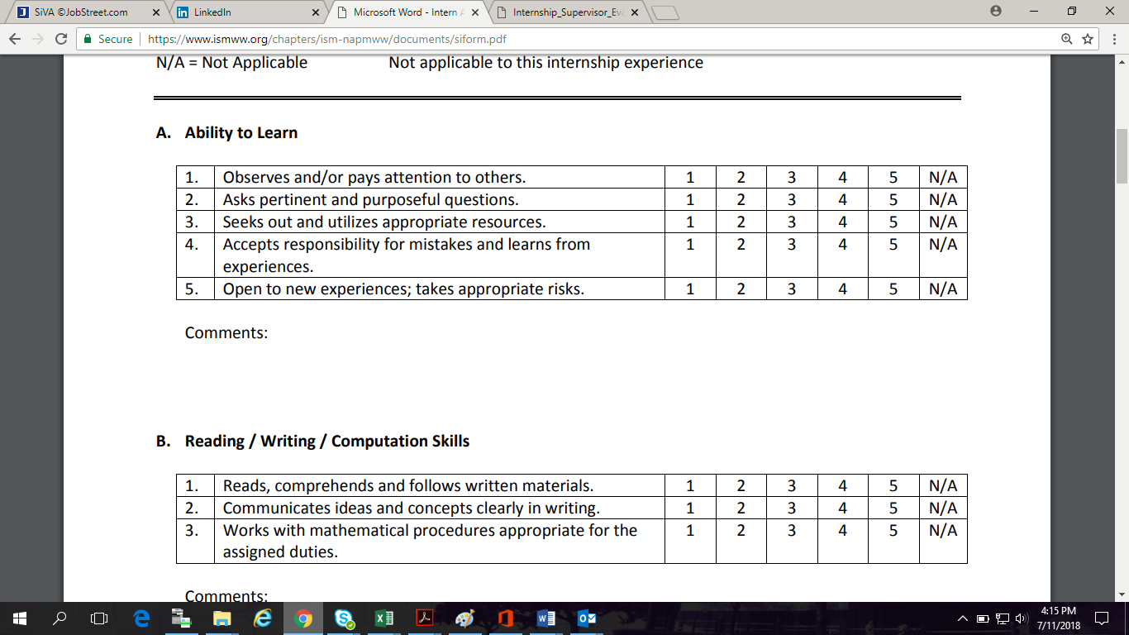
B. Reading / Writing / Computation Skills
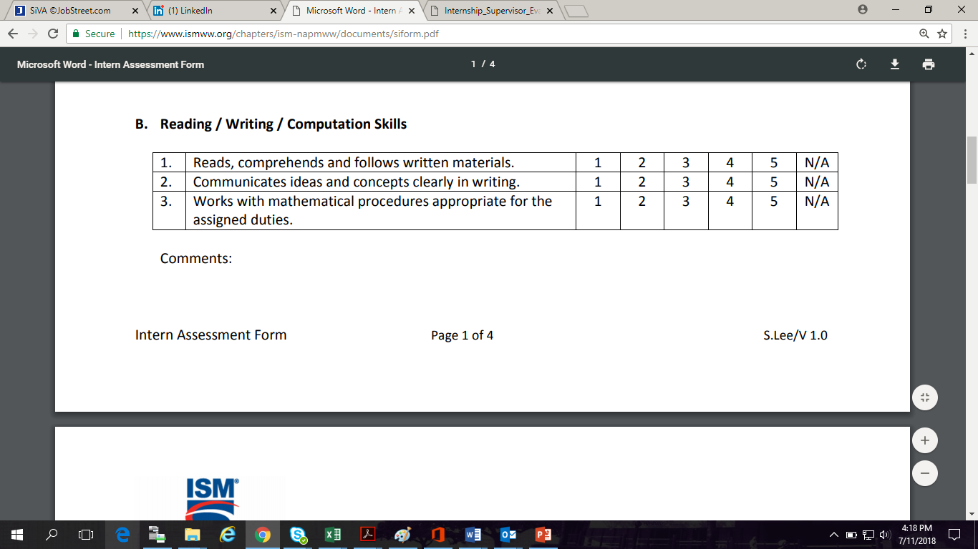

C. Listening and Oral Communication Skills
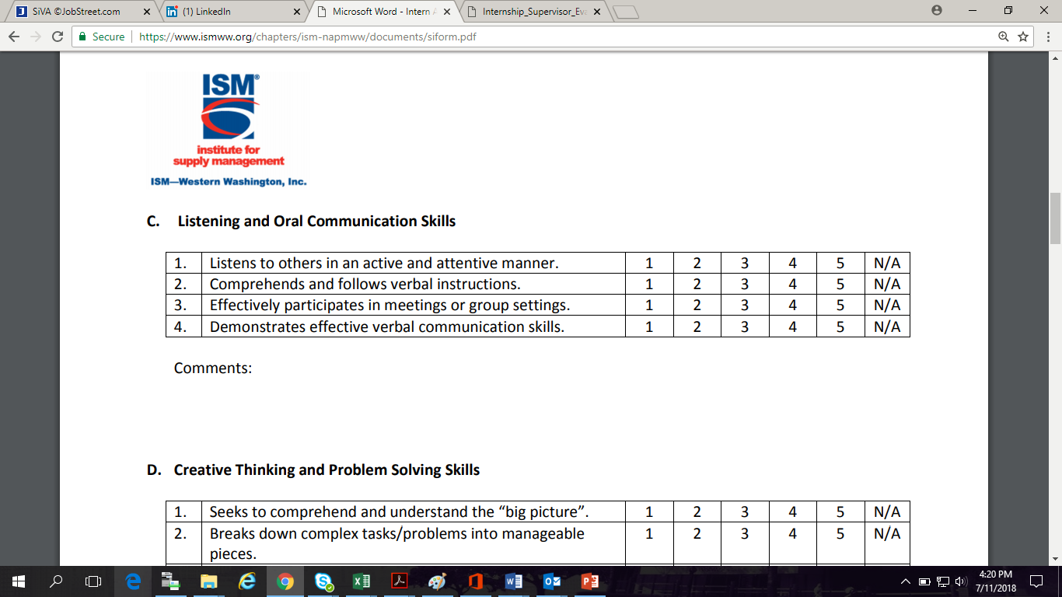
D. Creative Thinking and Problem Solving Skills
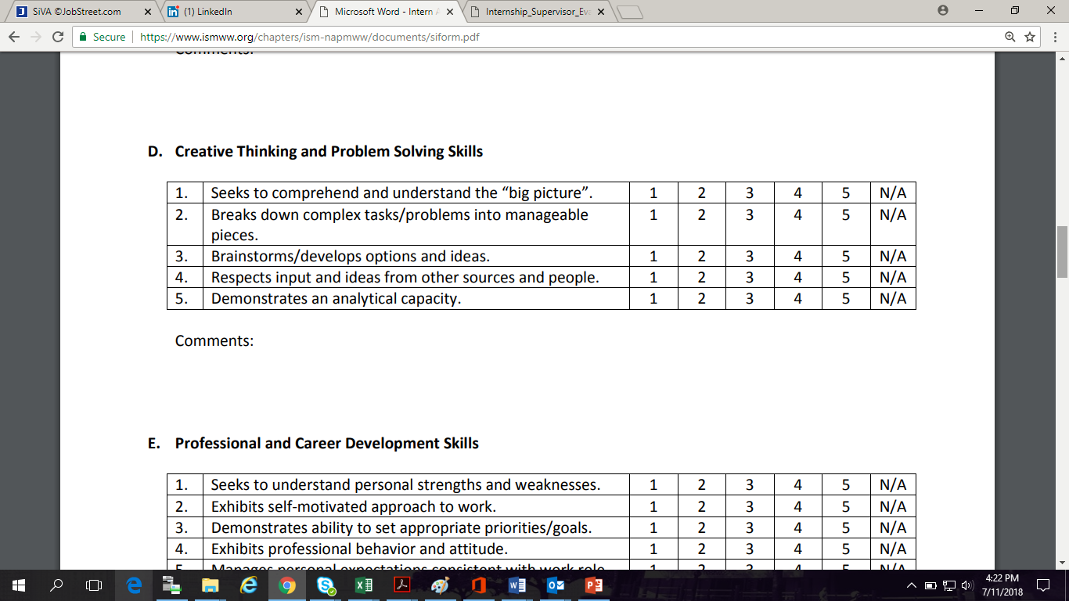
E. Professional and Career Development Skills
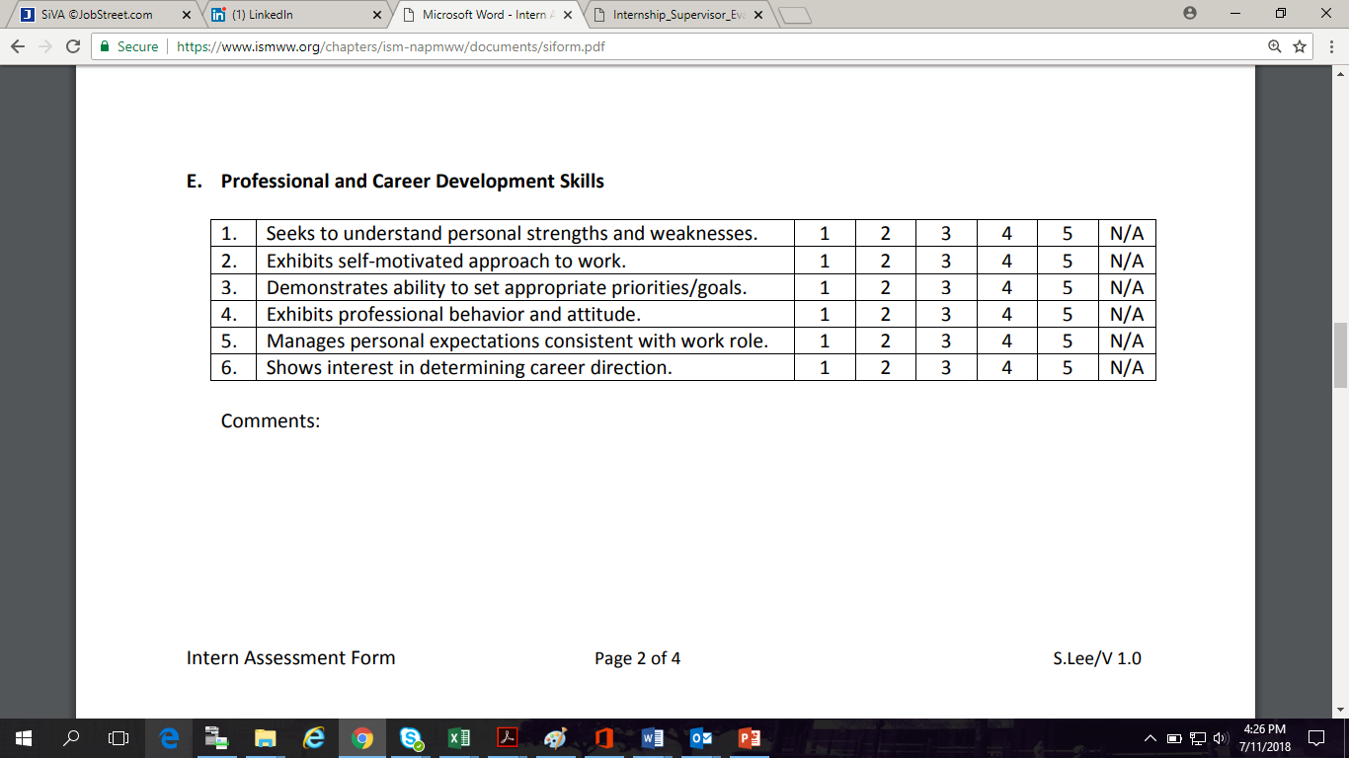
F. Interpersonal and Teamwork Skills
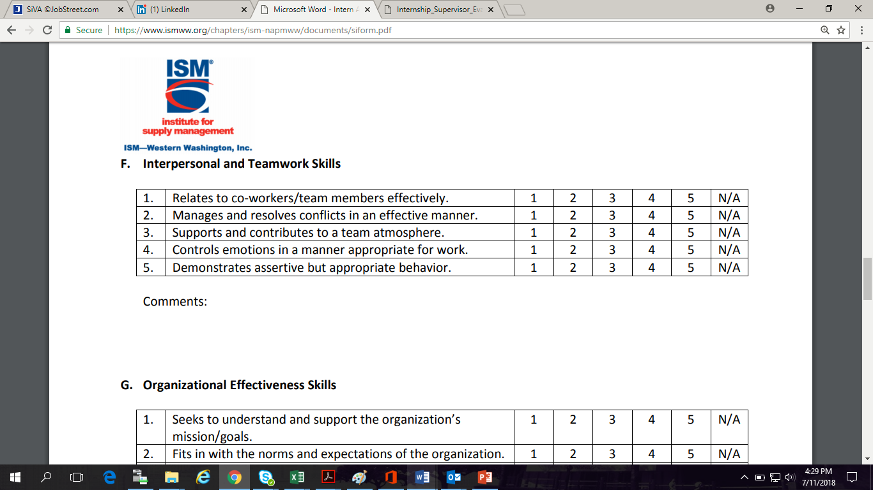
G. Organizational Effectiveness Skill
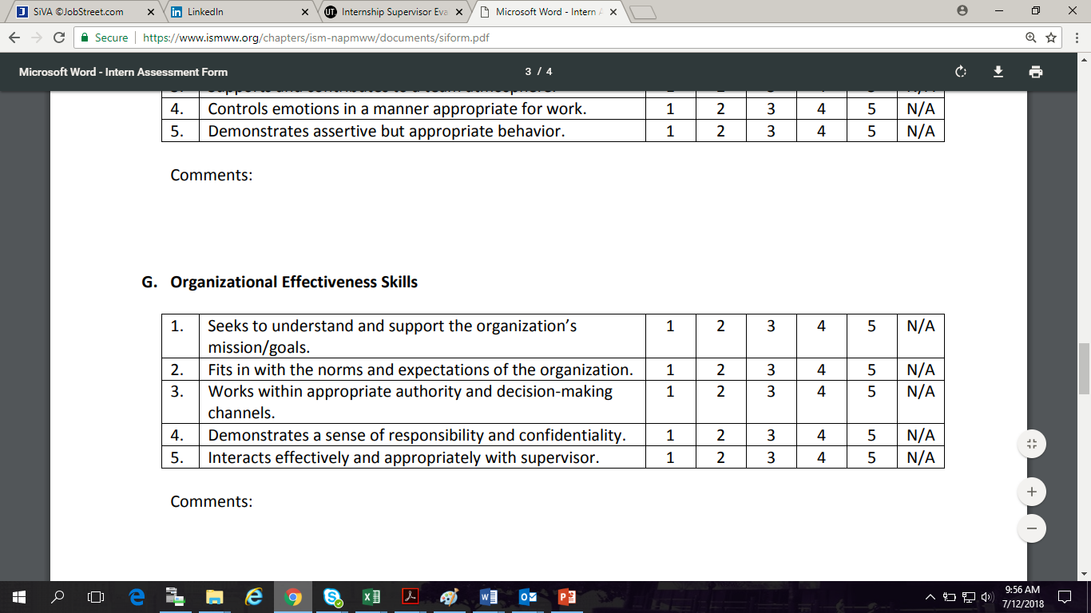

H. Basic Work Skills
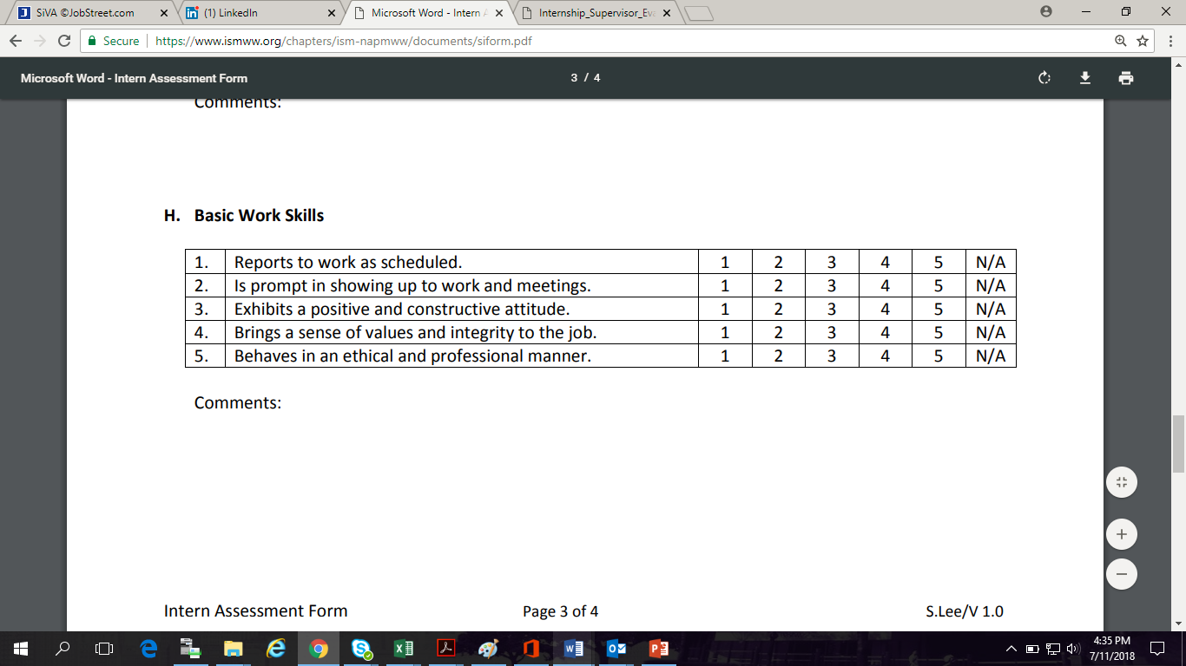
- Describe the ways in which the intern’s performance benefited your team?

- What development have you observed in the student’s skills, knowledge, personal and/or professional performance?

- What do you consider to be the intern’s strengths?

- In what areas does the intern need to improve?

- Overall, how do you rate your experience with this intern?

Unsatisfactory Poor Average Good Outstanding

___ I have ___ I have not discussed this assessment with the intern.

Intern Supervisor Name: ____________________________ Date of Assessment: ____________

Signature: _____________________________________________

*** Send this completed form to the Internship Coordinator. ***

