Project Proposal - Cargo Race

Sean Trant, x13332576, seantrant@gmail.com

BSc Hons in Computing

Gaming and Multimedia

19/10/2016

# Objectives

* Setup phase
* Load cargo and chaser sets obstacles and traps
* Race against other players/AI, maintain as much cargo as possible and go fast to win
* 2 maps (jungle and underwater)
* Chasers: gorilla and shark

The idea behind this project is a racing game in which a player’s vehicle will have a cargo compartment with cargo inside. Racing other players to the finish line, the player must keep as much cargo inside the vehicle as possible as score is not just reliant on who finishes first, but also who has the most cargo remaining.

There will be a chaser in the race, currently plans for a gorilla in a jungle map and a shark in an ocean race. The chaser will pursue players through the race and attempt to take them out of it. If the chaser gets close to a player, the player has an option to throw some of his loaded cargo away to go faster.

Before the race begins, there will be a setup phase in which the chaser will have a certain amount of time to lay traps and move the obstacles of the track to his own preference. During this time, the player can choose from a pile which cargo to load into their vehicle, some being heavier than others but contributing more to the score at the end.

# Background

The idea stemmed from a simple project from 3rd year, a racing game in which a player would lose points when cargo fell out of the vehicle. Upon completion of the project, I felt unsatisfied, like my team and I had merely scratched the surface of a good idea. So, from here I expanded and developed it to the point where it was entirely upgraded.

The highly popular mobile game Temple Run showed that the idea of being chased could add a fresh improvement to the standard racing game. I then found this thought reinforced by a multiplayer game called Speed Runners, in which 4 players race each other in a 2D setting continuously until the camera closes off behind them and begins eliminating players from the race.

In the initial idea proposal, I was advised to add more original elements to the game. This made me think of a setup phase, which could allow players to alter the race track and select different pieces of cargo to load onto their vehicle, which would affect its weight and speed, but also the value at the end.

# Technical Approach

Brief description of the approach to be followed (Max. 1 Page), Research, literature review, requirements capture, implementation etc

The technical approach at this pre-development / planning stage is largely subject to change, but I am currently looking at developing the game using an engine called Unity. Unity is a free, cross platform development engine so it is simple to mount projects on both computer and mobile. The central language for this engine is C#, and I will be using Autodesk Maya to make models or other environments and animations.

# Project Plan

Gantt chart using Microsoft Project with details on implementation steps and timelines

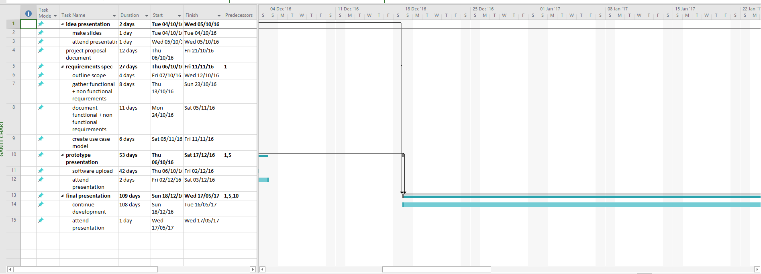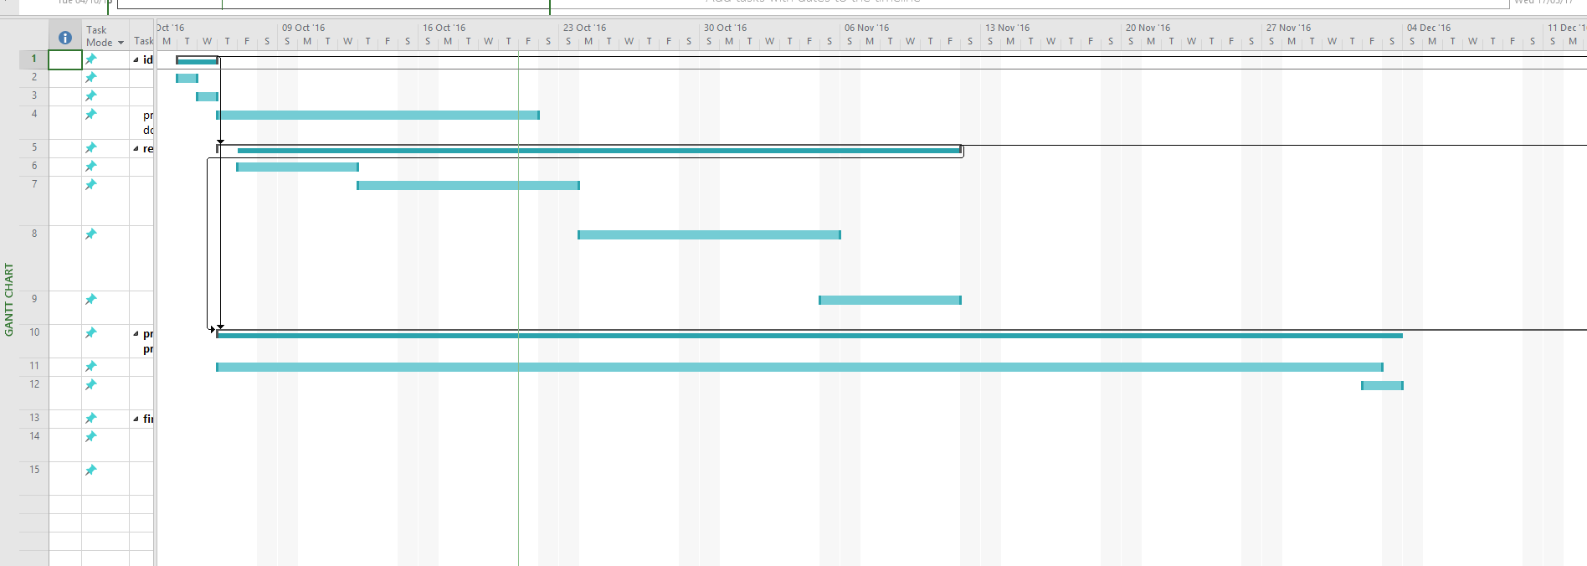



# Technical Details

Unity, C#, javascript, Autodesk maya

# Evaluation

Describe how you will evaluate the system with real technical data using system tests, integration tests etc. In addition, where possible describe how you will evaluate the system with an end user.

I plan to test the project under the following conditions:

* Does it satisfy the functional requirements that drove development in the first place?
* Do the functions complete within an acceptable timeframe? Is the game stable?
* Does it run on all intended platforms?

These conditions will make it easier to identify problems and address either the problems themselves or unachievable requirements.