1 – Kernel Function

I am confused by the Radial Basis Kernel function. The function in the example in the github takes in the x-values divided in interval [0,1]. Then performs the opperations below on it.



So this kernel function gives x points closer to each other a higher correlation. The below code illustrates my point

The Xshow matrix divides interval [0,1] into 5 pieces. Then the Kernel finds the variance between each of this x points. From what I can see the Kernel tells us that x=0.25 is closer to x=0 than x=0.5 and so on which is obvious.I don’t understand how this is then utilised into finding f(x) values closer to the previous f(x) to plot a smooth line.

Example below where the Kernel smooths the lines. The top example utilises the kernel the bottom doesn’t. I think my issue in understanding is potentially with the multivariate normal distribution. I don’t understand how the correlation of x values improves the f(x) estimation. Because at each f(x) all the x-values are the same.

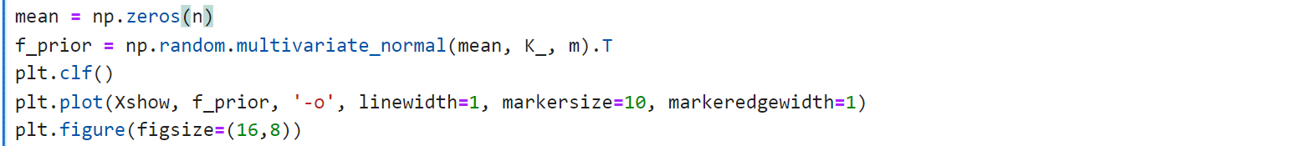

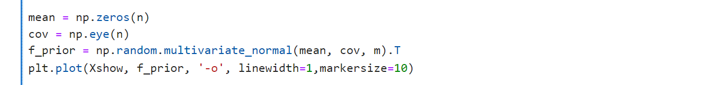

2- Basic understanding of GPR

Just so you can correct my incorrect thinking!.

