Scripting for Cyber Security – Project Report

Cyber Threat Checker
A process and Network Threat Intelligence Automation Tool

Submitted by:
SEAN WOGAN - B00173757
ABHIJEET SINGH RATHORE - B00168190

Module: Scripting for Cyber Security
Lecturer: Stephen O'Shaughnessy

Table of Contents
- Introduction
- Why We Chose This Tool
- Project Overview
- Use Cases of the Cyber Threat Checker
- Real-World Scenarios Where This Tool is Useful
- Tool Demonstration
- Summary

1. Introduction
Modern companies depend much on automated systems to identify, examine, and answer to cyberattacks. Faster and more dependable means for security teams to detect dubious processes, hostile network connections, and possible compromise indications are needed as attacks get more complex and networks develop. Particularly in the early phases of an event, manual inquiry can be erratic and time-consuming.
Our team came up with Cyber Threat Checker, an automatic tool that combines Python-based threat intelligence analysis with PowerShell system artifact gathering, to meet this need. While Python uses the VirusTotal API to analyse these artefacts to see if any distant IPs are known to be harmful, PowerShell collects information such active network connections and running processes.
The choice of this subject stems from its tight mirroring of actual cybersecurity activities employed in incident response, monitoring, and digital forensics. Combining scripting automation, system auditing, API usage, JSON data handling, and report generating, the project fits exactly the learning outcomes of the module Scripting for Cyber Security.
Simple, lightweight, and very practical early detection of suspicious behaviour or harmful activity inside a system results from this tool.

2. Why We Chose This Tool

This topic was chosen since it mirrors basic duties found in digital forensics, system administration, and Security Operations Centres (SOCs). Among the most common duties during an investigation is detecting malicious IP traffic or unusual behavior. This project let us:
Gather system data using PowerShell knowledge.
Automate threat intelligence verification using Python.
One should understand real-world API usage.
Prepare reports for production analysts.
This topic also matches professional security processes very well and is still realistic within the bounds of the project. It is practical and reasonable.

3. Project Overview

Cyber Threat Checker basically serves two purposes:
component of PowerShell
Gathers running processes
gathers TCP network connections.
Structured JSON outputs for study
component of Python
Reads system artifacts
extracts distinct distant IP addresses
Queries the API for VirusTotal
Producing a JSON report and terminal overview
This design matches professional incident response methods in which artifacts are gathered on a system and subsequently examined via automated tools or threat intelligence platforms.

4. Use Cases of the Cyber Threat Checker

Detection of Early Threat
Before an attack is totally triggered, it finds harmful outbound IP connections.
Response Support for Incidents
Gives responders a glimpse of questionable processes or network activity.
Compliance and System Auditing
Help companies confirm that only genuine procedures and behavior exist.
Ongoing Monitoring
Can be set to run on endpoints without complete SIEM coverage.
Training and Education
Shows actual system auditing and threat intelligence procedures.

5. Real-World Scenarios Where This Tool is Useful

Scenario 1: Suspicious Software Download
If a user downloads pirated software or a fake installer, it may run a hidden process that reaches out to malicious domains.
The tool would show:
- Unknown process names
- Remote IPs flagged as dangerous by VirusTotal
This gives analysts immediate evidence of compromise.

Scenario 2: Insider Threat or Lateral Movement
An attacker inside a network may try connecting to other internal or external systems.
Our tool would reveal:
- Unexpected connections
- Strange ports
- Multiple remote IPs with malware detections
This helps identify early signs of internal attacks.

Scenario 3: Post-Infection Verification
After removing malware, analysts need to confirm the machine is clean.
The tool helps verify:
- No suspicious processes remain
- No harmful external connections persist
- No known malicious IPs are contacted
This supports proper recovery and validation.

6. Tool Demonstration

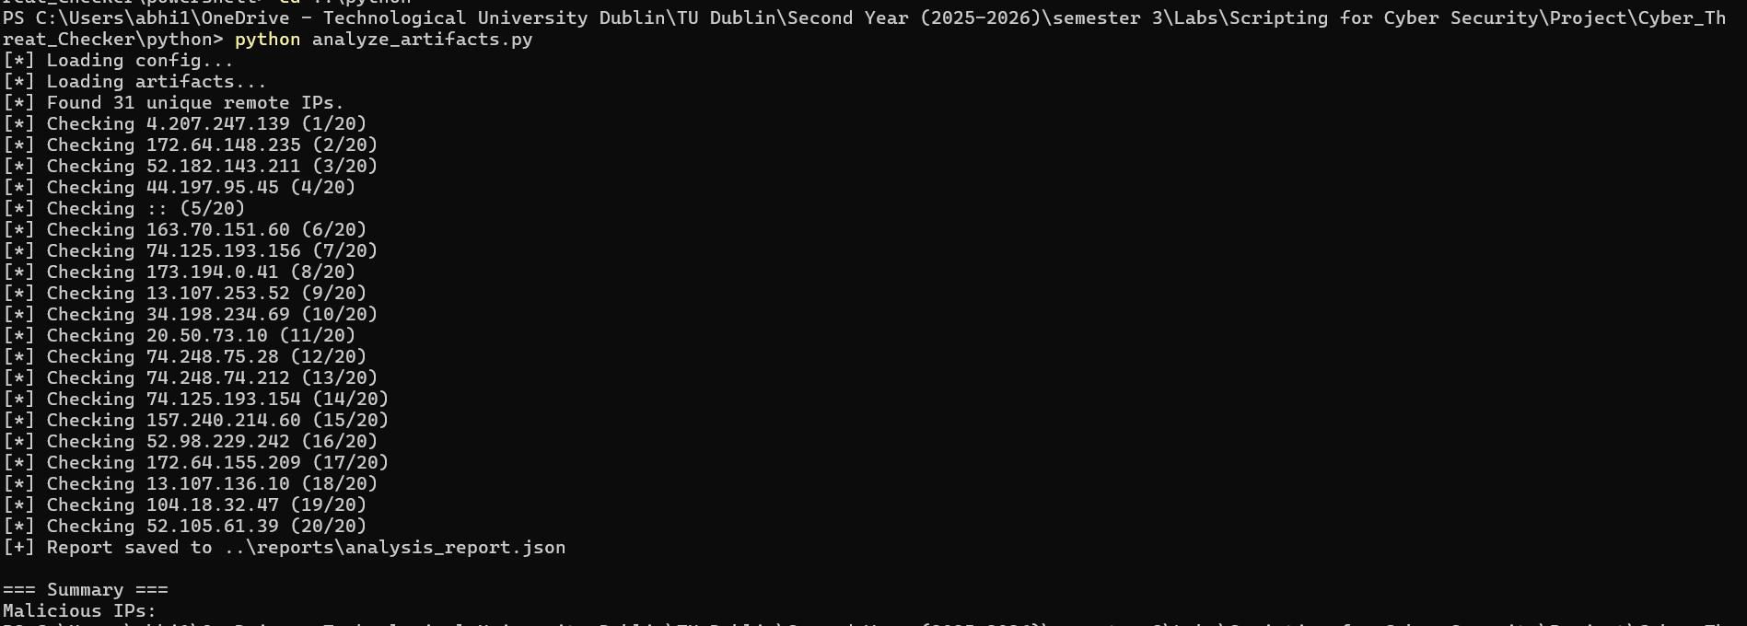

7. Summary

Our project, Cyber Threat Checker, automates the process of examining system activity for possible threats. PowerShell gathers running processes and network connections, while Python checks any remote IP addresses using the VirusTotal API. This helps identify suspicious or malicious communication quickly. The tool demonstrates essential skills like scripting, API usage, JSON handling, and report generation. Overall, the project provides a practical and easy-to-use method for detecting unusual behaviour and supporting basic security analysis.

