Cyberpunk ARPG Art and Audio Style Guide
Supporting design document • October 9 2026 • Version 1
Create a bleak industrial future in stylized realism. Augments replace flesh, limbs, faces, and heads. The visual spectrum includes both lightly modified people and radically rebuilt bodies. Manufacturer construction language remains recognizable across that spectrum.
This guide supports the Primary Requirements version 2 and Adaptive Story System secondary brief. The accepted mood boards are embedded below. Detailed palette, motion, audio, and production guidance is proposed direction for review; it does not change gameplay requirements.

Established direction
- Stylized realism: credible materials, anatomy, weight, and mechanisms with exaggerated shapes that read from an isometric camera.
- Bleak future: corporate control, invasive hardware, and worn infrastructure. No neon visual language.
- Manufacturer identity determines construction: heavy industrial, precision surgical, and economical mass-market.
- Hardware replaces body parts. Light modification and extreme posthuman transformation are both valid.
- Standard kills are stylistic and believable. Optional Bloody Mess permits exaggerated brutality. A non-graphic setting retains satisfying impact.
- Combat threats and loot remain readable on mobile and during five-player play.

Shared palette and materials
Use concrete grey, soot black, dirty bone, oxidized metal, and faded textiles as foundations. Manufacturer accents are restrained paint, material, or markings. Avoid neon strips, decorative emissive outlines, and saturated cyberpunk haze. Practical lighting can remain visible without turning the world into a neon spectacle.
Use ceramic, brushed and cast metal, rubber seals, worn polymers, fasteners, and healed implant interfaces. Surface condition should reflect manufacture, maintenance, and age. Preserve enough value contrast to separate actors from their surroundings.

Accepted visual spectrum

Light and moderate augmentation
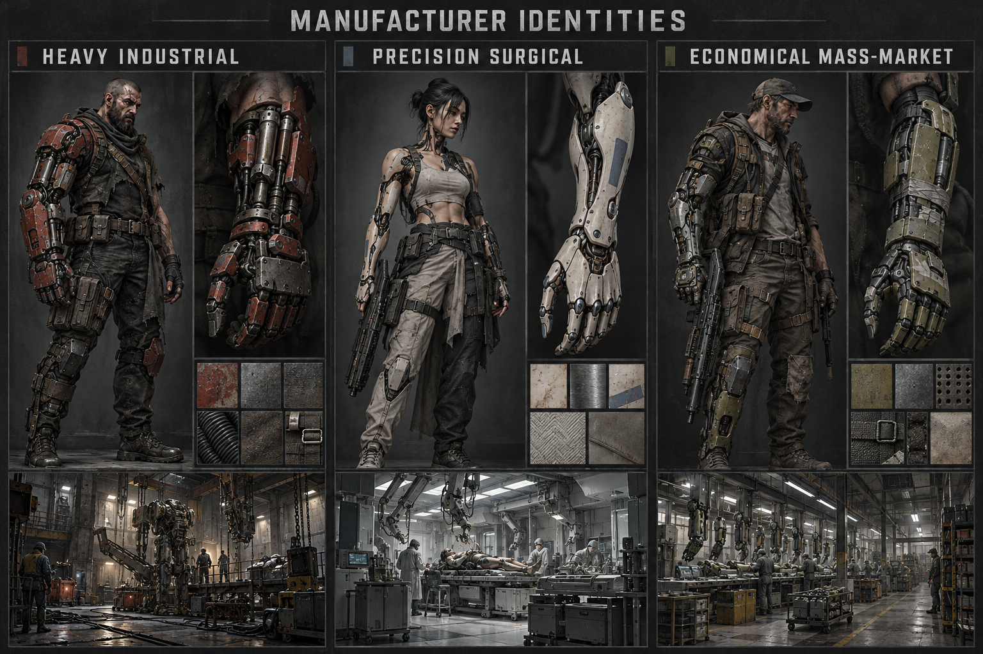
Reference A establishes manufacturer materials, restrained accents, and human silhouettes with partial replacements. Carry its grounded surfaces and brand distinctions into lightly augmented characters.

Radical replacement anatomy
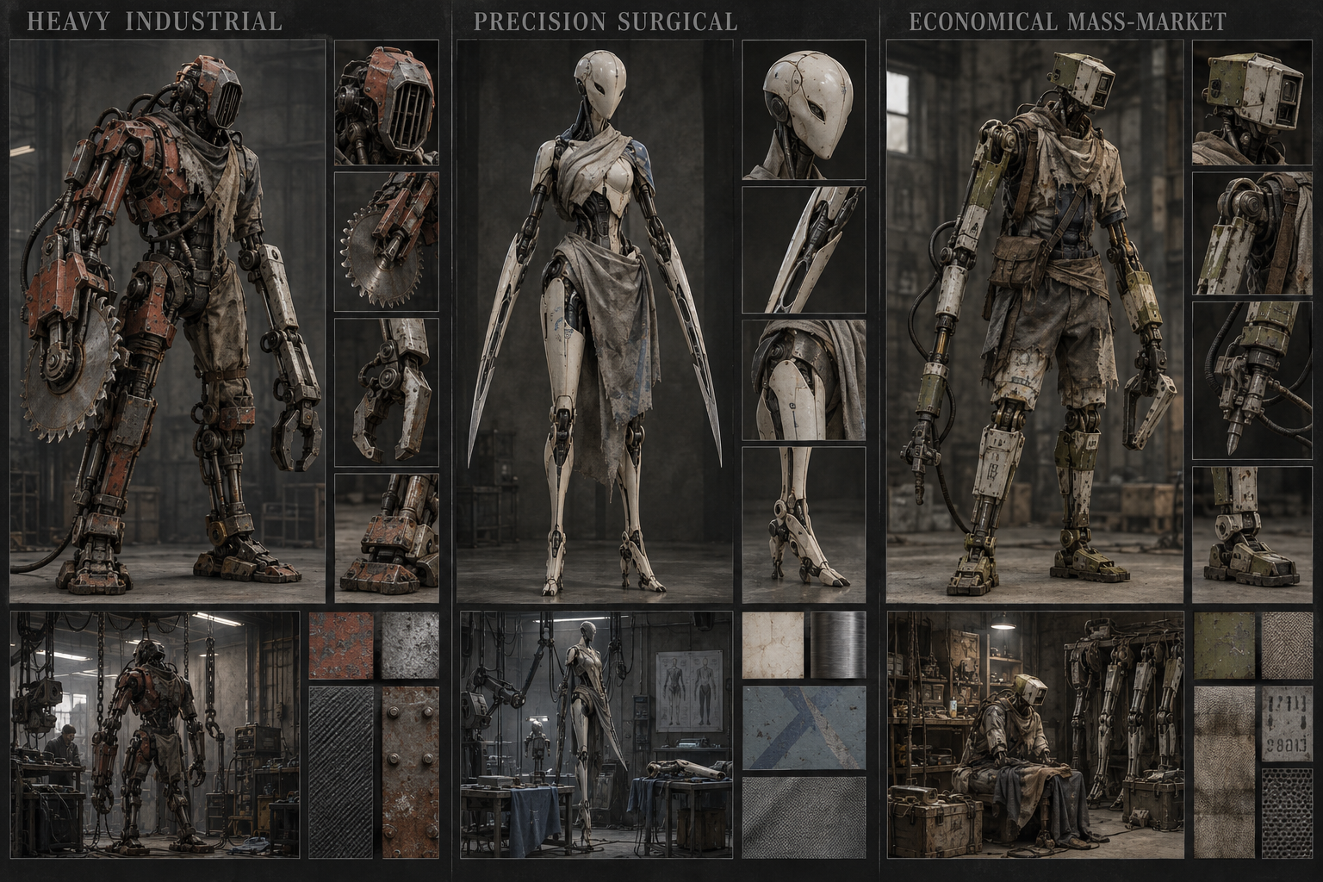
Reference B establishes saw and blade limbs, manufactured heads, nonhuman extremities, and mismatched replacement assemblies. Both boards are accepted endpoints, not competing directions. Reference images communicate direction rather than final asset specifications.

Manufacturer and body design

Heavy industrial
Favor exposed actuators, thick armor, bolted fittings, rubber bellows, replaceable modules, and broad load-bearing shapes. Muted oxide-red paint is a proposed accent. A light implant might be an exposed forearm mechanism; an extreme body might use a shoulder-mounted ripper, clamp ends, piston legs, and an intake grille instead of a jaw.

Precision surgical
Favor compact integration, flush seams, ceramic shells, precisely fitted metal joints, and controlled tapering forms. Dirty ivory with muted slate-blue markings is a proposed palette. A light implant can sit almost flush with anatomy; an extreme body can have blade arms and a seamless manufactured face without a mouth. Precision does not require conventional beauty.

Economical mass market
Favor stamped parts, molded polymers, standardized connectors, refurbished panels, exposed adapters, and visible repairs. Muted olive is a proposed accent. Light replacements remain practical and modular; extreme bodies may use repurposed leg mechanisms as arms and standardized sensor housings as heads.

Bodies and silhouette
Make replacement boundaries legible. Clothing hangs around installation points; hardware occupies the space flesh once did. Hands, feet, and human facial features are optional. Preserve believable connections and load paths even when anatomy is unsettling. Manufacturers supply multiple combat functions and do not map to classes.
Support mixed-brand bodies without losing the visual identity of individual parts. Independent left and right limb slots should be apparent. Account for the distinction between arm and hand slots, and leg and foot slots: a blade-ended assembly must still support a coherent gameplay and visual attachment model. Exact attachment conventions require asset-pipeline design.

Environment and lighting
Use industrial workshops, institutional clinics, cramped service passages, assembly lines, and corporate facilities. Oppression should appear through access control, production systems, standardized equipment, and signs of dependency. Mix worn public spaces with meticulously maintained corporate machinery. Use overcast light and practical work fixtures; bleakness must not make navigation unreadable.

Combat motion effects and sound

Impact and weapon identity
Build satisfaction through anticipation, contact, recoil, sound, and reaction before adding gore. Saws catch and tear; blades deliver clean directional cuts; heavy rounds produce forceful recoil and collapse; electricity produces brief muscular or mechanical lockup. These are proposed animation families to prototype.
Keep kills inside ordinary combat timing. Avoid execution cutaways, camera takeovers, or prolonged finishing sequences that interrupt movement and short dungeon clears. Optional camera shake, brief impact emphasis, and layered sound should be tuned for comfortable repeated play.

Gore settings
- Gore Off: retain timing, force, recoil, sound, and collapse. Remove blood, graphic wounds, exposed tissue, and violent dismemberment. Manufactured body replacements remain part of character identity.
- Standard: weapon-specific wounds, controlled blood bursts, and selective dismemberment. Grounded, decisive violence without constant explosions of remains.
- Bloody Mess: exaggerated ruptures, severing, and spectacular remains. High-intensity kills occur within normal combat flow.
All modes share damage, collision, attack timing, loot, and progression. Cosmetic remains must not create gameplay advantages. Separate gore intensity from reduced-effects settings so graphic content and performance can be adjusted independently.

Rarity and readability
Grey has no special rarity effect; green very slight, blue slight, purple restrained spectacle, and orange elaborate mechanical animation with controlled effects. Normal locomotion and attacks still animate at every rarity. Paid skins preserve silhouettes and stay within the item’s rarity tier. Orange items include impressive default animations.
Prefer moving machinery, distinct attack shapes, and material craftsmanship over particle volume. Establish a priority order: enemy telegraphs and hazards, targeting and player actions, loot feedback, then incidental cosmetic effects. Clear or fade remains before they obscure navigation or important objects. Confirm readability at actual mobile scale.

Proposed audio direction
Use physical machinery and close impact detail: motor strain, blade bite, hydraulic pressure, ceramic contact, and worn connectors. Give manufacturers distinct mechanical signatures. Reduce overlapping incidental sounds in crowds while preserving elite warnings. Music should support institutional dread and industrial tension; restrained percussion, low textures, and sparse motifs are candidates to audition.

Production use and review

Asset presentation
Present character and augment concepts at a readable isometric gameplay angle as well as close-up detail. Show silhouette, attachment interfaces, manufacturer materials, and proposed motion. Test mixed-brand combinations and the full spectrum from partial replacement to radically rebuilt bodies.

Review criteria
- Can the manufacturer be recognized by shape and materials without reading a name?
- Does hardware genuinely replace anatomy rather than sit on top as armor?
- Do both modest and extreme bodies belong to the same world?
- Do motion and sound communicate weight and weapon function?
- Can five players with orange equipment fight an elite without hiding its telegraphs?
- Do all gore settings preserve clear, satisfying combat feedback?

Next art decisions
Finalize proportions, manufacturer names and markings, material palettes, attachment conventions, environment references, UI typography and layout, animation budgets, and audio samples. The boards establish direction but do not yet define production-ready rigs, meshes, textures, or sound libraries.

