1. **Paper reading**:

Nogawa's paper (PRE 2012 ):

They didn't discuss Z2 systemmetry;

The paper showed the behaviors of magnetization and susceptibility in 3 asymptotic regimes.

I tried finding more papers from Nogawa and Hasega, but these papers are less relevant. I may try to search for more papers later.

1. **Fixed point analysis with magnetic fields:**

We already did the fixed pointed analysis for HNNP AFM without the magnetic field $H$, and found results as shown below:

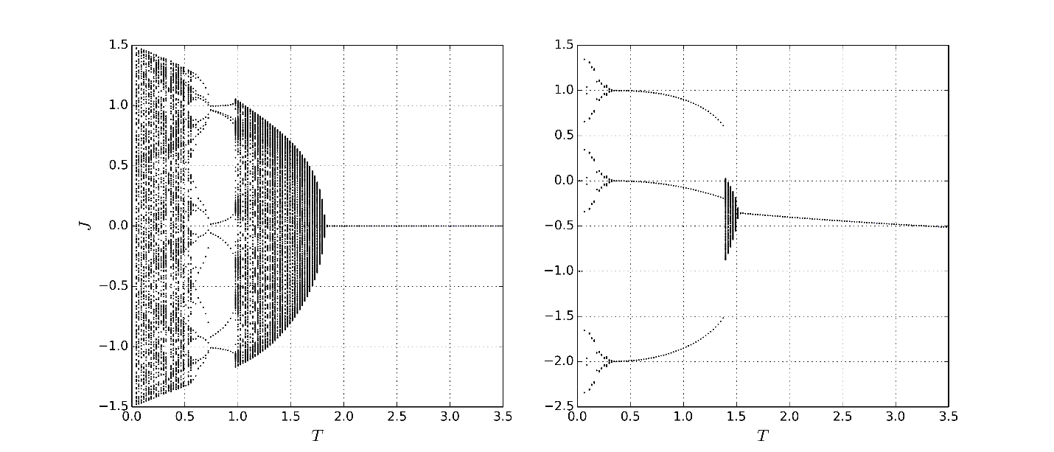

I can do the same thing for the recursive equations with the magnetic field $H$ (i.e. the recursive equations will have $η$ and other activity parameters), and test the following things:

1. H=0: it should produce the same plots shown above;
2. H>0: how $κ$ changes with bigger and bigger $H$. Hopefully, we can learn something about Z2 symmetry.

I will write the code in Python as what I did for HNNP without $H$. It can give me more flexibility for data visualization and export.

1. **2-point function renormalization group calculation:**

As we talked 3 weeks ago, if Z2 symmetry break can be realized by changing $H$, I may just try different $H$ for the calculation of 2-point functions. Hope it can give us some sense of AFM symmetry breaking.

However, I suspect there may be no such symmetry break as in the FM model (showed in Trent’s dissertation) based on what I seen from the plots of $m$ vs $μ$ at different H.