Sean McGrath-Bennett

May 17, 2022

Foundations of Programming: Python

Assignment 05

Creating the Home Inventory Menu Script

Introduction

This paper outlines the necessary steps to create the ToDo Python Menu Script which allows a user to input a “To-Do” list, indicate the priority, delete added rows, save the information to a text file, and then closes the program.

Writing and Running a Home Inventory Python Script

I wrote and ran the script using PyCharm.

The goal is to create a python script file that allows a user to input any number of “To-do” items and include a priority for each item. A user can add items and elect to display the current data. Each row of information, including the listed “Task” and “Priority” that matches a user input can be deleted. Once complete, a user can save the list to a text file and then close the program

Once the code was in place, I ran the code in PyCharm and via a Console Application. (Figure 1)

**Figure 1: Example Code**

After running, testing and finalizing the script I ran the code using the “Command Prompt” system. Although the script would mostly run using the Command Prompt window, it would not save to a text file. Subsequently, I changed the directory to the folder the script was in, typed “python” and then ran the script successfully. Once done, I hit enter which then prompts me to make my selection. I input several pieces of data, displayed the data and then closed the script which wrote the lists to a text file. (Figure 2)

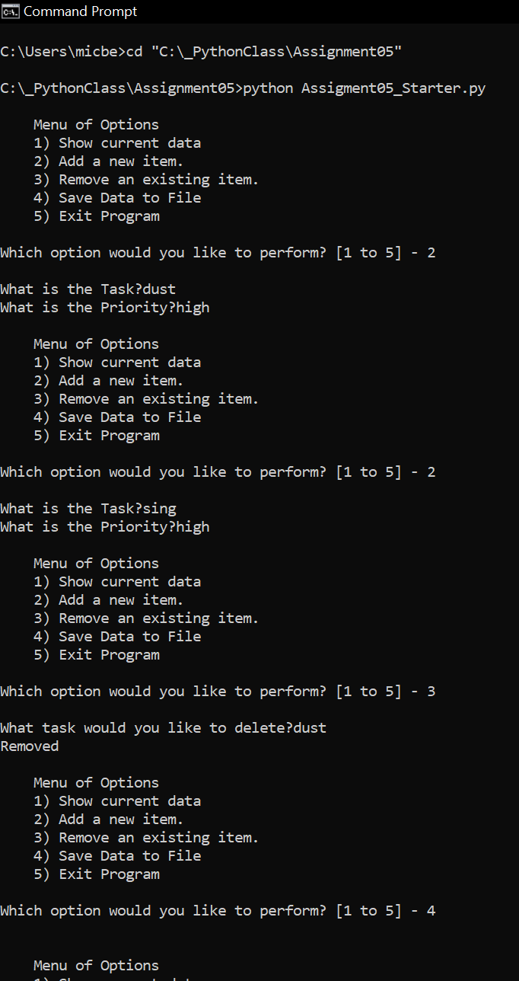

**Figure 2: Console Application running Python Script**

Summary

This paper described the process, using PyCharm (to create the Home Inventory Menu Script) and then explains how to run the script using Command Prompt to create a console application that receives input and writes the input information to a text file.