Group C7

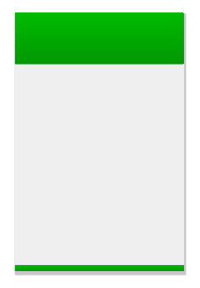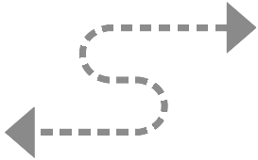MVC Diagrams

Controller

MainActivity.java

(Multiple event listeners linked to methods)

Data Handler Class

(To create/update/delete Databases)

View

All displays/UI

activity_main.xml

athelete_profile.xml

coach_profile.xml

create_challenge.xml

current_challenge.xml

future_chanllenge.xml

log_result.xml

...ect

Model

SQLite Database

(Store all data)

Users class

Team class

Challenges class

Result class

...ect

(Holds Entry Data to be passed into DB)

View Selection

User Events

State query

State changes

Update DB

Change Notification