NOTE: This storyboards were mocked up, not created in Android Studio. They intentionally have the same style as Android Studio.

1. Account Creation

As a user, I want to create my own personal account, so that all my information is saved.

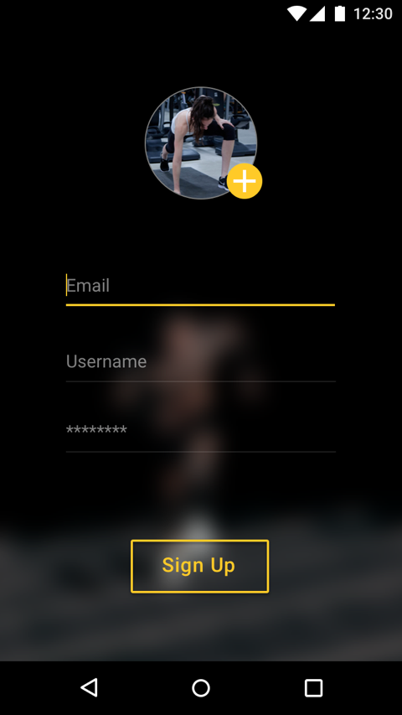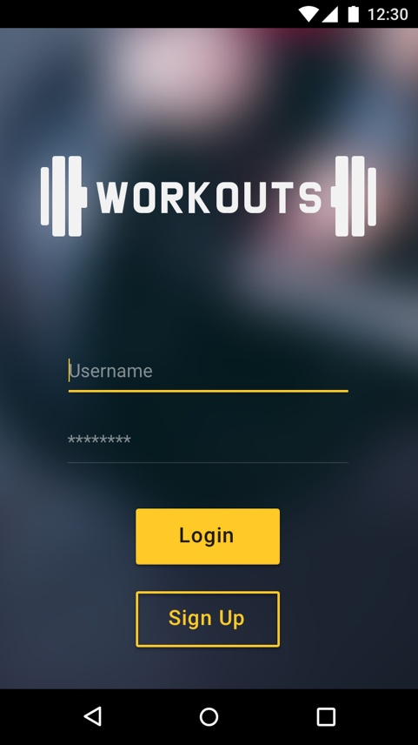

Scenario: User creates account

   Given a user click on the [Sign Up] button

   Then they should be taken to an account creation form page

   When they filled out the required information

   And click the [Sign Up] button

   Then they should have their account created.

2. Athlete Account Creation

As an athlete, I want to create my own athlete account, so that I can join challenges.

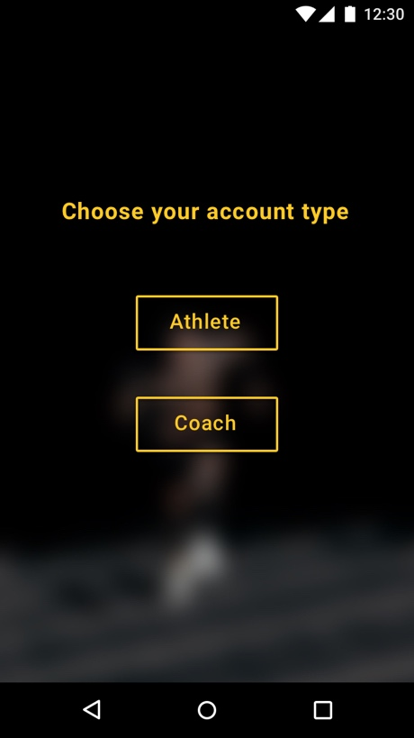

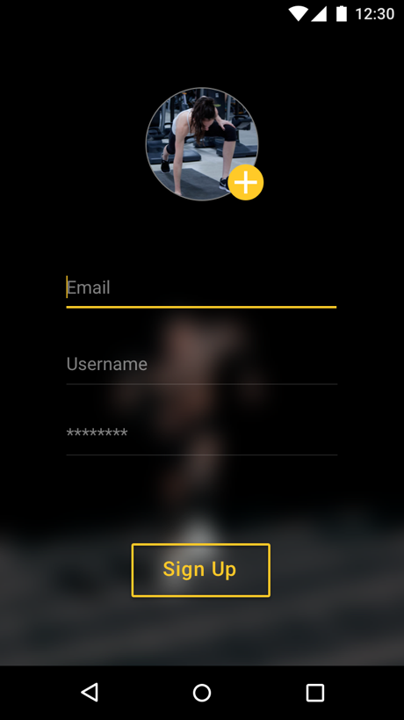

Scenario: User chooses an athlete account

   Given a user clicks on the [Sign Up] button

   Then they should be taken to an account creation form page

   When they filled out the required information and click [Sign Up]

   Then they are taken to the Account Type Page

   And click [Athlete]

   Then they should have their account created and registered as an athlete

3. Coach Type Creation

As a trainer/coach, I want to create my own coach account, so that I can be distinguished from other athletes.



    Scenario: User chooses a coach account

   Given a user clicks on the [Sign Up] button

   Then they should be taken to an account creation form page

   When they filled out the required information and click [Sign Up]

   Then they are taken to the Account Type Page

   And click [Coach]

   Then they should have their account created and registered as an coach

4. Log-in

As a user, I want to be able to log in with a unique Username and Password, so that all my information is private and secure.

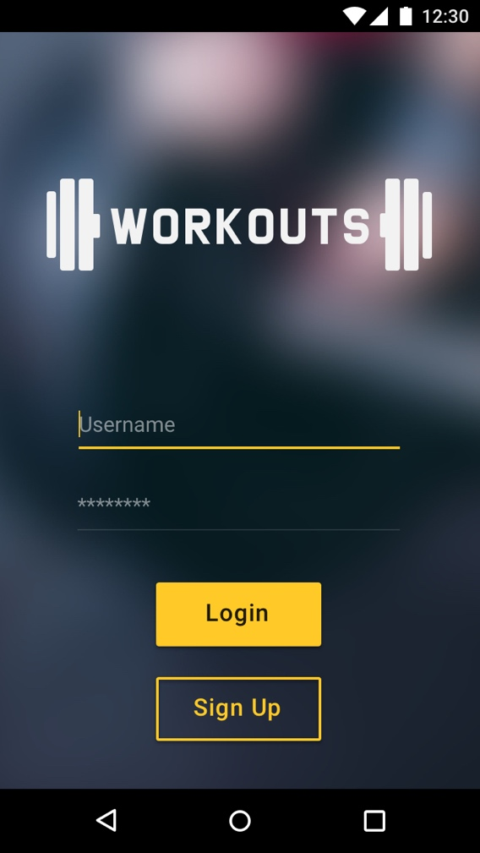

Scenario: User logs in

   Given a user fills out the {Username} field that's already registered

   And {Password} fields with the correct password

   When they click the [Log in] button

   Then they should see their homepage

5. Create team

As an athlete, I want to create a team for certain challenge, so I can participate with my friends.

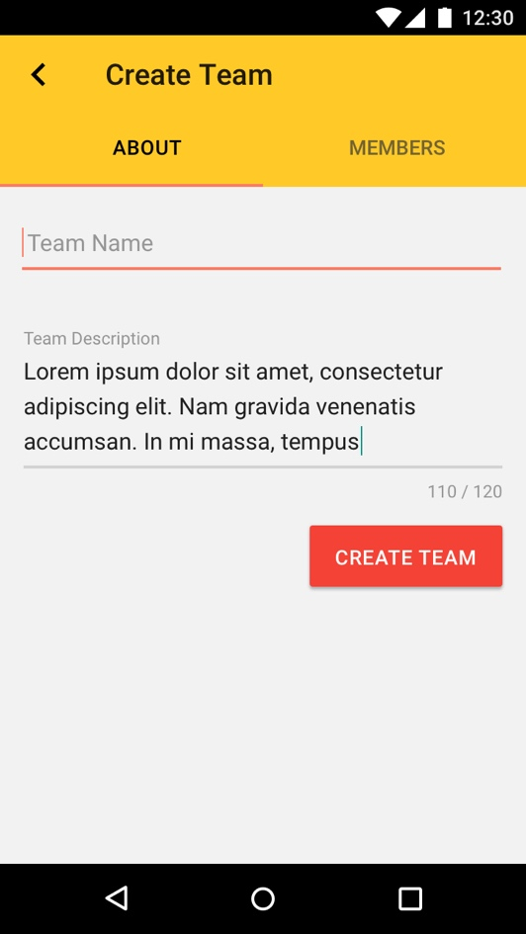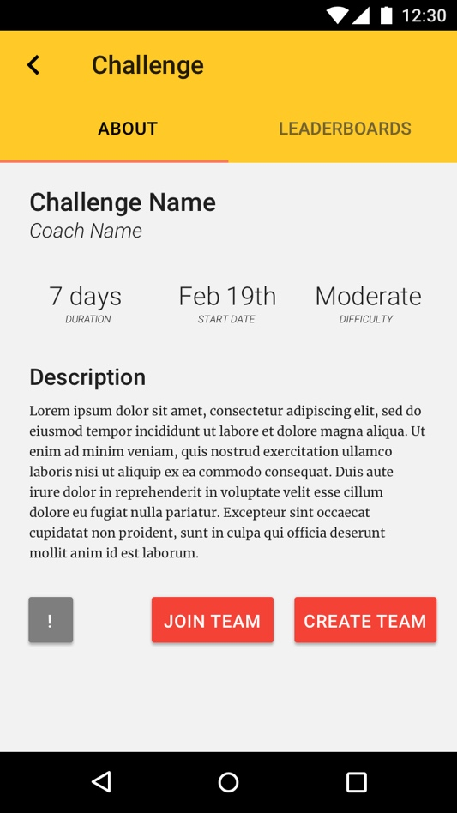

   Scenario: User creates a team

   Given a user is viewing their challenges

   When they click the [Create Team] button

   Then they should be taken to a team creation form page

   When they filled out the required information

   And click [Create Team]

   Then they should have their account created

6. Create/post Individual Challenges

As a trainer/coach, I want to create Individual challenges with vivid description and requirements, so that athletes can join and compete.

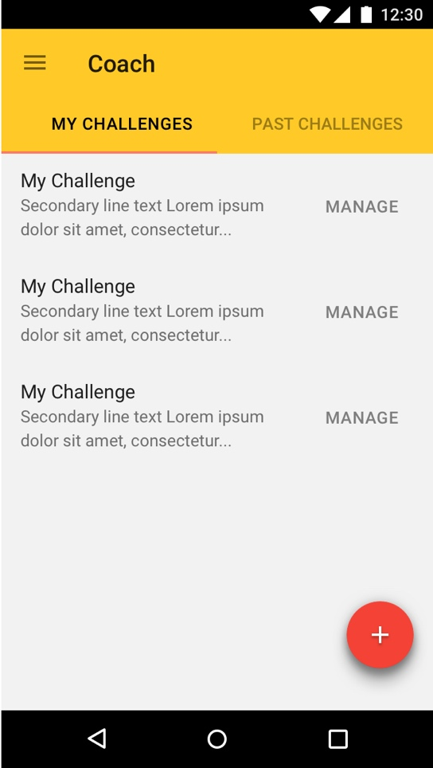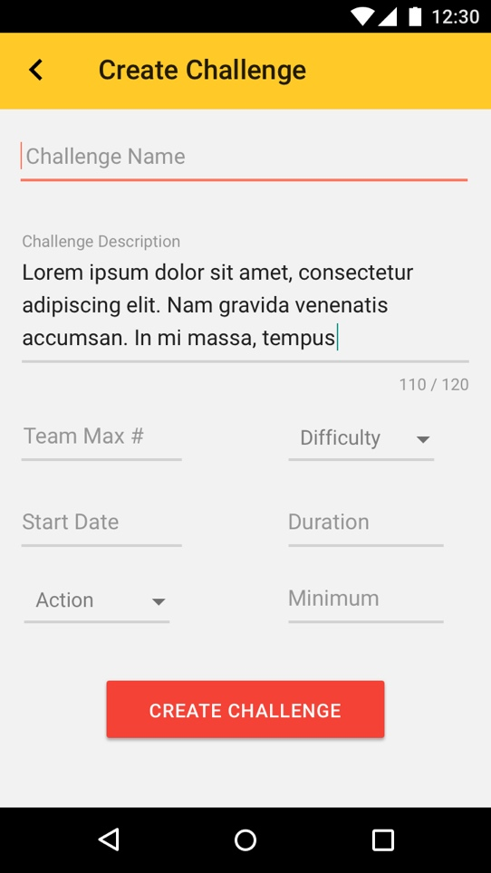

   Scenario: User(Coach) creates an individual Challenge

   Given a user(coach) is on their homepage

   When they click the [+] button

   Then they should be taken a challenge creation form page

   When they filled out the required information

   And select [1] for the {Team Size} field

   And click [Create Challenge]

   Then they should have their challenge created and posted

7. Create/post Team Challenges

As a trainer/coach, I want to create/post Team challenges with vivid description and requirements, so that Teams can join and compete.



   Scenario: User(Coach) creates an individual Challenge

   Given a user(coach) is on their homepage

   When they click the [Create Challenge] button

   Then they should be taken to a challenge creation form page

   When they filled out the required information

   And input a number for the {Team Size} field

   And click the [Ok] button

   Then they should have their challenge created and posted

7a. Register for Challenges

As a user, I want to pick and choose challenges from a list to join, so I can compete in the ones I like.

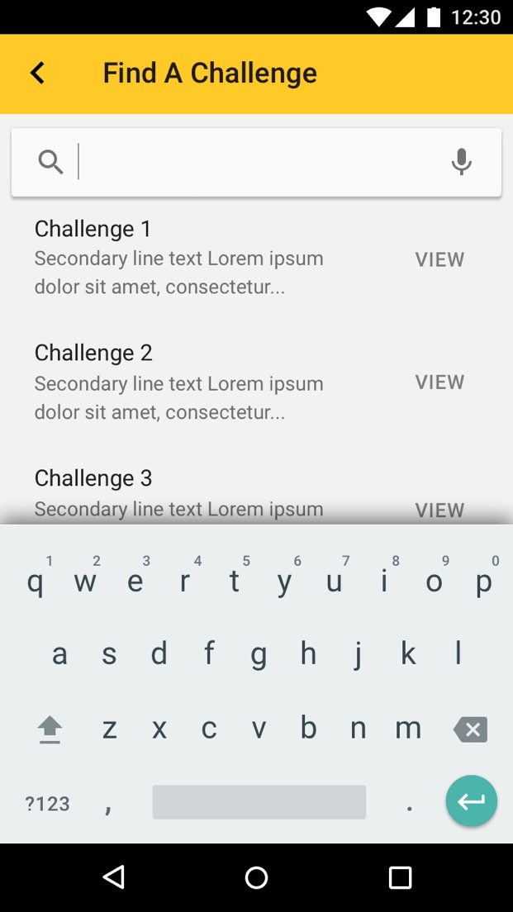

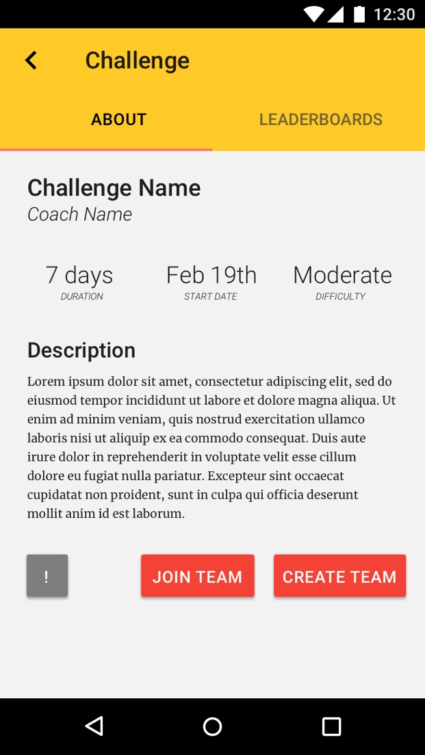

   Scenario: User registers for a challenge

   Given a user is on their homepage

   When they click the [\*Search Icon\*] button

   Then they should be taken to the future challenges page

   And see all the future challenges that they have not yet registered for

   When they select a challenge

   And click the [Join Team/Create Team] button

   Then they should be able to join an existing team or create a new team

8. View current challenges

As an athlete, I want to be able to view current challenges I have registered, so that I can refer to the challenge information.

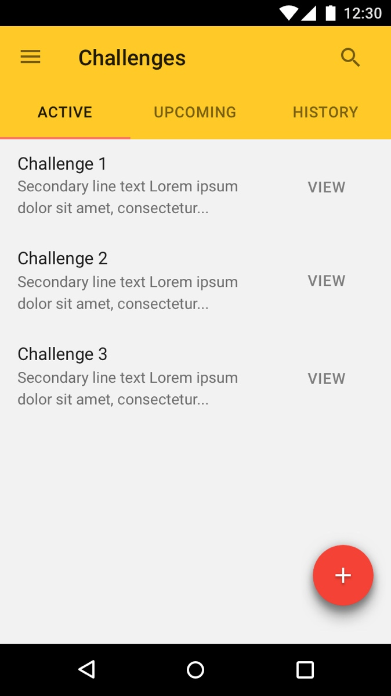

   Scenario: User views their current challenges

   Given a user is on their homepage

   When they click the [Current Challenges] button

   Then they should see all the challenges they are currently registered in, along with information

9. Friend list

As a user, I want to have the ability to add other users to my friends list, so that I can invite them to join my team.

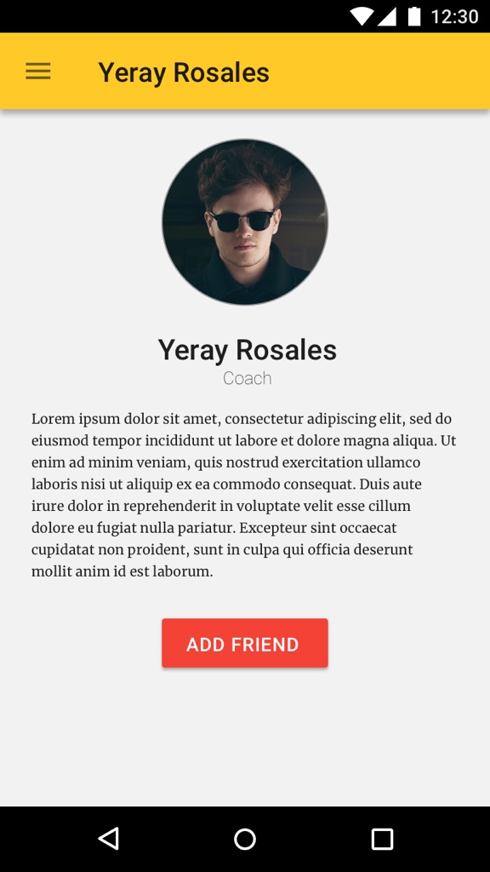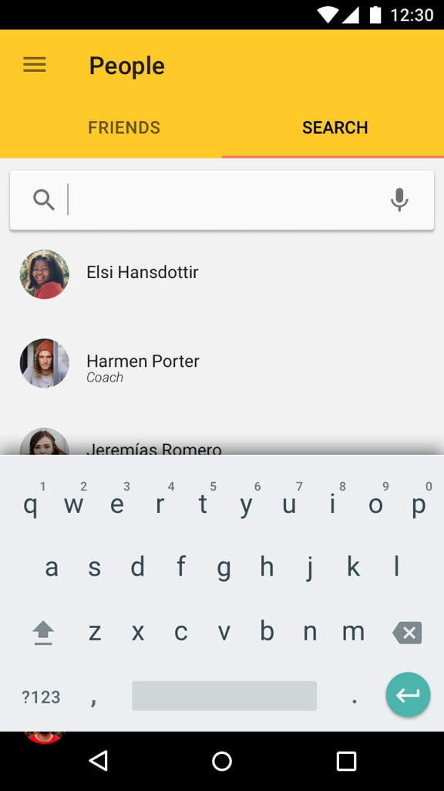

Scenario: User adds another user to Friend list

   Given a user is on their homepage

   When they click on the [People] button

   And click the [Search] button

Then input an existing user name

   Then click the [Add Friend] button

   Then that searched user should be on their friends list

10. Create Profiles

As a user, I want to have a profile with general information and a short bio, so that other users may get to know me better.

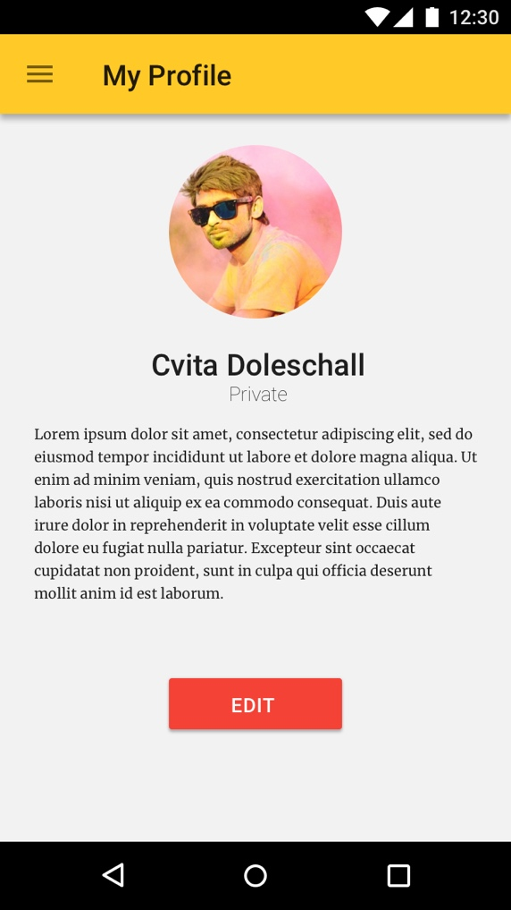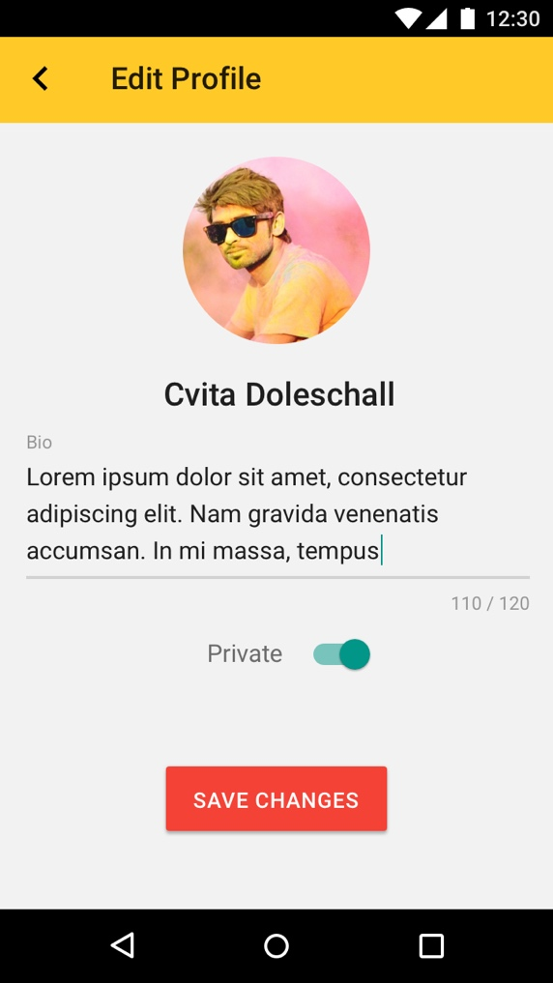

   Scenario: User makes a profile

   Given a user is on their homepage

   When they click the [Profile] button

   Then they should be taken a profile creation form page

   When they click on the [Edit] button

And fill out the desired information

   And click the [Save Changes] button

   Then they should have edited and saved their profile

10b. Make profiles public

As a user, I want to make my profile public, so that all other users may view it.



   Scenario: User makes their profile public

   Given a user is on their homepage

   When they click the [Profile] Button

   Then they should be taken to their profile

   When they select [Edit]

Then they should be able to edit their profile

When they toggle the [Private] toggle to off

   And click the [Save Changes] button

   Then they should have their profile set as public

11. View profiles(Only public)

As a user, I want to view other user's profiles, so I can get to know them better.

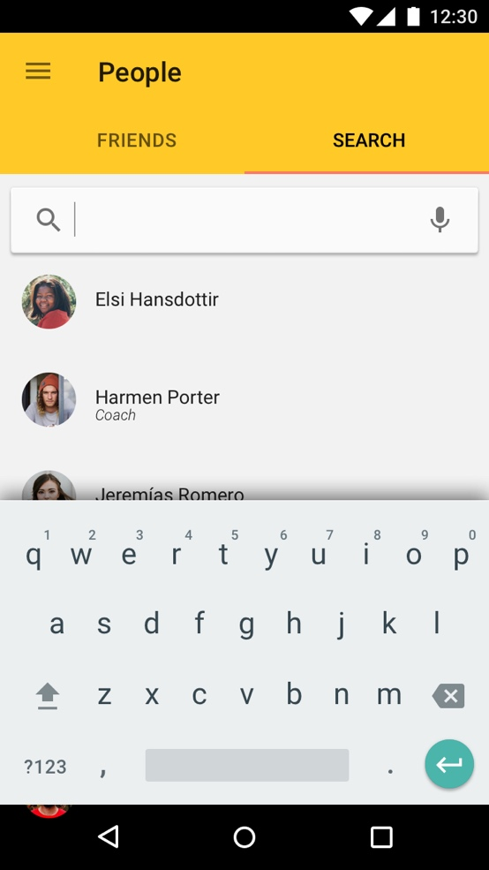

   Scenario: User views another user's profile

   Given a user is on their homepage

   When they clicks on the [People] button

   Then inputs a existing user name with a public profile

   And click the [Search] button

   Then click the [View] button

   Then they should be taken to the searched user's profile page

11. Profiles(private)

As a user, I want to have my profile set as private, so that none can view my information.





   Scenario: User makes their profile private

   Given a user is on their homepage

   When they click the [Profile] Button

   Then they should be taken to their profile

   When they select [Edit]

Then they should be able to edit their profile

When they toggle the [Private] toggle to on

   And click the [Save Changes] button

   Then they should have their profile set as private

11a. Invite friends to team

As a user, I want to invite users on my friend list to join my team, so we can all participate in the same challenge and motivate each other

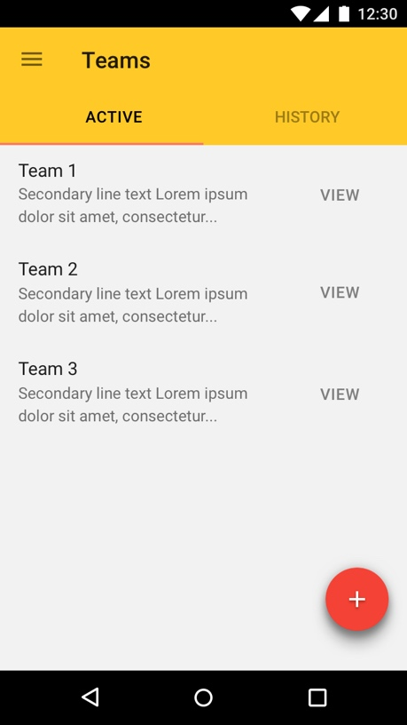

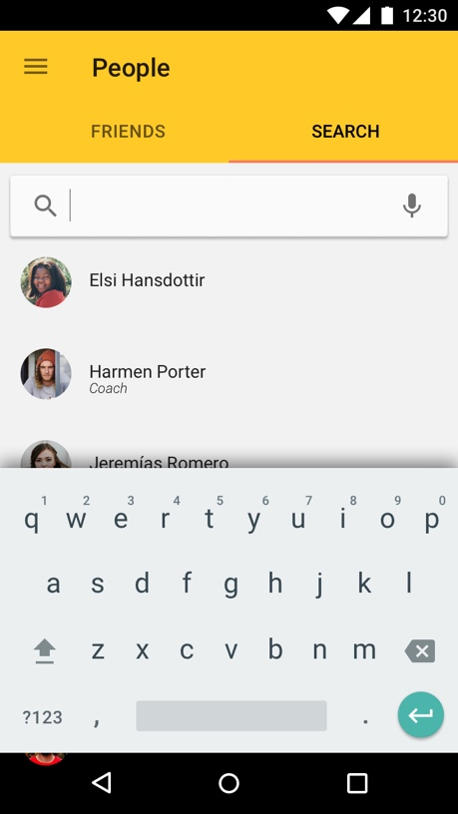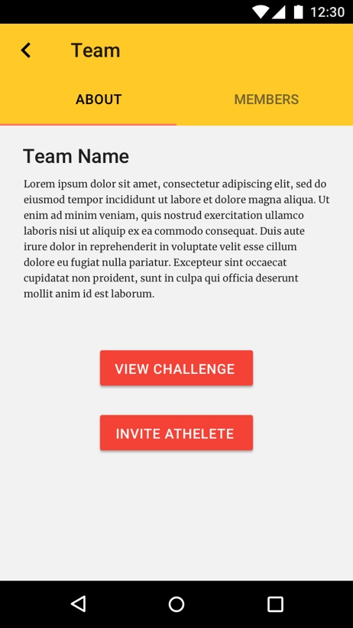

   Scenario: User invites users from their friend list to join team

   Given a user is on their homepage

   When they click the [Active Teams] button

   Then they should see a list of teams they are currently in

   When they select a team

   And click the [Invite Athlete] button

   Then they should see a list of users on their friend list

   When they select the desired users

   And click the [Invite] button

   Then those selected users should have invitation notifications sent to them

11b. Leave team

As a user, I want to be able to quit a team, so I do not take up a spot if I can not participate for that challenge.

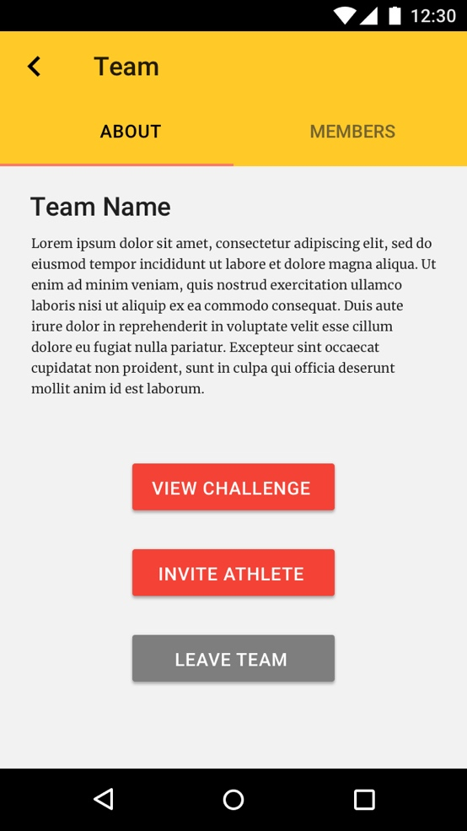

   Scenario: User leaves a team they are currently on

   Given a user is on their homepage

   When they click the [Active Teams] button

   And select a team

   And click the [Leave Team] button

   Then they should no longer be a member of that selected team

12. Invite Athletes

As a trainer/coach, I want to be able to see a list of all users(not coaches), so that I can invite them to join my challenge.

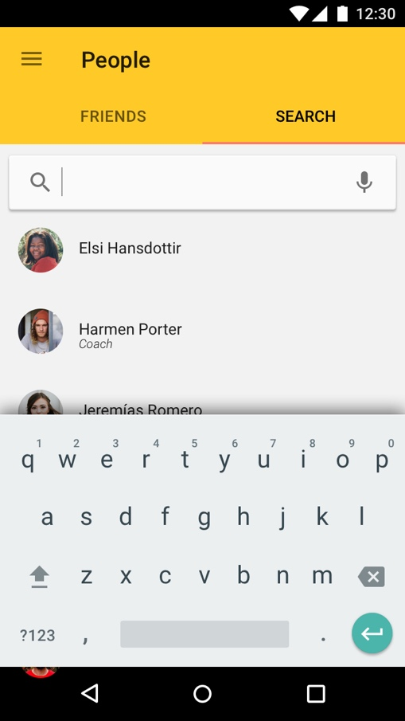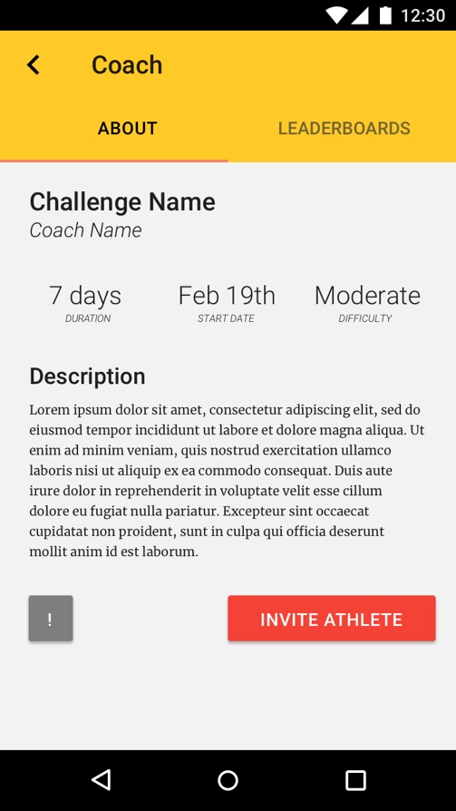

   Scenario: Coach invites users to join their challenge

   Given a Coach on their homepage

   When they click the [My Challenges] button

   Then they should see a list of their created challenges

   When they select a challenge

   And click the [Invite Athlete] button

   Then they should see a list of all users

   When they select the desired users

   And click the [Ok] button

   Then those selected users should have invitation notifications sent to them

13. Leader boards

As a user, I want to see top performers for both individual and team challenges with respected results, so I can compare my own results.

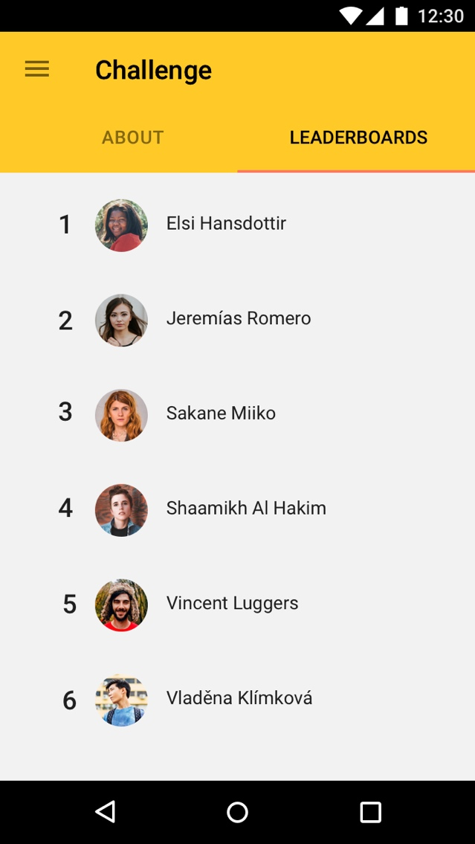

   Scenario: User views leader boards for all challenges

   Given a user is viewing a challenge

   When they click the [Leaderboards] button

   Then they should be taken to the leaderboards page

   And they should see top performers with respected challenges and results

14. Logging results

As an athlete, I want to be able to log my results within 24 hours after the challenge ends, so that I have adequate time to log my results.

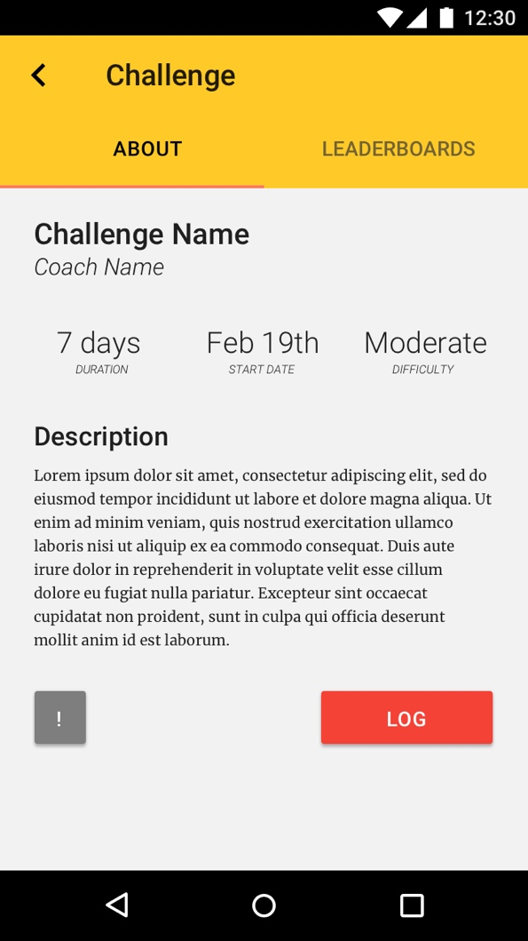

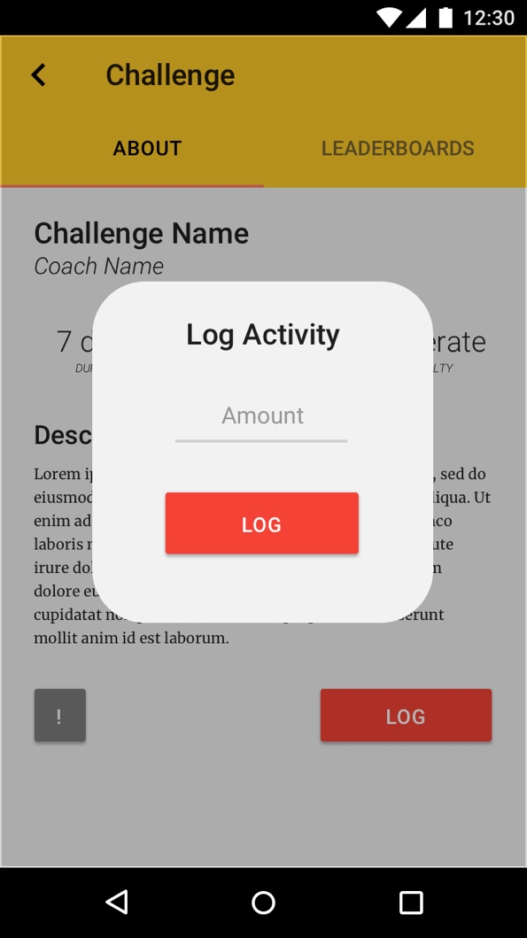

   Scenario: User logs their results

   Given a user is viewing a challenge

   Then they click the [Log] button

   And they should see a open input field for {Amount}

   When they input a number

   And they click the [Log] button

   Then their result for the selected challenge should be logged

15. History

As an athlete, I want to be able to see a history of past challenges I competed in with respected results, so that I can track my progress.

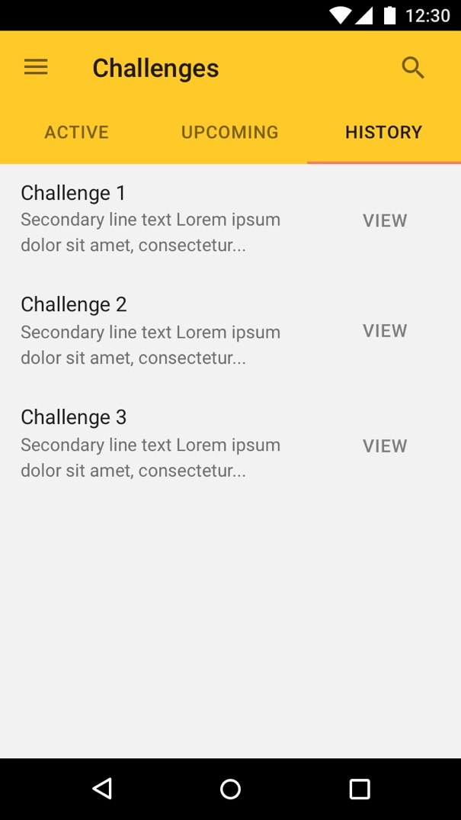

   Scenario: User views their history of past challenges

   Given a user is on their homepage

   When they click on the [History] button

   Then they should be taken to a history page

   And they should see all past challenges they have participated in with their logged results

16. Remove History

As an athlete, I want to be able to remove history of past challenges, so that I can start anew.

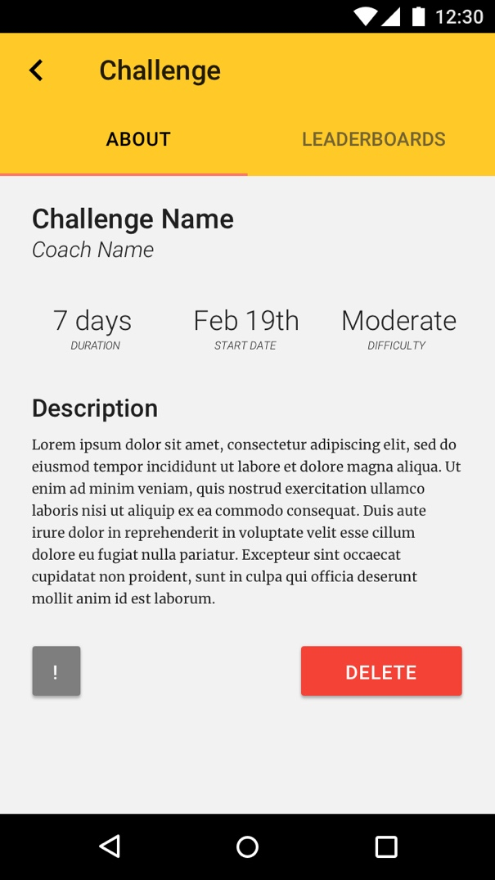

   Scenario: User deletes history

   Given a user is on their homepage

   Then they click on the [History] button

   And they select the challenge they with to delete

   When they click on the [Delete] button

   Then the history of that challenge should be removed

17. Challenge start notifications

As an athlete, I want to receive notification prior to when a challenge is about to start, so that I do not forget to participate.

No story board needed. Default Notification.

   Scenario: User receives notification before the challenge is to start

   Given a user is registered for a challenge

   When the challenge is near its start time

   Then the user should receive a notification from the app to remind them

18. Logging notifications

As an athlete, I want to receive notification if I have not yet logged my results by 8pm on the last day to log, so that I do not forget to log.

No Storyboard needed. Default Notification.

   Scenario: User receive notification at 8pm(Eastern) on the last day to log results if they have not yet logged

   Given a user is registered for a challenge

   And they have not yet logged their results

   When it is 8pm(Eastern) on the last day to log

   Then they should receive a notification from the app to remind them

19. Coach notifications

As a coach, I want to be able to send notifications to all athletes registered to my challenge, so that I can send reminders, changes and updates.

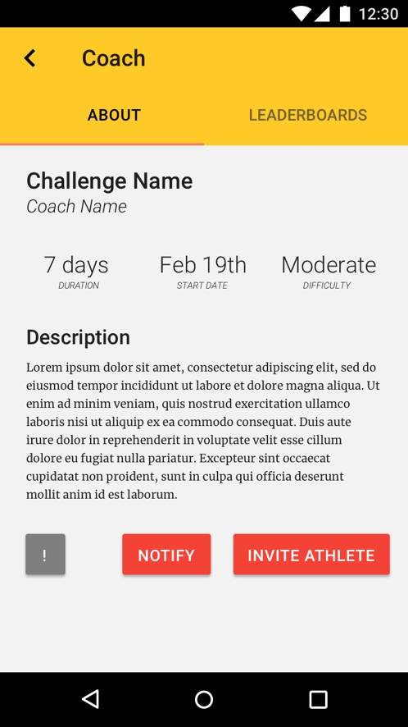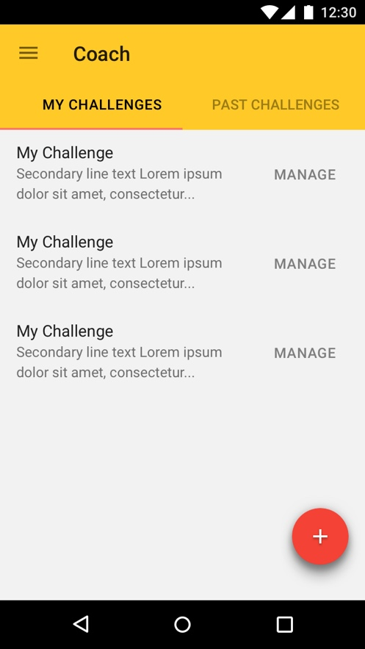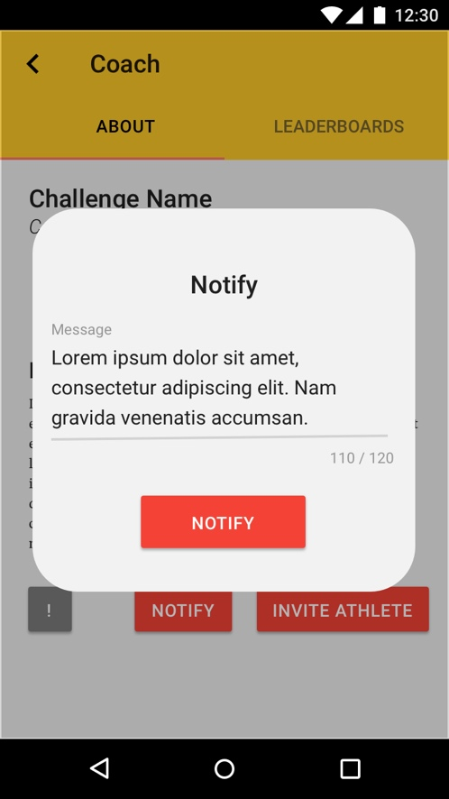

   Scenario: Coach sends notification to all athletes registered to their challenge

   Given a Coach is on their homepage

   When they click the [My Challenges] button

   Then they should see all the challenges they have created (Not expired)

   When they click the [Notify] button

   Then they should see a text input field for {Message}

   When they filled out the field with desired content

   And click the [Notify] button

   Then all users registered to that challenge should receive the notification with its message

19. Receiving notifications

As a user, I want to be able to see all notifications sent to me, so I can read them and act accordingly

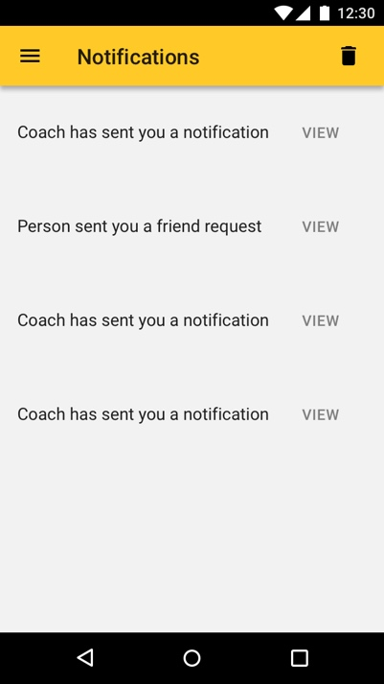

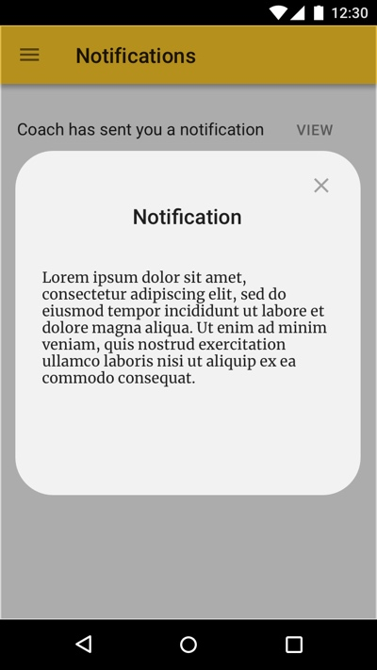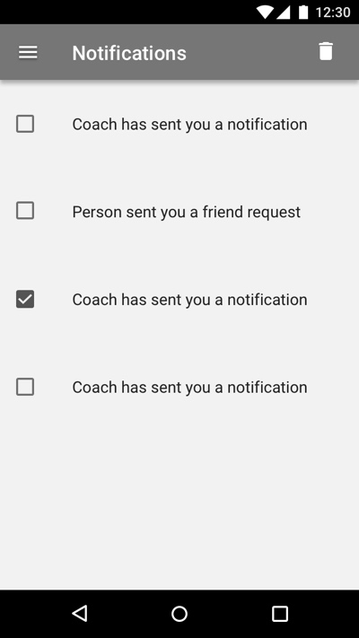

   Scenario: A user receives notifications

   Given a user has notifications sent to them

   When they are on their homepage

   Then they should see the notification messages

When they click on [View]

Then the message appears

Scenario: A user deletes a notification

Given a user wants to delete a notification

   When they click the [Trash] button

Then they can select which notifications they want to delete

When they have selected the desired notifications

Then they can click the [Trash] button again

   Then the notification(s) should disappear

20. Accept/Decline invitations

As a user, I want to be able to accept or decline all invitations, so I can accept what I am willing to join and decline what I am not.

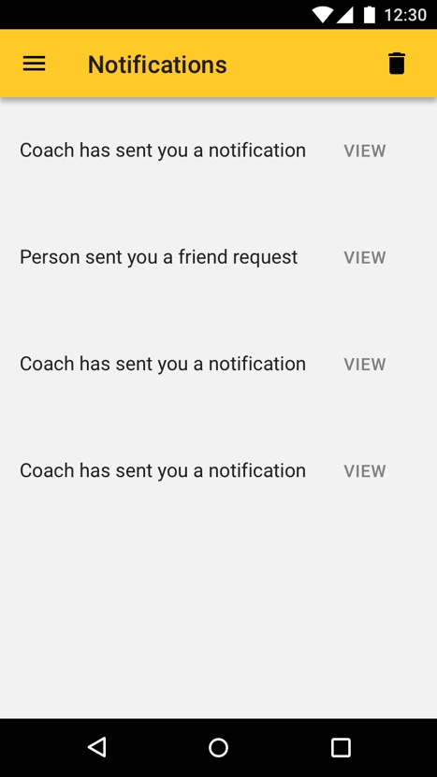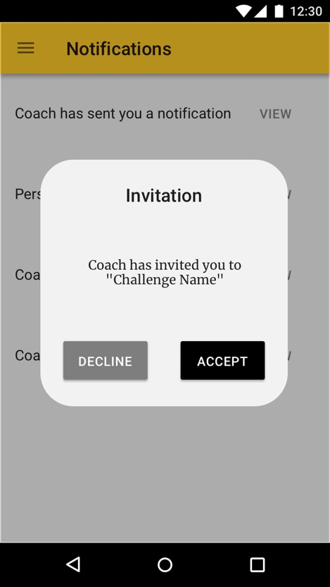

   Scenario: A users Accept/Declines invitation

   Given a user has been invited to a team or challenge or friend request

   When they are on their homepage

   Then they should see invitation notifications

   When they select an invitation

   And they click on the [Accept] button

   Then they should have joined the selected team or challenge and the invitation should disappear

   When they select an invitation

   And they click on the [Decline] button

   Then no action is taken and the invitation should disappear

20. Change Username

As a user, I want to be able to change my username, so if there is another user with similar username I can be distinguished.

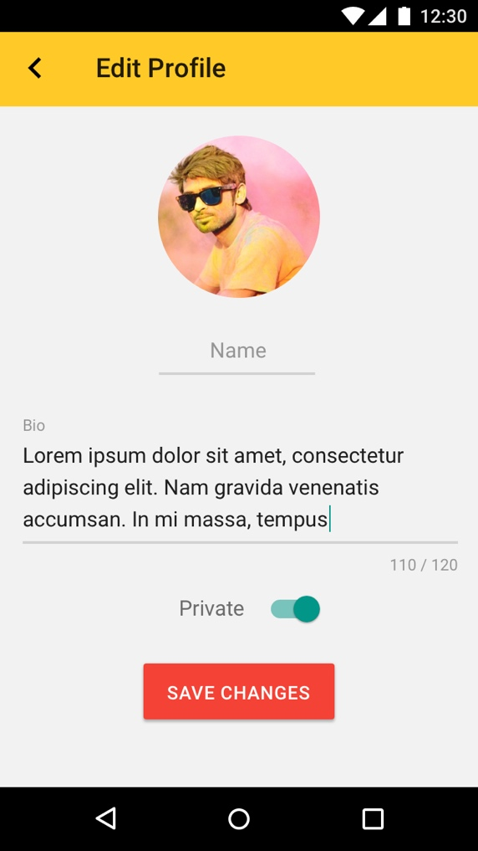

   Scenario: User changes their username

   Given a user is on their homepage

   When they click on the [Profile] button

   When they filled out the {Name}

   And they click the [Save Changes] button

   Then their username should be changed

21. Disclaimers

As a coach, I want disclaimers regarding health conditions posted on all challenges, so that I am not responsible for legal claims.

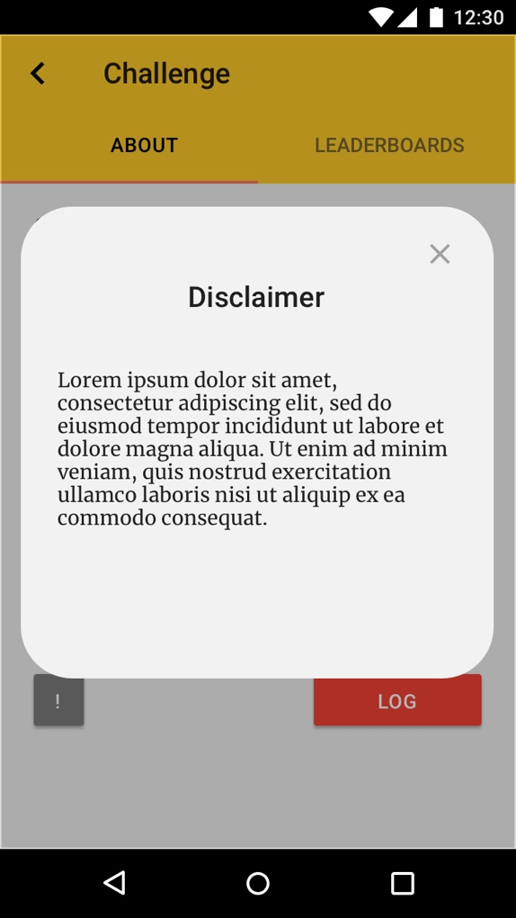

   Scenario: All users registering for a challenge should see Disclaimers

   Given a user is on the future challenges page

   When a challenge is selected

   Then they should a disclaimer regarding health conditions

22. Difficulty indicator

As an user, I want to see the level of difficulty on challenges, so I can pick the most suitable challenge for my condition.

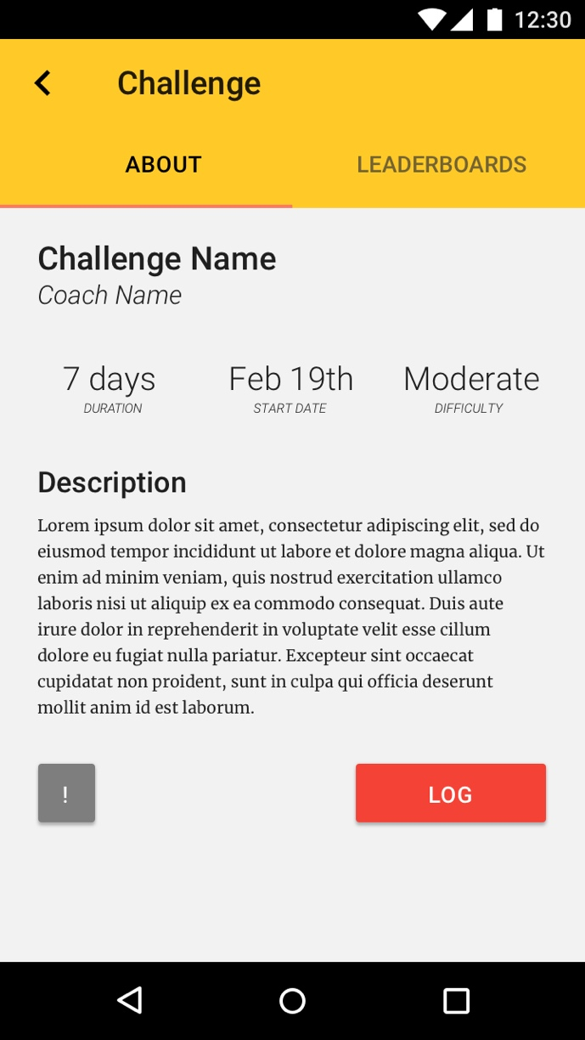

   Scenario: Difficulty of challenges are indicated to all users

   Given a user is on the future challenges page

   When a challenges is selected

   Then they should see the level of difficulty for that challenge indicated

23. User-name search

As a user, I want to be able to search other Users by their usernames, so I can add them to my friend list.

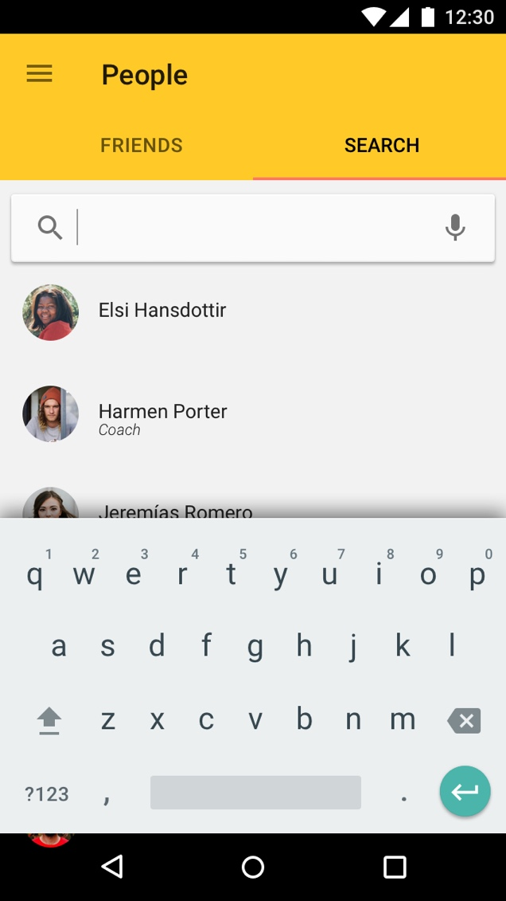

   Scenario: User searches for another user

   Given a user is on their homepage

   When they click the [People] button

   Then they should see a search bar

   When they input a username

   And click the [Search] button

   Then they should either see that the user exists with the option to [View] or "No users found"

24. Forgot username/password

As a user, I want to be able to retrieve my username/password via email, so I do not have to worry if I forgot my username or password.

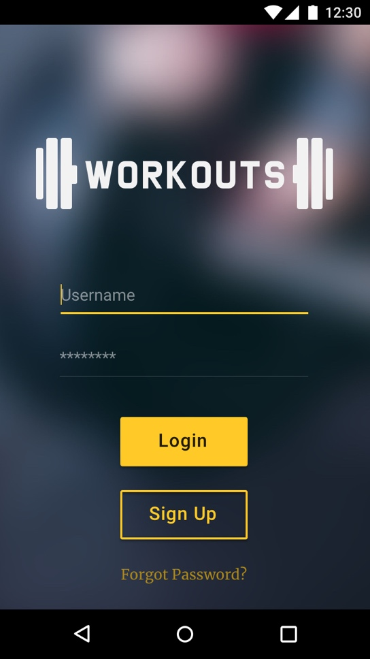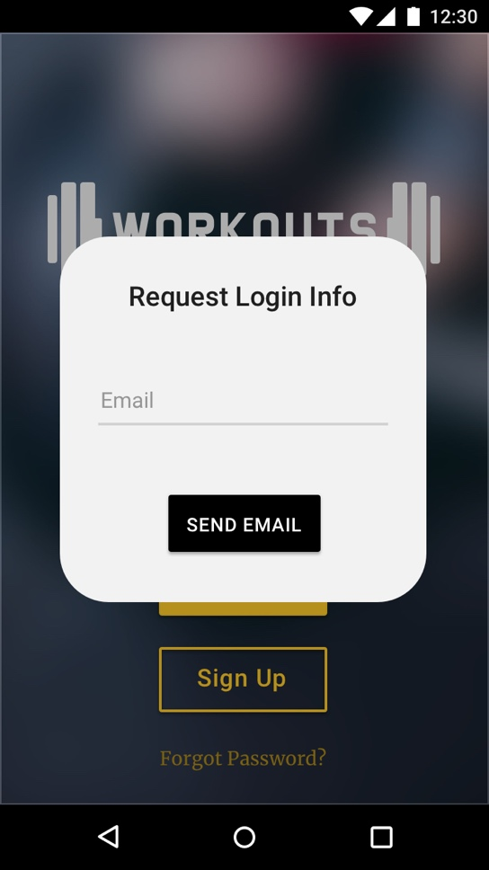

   Scenario: User retrieves their forgotten username/password

   Given a user is on the log-in page

   When they click on the "Forgot my Username/Password" link

   Then they should be taken to the Forgot User/Pass page

   When they filled out the required information

   And answered the security questions correctly

   Then an email with the forgotten username/password should be sent to the address registered with the account.