INFO2222 - Usability and Security

School of Computer Science

Group Project - Project Plan

Please use this template to answer your project phase 1. Do not change the titles of the questions; just answer below the title. Each part of the question should start on a new page. If necessary, you can take more than 1 page to answer the questions, but please start each question on a new page.

Do not edit the first page of the template except for entering your name and SID below.

Group Name (as it appears in Canvas) | INFOP2222-PRJ-T02-G04
Tutorial Number | Tutorial 2
Student 1 - Name: | Adam Li
Student 1 - SID: | 550231811
Student 2 - Name: | Christina Liu
Student 2 - SID: | 550732385
Student 3 - Name: | Jimu Li
Student 3 - SID: | 540735585
Student 4 - Name: | Seonghyun Kim
Student 4 - SID: | 520000870

Task 1-a (~ 50 words)

The aim of the system is to provide a platform that enables university students to collaborate on a communal task board. The platform would provide weighted tasks and features that allow effective communication and task assignment within the team. The platform seeks to streamline the distribution of responsibility and goal setting.

Task 1-b (~30 words)

One unique feature that we could implement is weighted tasks. These tasks would be able to be divided up amongst team members and sorted based on priority or size on individual and group task boards.

Task 1-c (~30 words)

The above feature would allow for a more transparent and even distribution process for group work. It would ensure group responsibility and accountability for project elements and set clear, defined goals.
[New Page]
Task 2-a (Please use the table below to answer)

Platform name | Version (if exists) | URL
Canva | N/A | https://www.canva.com/
Perplexity | N/A | https://www.perplexity.ai/
ChatGPT (Open.ai) | ChatGPT v5.4 | https://chatgpt.com
Claude.ai | Sonnet 4.6 | https://claude.ai
Gemini | Gemini 3 (fast) | https://gemini.google.com/app?hl=en-AU
Firefly | Firefly image 4 | https://firefly.adobe.com/?media=featured

Task 2-b (Please use the table below to answer)

Platform | Advantage | Disadvantage
Canva | - Clean design and details, editable elements with various colour (title, name, etc). | - Limited interaction: files cannot be downloaded, no file upload functionality
Perplexity | - Provides simple minimal intuitive design | - All pages have similar composition and design, and Lack of colour for each pages
Claude.ai | - Summaries: effective at condensing lengthy texts into accurate summaries. This would make it useful at the Ai meeting summary feature. | - Not design-oriented: making it lack ability to generate appealing visuals. Instead, it often uses similar generic designs and layouts without detailed prompts and ongoing feedback.
ChatGPT | - UI features: Capable of generating complete user interface flows between features (dashboard, chats, etc.). As it can create and handle multi-screen/feature systems coherently, which is necessary for implementing this system. | - Lack of visuals: Lacks the ability to include visual representations to make the user interface more interactive and appealing to students. This is as it cannot produce prefect-pixel level designs.
Gemini | - Image creating: Equipped with Nano Banana 2, the model can create images with higher quantity. | - Multiple perspectives: According to the overview of the model provided by Google, when facing the general and subjective instructions, the model prefers to provide multiple perspectives and different viewpoints. It requires users to make the prompt as clear as possible.
Firefly | - Stylized: Based on the general setting dashboard, users can change the styles, sizes, compositions very straight forward. | - Can only generate image: Firefly cannot generate the code base of the design.

Task 2-c

Prompt Used for Prototypes:

Design a simple prototype of a web-based communication platform specifically for university students collaborating on group assignments and projects. The platform should focus on helping students organise their work, communicate efficiently, and keep track of shared responsibilities throughout the assignment lifecycle.

The prototype should include the following key interface components:
- Login Screen – simple authentication for students to access their groups
- Group Dashboard – overview of group members, upcoming deadlines, recent activity, and quick access to group tools.
- Group Chat – real-time messaging for discussion and coordination.
- Task Management Board – a simple Kanban/Jira-style board where tasks can be created, assigned to members, and moved between stages (e.g., To Do, In Progress, Completed).
- File Sharing Section – a space where group members can upload, download, and organise shared documents.
- AI Meeting Summary Feature – an integrated AI tool that automatically summarises meeting discussions or chat messages into key points, action items, and assigned tasks to help students keep track of decisions and responsibilities.

The design should be clean, minimal, and intuitive, suitable for quick usability testing and early-stage prototyping. Focus on simple layouts, clear navigation, and essential functionality rather than visual polish.

Task 2-d (Please use the table below to answer)

Platform | Screenshots (Write a short caption describing the screenshot, along with a USyd GitHub URL with code base for each generated project)
Canva | 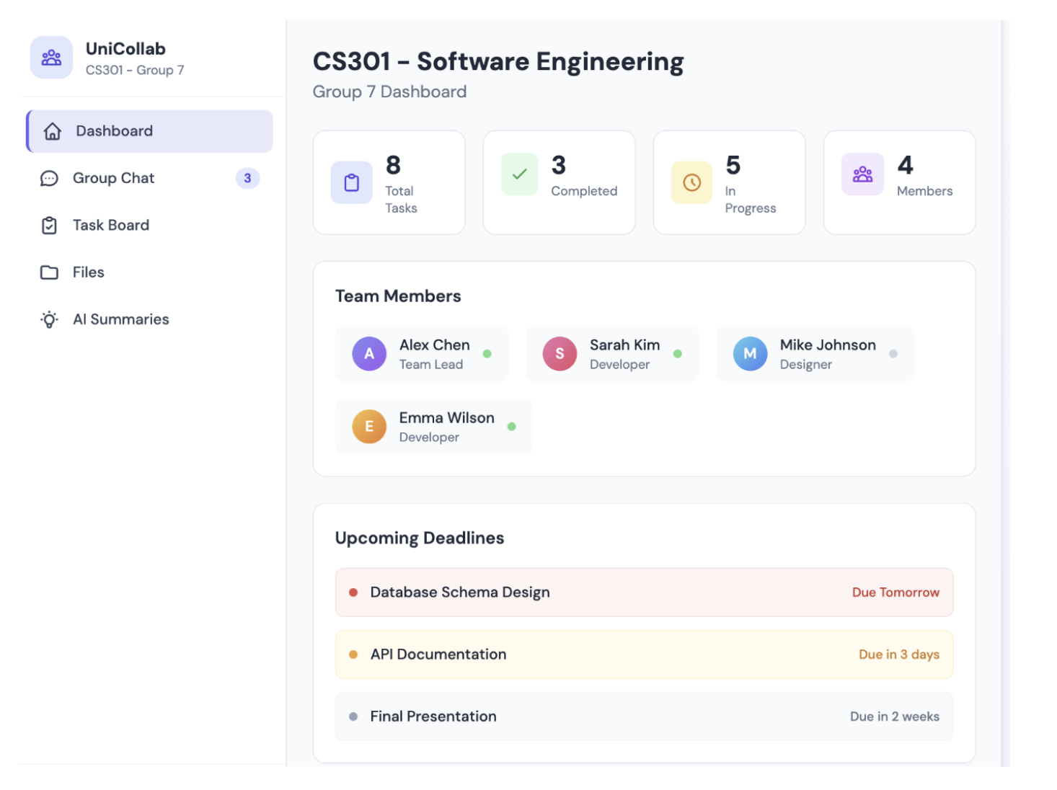  The dashboard shows team members and provides tools for managing their schedules efficiently and summarises the types of tasks.  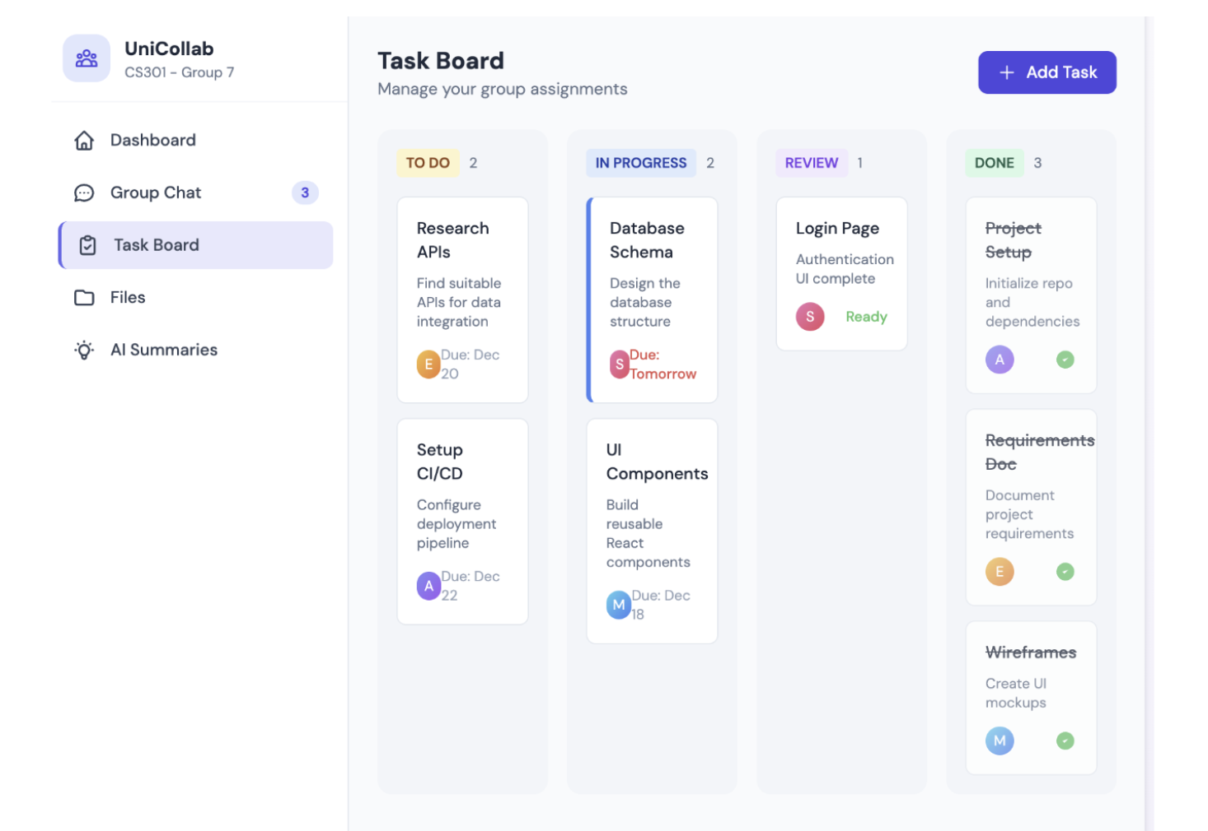  The task board organises the types of tasks and helps students understand the processes required to complete each one.  https://github.sydney.edu.au/INFO2222-2026-S1/PRJ-T02-G04/tree/main/prototypes/canva
Perplexity | 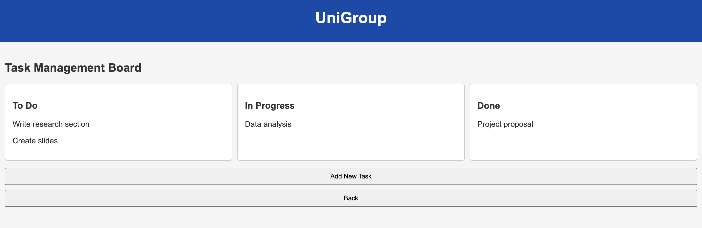  Simple interface to recognise the types of tasks.  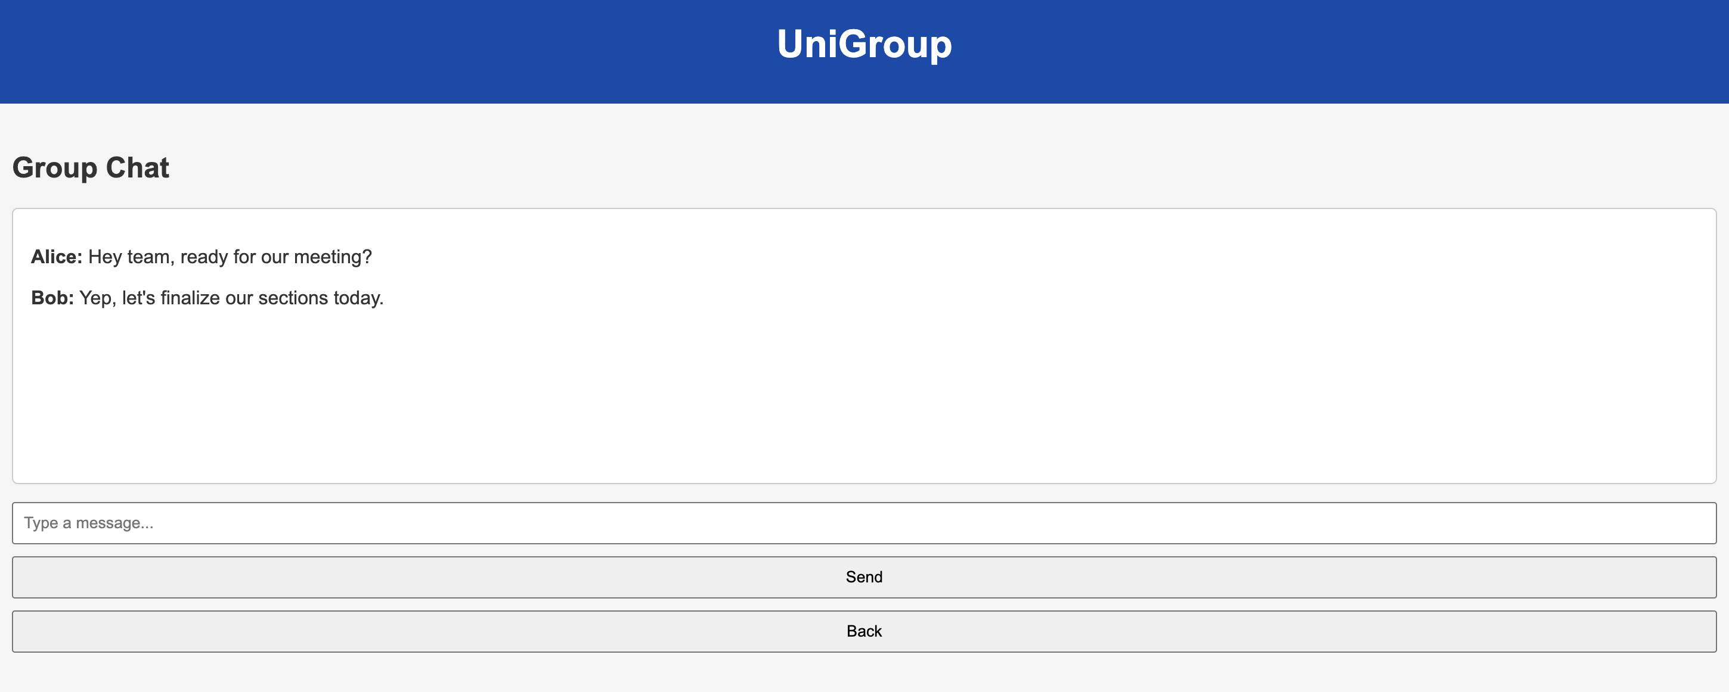  Able to leave a chat.  https://github.sydney.edu.au/INFO2222-2026-S1/PRJ-T02-G04/tree/main/prototypes/perplexity
Claude.ai | 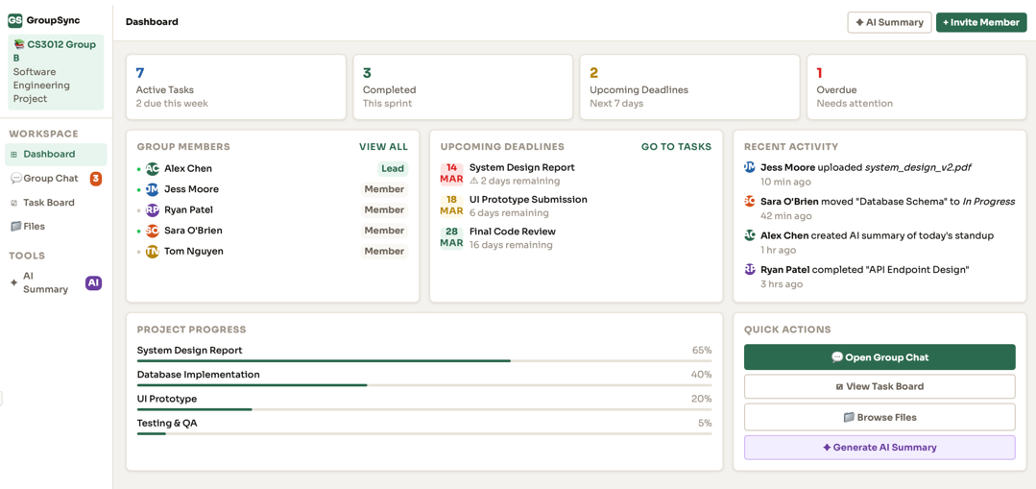  The dashboard includes all features mentioned in the prompt. Easy readability and clear signposting of all features. Project progress and upcoming deadlines are all visible on first glance, providing simple trackability.  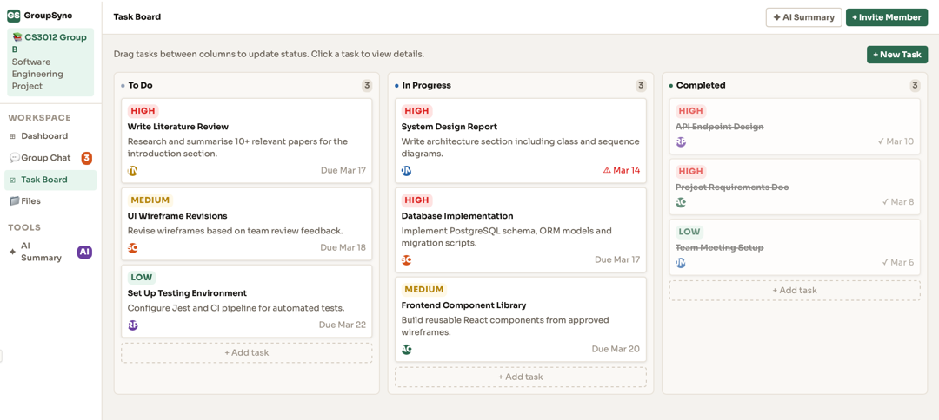  Each task has a brief description, due date and team member allocated to complete it. This allows easy trackability of progress and ensures all members are aware of their allocated tasks and when they must be completed by.  Link to code: https://github.sydney.edu.au/INFO2222-2026-S1/PRJ-T02-G04/tree/31dfde7bc09f0b72c7b803f83945100f8ebab4b7/prototypes/Claude
ChatGPT | 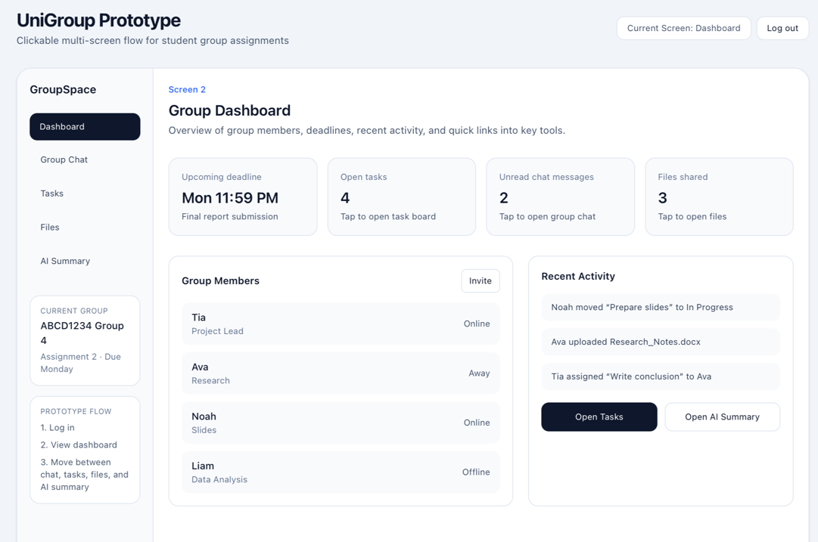  Minimalistic dashboard (after log-in screen) that provides an overview of all features in the tab on the left for easy navigation.  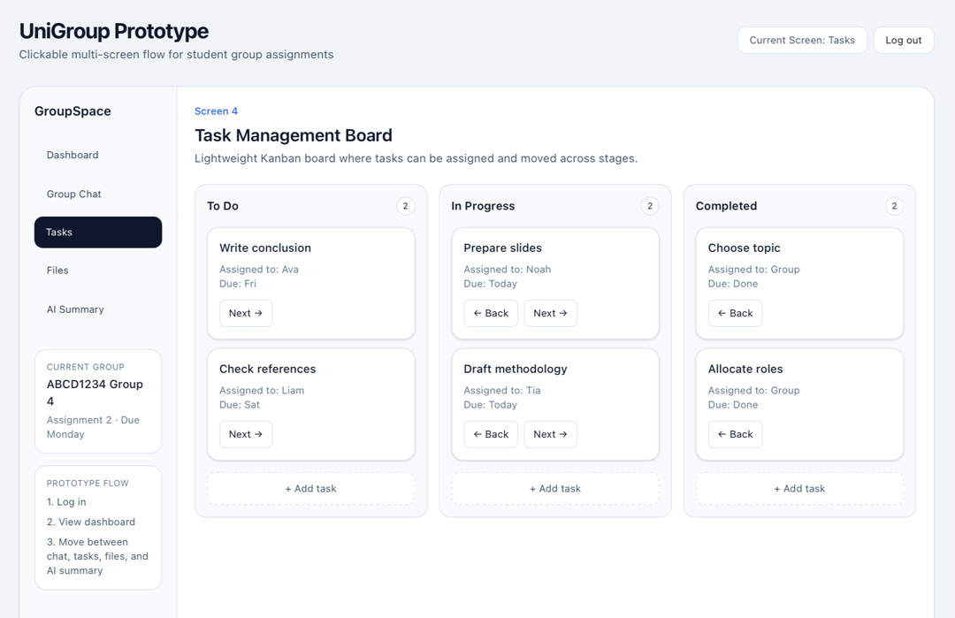  Includes all tasks to be completed, sorted by progress. It includes the team member assigned to the task as well as the due day of week (not date).  Link to code: https://github.sydney.edu.au/INFO2222-2026-S1/PRJ-T02-G04/tree/31dfde7bc09f0b72c7b803f83945100f8ebab4b7/prototypes/ChatGPT
Gemini | 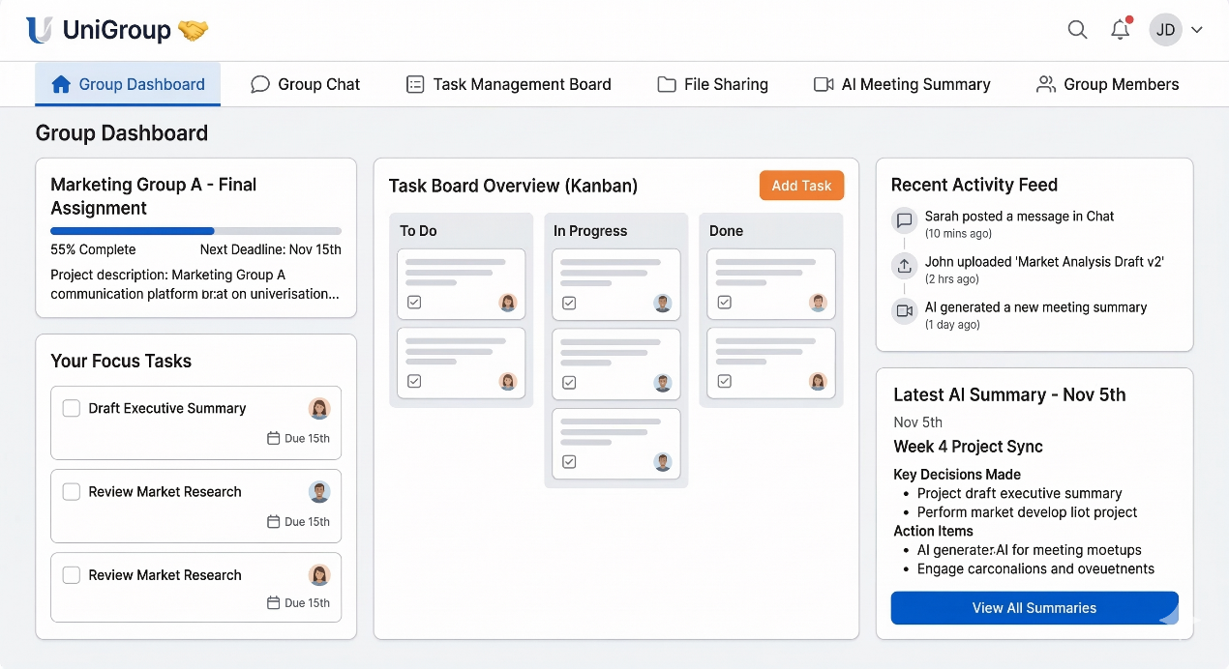  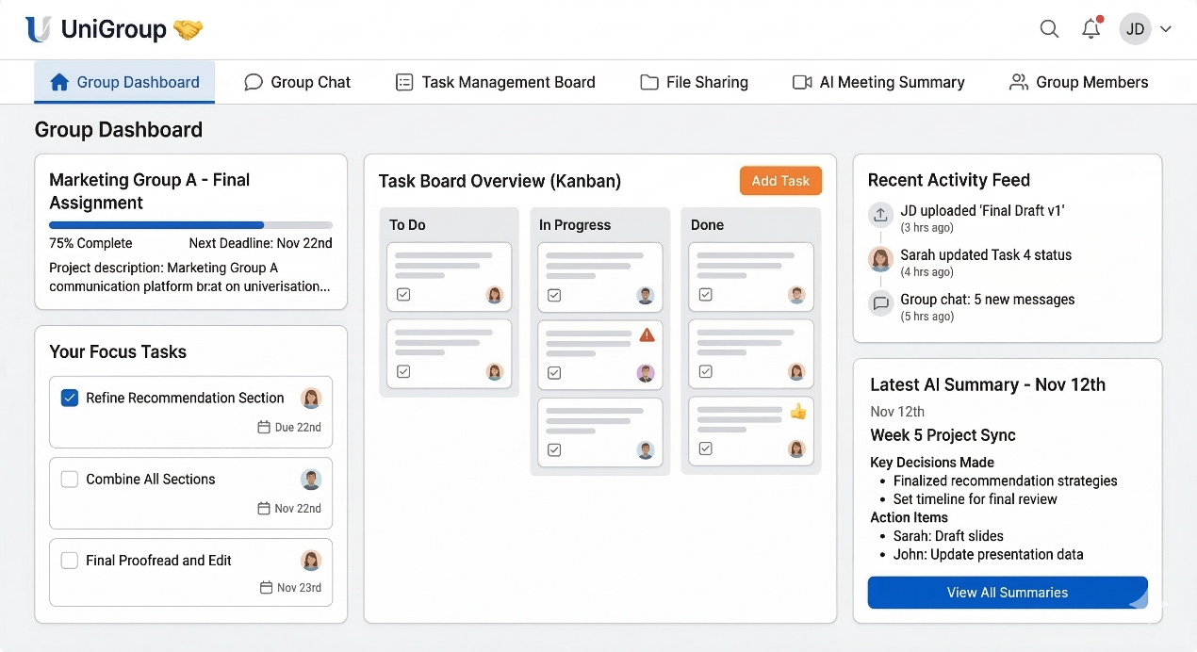  The screenshots contain the basic elements such as group dashboard, task management board and so on. However, the two screenshots generated by Gemini are quite similar. Besides, all the features are placed in a single page.  Link to code:  https://github.sydney.edu.au/INFO2222-2026-S1/PRJ-T02-G04/tree/main/prototypes/Gemini
Firefly | 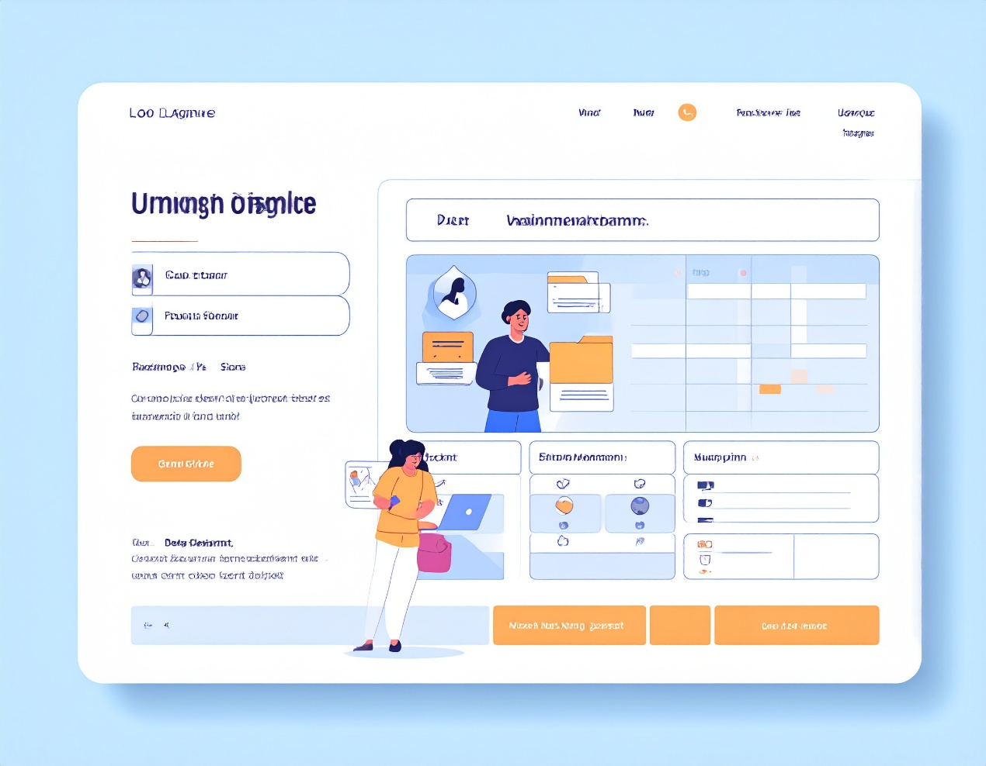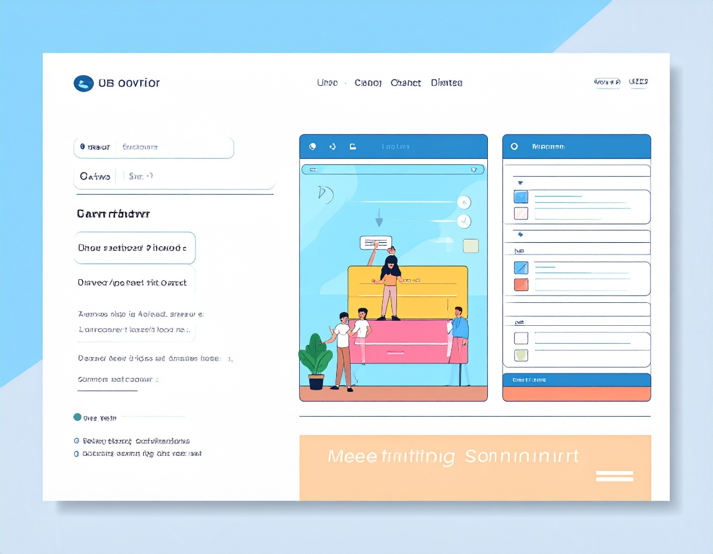  Firefly ai separated the features into four pages. (Only two of them are shown here.) However, the distinguishments are not so clear between the screenshots. For example, the first two pages both seem to be the login page. Besides, there exist some garbled characters.

Task 2-e (Please use the table below to answer)

Platform name | Rank | Reasons
Canva | 8/10 | This platform produces satisfying and likeable design for majority. Evident icons and layout are also one of advantages.
Perplexity | 2/10 | The design is too simple to use. This can be advantage to minority but it seems that it has no familiar and warm design.
Claude.ai | 9/10 | The design is easy to follow and clean but colourful which aids in guiding users to more important aspects of the dashboard. The task board interface is well structured, with the priority of tasks an useful feature for users. If the interface included a countdown to the due date, it would aid users in more effective organisation.
ChatGPT | 5/10 | The design is considered boring due to its lack of colour and icons. Additionally, the task management screen is not very effective. Each task does not have a short description entailing what that specific task encompasses. The lack of specific due dates is not a desirable feature.
Gemini | 9/10 | The model is so powerful that cannot be avoid in image designing. However, the images it generated are a little bit rigid.
Firefly | 5/10 | The existing of garbled characters is a big shortage. However, the model enables users to upload image to create a style, which may be useful later.

[New Page]

Weekly Diary (Always use the name as it appears in Canvas):

Group Name
Week | Student Name | Activities

W01
W01 | Christina Liu | Created Instagram group chat for communication between team members.
W01 | Jimu Li | Read through assignment brief
W01 | Seonghyun Kim | Planned the steps of tasks to complete
W02 | Adam Li | Explore different kinds of GenAI.
W02 | Christina Liu | Researched commonly used AI platforms for generating code.
W02 | Jimu Li | Brainstormed ideas for potential unique platform features
W02 | Seonghyun Kim | Allocated roles for each member
W03 | Adam Li | Test Gemini and Firefly and write the report.
W03 | Christina Liu | Added more detail to the prompt used for prototypes, and completed all parts of question 2 for two platforms (Claude.ai and ChatGPT).
W03 | Jimu Li | Discussed ideas for platform features. Completed Task 1 and contributed to Task 2 by probing Microsoft Copilot for a platform prototype.
W03 | Seonghyun Kim | Provided the concept of platform and worked with Canva and Perplexity for Task 2

