**Appendices**

A.1 Analysis of The First Fraction

WORKSHEET 1

**Factorial Regression: Range versus Pull-back angle, Release angle, Eye hook position, Tension arm**

**Coded Coefficients**

|  |  |  |  |  |  |  |
| --- | --- | --- | --- | --- | --- | --- |
| **Term** | **Effect** | **Coef** | **SE Coef** | **T-Value** | **P-Value** | **VIF** |
| Constant |  | 51.88 | * | * | * |  |
| Pull-back angle | 27.25 | 13.63 | * | * | * | 1.00 |
| Release angle | -17.250 | -8.625 | * | * | * | 1.00 |
| Eye hook position | -10.750 | -5.375 | * | * | * | 1.00 |
| Tension arm | -19.250 | -9.625 | * | * | * | 1.00 |
| Pull-back angle*Release angle | -7.750 | -3.875 | * | * | * | 1.00 |
| Pull-back angle*Eye hook position | 5.750 | 2.875 | * | * | * | 1.00 |
| Pull-back angle*Tension arm | 2.250 | 1.125 | * | * | * | 1.00 |

**Analysis of Variance**

|  |  |  |  |  |  |
| --- | --- | --- | --- | --- | --- |
| **Source** | **DF** | **Adj SS** | **Adj MS** | **F-Value** | **P-Value** |
| Model | 7 | 3248.87 | 464.12 | * | * |
| Linear | 4 | 3052.50 | 763.13 | * | * |
| Pull-back angle | 1 | 1485.12 | 1485.12 | * | * |
| Release angle | 1 | 595.13 | 595.13 | * | * |
| Eye hook position | 1 | 231.12 | 231.12 | * | * |
| Tension arm | 1 | 741.13 | 741.13 | * | * |
| 2-Way Interactions | 3 | 196.38 | 65.46 | * | * |
| Pull-back angle*Release angle | 1 | 120.13 | 120.13 | * | * |
| Pull-back angle*Eye hook position | 1 | 66.13 | 66.13 | * | * |
| Pull-back angle*Tension arm | 1 | 10.12 | 10.12 | * | * |
| Error | 0 | * | * |  |  |
| Total | 7 | 3248.87 |  |  |  |

**Regression Equation in Uncoded Units**

|  |  |  |
| --- | --- | --- |
| Range | = | 17.00 + 0.7583 Pull-back angle + 34.00 Release angle - 37.00 Eye hook position - 22.00 Tension arm - 0.2583 Pull-back angle*Release angle + 0.1917 Pull-back angle*Eye hook position + 0.07500 Pull-back angle*Tension arm |

**Alias Structure**

|  |  |  |
| --- | --- | --- |
| **Factor** | **Name** | |
| A | Pull-back angle | |
| B | Release angle | |
| C | Eye hook position | |
| D | Tension arm | |
| **Aliases** | |
| I + ABCD | |
| A + BCD | |
| B + ACD | |
| C + ABD | |
| D + ABC | |
| AB + CD | |
| AC + BD | |
| AD + BC | |

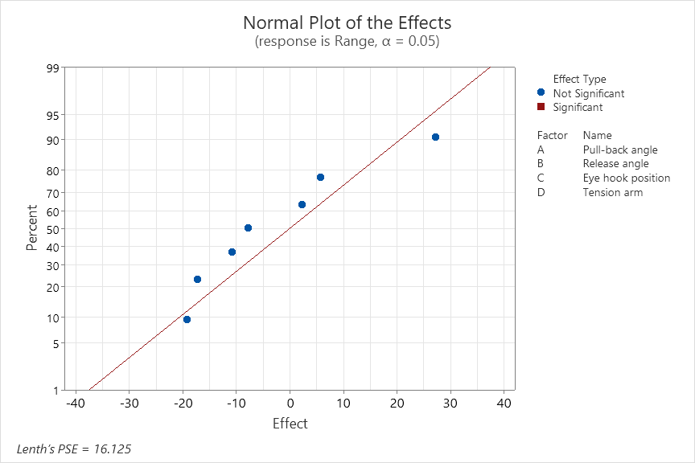

A.2 Analysis of The Full Model

WORKSHEET 7

**Factorial Regression: Range versus Pull-back angle, Release angle, Eye hook position, Tension arm**

* NOTE * This design is not orthogonal.

The following terms cannot be estimated and were removed:  
Pull-back angle*Release angle*Tension arm, Release angle*Eye hook position*Tension arm, Pull-back angle*Release angle*Eye hook position*Tension arm

**Coded Coefficients**

|  |  |  |  |  |  |  |
| --- | --- | --- | --- | --- | --- | --- |
| **Term** | **Effect** | | **Coef** | **SE Coef** | **T-Value** | **P-Value** |
| Constant |  | | 50.60 | 2.36 | 21.43 | 0.000 |
| Pull-back angle | 29.21 | | 14.60 | 2.36 | 6.19 | 0.000 |
| Release angle | -11.29 | | -5.65 | 2.15 | -2.63 | 0.034 |
| Eye hook position | -11.54 | | -5.77 | 2.36 | -2.44 | 0.044 |
| Tension arm | -26.00 | | -13.00 | 2.59 | -5.03 | 0.002 |
| Pull-back angle*Release angle | -7.04 | | -3.52 | 2.15 | -1.64 | 0.145 |
| Pull-back angle*Eye hook position | -2.04 | | -1.02 | 3.36 | -0.30 | 0.770 |
| Pull-back angle*Tension arm | -11.25 | | -5.63 | 3.52 | -1.60 | 0.155 |
| Release angle*Eye hook position | 10.21 | | 5.10 | 3.50 | 1.46 | 0.188 |
| Release angle*Tension arm | 4.50 | | 2.25 | 3.39 | 0.66 | 0.528 |
| Eye hook position*Tension arm | -3.25 | | -1.63 | 2.59 | -0.63 | 0.550 |
| Pull-back angle*Release angle*Eye hook position | 5.96 | | 2.98 | 2.15 | 1.39 | 0.208 |
| Pull-back angle*Eye hook position*Tension arm | -4.00 | | -2.00 | 2.59 | -0.77 | 0.465 |
| **Term** | **VIF** |
| Constant |  |
| Pull-back angle | 1.80 |
| Release angle | 1.50 |
| Eye hook position | 1.82 |
| Tension arm | 2.17 |
| Pull-back angle*Release angle | 1.51 |
| Pull-back angle*Eye hook position | 3.66 |
| Pull-back angle*Tension arm | 4.06 |
| Release angle*Eye hook position | 3.97 |
| Release angle*Tension arm | 3.60 |
| Eye hook position*Tension arm | 1.64 |
| Pull-back angle*Release angle*Eye hook position | 1.51 |
| Pull-back angle*Eye hook position*Tension arm | 2.19 |

**Model Summary**

|  |  |  |  |
| --- | --- | --- | --- |
| **S** | **R-sq** | **R-sq(adj)** | **R-sq(pred)** |
| 7.82091 | 96.75% | 91.18% | * |

**Analysis of Variance**

|  |  |  |  |  |  |
| --- | --- | --- | --- | --- | --- |
| **Source** | **DF** | **Adj SS** | **Adj MS** | **F-Value** | **P-Value** |
| Model | 12 | 12746.8 | 1062.23 | 17.37 | 0.000 |
| Linear | 4 | 10247.4 | 2561.84 | 41.88 | 0.000 |
| Pull-back angle | 1 | 2340.0 | 2340.00 | 38.26 | 0.000 |
| Release angle | 1 | 422.1 | 422.07 | 6.90 | 0.034 |
| Eye hook position | 1 | 365.4 | 365.38 | 5.97 | 0.044 |
| Tension arm | 1 | 1545.1 | 1545.14 | 25.26 | 0.002 |
| 2-Way Interactions | 6 | 1691.5 | 281.91 | 4.61 | 0.033 |
| Pull-back angle*Release angle | 1 | 164.1 | 164.14 | 2.68 | 0.145 |
| Pull-back angle*Eye hook position | 1 | 5.6 | 5.64 | 0.09 | 0.770 |
| Pull-back angle*Tension arm | 1 | 155.8 | 155.77 | 2.55 | 0.155 |
| Release angle*Eye hook position | 1 | 129.9 | 129.92 | 2.12 | 0.188 |
| Release angle*Tension arm | 1 | 27.0 | 27.00 | 0.44 | 0.528 |
| Eye hook position*Tension arm | 1 | 24.1 | 24.14 | 0.39 | 0.550 |
| 3-Way Interactions | 2 | 135.6 | 67.78 | 1.11 | 0.382 |
| Pull-back angle*Release angle*Eye hook position | 1 | 117.5 | 117.52 | 1.92 | 0.208 |
| Pull-back angle*Eye hook position*Tension arm | 1 | 36.6 | 36.57 | 0.60 | 0.465 |
| Error | 7 | 428.2 | 61.17 |  |  |
| Total | 19 | 13174.9 |  |  |  |

**Regression Equation in Uncoded Units**

|  |  |  |
| --- | --- | --- |
| Range | = | -637 + 5.35 Pull-back angle + 165 Release angle + 55 Eye hook position - 62 Tension arm - 1.228 Pull-back angle*Release angle - 0.463 Pull-back angle*Eye hook position + 0.292 Pull-back angle*Tension arm - 27.7 Release angle*Eye hook position + 2.25 Release angle*Tension arm + 20.4 Eye hook position*Tension arm + 0.199 Pull-back angle*Release angle*Eye hook position - 0.133 Pull-back angle*Eye hook position*Tension arm |

**Fits and Diagnostics for Unusual Observations**

|  |  |  |  |  |  |
| --- | --- | --- | --- | --- | --- |
| **Obs** | **Range** | **Fit** | **Resid** | **Std Resid** |  |
| 5 | 31.00 | 31.00 | -0.00 | * | X |
| 7 | 84.00 | 84.00 | 0.00 | * | X |
| 9 | 36.00 | 36.00 | 0.00 | * | X |
| 11 | 72.00 | 72.00 | -0.00 | * | X |
| 14 | 42.00 | 42.00 | -0.00 | * | X |
| 15 | 35.00 | 35.00 | 0.00 | * | X |
| 19 | 42.00 | 42.00 | 0.00 | * | X |

*X  Unusual X*

**Alias Structure**

|  |  |  |
| --- | --- | --- |
| **Factor** | **Name** | |
| A | Pull-back angle | |
| B | Release angle | |
| C | Eye hook position | |
| D | Tension arm | |
| **Aliases** | |
| I + ABCD | |
| A + BCD | |
| B + BCD | |
| C + ABD | |
| D - ABD | |
| AB + ABCD | |
| AC - ABD + BCD + ABCD | |
| AD + ABD - BCD - ABCD | |
| BC - ABD + BCD + ABCD | |
| BD + ABD - BCD - ABCD | |
| CD - ABCD | |
| ABC + ABD | |
| ACD - BCD | |

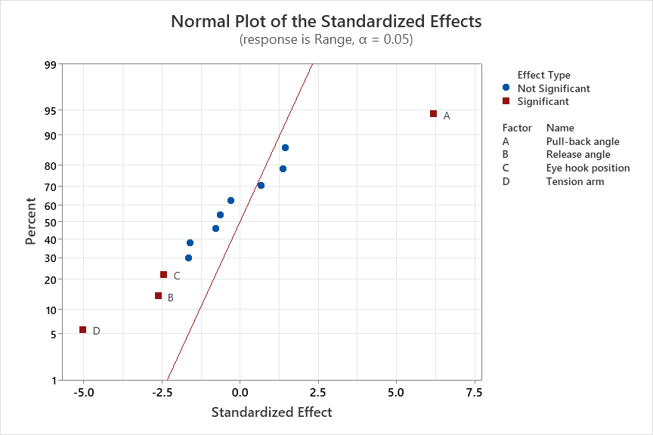

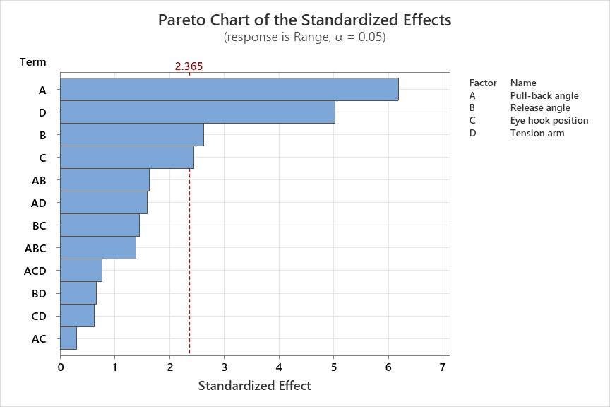

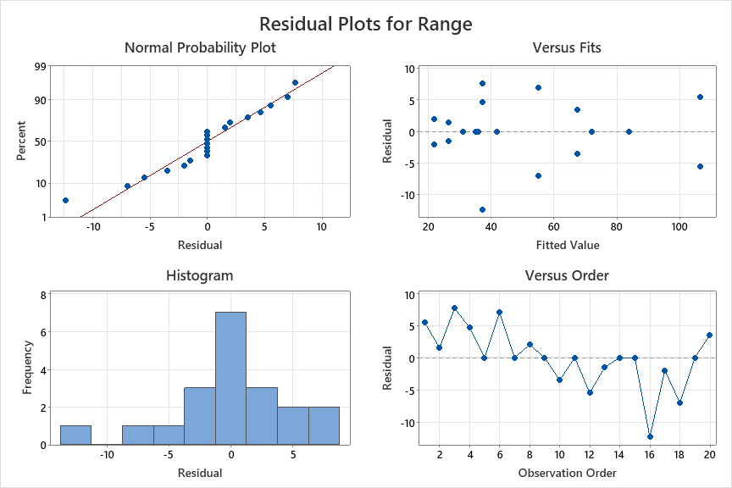

A.3 Firing Table

A.4 Full Dataset

|  |  |  |  |  |  |  |  |
| --- | --- | --- | --- | --- | --- | --- | --- |
| RunOrder | CenterPt | Blocks | Pull-back angle | Release angle | Eye hook position | Tension arm | Range |
| 1 | 1 | 1 | 180 | 3 | 4 | 2 | 112 |
| 2 | 1 | 1 | 150 | 5 | 6 | 4 | 28 |
| 3 | 1 | 1 | 180 | 5 | 6 | 4 | 45 |
| 4 | 1 | 1 | 180 | 5 | 6 | 4 | 42 |
| 5 | 1 | 1 | 150 | 5 | 4 | 4 | 31 |
| 6 | 1 | 1 | 150 | 3 | 4 | 2 | 62 |
| 7 | 1 | 1 | 180 | 3 | 6 | 2 | 84 |
| 8 | 1 | 1 | 150 | 3 | 6 | 4 | 24 |
| 9 | 1 | 1 | 150 | 5 | 6 | 2 | 36 |
| 10 | 1 | 1 | 180 | 5 | 4 | 2 | 64 |
| 11 | 1 | 1 | 180 | 3 | 4 | 4 | 72 |
| 12 | 1 | 1 | 180 | 3 | 4 | 2 | 101 |
| 13 | 1 | 1 | 150 | 5 | 6 | 4 | 25 |
| 14 | 1 | 1 | 180 | 5 | 4 | 4 | 42 |
| 15 | 1 | 1 | 180 | 3 | 6 | 4 | 35 |
| 16 | 1 | 1 | 180 | 5 | 6 | 4 | 25 |
| 17 | 1 | 1 | 150 | 3 | 6 | 4 | 20 |
| 18 | 1 | 1 | 150 | 3 | 4 | 2 | 48 |
| 19 | 1 | 1 | 150 | 5 | 4 | 2 | 42 |
| 20 | 1 | 1 | 180 | 5 | 4 | 2 | 71 |

A.5 Python Code for Firing Table Generation

# %%

import pandas as pd

from numpy.linalg import inv

import numpy as np

from sympy.solvers import solve

from sympy import Symbol

import warnings

warnings.filterwarnings("ignore")

# %%

df = pd.read_excel('Statapult data.xlsx')

df = df.loc[:, 'RunOrder': 'Range']#.sort_values(by=['Range'])

firing = pd.read_csv('Firing Table Template.csv')

#Encoding the variables

def encode(df):

df['A'] = [-1 if i < 180 else 1 for i in df['Pull-back angle'].values ]

df['B'] = [-1 if i < 5 else 1 for i in df['Release angle'].values ]

df['C'] = [-1 if i < 6 else 1 for i in df['Eye hook position'].values ]

df['D'] = [-1 if i < 4 else 1 for i in df['Tension arm'].values ]

return df

# %%

X = pd.read_excel('design matrix.xlsx')

Y = df['Range']

betahat = inv(X.T.dot(X)).dot(X.T.dot(Y)).reshape(13,1)

def regression_coded(A, B, C, D):

'''Regression Model (Coded)'''

X0 = np.array([1, A, B, C, D, A*B, A*C, A*D, B*C, B*D, C*D, A*B*C, A*C*D]).reshape(13,1)

return betahat.T.dot(X0)[0][0]

# %%

index = 0

for r in firing['Range'].values:

temp = df[(df['Range'] >= r-10) & (df['Range'] <= r+10)]

temp = encode(temp)

sigma_sq = 61.17

for row in temp.index:

B = temp.loc[row, 'B']

C = temp.loc[row, 'C']

D = temp.loc[row, 'D']

x = Symbol('x')

V_temp = 100000

best_setting = []

#Calculate ideal angle

angle_coded = solve(50.6 + 14.6*x - 5.65*B -5.77*C - 13*D - 3.52*x*B -1.02*x*C - 5.63*x*D +5.10*B*C \

+2.25*B*D - 1.63*C*D + 2.98*x*B*C -2*x*C*D - r, x)[0]

angle_original = angle_coded * 15 + 165

#print (int(angle_original))

#print (round(angle_coded, 2))

if angle_original < 140 or angle_original > 180: #if the angle is not possible

#print (r)

continue

X_0 = get_X0(angle_coded, B, C, D)

V_yhat = sigma_sq* (1+X_0.T.dot(inv(X.T.dot(X))).dot(X_0))[0][0]

#print (row, angle_original, V_yhat, regression_coded(angle_coded, B, C, D))

if V_yhat < V_temp:

V_temp = V_yhat

#L = regression_coded(angle_coded, B, C, D) - 4.303 * np.sqrt(float(V_yhat))

best_setting = [r, round(angle_original), temp.loc[row, 'Release angle'], temp.loc[row, 'Eye hook position'], temp.loc[row, 'Tension arm'], 'cup', V_temp, 'L', 'U']

if best_setting == []:

print (r)

else:

firing.loc[index] = best_setting

print (best_setting)

index+=1

if best_setting == []:

print (r)

else:

firing.loc[index] = best_setting

print (best_setting)

index+=1

firing.to_csv('final firing.csv')