**SET Lab**

**Assignment No.: 01**

**Name: Yash Barikrao Pandhare**

**Roll No: 2019BTECS00085**

**Class: TY CSE 2021-22, Sem II**

**Batch: T4**

**Q.3. Differentiate in between free software, Open source software and proprietary software with respect to its properties.**

1. Difference in free software and Open source software:

|  |  |
| --- | --- |
| Free software | Open source software |
| 1. Free Software is Open Source Software | 1. Open Source software may not necessarily be Free Software. |
| 2. Free Software not allows the coder more control over his program compared to Opens Source Software | 2. Open Source allows the coder more control over his program compared to Free Software |
| 3. Open Source software can work with other proprietary software, while Free Software does not allow the same. | 3. Open Source software can work with other proprietary software, while Free Software does not allow the same. |

2. Difference in Open source software and Proprietary software:

|  |  |
| --- | --- |
| Open source software | Proprietary software |
| 1. Developed by and tested through open collaboration | 1. Software that owned y individual or organization |
| 2. Anyone can access modify inspect | 2. Only owned organization or publisher have rights of cade |
| 3. Only for skill users are aimed | 3. Cover all market like skilled and unskilled user are aimed |
| 4. Android , Drupal | 4. Windows , macOS |

3. Free software and Proprietary software:

|  |  |
| --- | --- |
| Free software | Proprietary software |
| 1. This are free software | 1. Pay for use |
| 2. have code rights | 2. have code rights |
| Packet tracer | Windows |

**Q.4.** **Using Anaconda Python create Histogram, Scatter plot and Bar plot for the dataset given below.**

a. Scatter plot- Scatter plot of Price Vs Age

b. Histogram- for Kilometres and CC

c. Bar plot- Bar plot for different fuel types

Histogram:

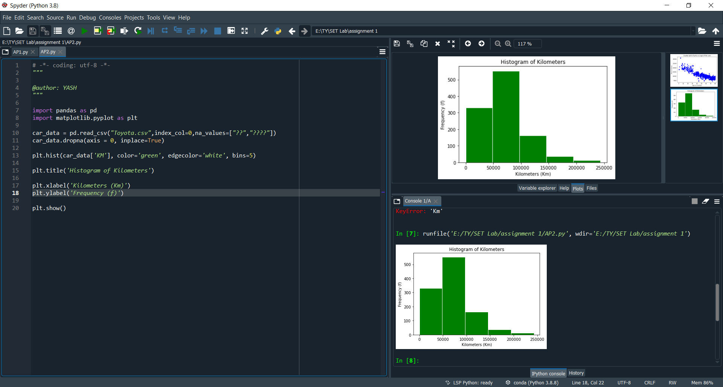

Scattered Plot:

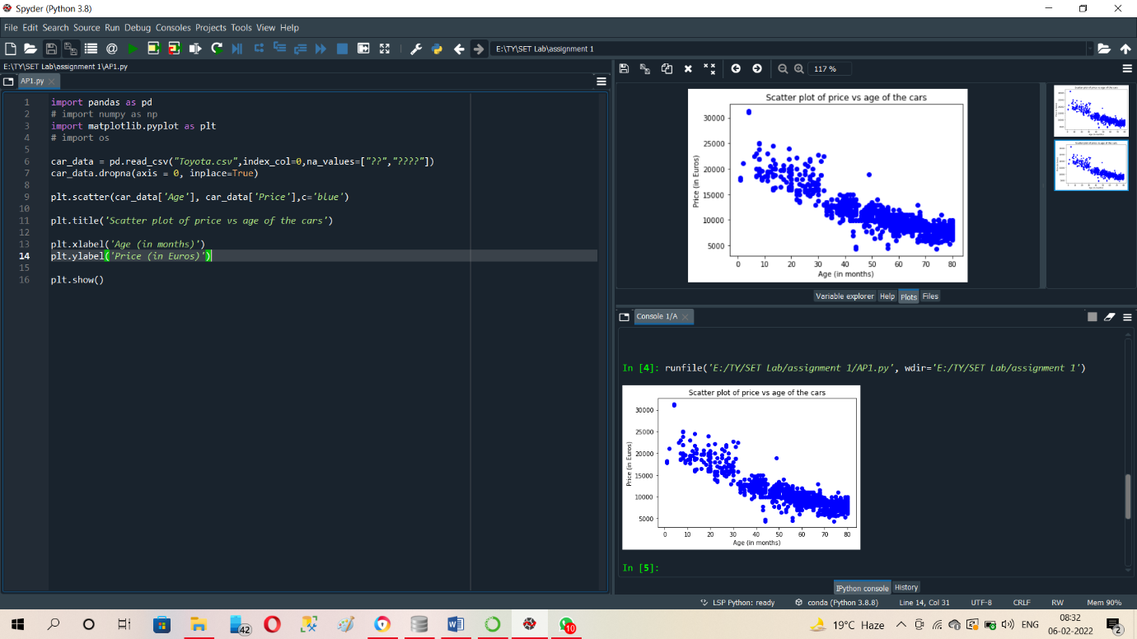

Bar Plot:

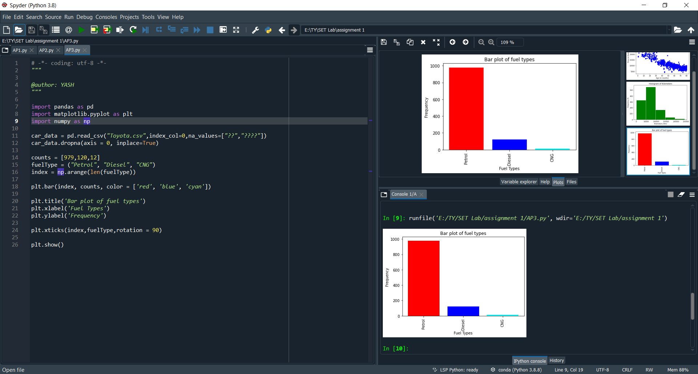

**Q.5. Enlist some examples along with its purpose and properties (at least 10) of FOSS and proprietary software with respect to database.**

**FOSS**

1. **Git**

Git is**an open-source distributed version control system.** It is designed to handle minor to major projects with high speed and efficiency.

1. **Msql**

**MySQL** is a widely used relational database management system (RDBMS). **MySQL** is free and open-source. **MySQL** is ideal for both small and large applications.

1. **Php**

PHP is a server-side language that can be used in conjunction with a database to create dynamic web pages. By the word "dynamic" it allows you to input or query data from a web page. These aren't the only things PHP allows you to do interaction with databases are a key feature of server-side languages.

1. **Mongodb**

Collection is**a group of MongoDB documents.** It is the equivalent of an RDBMS table. A collection exists within a single database. Collections do not enforce a schema. Documents within a collection can have different fields. Typically, all documents in a collection are of similar or related purpose.

1. **Open** **suse**

Open SUSE Distributions. For desktop, server, and everything in between. Desktop Selection of distributions for desktop use

1. **Wordpress**

WordPress ( WP, WordPress.org) is a free and open-source content management system (CMS) written in PHP and paired with a MySQL or MariaDB database

1. **Python**

Programming genral purose language

1. **Linux**

Operating sytem

1. **Ubantu**

OS

1. **Cake php**

CakePHP Tutorial. CakePHP is an open-source framework for PHP. It is intended to make developing, deploying and maintaining applications much easier.

1. **Openmoko**

**Openmoko** is a project dedicated to delivering mobile phones with an open source software stack.

1. **Mozila firefox**

**Web browser**

**Proprietary software**

1. **Windows**

**OS**

1. **Winrar**

**WinRAR** is a powerful archive manager. It can backup your data and reduce the size of email attachments, open and unpack **RAR** , ZIP and other files downloaded from Internet

1. **Itunes**

Microsoft **Intune** is a cloud-based mobile device management and mobile application management solution.

1. **Microsoft office**

Collaborate for free with online versions of **Microsoft** Word, PowerPoint, Excel, and OneNote. Save documents, workbooks, and presentations online, in OneDrive.

1. **Skype**

Get **Skype**, free messaging and video chat app. Conference calls for up to 25 people. Download **Skype** for Windows, Mac or Linux today.

1. **Mac**

**OS**

1. **Google earth**

Adding Street View and a 3D view to a **Google Earth** project. Viewing your story as a presentation and sharing It with a collaborator.

1. **Visual studio**

Visual Studio Code is a code editor redefined and optimized for building and debugging modern web and cloud applications. Visual Studio Code is **free** and available on your favorite platform - Linux, macOS, and Windows.

1. **Intel**

A full-service, turn-key program. Worldwide Pre-Packaged or Custom Bundles.

1. **Adobe**

**Adobe Acrobat** Reader. The best PDF viewer just got better. View, sign, collaborate on and annotate PDF files with our free Acrobat Reader **software**.