module9.R

Justin

2020-03-15

florida <- read.csv("florida.csv")  
  
plot(florida)  
  
library(lattice)



xyplot(X ~ BUSH, florida, grid = TRUE)

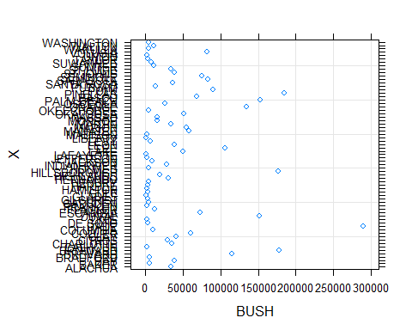

plot(florida$X, florida$BUSH, main = "FL County Votes")

