STAR511: HW

Megan Sears

# Q1

## Q1A

## 'data.frame': 30 obs. of 1 variable:  
## $ rates: int 49 40 59 56 55 70 49 59 55 49 ...

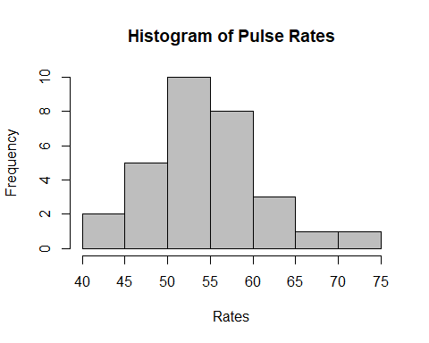

## Q1B

|  |  |
| --- | --- |
| Pulse rate mean | Pulse rate median |
| 55.23333 | 55 |

# Q2

## Q2A

## 'data.frame': 28 obs. of 2 variables:  
## $ StandardTherapy: int 4 14 29 6 15 2 6 13 24 16 ...  
## $ NewTherapy : int 5 17 27 9 20 15 14 18 29 19 ...

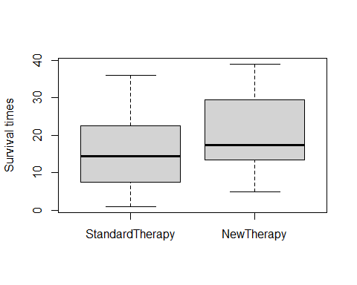

## Q2B

|  |  |
| --- | --- |
| Standard therapy mean | Standard therapy SD |
| 15.67857 | 9.630405 |

|  |  |
| --- | --- |
| New therapy mean | New therapy SD |
| 20.71429 | 9.808753 |

# Appendix

#Retain (and do not edit) this code chunk!!!  
library(knitr)  
knitr::opts_chunk$set(echo = FALSE)  
knitr::opts_chunk$set(message = FALSE)  
library(dplyr)  
#Q1A  
pulse <- read.csv("ex3-34.txt", quote="'")  
str(pulse)  
hist(pulse$rates, col = "grey", main="Histogram of Pulse Rates", xlab="Rates")  
  
#Q1B  
pulserate_stats <- pulse %>%  
 summarize("Pulse rate mean" = mean(rates),  
 "Pulse rate median" = median(rates))  
kable(pulserate_stats)  
#Q2A  
survival <- read.csv("ex3-7.txt", quote="'")  
str(survival)  
boxplot(survival, ylab="Survival times")  
  
#Q2B  
#Standard therapy  
ST <- survival %>%  
 summarize("Standard therapy mean"= mean(StandardTherapy),  
 "Standard therapy SD" = sd(StandardTherapy))  
  
#New therapy  
NT <- survival %>%  
 summarize("New therapy mean"= mean(NewTherapy),  
 "New therapy SD" = sd(NewTherapy))  
  
kable(ST)  
kable(NT)