STAR511: HW 2

Megan Sears

# Q1

## [1] 0.4168338

# Q2

## [1] 0.6270103

# Q3

## [1] -0.2070126

# Q4

## [1] 0.2169285

# Q5

## [1] 0.300926

# Q6

## [1] 0.4821455

# Q7

## [1] 0.9565217

# Q8

A Z-score of approximately 0.957 indicates that Jane did unusually well on the exam. One standard deviation above the mean is 625 and Jane scored 620. In other words, a Z-score of 1.0 equals one standard deviation above the mean, and Jane’s was 0.956.

# Q9

A score of at least 657.38 or greater is needed to join the honor society.

## [1] 657.3784

# Q10

## [1] 0.01485583

# Q11

The data are right skewed based on the histogram.

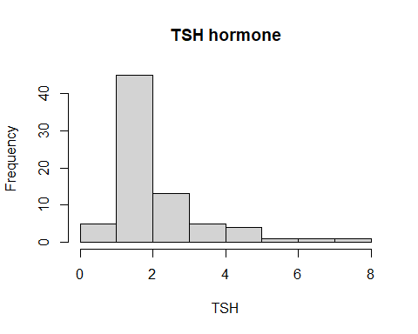

# Q12

Yes, I would expect the distribution to become near normal with 1000 observations based on the Central Limit Theory.

# Q13

Median = 1.58  
Mean = 2.0778667  
Standard deviation = 1.3247369

| Median | Mean | StDev |
| --- | --- | --- |
| 1.58 | 2.077867 | 1.324737 |

# Appendix

#Retain (and do not edit) this code chunk!!!  
library(knitr)  
knitr::opts_chunk$set(echo = FALSE)  
knitr::opts_chunk$set(message = FALSE)  
  
library(tidyverse)  
#Q1  
pnorm(-0.21)  
#Q2  
pnorm(0.53) - pnorm(-1.44)  
#Q3  
qnorm(0.4180)  
#Q4  
1-pnorm((600-510)/115)  
#Q5  
pnorm((450-510)/115)  
#Q6  
pnorm(600, mean = 510, sd = 115) - pnorm(450, mean = 510, sd = 115)  
#Q7  
(620-510)/115  
#Q9  
qnorm(0.90, mean = 510, sd = 115)  
#Q10  
pnorm(485, mean = 510, sd = 115/sqrt(100))  
  
#Q11  
  
hormone <- read.csv('Hormone.csv')  
#str(hormone)  
  
hist(hormone$TSH, main = 'TSH hormone',  
 xlab = 'TSH')  
  
#Q13  
  
hormone_stats <- hormone %>%  
 summarize(Median = median(TSH),  
 Mean = mean(TSH),  
 StDev = sd(TSH))  
  
kable(hormone_stats)