STAR511: HW 5

Megan Sears

# Q1

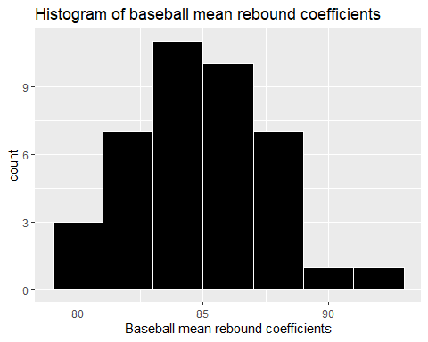

# Q2

| Mean | StDev |
| --- | --- |
| 84.8 | 2.68 |

# Q3

Since the p-value is greater than 0.05 (assuming alpha is 0.05), which indicates the null hypothesis (greater than or equal to 85) should not be rejected. No, our data do not suggest that population mean rebound coefficients is less than 85.

##   
## One Sample t-test  
##   
## data: baseballs$coefficient  
## t = -0.47717, df = 39, p-value = 0.318  
## alternative hypothesis: true mean is less than 85  
## 95 percent confidence interval:  
## -Inf 85.51252  
## sample estimates:  
## mean of x   
## 84.7975

# Q4

## $statistic  
## Chi-Squared   
## 70.23744   
##   
## $parameters  
## df   
## 39   
##   
## $p.value  
## [1] 0.001582505  
##   
## $estimate  
## variance   
## 7.20384   
##   
## $null.value  
## variance   
## 4   
##   
## $alternative  
## [1] "greater"  
##   
## $method  
## [1] "Chi-Squared Test on Variance"  
##   
## $data.name  
## # A tibble: 40 x 1  
## coefficient  
## <dbl>  
## 1 84.8  
## 2 88.1  
## 3 85.1  
## 4 88   
## 5 86.6  
## 6 85.3  
## 7 85.1  
## 8 91.4  
## 9 83.4  
## 10 87.2  
## # ... with 30 more rows  
##   
## $conf.int  
## LCL UCL   
## 5.148218 Inf   
## attr(,"conf.level")  
## [1] 0.95  
##   
## attr(,"class")  
## [1] "htestEnvStats"

A. The test statistic is 70.24.

B. The p-value is 0.0015825.

C. The null hypothesis should be rejected since the p-value is less than 0.05. Therefore, we find evidence that the true standard deviation of baseball rebound coefficients is greater than 2.

# Q5

In HW4, I stated: since the max standard deviation (Current samples) and min standard deviation (Stored samples) ratio is less than 2, we can assume “equal” variances and use a pooled two-sample t-test. Since the sample sizes are equal, the effect of unequal variances on the t-test is minimal. However, pooled test is preferred since the standard deviation ratio is less than 2.

Here, the null hypothesis is that the population variances are equal (i.e., ratio of sigma squared is 1). We fail to reject the ratio of variances squared since the p-value is greater than alpha. This indicates there is evidence that the population variances are equal. This supports the statistical result from HW4 since we concluded the standard deviation ratios are less than 2 and assumed “equal” variances.

##   
## F test to compare two variances  
##   
## data: potency$Sample1 and potency$Sample2  
## F = 1.8061, num df = 9, denom df = 9, p-value = 0.3917  
## alternative hypothesis: true ratio of variances is not equal to 1  
## 95 percent confidence interval:  
## 0.4486201 7.2715173  
## sample estimates:  
## ratio of variances   
## 1.806142

# Appendix

#Retain (and do not edit) this code chunk!!!  
library(knitr)  
knitr::opts_chunk$set(echo = FALSE)  
knitr::opts_chunk$set(message = FALSE)  
  
library(tidyverse)  
library(here)  
library(EnvStats)  
  
#Q1  
baseballs <- read_csv(here('./HW5/exp07-9.txt'), quote = "'")  
  
ggplot(baseballs, aes(x=coefficient)) +  
 geom_histogram(color='white', fill='black', binwidth = 2) +  
 xlab('Baseball mean rebound coefficients') +  
 ggtitle('Histogram of baseball mean rebound coefficients')  
   
#Q2  
bball_summ <- baseballs %>%  
 summarize(Mean = round(mean(coefficient),2),  
 StDev = round(sd(coefficient),2))  
  
kable(bball_summ)  
  
#Q3  
t.test(baseballs$coefficient, alternative = 'less', mu = 85)  
#Q4A  
n <- 40  
s <- sd(baseballs$coefficient)  
ts <- ((n-1)*(s^2))/4  
  
#Q4B  
pval <- 1-pchisq(ts, df = n-1)  
  
varTest(baseballs$coefficient, alternative = 'greater', data.name = baseballs, sigma.squared=4)  
  
#Q5  
potency <- read_csv(here('./HW4/ex6-59.txt'), quote = "'")   
  
var.test(potency$Sample1, potency$Sample2)